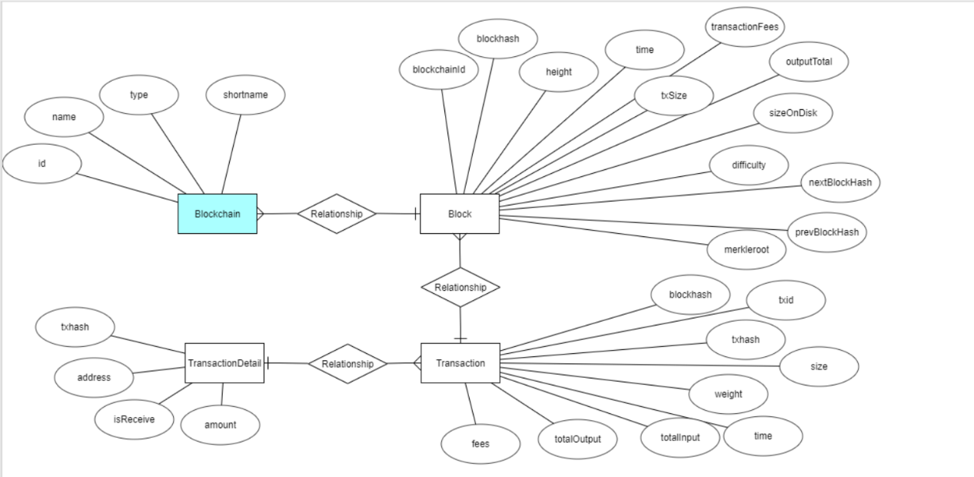

Blockchain表

|  |  |  |  |
| --- | --- | --- | --- |
| 字段 | 类型 | 主键 | 描述 |
| id | int | pk | Id自增长 |
| name | varchar | not null | 区块名称 |
| type | varchar | not null | 类型 |
| shortname | varchar | not null | 简称 |

Block表

|  |  |  |  |
| --- | --- | --- | --- |
| blockchainId | int |  |  |
| blockhash | char |  |  |
| height | varchar |  |  |
| time | datetime |  |  |
| txSize | Int |  |  |
| TransactionFees | varchar |  |  |
| outputTotal | double |  |  |
| inputTotal | double |  |  |
| difficulty | double |  |  |
| nectBlockHash | varchar |  |  |
| prevBlockHash | char |  |  |
| merkleroot | char |  |  |

Transaction表

|  |  |  |  |  |  |
| --- | --- | --- | --- | --- | --- |
| txid | char | |  | |  |
| blockhash | varchar | |  | |  |
| txhash | Int | |  | |  |
| size | bigint | |  | |  |
| weight | varchar | |  | |  |
| time | datetime | |  | |  |
| totallInput | double | |  | |  |
| totalOutput | double | |  | |  |
| Fees | double |  | |  | |

TransactionDetail表

|  |  |  |  |
| --- | --- | --- | --- |
| txhash | int |  |  |
| address | varchar |  |  |
| isReceice | varchar |  |  |
| amount | double |  |  |