**DATASET** : UNIVERSITY IN KOREA

**VARIABLES** : mortgage(rates of education mortgage), scholarship, tuition(tuition fee)

**PLOT1** : hist(data$mortgage)

Histogram about the rates of education mortgage. From the graph, it seems that most universities’ rates of the mortgage is in the interval of 10% to 25%.

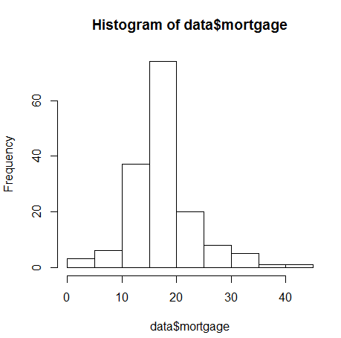

**PLOT2** : plot(x=data$tuition, y=data$mortgage)

It seems to be no relationship between the rates of education mortgage and the tuition fee.

