**# read in data**

P <- read.csv(file.choose())

P

**# (1) Compare the precipitation from 1999 to 2005. Are they different?**

year1999 <- P[P$Year==1999,]

year2005 <- P[P$Year==2005,]

hist(year1999$Value)

hist(year2005$Value)

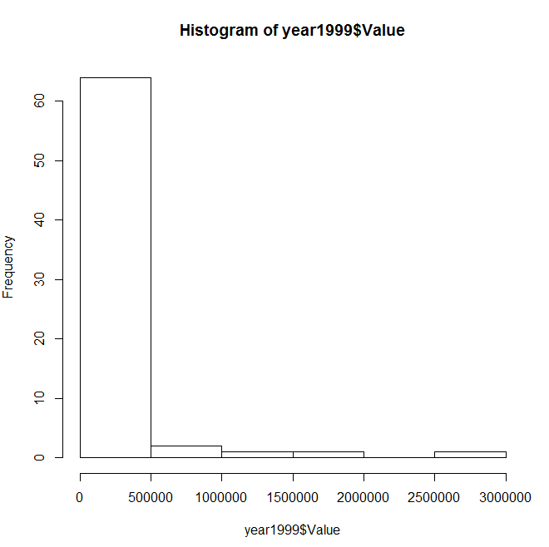 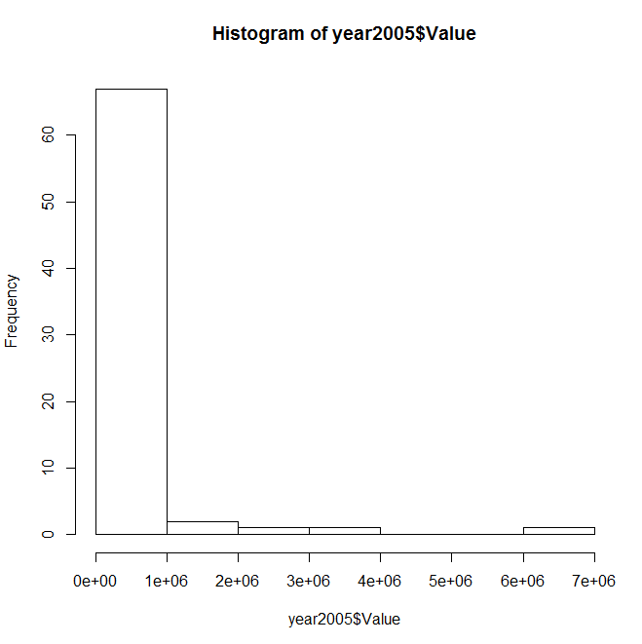

t.test(log10(year1999$Value),log10(year2005$Value))

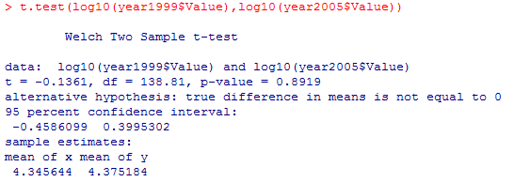

Since the p-value is much greater than the significant level, we can conclude that there is no difference between the precipitation of year 1999 and year 2005.

**# (2) Precipitation for all countries over time.**

means <- tapply(P$Value,P$Year,mean)

plot(x=levels(factor(P$Year)), y=means)

abline(lm(Value ~ Year, data=P))

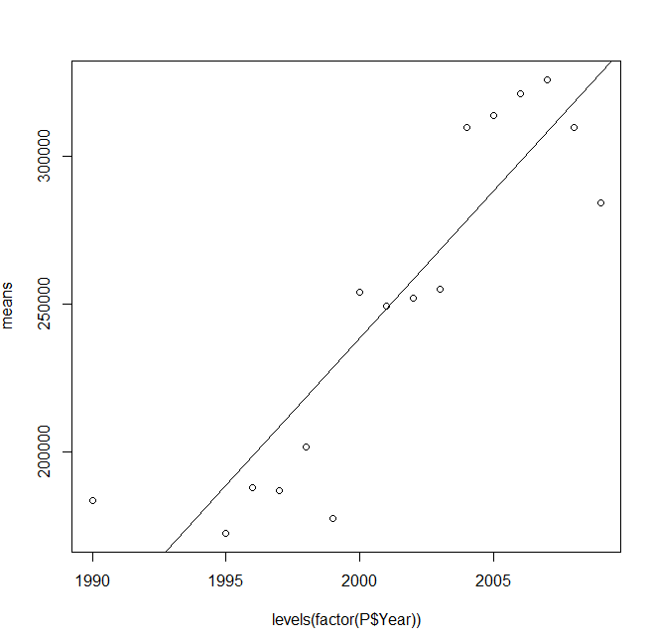

There is no value in 1991 to 1994, I excluded the years with missing values.