|  |  |
| --- | --- |
| **Submit date** | **2019. 09. 18** |
| **Department** | **Software Dept** |
| **Team No.** | **9** |
| **Team Name** | **Moja Dol** |
| **Class No.** | **04** |
| **Prof.** | **Sangoh Park** |



**Yofficial**

**Capston Design Proposal**

Contents

Chapter Page

1. Introduction our team

* 1. Team name························································································································································2
  2. Team Member··················································································································································2

2. Project

* 1. Introduction························································································································································2
  2. Motivation···························································································································································2
  3. Goal········································································································································································3
  4. Development and implementation contents························································································5

3. Project plan

* 1. Members’ role··················································································································································6
  2. Schedule······························································································································································7

4. Reference·······································································································································································7

**1. Introduction our team**

**Our team name is Moja Dol.**

1.2 Team member

20140006 Junhong Min

20132697 Jaewon Lee

20141226 Hyeonwoo Park

**2. Project**

2.1 Introduction

There are lots of recipe applications, but there isn’t any application which is fit for beginner. Because of tons of leaping description of each cooking phase, it isn’t understandable for novice cooks. So here is new cooking application which can help new cooks to improve their cooking skills and get plentiful motivation for cooking.

* 1. Motivation

<Current recipe applications’ problems>

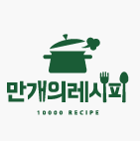

* These are three main applications in this area.
* All of them have some problems written below.

1. Too much omission of cooking phase which deteriorate understandability.

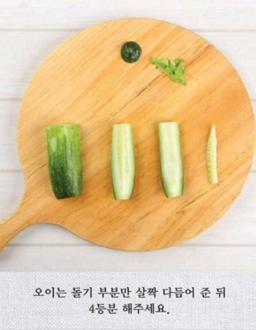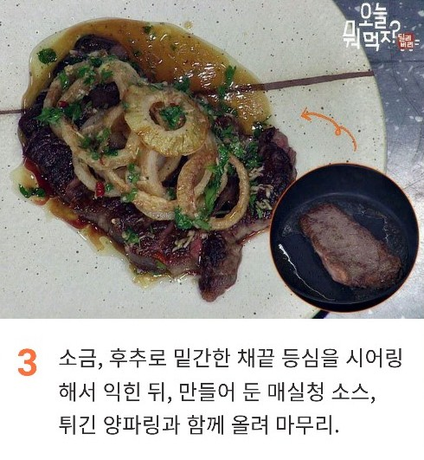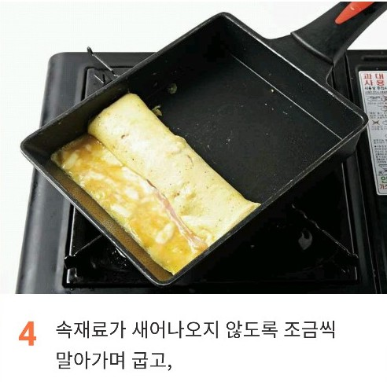

* All the applications support only pictures for describing each phase. For beginners it is really hard to understand and follow the exact way to do right same thing.

1. Lack of boosting motivation for someone unfamiliar with cooking.

* The critical point for helping users to improve their cooking skill is making them keep using app continuously. But, current apps on the market don’t give enough motivation to users for using their app steadily.

1. Extension of convenience

* There are many points that could be extended in the realms of convenience which is described next chapter.

2.3 Goal

1. Giving users concrete explanation of cooking.

* Showing users a video for each step like health applications.

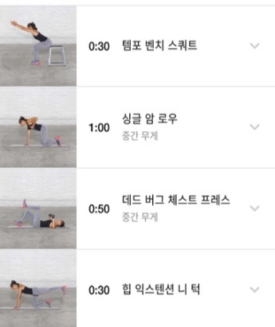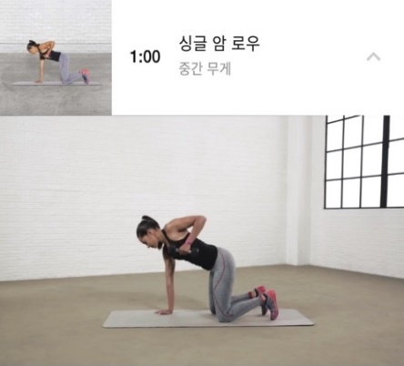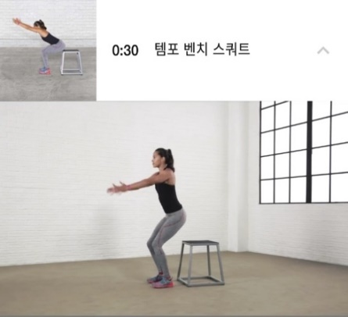

* 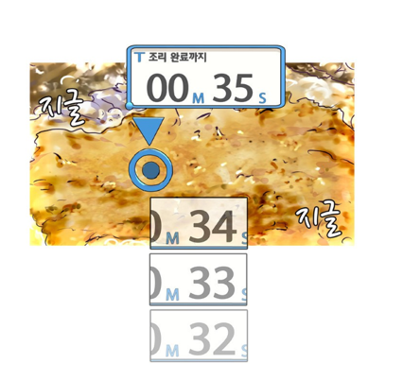In video, instructor is cooking simultaneously while you are cooking without any omission. So, for example, if your dish needs boiling time about 5minutes, then, in apps, video will be played about 5 minutes also to show whether instructor really doesn’t do anything in those time or doing some extra actions while waiting such as stirring dishes. In addition, it also allows users to get some extra useful information like how strong the fire is.

1. Encouraging cooks to developing their cooking skills.

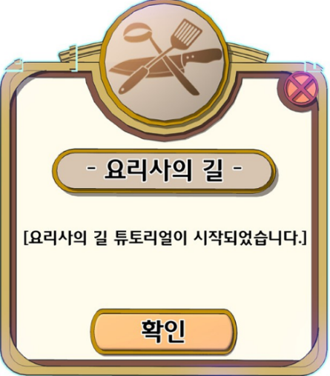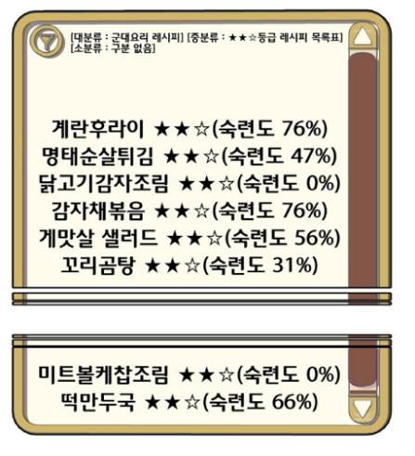

* Implement application as if users are playing game while they are cooking.
* Introduction of cooks’ level system so that they feel satisfaction and increase their ability of making diverse cuisine.
* Adoption training system which makes users improve their specific skills like slicing methods and be evaluated by computer by capturing their results. It is also a video that shows one specific task repeatedly.

1. Add lots of functions to increase user comfortability

* Function of ordering all the ingredients needed in current recipe interlocking with online market application.
* Showing users lists of what they can cook when they put all the ingredients they currently have.
* Pausing or fast-forwarding function with voice recognition.
* Uploading their results of cook with SNS system.

1. Encouraging users upload their recipe by allowing them earning some benefits with this app.

* If the recipe that users uploaded get many likes, these users can get discounts from allied online market.
* Borrowing a revenue model of YouTube which allows streamer to transmit advertisement between their clip. In the same way, because our app necessarily contains idling time in clips (no omission), instructor can insert short advertisement in their recipe.

2.4 Development and implementation contents

d.pngVoice recognition and processing for a navigation

* Recognition human voice and change into text.
* Processing result text and Accomplishing designated action.

Recommendation Algorithm using DFS

* Analyzing users’ preference and showing posts that users might like first.
* Searching all the data we have and Casting results users required.

Compatibility with YouTube

* Getting recipe videos in YouTube and editing them according to our purpose.

Interlocking with other Apps

* Ordering delivery necessary ingredients in a recipe at online market automatically.

Overall Android App Programming Knowledge.

* UI developing with xml.
* Interaction between multiple layouts.
* Reaction when outside stimulation occurs.

**3. Our schedule**

3.1 Members’ role

Junhong Min’s part

- Voice Recognition

- Compatibility with YouTube

Jaewon Lee’s part

- Overall program structure design

- Interlocking with other Apps

Hyeonwoo Park’s part

- Recommendation algorithm using DFS

- QA (Quality assurance)

Cooperation part

- UI design

3.2 Schedule table

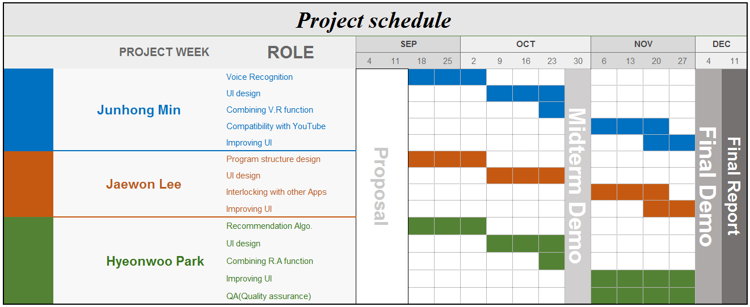

**4. Reference**

- “이밥차” app in google play store.

- “해먹남녀” app in google play store.

- “만개의 레시피” app in google play store.

- “Nike training” app in google play store.

- “취사병 전설이 되다” webtoon in Naver.