|  |  |
| --- | --- |
| **Submit date** | **2019. 09. 25** |
| **Department** | **Software Dept** |
| **Team No.** | **9** |
| **Team Name** | **Moja Dol** |
| **Class No.** | **04** |
| **Prof.** | **Sangoh Park** |



**Yofficial**

**Capston Design Proposal**

Contents

Chapter Page

1. Our Team Introduction

* 1. Team name························································································································································2
  2. Team Member··················································································································································2

2. Project

* 1. Introduction························································································································································2
  2. Motivation···························································································································································2
  3. Goal········································································································································································3
  4. Development and implementation contents························································································5

3. Solutions for feedbacks···········································································································································6

4. Project plan

* 1. Members’ role··················································································································································7
  2. Schedule······························································································································································8

5. Reference·······································································································································································8

**1. Our team introduction**

1.1 Team name

**Our team name is Moja Dol.**

1.2 Team member

20140006 Junhong Min

20132697 Jaewon Lee

20141226 Hyeonwoo Park

**2. Project**

2.1 Introduction

There are lots of recipe applications, but there isn’t any application which is fit for beginner. Because of tons of leaping description of each cooking phase, it isn’t understandable for novice cooks. So here is new cooking application which can help new cooks to improve their cooking skills and get plentiful motivation for cooking.

* 1. Motivation

<Current recipe applications’ problems>



* These are three main applications in this area.
* All of them have some problems written below.

1. Too much omission of cooking phase which deteriorate understandability.

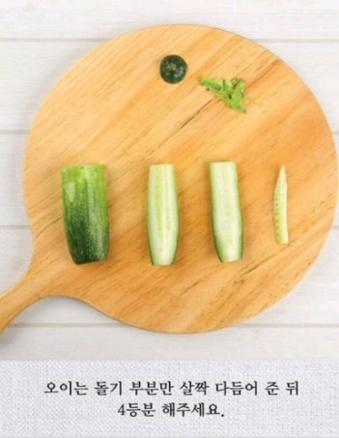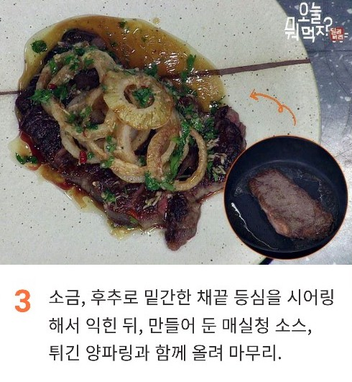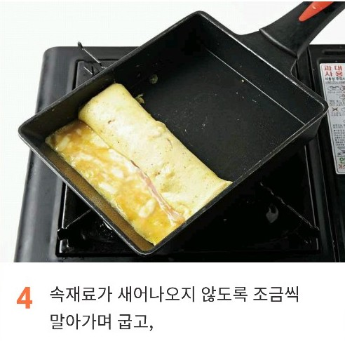

* All the applications support only pictures for describing each phase. For beginners it is really hard to understand and follow the exact way to do right same thing.

1. Lack of boosting motivation for someone unfamiliar with cooking.

* The critical point for helping users to improve their cooking skill is making them keep using app continuously. But, current apps on the market don’t give enough motivation to users for using their app steadily.

1. Extension of convenience

* There are many points that could be extended in the realms of convenience which is described next chapter.

2.3 Goal

1. Giving users concrete explanation of cooking.

* Showing users a video for each step like health applications.

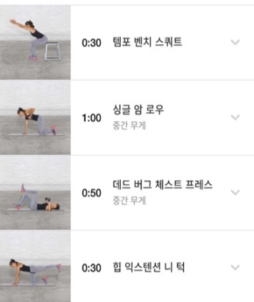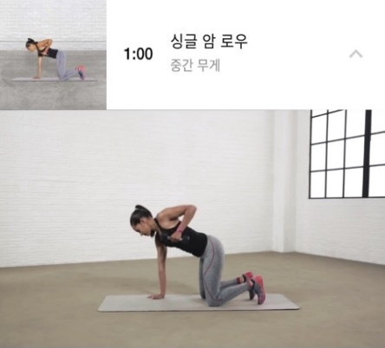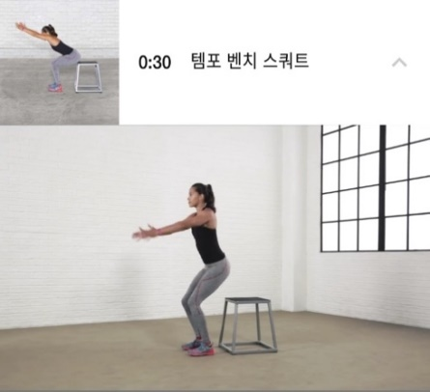

* 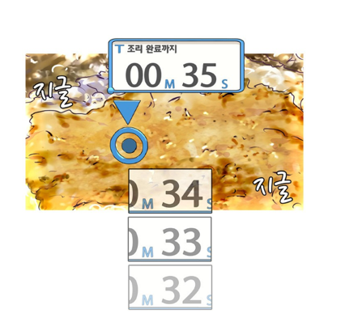In video, instructor is cooking simultaneously while you are cooking without any omission. So, for example, if your dish needs boiling time about 5minutes, then, in apps, video will be played about 5 minutes also to show whether instructor really doesn’t do anything in those time or doing some extra actions while waiting such as stirring dishes. In addition, it also allows users to get some extra useful information like how strong the fire is.

1. Encouraging cooks to developing their cooking skills.

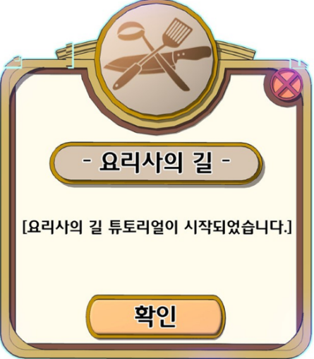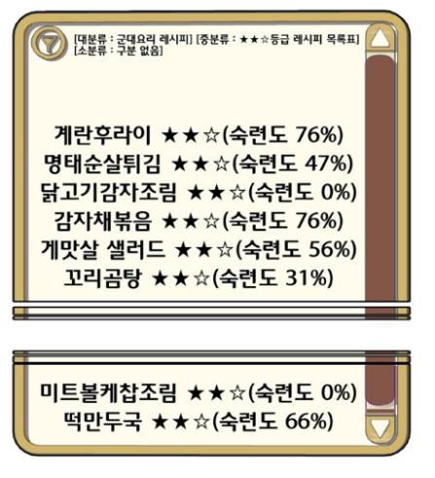

* Implement application as if users are playing game while they are cooking.
* Introduction of cooks’ level system so that they feel satisfaction and increase their ability of making diverse cuisine.



1. Add lots of functions to increase user comfortability

* Function of ordering all the ingredients needed in current recipe by interlocking with online market application.
* d.pngShowing users lists of what they can cook when they put all the ingredients they currently have.
* Pausing or fast-forwarding function with voice recognition.
* Uploading their results of cook with SNS system.

1. Encouraging users upload their recipe by allowing them earning some benefits with this app.

* If the recipe that users uploaded get many likes, these users can get discounts from allied online market.
* Borrowing a revenue model of YouTube which allows streamer to transmit advertisement between their clip. In the same way, because our app necessarily contains idling time in clips (no omission), instructor can insert short advertisement in their recipe.

2.4 Development and implementation contents

Voice recognition and processing for a navigation

* Recognize human voice and change into text.
* Processing result text and accomplishing designated action.

Recommendation Algorithm

* Analyzing users’ preference and showing posts that users might like first.
* Searching all the data we have and Casting results users required.

Interlocking with YouTube

* Getting recipe videos from YouTube and editing them according to our purpose.

Interlocking with other Apps

* Ordering necessary ingredients in a recipe at online market automatically.

Overall Android App Programming Knowledge.

* UI developing with xml.
* Interaction between multiple layouts.
* Reaction when outside stimulation occurs.

**3. Solutions for feedbacks**

3.1 Is this application better than YouTube?

We think that there are two types of people, chefs and cooks. In the case of chefs, uploaders who already use YouTube platform can also use our service easily because our application is based on YouTube videos, and they can get extra revenue by using our application. Only thing they should do is giving us time tags and its simple description. For cooks, we believe our app gives them man-to-man guides by showing videos simultaneously when they are cooking. Moreover, YouTube is too big for lazy users to surf in such a big ocean of information. In contrast, our app is specialized only for cooking so that it must be much easier to find their longing posts.

3.2 Can your app cut out poor chefs among good chefs?

In the concept of the survival of the fittest, poor chefs will be cut out automatically due to our level system. Cooks could determine good chefs by their numbers of likes or their level. In addition, chef can fill out their career or award records in their personal info.

3.3 It seems our app is lack of functions for beginner

We currently have these functions

1. Show them concrete step by step explanation videos
2. Give them motivation through gamification
3. Order ingredients easily

We will add some functions for beginner

1. Showing cooks a selected recipe based on their tier(level). Some videos might be praised only by high level users, not by beginners because of lack of explanation. So, we will recommend a recipe that is praised by users of similar level.
2. There might be hardship for beginner when the serving size of video and their real time meal are different. In case of that, we will tag serving size for each recipe so that cooks can find recipe video by their requirements.

3.4 Battery issue when processing voice recognition while playing video

It seems there are two ways to recognize users voice while playing recipe videos. One is just keeping open the microphone channel to get users voice all the time while video is playing. This one might use battery too much. The other one is using google assistant so that calling them with special command like ‘ok google’ and then speak out our instructions. It might use less battery than the first one but there is some trades off. We currently consider both ways, and soon we will take some experiment for each way and choose best one for our app.

**4. Project Plan**

4.1 Members’ role

Junhong Min’s part

- Voice Recognition

- Recommendation algorithm

Jaewon Lee’s part

- Interlocking with YouTube

- Interlocking with other Apps

Hyeonwoo Park’s part

- Overall UI structure design

- QA (Quality assurance)

Team’s role

- Design a Gamification’s detail

- Lay out Overall Interface Structure

4.2 Schedule table

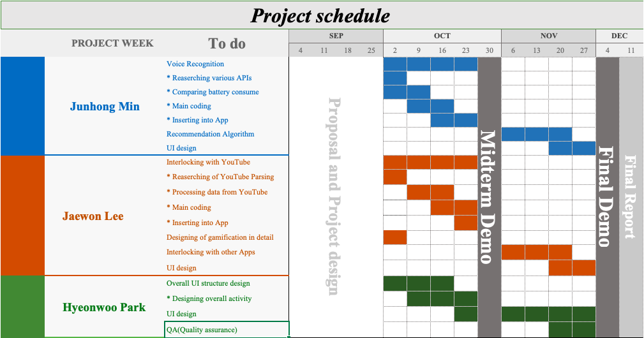

**5. Reference**

- “이밥차” app in google play store.

- “해먹남녀” app in google play store.

- “만개의 레시피” app in google play store.

- “Nike training” app in google play store.

- “취사병 전설이 되다” webtoon in Naver.