Yofficial menual

Index

1. Overall app information
2. Search recipe
3. Food recommendation
4. Take good care of the fridge
5. Community
6. My page
7. Recipe upload
8. Overall app information

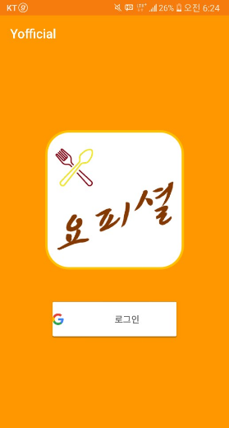

Touch the button to log-in.

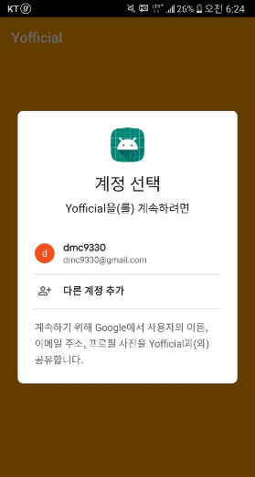

Please log-in using your

google account

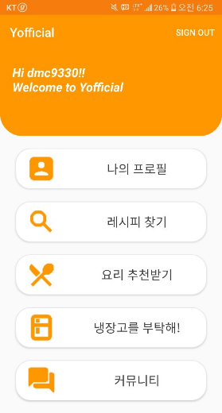

This is Yofficial

mainpage!

1. Search recipe

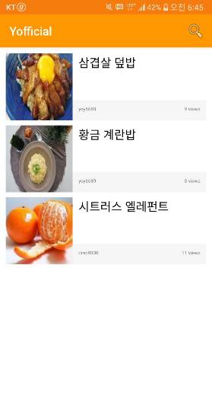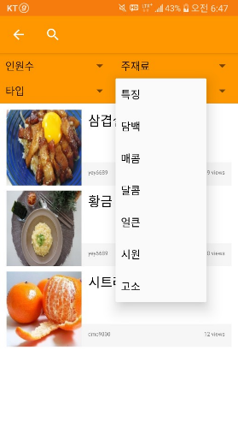 

You can see a list of recipes.

Let touch the search button.

You can search recipes using several conditions.

Let touch this button for finding recipes you want.

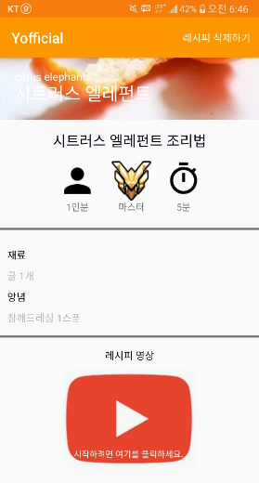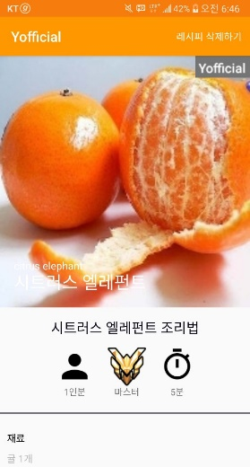

When you touch this button, you can watch recipe videos.

This is our recipe page.

This page has a information of recipe’s level of difficult, serving size cooking time and recipe information ( ingredients etc..)

Let enter the recipe of 시트러스 엘러펀트

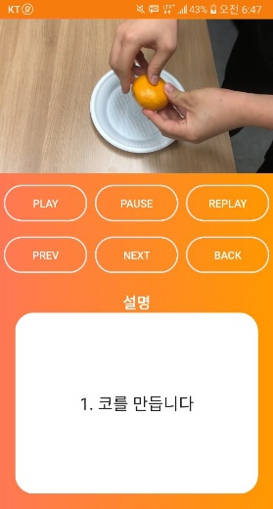

You can read explanations of each video’s step.

You can control video recipes by these buttons.

Also, you can control video recipes by your voice! Put your hand in front of phone (do not need touch, just nearby)

Then voice recognition will be run, you can control video recipes by your voice!

This is our video recipe page. You can watch recipe videos step by step.

1. 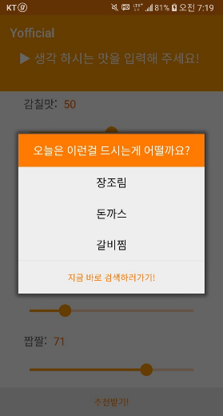 Food recommendation

This page is Food recommendation.

First, please set taste values you think. ( Absolute value is not important, just set relatively)

Second, just touch a button in bottom. Then you can see food list recommended by Yofficial.

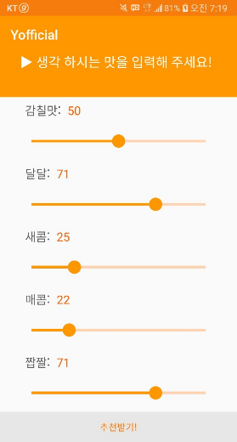

1. 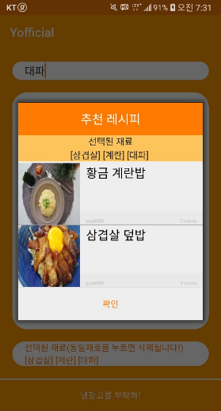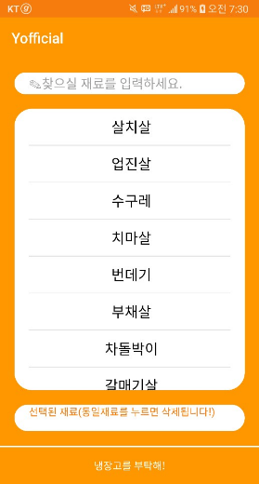Take good care of the fridge

This page is Take good care of the fridge.

First, please choose ingredients you have. When you choose ingredients, that list is added below list box.

(If you select wrong ingredients, please touch same ingredients then that ingredients will be deleted.)

Second, just touch a button in bottom. Then you can see food list you can make using ingredients in your fridge.

1. Community

This page is Community page.

Left is first page of community function. You can see list of post, and search using title.

Right is post upload page. You can enter this page by touching. below button first page. You can upload your post using this page.

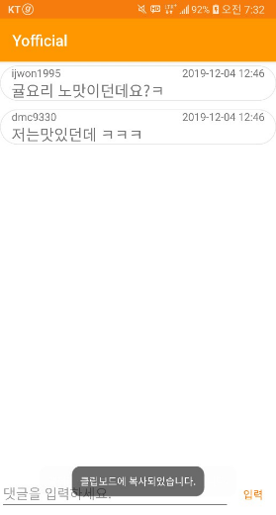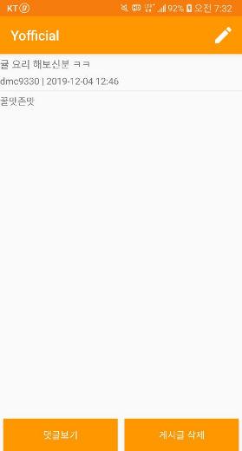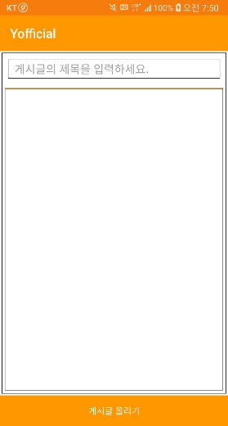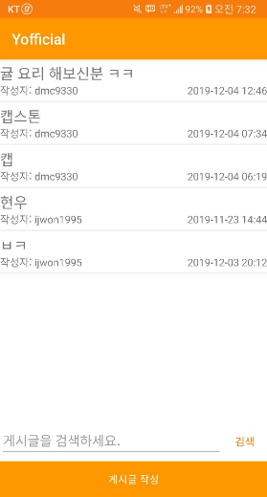

This page is for post’s comment.

You can see comments of post.

Also, you can write, edit and delete comments. Of course, edit and delete comment possible only yours.

This page is for post’s content.

You can see information of post.

Also, you can edit and delete a post if you made it.

1. My page

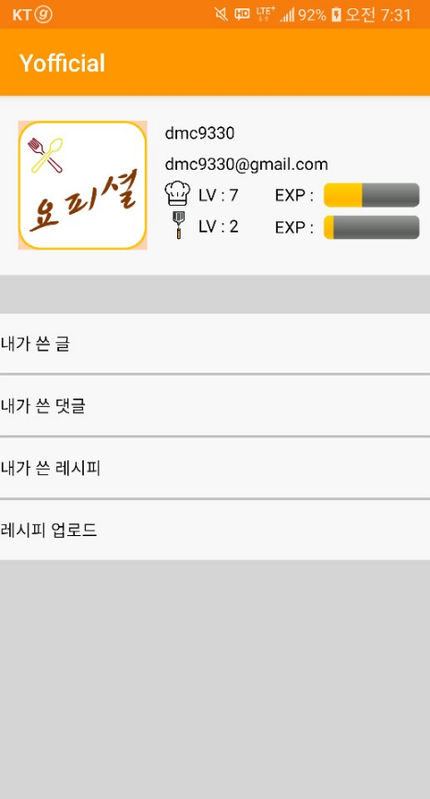

This page has user information. You can identify your account information(e mail address, level, etc..) in this page.

Also, you can see your activities in our app.

When you want to write your recipe. Please touch this button.

1. Recipe upload

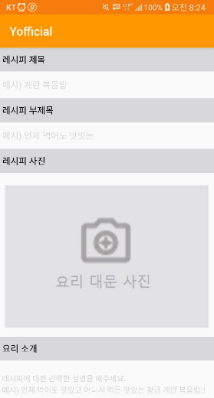You can upload your recipe using below pages!

