STUDENT REPORT COM4402

Student Name | Subhan Yasin
Student Number | 2436238
Module Name | Programming
Module Code | COM4402
Assignment | A2: Implementation
Date of Submission | 24/01/2026

INTRODUCTION

The project is to build a multiple choice quiz for Holton College. It runs in a console, written in Python. A set of questions appears on the screen, the user types an answer to each one and the program replies at once with “right” or “wrong” - at the end it prints the total score. The aim is a working prototype that shows how to hold data in structures, split the work into small clear parts plus let the user move through the quiz without error.

Questions are kept in Python structures that suit the task - loops and tests guide the program from one step to the next. Each correct choice raises the score by one. Functions separate the work - the code remains short, plain but also easy to fix or extend. The whole design stays light enough for a beginner to read but it follows the habits that experienced programmers expect.

GITHUB REPOSITORY LINK

Public GitHub Repository URL: _[Paste your GitHub link here.]_
Paste the full clickable URL to your public GitHub repository, for example:
https://github.com/your-username/COM4402-quiz-project
Make sure:
- The repository is PUBLIC.
- The link works when you click it.
- The repository contains all your Python source files (e.g., quiz.py).
- The repository includes a README.md with your student number, module code, and basic run instructions.
Test the link yourself in a private/incognito window before submitting.

DEVELOPMENT PROCESS & KEY DECISIONS

3.1 Overall Development Approach
I started the job by carefully going over the assignment brief and determining the essential needs. To design out the fundamental flow of the quiz application, including how questions would be presented, how user input would be gathered, and how scoring would operate, I began with basic pseudocode. I made a simple flowchart that displays the primary program loop and decision points.
Throughout the development process, I made frequent commits to GitHub, usually after finishing each function or resolving a major bug. This method gave me a safety net in case I had to go back to a previous version and assisted me in keeping track of changes. My development was incremental, starting with a simple working version that displayed one question, then gradually adding more features such as multiple questions, score tracking, and input validation.

3.2 Choice of Data Structures

I included a list of dictionaries with the quiz questions. I considered using a list of tuples, but a dictionary allows me to clearly name each item of data. Each entry has the labels "question," "options," and "answer"; I just type question['question'] when I require the question's content. I don't need to remember that the text is stored in the first slot of a tuple. When a novice reads the code, they see the labels and immediately understand what each component does, making it easy to find a mistake.

3.3 Code Structure and Functions
I divided my code into several functions to make it more organised and easier to test. The main functions I created were:
- get_questions() - Returns the list of quiz questions. This keeps the question data separate from the logic.
- display_question() - Takes a question dictionary and displays it to the user in a formatted way.
- get_user_answer() - Prompts the user for their answer and validates the input to ensure it is a valid option.
- check_answer() - Compares the user's answer with the correct answer and returns whether they were right or wrong.
- run_quiz() - The main function that controls the overall flow of the quiz, calling the other functions as needed.
I chose this structure because it follows the principle of separation of concerns, where each function has one clear purpose. This made the code easier to debug because I could test each function individually. It also improved readability because the main run_quiz() function reads almost like plain English, showing the high-level flow without getting bogged down in details.
I followed PEP 8 naming conventions, using lowercase with underscores for function names and variables. I also added comments to explain the purpose of each function and any complex logic.

3.4 Problems Encountered and How You Solved Them
Managing invalid user input was one major issue I ran across. At first, if a user input a letter in place of a number or a number outside of the allowed range, my program would crash. In order to overcome this, I added a while loop to the get_user_answer() function that continuously requests input until a valid option is entered. I used an if statement to determine whether the number was within the acceptable range and a try-except block to capture situations in which the input could not be converted to an integer.
My score wasn't initially calculated correctly, which was another problem. The score was being increased within the check_answer() function, but the updated score was not being returned to the main quiz function. This meant the score always stayed at zero. I fixed this by making check_answer() return a boolean value indicating whether the answer was correct, and then incrementing the score in the run_quiz() function based on this return value. I debugged this by adding print statements to show the score after each question, which helped me see that it was not changing.
I also had some problems with the formatting of the question display. The options were not aligning properly and looked messy. I solved this by using f-strings to format the output more carefully, ensuring consistent spacing and line breaks. Testing the output visually helped me refine the presentation until it looked professional.

3.5 Comparison with Original Design (Flowchart / Pseudocode)

With a few significant modifications, my final implementation largely adheres to my initial flowchart. In my original concept, I did not want to divide concerns into smaller functions; instead, I intended to have all the code in one main function. When I began coding, I understood that this would make the software hard to read and test, so I divided it into the above-described modular structure.
The addition of input validation was another modification to my initial idea. During development, I found that my original flowchart's assumption that the user would always enter valid input was unreasonable. Although it wasn't part of my initial idea, I included a validation loop to handle faulty inputs graciously, which greatly increased the program's resilience.
I also made the feedback system simpler. Originally I planned to show detailed explanations for each answer, but I decided to keep it simple with just "Correct!" or "Incorrect" messages. This kept the program focused on the core requirements and avoided making it too complicated for this stage of development.

TESTING STRATEGY

4.1 Overall Testing Approach

I used both systematic test cases and manual testing to test my code. In general, I tested each function separately to make sure it functioned well before testing the program as a whole using various input combinations.
I ran the program several times with various inputs for manual testing, purposefully attempting to break it by inputting invalid data, such as letters, negative numbers, numbers outside the valid range, and empty inputs. Additionally, I tested the happy path, in which everything functions as it should. In order to find some UI problems that I had missed, I requested a buddy to try the software as well.
I did not use automated testing frameworks for this project, but I did use print statements extensively during development to check that variables contained the expected values at different points in the program. I also ran the code through a linter to check for style issues and potential bugs, fixing any warnings that appeared.
Each time I made a change to the code, I re-ran several test cases to make sure I had not introduced new bugs. This iterative testing approach helped me catch problems early before they became more difficult to fix.

4.2 Detailed Test Cases

Case No. | TC01
Description | Testing that a correct answer to the first question increases the score
Input Data | Start quiz, enter '2' for the first question
Expected Outcome | Program displays "Correct!" and score increases by 1
Actual Outcome | Program displayed "Correct!" and score increased to 1
Pass/Fail | Pass

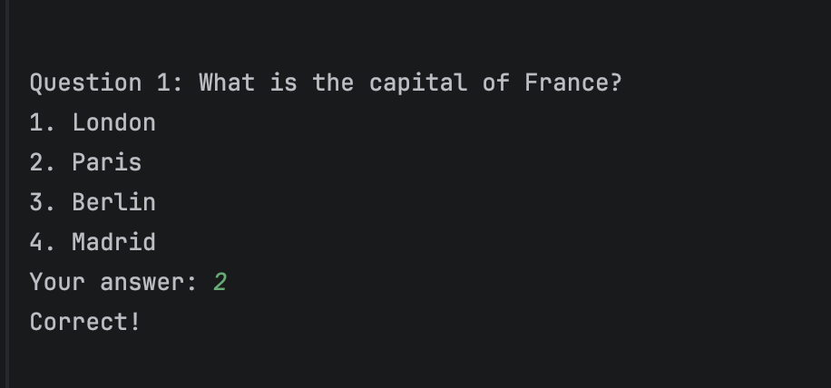

Case No. | TC02
Description | Testing that an incorrect answer does not increase the score
Input Data | Enter '1' for a question where the correct answer is '3'
Expected Outcome | Program displays "Incorrect" and score remains the same
Actual Outcome | Program displayed "Incorrect" and score did not change
Pass/Fail | Pass
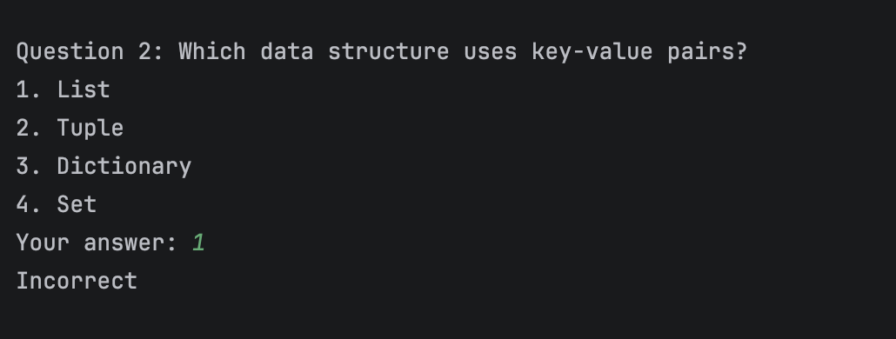

Case No. | TC03
Description | Testing input validation with a letter instead of a number
Input Data | Enter 'a' when prompted for an answer
Expected Outcome | Program displays error message and prompts for input again
Actual Outcome | Program displayed "Please enter a valid number between 1 and 4" and asked for input again
Pass/Fail | Pass

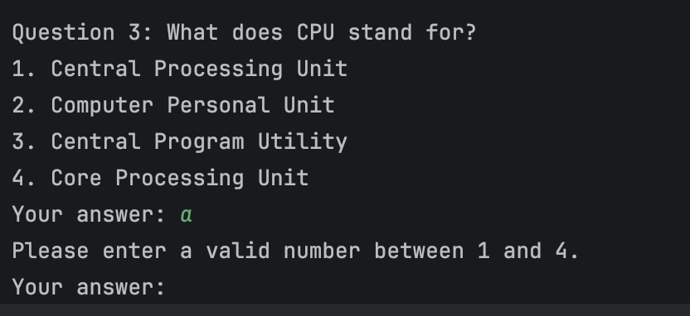
Case No. | TC04
Description | Testing input validation with a number outside the valid range
Input Data | Enter '5' when only options 1-4 are available
Expected Outcome | Program displays error message and prompts for input again
Actual Outcome | Program displayed "Please enter a valid number between 1 and 4" and asked for input again
Pass/Fail | Pass

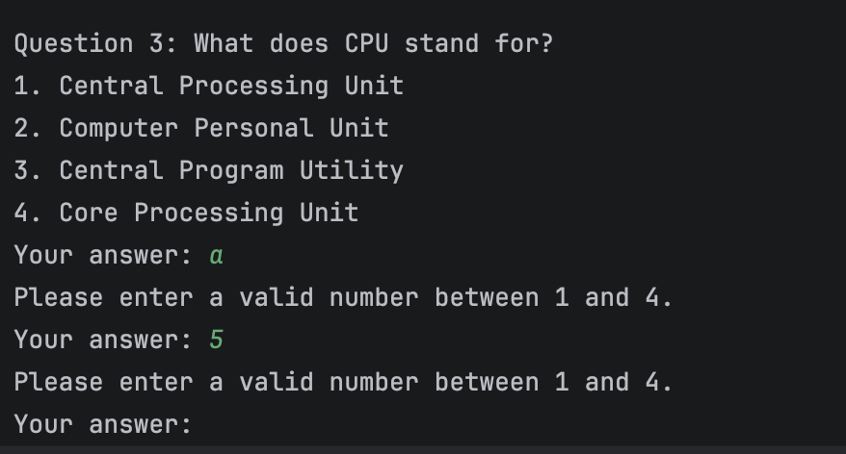

Case No. | TC05
Description | Testing input validation with a negative number
Input Data | Enter '-1' when prompted for an answer
Expected Outcome | Program displays error message and prompts for input again
Actual Outcome | Program displayed "Please enter a valid number between 1 and 4" and asked for input again
Pass/Fail | Pass

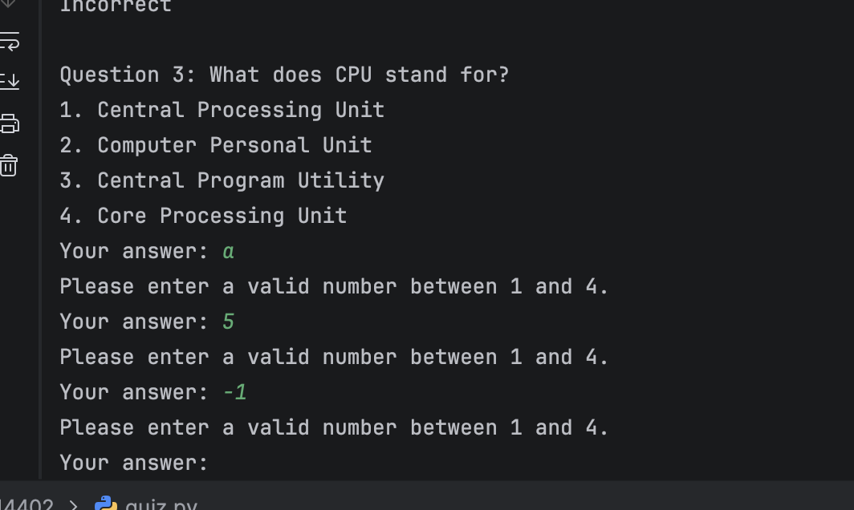
Case No. | TC06
Description | Testing that all five questions are displayed in sequence
Input Data | Answer all questions with valid inputs (1, 2, 3, 4, 1)
Expected Outcome | All 5 questions displayed one after another
Actual Outcome | All 5 questions were displayed correctly in order
Pass/Fail | Pass

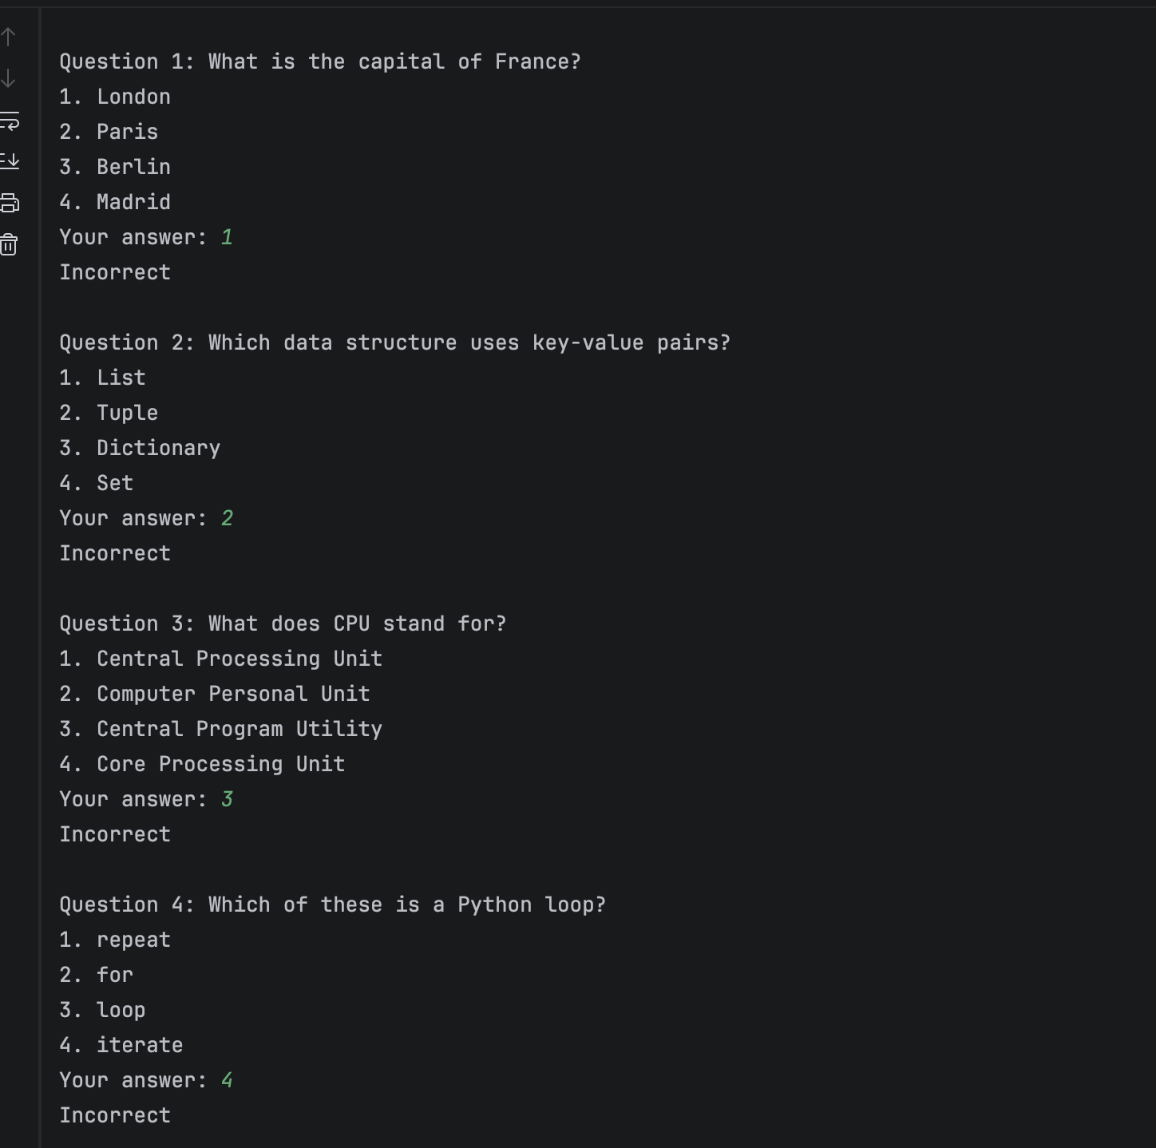
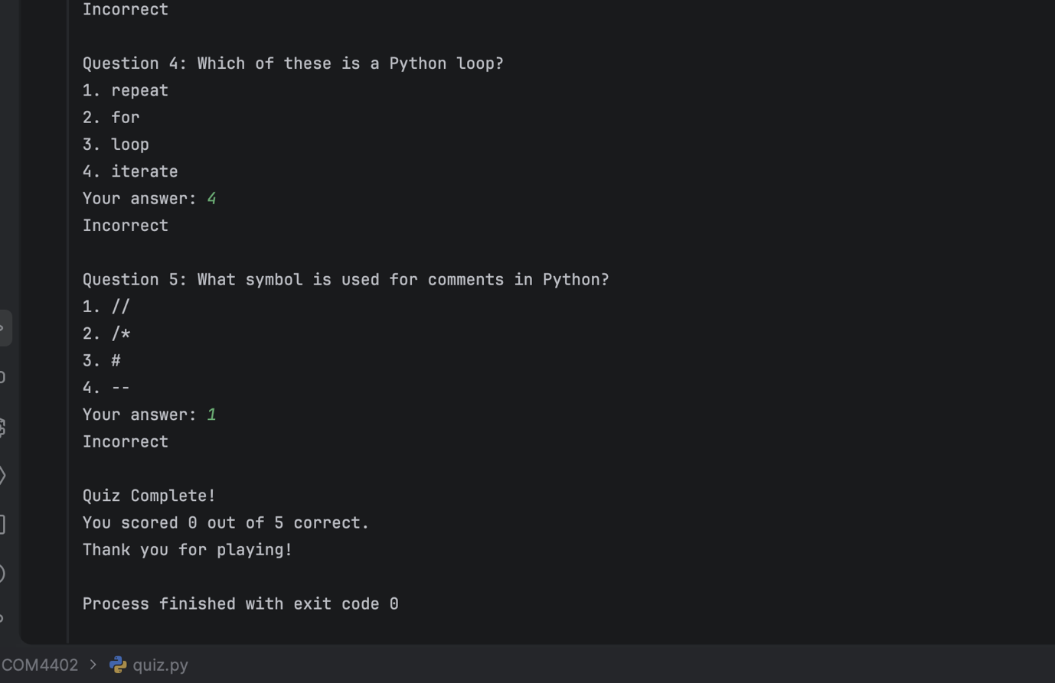

Case No. | TC07
Description | Testing final score display when all answers are correct
Input Data | Answer all 5 questions correctly.
Expected Outcome | Program displays "You scored 5 out of 5 correct"
Actual Outcome | Program displayed "You scored 5 out of 5 correct"
Pass/Fail | Pass

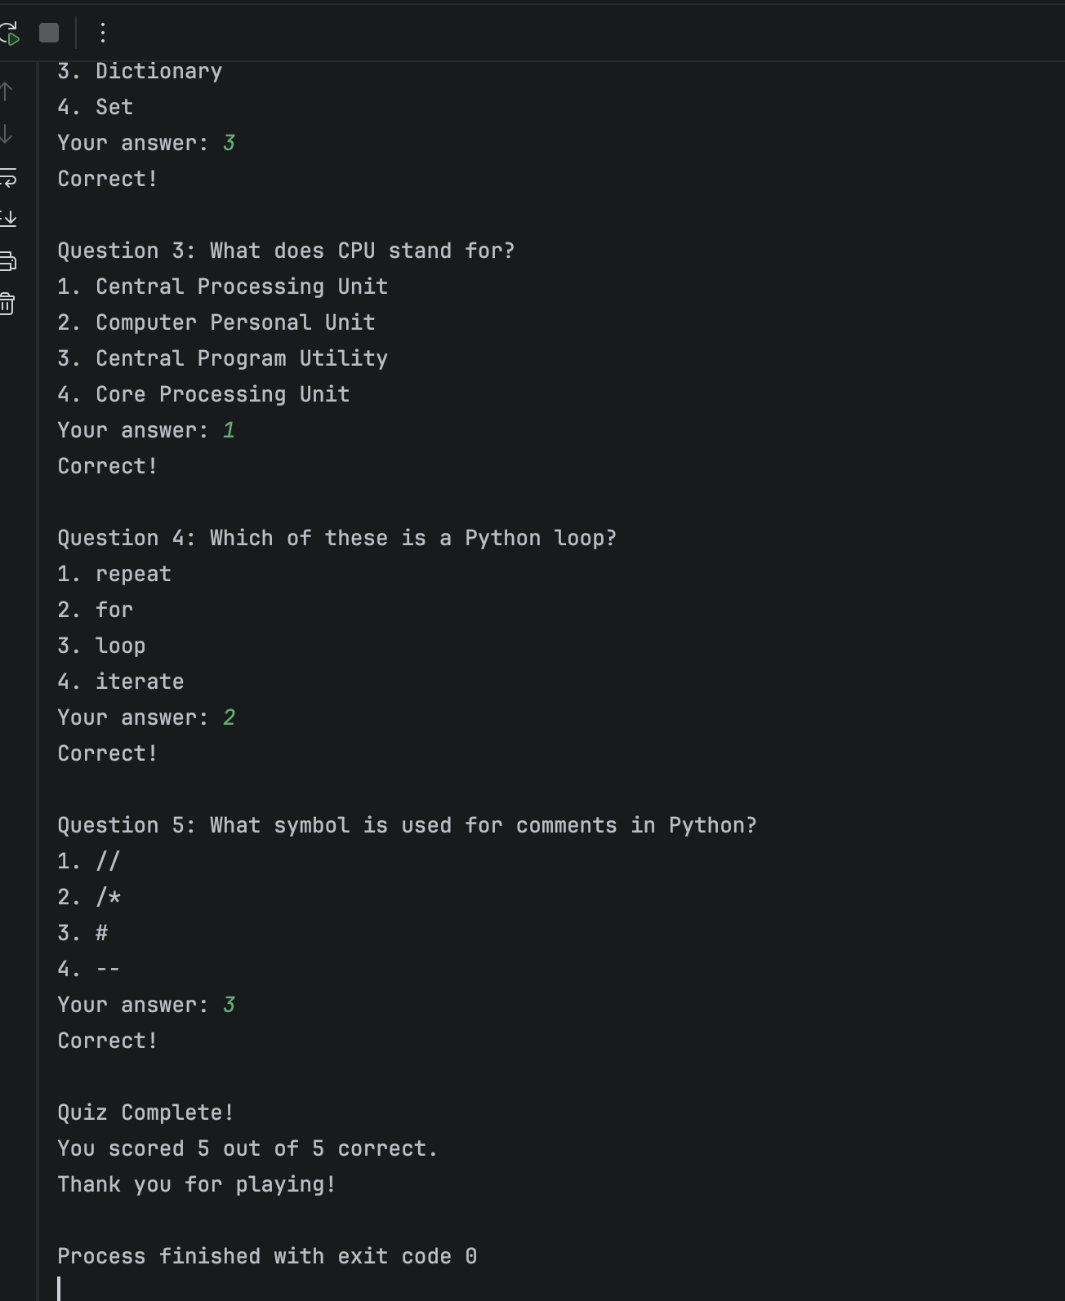

Case No. | TC08
Description | Testing final score display when no answers are correct
Input Data | Answer all 5 questions incorrectly
Expected Outcome | Program displays "You scored 0 out of 5 correct"
Actual Outcome | Program displayed "You scored 0 out of 5 correct"
Pass/Fail | Pass
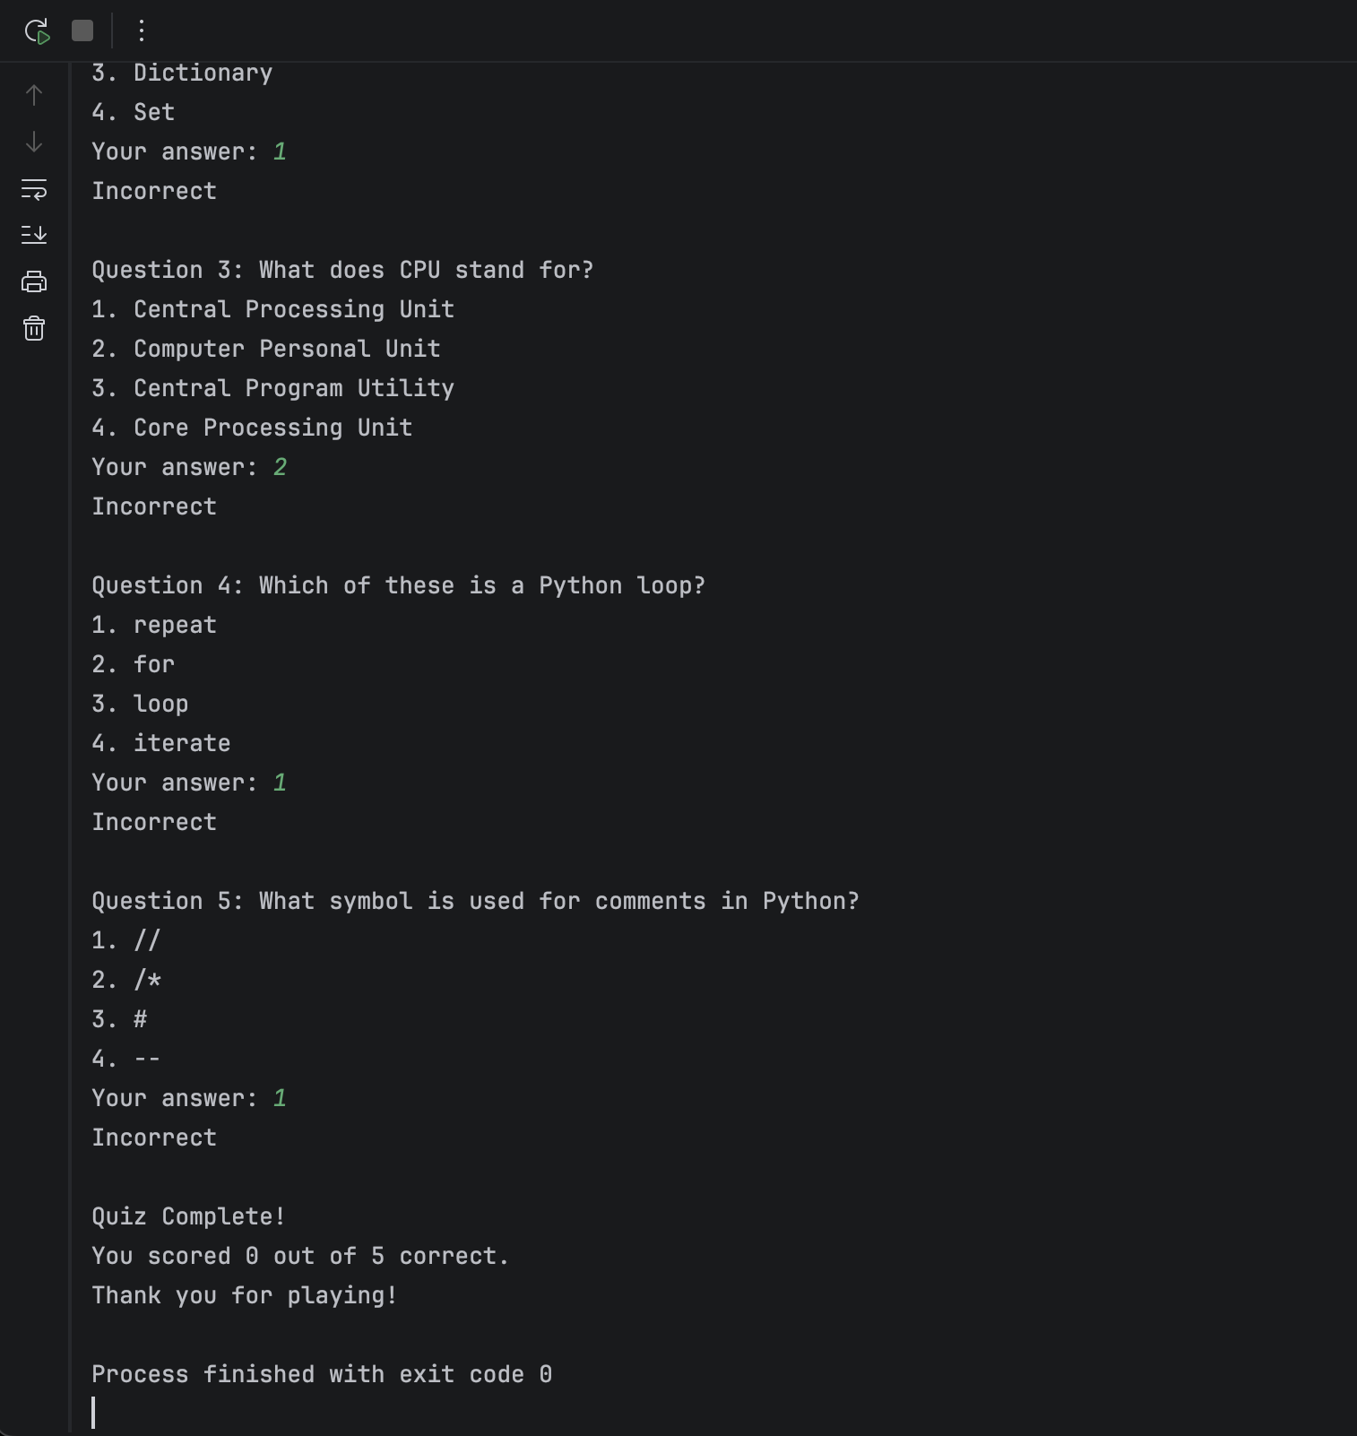

Case No. | TC09
Description | Testing partial score calculation
Input Data | Answer 3 questions correctly and 2 incorrectly
Expected Outcome | Program displays "You scored 3 out of 5 correct"
Actual Outcome | Program displayed "You scored 3 out of 5 correct"
Pass/Fail | Pass
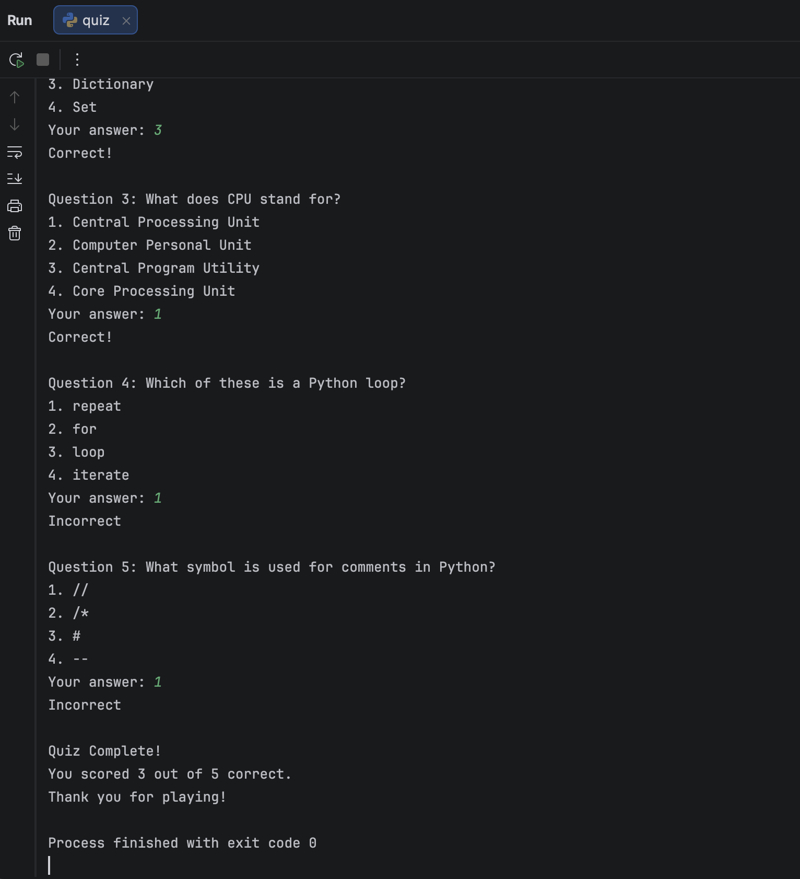

Case No. | TC10
Description | Testing that the program displays the closing message after the quiz
Input Data | Complete the entire quiz
Expected Outcome | Program displays "Thank you for playing!" at the end
Actual Outcome | Program displayed "Thank you for playing!" after showing the final score
Pass/Fail | Pass
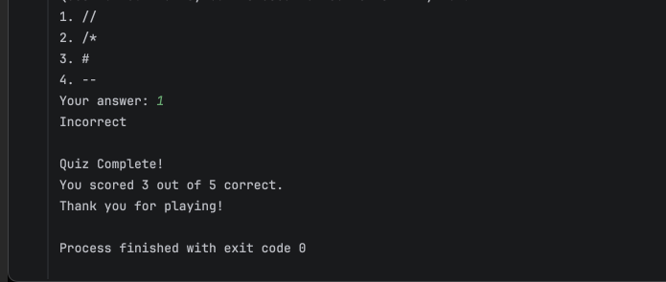

REFLECTION

My code's modular design and strong input validation are what I am most proud of. It was much simpler to debug and test the program when it was divided into distinct functions, and even at a novice level, I believe this shows good programming technique. It feels much more professional because the input validation makes sure the program doesn't crash no matter what the user enters.
If I had more time, I would add extra features to the application, such the option to load questions from an external file, randomise the order of the questions, or replay the quiz without restarting it. Additionally, I would like to provide more thorough feedback for wrong replies, possibly including an explanation or the proper response.
Through this assignment, I significantly improved my understanding of how to structure code using functions and how to use data structures effectively. I also became more comfortable with debugging, learning to use print statements strategically and to read error messages carefully. Using Git regularly helped me develop good version control habits, and I can see how valuable this will be for larger projects in the future.

SUBMISSION CHECKLIST (DO NOT DELETE)

Submission Checklist:
The report is saved as a Word document (.docx).
The file name follows the required convention: STUDENTNUMBER_COM4402_Report.docx
Example: 2532851_COM4402_Report.docx
My student number, name, module name, and module code (COM4402) are included on the first page.
I have included a correct, clickable URL to my public GitHub repository.
My GitHub repository is public, contains all source code, and shows a sensible commit history.
My GitHub repository includes a README.md with my student number, module code, and simple instructions for running the program.
The report includes all required sections: Introduction, GitHub Link, Development Process & Decisions, Testing Strategy (with at least 10 test cases).
All test cases include Test ID, Test Description, Input Data, Expected Outcome, Actual Outcome, Pass/Fail, and screenshots of input and output.
I have removed ALL red guidance text before submitting.
I have checked spelling and grammar.

DECLARATION

I used the following software tools in the development of this assessment:
- Pycharm for writing and executing the code
- Visual Studio Code as my text editor and integrated development environment
- Git and GitHub for version control and repository hosting
- Microsoft Word for writing this report
- I used the spelling and grammar check features built into Microsoft Word to ensure my report was free from errors
All code, design decisions, testing procedures, and report content are entirely my own work. No generative AI tools were used in the creation of this submission.

REFERENCES

Downey, A. (2015) Think Python: How to Think Like a Computer Scientist. 2nd ed. Sebastopol, CA: O'Reilly Media.
Python Software Foundation (2024) The Python Tutorial. (Accessed: 19 January 2026).
Shaw, Z.A. (2017) Learn Python 3 the Hard Way. Boston, MA: Addison-Wesley.
Sweigart, A. (2019) Automate the Boring Stuff with Python. 2nd ed. San Francisco, CA: No Starch Press.
University of Bolton (2024) COM4402 Programming Module Guide. Bolton: University of Bolton.
University of Bolton Library (2024) Harvard Referencing Guide. (Accessed: 19 January 2026).
University of Bolton IT Services (2024) Software Installation Guide for Students. Bolton: University of Bolton.
W3Schools (2024) Python Tutorial. (Accessed: 19 January 2026).

