* **Description of system: x[n], h[k], y[n]**

Input is **white noise:**

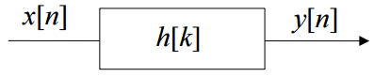

**Figure 1** Definition of a Discrete-Time Linear System

* **Uncorrelated Ergodic WSS Stochastic Random Process**
* **Random** Process**:**
* 1st moment µ (mean), 2nd moment 𝜎 (covariance) are sufficient to model signal
* **Stochastic** Process:
  + Repeated measurements e1, e2, e3 of random process S, sampled in **time**

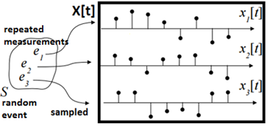

**Figure 2** Definition of a Stochastic Process

* ex) spike train, thermal noise in amplifier
* **Stationary** Process: $p(x\left(t_{1}\right),x\left(t_{2}\right),… ,x(t_{n})$ is independent of time
* **Wide Sense Stationary**: µ and 𝜎 are independent of time
  + **Ergodic**: sample mean converges to ensemble mean: $µ_{X\left[t\right]}=µ_{x_{1}\left[t\right]}$
  + **Uncorrelated (white)**: 𝜎 is constant
* Since white noise is **uncorrelated ergodic WSS**, only 𝜎 is needed to model signal!
* **Estimate Autocorrelation ${\hat{r}}_{x}[k]$**
* Input is equidistantly sampled white noise
  + 2nd moment = 𝜎 = ${\hat{r}}_{x}\left[k\right]$
* Estimate ${\hat{r}}_{x}[k]$:
  + direct estimate method:
 $${\hat{r}}_{x}[k]=\frac{1}{N-k}\sum_{l}^{N-k}{x\left[l+k\right] x^{*}[l]}$$

 + use **xcorr( )**
* **Estimate Power spectrum ${\hat{P}}_{x}\left(e^{jw}\right)$** 
  + Oscillations of 𝜎 best viewed in **frequency** domain
  + Estimate ${\hat{P}}_{x}\left(e^{jw}\right)$
$${\hat{P}}_{x}\left(e^{jw}\right)=\frac{1}{N}{\left|X(e^{jw})\right|}^{2}$$

* Estimate improves in µ with increasing N
* Estimate inconsistent (𝜎 does not converge to 0) with increasing N
* Use **periodogram** to average over K windows: **psd(x)**; **pwelch(x)**;
* **Filtering $r_{x}\left[n\right]$: $h\left[n\right]$**
* Filter $h\left[n\right]$ is defined as the convolution of autocorrelation $r_{x}\left[n\right]$

$$r_{y}\left[n\right]=r_{x}\left[n\right]*h\left[n\right]$$

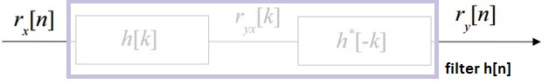

**Figure 3** Definition of Filter h[n] for $r_{x}\left[n\right]$

* **Filtering $P_{x}\left(e^{jw}\right)$: ${\left|H\left(e^{jw}\right)\right|}^{2}$**
* Filter ${\left|H\left(e^{jw}\right)\right|}^{2}$ shapes the power spectrum

$$P_{y}\left(e^{jw}\right)={{\left|H\left(e^{jw}\right)\right|}^{2}P}_{x}\left(e^{jw}\right)$$

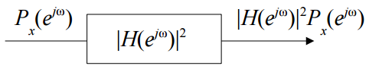

**Figure 4** Definition of Filter ${\left|H\left(e^{jw}\right)\right|}^{2}$ for $P_{x}\left(e^{jw}\right)$

* Use **abs(fft(h,N)).^2**
* **Wold Decomposition Theorem**
* Any WSS input $x\left[n\right]$ can be decomposed into a sum of:
  + Regular process $x_{r}[n]$
  + Predictive process $x_{p}\left[n\right]$
$$x\left[n\right]=x_{p}\left[n\right]+x_{r}[n]$$

* **IF** regular process $x_{r}\left[n\right]$ and predictive process $x_{p}\left[n\right]$ are orthogonal:
$$E[x_{p}\left[n\right]{x_{r}}^{*}\left[m\right]]=0$$

* Power spectrum of WSS input $x\left[n\right]$ is made of:
  + Continuous component with invertible H(z) (from $x_{r}[n]$)
  + Discrete lines (from $x_{p}\left[n\right]$)
$$P_{x}\left(e^{jw}\right)={\left|H(e^{jw})\right|}^{2}+\sum_{k=1}^{∞}{a_{k} δ(w-w_{k})}$$

* Power spectrum is additive:
$$z\left[n\right]=x\left[n\right]+y[n]$$

$$P_{z}\left(e^{jw}\right)=P_{x}\left(e^{jw}\right)+P_{y}\left(e^{jw}\right)$$

* Application: Modeling Speech using Spectrogram
  + Power spectrum with strong spectral component
  + Assuming WSS, estimate power spectrum for a short window
  + Add windows together over time to create spectrogram
  + Use specgram(x)

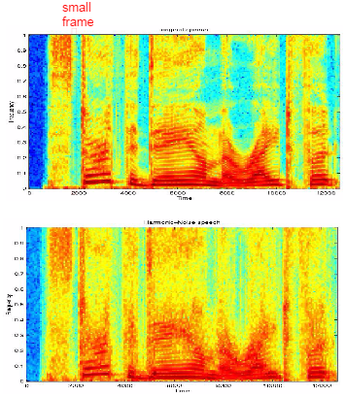

**Figure 5** Modeling Speech using Wold Decomposition

* **Regular Process $x_{r}[n]$**
* Input: white noise v[n]
* Filter: h[n] is causal, invertible
* Output: colored noise x[n]

**D:\Documents\Steven\regular process.png**

**Figure 6** Definition of Regular Process

* $x_{r}[n]$ is the regular process
* $v[n]$ the corresponding innovation process

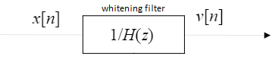

**Figure 7** Definition of Whitening Filter

* Inverse filter 1/H(z)is **whitening filter** of x[n]
* **Power Spectrum of Regular Process**

**D:\Documents\Steven\regularpower.png**

**Figure 8** Power Spectrum of Regular Process

* Power spectrum $P_{x_{r}}(e^{jw})$ is **continuous**

|  |
| --- |
| * **Predictive Process $x_{p}[n]$** * Predicted exactly from linear combination of past $$x\left[n\right]=\sum_{k=1}^{∞}{a_{k} x[n-k]}$$* **Power Spectrum of Predictive Process** * Power spectrum $P_{x_{p}}(e^{jw})$ is **discrete lines $$P_{x_{r}}\left(e^{jw}\right)=\sum_{k=1}^{∞}{a_{k} δ(w-w_{k})}$$**   more in Lecture 7! – Harmonic Analysis |

* **AR modeling**
* **Find a[k] by AR modeling**

White noise v[n] filtered by a rational transfer function

$$H\left(z\right)=\frac{B(z)}{A(z)}$$

AR modeling approximate Px(e^jw) for a given x[n]

$$P_{x}\left(e^{jw}\right)=\frac{{\left|B(e^{jw})\right|}^{2}}{{\left|A(e^{jw)}\right|}^{2}}$$

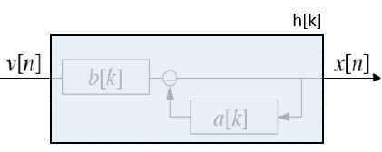

$$x\left[n\right]=\sum_{l=0}^{Q}{b\left[l\right]v[n-l]}-\sum_{l=0}^{P}{a\left[l\right]x\left[n-l\right]}$$

Since input is WSS, need to derive a statistical AR model

$$\sum_{l=0}^{Q}{b\left[l\right]h^{*}[l-k]}-\sum_{l=0}^{P}{a\left[l\right]r_{x}\left[k-l\right]}=0$$

normal equations

$$\sum_{l=0}^{P}{a\left[l\right] r_{x}\left[k-l\right]={\left|b\left[0\right]\right|}^{2}δ(k)}$$

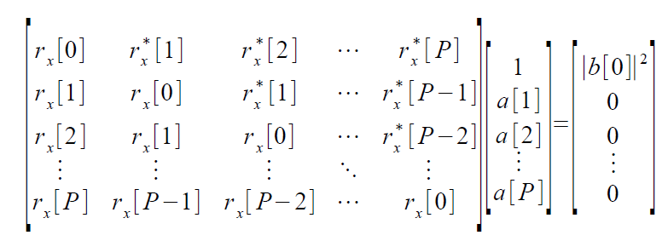

Can be rewritten

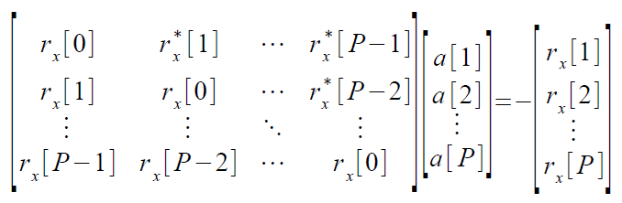

$$R_{xx}a=-r_{x}$$

**Linear Prediction**

$$\hat{x}\left[n\right]=\sum_{k=1}^{P}{a\left[k\right]x[n-k]}$$

Predict sample x[n] from its past P samples