**GROUP MEMBERS:**

Tam Yat Pang 105079 Mail.dtam@gmail.com

Li Ailing 105006 bonjourireneee@gmail.com

Leung Ching Yee 105154 ivy_leung92@hotmail.com

|  |  |
| --- | --- |
| **Story Title** | Fin / Free The Sharks |
| Journey Origin | Fin / Free The Sharks |
| Journey Destination | Continue enjoying your soup by killing the innocents or stop the massacre? The choice is yours. |
| No. of Moments | 6 |
| Text Segments | 1. Fin / Free The Sharks |
|  | 2. About 100 million sharks were killed every year to feed the growing demand for shark fin soup, which made sharks become endangered. |
|  | 3. Most sharks were finned alive. The bodies were tossed back into the sea and bleed to death. |
|  | 4. In Chinese culture, shark fin soup is a popular cuisine usually served at special occasions such as weddings and banquets, or as a luxury item. |
|  | 5. Hong Kong imported 1,162 tonnes of shark fins last year, which was roughly half of the world's harvest. |
|  | 6. Continue enjoying your soup by killing the innocents or stop the massacre? The choice is yours. |

CONTENT STRUCTURE

VISUAL STRUCTURE - LINEAR MOTIF

Journey Origin:



Journey Destination:



VISUAL STRUCTURE - COLOR SCRIPT

Journey Origin:

Journey Halfway:

Journey Destination:

IMAGE TRANSITION – IDENTIFIED OBJECT

|  |
| --- |
|  |

IMAGE TRANSITION – STORYBOARD

Moment 1:

Text Segment:

Fin / Free The Sharks

Other Description:

Background music 1:26 minutes



Transition: match out

Moment 2:

Text Segment:

About 100 million sharks were

killed every year to feed the

growing demand for shark fin

soup, which made sharks

become endangered.

Other Description: N/A

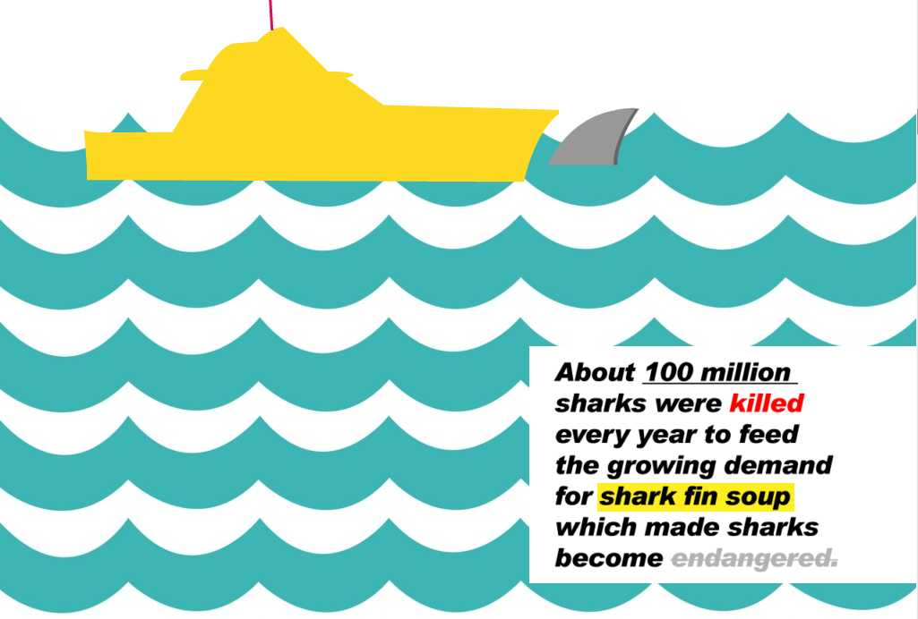

Transition: match out

Moment 3:

Text Segment:

Most sharks were finned alive.

The bodies were tossed back

into the sea and bleed to death.

Other Description: N/A

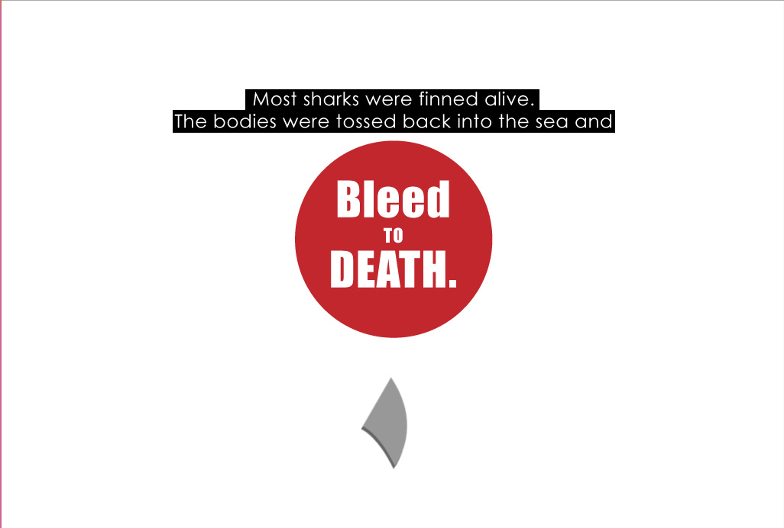

Transition: zero out

Moment 4:

Text Segment:

In Chinese culture, shark fin

soup is a popular cuisine

usually served at special

occasions such as weddings

and banquets, or as a luxury

item.

Other Description: N/A

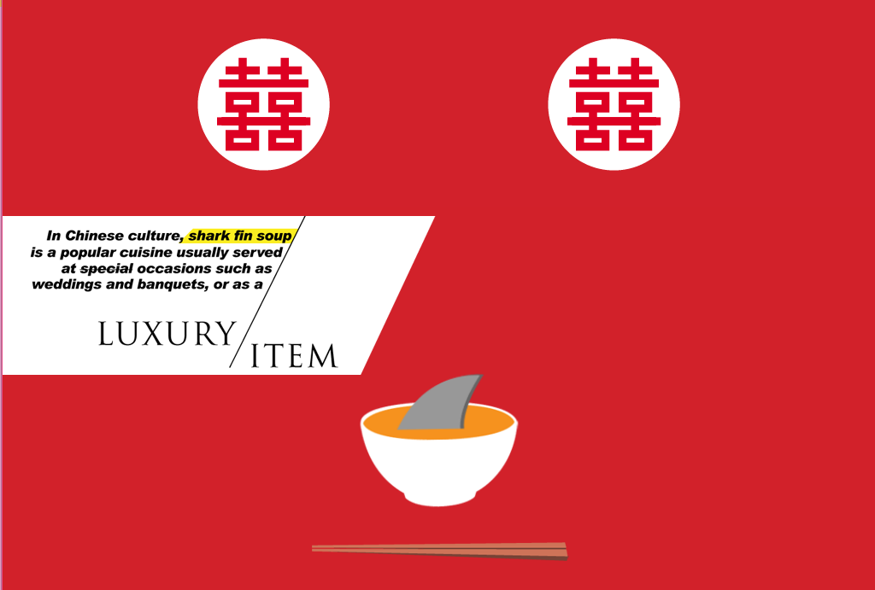

Transition: match out

Moment 5:

Text Segment:

Hong Kong imported 1,162

tonnes of shark fins last year,

which was roughly half of the

world's harvest.

Other Description: N/A

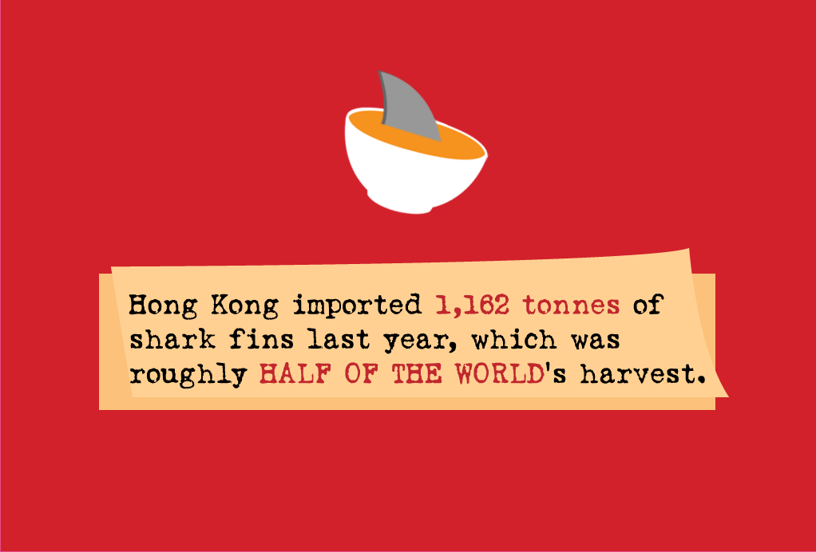

Transition: match out

Moment 6:

Text Segment:

Continue enjoying your soup

by killing the innocents or stop

the massacre? The choice is

yours

Other Description: N/A

