**Jour 460 Digitization and Interactive Multimedia**

**Final Group Project**

|  |  |  |
| --- | --- | --- |
| **Name / ID no.** | **Contact** | **Responsible for** |
| Tse Ka Kee 115068 | tkkbb@hotmail.com | Research, written report, storyboard, ppt. |
| Tse Lai Wai 115073 | tselaiwai@gmail.com | Graphic and Web design |
| Kwan Chung Ping 115081 | kobekwan@hotmail.com | Research, written report, storyboard, ppt. |
| Chan Jeco 115088 | jecohi@gmail.com | Graphic and Web design |
| Fong Kin Ming 115141 | henryfong708@gmail.com | Insert code |

|  |  |
| --- | --- |
| Story Title | 欄離難捨 |
| Journey Origin | Born in Shanghai, 1983 |
| Journey Destination | Announced retirement in 7th April 2015 |
| No. of Moments | 7 |
| Text Segments | 1.無名誕生  1983年 – 劉翔生於上海一個小康之家。因從少不好好走路，父母一度以為他患了「過度活躍症」，直至十歲那年，彈跳力受體校跳高教練專業眼光肯定，加入田徑隊。 |
|  | 2.貴人扶助  1998年 – 劉翔在體校建議下，轉受跨欄訓練，但成績未如理想。在孫海平全爭取下才能留下，並在1999年以16歲之齡躋身國家隊。 |
|  | 3.漸露頭角  2001年 － 劉翔在世界大學生運動會上以13.33秒奪冠，是中國在大運會上首枚田徑金牌，也是劉翔本人所拿到的第一個世界冠軍。 |
|  | 4.一跑成皇  2004年 – 劉翔在雅典奧運110米欄，以12.91秒成績奪金，打破奧運紀錄，追平科林.傑克創出並保持11年的世界紀錄，更為中國奪得首面男子田徑金牌。 |
|  | 5.因傷失冕  2008年 – 劉翔在北京奧運110米欄，被分配在第六組第二道，但由於傷勢復發，臨場退賽，衛冕失敗。 |
|  | 6.最後一戰  2012年 – 劉翔在倫敦奧運110米欄預賽第六組中的第一欄意外摔倒，未能進入準決賽，賽後被診斷為筋腱斷裂，這是他最後一場比賽。 |
|  | 7.欄王退位  2015年 – 劉翔在個人微博中發出題為「我的跑道﹗我的欄﹗」的文章，宣佈結束19年的跨欄運動生涯，發表退役感言。 |

**Text Content**

**Visual structure: Storyboard**

**Movement 1**

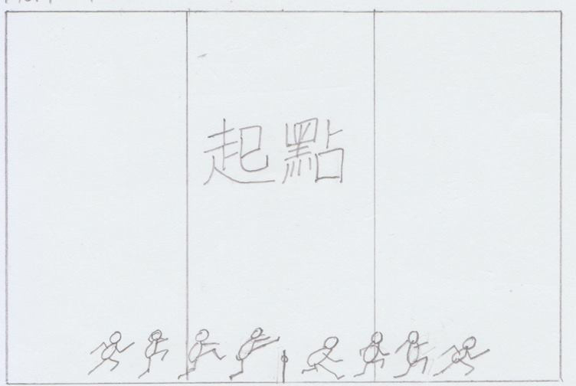

Text Segment:

起點

Other Description:

Background: Track and field

Use of lines and colours: Pure colour-red

Movement of the object: Still

Movement of camera: 2D

Use of sound, video:

Transition: Straight linear movement, moving upward

**Movement 2**

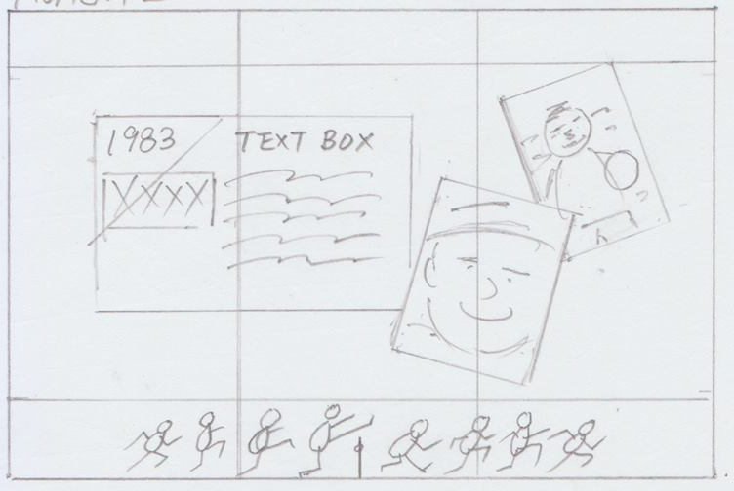

Text Segment:

無名誕生

1983年 – 劉翔生於上海一個小康之家。因從小不好好走路，父母一度以為他患了「過度活躍症」，直至十歲那年，彈跳力受體校跳高教練專業眼光肯定，加入田徑隊。

Other Description:

Background: Track and field

Use of lines and colours: Pure colour-red

Movement of the object: 1. Textbox title- Straight movement, from left to right

2. Textbox- Dissolve

3. Photos- Straight movement, from right to left

Movement of camera: 2D

Use of sound, video:

Transition: Straight linear movement, moving upward

**Movement 3**

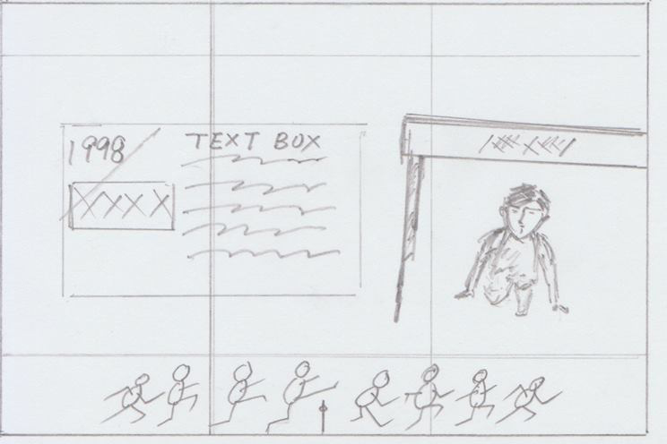

Text Segment:

貴人扶助

1998年 – 劉翔在體校建議下，轉受跨欄訓練，但成績未如理想。在孫海平全爭取下才能留下，並在1999年以16歲之齡躋身國家隊。

Other Description:

Background: Track and field

Use of lines and colours: Pure colour-red

Movement of the object: 1. Textbox title- Straight movement, from left to right

2. Textbox- Dissolve

3. Hurdle-From bottom to the top

4. Liu Xiang- Zoom in, from center to the right, under the hurdle

Movement of camera: 2D

Use of sound, video:

Transition: Straight linear movement, moving upward

Liu Xiang and hurdle- Match cut

**Movement 4**

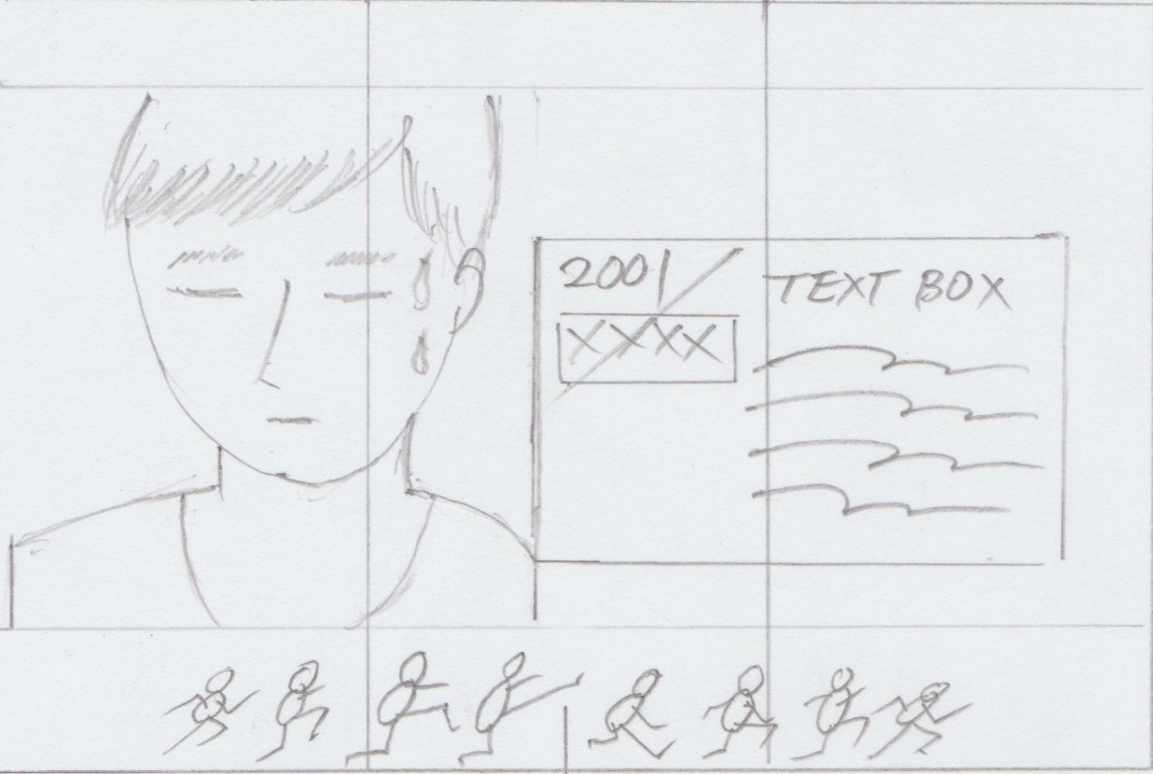

Text Segment:

漸露頭角

2001年 － 劉翔在世界大學生運動會上以13.33秒奪冠，是中國在大運會上首枚田徑金牌，也是劉翔本人所拿到的第一個世界冠軍。

Other Description:

Background: Track and field

Use of lines and colours: Pure colour-red

Movement of the object: 1. Textbox title- Straight movement, from right to left

2. Textbox- Stragiht movement, right to left

3. Liu Xiang- Straight movement, from left to right

Movement of camera: 2D

Use of sound, video:

Transition: Straight linear movement, moving upward

Liu Xiang and textbox- Zero cut

**Movement 5**

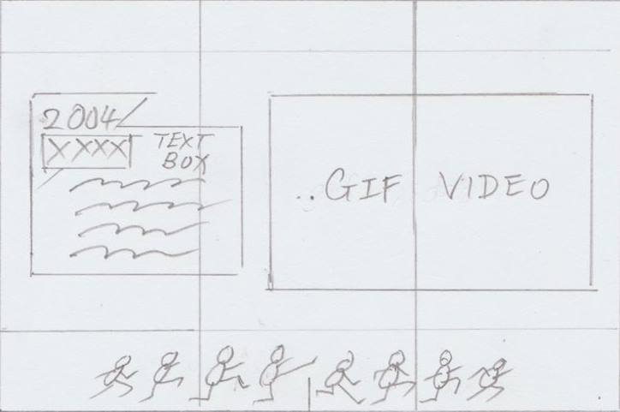

Text Segment:

一跑成皇

2004年 – 劉翔在雅典奧運110米欄，以12.91秒成績奪金，打破奧運紀錄，追平科林.傑克創出並保持11年的世界紀錄，更為中國奪得首面男子田徑金牌。

Other Description:

Background: Track and field

Use of lines and colours: Pure colour-red

Movement of the object: 1. Textbox title- Straight movement, from left to right

2. Textbox- Straight movement, from left to right

Movement of camera: 2D

Use of sound, video: Sound- Voice over of the video

Video-GIF, dissolve, appears from the right

Transition: Straight linear movement, moving upward

Textbox and GIF- Zero cut

**Movement 6**

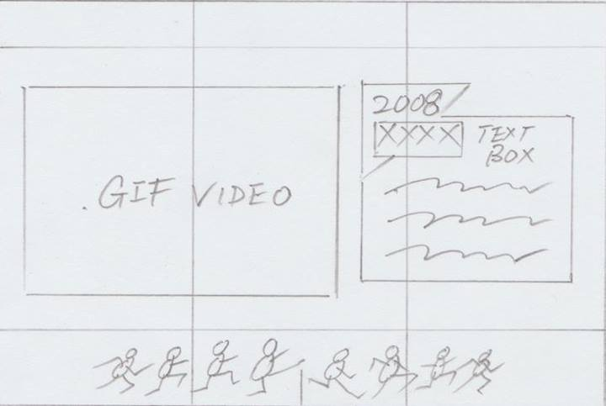

Text Segment:

因傷失冕

2008年 – 劉翔在北京奧運110米欄，被分配在第六組第二道，但由於傷勢復發，臨場退賽，衛冕失敗。

Other Description:

Background: Track and field

Use of lines and colours: Pure colour-red

Movement of the object: 1. Textbox title- Straight movement, from right to left

2. Textbox- Straight movement, from right to left

Movement of camera: 2D

Use of sound, video: Sound- Voice over of the video

GIF, straight linear movement, from the top to the middle

Transition: Straight linear movement, moving upward

Textbox and GIF: Zero Cut

**Movement 7**

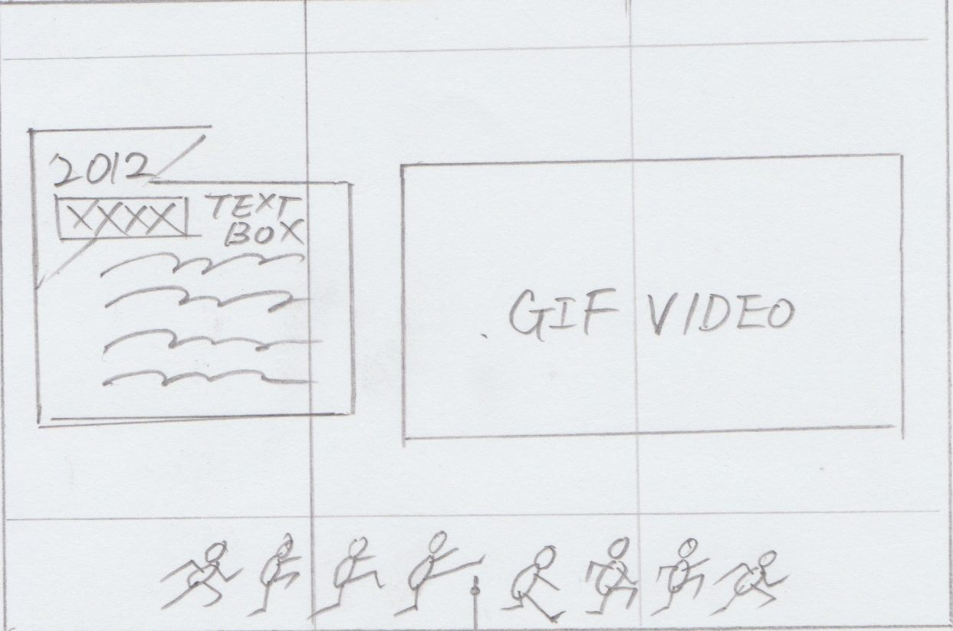

Text Segment:

最後一戰

2012年 – 劉翔在倫敦奧運110米欄預賽第六組中的第一欄意外摔倒，未能進入準決賽，賽後被診斷為筋腱斷裂，這是他最後一場比賽。

Other Description:

Background: Track and field

Use of lines and colours: Pure colour-red

Movement of the object: 1. Textbox title- Straight movement, from left to right

2. Textbox- Straight movement, from right to left

Movement of camera: 2D

Use of sound, video: Sound- Voice over of the video

Video: GIF, straight linear movement, from the bottom to the middle

Transition: Straight linear movement, moving upward

**Movement 8**

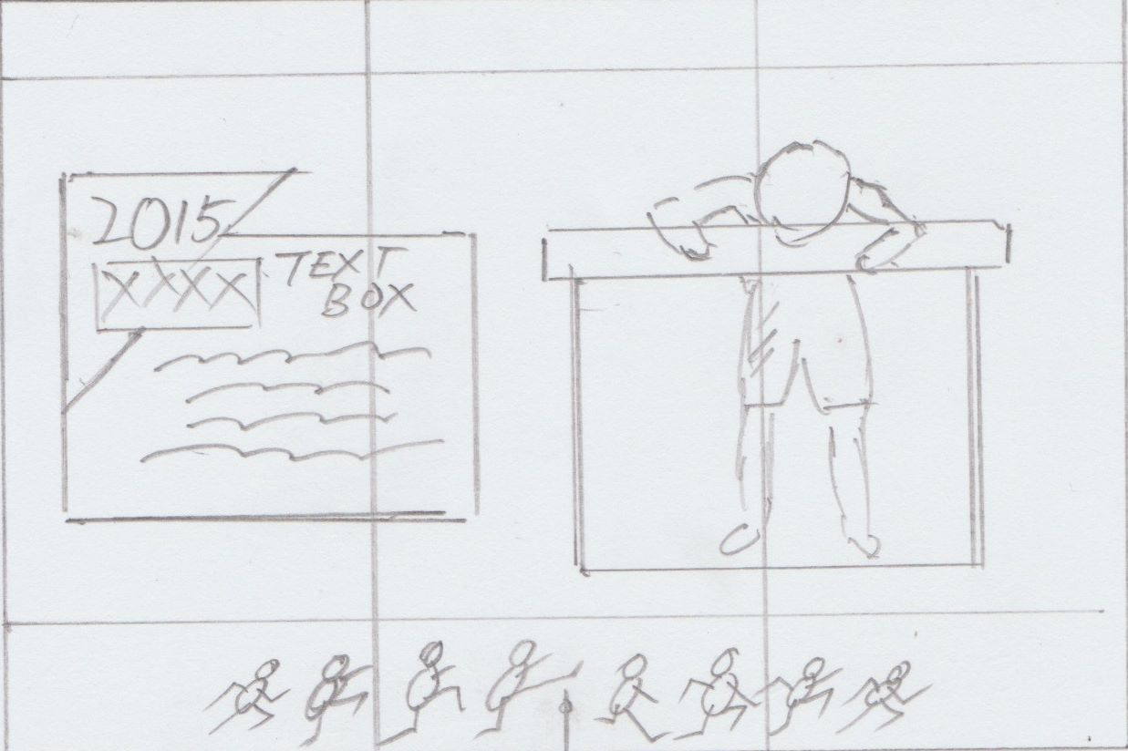

Text Segment:

欄王退位

2015年 – 劉翔在個人微博中發出題為「我的跑道﹗我的欄﹗」的文章，宣佈結束19年的跨欄運動生涯，發表退役感言。

Other Description:

Background: Track and field

Use of lines and colours: Pure colour-red

Movement of the object: 1. Textbox title- Straight movement, from left to right

2. Textbox- Straight movement, from the bottom to the middle

3. Liu Xiang and hurdle- Straight movement, from the top to the middle

Movement of camera: 2D

Use of sound, video: Nil

Transition: Straight linear movement, moving upward

Liu Xiang and hurdle- Wipe left to replace the textbox

**Movement 9**

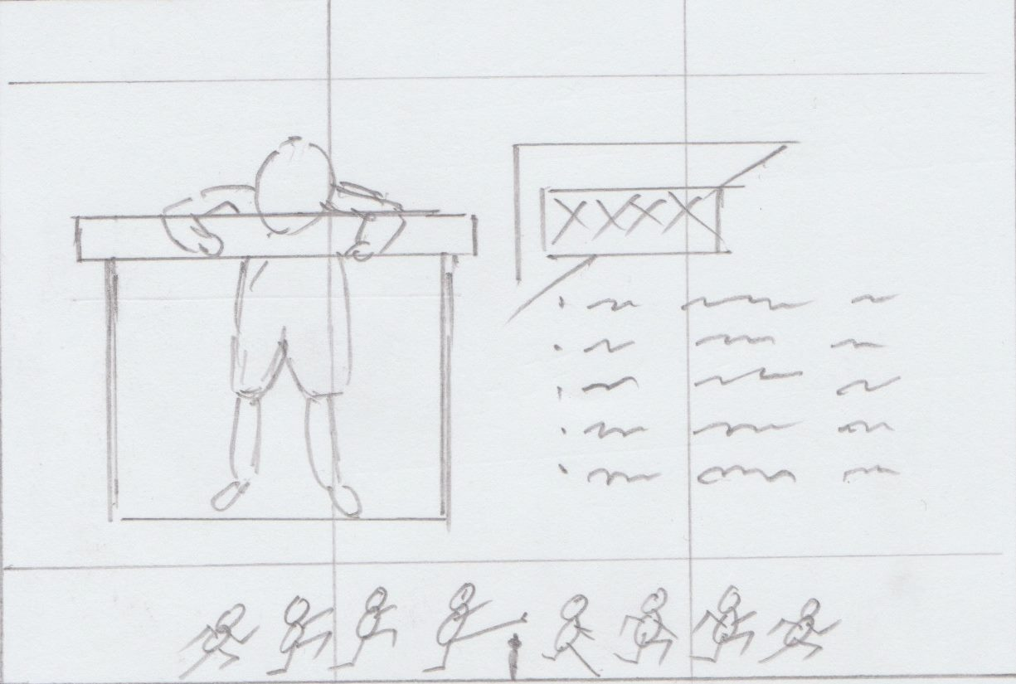

Text Segment:

Nil

Other Description:

Background: Track and field

Use of lines and colours: Pure colour-red

Movement of the object: 1. Textbox title- Straight movement, from right to left

2. Liu Xiang and hurdle- Wipe left

Movement of camera: 2D

Use of sound, video: Sound-Background music, Chinese national anthem, fade out

Video: GIF- Text rolling, fast dissolve, from the bottom to the top

Transition: Nil

**Foreground**

- 儷黑金體, high readability

- Guiding the eye

- High clarity

- Color from saturated to no-color

- Contrast color in text box title

- Place a transparent rectangle at the back of the textbox in order to differentiate

the color of words and background

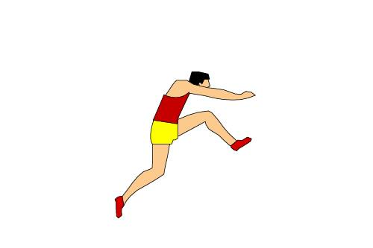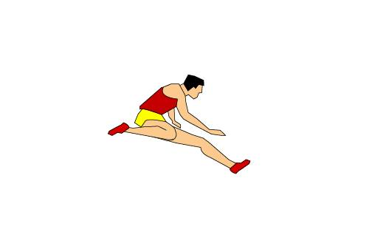**Midground**

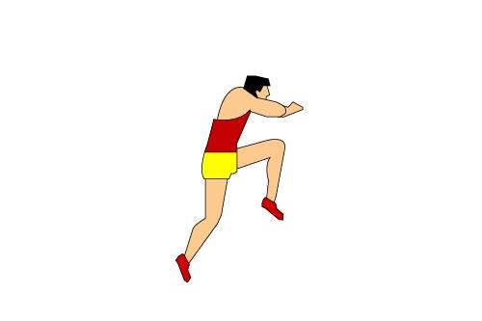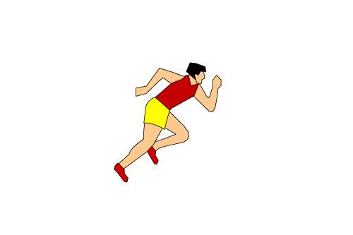

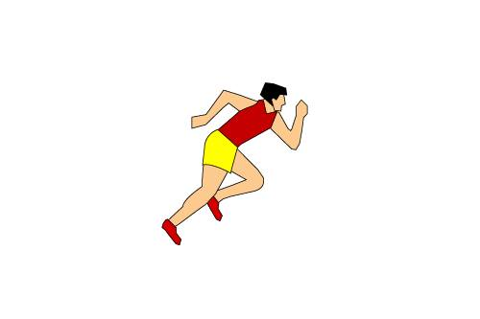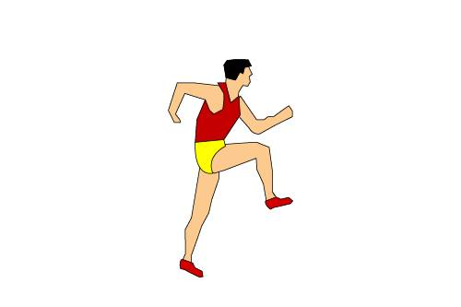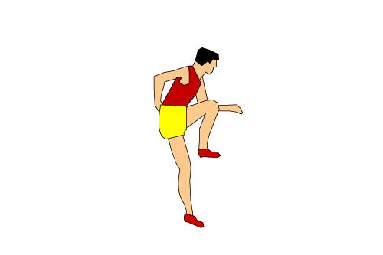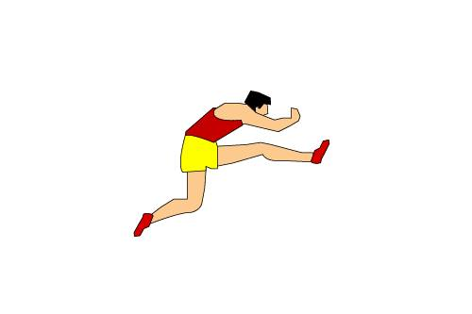

- Stay at bottom of the webpage throughout the timeline

- Stepwise progression, each image is an extension of the previous one

- Act as a button, a hyperlink to its individual page, different motion refer to different hyperlink

- Related to hurdle

**Background**



- Track and Field, pure color, red, coordinate with the theme of the webpage

- A long track and field, around 10000 pixels, thus it will not be cut

- High resolution