IV. IMPLEMENTATION
The program is written as a single C++ source file that uses only the iostream and string libraries. All assignments are kept in an array of up to 100 Assignment structures (Section III-A), and a while loop keeps the program running until the user chooses Exit.
A. Adding Assignments
The code is divided into four parts listed in Table IV. The function main() repeatedly calls printMenu() which draws the dashboard and returns the user’s choice. Then, the choice is matched to one of the five options (add, view, work on, delete, or pass a day) or to Exit. If the input is not a number, printMenu() returns -1, which matches no option.
TABLE 4
Function | Role
calculateUrgency() | Adds points for time, analysis, and task volume, then returns the urgency label
getQuoteByDays() | Returns a motivational quote based on the days left
printMenu() | Shows the dashboard and menu and reads the user’s choice
main() | Runs the main loop and handles each menu option

B. Urgency Classification
The function calculateUrgency() implements the scoring in Table I. It starts with a score of zero, adds points for the days left, the ‘deep analysis’ answer, and the number of tasks, and then converts the total into a label, as shown in Listing 1. It is called when an assignment is added and again whenever a day passes, so the label always follows the current deadline.
if (days >= 1) {
if (days <= 3) {
score += 50;
}
}
...
if (score > 70) {
return "[Red] HIGH URGENCY";
}
if (score >= 40) {
return "[Yellow] MODERATE URGENCY";
}
return "[Green] LOW URGENCY";
Listing 1. Excerpt of calculateUrgency():

C. Work Logic
Option 3 first checks the days left of the selected assignment. If the deadline is today (daysLeft = 0), the program enters a do-while loop that keeps asking whether the assignment is completely done and only ends when the user answers Y. The user therefore cannot leave a ‘due today’ assignment unfinished. After the loop, the assignment is marked as ‘completed’ and a quote is shown.
If days remain, the user chooses one of the three options in Table II. Choosing delay increases the delayCount of the assignment by one (shown in Listing 2). When the deadline is tomorrow, a critical warning is shown instead of the normal messages. Otherwise, the message becomes stronger with every delay: a mild reminder for the first, a procrastination warning for the second, and a strong warning on the third delay and on every delay after it.
if (workOption == 2) {
list[actualIndex].delayCount++;
if (list[actualIndex].daysLeft == 1) {
cout << "...";
}
if (list[actualIndex].daysLeft != 1) {
...
if (list[actualIndex].delayCount == 3) {
cout << "...";
}
}
}
Listing 2. Excerpt of the delay option
D. Day simulation
The program does not use real calendar dates. Instead, option 5 simulates the passing of one day: it reduces daysLeft by one for every unfinished assignment that still has days left and recalculates its urgency label. A deadline therefore never goes below zero.
E. Program output
Figure 1 shows the main menu with the dashboard, where each assignment is listed with its days left and urgency label. Adding an assignment is shown in Figure 2, the user enters the name, days left, deep-analysis answer, and number of tasks, and the program returns the classification. The detailed view of all assignments is shown in Figure 3, and Figure 4 shows the warning displayed on the third delay. In Figure 5, passing one day moves Stats Practicum from Yellow to Red because it enters the 1-3 days range.
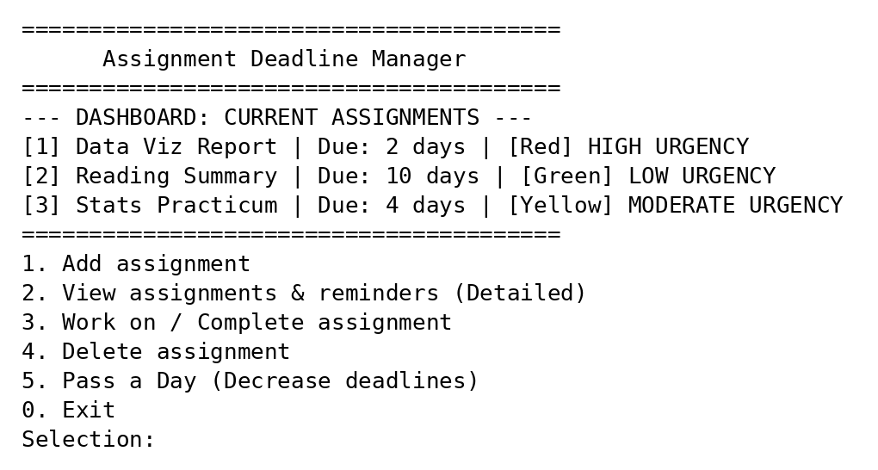
- Main menu with the dashboard of tracked assignments.
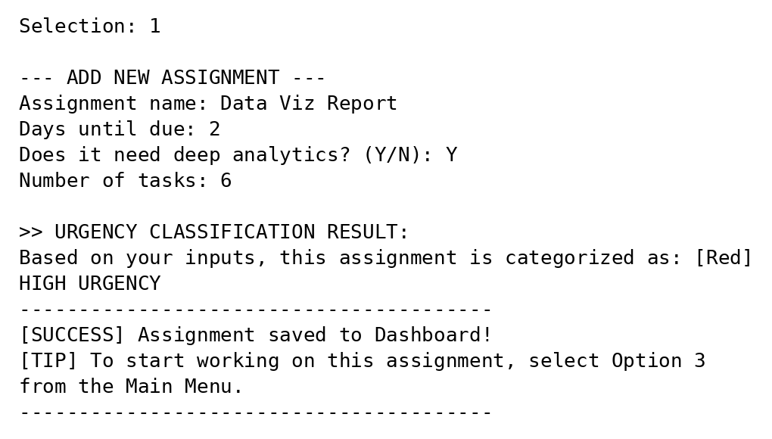
- Adding an assignment and its urgency classification
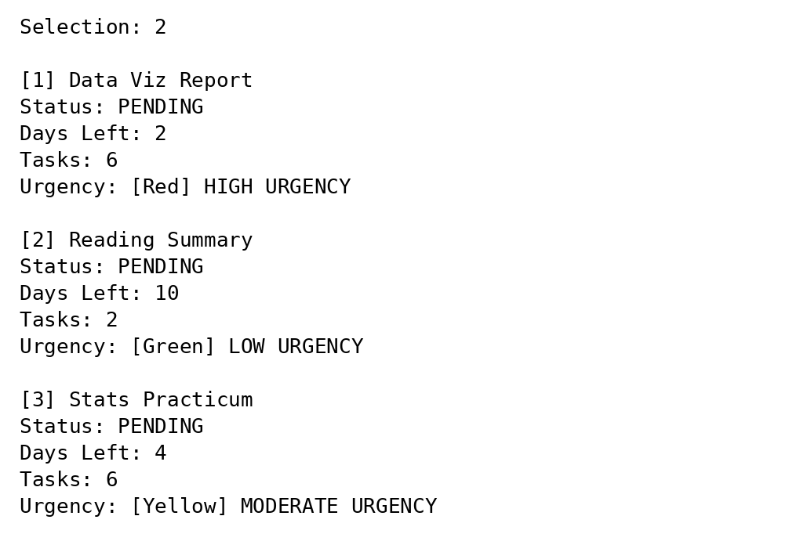
- Detailed view of the assignments
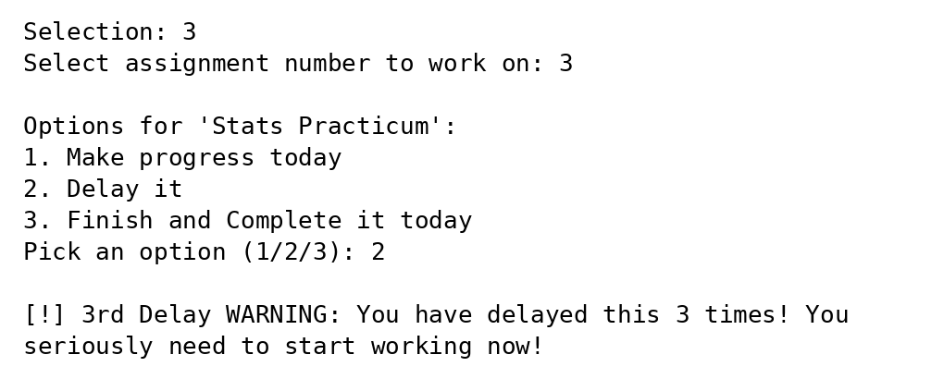
- Third delay warning when working on an assignment
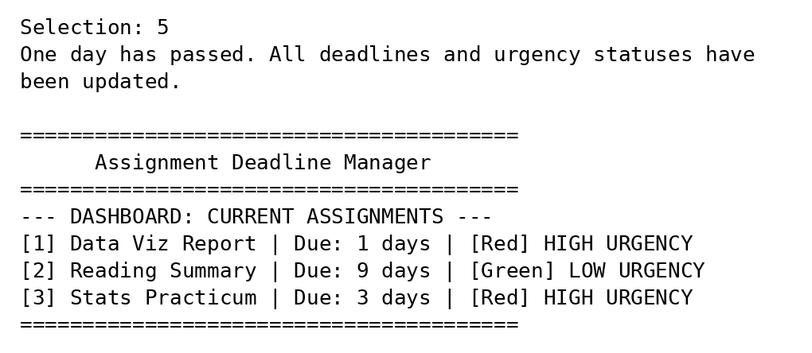
- Dashboard after passing one day

VI. CONCLUSION & FUTURE WORK
We built the Assignment Deadline Manager because many students do not know which assignment to do first. The program takes the days left, whether the assignment needs deep analysis, and the number of tasks, and turns them into one score. That score decide if the assignment is either Red, Yellow, or Green. When an assignment is due today, the program keeps asking until the user finishes it. It warns the user who keeps delaying, and it shows a motivational quote after an assignment is completed. We think this meets the objective of the project. However, It is still a small early sample, and the biggest problem is that every data that is saved in the initial run is lost once it is closed.
Several improvements are planned for our future work. The first is the file storage libraries via ofstream and ifstream, so that assignments are saved when the program closes. The second is input validation, for example for negative days or answers other than Y and N. The third is to replace the manual ‘Pass a Day’ option with real calendar dates and to add an overdue state for missed deadlines. The urgency score can also include the grade weight of each assignment, and the dashboard can be sorted from the most to the least urgent. Lastly, the program can be developed into a graphical or mobile application that is connected to an external calendar.

