**B.1 OVERVIEW**

This project aims to develop a web-based online education platform that allows users to interact with learning content in various ways. The platform is built using PHP for the backend and MySQL for the database, which together power the functionality of user registration, login, course management, bookmarking, liking, and commenting. The frontend relies on HTML, CSS, and possibly JavaScript to provide an interactive and user-friendly interface.

Users of the platform can sign up to create personalized accounts, which allow them to explore a curated list of courses organized into playlists. Each course consists of descriptions and multimedia elements (e.g., videos or images) to aid the learning process. The users can engage further with the content by bookmarking their favorite courses, liking them, and leaving comments for discussions or feedback.

Additionally, the platform includes static informational pages such as "About" and "Contact," offering general information about the platform's purpose and a channel for user inquiries, respectively. The structure of the project is modular and scalable, designed to accommodate future additions such as quizzes, progress tracking, certificates, and admin dashboards.

The project directory includes various PHP files that correspond to specific functionalities such as home page rendering (home.php), course listing (courses.php), playlist management (playlist.php), and user interaction features (likes.php, comments.php, bookmark.php). The course_db.sql file contains the database schema necessary to initialize the application's backend.

**B.2 BUSINESS RULES AND ASSUMPTIONS**

1. Users must be able to register by providing a unique username, password, and email address.
2. Upon registration, each user will be assigned a unique identifier (user_id) to facilitate database referencing.
3. A user must be able to log in with their username and password to access personalized features.
4. Users can browse all available courses without logging in, but actions such as liking, commenting, or bookmarking require authentication.
5. Each course must have a unique identifier (course_id), a title, a description, and may optionally include media content.
6. Courses are grouped under playlists, and each playlist can include multiple courses.
7. A user can like a course once. Each like is recorded with the user_id and course_id.
8. A user can bookmark a course for quick future reference. Like likes, bookmarks are recorded using user_id and course_id.
9. Users can comment on any course multiple times, and each comment is timestamped and associated with both the user_id and course_id.
10. Comments must be moderated or stored in such a way to prevent spam or offensive content.
11. Static pages (About, Contact) are accessible without authentication and serve informational purposes only.
12. The application stores timestamps for all likes, bookmarks, and comments to allow chronological sorting and display.
13. Each playlist must have a unique identifier (playlist_id), a name, and a brief description.
14. The system does not allow duplicate bookmarks or likes by the same user for the same course.
15. The database schema must support referential integrity using foreign keys among users, courses, comments, likes, and playlists.
16. The contact page must include a functional form that allows users to send messages or inquiries, which can be handled via email or stored in a database table.
17. Administrators can manage content directly in the database or through an extended content management module.
18. The backend must validate all user inputs to prevent SQL injection and XSS attacks.
19. The application should support future extensibility including quiz features, certification issuance, and user role distinctions (student, teacher, admin).

**B.3 ERD (CONCEPTUAL DATA MODELLING)**

The following entities have been defined for the conceptual model:

* **Users**: user_id (PK), username, email, password
* **Courses**: course_id (PK), title, description, playlist_id (FK)
* **Playlists**: playlist_id (PK), name, description
* **Comments**: comment_id (PK), user_id (FK), course_id (FK), text, timestamp
* **Likes**: user_id (PK, FK), course_id (PK, FK)
* **Bookmarks**: user_id (PK, FK), course_id (PK, FK)

Each entity corresponds to a specific component or interaction in the application. The relationships among them are maintained via foreign key constraints.

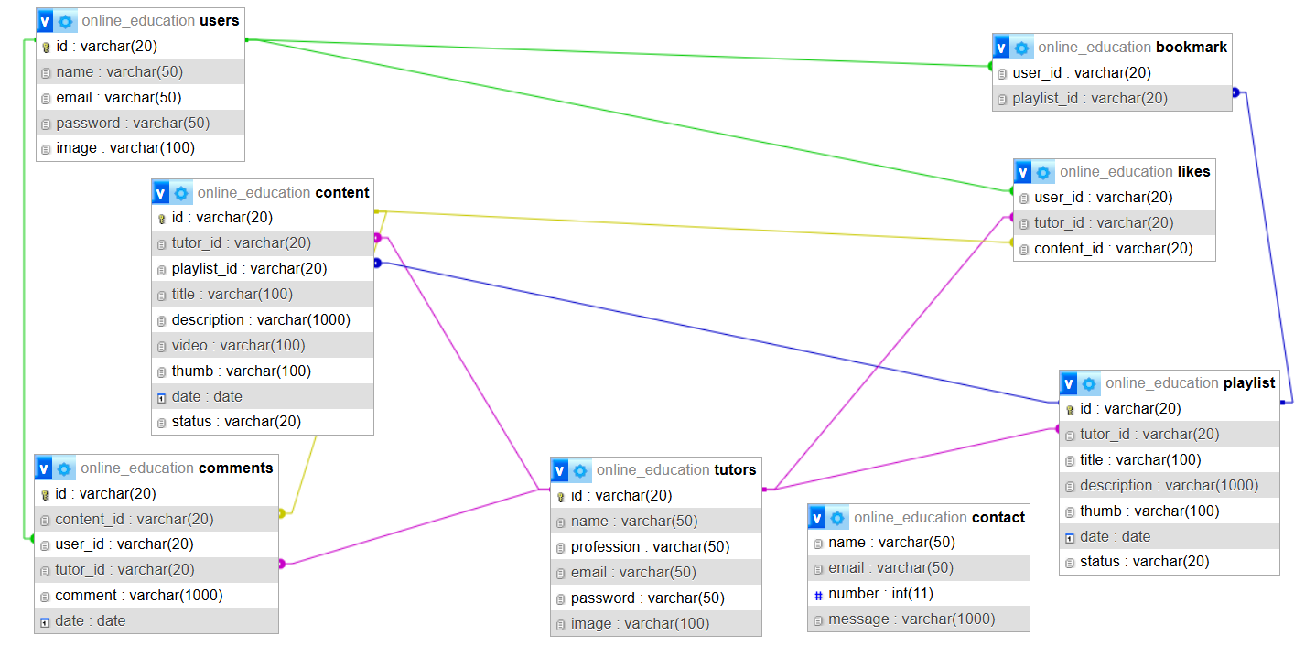

Image B.3.1 (Online education project diagram)

**B.4 JUSTIFICATIONS OF ENTITY CHOICES**

**USERS**

* **Justification**: To enable user-specific functionality such as bookmarks, comments, and likes. The user_id serves as a primary key and a reference in all relational mappings.

**COURSES**

* **Justification**: Core content entity representing each learning module. Courses are tied to playlists for organization and include metadata for display.

**PLAYLISTS**

* **Justification**: Allows courses to be grouped logically, enhancing user navigation and course discovery.

**COMMENTS**

* **Justification**: Facilitates interaction and feedback. Each comment is linked to both the user who made it and the course it refers to. Timestamping supports sorting and moderation.

**LIKES**

* **Justification**: Captures user appreciation. As a weak entity, it requires a composite primary key of user_id and course_id. Ensures that each user can only like a course once.

**BOOKMARKS**

* **Justification**: Allows users to save content for future access. Also a weak entity with composite keys. Enhances user retention and convenience.

**B.5 FUTURE DEVELOPMENT OPPORTUNITIES**

* **Admin Panel**: To manage courses, users, and content efficiently.
* **Quiz and Certification**: To validate learning and provide recognition.
* **Analytics Dashboard**: For users to track progress and for admins to measure course performance.
* **Role Management**: Distinguish between students, instructors, and administrators.
* **Mobile Responsiveness**: Ensure accessibility on all devices.
* **Multimedia Enhancements**: Integrate embedded video players, PDFs, and interactive content.