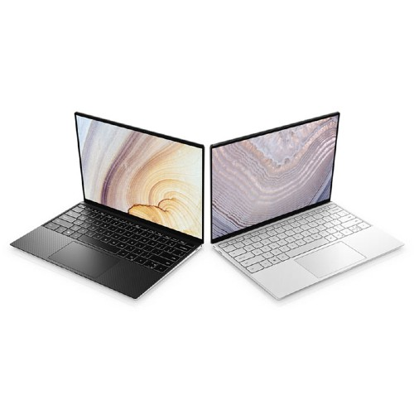

**Dell XPS 13 2020 (Core i5)**

The XPS 13 is the best laptop you can buy, and this year’s version raises the bar yet again.

[**$1,099 FROM AMAZON**](https://www.amazon.com/dp/B08DR2MJTQ?tag=digitren08-20&linkCode=ogi&th=1&psc=1&ascsubtag=1600917682158ny0u)[**$1,100 FROM DELL**](https://www.dell.com/en-us/shop/cty/pdp/spd/xps-13-9300-laptop?sid=16009176821582bhh)[**$1,100 FROM B&H PHOTO VIDEO**](https://bhpho.to/3iQU9tH)

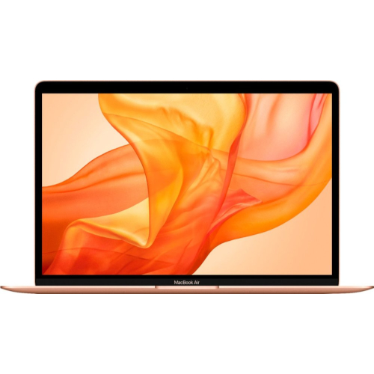

**MacBook Air (2020)**

The MacBook Air is the ultimate laptop to bring to college.

[**$900 FROM AMAZON**](https://www.amazon.com/dp/B08636NKF8?tag=digitren08-20&linkCode=ogi&th=1&psc=1&ascsubtag=1600917682164wl6n)[**$900 FROM BEST BUY**](https://bestbuy.7tiv.net/c/1661513/633495/10014?prodsku=6366612&u=https%3A%2F%2Fapi.bestbuy.com%2Fclick%2F-%2F6366612%2Fpdp&intsrc=CATF_4831&subid1=1600917682164nhw8)

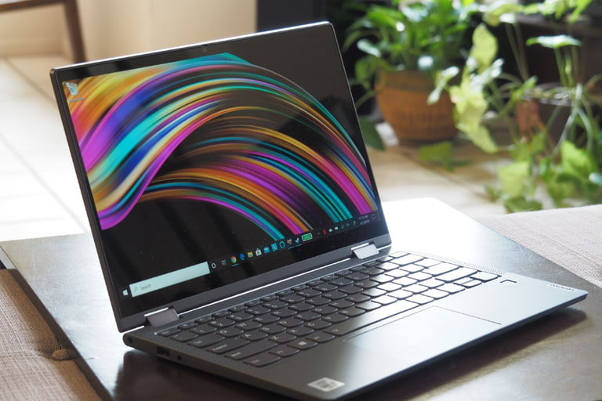

**Why you should buy this:** Good performance for so little money, and a complete complement of hardware features.

**Yoga C640**

[**$935 FROM AMAZON**](https://www.amazon.com/dp/B08D6FXZ4W?tag=digitren08-20&linkCode=ogi&th=1&psc=1&ascsubtag=1600917682164n3r1)[**$730 FROM LENOVO**](https://lenovo.vzew.net/Q5EeM?subid1=1600917682164mvv3)

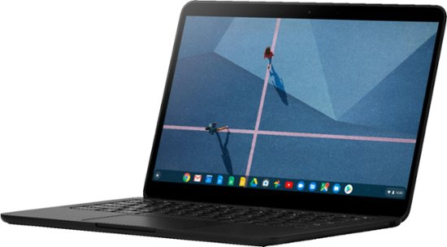

**Pixelbook Go**

If you’re comfortable with the limitations of a Chromebook, the Pixelbook Go is the best one your can buy.

[**$649 FROM GOOGLE**](https://store.google.com/us/product/pixelbook_go)[**$649 FROM BEST BUY**](https://bestbuy.7tiv.net/c/1661513/633495/10014?prodsku=6382912&u=https%3A%2F%2Fapi.bestbuy.com%2Fclick%2F-%2F6382912%2Fpdp&intsrc=CATF_4831&subid1=1600917682173g1hl)[**$649 FROM B&H PHOTO VIDEO**](https://bhpho.to/2Yamp2o)

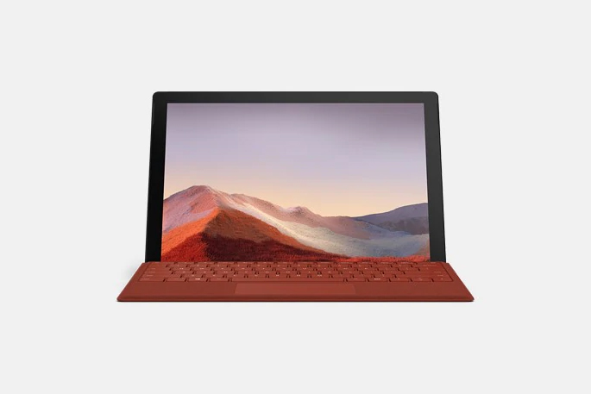

**Microsoft Surface Pro 7**

The Surface Pro 7 is a 2-in-1 detachable that combines stellar performance with a flexible, premium-built chassis.

[**$749 FROM AMAZON**](https://www.amazon.com/dp/B07YNHXX8D?tag=digitren08-20&linkCode=ogi&th=1&psc=1&ascsubtag=1600917682173dg8p)[**$900 FROM BEST BUY**](https://bestbuy.7tiv.net/c/1661513/633495/10014?prodsku=6375055&u=https%3A%2F%2Fapi.bestbuy.com%2Fclick%2F-%2F6375055%2Fpdp&intsrc=CATF_4831&subid1=1600917682173gkib)[**$729 FROM B&H PHOTO VIDEO**](https://bhpho.to/3eubZ4r)