**[Sonos Surround Set with Arc Sound Bar, Subwoofer, and One SL Speakers](https://www.worldwidestereo.com/products/sonos-surround-set-with-arc-wireless-dolby-atmos-sound-bar-subwoofer-and-one-sl-speakers)**

[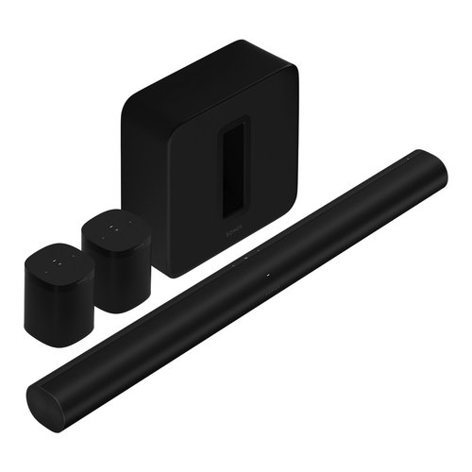](https://www.worldwidestereo.com/products/sonos-surround-set-with-arc-wireless-dolby-atmos-sound-bar-subwoofer-and-one-sl-speakers)

The [Sonos Arc 5.1 Surround Set](https://www.worldwidestereo.com/products/sonos-surround-set-with-arc-wireless-dolby-atmos-sound-bar-subwoofer-and-one-sl-speakers)

**This Package Includes**: [Arc Wireless Sound Bar with Dolby Atmos, Apple AirPlay 2 and Built-In Voice Control](https://www.worldwidestereo.com/products/sonos-arc-wireless-sound-bar-with-dolby-atmos-apple-air-play-2-and-built-in-voice-assistant)| [SUB Wireless Subwoofer (Gen 3)](https://www.worldwidestereo.com/products/sonos-wireless-subwoofer-gen-3) | [2 OneSL Speakers for Stereo Pairing and Home Theater Surrounds](https://www.worldwidestereo.com/products/sonos-one-sl-speaker-for-stereo-pairing-and-home-theater-surrounds) | Power Cords | HDMI Cable | Available in Black or White

**Reg. Price:**$1,856.00

[**Bose Soundbar 700 with Bass Module 700 and Surround Wireless Speakers**](https://www.worldwidestereo.com/products/bose-soundbar-700-5-1-home-theater-system-with-built-in-amazon-alexa-surround-wireless-speakers-and-bass-module-700-subwoofer)

[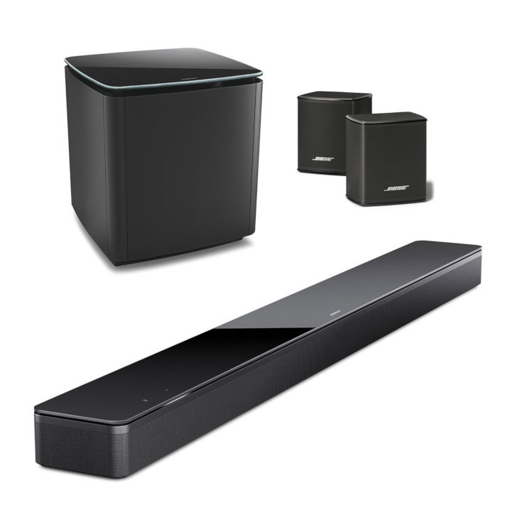](https://www.worldwidestereo.com/products/bose-soundbar-700-5-1-home-theater-system-with-built-in-amazon-alexa-surround-wireless-speakers-and-bass-module-700-subwoofer)

**Reg. Price:**$1,797.00

[**SHOP NOW**](https://www.worldwidestereo.com/products/bose-soundbar-700-5-1-home-theater-system-with-built-in-amazon-alexa-surround-wireless-speakers-and-bass-module-700-subwoofer)

[**SVS Prime Satellite 5.1 Package**](https://www.worldwidestereo.com/products/svs-prime-satellite-5-1-package)

[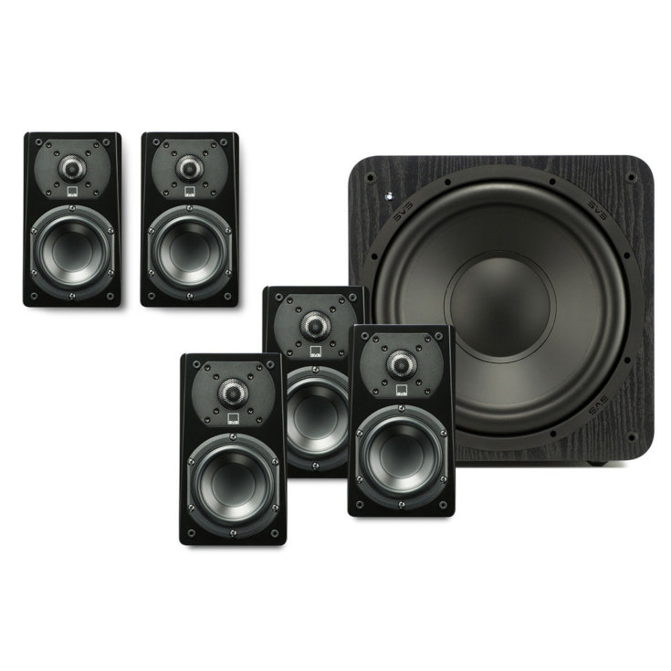](https://www.worldwidestereo.com/products/svs-prime-satellite-5-1-package)

**Reg. Price:**$999.99

[**KLH Kendall 5.1 Speaker System**](https://www.worldwidestereo.com/products/klh-kendall-5-1-speaker-system)

[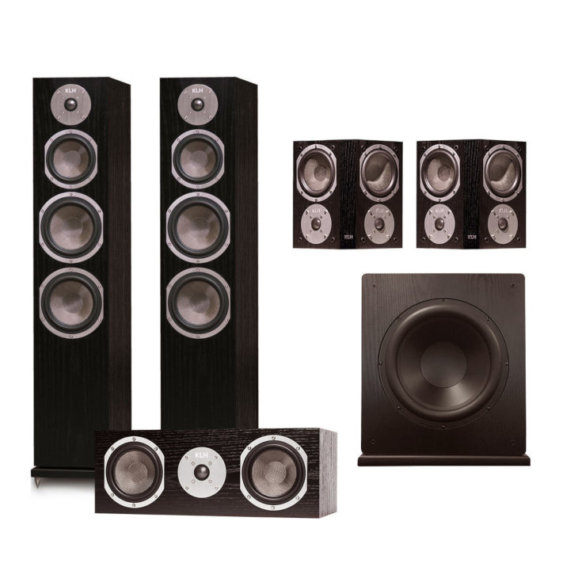](https://www.worldwidestereo.com/products/klh-kendall-5-1-speaker-system)

**Reg. Price:**$2,796.95

[**Klipsch 7.2.2 Reference Premiere Home Theater System with Marantz SR7013 9.2-Channel AV Receiver**](https://www.worldwidestereo.com/products/klipsch-7-2-2-reference-premiere-home-theater-system-with-marantz-sr7013-9-2-channel-av-receiver-wws86e72sr)

[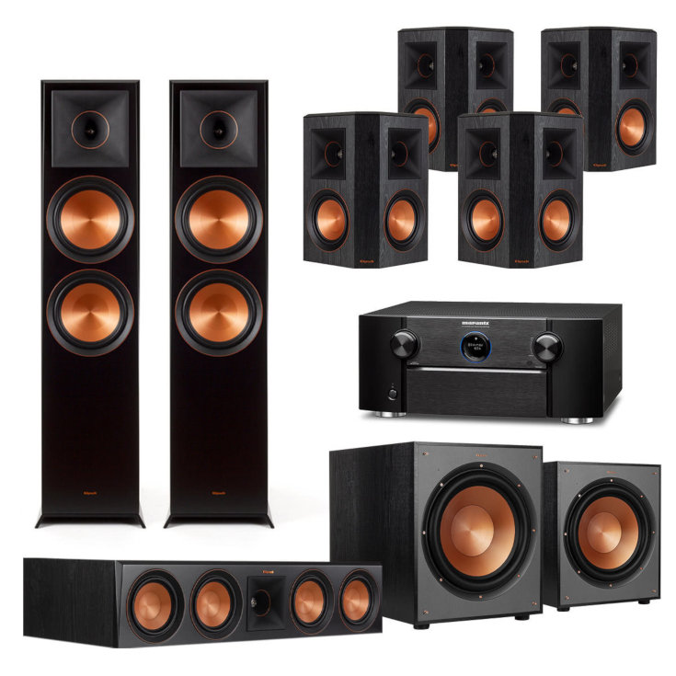](https://www.worldwidestereo.com/products/klipsch-7-2-2-reference-premiere-home-theater-system-with-marantz-sr7013-9-2-channel-av-receiver-wws86e72sr)

**Reg. Price:**$8,282.00