**OLED 55B9PUA B9 Series TV**

[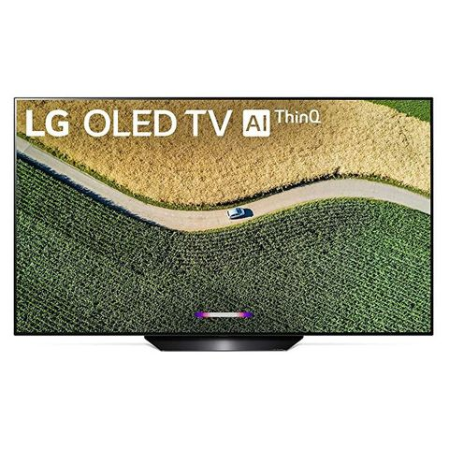](https://www.amazon.com/dp/B07RMSJT4J?linkCode=ogi&tag=goodhousekeeping_auto-append-20&ascsubtag=%5bartid|10055.g.32066100%5bsrc|%5bch|%5blt|)

**LG**

**LG**amazon.com

$1,999.99

**QLED 4K Q80 Series TV**

[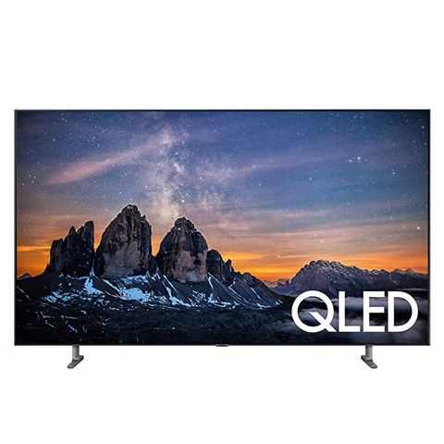](https://www.amazon.com/dp/B07N4M3Q5Y?linkCode=ogi&tag=goodhousekeeping_auto-append-20&ascsubtag=%5bartid|10055.g.32066100%5bsrc|%5bch|%5blt|)

**SAMSUNG**

**SAMSUNG**amazon.com

$1,599.95

**M-Series Quantum HDR 4K UHD Smart Quantum Dot LED TV**

[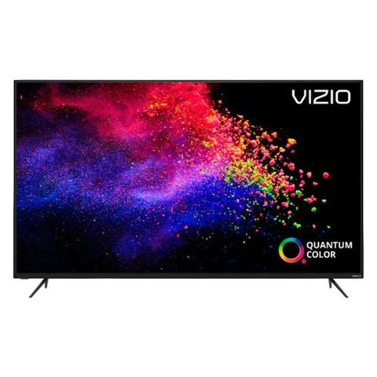](https://go.redirectingat.com/?id=74968X1525078&xs=1&url=https%3A%2F%2Fwww.bestbuy.com%2Fsite%2Fvizio-55-class-m-series-quantum-series-led-4k-uhd-smartcast-tv%2F6345457.p%3FskuId%3D6345457&sref=https%3A%2F%2Fwww.goodhousekeeping.com%2Felectronics%2Fg32066100%2Fbest-tv-brands%2F%3Fpre%3Delectronics%252F%26prefix%3Dg%26id%3D32066100%26del%3D%26variantId%3D%26post%3D%252Fbest-tv-brands)

**VIZIO**

**VIZIO**bestbuy.com

$522.99

**Class 6-Series 4K UHD QLED TV**

[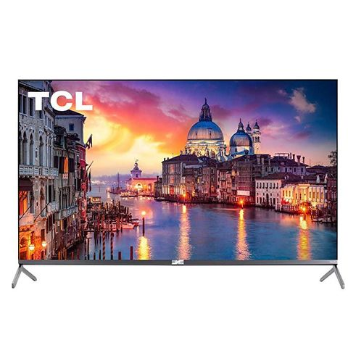](https://www.amazon.com/dp/B07V5WY147?linkCode=ogi&tag=goodhousekeeping_auto-append-20&ascsubtag=%5bartid|10055.g.32066100%5bsrc|%5bch|%5blt|)

**TCL**

**TCL**amazon.com

$817.17

**Class 4K UHD LED Android Smart TV**

[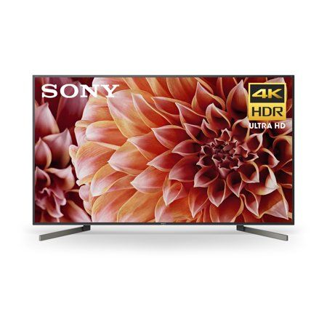](https://go.redirectingat.com/?id=74968X1525078&xs=1&url=https%3A%2F%2Fwww.walmart.com%2Fip%2F805161244&sref=https%3A%2F%2Fwww.goodhousekeeping.com%2Felectronics%2Fg32066100%2Fbest-tv-brands%2F%3Fpre%3Delectronics%252F%26prefix%3Dg%26id%3D32066100%26del%3D%26variantId%3D%26post%3D%252Fbest-tv-brands)

**SONY**

**SONY**walmart.com

$1,098.00