Q1) **Jira automation rule**

To create a automation rule in a scrum or kanban project, these are the steps which you need to follow:

Step 1:

Create 2-3 sample story by going to the backlog and assigning it to the sprint:

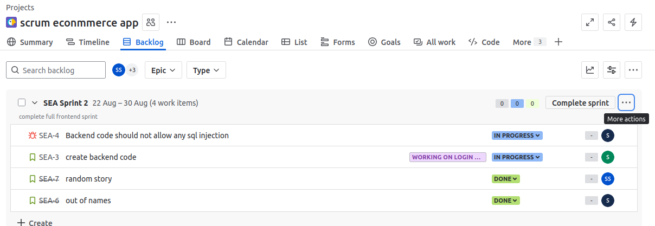

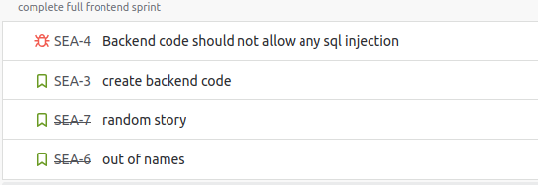

Step 2:After starting the sprint go to project settings -> Automation:

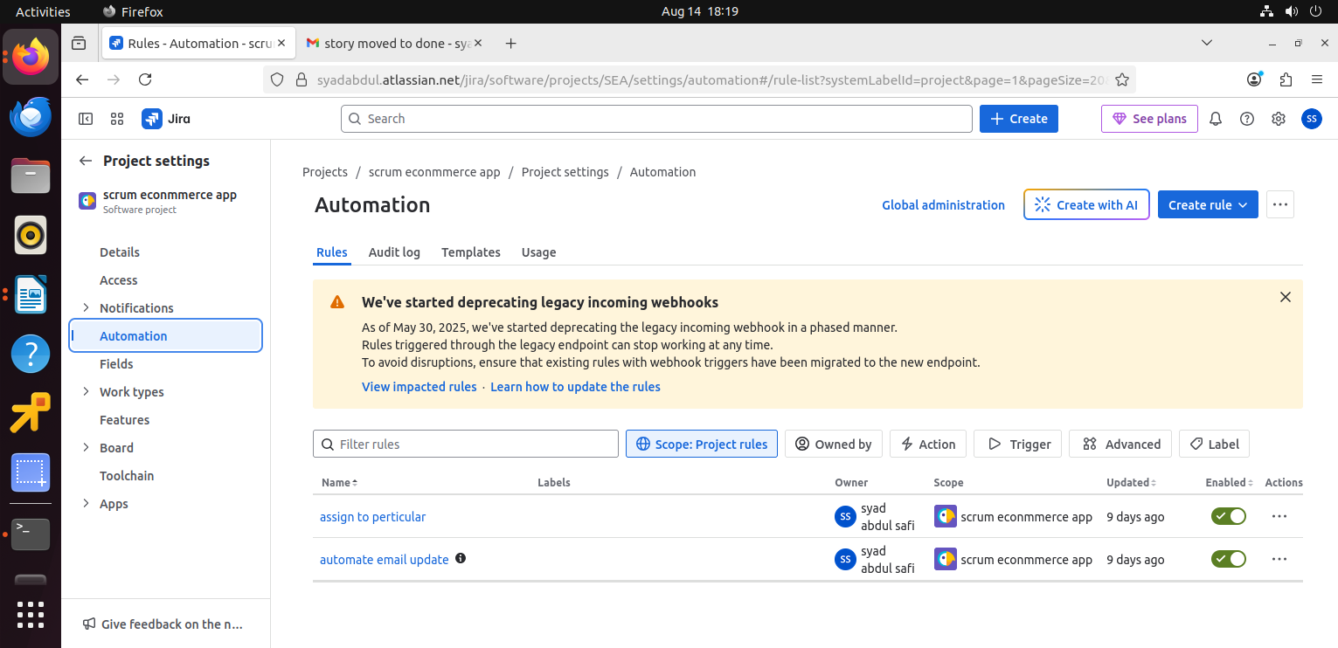Step 3:

Inside Automation click on “Create rule”

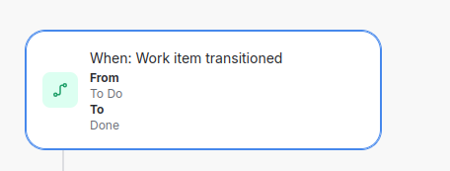search for “work item transitioned”

Step 4:

After that add component

“work iterm fied condition”. In this you can choose any value like bug, story, epic. Set field as “issue type” and condition “equals”

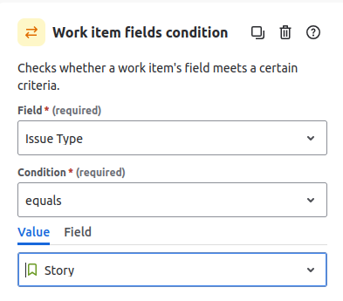

Step 5:

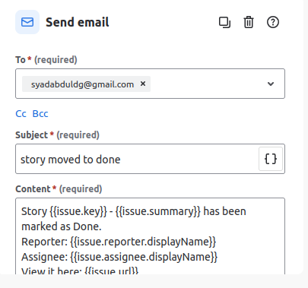Add component “send email”

add the respected personal email, also you can give subject and content to the email, use {{}} for special operation.

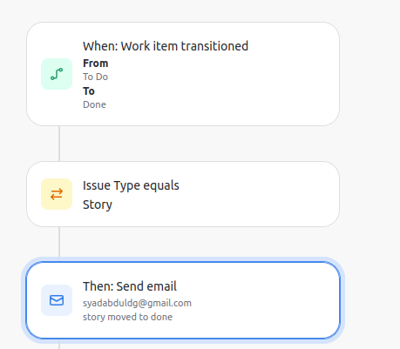It should look like this :

Step 6:

Transition a story form the board form “To Do ” to “Done”

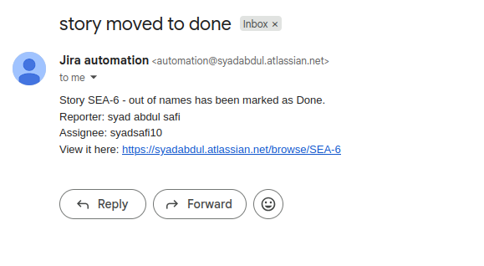and check the email for confirmation: