**Shell scripting**

**q)**List all running process, saves op to log,check for high mem, logs a warning

1)This script will list all running processes using : ps aux

2)save process list to a file

ps aux > processlist.txt

aux-> show processes for all user, (u) display in user oriented format, (x) include processes without a terminal

3)Filter high memory process using awk

awk is a text processing tool.

4)log warning if any process exceeds threshold

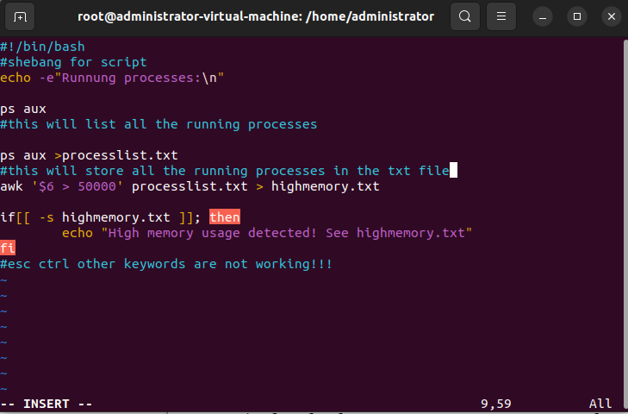as esc and ctrl and other keywords are locked i couldnt test the script and show log output