DESIGN

Introduction

Design is the process to solve the possible problem. This technique is helpful for overcoming those problems which may arise in future while working In small and core level project. I will use some software to create the design and prototype This process is done after analysis phase which is much composite than analysis. Here we gather user requirement and after analyzing user requirement we perform best possible design that can be made.

There are mainly two types of design which we described below:

1. Conceptual design: Here conceptual denotes customer.
2. Technical design: Here technical denotes system builders.
3. Structural design

Here structural design focus on structural modelling of system which capture static feature. This contain following:

1. Class diagram
2. Object diagram
3. Data flow diagram

Structural design is the process where we can find safe and serviceable specification of materials and member type, size and configuration to carry loads and it supports each other in sharing the loads.

1. Class diagram

Class diagram represents a set of objectives which has similar relationships, operation and behavior. Class diagram describes the object and classes inside the system and the relationship between them. It is also a classifier that describe the set of objects. Class diagram is mainly used in structural diagram. In UML class diagram is essential elements which has some

* Attributes
* Class
* Relationship
* Operation
* Constraint rules and notes

Relationships is class diagram are:

* Association: Association is also a structural relationship, which specific the object of the first class are connected to object of another class. i.e. an employee is working for a particular company.
* Generalization: It specifies the object of the sub class of one identical for object of the general class. It is a relation.
* Dependency: The whole part is dependent to life time.
* Realization: An interface can be grasped by many of the classes.

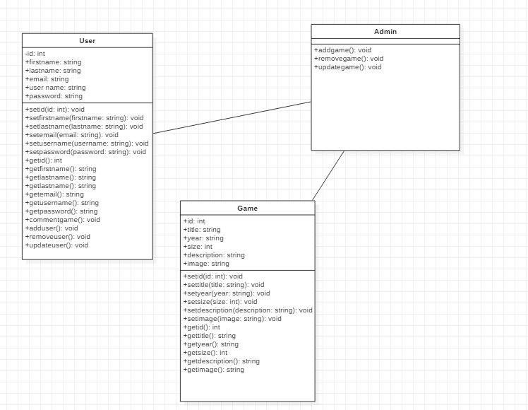

Figure : Final classs diagram

Firstly, the user can have id, first name, last name, email, username, password. User can login in the website using id and password which was register in the game details. User can comment in the post and games. It can add user and remove user and update user.

1. Dataflow diagram

* The dataflow diagram is a hierarchical graphical model of a system which process the activities and function made by the system performs where the data is interchange with the following function.
* Symbols that are used in dataflow diagram are as follows:

1. External entity: It is the source of information which flows through out the system and where information leaves the system.
2. Process: This are the activities that are carried out by the system which is use to use and transform data and information.
3. Dataflow: Those dataflows happening in the system are noted by a named arrow.
4. Datastore: It is the storage of all the information within the system.

* Dataflow model graphically represents the transformation of the data input through a hierarchy levels to the final data.

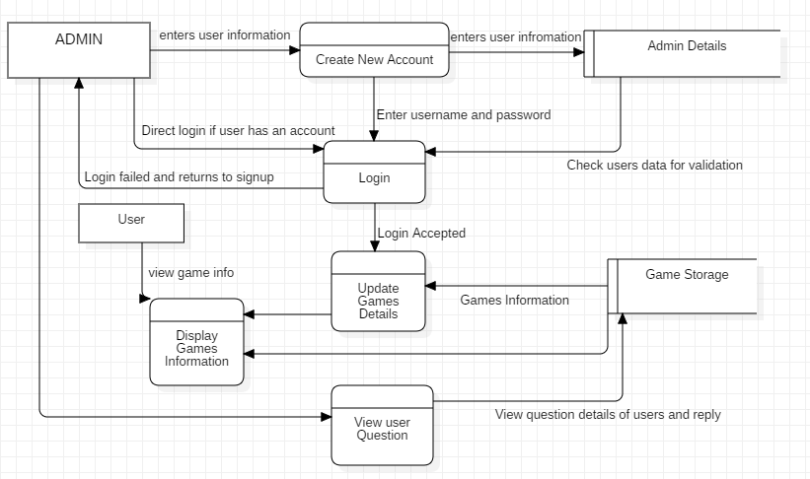

Figure : DFD diagram

1. Behavioral diagram

Behavioral diagram consists of both activity diagram and sequence diagram.

1. Activity

* It is a special kind of diagram that shows the flow of activity diagram to activity.
* Activity diagram states the dynamic view of the system and its interface.
* They are mainly used in modeling the function with in the system and the control flow among the objects.

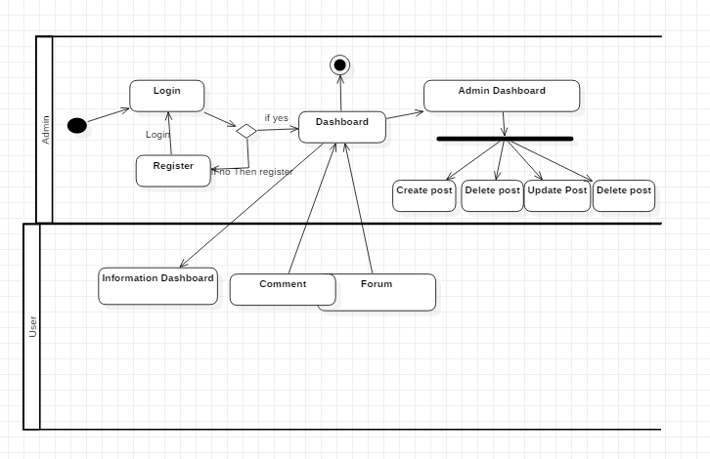

Figure : Activity diagram

1. Sequence diagram

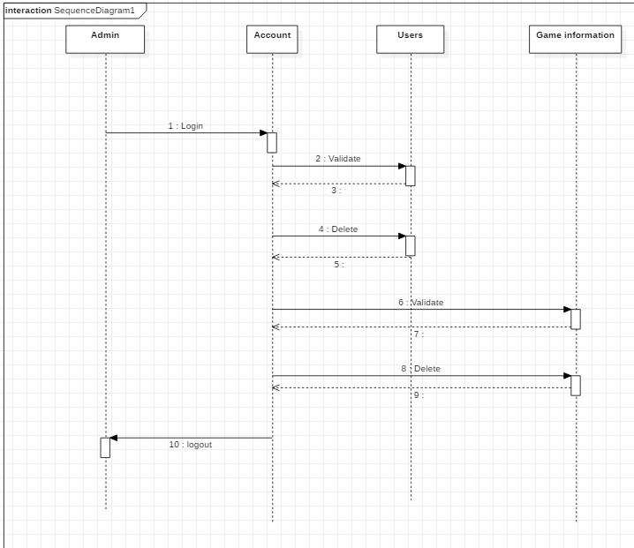

## Database design

There are two kind approaches of database design that are

* Bottom up
* Top down

Bottom up is used for collecting information and data for example: in game info we collect all the data of post and comments and the entities and which shows the relationship where as top down means to break large entities into small entities.

### Data dictionary

* It is a storage where data and information contains of data flow process and data storage.
* It is a repository of data of data.
* It is a set of all data and information of flow diagram elements.

The data dictionary contains following item and are as follows:

* Data structure: It is a set of element handled with in a unit.
* Data element: Smallest unit of data doesn’t not contains further decompostion.
* Data flow and data stores: Data flow are motion and data stores means where data structure are stored.

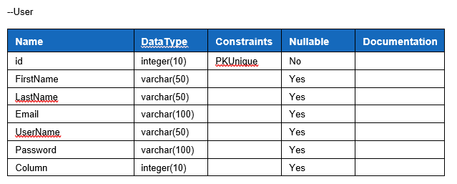

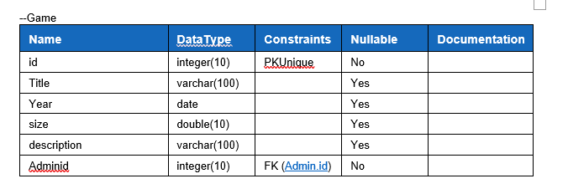

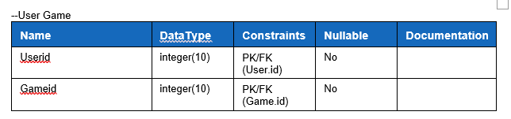

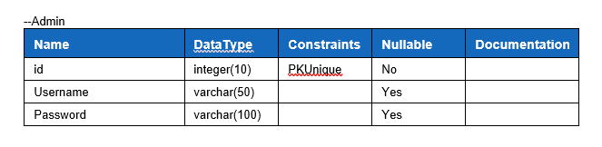

1. ERD

Entity realtionship modeling:

* Entity realtionship is a systematic way to describing business process.
* Diagram which is created by relationship, entities and attribuites graphically are known as entity realationship diagram.
* Various properties attributes of entities can characterize them.

The main components in database design are mentioned below:

* Relationship: It represents the relationship entites.
* Entity: Entity can be place, person, thing or an event.
* Attributes: Attributes are the process of describing entity.

ER diagram are categorised in four types of relationship which are as follow:

* One to one realtionship
* One to many relationship
* Many to many relationship
* Many to one relationship

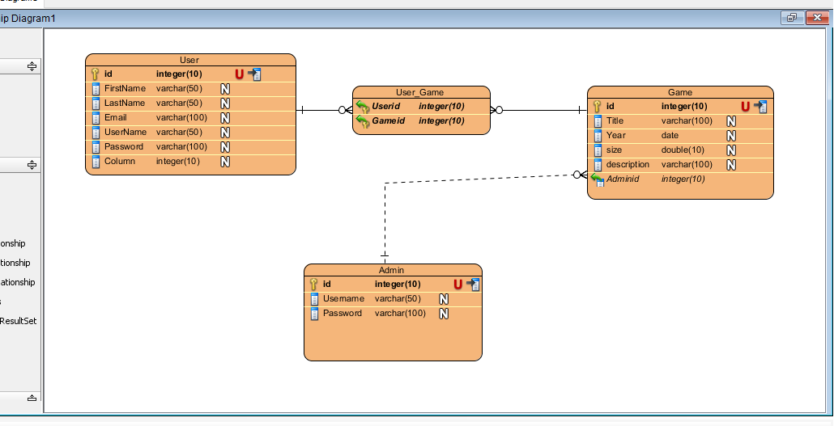

1. Architectural design

Architectural design are basically a data structure that represent the build of a computer based system. It’s the logical and conceptual structure organization of a computer based system. An idea which then takes part in forming a structure turns into a whole or computer system. Architectural design has context in the system

* External entites of a context diagram model in which the system interacts.
* System engineer must context in the model.

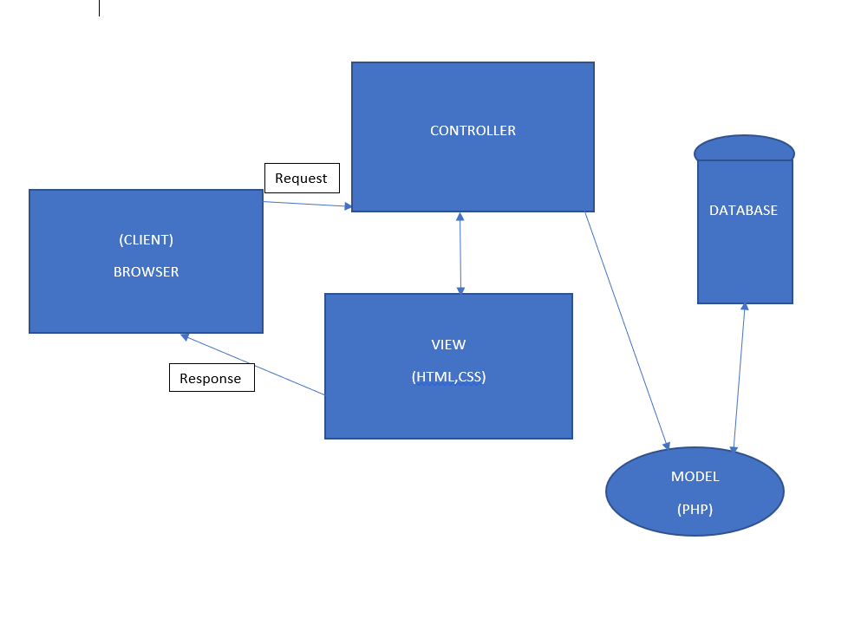

1. UI Design

User Interface is short (UI) design is the process and maintaining iterface wit in the computerized device or system with a special focuse design, style and looks.User Interface is an iterative process where is it often talked about the user experience which includes the interface and appearance of the device or system.

1. User interface is a front end application view where the user interacts with the system to use it.
2. User interface manipulate and control hardware and software of the user.
3. For example: If my game info is complicat to use by gamers and users for that the user interface should be user friendly and easy to use.
4. Users becomes familiar to the certain way to use the layout and interface. Doing so will get easy with task completion, satifaction and to be consistent.

There are some user interface design fundamentals which leps in improving such as:

* Know your User
* Stay consistent
* Pay attention to design, layout and patterns
* Use visual hierarchy
* Feedback is necessary
* Be forgiving
* Empower the user
* Speaking with the current language
* Keep it simple as possible
* Keep moving straight and forward

1. Digital Prototype

Digital prototype is a conceputal design for all the fields and in desiging website where it provides a virtual explore expericence of a complete product before its build. Digital prototype gives a wider range of testing opportunities unlike paper prototype. Where in my website I have used a software called (BALSAMIQ) for the run test. It is a software to create a didgital prototype wit al the features before taking it into action and made in reality.

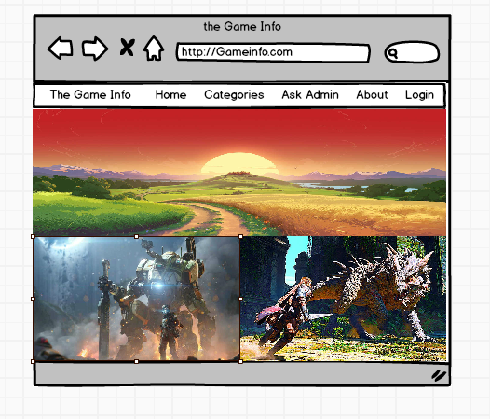

Figure 4: HOME

Home is where user is shown an d taken first in the webpage is HOME. They are explore about the webpage and see what they are looking for. It has all the information needed to view the webpage.

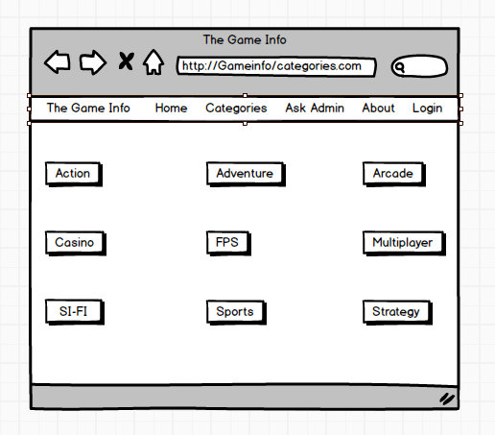

Figure 5:CATEGORIES

Then in the categories area they can search for the games they are looking for the games and new games and can access to all the game details. There are total of 9 option in categories sector.

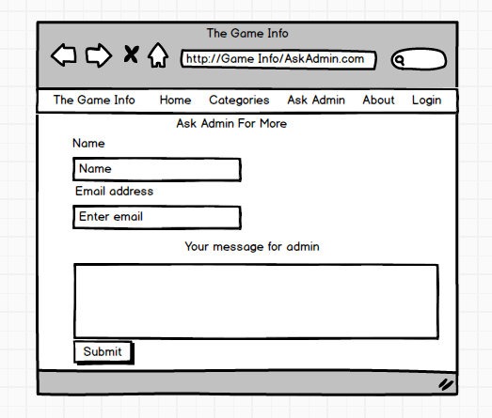

Figure 6:ASK ADMIN

It is for those user who wants to create a post or to upload of their games in the following website and for asking more question and the admin will try to give reply of those question with in a day or more. They can even contact admin for further details and information with is not in the website.

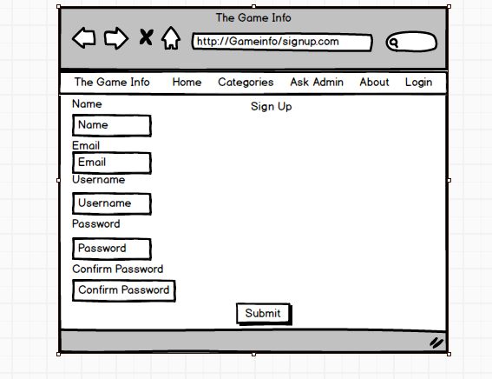

Figure 7: SIGN UP

It is the page to create new user and it has only access with the admin for which the user has to contact the admin in the “ASK ADMIN ” sector. User has to give some details to create their own account in the website.

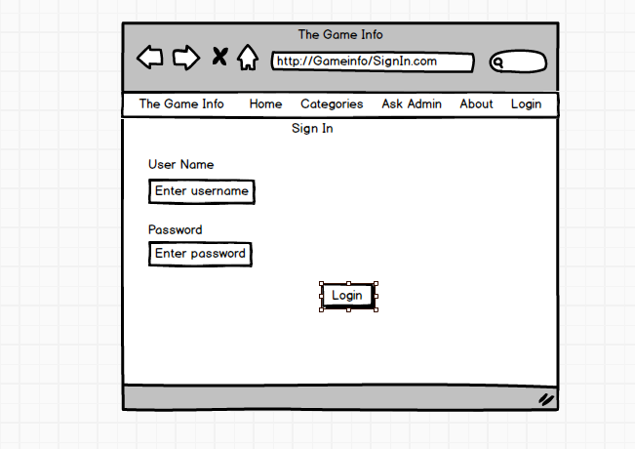

Figure 8:SIGN IN

It is where the user has to give their username and password which the user can create their account in the “Sign UP” sector. With that all they can access to create a post, delete their post which they cant delete or edit others user post and games.