# Chapter 4 Implementation

## Introduction

It is the fun part of every developer and user because it where all the coding and commands are written in software to create a website or application. Coding is the process to communicate with the system.

## Programming language

There are different kinds of programming language to create a website like Lara bell, php, JAVA, python etc. and I have selected PHP because it the most used programming language to create a web-based application software cause of:

1. Security
2. It is easy to use and to interact with the system.
3. Pages and model can be easily be readable.

For the software to work I have selected XAMPP control panel where I can access my PHP code and deliver in webpage without it I couldn’t have completed my project. The reason I have chosen this software:

* It is a very popular use control panel.
* It is stable with new projects and easy to use.
* The user interaction is smooth.

## Coding and user Interface

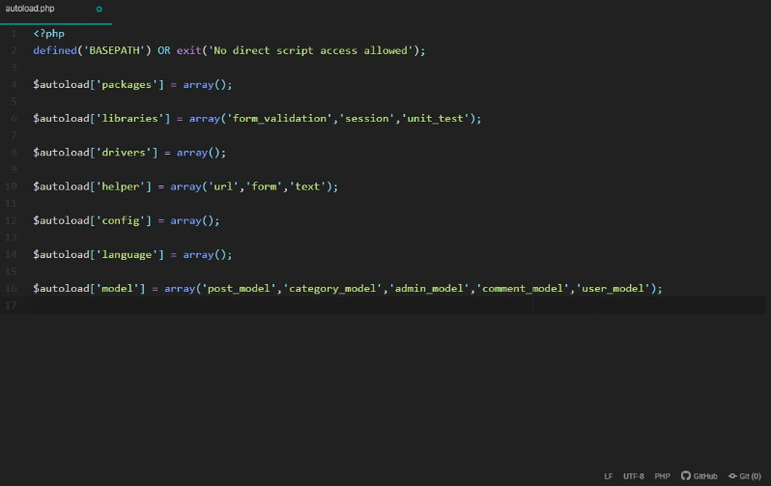

Figure 10:autoload.php

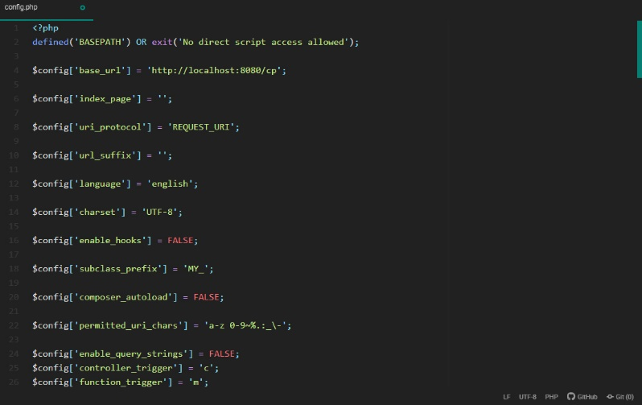

Figure 11:config.php

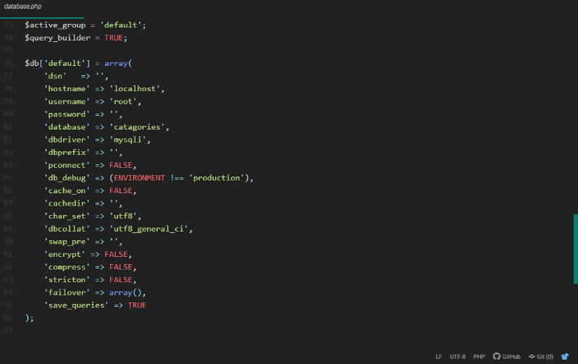

Figure 12:database.php

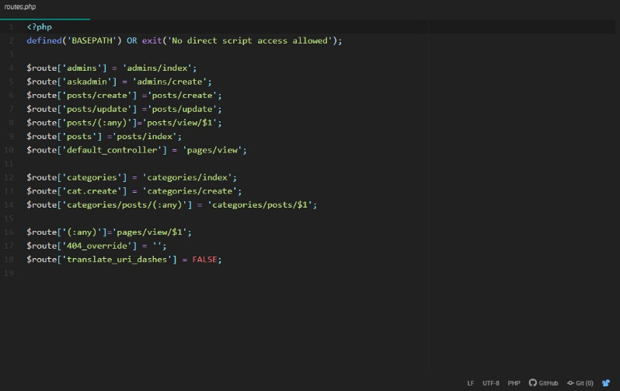

Figure 13:routes.php

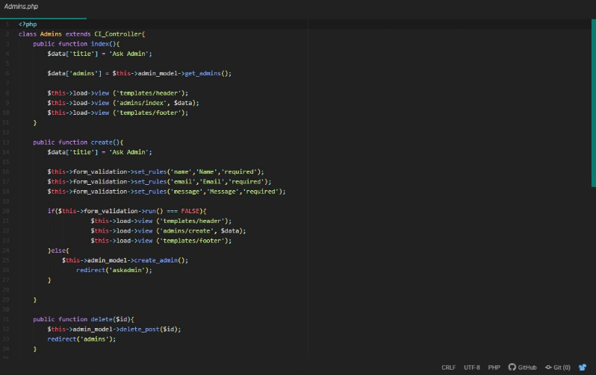

Figure 14:admins.php

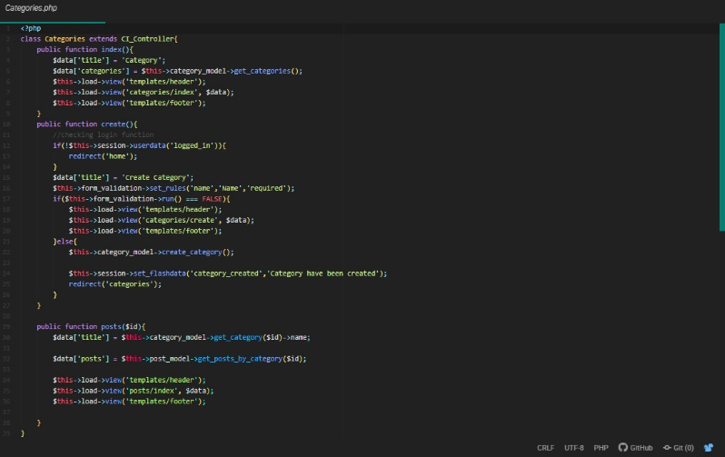

Figure 15:categories.php

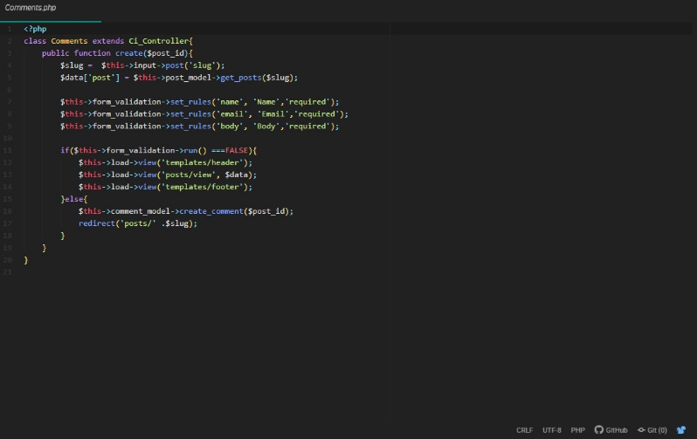

Figure 16:comments.php

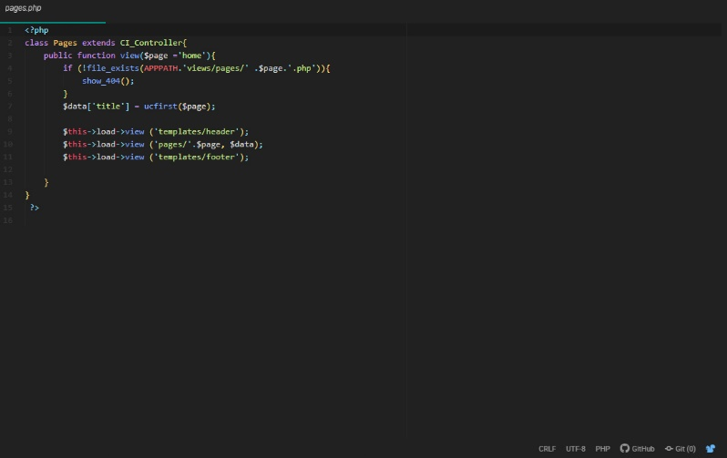

Figure 17:pages.php

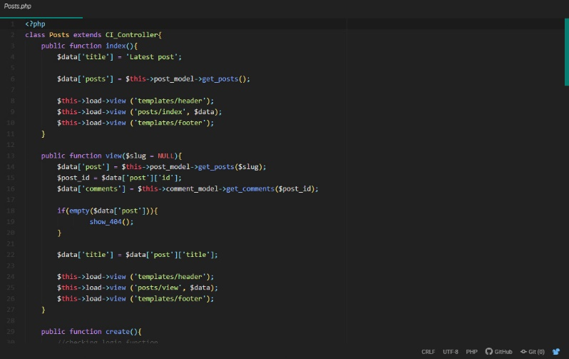

Figure 18:posts.php

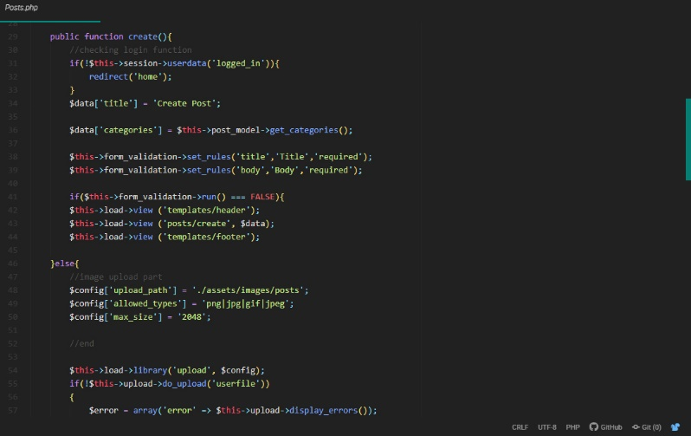

Figure 19:posts.php

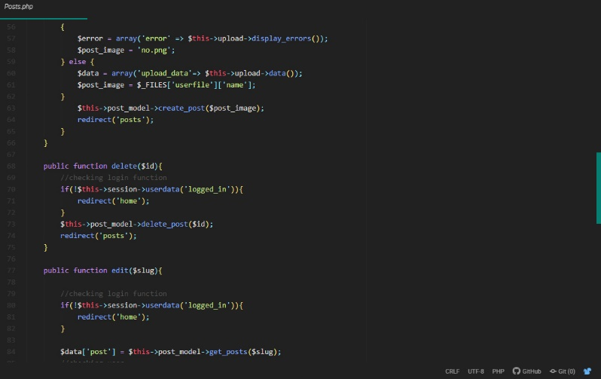

Figure 20:posts.php

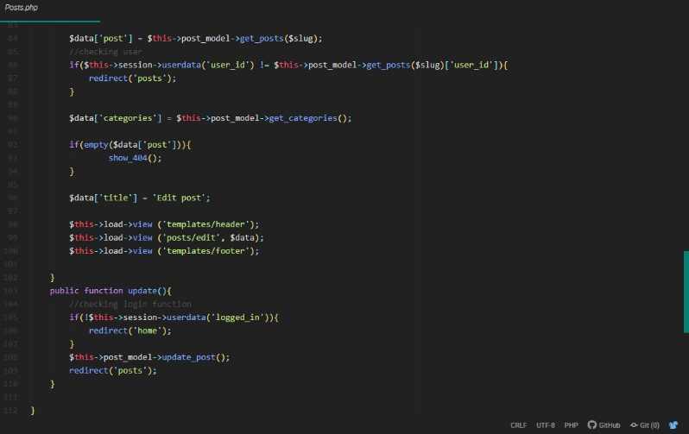

Figure 21:posts.php

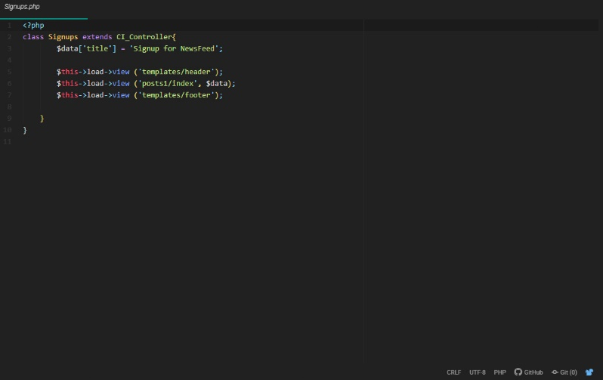

Figure 22:signups.php

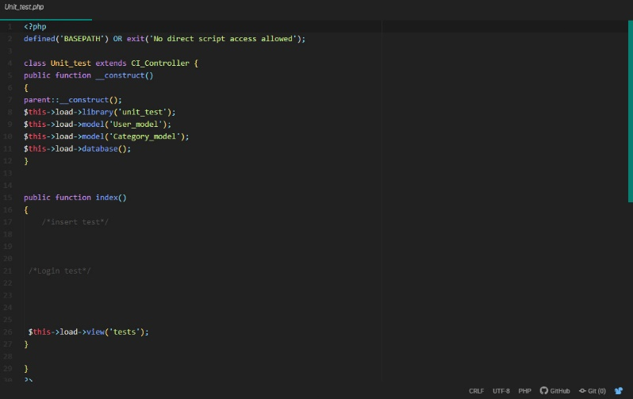

Figure 23:unittest.php

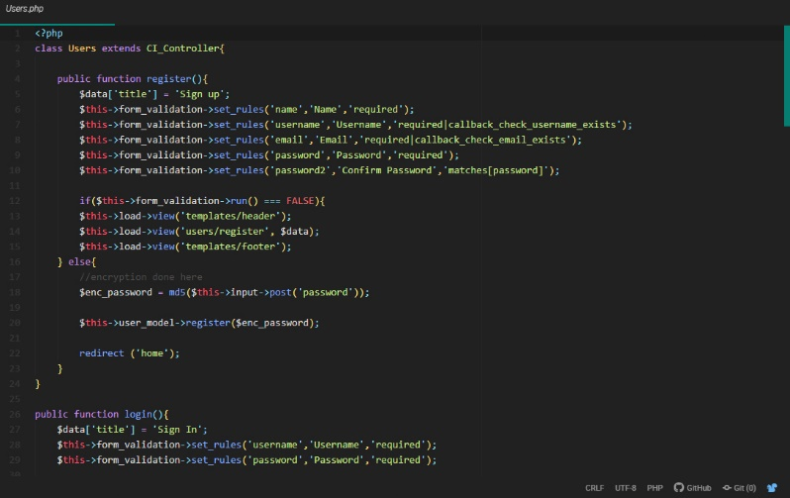

Figure 24:users.php

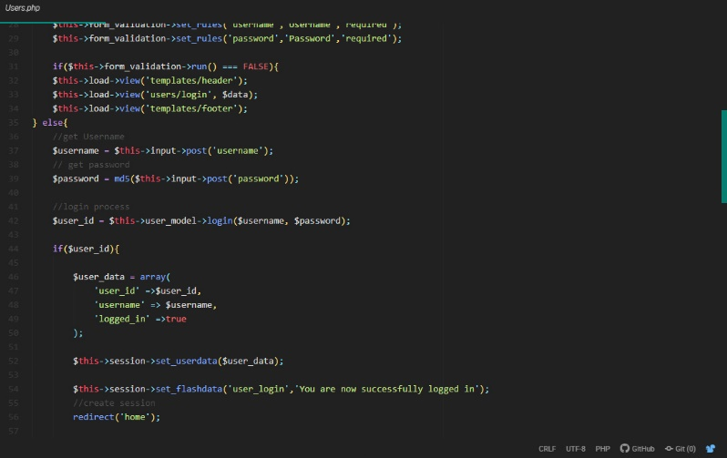

Figure 25:users.php

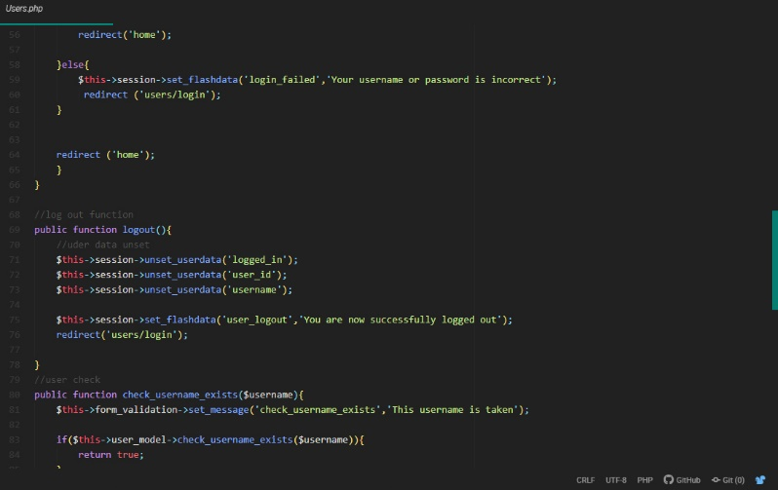

Figure 26:users.php

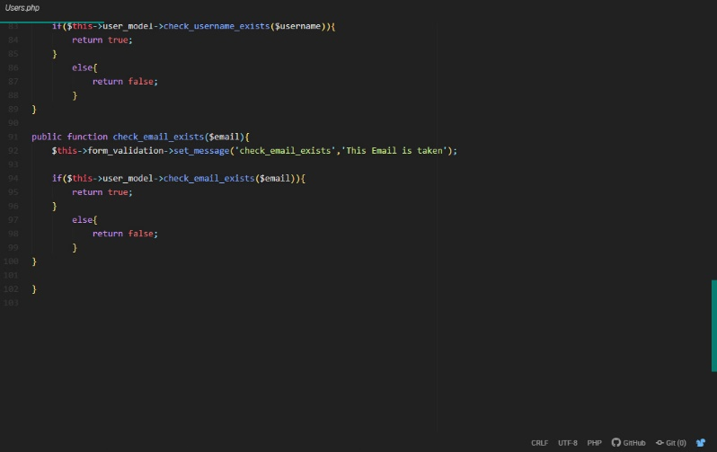

Figure 27:users.php

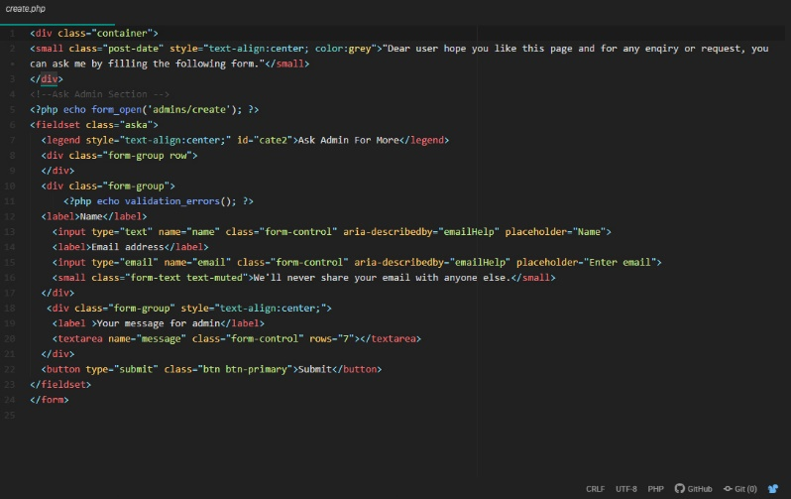

Figure 28:create.php

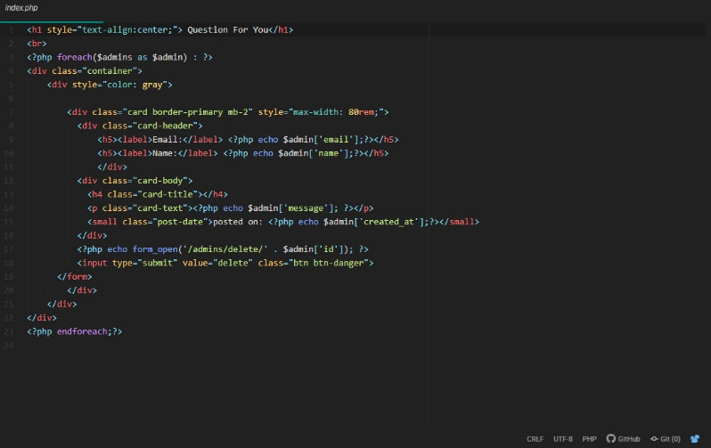

Figure 29:index.php

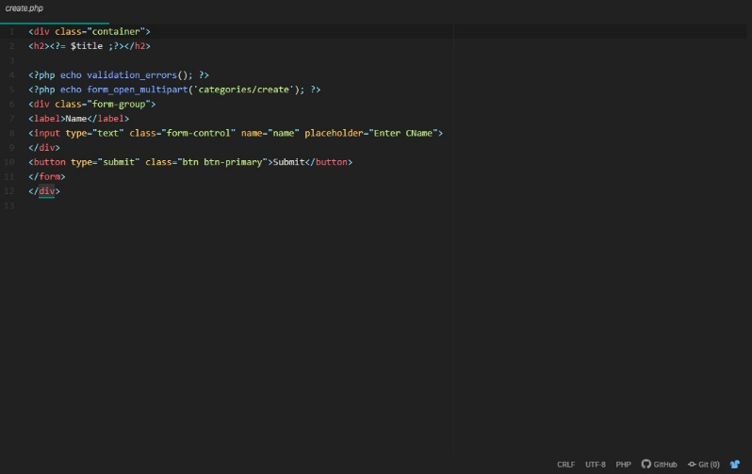

Figure 30:create.php

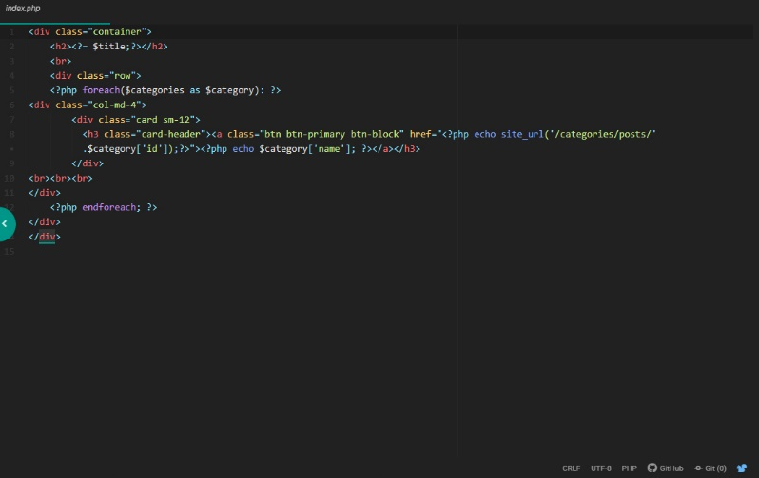

Figure 31:index.php

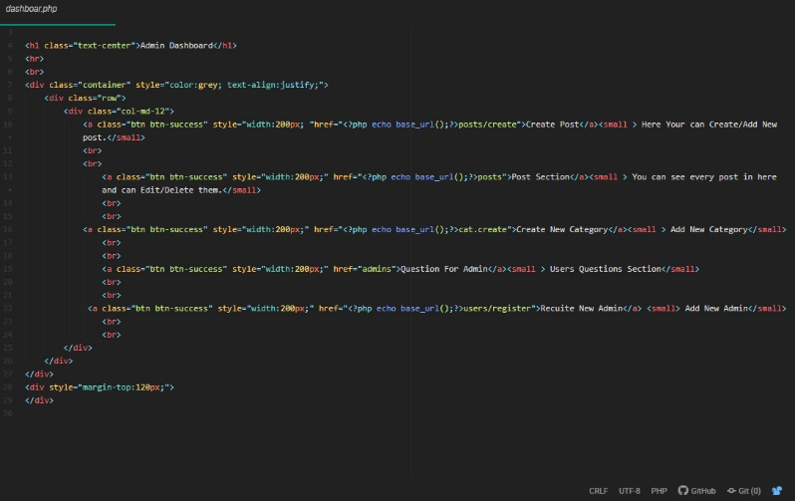

Figure 32:dashboard.php

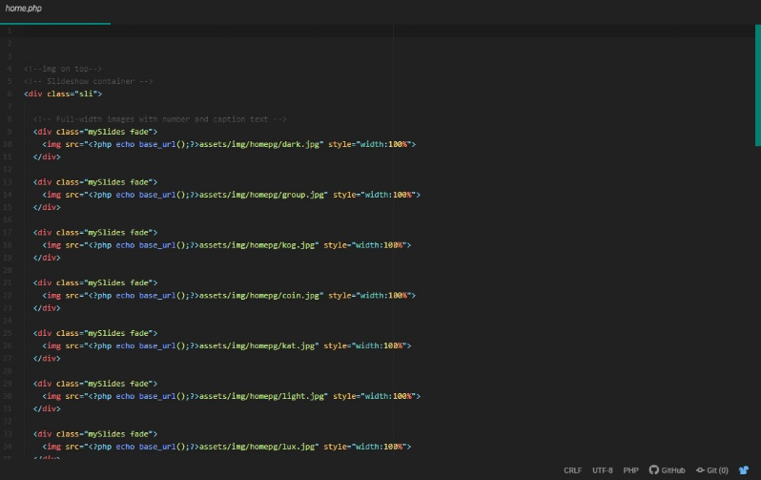

Figure 33:home.php

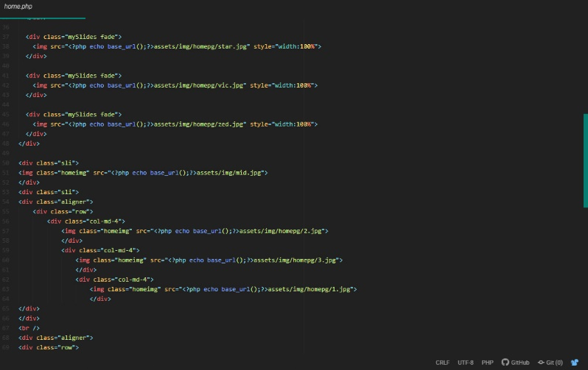

Figure 34:home.php

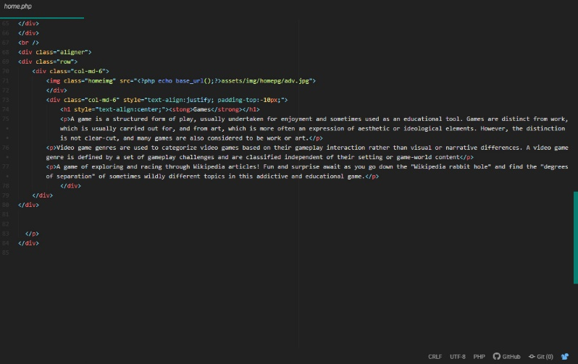

Figure 35:home.php

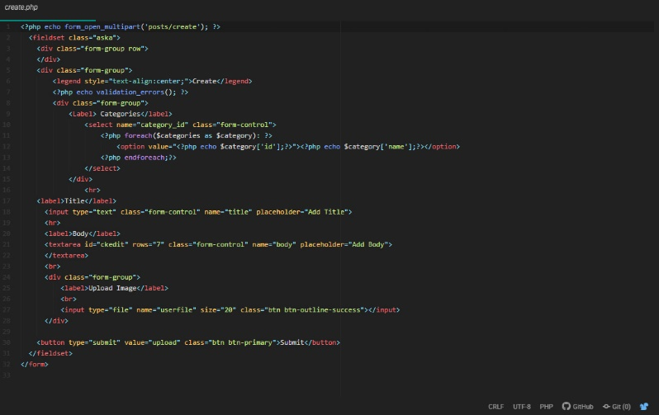

Figure 36:create.php

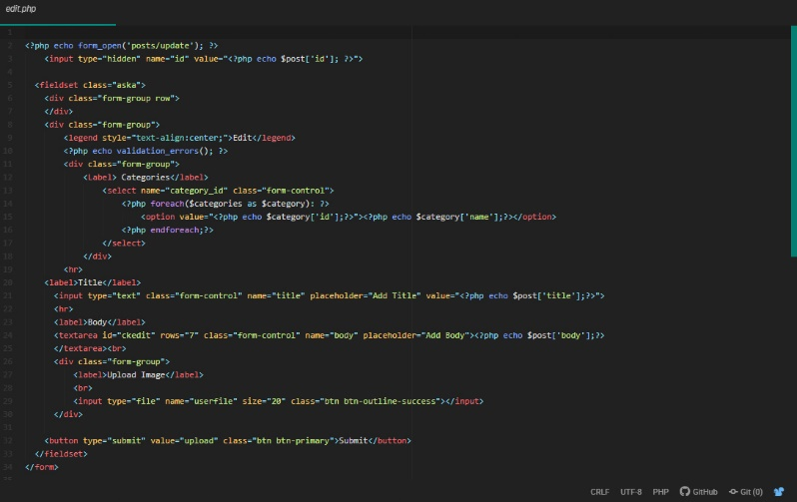

Figure 37:edit.php

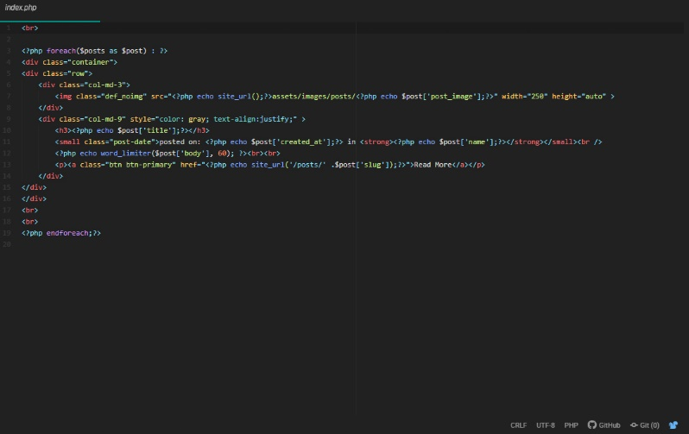

Figure 38:index.php

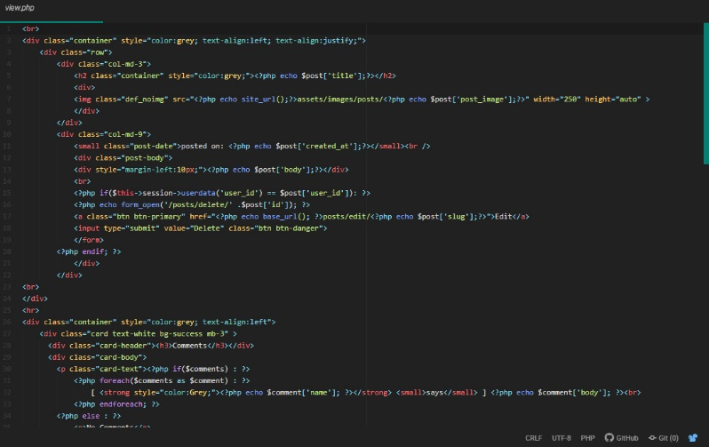

Figure 39:view.php

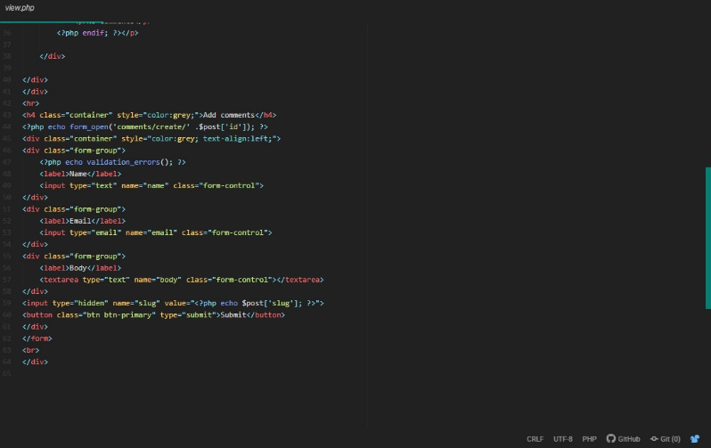

Figure 40:view.php

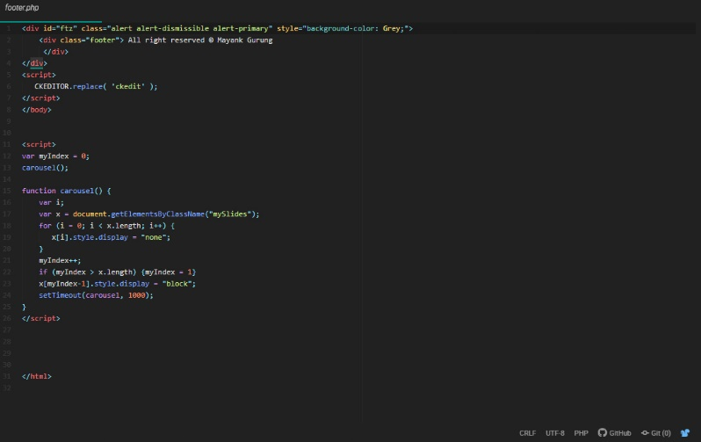

Figure 41:footer.php

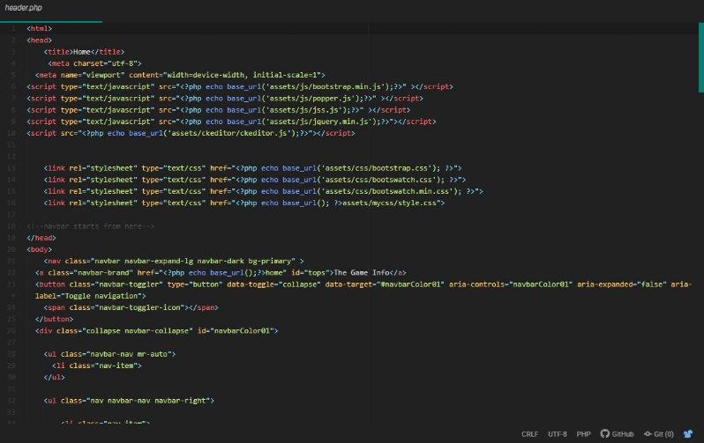

Figure 42:header.php

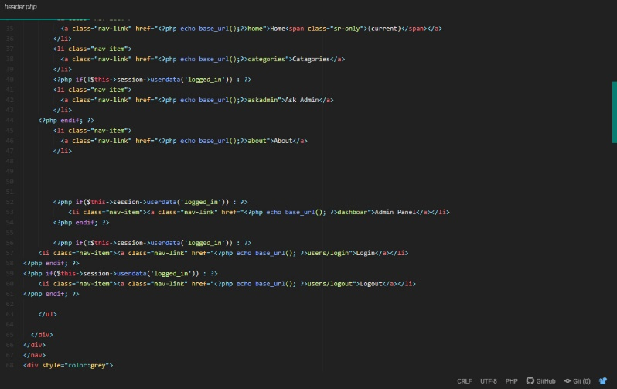

Figure 43:header.php

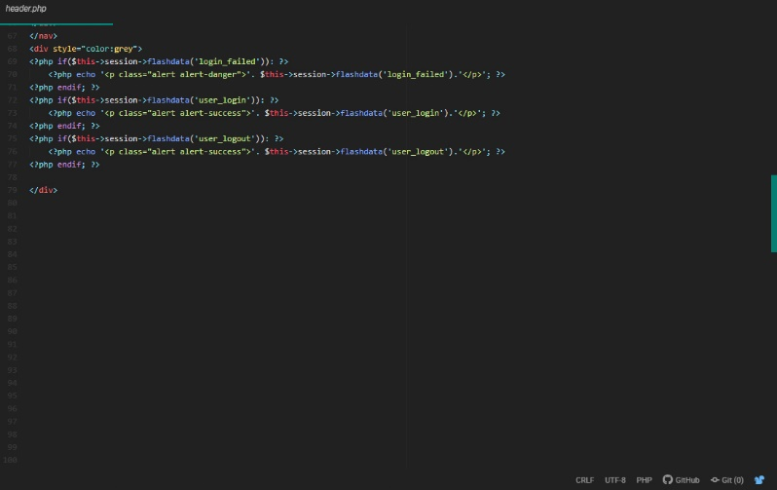

Figure 44:header.php

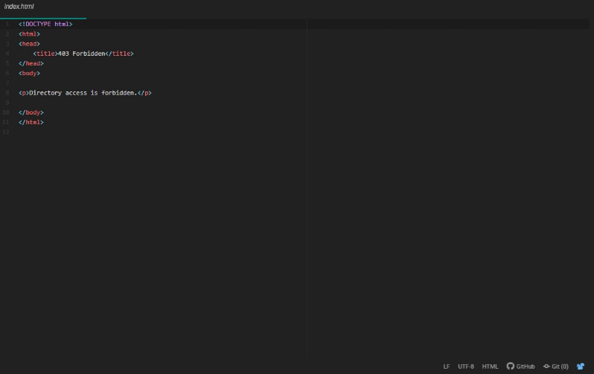

Figure 45:index.html

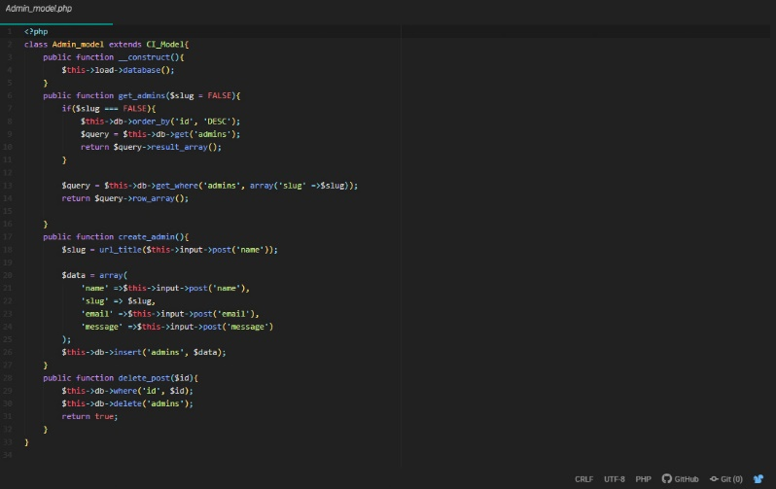

Figure 46:admin_model.php

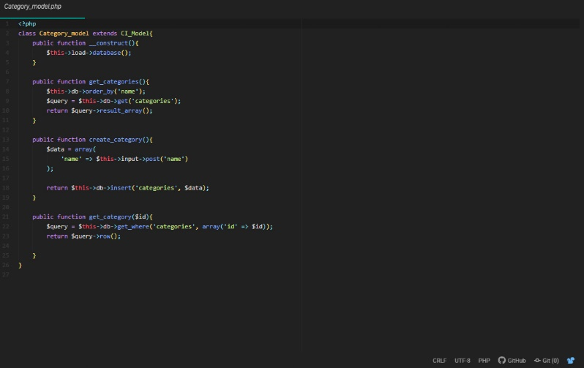

Figure 47:category_model.php

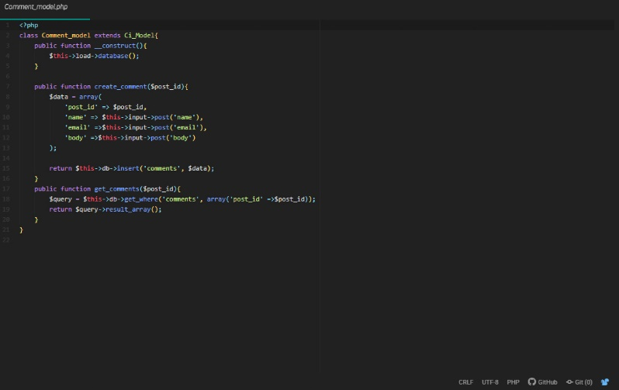

Figure 48:comment_model.php

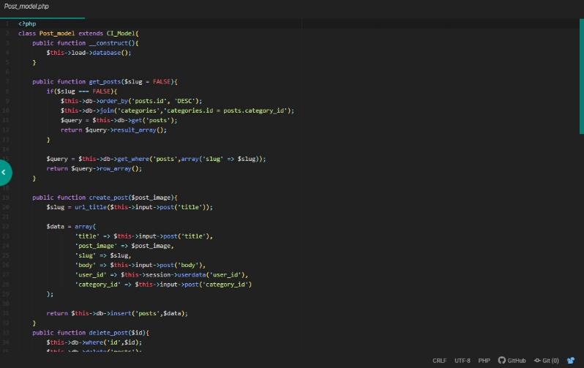

Figure 49:post_model.php

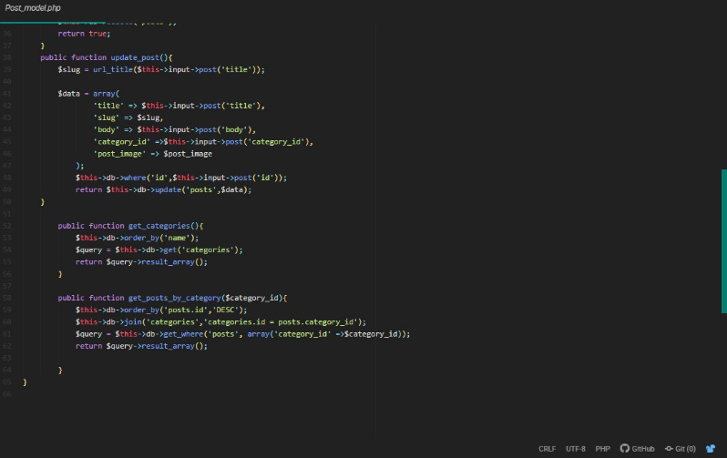

Figure 50:post_model.php

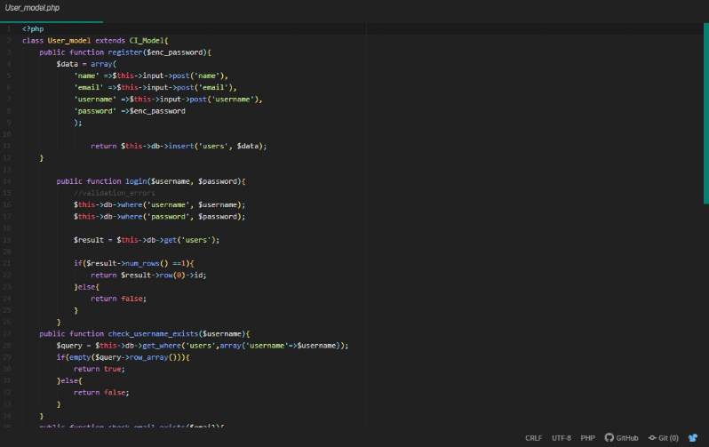

Figure 51:user_model.php

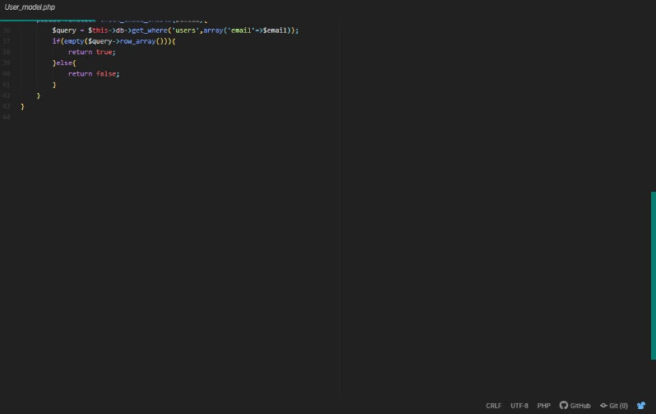

Figure 52:user_model.php