Syafik Barda
Frontend Developer

Semarang, Indonesia · +62 838-6919-3470 · syafikbarda60@gmail.com
portofolio-web-five-hazel.vercel.app · github.com/syafikbarda60
I build interfaces that hold up in production: motion-heavy marketing sites, real-time dashboards, and cross-platform mobile apps. Most of my work is React and Next.js with TypeScript, and I am comfortable going down into the API and the database when the interface needs something the backend does not expose yet. The nine projects here are ordered by how much of the work was interface work. Every screenshot is a capture of the running system.
Selected work
01 Drift Web-Based Animation Template Platform 2026 — Present
02 HIMASKOM Official Web Portal Student Association Digital Hub 2026
03 PT WHS Maritime Corporate Portal & CMS · Client work 2025
04 CREATION 2026 Exam Online Examination Platform with Proctoring 2026
05 SITIGA RFID-Based Child Growth Monitoring 2026
06 ExpenseTracker Personal Finance Mobile App 2025
07 Gropyok Thermal Pest Detection Dashboard 2026
08 Swadaya Panen IoT Rice Field Monitoring 2025
09 NPK Precision Soil Analyzer Soil Nutrient Telemetry 2025

01 Drift 2026 — Present
Web-Based Animation Template Platform

A motion-template editor for people with no motion-design background. Pick a Lottie preset, drop in your own text and logo, arrange the scene on a canvas, and export a short showcase video — no keyframing anywhere in the flow.
Frontend work
- Built the canvas editor over Lottie: scenes composed visually, layers arranged directly, and the result rendered out to video, so the export is the product rather than a snippet.
- Designed the preset browser and the marketing site around GSAP motion, with the animation itself as the sales argument.
- Wired the whole stack on the Next.js App Router — the API lives as Route Handlers in the same codebase, including registration, email OTP, and JWT sessions.
Stack Next.js · React · Tailwind CSS · GSAP · Lottie · PostgreSQL

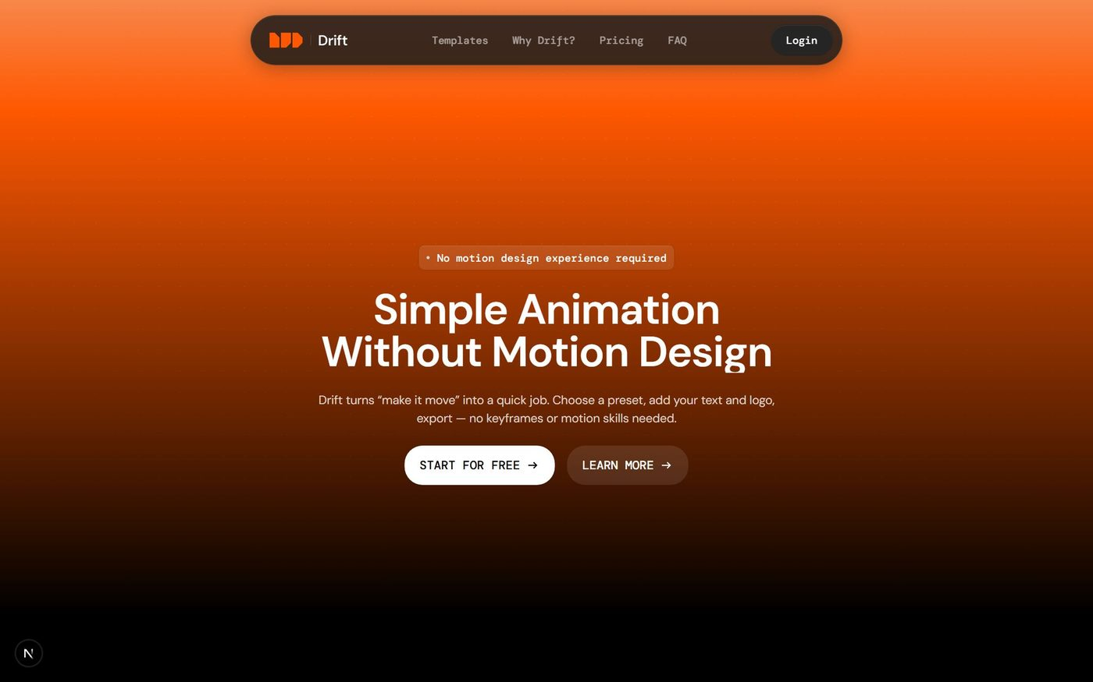
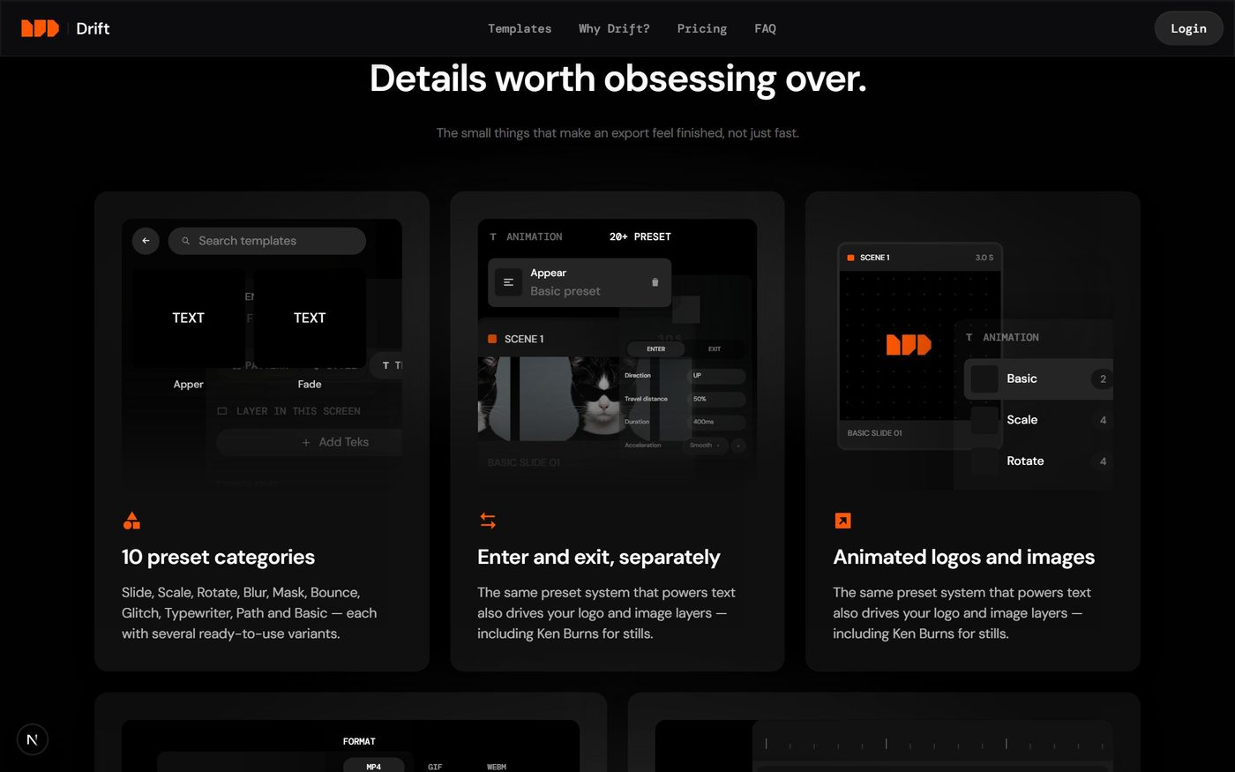

02 HIMASKOM Official Web Portal 2026
Student Association Digital Hub

The official site for the Computer Engineering Student Association at Diponegoro University, presenting the cabinet, division structure, work programmes, articles, and merchandise store to current and prospective members.
Frontend work
- Layered GSAP and Lenis across the whole site so the scrolling and section transitions carry the organisation's identity instead of sitting on a stock template.
- Modelled the hierarchy, division catalogue, article index, and store as one typed data module, so internal staff keep the site current without touching layout code.
Stack Next.js · React · TypeScript · CSS Modules · GSAP · Lenis
Code github.com/syafikbarda60/Company-Profile-of-Himaskom
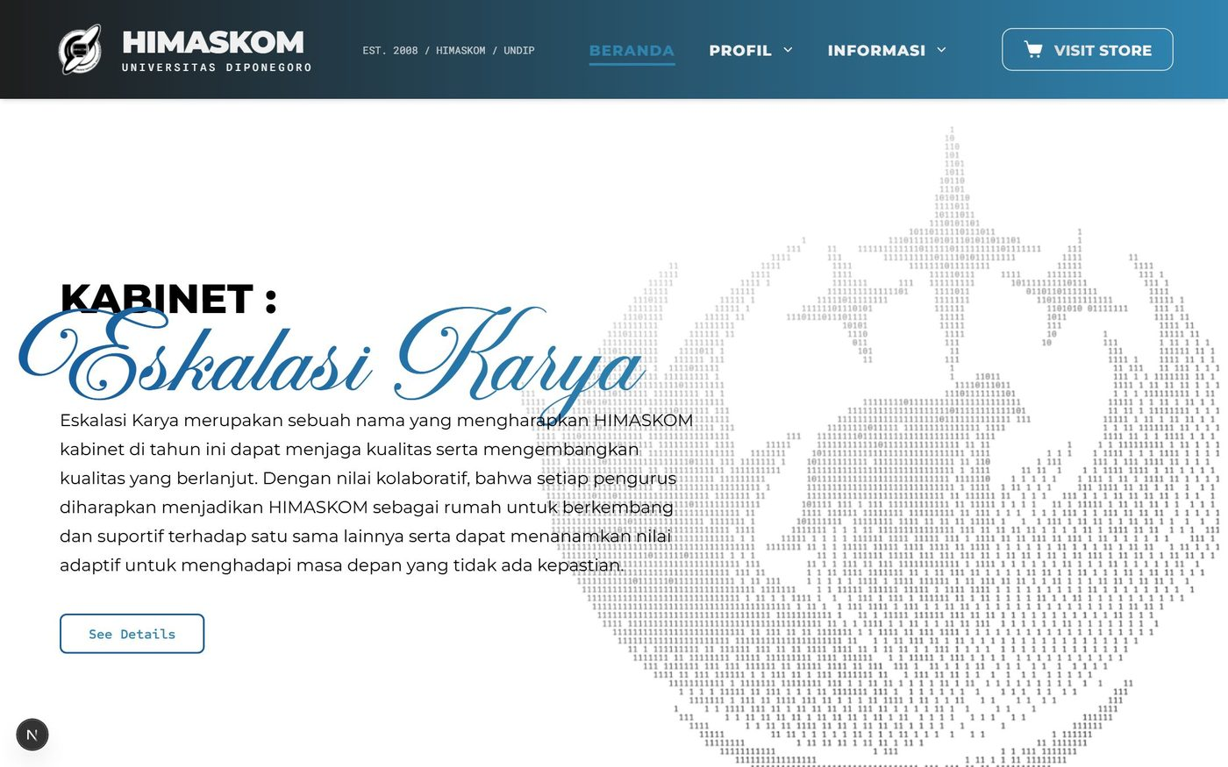
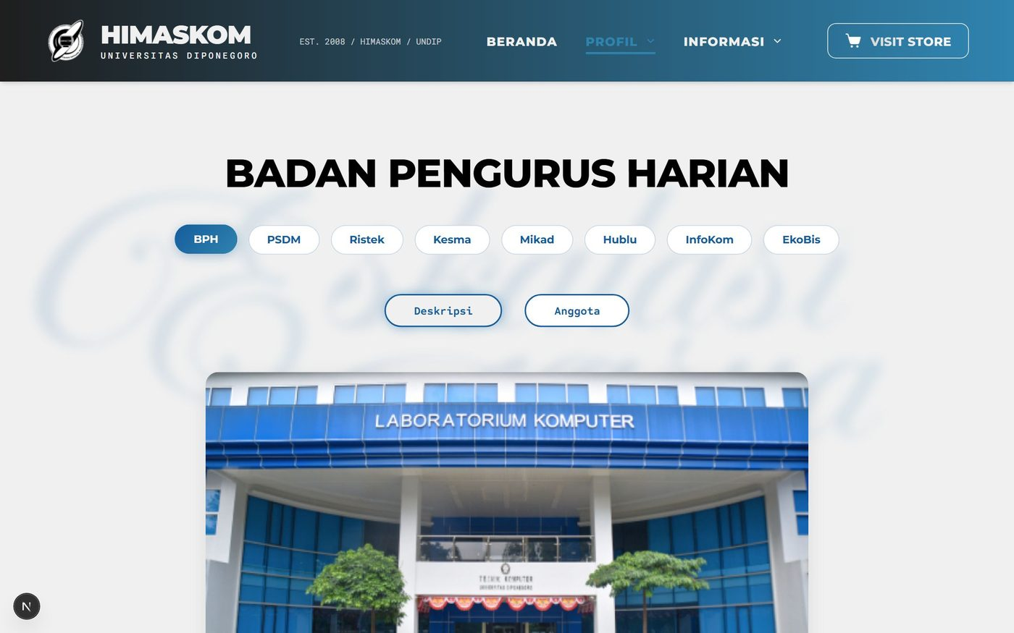

03 PT WHS Maritime 2025
Corporate Portal & CMS · Client work

A full digital overhaul for PT WHS Maritime Investments, a maritime investment firm in South Jakarta. Delivered during a three-month engagement as their website developer.
Frontend work
- Rebuilt the public site as responsive, high-performance pages aligned to the firm's brand, working with stakeholders to structure how services reach institutional clients.
- Built a CMS layer so the internal team publishes news, portfolio entries, and company information without a developer in the loop.
Stack Laravel · React · Vite · Material UI · Bootstrap
Code github.com/syafikbarda60/WHS_Maritime-Project
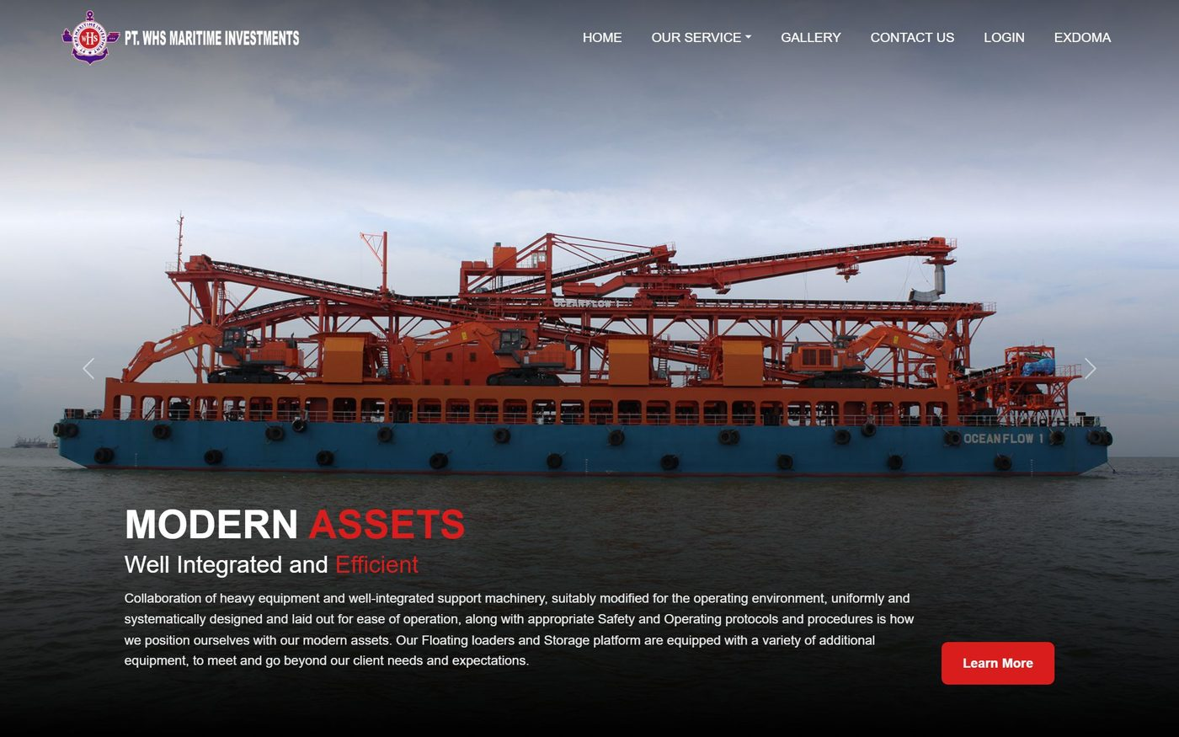
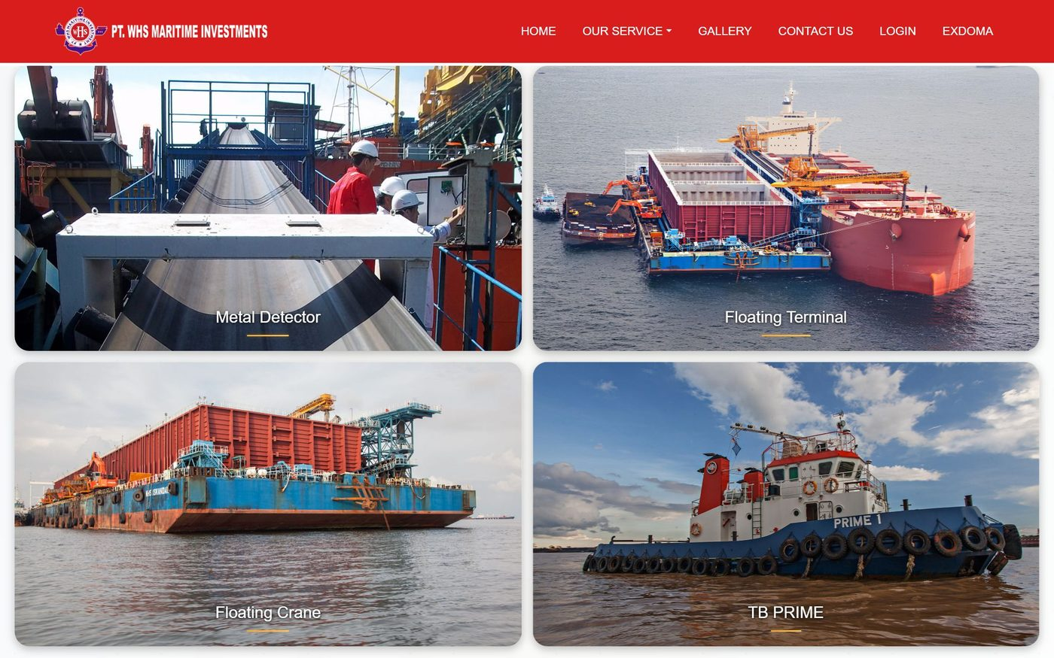

04 CREATION 2026 Exam 2026
Online Examination Platform with Proctoring

A secure examination platform built for the CREATION 2026 event, where proctors watch every participant live and the system flags suspicious behaviour as it happens.
Frontend work
- Built the proctoring view on LiveKit, holding a live webcam feed of each participant for the full duration of the exam.
- Implemented focus-lockdown detection in the browser: every tab and window switch is logged and pushed to the proctor's violations feed over SSE.
- Joined three services — a Laravel portal, an Express API, and the Next.js exam client — behind single sign-on with HMAC-SHA256 signed tokens.
Stack Next.js · Laravel · Express.js · LiveKit · SSE · MySQL

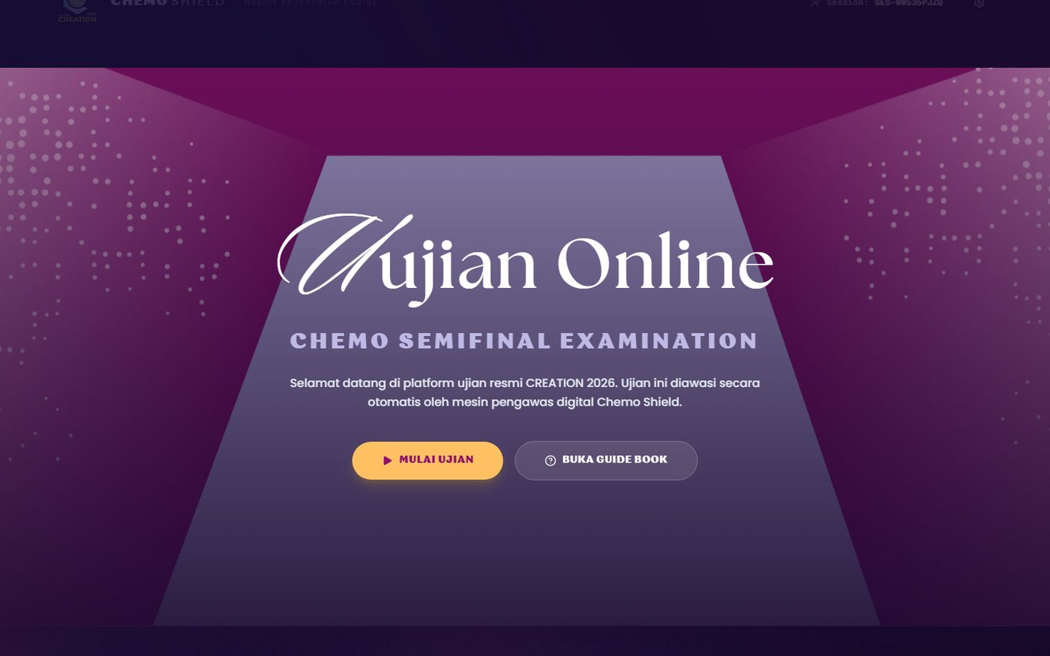
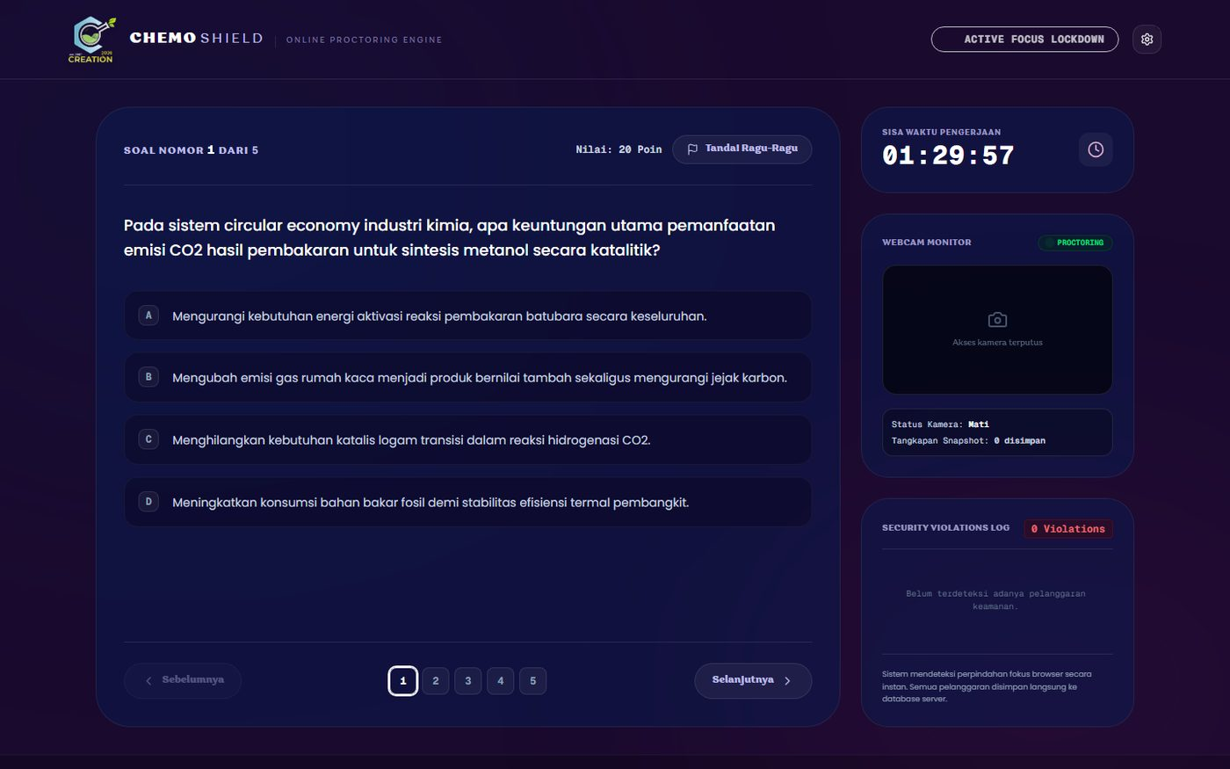

05 SITIGA 2026
RFID-Based Child Growth Monitoring

A growth-monitoring platform for parents and health workers. A child taps an RFID card at the post, the measurement is recorded against WHO growth standards, and the history stays visible only to whoever is permitted to see it.
Frontend work
- Built the charting layer on Recharts, plotting each child's measurements against WHO reference curves so a health worker reads the trend, not a table of numbers.
- Layered role-based views across user, admin, and super-admin, with an approvals queue for new accounts and bulk spreadsheet import for existing records.
Stack Next.js · Express.js · Recharts · Tailwind CSS · MySQL · RFID
Code github.com/syafikbarda60/SITIGA
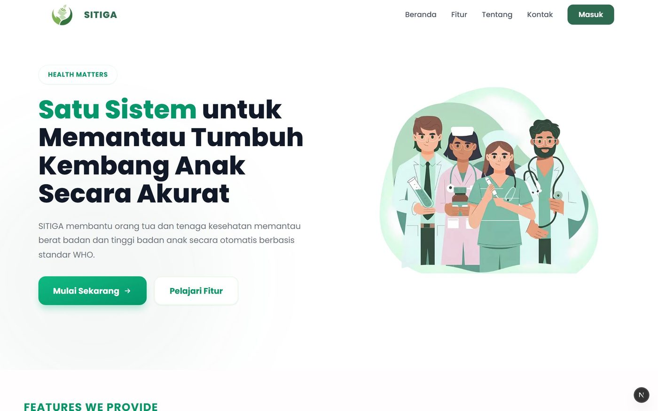
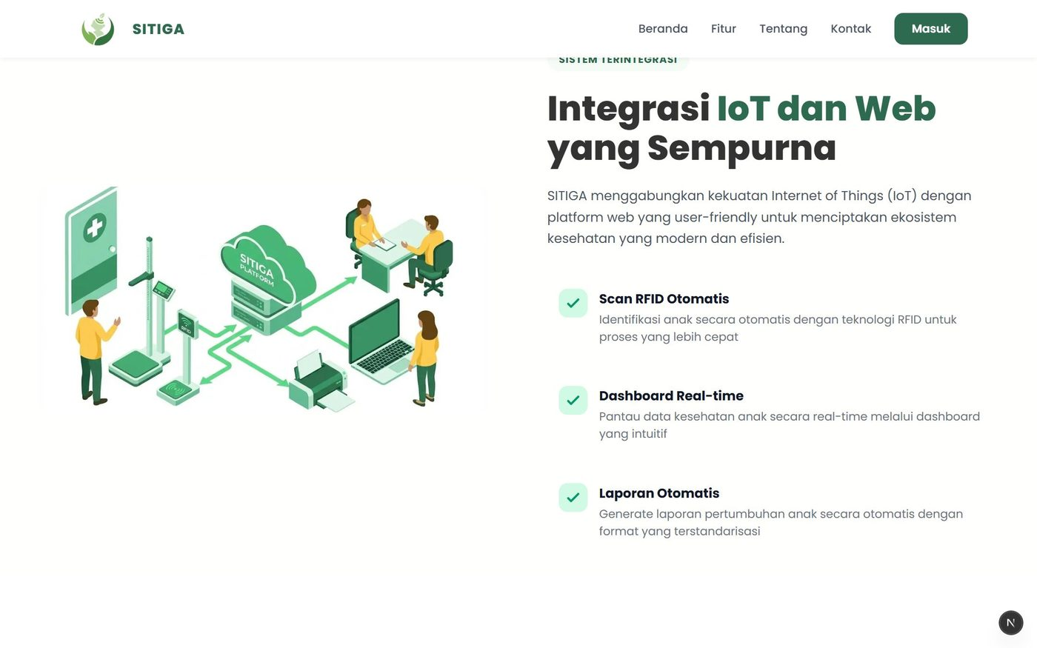

06 ExpenseTracker 2025
Personal Finance Mobile App

A cross-platform mobile app for tracking personal cash flow, built to make daily logging fast enough that people actually keep doing it.
Frontend work
- Built the app on Expo Router and React Native, with transaction logging designed around as few taps as possible.
- Implemented monthly cash-flow and category charts, PDF export and sharing from the device, and on-device caching so the ledger stays readable with no connection.
Stack React Native · Expo · TypeScript · Chart Kit · Supabase · Express.js
Code github.com/syafikbarda60/ExpenseTracker
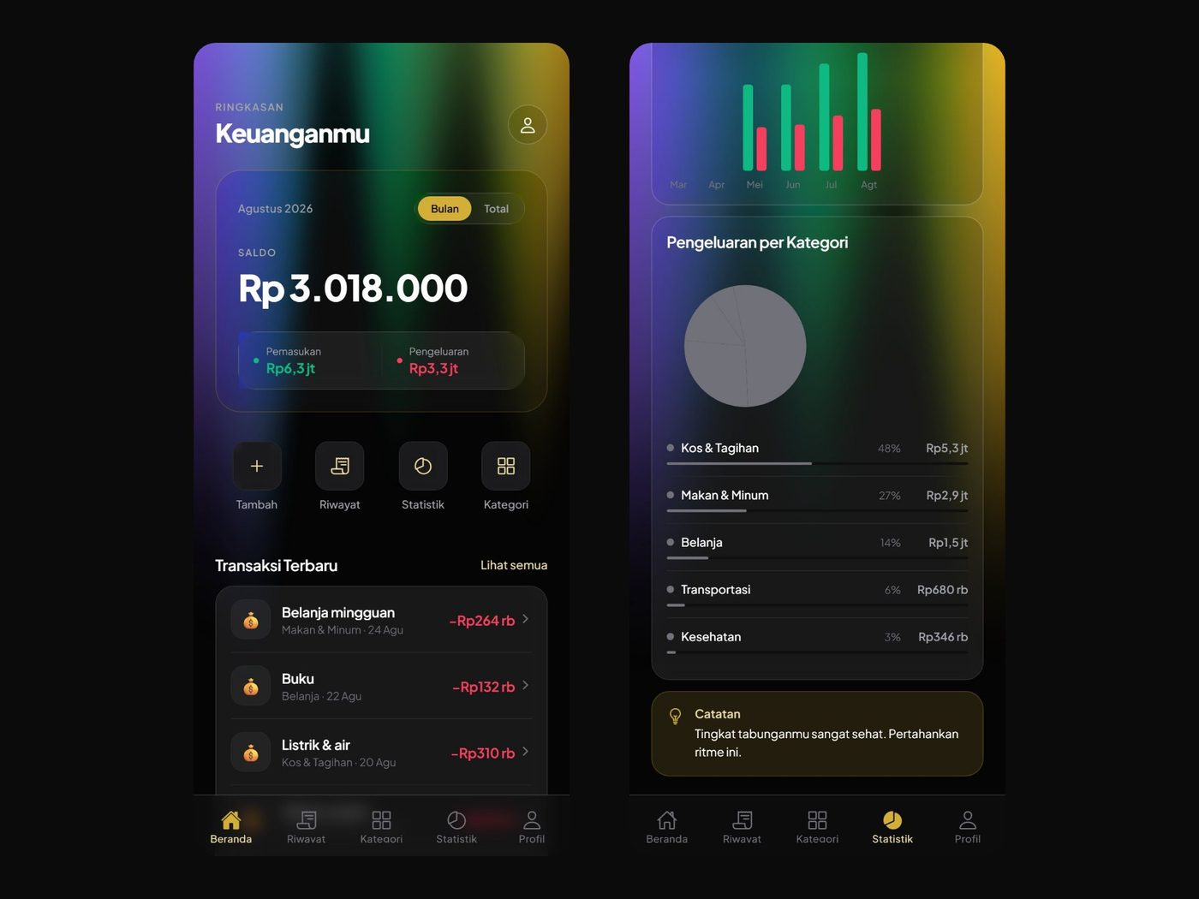
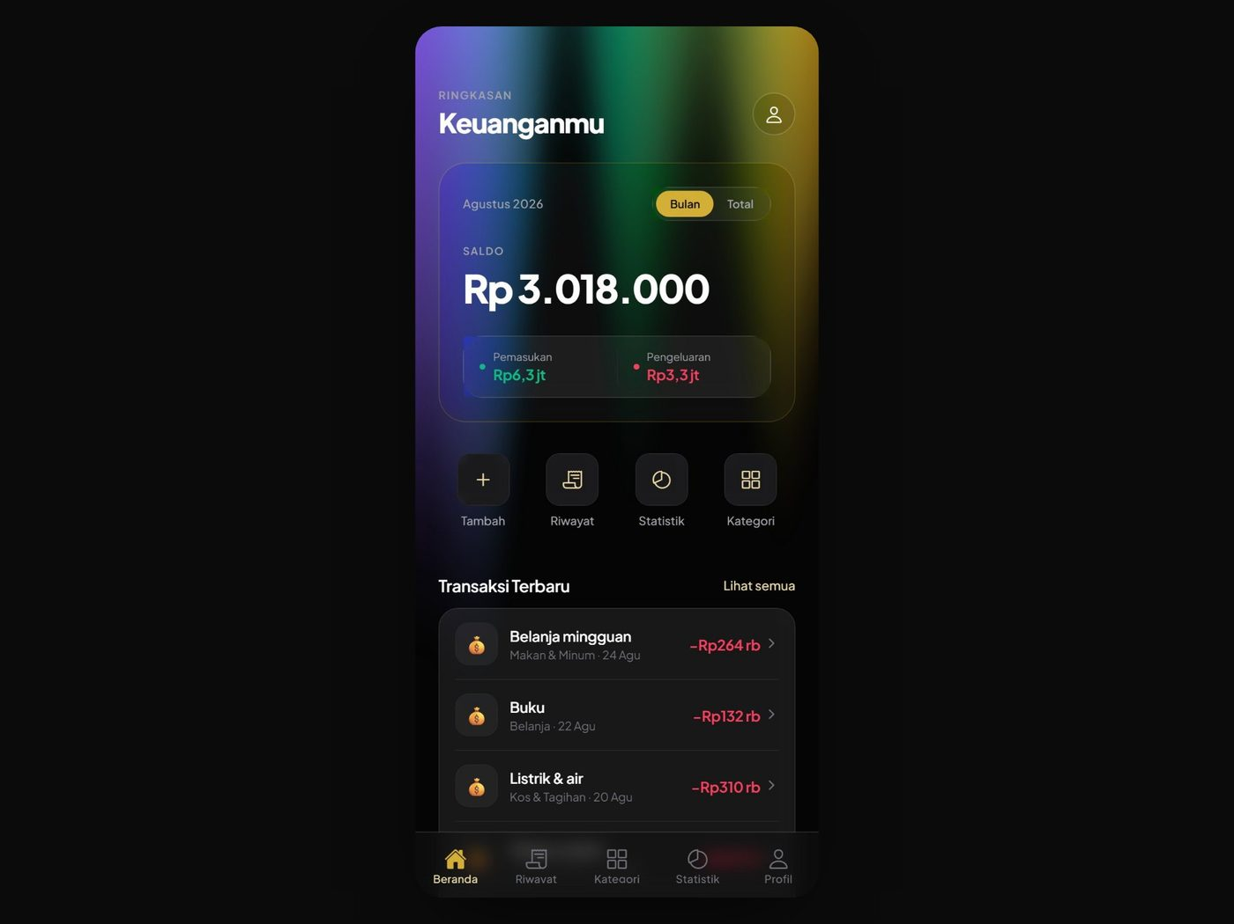

07 Gropyok 2026
Thermal Pest Detection Dashboard

A field system that detects rat activity in rice paddies with thermal imaging and drives ultrasonic repellers against it. The dashboard is where the farm actually reads the system.
Frontend work
- Built the operations dashboard: device health, detection trends over time, hot-spot ranking per plot, and event rules, polled live in the browser.
- Trained the detection model itself — a CNN over MLX90640 thermal captures, separating rat activity from background heat at night.
Stack Next.js · Recharts · PostgreSQL · Python · CNN · ESP32 · Raspberry Pi
Code github.com/syafikbarda60/ArgoShield-Rodent-Detection
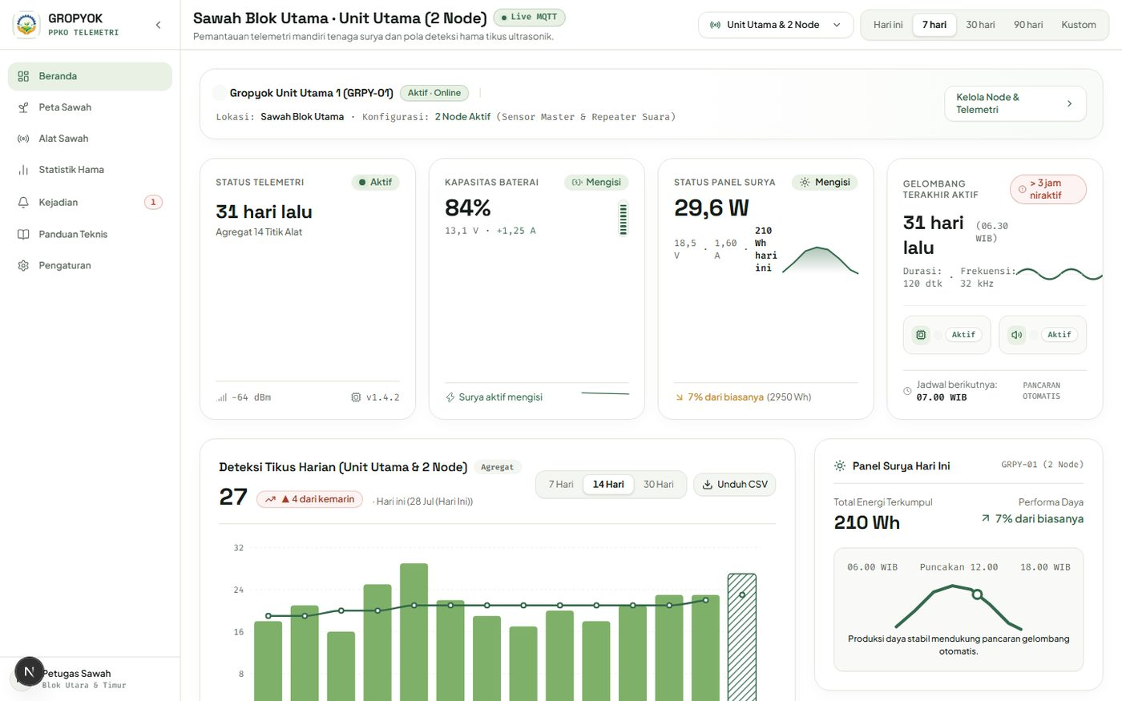
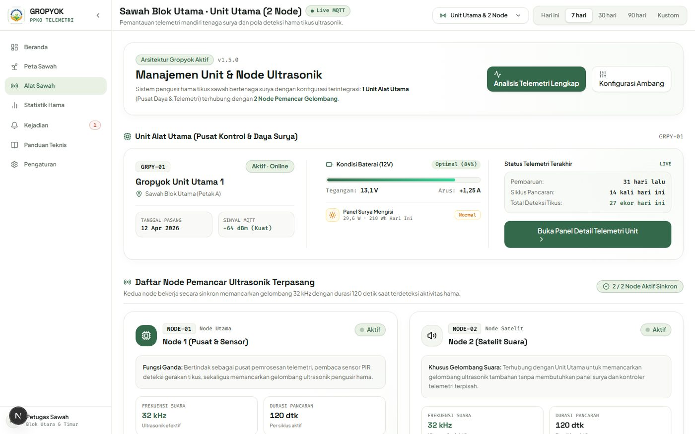

08 Swadaya Panen 2025
IoT Rice Field Monitoring

Precision-farming telemetry: sensor nodes in the field log the microclimate, and the dashboard turns that stream into something a farmer can act on remotely.
Frontend work
- Built the responsive dashboard over soil moisture, air temperature, humidity, and light intensity, with threshold alarms that surface critical conditions immediately.
- Engineered the field nodes behind it, logging every sensor on a single timestamped reading.
Stack React · Vite · Chakra UI · Laravel · MySQL · IoT sensors

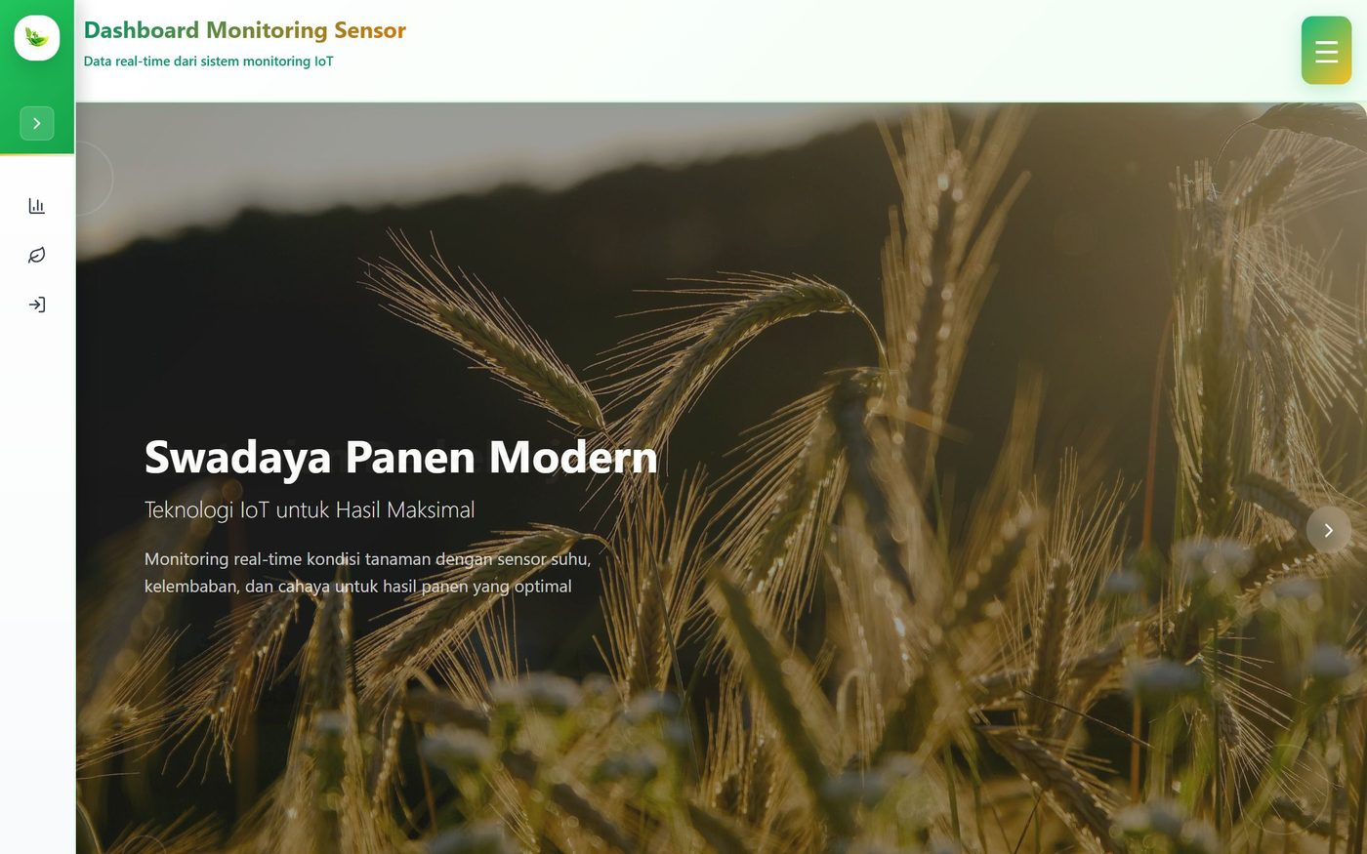
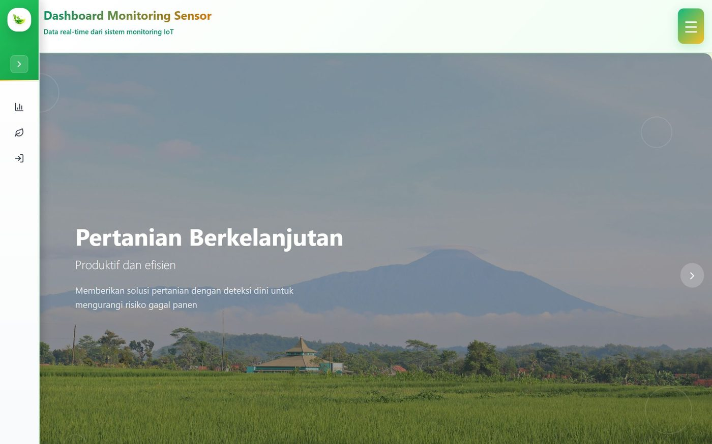

09 NPK Precision Soil Analyzer 2025
Soil Nutrient Telemetry

A solar-powered system that reads soil Nitrogen, Phosphorus, and Potassium continuously and drives automatic nutrient control, so fertiliser is matched to what the soil actually lacks.
Frontend work
- Built the dashboard around hourly N-P-K averages, daily aggregates, and full sensor history, with harvest logging alongside so nutrient levels read against real yield.
- Integrated the industrial NPK probes with microcontroller firmware, running the node off a standalone solar array.
Stack React · Material UI · Laravel · MySQL · C++ / Embedded · Solar

