
About Me
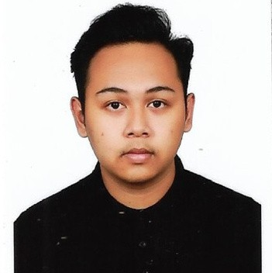
A hardworking and detail-oriented individual with experience in parcel sorting, customer service, and retail assistance.Strong communication and problem-solving abilities developed through experience.
Able to work effectively in fast-paced environments, collaborate with teams, and provide excellent service to customers.with a willingness to learn and adapt to new challenges.
Education

MOHAMAD SYAFIQ BIN IBRAHIM

DIPLOMA IN ENGINEERING ELECTRONICS (COMPUTER)
2023 - 2026
POLITEKNIK SEBERANG PERAI

SIJIL PELAJARAN MALAYSIA (SPM)
2018 - 2023

SMK GUAR PERAHU
Work Experience


Contact

NO.1929 Mukim 21 Guar
 Perahu Kubang Semang 14400
Bukit Mertajam Pulau Pinang  +6017-4184197
 syafiqsyafiq0501@gmail.com


Skills

Proficiency in SQL Basic Computer
Mathematics & Analytical Skills

Shopee Express 2024 - 2025

Parcel Sorter
Sorting & Organizing Parcels: Categorized packages based on destination and delivery route.
Attention to Detail: Checked package labels and tracking details to avoid misdelivery.
Team Collaboration: Worked with couriers and warehouse staff to ensure smooth parcel processing.

RozyKozzy Cafe & Bistro 2023 - 2024

WAITER AND CASHIER
Customer Service: Greeted customers warmly and guided them to their tables.
Teamwork & Efficiency: Maintained a friendly and cooperative attitude with coworkers.
Product Knowledge: Assisted customers with product selections when needed.

Nursery Jendela Rimbunan 2021 - 2023

Sales Assistant / Retail Associate
Problem-Solving: Handled customer complaints and resolved minor issues professionally.
Inventory Control: Checked stock levels, reported low inventory, and assisted in restocking.

Honours & Awards


DIGITAL COMPETENCY SCORE
References
by achieving DIGITAL ADVANCE level

STUDENT COMMITTEE MEMBERS for MALAYSIA POLYTECHNIC BRIGED BOMBA TRAINING AND COMMISSIONING CEREMONY 2023

JULIAH BINTI SULAIMAN
Position: Lecturer
Position: Academic Advisor No. Tel : +60 13-531 7072
Email: Juliah@psp.edu.my

SITI ZAWANA BINTI ABDUL RANI
Position: Lecturer
No. Tel : +60 19-475 4788


Curricular Activities

Joined Briged Bomba in Politeknik Seberang Perai. Position: Platoon Leader (2024 - 2025)
Joined kadet Bomba in SMK Guar Perahu. Position: Vice Chairman (2023 - 2024) Joined School Prefect in SMK Guar Perahu (2018-2024)
Joined Handball in SMK Guar Perahu (2023 2024)

