

TCP2201 Myrmidon Chess Project
Trimester 1, 2018/2019
By Scrum

Team Leader:
Muhammad Syafiq bin Zahri (1161102129), 013-9366193, syafiqzahri321@gmail.com
Team Members:
- Bobby Alistor anak Jotem (1161102258), 011-31870263, bo13by.alistor@gmail.com
- Muhammad Fahmi Bin Abu Bakar (1161102263), 011-27279257, fahmibakar98@gmail.com
- Nur Farisha Shahirah Binti Abdul Rahman (1171302013), 018-6675366, farisha9810@gmail.com

How to Compile the Program

1. Open Command Prompt. If you save the files in “D:” drive, type in d: in the command line then press enter, but if you save the file in “C:” drive, you can proceed to the next step.
2. Type in dir ScrumMyrmidonChess.java /s /p
3. Commad Prompt will display the path of the containing folder.
4. Change the directory to the given path.
5. Compile the Java file:
javac ScrumMyrmidonChess.java
6. Run the Java file:
java ScrumMyrmidonChess

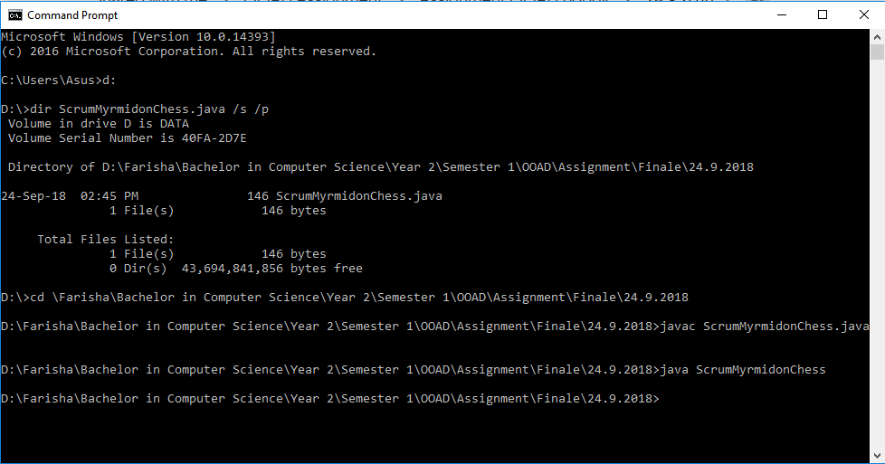
Example on compiling and running the Program

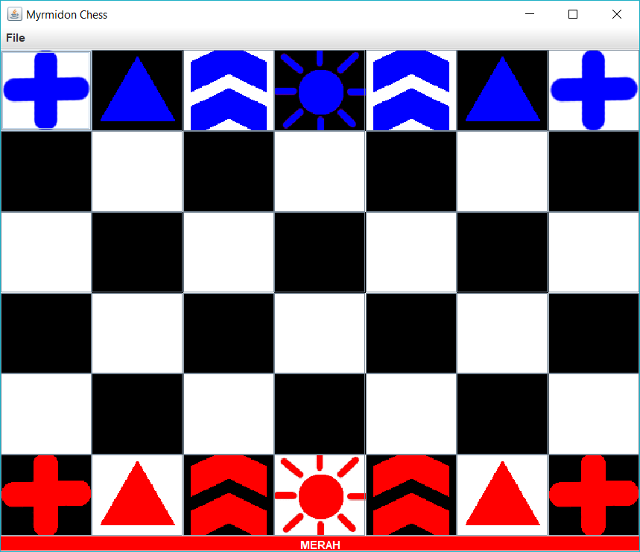
How to Play

The above layout is the initial position of the game pieces.
The Plus can move vertically or horizontally, up to 2 steps in any direction in a straight line.
The Triangle can move diagonally, both up and down, up to 2 steps in any direction in a straight line.
The Chevron must move in an L shape, exactly two steps then 1 step right or left. (This is the only piece that can jump over other pieces.)
The Sun can move only 1 step in any direction. The game ends when the sun is captured by the other side.
Player 1(Red) needs to click on one of the red pieces and click on another button to move the piece. Next, Player 2(Blue) clicks on one of the blue pieces and does the same thing.
After 3 turns of each player, a Plus will turn into a Triangle, a Triangle will turn into a Chevron, and a Chevron will turn into a Plus.
After the games end, a message box will pop up asking players to play a new game or quit the game.
Players can save the current state of the game and load it back at anytime.

UML Class Diagram

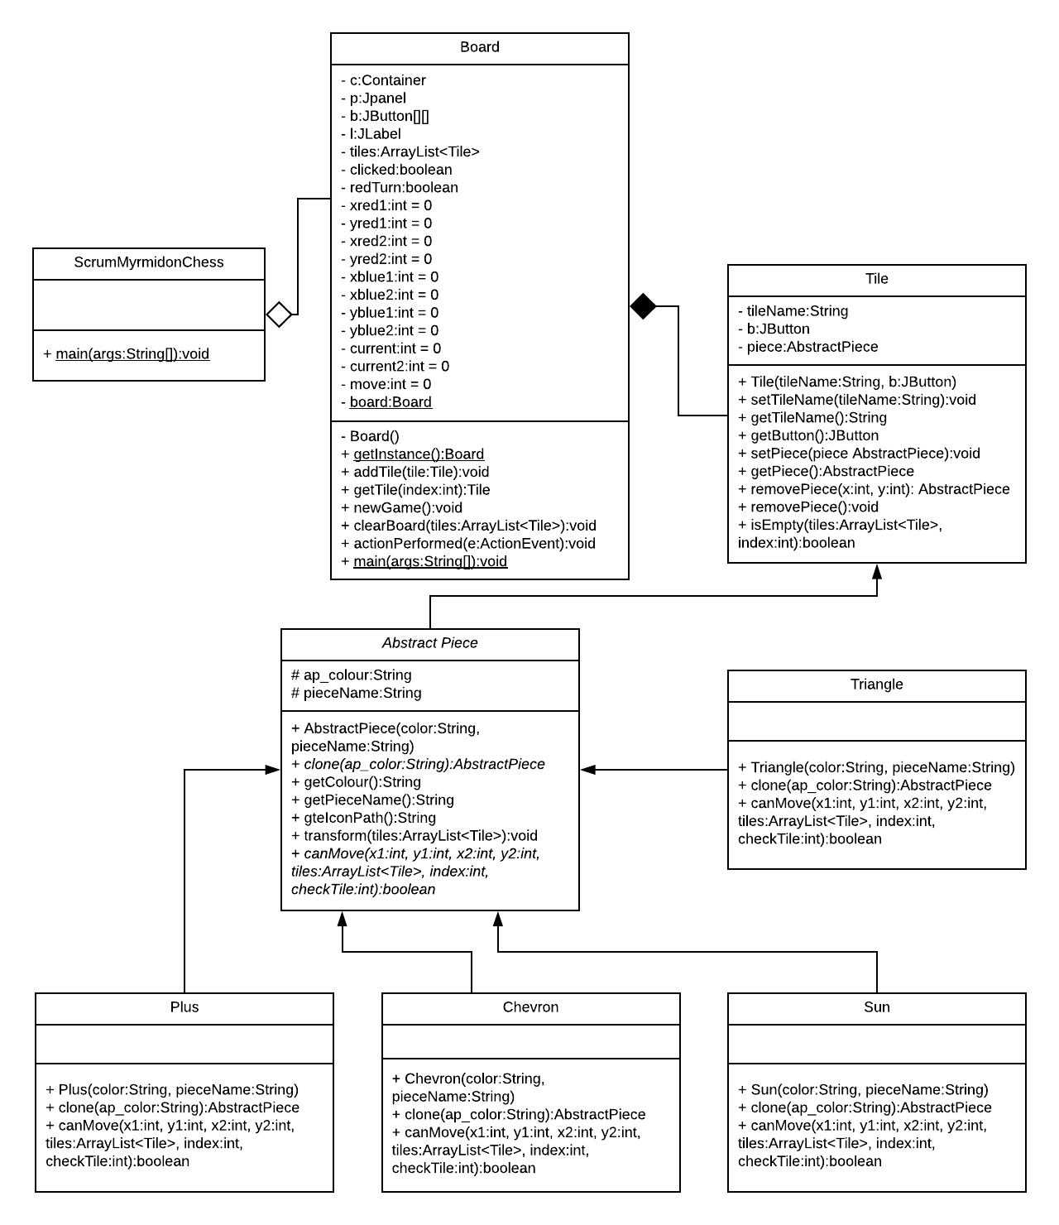

Use Case Diagram

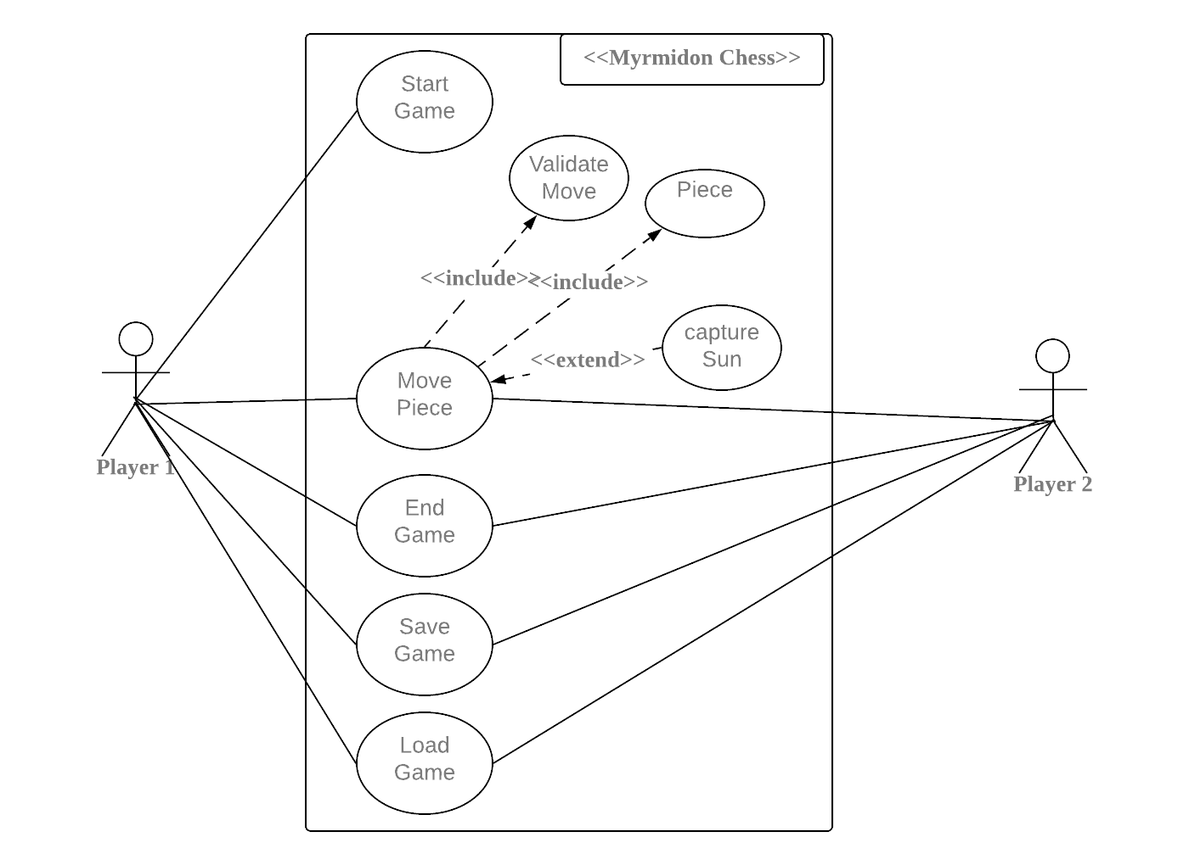

Sequence Diagram

New Game
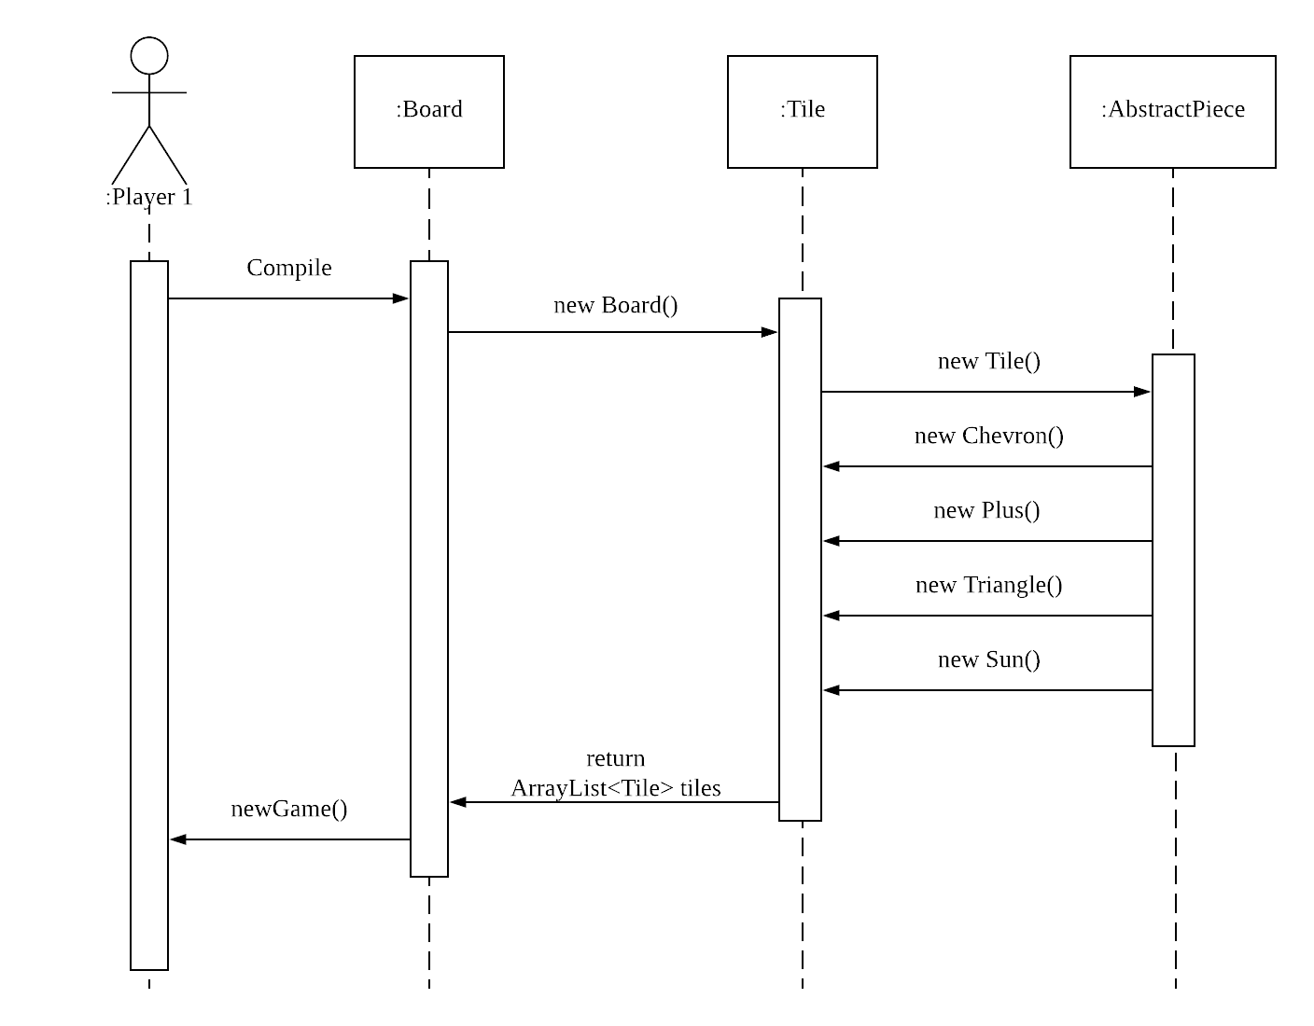

Move Pieces
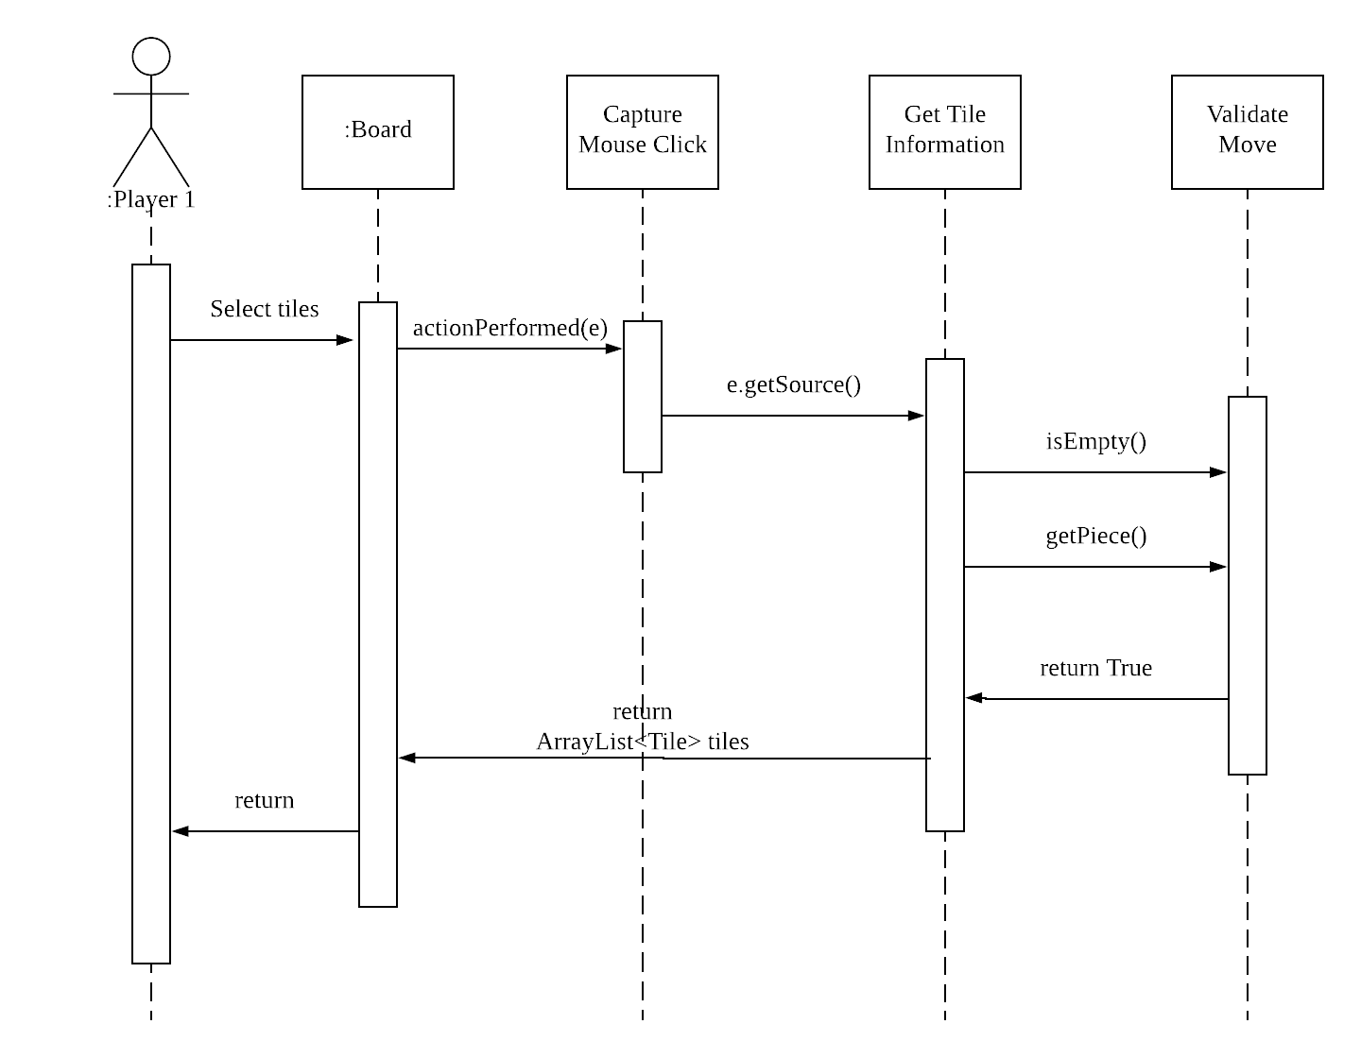

Validate Move
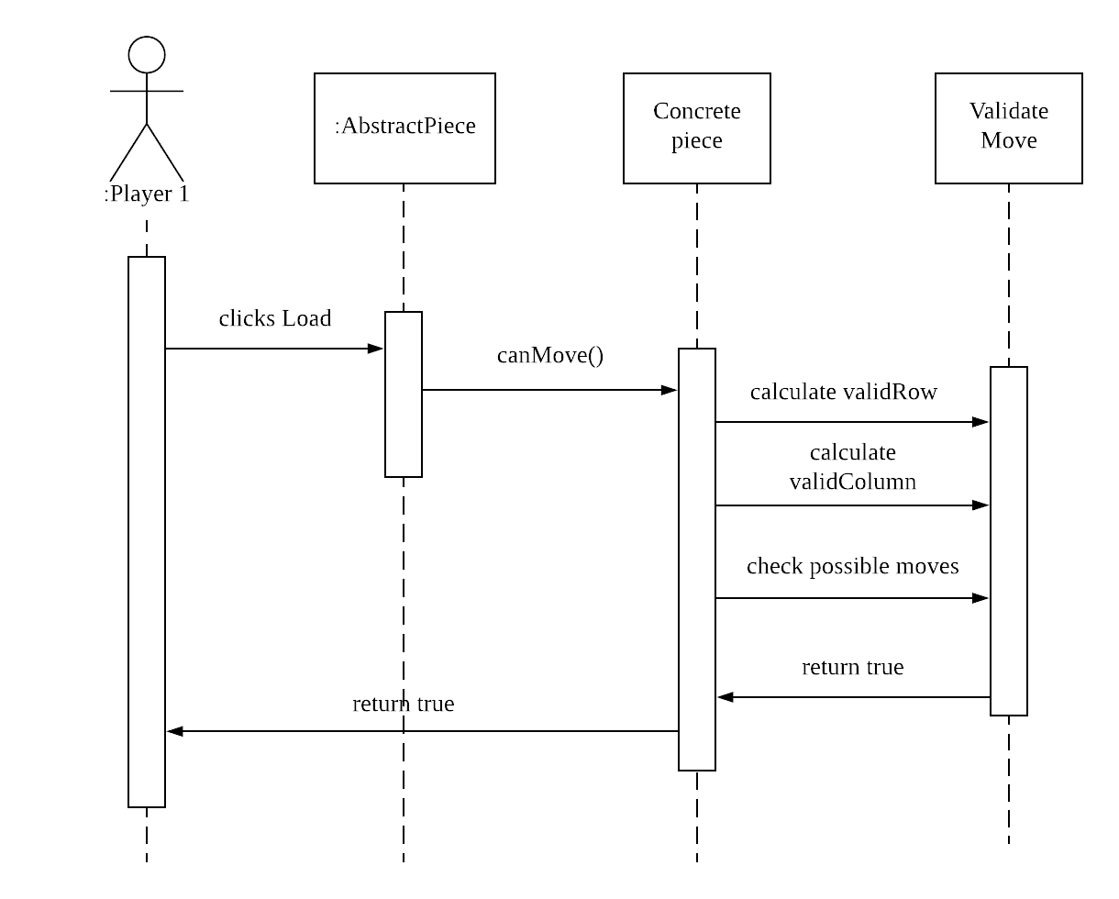
Transform Pieces
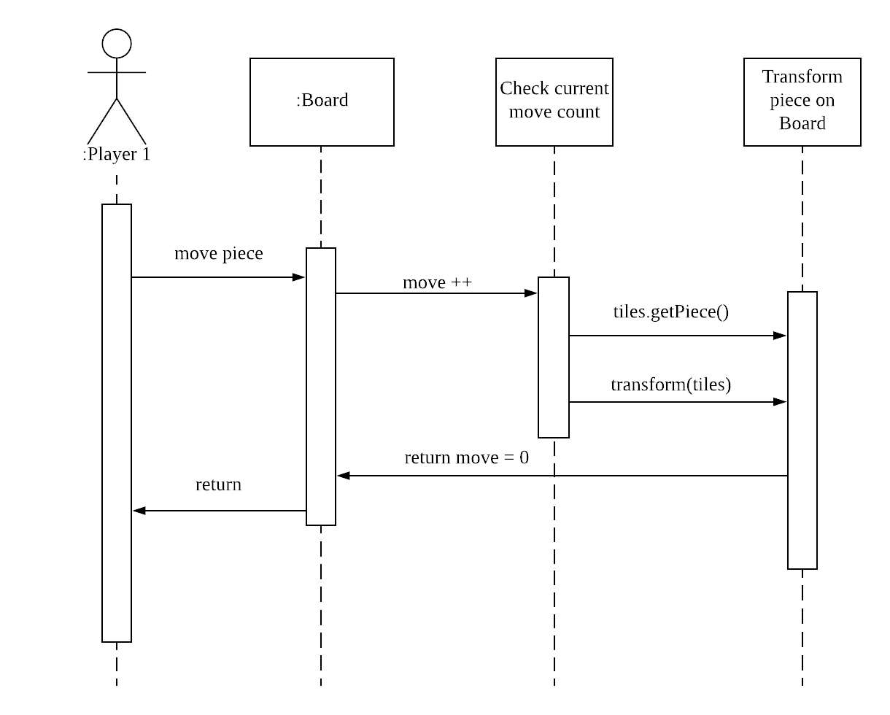

Sun Capture (Win)
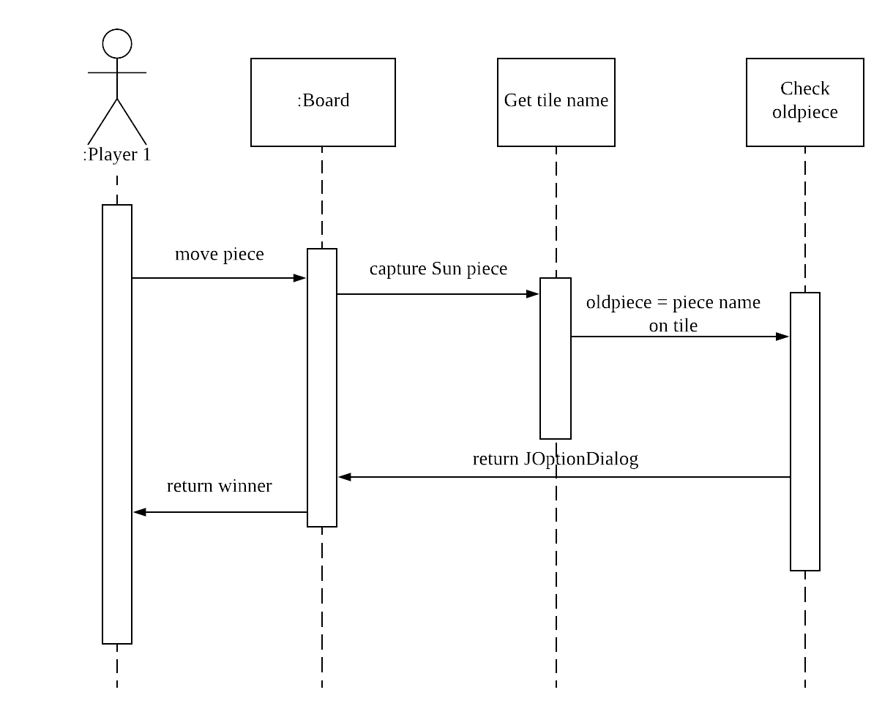

Save file
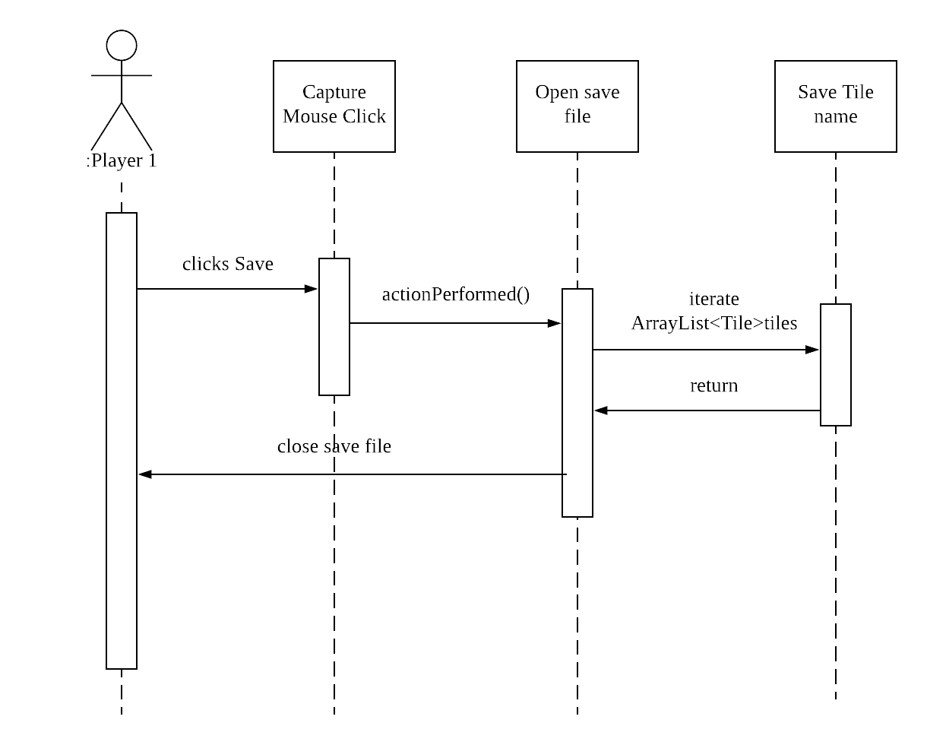

Load File
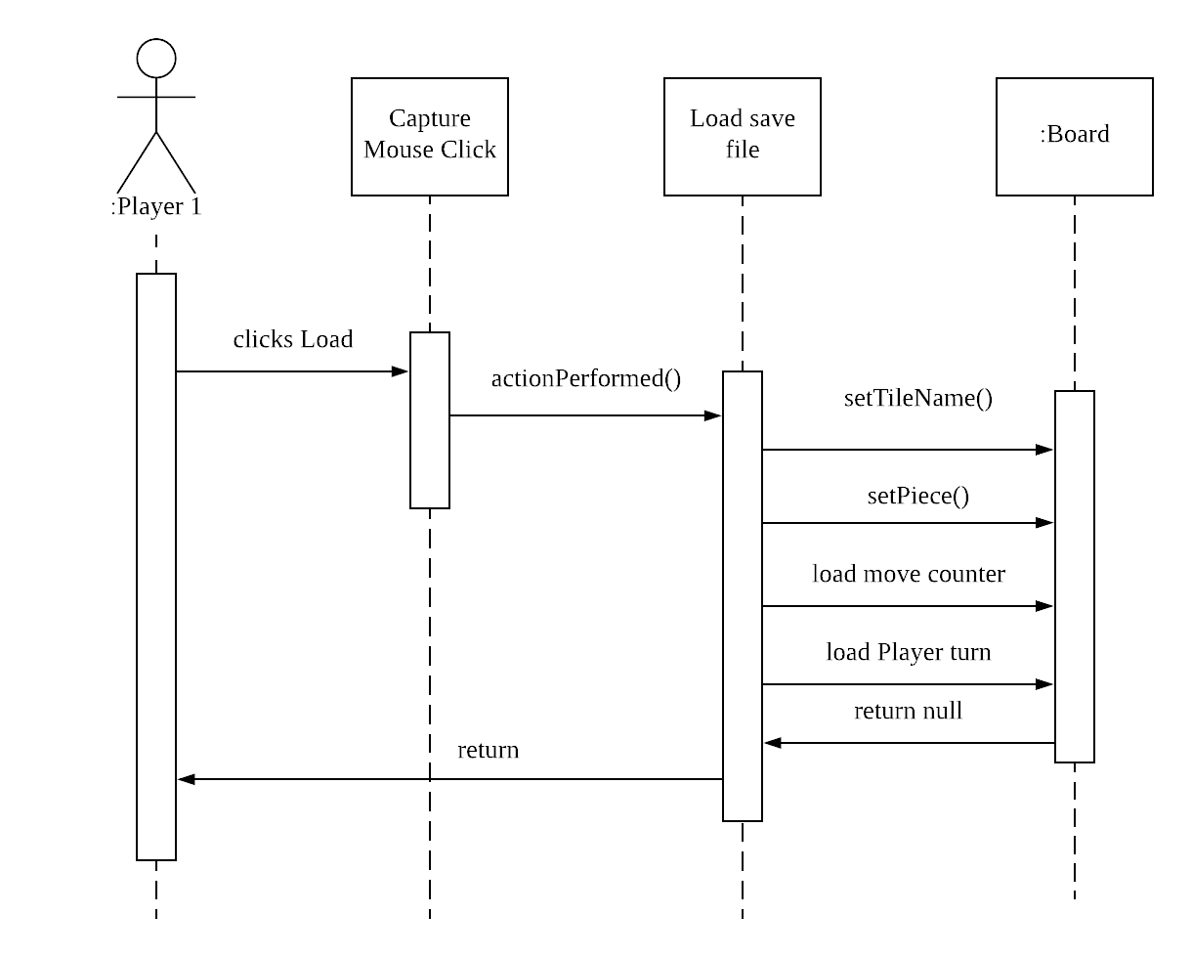

Exit Game
