# PROG140 Assignment 5

### Your Name here:

Save this document as Xxxxx-PROG140-Assignment-05, where Xxxxx is your last and first name. For example, I would name this file FreebergCarl- PROG140-Assignment-05.

### Chapter 10

For this assignment you can create diagrams using paper and pencil/pen, or a diagramming tool like draw.io (<https://www.draw.io/>) or Visio. Take a picture or screen shot of each diagram and save it as an image.

1. Create a database diagram that shows the relationships between the seven tables in the MyGuitarShop database. (The administrators table is not related to the other six tables.)

### Paste a picture of your diagram here:

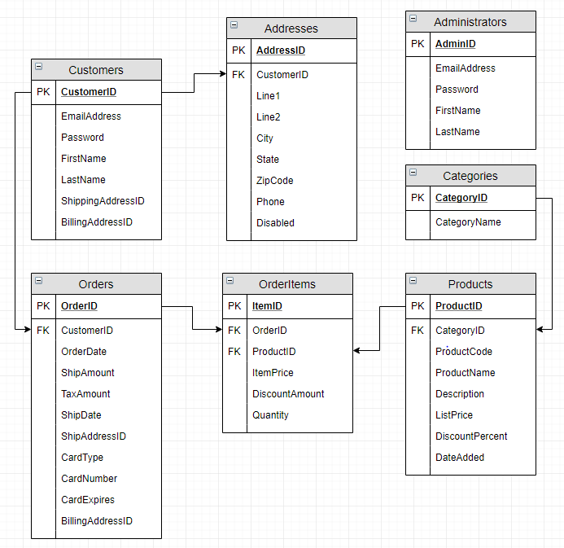

1. Design a database diagram for a database that stores information about the downloads that users make from a website.

Each user must have an email address, first name, and last name.

Each user can have one or more downloads.

Each download must have a filename and download date/time.

Each product can be related to one or more downloads.

Each product must have a name.

### Paste a picture of your diagram here:

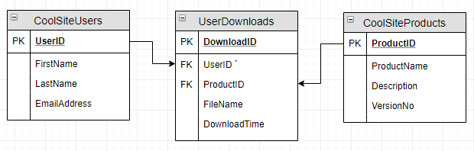

### Chapter 11

1. Write a script that adds an index to the MyGuitarShop database for the zip code field in the Addresses table.

### Paste your code here:

USE MyGuitarShop;

CREATE INDEX IX_Addresses_ZipCode

ON Addresses (ZipCode);

1. Write a script that implements the following design in a database named MyWebDB:

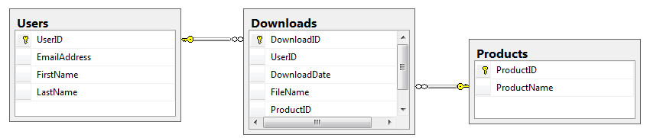

In the Downloads table, the UserID and ProductID columns are the foreign keys.

Include a statement to drop the database if it already exists.

Include statements to create and select the database.

Include any indexes that you think are necessary.

### Paste your code here:

IF OBJECT_ID('MyWebDB') IS NOT NULL DROP DATABASE MyWebDB;

GO

CREATE DATABASE MyWebDB;

GO

USE MyWebDB;

CREATE TABLE Users

(UserID INT NOT NULL PRIMARY KEY,

EmailAddress varchar(35) NOT NULL,

FirstName varchar(25) NOT NULL,

LastName varchar(25) NOT NULL);

CREATE TABLE Products

(ProductID INT NOT NULL PRIMARY KEY,

ProductName varchar(35) NOT NULL);

CREATE TABLE Downloads

(DownloadID INT NOT NULL PRIMARY KEY IDENTITY,

UserID INT REFERENCES Users(UserID),

DownloadDate DATETIME NOT NULL DEFAULT GETDATE(),

FileName VARCHAR(50) NOT NULL,

ProductID INT REFERENCES Products(ProductID));

CREATE INDEX IX_DownloadDate

ON Downloads(DownloadDate DESC);

1. Write a script that adds rows to the database that you created in for question 4.

Add two rows to the Users table and Products tables. Look at Figure A below for ideas.

Add three rows to the Downloads table:

* one row for user 1 and product 2
* one row for user 2 and product 1
* one row for user 2 and product 2

Use the GETDATE function to insert the current date and time into the DownloadDate column.

Write a SELECT statement that joins the three tables and retrieves the data from these tables like this:

### Figure A

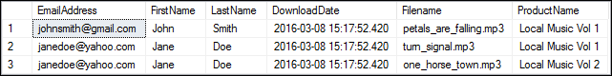

Sort the results by the email address in descending order and the product name in ascending order.

### Paste your code here:

USE MyWebDB;

INSERT INTO Users (UserID, EmailAddress, FirstName, LastName)

VALUES (1001, 'tony@starkindustries.com', 'Tony', 'Stark'),

(1002, 'bruce@bannertechnology.com', 'Bruce', 'Banner');

INSERT INTO Products (ProductID, ProductName)

VALUES (11, 'Best Boy Bands'),

(12, 'Greatest 80s Hits');

INSERT INTO Downloads (UserID, DownloadDate, FileName, ProductID)

VALUES (1001, GETDATE(), 'eye_of_the_tiger.mp3', 12),

(1002, GETDATE(), 'larger_than_life.mp3', 11),

(1002, GETDATE(), 'under_pressure.mp3', 12);

SELECT EmailAddress, FirstName, LastName, DownloadDate, FileName, ProductName

FROM Users u JOIN Downloads d ON u.UserId = d.UserID

JOIN Products p ON d.ProductID = p.ProductID

ORDER BY EmailAddress ASC, ProductName DESC;

1. Write an ALTER TABLE statement that adds two new columns to the Products table created in question 4.

Add one column for product price that provides for three digits to the left of the decimal point and two to the right. This column should have a default value of 9.99.

Add one column for the date and time that the product was added to the database.

### Paste your code here:

ALTER TABLE Products

ADD ProductPrice DECIMAL(5,2) DEFAULT 9.99 NOT NULL,

DateAdded DATETIME NULL;

1. Write an ALTER TABLE statement that modifies the Users table created in question 6 so the FirstName column cannot store null values and can store a maximum of 20 characters.

### Paste your code here:

ALTER TABLE Users

ALTER COLUMN FirstName VARCHAR(20) NOT NULL;

Code an UPDATE statement that attempts to insert a null value into this column. It should fail due to the not null constraint.

### Paste your code here:

UPDATE Users

SET FirstName = 'Thor is the best Avenger actually'

### WHERE UserID = 1001;

### Paste a screen shot of the error message here:

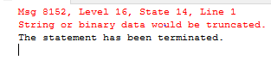

Code another UPDATE statement that attempts to insert a first name that’s longer than 20 characters. It should fail due to the length of the column.

### Paste your code here:

### Paste a screen shot of the error message here: