Lesson 04

Overview
This worksheet will guide your team in working on the first milestone of the C372 Graded Assignment. In this stage, you’ll research market gaps, suggest an e-commerce solution, and discuss the features required, including key features like secure payments and a digital wallet.
You’ll also check which regulations apply (e.g., PCI DSS, AML/KYC, MAS guidelines) and explain how your solution meets them. Update your C372 Graded Assignment Project Report - Team X.docx as you work through this worksheet.
Worksheet | Notes
Section A | Product/Service Analysis
Section B | Regulatory Requirements
Section C | System Design
Section D | Functional Requirements
Section E | Submissions

Ensure that the team has read through the project requirements in C372 Graded Assignment.pdf.

Section A – Product/Service Analysis
What is the identified market gap?
(Describe the unmet need or problem in the e-commerce/payment space.)

The identified market gap in the perfume industry centres around accessibility, personalization and trust.

What product or service are you proposing to address this gap?
(Briefly describe your solution.)
AI Powered Fragrance Recommendations, Secure and Flexible Payments, Authenticity and Trust Guarantee

A platform that allows users to customize their own perfume blends, view ingredient safety (compliant with HSA and ASEAN Cosmetic Directive), and receive samples before committing to full-size purchases.

Who is your target audience?
(Specify underserved groups if relevant.)
18 to 34years old as they are more likely to be motivated by fashion, social media and personalization.

Update the section on Project Overview in C372 Graded Assignment Project Report - Team X.docx

Section B – Regulatory Requirements
List the key regulatory requirements your solution must comply with:
(E.g., PCI DSS, AML/KYC, MAS guidelines, etc.)

Key Regulatory Requirements in Singapore

1. Consumer Protection (Fair Trading) Act (CPFTA)
- You must ensure honest marketing , no false claims about the perfume’s brand, origin, or ingredients.
- Products must match their description (e.g., if you claim “original brand,” it must be authentic).
- Covers both online and retail perfume sales.

2. Sale of Goods Act & Lemon Law
- Goods sold must be of satisfactory quality, fit for purpose, and as described.
- Offer repair, replacement, or refund if a product is defective within 6 months of purchase.

3. Personal Data Protection Act (PDPA)
- Applies if collect customer information (e.g. for delivery, marketing, or user accounts).
- Must Obtain consent before collecting personal data, securely store and protect customer information and allowing customers to withdraw consent or request deletion.

4. Electronic Transactions Act (ETA)
- Ensures that online transactions, e-receipts, and digital contracts are legally valid.
- Clearly show order confirmation, payment details, and delivery terms.

5. Payment Card Industry Data Security Standard (PCI DSS)
- Applies if your business handles or stores credit/debit card data directly.
- Comply with card security standards (e.g., data encryption).
- If use trusted third-party payment gateways such as Stripe, PayPal, PayNow, or Shopify Payments, they are already PCI DSS compliant and handle all payment security requirements on our behalf.

6. Intellectual Property (IP) Laws & Trademarks Act
- Must only sell genuine branded perfumes as counterfeit or imitation products are illegal.
- Cannot use a brand’s logo or name without permission in your own marketing or packaging.

7. Advertising Standards Authority of Singapore (ASAS) Guidelines
- Ads must be truthful, not misleading, and avoid false claims like “clinically proven” or “100% natural” unless supported by evidence.
8. Employment Act (if you hire staff)
- Covers basic employment terms such as working hours, salary, and rest days.
- Provide proper employment contracts if you have sales staff or warehouse workers
9. Goods and Services Tax (GST)
- If annual revenue exceeds SGD 1 million, must register for GST with IRAS.
- Display prices inclusive of GST and file returns on time.
10. Singapore Chemical and Cosmetics Regulations (under HSA)
- Perfumes are classified as cosmetic products under the Health Sciences Authority (HSA).
- Ensure the perfume ingredients are safe and compliant with ASEAN Cosmetic Directive (ACD).
- Notify HSA before placing the product on the market.
- Follow labelling rules (product name, batch number, country of manufacture, ingredients, and company details).

How will your solution address these requirements?
(Summarize your approach to compliance.)
Our perfume e-commerce platform ensures full compliance with Singapore’s e-commerce and cosmetics regulations. We will follow the Consumer Protection and Sale of Goods Acts by providing accurate product descriptions, safe ingredients and fair refund policies. All perfumes are manufactured following health and safety guidelines. All personal data collected will be handled securely according to PDPA rules and transactions will be processed through trusted payment gateways that meet PCI DSS standards. We will also comply with HSA cosmetic regulations by using approved ingredients, proper labelling, and notifying HSA before selling. All online content and advertisements will follow ASAS guidelines, ensuring our marketing is truthful and ethical.

Update the section on Project Overview in C372 Graded Assignment Project Report - Team X.docx

Section C – System Design
Use Cases
Use draw.io or an equivalent tool to create a diagram illustrating the actors and use cases for your project.
(Remember to refer to C372 Graded Assignment.pdf)
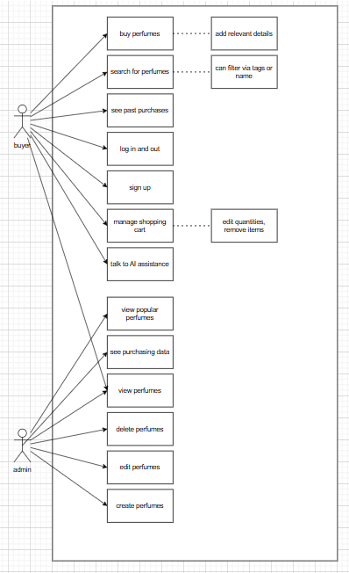

Entity Relationship Diagram(ERD)
Identify the table(s) and fields required for your project.

Table name: users
Field | Datatype
name | char
qty | int
tags | varchar
img | varchar

Table name: users
Field | Datatype
username | char
password | varchar
email | varchar
Address  role | Varchar  char

Table name: tags
Field | Datatype
name | Char

Update the section on System Design in C372 Graded Assignment Project Report - Team X.docx

Section D – Functional Requirements

Based on the identified use cases, what functional requirements should be defined for each?
(Remember to refer to C372 Graded Assignment.pdf)
Functional Requirements (FR):
- Users can browse perfumes and colognes collections and view product details.
- Customers can use the filter/search function to browse products by brand or tags.
- Customers can sign up/log in, add or remove perfumes and colognes from the cart, update item quantities, and retain cart contents after logout.
- Customers can update personal information (contact details, address, phone number).
- Customers can proceed to checkout and make secure payments through a payment gateway.
- Customers receive a confirmation email or message upon successful payment.
- Administrators can add, update, or delete perfumes and colognes product details.
- Administrators can manage user accounts and view order information.
- Front-end and back-end validations are implemented for all user inputs and transactions.

Update the section on Functional Requirements in C372 Graded Assignment Project Report - Team X.docx

Section G – Submissions
Deliverables for GA Milestone 1
- Worksheet (Individual)
- C372 Graded Assignment Project Report - Team X.docx(Individual)
Upload your deliverables to POLITEMALL even if it is incomplete before the next session.
You can resubmit later when there are updates.

