**Supporting Information**

*Engineered Mycobacterium tuberculosis* antigen assembly into core-shell nanobeads for diagnosis of tuberculosis

Nurul Syahidah Sheffee, Patricia Rubio-Reyes, Shuxiong Chen, Mayelin Mirabal, Romel Calero, Humberto Carrillo-Calvet, Kai Ling Chin, Nur Atiqah Syairah Shakimi, Fadhilah Zulkipli Anis, Siti Suraiya, Maria E. Sarmiento, Mohd Nor Norazmi, Armando Acosta, Bernd H.A. Rehm

Table of content

Table S1. Plasmids, oligonucleotides and strains used S3

Table S2. Amino acid sequence of the CFP10-TB7.7-PhaC-ESAT6 fusion protein S4

Table S3. Confidence intervals for AUC, sensitivity and specificity of each cytokine between the different groups: (PTB vs TSTn; PTB vs TSTp and TSTp vs TSTn) S5

Table S4. Confidence intervals for AUC, sensitivity and specificity of each cytokine between the different groups: PTB vs Healthy individuals (TSTp + TSTn) and Infected individuals (PTB + TSTp) vs TSTn. S6

Details of the ROC analysis performed for individual and cytokine combinations S7

A. Details of the ROC analysis performed for each cytokine evaluated. S7

B. Details of the ROC analysis performed for each cytokine combination evaluated S67

# Table S1. Plasmids, oligonucleotides and strains used

|  |  |  |
| --- | --- | --- |
| **Plasmids/oligonucleotides/**  **strains** | **Description or genotype** | **Source** |
| **Plasmids** | | |
| pUC57_tb7.7 | Contains synthetic gene encoding TB7.7 | GenScript (USA) |
| pET14b_cfp10-rv3615c-phaC-esat6-rv3020v | pET14b derivative. Used for amplifying *cfp10* and subcloning *esat6*. |  |
| pPolyC | pET-14b derivative. Contains *phaC* gene from *Cupriavidus necator* | (2) |
| pPOLYC_cfp10-tb7.7-phaC-esat6 | pPOLYC derivative. Contains *cfp10, tb7.7* and *esat6* genes. AmpR. | This study |
| pMCS69 | pBBR1MCS derivative containing genes phaA and phaB from *C. necator*. CmR. | (3) |
| **Oligonucleotides** | | |
| XbaI cfp10 fwd | 5’-CCCTCTAGAATATAGGAGATAGGTATGGCAGAAATG-3 | This study |
| SpeI cfp10 rev | 5’-GCTACTAGTGAAACCCATTTGAGAGCTCAG-3’ | This study |
| **Strains** | | |
| *E. coli* XL1Blue | *endA1 gyrA96(nalR) thi-1 recA1 relA1 lac glnV44 F'[ ::Tn10 proAB+ lacIq Δ(lacZ)M15] hsdR17(rK- mK+)* | Stratagene |
| Clearcoli BL21 (DE3) | *F– ompT hsdSB (rB- mB-) gal dcm lon λ(DE3 [lacI lacUV5-T7 gene 1 ind1 sam7 nin5]) msbA148 ΔgutQΔkdsD ΔlpxL ΔlpxMΔpagP ΔlpxP ΔeptA* | Lucigen |

# Table S2. Amino acid sequence of the CFP10-TB7.7-PhaC-ESAT6 fusion protein

|  |  |  |  |  |  |
| --- | --- | --- | --- | --- | --- |
| 1 | M**AEMKTDAAT** | **LAQEAGNFER** | **ISGDLKTQID** | **QVESTAGSLQ** | **GQWRGAAGTA** |
| 51 | **AQAAVVRFQE** | **AANKQKQELD** | **EISTNIRQAG** | **VQYSRADEEQ** | **QQALSSQMGF** |
| 101 | **TSGGGGGMSG** | **HALAARTLLA** | **AADELVGGPP** | **VEASAAALAG** | **DAAGAWRTAA** |
| 151 | **VELARALVRA** | **VAESHGVAAV** | **LFAATAAAAA** | **AVDRGDPPTS** | **MATGKGAAAS** |
| 201 | **TQEGKSQPFK** | **VTPGPFDPAT** | **WLEWSRQWQG** | **TEGNGHAAAS** | **GIPGLDALAG** |
| 251 | **VKIAPAQLGD** | **IQQRYMKDFS** | **ALWQAMAEGK** | **AEATGPLHDR** | **RFAGDAWRTN** |
| 301 | **LPYRFAAAFY** | **LLNARALTEL** | **ADAVEADAKT** | **RQRIRFAISQ** | **WVDAMSPANF** |
| 351 | **LATNPEAQRL** | **LIESGGESLR** | **AGVRNMMEDL** | **TRGKISQTDE** | **SAFEVGRNVA** |
| 401 | **VTEGAVVFEN** | **EYFQLLQYKP** | **LTDKVHARPL** | **LMVPPCINKY** | **YILDLQPESS** |
| 451 | **LVRHVVEQGH** | **TVFLVSWRNP** | **DASMAGSTWD** | **DYIEHAAIRA** | **IEVARDISGQ** |
| 501 | **DK**INVLGFCV | GGTIVSTALA | VLAARGEHPA | ASVTLLTTLL | DFADTGILDV |
| 551 | FVDEGHVQLR | **EATLGGGAGA** | **PCALLR**GLEL | ANTFSFLRPN | DLVWNYVVDN |
| 601 | YLKGNTPVPF | DLLFWNGDAT | NLPGPWYCWY | LR**HTYLQNEL** | **KVPGKLTVCG** |
| 651 | **VPVDLASIDV** | **PTYIYGSRED** | **HIVPWTAAYA** | **STALLANKLR** | **FVLGASGHIA** |
| 701 | **GVINPPAK**NK | RSHWTNDALP | ESPQQWLAGA | IEHHGSWWPD | WTAWLAGQAG |
| 751 | AK**RAAPANYG** | **NARYRAIEPA** | **PGRYVKAKAV** | **LAVAIDKRGG** | **GGGLEMTEQQ** |
| 801 | **WNFAGIEAAA** | **SAIQGNVTSI** | **HSLLDEGK**QS | LTK**LAAAWGG** | **SGSEAYQGVQ** |
| 851 | **QKWDATATEL** | **NNALQNLART** | **ISEAGQAMAS** | **TEGNVTGMFA** |  |

**NOTE:** . In bold, peptides identified by MALDI-TOF/MS. Sequence coverage: 81%.

# Table S3. Confidence intervals for AUC, sensitivity and specificity of each cytokine between the different groups: (PTB vs TSTn; PTB vs TSTp and TSTp vs TSTn)

|  |  |  |  |  |  |
| --- | --- | --- | --- | --- | --- |
|  | **Difference/**  **Ratio** |  | AUC (IC 95%) | Sen (IC 95%) | Spe (IC 95%) |
| **PTB**  **vs**  **TSTn** | **Difference** | **IFNγ** | 0.818 (0.65-0.987) | 0.7273 (0.3903-0.9398) | 0.7857 (0.4920-0.9534) |
| **IP10** | 0.844 (0.677-1.011) | 0.9091 (0.5872-0.9977) | 0.7857 (0.4920-0.9534) |
| **IL-2** | 0.916 (0.798-1.033) | 0.9091 (0.5872-0.9977) | 0.8571 (0.5719-0.9822) |
| **TNFα** | 0.422 (0.188-0.656) | 0 (NaN-0.2316) | 1(0.7151-NaN) |
| **CCL3** | 0.656 (0.423-0.889) | 0.8182 (0.4822-0.9772) | 0.5714 (0.2886-0.8234 |
| **CCL11** | 0.838 (0.639-1.037) | 0.8182 (0.4822-0.9772) | 0.9286 (0.6613-0.9982) |
| **Ratio** | **IFNγ** | 0.896 (0.774-1.018) | 0.7273 (0.3903-0.9398) | 0.9286 (0.6613-0.9982) |
| **IP10** | 0.896 (0.76-1.033) | 1 (0.7151-NaN) | 0.7857 (0.4920-0.9534) |
| **IL-2** | 0.929 (0.829-1.028) | 0.9091 (0.5872-0.9977) | 0.8571 (0.5719-0.9822) |
| **TNFα** | 0.39 (0.158-0.621) | 0.8182 (0.4822-0.9772) | 0.2857 (0.0839-0.5810) |
| **CCL3** | 0.656 (0.423-0.889) | 0.8182 (0.4822-0.9772) | 0.5714 (0.2886-0.8234) |
| **CCL11** | 0.857 (0.681-1.033) | 0.8182 (0.4822-0.9772) | 0.9286 (0.6613-0.9982) |
| **PTB**  **vs**  **TSTp** | **Difference** | **IFNγ** | 0.826 (0.65-1.001) | 0.8182 (0.4822-0.9772) | 0.7500 (0.4281-0.9451) |
| **IP10** | 0.864 (0.701-1.027) | 0.7273 (0.3903-0.9398) | 1.0000 (0.7354-NaN) |
| **IL-2** | 0.902 (0.769-1.034) | 0.8182 (0.4822-0.9772) | 0.9167 (0.6152-0.9979) |
| **TNFα** | 0.682 (0.453-0.911) | 0.6364 (0.3079-0.8907) | 0.7500 (0.4281-0.9451) |
| **CCL3** | 0.644 (0.395-0.892) | 0.5455 (0.2338-0.8325) | 0.8333 (0.5159-0.9791) |
| **CCL11** | 0.886 (0.722-1.05) | 0.8182 (0.4822-0.9772) | 1 (0.7354-NaN) |
| **Ratio** | **IFNγ** | 0.871 (0.726-1.017) | 0.7273 (0.3903-0.9398) | 0.9167 (0.6152-0.9979) |
| **IP10** | 0.871 (0.721-1.021) | 0.9091 (0.5872-0.9977) | 0.7500 (0.4281-0.9451) |
| **IL-2** | 0.902 (0.769-1.034) | 0.8182 (0.4822-0.9772) | 0.9167 (0.6152-0.9979) |
| **TNFα** | 0.902 (0.777-1.026) | 0.8182 (0.4822-0.9772) | 0.9167 (0.6152-0.9979) |
| **CCL3** | 0.644 (0.394-0.893) | 0.5455 (0.2338-0.8325) | 0.8333 (0.5159-0.9791) |
| **CCL11** | 0.894 (0.745-1.043) | 0.8182 (0.4822-0.9772) | 1 (0.7354- NaN) |
| **TSTp**  **vs**  **TSTn** | **Difference** | **IFNγ** | 0.464 (0.23-0.699) | 0.08333 (0.0021-0.3848) | 1 (0.7684-NaN) |
| **IP10** | 0.583 (0.354-0.813) | 0.6667 (0.3489-0.9008) | 0.571 (0.2886-0.8234) |
| **IL-2** | 0.643 (0.414-0.872) | 1 (0.7354-NaN) | 0.3571 (0.1276-0.6486) |
| **TNFα** | 0.25 (0.058-0.442) | 0 (NaN-0.2316) | 1 (0.7354- NaN) |
| **CCL3** | 0.518 (0.283-0.753) | 1 (0.7354-NaN) | 0.2143 (0.0466-0.5080) |
| **CCL11** | 0.53 (0.29-0.769) | 0.5000 (0.2109-0.7891) | 0.7857 (0.4920-0.9534) |
| **Ratio** | **IFNγ** | 0.524 (0.288-0.759) | 0.2500 (0.0549-0.5719) | 0.9286 (0.6613-0.9982) |
| **IP10** | 0.607 (0.38-0.834) | 0.4167 (0.1517-0.7233) | 0.857 (0.5719-0.9822) |
| **IL-2** | 0.649 (0.422-0.875) | 1 (0.7354- NaN) | 0.3571 (0.1276-0.6486) |
| **TNFα** | 0.089 (-0.017-0.196) | 0 (NaN-0.2316) | 1 (0.7354-NaN) |
| **CCL3** | 0.512 (0.276-0.748) | 1(0.7354-NaN) | 0.2143 (0.0466-0.5080) |
| **CCL11** | 0.542 (0.301-0.782) | 0.5000(0.2109-0.7891) | 0.7857 (0.4920-0.9534) |

# Table S4. Confidence intervals for AUC, sensitivity and specificity of each cytokine between the different groups: PTB vs Healthy individuals (TSTp + TSTn) and Infected individuals (PTB + TSTp) vs TSTn.

|  |  |  |  |  |  |
| --- | --- | --- | --- | --- | --- |
|  | **Difference/**  **Ratio** |  | AUC (IC 95%) | Sen (IC 95%) | Spe (IC 95%) |
| **PTB**  **vs**  **(TSTp+TSTn)** | **Difference** | **IFNγ** | 0.822 (0.678-0.965) | 0.6364 (0.3079-0.8907) | 0.8846 (0.6985-0.9755) |
| **IP10** | 0.853 (0.711-0.995) | 0.7273 (0.3903-0.9398) | 0.9231 (0.7487-0.9905) |
| **IL-2** | 0.909 (0.807-1.011) | 0.8182 (0.4822-0.9772) | 0.9231 (0.7487-0.9905) |
| **TNFα** | 0.542 (0.331-0.753) | 0.6364 (0.3079-0.8907) | 0.5385 (0.3337-0.7341) |
| **CCL3** | 0.65 (0.432-0.868) | 0.8182 (0.4822-0.9772) | 0.5385 (0.3337-0.7341) |
| **CCL11** | 0.86 (0.691-1.029) | 0.8182 (0.4822-0.9772) | 0.9615 (0.8036-0.9990) |
| **Ratio** | **IFNγ** | 0.885 (0.771-0.998) | 0.7273 (0.3903-0.9398) | 0.9231 (0.7487-0.9905) |
| **IP10** | 0.885 (0.778-0.991) | 0.9091 (0.5872-0.9977) | 0.8077 (0.6065-0.9345) |
| **IL-2** | 0.916 (0.818-1.014) | 0.8182(0.4822-0.9772) | 0.9231 (0.7487-0.9905) |
| **TNFα** | 0.626 (0.44-0.812) | 0.8182(0.4822-0.9772) | 0.5769 (0.3692-0.7665) |
| **CCL3** | 0.65 (0.432-0.869) | 0.8182(0.4822 -0.9772) | 0.5385(0.3337-0.7341) |
| **CCL11** | 0.874 (0.73-1.018) | 0.8182 (0.4822-0.9772) | 0.9615 (0.8036-0.9990) |
| **(PTB+TSTp)**  **vs**  **TSTn** | **Difference** | **IFNγ** | 0.634 (0.448-0.819) | 0.7826 (0.5630-0.9254) | 0.5000 (0.2304-0.7696) |
| **IP10** | 0.708 (0.527-0.889) | 0.6522 (0.4273-0.8362) | 0.7857 (0.4920-0.9534) |
| **IL-2** | 0.773 (0.612-0.935) | 0.6957 (0.4708-0.8679) | 0.8571 (0.5719-0.9822) |
| **TNFα** | 0.332 (0.147-0.517) | 0 (NaN-0.2316) | 1(0.8518- NaN) |
| **CCL3** | 0.584 (0.385-0.783) | 0.5652 (0.3449-0.7681) | 0.7143 (0.4190-0.9161) |
| **CCL11** | 0.677 (0.491-0.863) | 0.6957 (0.4708-0.8679) | 0.7857 (0.4920-0.9534) |
| **Ratio** | **IFNγ** | 0.702 (0.533-0.871) | 0.4783 (0.2682-0.6941) | 0.9286 (0.6613-0.9982) |
| **IP10** | 0.745 (0.574-0.917) | 0.6522 (0.4273-0.8362) | 0.8571 (0.5719-0.9822) |
| **IL-2** | 0.783 (0.628-0.937) | 0.6957 (0.4708-0.8679) | 0.8571 (0.5719-0.9822) |
| **TNFα** | 0.233 (0.077-0.389) | 0 ( NaN-0.2316) | 1 (0.8518-NaN) |
| **CCL3** | 0.581 (0.382-0.78) | 0.5652 (0.3449-0.7681) | 0.7143 (0.4190-0.9161) |
| **CCL11** | 0.693 (0.509-0.876) | 0.6957 (0.4708-0.8679) | 0.7857 (0.4920-0.9534) |

# Details of the ROC analysis performed for individual and cytokine combinations

# Details of the ROC analysis performed for each cytokine evaluated.

**Analysis PTB vs TSTn. Responses for all groups and cytokines corrected for background by subtraction.**

**IFNγ**  
 Method: maximize_metric   
 Predictor: var   
 Outcome: Grupo   
 Direction: >=   
 Subgroups: BEADS   
   
 Subgroup: BEADS   
 ---------------------------------------------------------------------------   
 AUC n n_pos n_neg  
 0.8182 25 11 14  
   
 optimal_cutpoint youden acc sensitivity specificity tp fn fp tn  
 14.8205 0.513 0.76 0.7273 0.7857 8 3 3 11  
   
 Predictor summary:   
 Min. 5% 1st Qu. Median Mean 3rd Qu. 95% Max. SD  
 overall -6.045 -2.323 2.627 13.459 30.103 37.008 134.669 173.913 45.019  
 No (TSTn) -6.045 -3.791 -0.333 7.366 10.103 13.696 39.306 43.573 14.787  
 Yes (pTB) 4.560 7.312 12.919 32.351 55.558 72.591 160.570 173.913 57.506  
 NAs  
 overall 0 No 0 Yes 0

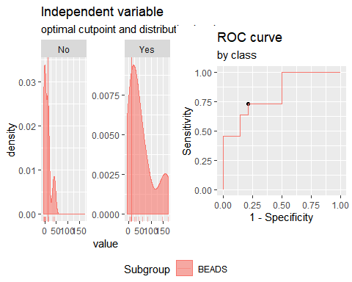 **IP10**  
 Method: maximize_metric   
 Predictor: var   
 Outcome: Grupo   
 Direction: >=   
 Subgroups: BEADS   
   
 Subgroup: BEADS   
 ---------------------------------------------------------------------------   
 AUC n n_pos n_neg  
 0.8442 25 11 14  
   
 optimal_cutpoint youden acc sensitivity specificity tp fn fp tn  
 -46.7508 0.6948 0.84 0.9091 0.7857 10 1 3 11  
   
 Predictor summary:   
 Min. 5% 1st Qu. Median Mean 3rd Qu. 95%  
 overall -1997.979 -944.812 -337.466 -46.751 35.653 251.111 1718.033  
 No (TSTn) -1997.979 -1365.221 -511.676 -205.549 -360.622 -94.031 327.698  
 Yes (pTB) -419.981 -233.366 34.696 225.597 540.003 1004.074 1819.003  
 Max. SD NAs  
 overall 1915.317 824.238 0  
 No 337.740 591.528 0  
 Yes 1915.317 822.164 0

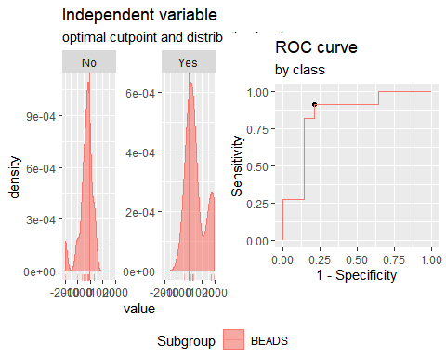

**IL2**  
 Method: maximize_metric   
 Predictor: var   
 Outcome: Grupo   
 Direction: >=   
 Subgroups: BEADS   
   
 Subgroup: BEADS   
 ---------------------------------------------------------------------------   
 AUC n n_pos n_neg  
 0.9156 25 11 14  
   
 optimal_cutpoint youden acc sensitivity specificity tp fn fp tn  
 0.9491 0.7662 0.88 0.9091 0.8571 10 1 2 12  
   
 Predictor summary:   
 Min. 5% 1st Qu. Median Mean 3rd Qu. 95% Max. SD  
 overall -9.247 -6.044 -0.955 0.318 5.258 10.263 29.996 37.222 11.398  
 No -9.247 -7.204 -4.298 -0.796 -1.282 0.198 5.775 13.208 5.195  
 Yes -0.382 0.284 7.887 10.263 13.581 14.669 35.328 37.222 11.858  
 NAs  
 overall 0  
 No 0  
 Yes 0

Multiple optimal cutpoints found, applying break_ties.

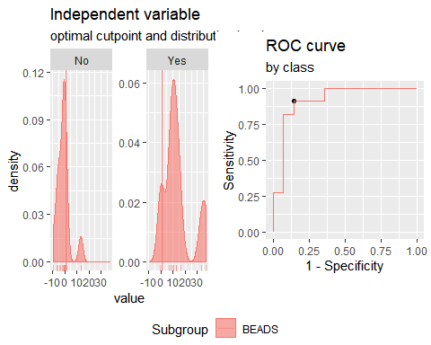

**TNFα**

Method: maximize_metric   
 Predictor: var   
 Outcome: Grupo   
 Direction: >=   
 Subgroups: BEADS   
   
 Subgroup: BEADS   
 ---------------------------------------------------------------------------   
 AUC n n_pos n_neg  
 0.4221 25 11 14  
   
 optimal_cutpoint youden acc sensitivity specificity tp fn fp tn  
 Inf 0 0.56 0 1 0 11 0 14  
   
 Predictor summary:   
 Min. 5% 1st Qu. Median Mean 3rd Qu. 95%  
 overall 1841.040 2066.785 3458.645 6342.813 8537.618 14105.20 16951.15  
 No 1920.867 2410.888 4674.842 7476.587 9153.103 13794.49 18008.90  
 Yes 1841.040 2245.748 3293.073 6176.805 7754.273 11462.78 15764.48  
 Max. SD NAs  
 overall 19937.60 5604.953 0  
 No 19937.60 5956.919 0  
 Yes 16874.28 5297.311 0

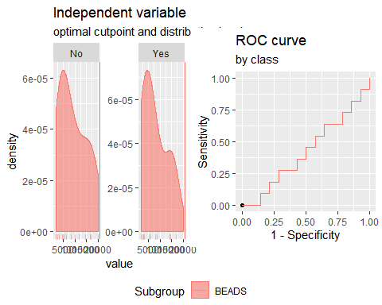

**CCL3**

Method: maximize_metric   
 Predictor: var   
 Outcome: Grupo   
 Direction: >=   
 Subgroups: BEADS   
   
 Subgroup: BEADS   
 ---------------------------------------------------------------------------   
 AUC n n_pos n_neg  
 0.6558 25 11 14  
   
 optimal_cutpoint youden acc sensitivity specificity tp fn fp tn  
 -64.3795 0.3896 0.68 0.8182 0.5714 9 2 6 8  
   
 Predictor summary:   
 Min. 5% 1st Qu. Median Mean 3rd Qu. 95%  
 overall -2136.280 -757.569 -438.551 -16.564 186.615 665.090 1826.702  
 No -759.162 -753.985 -455.148 -278.073 60.991 240.161 1652.318  
 Yes -2136.280 -1371.224 -42.956 307.210 346.500 1051.463 1779.952  
 Max. SD NAs  
 overall 2465.435 1003.081 0  
 No 2465.435 911.198 0  
 Yes 1857.869 1133.681 0

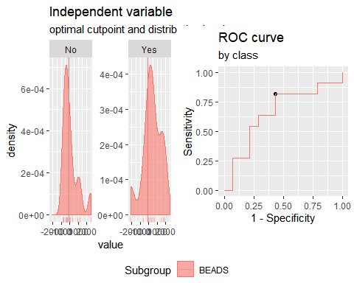

**CCL11**

Method: maximize_metric   
 Predictor: var   
 Outcome: Grupo   
 Direction: >=   
 Subgroups: BEADS   
   
 Subgroup: BEADS   
 ---------------------------------------------------------------------------   
 AUC n n_pos n_neg  
 0.8377 25 11 14  
   
 optimal_cutpoint youden acc sensitivity specificity tp fn fp tn  
 29.8881 0.7468 0.88 0.8182 0.9286 9 2 1 13  
   
 Predictor summary:   
 Min. 5% 1st Qu. Median Mean 3rd Qu. 95% Max.  
 overall -271.455 -82.706 -36.332 -10.866 44.432 38.954 282.685 826.836  
 No -271.455 -133.163 -46.194 -25.237 17.022 -15.304 300.581 826.836  
 Yes -88.708 -49.787 33.890 38.954 79.319 126.180 260.232 297.653  
 SD NAs  
 overall 194.975 0  
 No 243.010 0  
 Yes 109.889 0

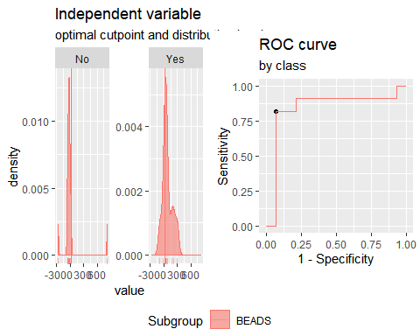

**Analysis PTB vs TSTn. Responses for all groups and cytokinescorrected for background by division (ratio).**

**IFNγ**

Method: maximize_metric   
 Predictor: var   
 Outcome: Grupo   
 Direction: >=   
 Subgroups: BEADS   
   
 Subgroup: BEADS   
 ---------------------------------------------------------------------------   
 AUC n n_pos n_neg  
 0.8961 25 11 14  
   
 optimal_cutpoint youden acc sensitivity specificity tp fn fp tn  
 2.2597 0.6558 0.84 0.7273 0.9286 8 3 1 13  
   
 Predictor summary:   
 Min. 5% 1st Qu. Median Mean 3rd Qu. 95% Max. SD NAs  
 overall 0.838 0.920 1.233 1.480 2.509 2.372 7.906 11.221 2.529 0  
 No 0.838 0.887 0.962 1.305 1.319 1.462 2.009 2.372 0.435 0  
 Yes 1.317 1.393 1.912 2.520 4.024 5.324 9.732 11.221 3.255 0

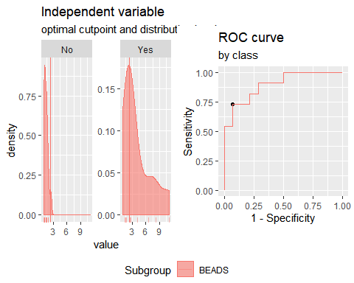

**IP10**

Method: maximize_metric   
 Predictor: var   
 Outcome: Grupo   
 Direction: >=   
 Subgroups: BEADS   
   
 Subgroup: BEADS   
 ---------------------------------------------------------------------------   
 AUC n n_pos n_neg  
 0.8961 25 11 14  
   
 optimal_cutpoint youden acc sensitivity specificity tp fn fp tn  
 0.7703 0.7857 0.88 1 0.7857 11 0 3 11  
   
 Predictor summary:   
 Min. 5% 1st Qu. Median Mean 3rd Qu. 95% Max. SD NAs  
 overall 0.222 0.378 0.545 0.781 1.178 1.388 2.500 6.228 1.198 0  
 No 0.222 0.321 0.451 0.545 0.667 0.702 1.467 1.557 0.379 0  
 Yes 0.770 0.846 1.024 1.357 1.829 1.848 4.408 6.228 1.558 0

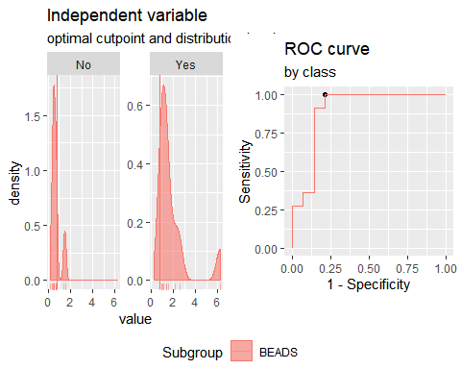

**IL2**

Method: maximize_metric   
 Predictor: var   
 Outcome: Grupo   
 Direction: >=   
 Subgroups: BEADS   
   
 Subgroup: BEADS   
 ---------------------------------------------------------------------------   
 AUC n n_pos n_neg  
 0.9286 25 11 14  
   
 optimal_cutpoint youden acc sensitivity specificity tp fn fp tn  
 1.0245 0.7662 0.88 0.9091 0.8571 10 1 2 12  
   
 Predictor summary:   
 Min. 5% 1st Qu. Median Mean 3rd Qu. 95% Max. SD NAs  
 overall 0.821 0.872 0.971 1.010 1.168 1.308 1.894 2.200 0.340 0  
 No 0.821 0.853 0.885 0.976 0.977 1.006 1.173 1.361 0.131 0  
 Yes 0.989 1.007 1.229 1.308 1.412 1.428 2.102 2.200 0.373 0

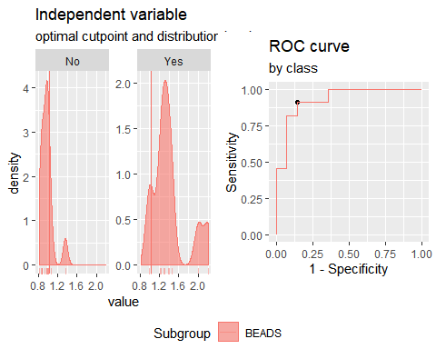

**TNFα**

Method: maximize_metric   
 Predictor: var   
 Outcome: Grupo   
 Direction: >=   
 Subgroups: BEADS   
   
 Subgroup: BEADS   
 ---------------------------------------------------------------------------   
 AUC n n_pos n_neg  
 0.3896 25 11 14  
   
 optimal_cutpoint youden acc sensitivity specificity tp fn fp tn  
 3.2806 0.1039 0.52 0.8182 0.2857 9 2 10 4  
   
 Predictor summary:   
 Min. 5% 1st Qu. Median Mean 3rd Qu. 95% Max. SD NAs  
 overall 2.039 2.210 3.281 3.892 5.644 5.752 14.873 16.032 4.208 0  
 No 2.487 2.624 2.989 4.660 6.411 5.757 15.385 16.032 4.860 0  
 Yes 2.039 2.090 3.311 3.849 4.669 4.950 9.728 13.470 3.148 0

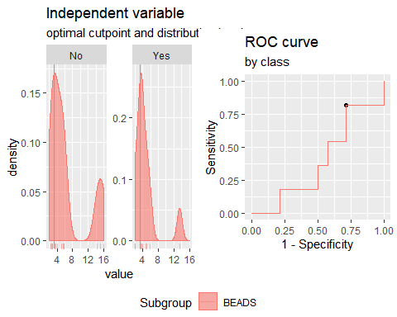

**CCL3**

Method: maximize_metric   
 Predictor: var   
 Outcome: Grupo   
 Direction: >=   
 Subgroups: BEADS   
   
 Subgroup: BEADS   
 ---------------------------------------------------------------------------   
 AUC n n_pos n_neg  
 0.6558 25 11 14  
   
 optimal_cutpoint youden acc sensitivity specificity tp fn fp tn  
 0.9884 0.3896 0.68 0.8182 0.5714 9 2 6 8  
   
 Predictor summary:   
 Min. 5% 1st Qu. Median Mean 3rd Qu. 95% Max. SD NAs  
 overall 0.598 0.888 0.945 0.998 1.046 1.116 1.383 1.589 0.198 0  
 No 0.888 0.890 0.937 0.964 1.028 1.035 1.331 1.589 0.184 0  
 Yes 0.598 0.751 0.993 1.047 1.070 1.204 1.363 1.395 0.221 0

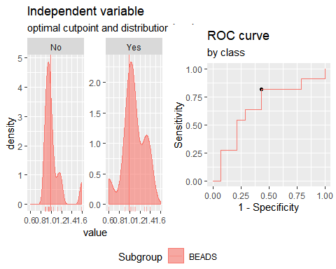

**CCL11**

Method: maximize_metric   
 Predictor: var   
 Outcome: Grupo   
 Direction: >=   
 Subgroups: BEADS   
   
 Subgroup: BEADS   
 ---------------------------------------------------------------------------   
 AUC n n_pos n_neg  
 0.8571 25 11 14  
   
 optimal_cutpoint youden acc sensitivity specificity tp fn fp tn  
 1.051 0.7468 0.88 0.8182 0.9286 9 2 1 13  
   
 Predictor summary:   
 Min. 5% 1st Qu. Median Mean 3rd Qu. 95% Max. SD NAs  
 overall 0.829 0.901 0.959 0.986 1.024 1.077 1.233 1.270 0.106 0  
 No 0.829 0.872 0.946 0.969 0.977 0.983 1.104 1.270 0.097 0  
 Yes 0.944 0.965 1.051 1.077 1.084 1.105 1.232 1.233 0.087 0

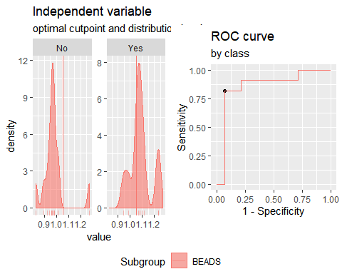

**Analysis PTB vs TSTp. Responses for all groups and cytokines corrected for background by subtraction.**

**IFNγ**

Method: maximize_metric   
 Predictor: var   
 Outcome: Grupo   
 Direction: >=   
 Subgroups: BEADS   
   
 Subgroup: BEADS   
 ---------------------------------------------------------------------------   
 AUC n n_pos n_neg  
 0.8258 23 11 12  
   
 optimal_cutpoint youden acc sensitivity specificity tp fn fp tn  
 11.0172 0.5682 0.7826 0.8182 0.75 9 2 3 9  
   
 Predictor summary:   
 Min. 5% 1st Qu. Median Mean 3rd Qu. 95% Max.  
 overall -14.133 -1.628 4.675 11.017 33.835 38.929 143.842 173.913  
 No -14.133 -7.287 -0.927 6.697 13.923 12.238 62.270 113.385  
 Yes 4.560 7.312 12.919 32.351 55.558 72.591 160.570 173.913  
 SD NAs  
 overall 49.891 0  
 No 32.672 0  
 Yes 57.506 0

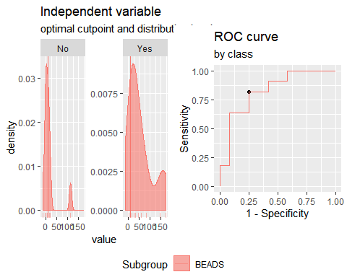

**IP10**

Method: maximize_metric   
 Predictor: var   
 Outcome: Grupo   
 Direction: >=   
 Subgroups: BEADS   
   
 Subgroup: BEADS   
 ---------------------------------------------------------------------------   
 AUC n n_pos n_neg  
 0.8636 23 11 12  
   
 optimal_cutpoint youden acc sensitivity specificity tp fn fp tn  
 93.1022 0.7273 0.8696 0.7273 1 8 3 0 12  
   
 Predictor summary:   
 Min. 5% 1st Qu. Median Mean 3rd Qu. 95%  
 overall -658.117 -566.201 -179.143 -12.899 149.730 220.056 1720.361  
 No -658.117 -610.676 -335.156 -153.565 -208.021 -11.183 41.838  
 Yes -419.981 -233.366 34.696 225.597 540.003 1004.074 1819.003  
 Max. SD NAs  
 overall 1915.317 695.573 0  
 No 44.508 247.402 0  
 Yes 1915.317 822.164 0

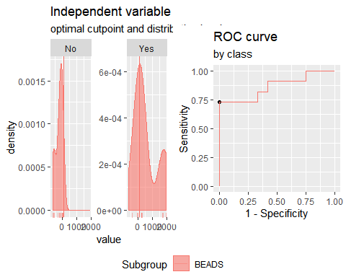

**IL2**

Method: maximize_metric   
 Predictor: var   
 Outcome: Grupo   
 Direction: >=   
 Subgroups: BEADS   
   
 Subgroup: BEADS   
 ---------------------------------------------------------------------------   
 AUC n n_pos n_neg  
 0.9015 23 11 12  
   
 optimal_cutpoint youden acc sensitivity specificity tp fn fp tn  
 7.0677 0.7348 0.8696 0.8182 0.9167 9 2 1 11  
   
 Predictor summary:   
 Min. 5% 1st Qu. Median Mean 3rd Qu. 95% Max. SD  
 overall -3.408 -2.650 -1.064 3.802 6.936 10.075 31.715 37.222 10.642  
 No -3.408 -3.004 -2.329 -0.163 0.844 3.636 6.092 8.196 3.747  
 Yes -0.382 0.284 7.887 10.263 13.581 14.669 35.328 37.222 11.858  
 NAs  
 overall 0  
 No 0  
 Yes 0

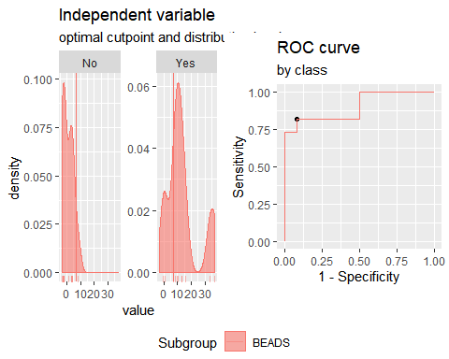

**TNFα**

Method: maximize_metric   
 Predictor: var   
 Outcome: Grupo   
 Direction: >=   
 Subgroups: BEADS   
   
 Subgroup: BEADS   
 ---------------------------------------------------------------------------   
 AUC n n_pos n_neg  
 0.6818 23 11 12  
   
 optimal_cutpoint youden acc sensitivity specificity tp fn fp tn  
 5539.663 0.3864 0.6957 0.6364 0.75 7 4 3 9  
   
 Predictor summary:   
 Min. 5% 1st Qu. Median Mean 3rd Qu. 95%  
 overall 886.691 1059.894 2907.839 3580.945 5898.783 8351.840 14599.727  
 No 886.691 971.615 2323.397 3509.007 4197.917 5667.229 8917.506  
 Yes 1841.040 2245.748 3293.073 6176.805 7754.273 11462.780 15764.478  
 Max. SD NAs  
 overall 16874.281 4504.221 0  
 No 9237.983 2909.772 0  
 Yes 16874.281 5297.311 0

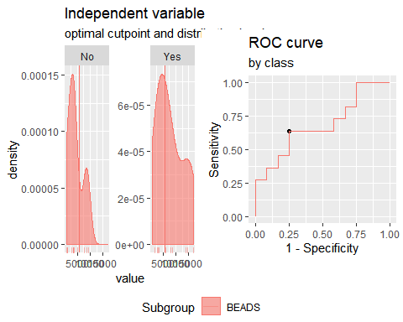

**CCL3**

Method: maximize_metric   
 Predictor: var   
 Outcome: Grupo   
 Direction: >=   
 Subgroups: BEADS   
   
 Subgroup: BEADS   
 ---------------------------------------------------------------------------   
 AUC n n_pos n_neg  
 0.6439 23 11 12  
   
 optimal_cutpoint youden acc sensitivity specificity tp fn fp tn  
 307.2103 0.3788 0.6957 0.5455 0.8333 6 5 2 10  
   
 Predictor summary:   
 Min. 5% 1st Qu. Median Mean 3rd Qu. 95%  
 overall -2136.280 -603.541 -446.171 161.359 170.828 586.773 1675.616  
 No -579.902 -552.284 -488.502 -89.976 9.796 257.478 991.071  
 Yes -2136.280 -1371.224 -42.956 307.210 346.500 1051.463 1779.952  
 Max. SD NAs  
 overall 1857.869 888.308 0  
 No 1305.391 592.148 0  
 Yes 1857.869 1133.681 0

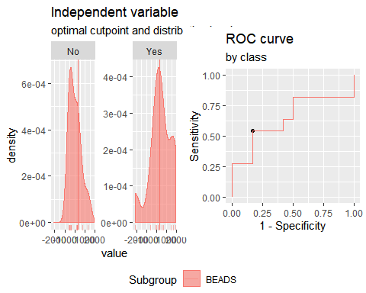

**CCL11**

Method: maximize_metric   
 Predictor: var   
 Outcome: Grupo   
 Direction: >=   
 Subgroups: BEADS   
   
 Subgroup: BEADS   
 ---------------------------------------------------------------------------   
 AUC n n_pos n_neg  
 0.8864 23 11 12  
   
 optimal_cutpoint youden acc sensitivity specificity tp fn fp tn  
 29.8881 0.8182 0.913 0.8182 1 9 2 0 12  
   
 Predictor summary:   
 Min. 5% 1st Qu. Median Mean 3rd Qu. 95% Max.  
 overall -122.061 -98.366 -27.808 1.348 21.908 38.790 217.419 297.653  
 No -122.061 -109.619 -52.941 -17.105 -30.718 -1.052 18.908 24.694  
 Yes -88.708 -49.787 33.890 38.954 79.319 126.180 260.232 297.653  
 SD NAs  
 overall 98.395 0  
 No 45.476 0  
 Yes 109.889 0

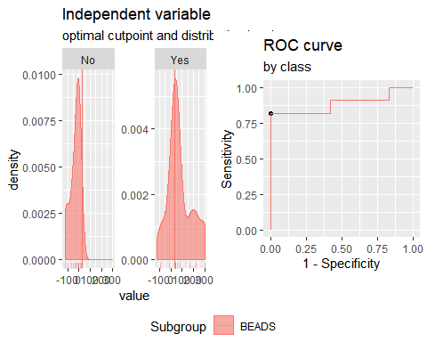

**Analysis PTB vs TSTp. Responses for all groups and cytokinescorrected for background by division (ratio).**

**IFNγ**

Method: maximize_metric   
 Predictor: var   
 Outcome: Grupo   
 Direction: >=   
 Subgroups: BEADS   
   
 Subgroup: BEADS   
 ---------------------------------------------------------------------------   
 AUC n n_pos n_neg  
 0.8712 23 11 12  
   
 optimal_cutpoint youden acc sensitivity specificity tp fn fp tn  
 2.2597 0.6439 0.8261 0.7273 0.9167 8 3 1 11  
   
 Predictor summary:   
 Min. 5% 1st Qu. Median Mean 3rd Qu. 95% Max. SD NAs  
 overall 0.800 0.926 1.254 1.633 2.662 2.612 8.074 11.221 2.601 0  
 No 0.800 0.868 0.967 1.254 1.414 1.733 2.341 2.707 0.584 0  
 Yes 1.317 1.393 1.912 2.520 4.024 5.324 9.732 11.221 3.255 0

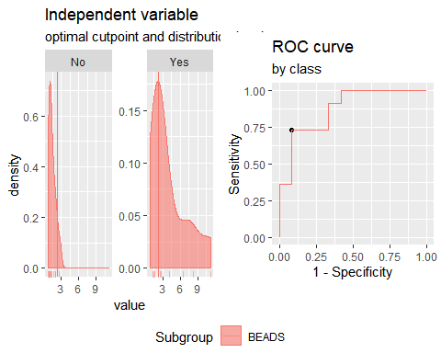

**IP10**

Method: maximize_metric   
 Predictor: var   
 Outcome: Grupo   
 Direction: >=   
 Subgroups: BEADS   
   
 Subgroup: BEADS   
 ---------------------------------------------------------------------------   
 AUC n n_pos n_neg  
 0.8712 23 11 12  
   
 optimal_cutpoint youden acc sensitivity specificity tp fn fp tn  
 0.9212 0.6591 0.8261 0.9091 0.75 10 1 3 9  
   
 Predictor summary:   
 Min. 5% 1st Qu. Median Mean 3rd Qu. 95% Max. SD NAs  
 overall 0.363 0.438 0.634 0.960 1.272 1.373 2.544 6.228 1.210 0  
 No 0.363 0.401 0.514 0.634 0.761 0.911 1.362 1.583 0.356 0  
 Yes 0.770 0.846 1.024 1.357 1.829 1.848 4.408 6.228 1.558 0

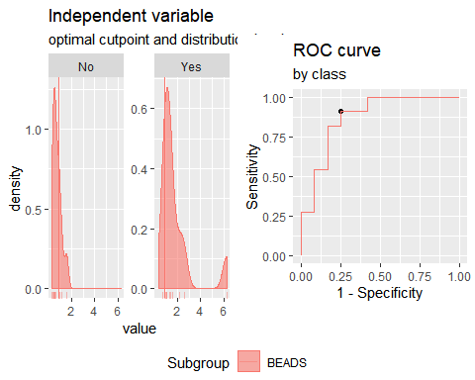

**IL2**

Method: maximize_metric   
 Predictor: var   
 Outcome: Grupo   
 Direction: >=   
 Subgroups: BEADS   
   
 Subgroup: BEADS   
 ---------------------------------------------------------------------------   
 AUC n n_pos n_neg  
 0.9015 23 11 12  
   
 optimal_cutpoint youden acc sensitivity specificity tp fn fp tn  
 1.2237 0.7348 0.8696 0.8182 0.9167 9 2 1 11  
   
 Predictor summary:   
 Min. 5% 1st Qu. Median Mean 3rd Qu. 95% Max. SD NAs  
 overall 0.920 0.928 0.969 1.113 1.210 1.303 1.949 2.200 0.328 0  
 No 0.920 0.924 0.937 0.993 1.025 1.104 1.168 1.226 0.102 0  
 Yes 0.989 1.007 1.229 1.308 1.412 1.428 2.102 2.200 0.373 0

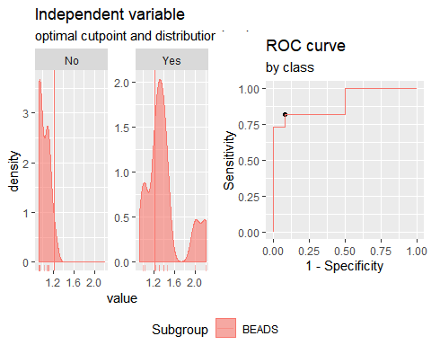

**TNFα**

Method: maximize_metric   
 Predictor: var   
 Outcome: Grupo   
 Direction: >=   
 Subgroups: BEADS   
   
 Subgroup: BEADS   
 ---------------------------------------------------------------------------   
 AUC n n_pos n_neg  
 0.9015 23 11 12  
   
 optimal_cutpoint youden acc sensitivity specificity tp fn fp tn  
 3.2806 0.7348 0.8696 0.8182 0.9167 9 2 1 11  
   
 Predictor summary:   
 Min. 5% 1st Qu. Median Mean 3rd Qu. 95% Max. SD NAs  
 overall 1.129 1.189 1.810 2.794 3.334 3.734 5.897 13.47 2.559 0  
 No 1.129 1.156 1.581 1.810 2.110 2.775 3.378 3.62 0.817 0  
 Yes 2.039 2.090 3.311 3.849 4.669 4.950 9.728 13.47 3.148 0

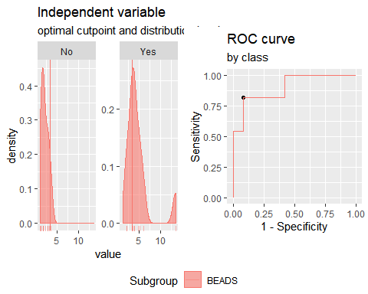

**CCL3**

Method: maximize_metric   
 Predictor: var   
 Outcome: Grupo   
 Direction: >=   
 Subgroups: BEADS   
   
 Subgroup: BEADS   
 ---------------------------------------------------------------------------   
 AUC n n_pos n_neg  
 0.6439 23 11 12  
   
 optimal_cutpoint youden acc sensitivity specificity tp fn fp tn  
 1.047 0.3788 0.6957 0.5455 0.8333 6 5 2 10  
   
 Predictor summary:   
 Min. 5% 1st Qu. Median Mean 3rd Qu. 95% Max. SD NAs  
 overall 0.598 0.904 0.933 1.025 1.034 1.091 1.327 1.395 0.166 0  
 No 0.904 0.916 0.927 0.986 1.001 1.040 1.144 1.194 0.088 0  
 Yes 0.598 0.751 0.993 1.047 1.070 1.204 1.363 1.395 0.221 0

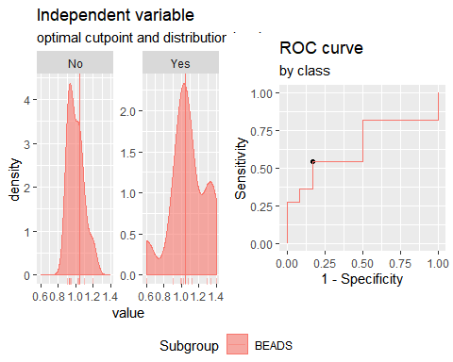

**CCL11**

Method: maximize_metric   
 Predictor: var   
 Outcome: Grupo   
 Direction: >=   
 Subgroups: BEADS   
   
 Subgroup: BEADS   
 ---------------------------------------------------------------------------   
 AUC n n_pos n_neg  
 0.8939 23 11 12  
   
 optimal_cutpoint youden acc sensitivity specificity tp fn fp tn  
 1.051 0.8182 0.913 0.8182 1 9 2 0 12  
   
 Predictor summary:   
 Min. 5% 1st Qu. Median Mean 3rd Qu. 95% Max. SD NAs  
 overall 0.885 0.901 0.965 1.003 1.023 1.071 1.219 1.233 0.091 0  
 No 0.885 0.893 0.931 0.984 0.966 0.998 1.022 1.029 0.048 0  
 Yes 0.944 0.965 1.051 1.077 1.084 1.105 1.232 1.233 0.087 0

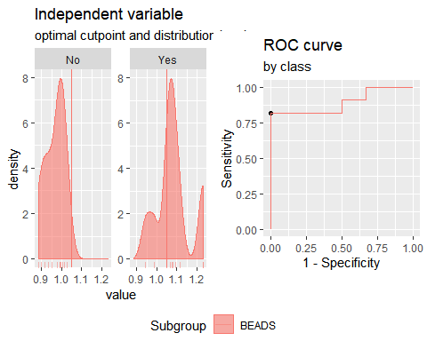

**Analysis TSTp vs TSTn. Responses for all groups and cytokines corrected for background by subtraction.**

**IFNγ**

Method: maximize_metric   
 Predictor: var   
 Outcome: GrupoTsTp   
 Direction: >=   
 Subgroups: BEADS   
   
 Subgroup: BEADS   
 ---------------------------------------------------------------------------   
 AUC n n_pos n_neg  
 0.4643 26 12 14  
   
 optimal_cutpoint youden acc sensitivity specificity tp fn fp tn  
 59.0875 0.0833 0.5769 0.0833 1 1 11 0 14  
   
 Predictor summary:   
 Min. 5% 1st Qu. Median Mean 3rd Qu. 95% Max. SD  
 overall -14.133 -5.178 -0.760 6.697 11.866 13.696 41.932 113.385 24.231  
 No -6.045 -3.791 -0.333 7.366 10.103 13.696 39.306 43.573 14.787  
 Yes -14.133 -7.287 -0.927 6.697 13.923 12.238 62.270 113.385 32.672  
 NAs  
 overall 0  
 No 0  
 Yes 0

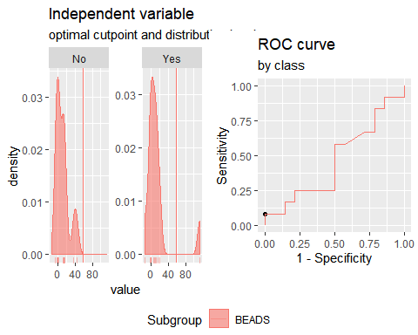

**IP10**

Method: maximize_metric   
 Predictor: var   
 Outcome: GrupoTsTp   
 Direction: >=   
 Subgroups: BEADS   
   
 Subgroup: BEADS   
 ---------------------------------------------------------------------------   
 AUC n n_pos n_neg  
 0.5833 26 12 14  
   
 optimal_cutpoint youden acc sensitivity specificity tp fn fp tn  
 -197.017 0.2381 0.6154 0.6667 0.5714 8 4 6 8  
   
 Predictor summary:   
 Min. 5% 1st Qu. Median Mean 3rd Qu. 95%  
 overall -1997.979 -932.908 -500.549 -179.143 -290.191 -30.476 252.845  
 No -1997.979 -1365.221 -511.676 -205.549 -360.622 -94.031 327.698  
 Yes -658.117 -610.676 -335.156 -153.565 -208.021 -11.183 41.838  
 Max. SD NAs  
 overall 337.740 463.574 0  
 No 337.740 591.528 0  
 Yes 44.508 247.402 0

Multiple optimal cutpoints found, applying break_ties.

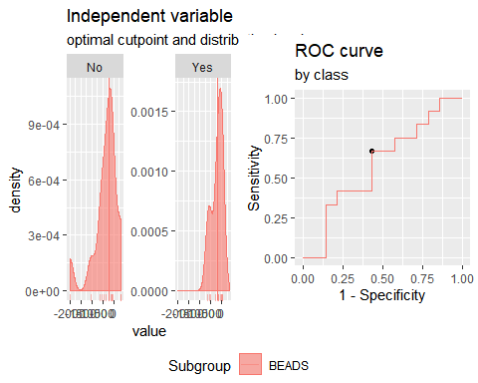

**IL2**

Method: maximize_metric   
 Predictor: var   
 Outcome: GrupoTsTp   
 Direction: >=   
 Subgroups: BEADS   
   
 Subgroup: BEADS   
 ---------------------------------------------------------------------------   
 AUC n n_pos n_neg  
 0.6429 26 12 14  
   
 optimal_cutpoint youden acc sensitivity specificity tp fn fp tn  
 -0.9935 -0.0714 0.4615 0.5 0.4286 6 6 8 6  
   
 Predictor summary:   
 Min. 5% 1st Qu. Median Mean 3rd Qu. 95% Max. SD NAs  
 overall -9.247 -6.029 -2.617 -0.796 -0.301 1.685 7.240 13.208 4.624 0  
 No -9.247 -7.204 -4.298 -0.796 -1.282 0.198 5.775 13.208 5.195 0  
 Yes -3.408 -3.004 -2.329 -0.163 0.844 3.636 6.092 8.196 3.747 0

Multiple optimal cutpoints found, applying break_ties.

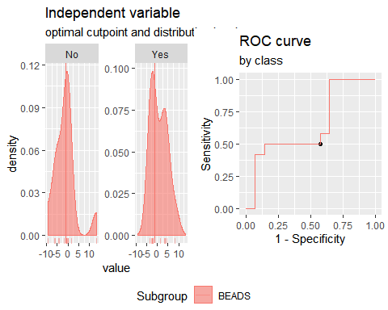

**TNFα**

Method: maximize_metric   
 Predictor: var   
 Outcome: GrupoTsTp   
 Direction: >=   
 Subgroups: BEADS   
   
 Subgroup: BEADS   
 ---------------------------------------------------------------------------   
 AUC n n_pos n_neg  
 0.25 26 12 14  
   
 optimal_cutpoint youden acc sensitivity specificity tp fn fp tn  
 Inf 0 0.5385 0 1 0 12 0 14  
   
 Predictor summary:   
 Min. 5% 1st Qu. Median Mean 3rd Qu. 95%  
 overall 886.691 1088.087 3182.569 4938.565 6866.094 9092.311 16929.229  
 No 1920.867 2410.888 4674.842 7476.587 9153.103 13794.490 18008.900  
 Yes 886.691 971.615 2323.397 3509.007 4197.917 5667.229 8917.506  
 Max. SD NAs  
 overall 19937.605 5340.763 0  
 No 19937.605 5956.919 0  
 Yes 9237.983 2909.772 0

Multiple optimal cutpoints found, applying break_ties.

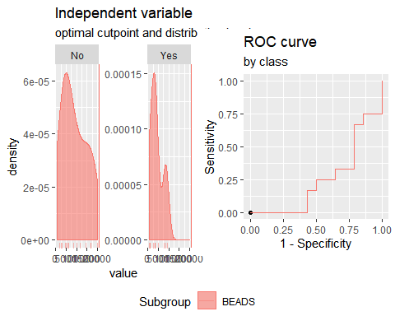

**CCL3**

Method: maximize_metric   
 Predictor: var   
 Outcome: GrupoTsTp   
 Direction: >=   
 Subgroups: BEADS   
   
 Subgroup: BEADS   
 ---------------------------------------------------------------------------   
 AUC n n_pos n_neg  
 0.5179 26 12 14  
   
 optimal_cutpoint youden acc sensitivity specificity tp fn fp tn  
 -211.452 0.0714 0.5385 0.5 0.5714 6 6 6 8  
   
 Predictor summary:   
 Min. 5% 1st Qu. Median Mean 3rd Qu. 95%  
 overall -759.162 -742.416 -475.848 -278.073 37.363 263.555 1282.665  
 No -759.162 -753.985 -455.148 -278.073 60.991 240.161 1652.318  
 Yes -579.902 -552.284 -488.502 -89.976 9.796 257.478 991.071  
 Max. SD NAs  
 overall 2465.435 765.967 0  
 No 2465.435 911.198 0  
 Yes 1305.391 592.148 0

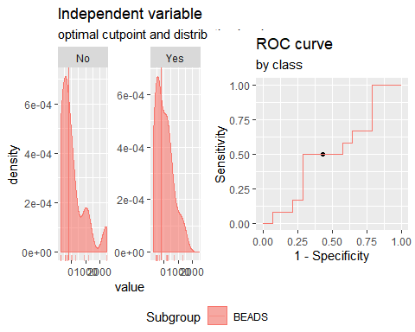

**CCL11**

Method: maximize_metric   
 Predictor: var   
 Outcome: GrupoTsTp   
 Direction: >=   
 Subgroups: BEADS   
   
 Subgroup: BEADS   
 ---------------------------------------------------------------------------   
 AUC n n_pos n_neg  
 0.5298 26 12 14  
   
 optimal_cutpoint youden acc sensitivity specificity tp fn fp tn  
 -11.073 0.2857 0.6538 0.5 0.7857 6 6 3 11  
   
 Predictor summary:   
 Min. 5% 1st Qu. Median Mean 3rd Qu. 95% Max.  
 overall -271.455 -116.405 -48.707 -22.249 -5.012 -2.402 22.824 826.836  
 No -271.455 -133.163 -46.194 -25.237 17.022 -15.304 300.581 826.836  
 Yes -122.061 -109.619 -52.941 -17.105 -30.718 -1.052 18.908 24.694  
 SD NAs  
 overall 179.463 0  
 No 243.010 0  
 Yes 45.476 0

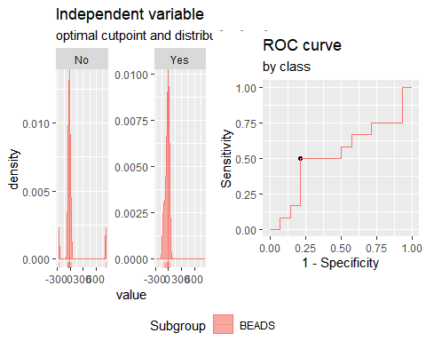

**Analysis TSTp vs TSTn. Responses for all groups and cytokines corrected for background by division (ratio).**

**IFNγ**

Method: maximize_metric   
 Predictor: var   
 Outcome: GrupoTsTp   
 Direction: >=   
 Subgroups: BEADS   
   
 Subgroup: BEADS   
 ---------------------------------------------------------------------------   
 AUC n n_pos n_neg  
 0.5238 26 12 14  
   
 optimal_cutpoint youden acc sensitivity specificity tp fn fp tn  
 2.0332 0.1786 0.6154 0.25 0.9286 3 9 1 13  
   
 Predictor summary:   
 Min. 5% 1st Qu. Median Mean 3rd Qu. 95% Max. SD NAs  
 overall 0.800 0.857 0.960 1.265 1.363 1.595 2.289 2.707 0.501 0  
 No 0.838 0.887 0.962 1.305 1.319 1.462 2.009 2.372 0.435 0  
 Yes 0.800 0.868 0.967 1.254 1.414 1.733 2.341 2.707 0.584 0

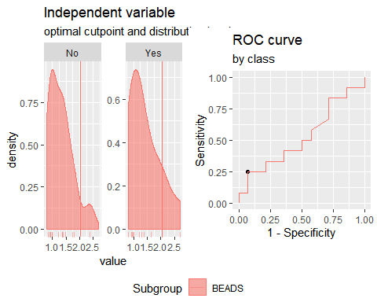

**IP10**

Method: maximize_metric   
 Predictor: var   
 Outcome: GrupoTsTp   
 Direction: >=   
 Subgroups: BEADS   
   
 Subgroup: BEADS   
 ---------------------------------------------------------------------------   
 AUC n n_pos n_neg  
 0.6071 26 12 14  
   
 optimal_cutpoint youden acc sensitivity specificity tp fn fp tn  
 0.876 0.2738 0.6538 0.4167 0.8571 5 7 2 12  
   
 Predictor summary:   
 Min. 5% 1st Qu. Median Mean 3rd Qu. 95% Max. SD NAs  
 overall 0.222 0.366 0.493 0.567 0.710 0.852 1.522 1.583 0.365 0  
 No 0.222 0.321 0.451 0.545 0.667 0.702 1.467 1.557 0.379 0  
 Yes 0.363 0.401 0.514 0.634 0.761 0.911 1.362 1.583 0.356 0

Multiple optimal cutpoints found, applying break_ties.

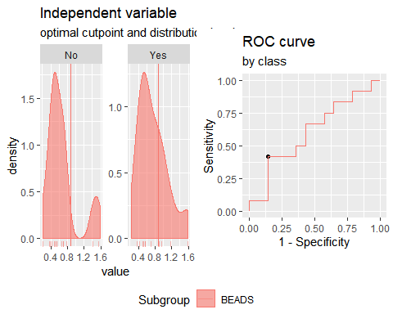

**IL2**

Method: maximize_metric   
 Predictor: var   
 Outcome: GrupoTsTp   
 Direction: >=   
 Subgroups: BEADS   
   
 Subgroup: BEADS   
 ---------------------------------------------------------------------------   
 AUC n n_pos n_neg  
 0.6488 26 12 14  
   
 optimal_cutpoint youden acc sensitivity specificity tp fn fp tn  
 0.9789 0 0.5 0.5 0.5 6 6 7 7  
   
 Predictor summary:   
 Min. 5% 1st Qu. Median Mean 3rd Qu. 95% Max. SD NAs  
 overall 0.821 0.873 0.929 0.976 0.999 1.063 1.200 1.361 0.119 0  
 No 0.821 0.853 0.885 0.976 0.977 1.006 1.173 1.361 0.131 0  
 Yes 0.920 0.924 0.937 0.993 1.025 1.104 1.168 1.226 0.102 0

Multiple optimal cutpoints found, applying break_ties.

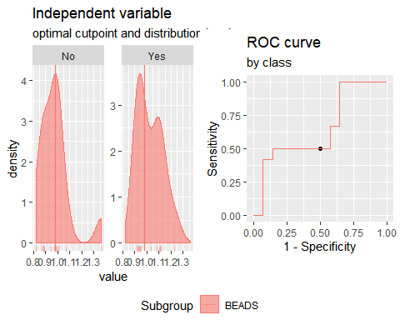

**TNFα**

Method: maximize_metric   
 Predictor: var   
 Outcome: GrupoTsTp   
 Direction: >=   
 Subgroups: BEADS   
   
 Subgroup: BEADS   
 ---------------------------------------------------------------------------   
 AUC n n_pos n_neg  
 0.0893 26 12 14  
   
 optimal_cutpoint youden acc sensitivity specificity tp fn fp tn  
 Inf 0 0.5385 0 1 0 12 0 14  
   
 Predictor summary:   
 Min. 5% 1st Qu. Median Mean 3rd Qu. 95% Max. SD NAs  
 overall 1.129 1.206 1.938 2.808 4.426 4.902 14.832 16.032 4.166 0  
 No 2.487 2.624 2.989 4.660 6.411 5.757 15.385 16.032 4.860 0  
 Yes 1.129 1.156 1.581 1.810 2.110 2.775 3.378 3.620 0.817 0

Multiple optimal cutpoints found, applying break_ties.

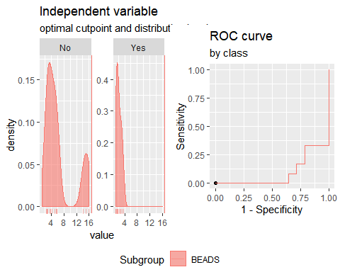

**CCL3**

Method: maximize_metric   
 Predictor: var   
 Outcome: GrupoTsTp   
 Direction: >=   
 Subgroups: BEADS   
   
 Subgroup: BEADS   
 ---------------------------------------------------------------------------   
 AUC n n_pos n_neg  
 0.5119 26 12 14  
   
 optimal_cutpoint youden acc sensitivity specificity tp fn fp tn  
 0.9647 0 0.5 0.5 0.5 6 6 7 7  
   
 Predictor summary:   
 Min. 5% 1st Qu. Median Mean 3rd Qu. 95% Max. SD NAs  
 overall 0.888 0.892 0.929 0.964 1.015 1.041 1.193 1.589 0.146 0  
 No 0.888 0.890 0.937 0.964 1.028 1.035 1.331 1.589 0.184 0  
 Yes 0.904 0.916 0.927 0.986 1.001 1.040 1.144 1.194 0.088 0

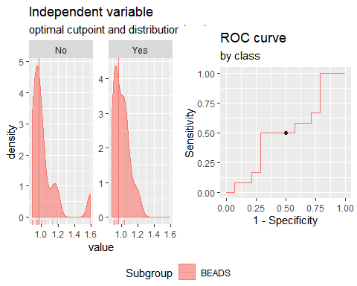

**CCL11**

Method: maximize_metric   
 Predictor: var   
 Outcome: GrupoTsTp   
 Direction: >=   
 Subgroups: BEADS   
   
 Subgroup: BEADS   
 ---------------------------------------------------------------------------   
 AUC n n_pos n_neg  
 0.5417 26 12 14  
   
 optimal_cutpoint youden acc sensitivity specificity tp fn fp tn  
 0.9902 0.2857 0.6538 0.5 0.7857 6 6 3 11  
   
 Predictor summary:   
 Min. 5% 1st Qu. Median Mean 3rd Qu. 95% Max. SD NAs  
 overall 0.829 0.887 0.937 0.971 0.972 0.996 1.026 1.270 0.077 0  
 No 0.829 0.872 0.946 0.969 0.977 0.983 1.104 1.270 0.097 0  
 Yes 0.885 0.893 0.931 0.984 0.966 0.998 1.022 1.029 0.048 0

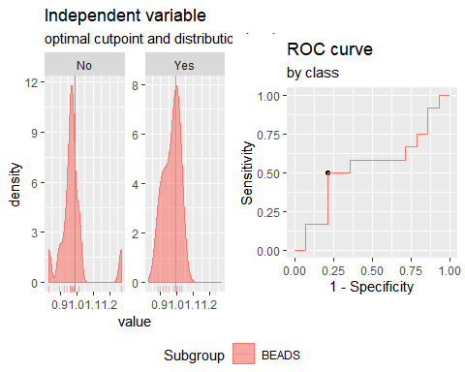

**Analysis PTB vs TSTp+TSTn. Responses for all groups and cytokines corrected for background by subtraction.**

**IFNγ**

Method: maximize_metric   
 Predictor: var   
 Outcome: Grupo   
 Direction: >=   
 Subgroups: BEADS   
   
 Subgroup: BEADS   
 ---------------------------------------------------------------------------   
 AUC n n_pos n_neg  
 0.8217 37 11 26  
   
 optimal_cutpoint youden acc sensitivity specificity tp fn fp tn  
 26.5005 0.521 0.8108 0.6364 0.8846 7 4 3 23  
   
 Predictor summary:   
 Min. 5% 1st Qu. Median Mean 3rd Qu. 95% Max.  
 overall -14.133 -3.271 0.000 11.017 24.856 26.501 120.153 173.913  
 No -14.133 -5.178 -0.760 6.697 11.866 13.696 41.932 113.385  
 Yes 4.560 7.312 12.919 32.351 55.558 72.591 160.570 173.913  
 SD NAs  
 overall 41.668 0  
 No 24.231 0  
 Yes 57.506 0

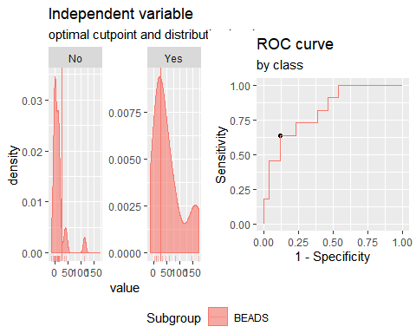

**"IP10**"  
 Method: maximize_metric   
 Predictor: var   
 Outcome: Grupo   
 Direction: >=   
 Subgroups: BEADS   
   
 Subgroup: BEADS   
 ---------------------------------------------------------------------------   
 AUC n n_pos n_neg  
 0.8531 37 11 26  
   
 optimal_cutpoint youden acc sensitivity specificity tp fn fp tn  
 93.1022 0.6503 0.8649 0.7273 0.9231 8 3 2 24  
   
 Predictor summary:   
 Min. 5% 1st Qu. Median Mean 3rd Qu. 95%  
 overall -1997.979 -731.395 -337.466 -94.016 -43.376 93.102 1704.064  
 No -1997.979 -932.908 -500.549 -179.143 -290.191 -30.476 252.845  
 Yes -419.981 -233.366 34.696 225.597 540.003 1004.074 1819.003  
 Max. SD NAs  
 overall 1915.317 696.410 0  
 No 337.740 463.574 0  
 Yes 1915.317 822.164 0

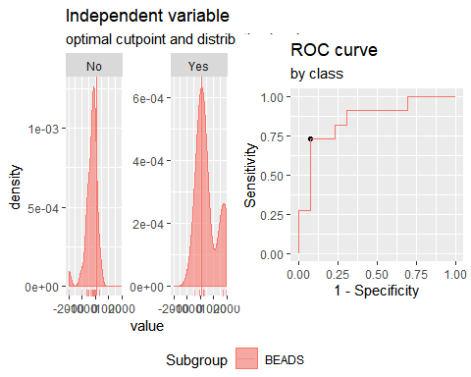

**IL2**

Method: maximize_metric   
 Predictor: var   
 Outcome: Grupo   
 Direction: >=   
 Subgroups: BEADS   
   
 Subgroup: BEADS   
 ---------------------------------------------------------------------------   
 AUC n n_pos n_neg  
 0.9091 37 11 26  
   
 optimal_cutpoint youden acc sensitivity specificity tp fn fp tn  
 7.0677 0.7413 0.8919 0.8182 0.9231 9 2 2 24  
   
 Predictor summary:   
 Min. 5% 1st Qu. Median Mean 3rd Qu. 95% Max. SD  
 overall -9.247 -5.864 -1.934 0.318 3.826 8.196 19.680 37.222 9.761  
 No -9.247 -6.029 -2.617 -0.796 -0.301 1.685 7.240 13.208 4.624  
 Yes -0.382 0.284 7.887 10.263 13.581 14.669 35.328 37.222 11.858  
 NAs  
 overall 0  
 No 0  
 Yes 0

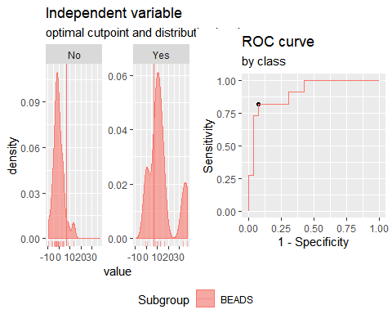

**TNFα**

Method: maximize_metric   
 Predictor: var   
 Outcome: Grupo   
 Direction: >=   
 Subgroups: BEADS   
   
 Subgroup: BEADS   
 ---------------------------------------------------------------------------   
 AUC n n_pos n_neg  
 0.542 37 11 26  
   
 optimal_cutpoint youden acc sensitivity specificity tp fn fp tn  
 5539.663 0.1748 0.5676 0.6364 0.5385 7 4 12 14  
   
 Predictor summary:   
 Min. 5% 1st Qu. Median Mean 3rd Qu. 95%  
 overall 886.691 1191.464 3152.992 5539.663 7130.148 9237.983 16893.50  
 No 886.691 1088.087 3182.569 4938.565 6866.094 9092.311 16929.23  
 Yes 1841.040 2245.748 3293.073 6176.805 7754.273 11462.780 15764.48  
 Max. SD NAs  
 overall 19937.60 5269.953 0  
 No 19937.60 5340.763 0  
 Yes 16874.28 5297.311 0

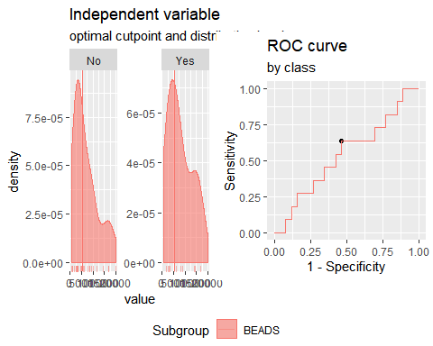

**CCL3**

Method: maximize_metric   
 Predictor: var   
 Outcome: Grupo   
 Direction: >=   
 Subgroups: BEADS   
   
 Subgroup: BEADS   
 ---------------------------------------------------------------------------   
 AUC n n_pos n_neg  
 0.6503 37 11 26  
   
 optimal_cutpoint youden acc sensitivity specificity tp fn fp tn  
 -64.3795 0.3566 0.6216 0.8182 0.5385 9 2 12 14  
   
 Predictor summary:   
 Min. 5% 1st Qu. Median Mean 3rd Qu. 95%  
 overall -2136.280 -752.790 -460.681 -16.564 129.268 508.456 1733.203  
 No -759.162 -742.416 -475.848 -278.073 37.363 263.555 1282.665  
 Yes -2136.280 -1371.224 -42.956 307.210 346.500 1051.463 1779.952  
 Max. SD NAs  
 overall 2465.435 885.981 0  
 No 2465.435 765.967 0  
 Yes 1857.869 1133.681 0

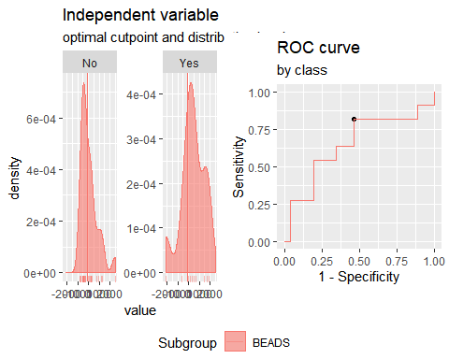

**CCL11**

Method: maximize_metric   
 Predictor: var   
 Outcome: Grupo   
 Direction: >=   
 Subgroups: BEADS   
   
 Subgroup: BEADS   
 ---------------------------------------------------------------------------   
 AUC n n_pos n_neg  
 0.8601 37 11 26  
   
 optimal_cutpoint youden acc sensitivity specificity tp fn fp tn  
 29.8881 0.7797 0.9189 0.8182 0.9615 9 2 1 25  
   
 Predictor summary:   
 Min. 5% 1st Qu. Median Mean 3rd Qu. 95% Max.  
 overall -271.455 -103.963 -38.462 -11.073 20.059 29.888 237.779 826.836  
 No -271.455 -116.405 -48.707 -22.249 -5.012 -2.402 22.824 826.836  
 Yes -88.708 -49.787 33.890 38.954 79.319 126.180 260.232 297.653  
 SD NAs  
 overall 165.068 0  
 No 179.463 0  
 Yes 109.889 0

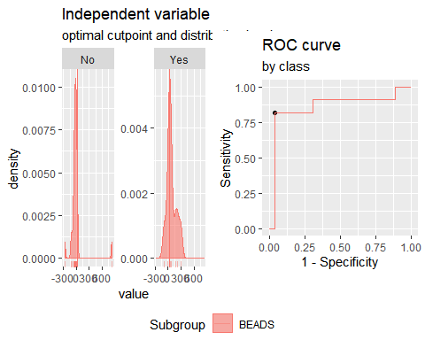

**Analysis PTB vs TSTp+TSTn. Responses for all groups and cytokines corrected for background by division (ratio).**

**IFNγ**

Method: maximize_metric   
 Predictor: var   
 Outcome: Grupo   
 Direction: >=   
 Subgroups: BEADS   
   
 Subgroup: BEADS   
 ---------------------------------------------------------------------------   
 AUC n n_pos n_neg  
 0.8846 37 11 26  
   
 optimal_cutpoint youden acc sensitivity specificity tp fn fp tn  
 2.2597 0.6503 0.8649 0.7273 0.9231 8 3 2 24  
   
 Predictor summary:   
 Min. 5% 1st Qu. Median Mean 3rd Qu. 95% Max. SD NAs  
 overall 0.800 0.898 1.000 1.409 2.154 2.260 6.897 11.221 2.154 0  
 No 0.800 0.857 0.960 1.265 1.363 1.595 2.289 2.707 0.501 0  
 Yes 1.317 1.393 1.912 2.520 4.024 5.324 9.732 11.221 3.255 0

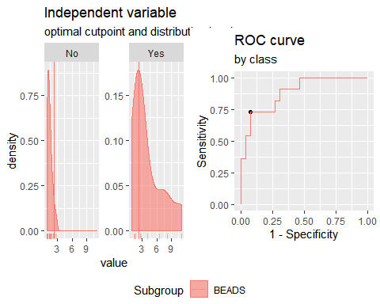

**IP10**

Method: maximize_metric   
 Predictor: var   
 Outcome: Grupo   
 Direction: >=   
 Subgroups: BEADS   
   
 Subgroup: BEADS   
 ---------------------------------------------------------------------------   
 AUC n n_pos n_neg  
 0.8846 37 11 26  
   
 optimal_cutpoint youden acc sensitivity specificity tp fn fp tn  
 0.9212 0.7168 0.8378 0.9091 0.8077 10 1 5 21  
   
 Predictor summary:   
 Min. 5% 1st Qu. Median Mean 3rd Qu. 95% Max. SD NAs  
 overall 0.222 0.372 0.519 0.770 1.043 1.180 2.234 6.228 1.017 0  
 No 0.222 0.366 0.493 0.567 0.710 0.852 1.522 1.583 0.365 0  
 Yes 0.770 0.846 1.024 1.357 1.829 1.848 4.408 6.228 1.558 0

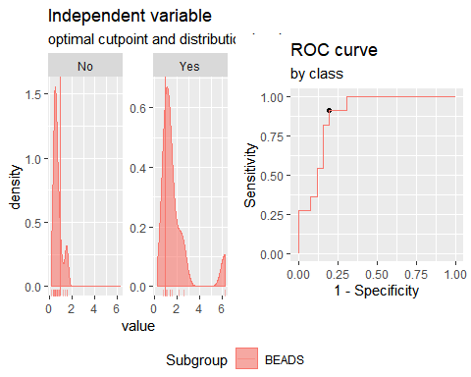

**IL2**

Method: maximize_metric   
 Predictor: var   
 Outcome: Grupo   
 Direction: >=   
 Subgroups: BEADS   
   
 Subgroup: BEADS   
 ---------------------------------------------------------------------------   
 AUC n n_pos n_neg  
 0.9161 37 11 26  
   
 optimal_cutpoint youden acc sensitivity specificity tp fn fp tn  
 1.2237 0.7413 0.8919 0.8182 0.9231 9 2 2 24  
   
 Predictor summary:   
 Min. 5% 1st Qu. Median Mean 3rd Qu. 95% Max. SD NAs  
 overall 0.821 0.879 0.945 1.010 1.122 1.226 1.567 2.200 0.292 0  
 No 0.821 0.873 0.929 0.976 0.999 1.063 1.200 1.361 0.119 0  
 Yes 0.989 1.007 1.229 1.308 1.412 1.428 2.102 2.200 0.373 0

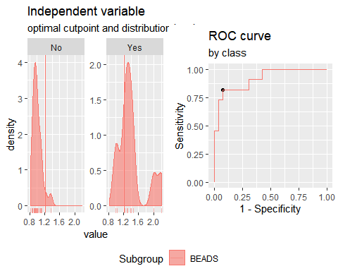

**TNFα**

Method: maximize_metric   
 Predictor: var   
 Outcome: Grupo   
 Direction: >=   
 Subgroups: BEADS   
   
 Subgroup: BEADS   
 ---------------------------------------------------------------------------   
 AUC n n_pos n_neg  
 0.6259 37 11 26  
   
 optimal_cutpoint youden acc sensitivity specificity tp fn fp tn  
 3.2806 0.3951 0.6486 0.8182 0.5769 9 2 11 15  
   
 Predictor summary:   
 Min. 5% 1st Qu. Median Mean 3rd Qu. 95% Max. SD NAs  
 overall 1.129 1.267 2.294 3.341 4.498 5.092 14.380 16.032 3.850 0  
 No 1.129 1.206 1.938 2.808 4.426 4.902 14.832 16.032 4.166 0  
 Yes 2.039 2.090 3.311 3.849 4.669 4.950 9.728 13.470 3.148 0

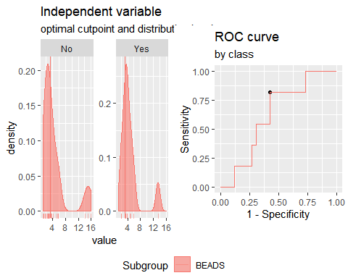

**CCL3**

Method: maximize_metric   
 Predictor: var   
 Outcome: Grupo   
 Direction: >=   
 Subgroups: BEADS   
   
 Subgroup: BEADS   
 ---------------------------------------------------------------------------   
 AUC n n_pos n_neg  
 0.6503 37 11 26  
   
 optimal_cutpoint youden acc sensitivity specificity tp fn fp tn  
 0.9884 0.3566 0.6216 0.8182 0.5385 9 2 12 14  
   
 Predictor summary:   
 Min. 5% 1st Qu. Median Mean 3rd Qu. 95% Max. SD NAs  
 overall 0.598 0.890 0.934 0.998 1.032 1.081 1.344 1.589 0.170 0  
 No 0.888 0.892 0.929 0.964 1.015 1.041 1.193 1.589 0.146 0  
 Yes 0.598 0.751 0.993 1.047 1.070 1.204 1.363 1.395 0.221 0

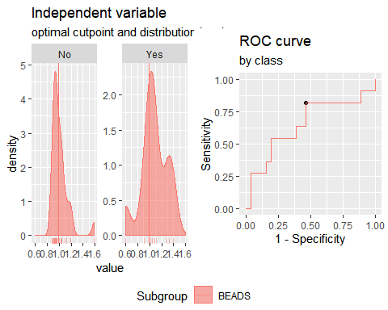

**CCL11**

Method: maximize_metric   
 Predictor: var   
 Outcome: Grupo   
 Direction: >=   
 Subgroups: BEADS   
   
 Subgroup: BEADS   
 ---------------------------------------------------------------------------   
 AUC n n_pos n_neg  
 0.8741 37 11 26  
   
 optimal_cutpoint youden acc sensitivity specificity tp fn fp tn  
 1.051 0.7797 0.9189 0.8182 0.9615 9 2 1 25  
   
 Predictor summary:   
 Min. 5% 1st Qu. Median Mean 3rd Qu. 95% Max. SD NAs  
 overall 0.829 0.893 0.951 0.986 1.005 1.051 1.231 1.270 0.095 0  
 No 0.829 0.887 0.937 0.971 0.972 0.996 1.026 1.270 0.077 0  
 Yes 0.944 0.965 1.051 1.077 1.084 1.105 1.232 1.233 0.087 0

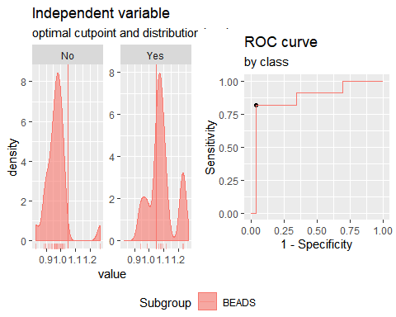

**Analysis PTB+TSTp vs TSTn. Responses for all groups and cytokines corrected for background by subtraction.**

**IFNγ**

Method: maximize_metric   
 Predictor: var   
 Outcome: GrupoTsTp   
 Direction: >=   
 Subgroups: BEADS   
   
 Subgroup: BEADS   
 ---------------------------------------------------------------------------   
 AUC n n_pos n_neg  
 0.6335 37 23 14  
   
 optimal_cutpoint youden acc sensitivity specificity tp fn fp tn  
 4.5601 0.2826 0.6757 0.7826 0.5 18 5 7 7  
   
 Predictor summary:   
 Min. 5% 1st Qu. Median Mean 3rd Qu. 95% Max.  
 overall -14.133 -3.271 0.000 11.017 24.856 26.501 120.153 173.913  
 No -6.045 -3.791 -0.333 7.366 10.103 13.696 39.306 43.573  
 Yes -14.133 -1.628 4.675 11.017 33.835 38.929 143.842 173.913  
 SD NAs  
 overall 41.668 0  
 No 14.787 0  
 Yes 49.891 0

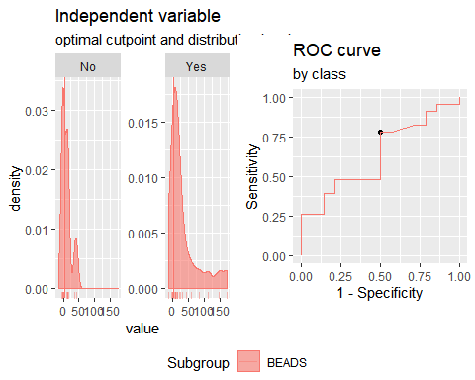

**IP10**

Method: maximize_metric   
 Predictor: var   
 Outcome: GrupoTsTp   
 Direction: >=   
 Subgroups: BEADS   
   
 Subgroup: BEADS   
 ---------------------------------------------------------------------------   
 AUC n n_pos n_neg  
 0.7081 37 23 14  
   
 optimal_cutpoint youden acc sensitivity specificity tp fn fp tn  
 -46.7508 0.4379 0.7027 0.6522 0.7857 15 8 3 11  
   
 Predictor summary:   
 Min. 5% 1st Qu. Median Mean 3rd Qu. 95%  
 overall -1997.979 -731.395 -337.466 -94.016 -43.376 93.102 1704.064  
 No -1997.979 -1365.221 -511.676 -205.549 -360.622 -94.031 327.698  
 Yes -658.117 -566.201 -179.143 -12.899 149.730 220.056 1720.361  
 Max. SD NAs  
 overall 1915.317 696.410 0  
 No 337.740 591.528 0  
 Yes 1915.317 695.573 0

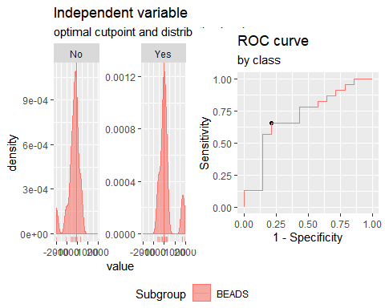**IL2**

Method: maximize_metric   
 Predictor: var   
 Outcome: GrupoTsTp   
 Direction: >=   
 Subgroups: BEADS   
   
 Subgroup: BEADS   
 ---------------------------------------------------------------------------   
 AUC n n_pos n_neg  
 0.7733 37 23 14  
   
 optimal_cutpoint youden acc sensitivity specificity tp fn fp tn  
 0.9491 0.5528 0.7568 0.6957 0.8571 16 7 2 12  
   
 Predictor summary:   
 Min. 5% 1st Qu. Median Mean 3rd Qu. 95% Max. SD  
 overall -9.247 -5.864 -1.934 0.318 3.826 8.196 19.680 37.222 9.761  
 No -9.247 -7.204 -4.298 -0.796 -1.282 0.198 5.775 13.208 5.195  
 Yes -3.408 -2.650 -1.064 3.802 6.936 10.075 31.715 37.222 10.642  
 NAs  
 overall 0  
 No 0  
 Yes 0

Multiple optimal cutpoints found, applying break_ties.

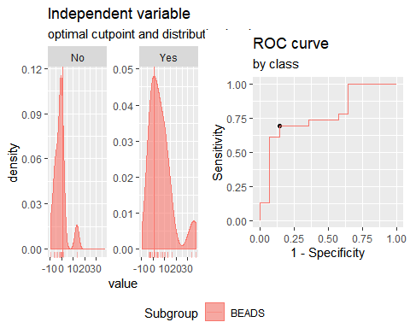

**TNFα**

Method: maximize_metric   
 Predictor: var   
 Outcome: GrupoTsTp   
 Direction: >=   
 Subgroups: BEADS   
   
 Subgroup: BEADS   
 ---------------------------------------------------------------------------   
 AUC n n_pos n_neg  
 0.3323 37 23 14  
   
 optimal_cutpoint youden acc sensitivity specificity tp fn fp tn  
 Inf 0 0.3784 0 1 0 23 0 14  
   
 Predictor summary:   
 Min. 5% 1st Qu. Median Mean 3rd Qu. 95%  
 overall 886.691 1191.464 3152.992 5539.663 7130.148 9237.983 16893.50  
 No 1920.867 2410.888 4674.842 7476.587 9153.103 13794.490 18008.90  
 Yes 886.691 1059.894 2907.839 3580.945 5898.783 8351.840 14599.73  
 Max. SD NAs  
 overall 19937.60 5269.953 0  
 No 19937.60 5956.919 0  
 Yes 16874.28 4504.221 0

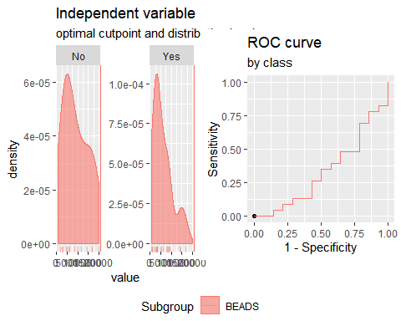

**CCL3**

Method: maximize_metric   
 Predictor: var   
 Outcome: GrupoTsTp   
 Direction: >=   
 Subgroups: BEADS   
   
 Subgroup: BEADS   
 ---------------------------------------------------------------------------   
 AUC n n_pos n_neg  
 0.5839 37 23 14  
   
 optimal_cutpoint youden acc sensitivity specificity tp fn fp tn  
 156.998 0.2795 0.6216 0.5652 0.7143 13 10 4 10  
   
 Predictor summary:   
 Min. 5% 1st Qu. Median Mean 3rd Qu. 95%  
 overall -2136.280 -752.790 -460.681 -16.564 129.268 508.456 1733.203  
 No -759.162 -753.985 -455.148 -278.073 60.991 240.161 1652.318  
 Yes -2136.280 -603.541 -446.171 161.359 170.828 586.773 1675.616  
 Max. SD NAs  
 overall 2465.435 885.981 0  
 No 2465.435 911.198 0  
 Yes 1857.869 888.308 0

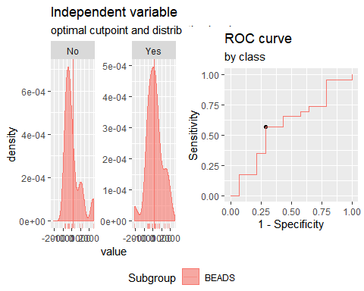

**CCL11**

Method: maximize_metric   
 Predictor: var   
 Outcome: GrupoTsTp   
 Direction: >=   
 Subgroups: BEADS   
   
 Subgroup: BEADS   
 ---------------------------------------------------------------------------   
 AUC n n_pos n_neg  
 0.677 37 23 14  
   
 optimal_cutpoint youden acc sensitivity specificity tp fn fp tn  
 -11.073 0.4814 0.7297 0.6957 0.7857 16 7 3 11  
   
 Predictor summary:   
 Min. 5% 1st Qu. Median Mean 3rd Qu. 95% Max.  
 overall -271.455 -103.963 -38.462 -11.073 20.059 29.888 237.779 826.836  
 No -271.455 -133.163 -46.194 -25.237 17.022 -15.304 300.581 826.836  
 Yes -122.061 -98.366 -27.808 1.348 21.908 38.790 217.419 297.653  
 SD NAs  
 overall 165.068 0  
 No 243.010 0  
 Yes 98.395 0

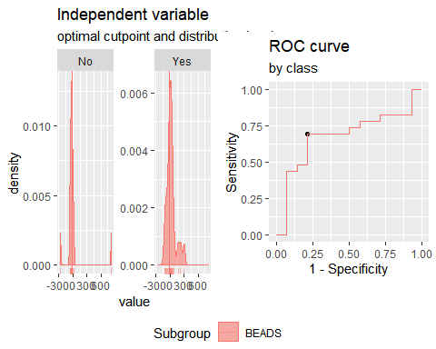

**Analysis PTB+TSTp vs TSTn. Responses for all groups and cytokines corrected for background by division (ratio).**

**IFNγ**

Method: maximize_metric   
 Predictor: var   
 Outcome: GrupoTsTp   
 Direction: >=   
 Subgroups: BEADS   
   
 Subgroup: BEADS   
 ---------------------------------------------------------------------------   
 AUC n n_pos n_neg  
 0.7019 37 23 14  
   
 optimal_cutpoint youden acc sensitivity specificity tp fn fp tn  
 2.0332 0.4068 0.6486 0.4783 0.9286 11 12 1 13  
   
 Predictor summary:   
 Min. 5% 1st Qu. Median Mean 3rd Qu. 95% Max. SD NAs  
 overall 0.800 0.898 1.000 1.409 2.154 2.260 6.897 11.221 2.154 0  
 No 0.838 0.887 0.962 1.305 1.319 1.462 2.009 2.372 0.435 0  
 Yes 0.800 0.926 1.254 1.633 2.662 2.612 8.074 11.221 2.601 0

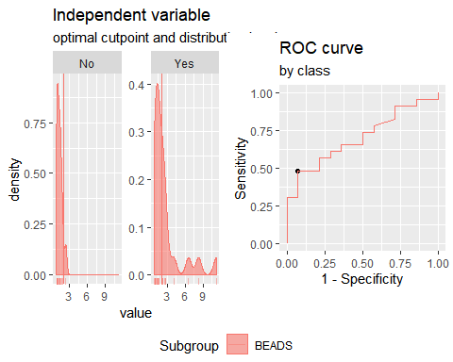

**IP10**

Method: maximize_metric   
 Predictor: var   
 Outcome: GrupoTsTp   
 Direction: >=   
 Subgroups: BEADS   
   
 Subgroup: BEADS   
 ---------------------------------------------------------------------------   
 AUC n n_pos n_neg  
 0.7453 37 23 14  
   
 optimal_cutpoint youden acc sensitivity specificity tp fn fp tn  
 0.876 0.5093 0.7297 0.6522 0.8571 15 8 2 12  
   
 Predictor summary:   
 Min. 5% 1st Qu. Median Mean 3rd Qu. 95% Max. SD NAs  
 overall 0.222 0.372 0.519 0.770 1.043 1.180 2.234 6.228 1.017 0  
 No 0.222 0.321 0.451 0.545 0.667 0.702 1.467 1.557 0.379 0  
 Yes 0.363 0.438 0.634 0.960 1.272 1.373 2.544 6.228 1.210 0

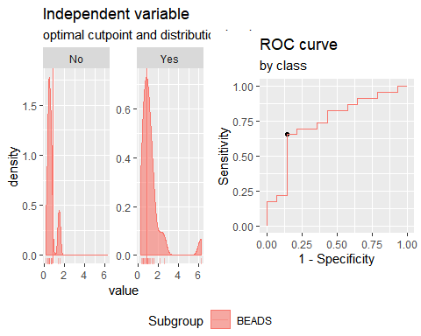

**IL2**

Method: maximize_metric   
 Predictor: var   
 Outcome: GrupoTsTp   
 Direction: >=   
 Subgroups: BEADS   
   
 Subgroup: BEADS   
 ---------------------------------------------------------------------------   
 AUC n n_pos n_neg  
 0.7826 37 23 14  
   
 optimal_cutpoint youden acc sensitivity specificity tp fn fp tn  
 1.0245 0.5528 0.7568 0.6957 0.8571 16 7 2 12  
   
 Predictor summary:   
 Min. 5% 1st Qu. Median Mean 3rd Qu. 95% Max. SD NAs  
 overall 0.821 0.879 0.945 1.010 1.122 1.226 1.567 2.200 0.292 0  
 No 0.821 0.853 0.885 0.976 0.977 1.006 1.173 1.361 0.131 0  
 Yes 0.920 0.928 0.969 1.113 1.210 1.303 1.949 2.200 0.328 0

Multiple optimal cutpoints found, applying break_ties.

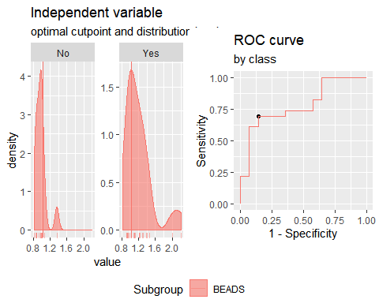

**TNFα**

Method: maximize_metric   
 Predictor: var   
 Outcome: GrupoTsTp   
 Direction: >=   
 Subgroups: BEADS   
   
 Subgroup: BEADS   
 ---------------------------------------------------------------------------   
 AUC n n_pos n_neg  
 0.2329 37 23 14  
   
 optimal_cutpoint youden acc sensitivity specificity tp fn fp tn  
 Inf 0 0.3784 0 1 0 23 0 14  
   
 Predictor summary:   
 Min. 5% 1st Qu. Median Mean 3rd Qu. 95% Max. SD NAs  
 overall 1.129 1.267 2.294 3.341 4.498 5.092 14.380 16.032 3.850 0  
 No 2.487 2.624 2.989 4.660 6.411 5.757 15.385 16.032 4.860 0  
 Yes 1.129 1.189 1.810 2.794 3.334 3.734 5.897 13.470 2.559 0

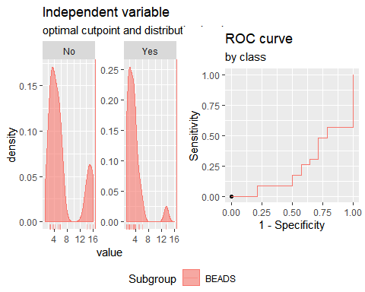

**CCL3**

Method: maximize_metric   
 Predictor: var   
 Outcome: GrupoTsTp   
 Direction: >=   
 Subgroups: BEADS   
   
 Subgroup: BEADS   
 ---------------------------------------------------------------------------   
 AUC n n_pos n_neg  
 0.5807 37 23 14  
   
 optimal_cutpoint youden acc sensitivity specificity tp fn fp tn  
 1.0247 0.2795 0.6216 0.5652 0.7143 13 10 4 10  
   
 Predictor summary:   
 Min. 5% 1st Qu. Median Mean 3rd Qu. 95% Max. SD NAs  
 overall 0.598 0.890 0.934 0.998 1.032 1.081 1.344 1.589 0.170 0  
 No 0.888 0.890 0.937 0.964 1.028 1.035 1.331 1.589 0.184 0  
 Yes 0.598 0.904 0.933 1.025 1.034 1.091 1.327 1.395 0.166 0

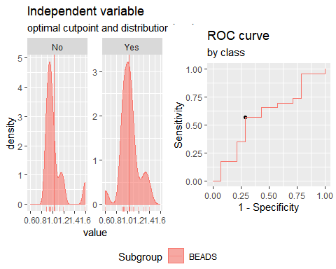

**CCL11**

Method: maximize_metric   
 Predictor: var   
 Outcome: GrupoTsTp   
 Direction: >=   
 Subgroups: BEADS   
   
 Subgroup: BEADS   
 ---------------------------------------------------------------------------   
 AUC n n_pos n_neg  
 0.6925 37 23 14  
   
 optimal_cutpoint youden acc sensitivity specificity tp fn fp tn  
 0.9863 0.4814 0.7297 0.6957 0.7857 16 7 3 11  
   
 Predictor summary:   
 Min. 5% 1st Qu. Median Mean 3rd Qu. 95% Max. SD NAs  
 overall 0.829 0.893 0.951 0.986 1.005 1.051 1.231 1.270 0.095 0  
 No 0.829 0.872 0.946 0.969 0.977 0.983 1.104 1.270 0.097 0  
 Yes 0.885 0.901 0.965 1.003 1.023 1.071 1.219 1.233 0.091 0

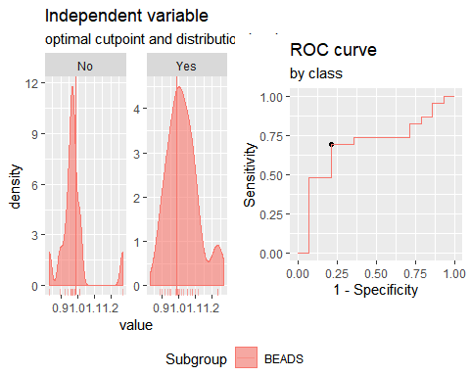

# B. Details of the ROC analysis performed for each cytokine combination evaluated

**Analysis PTB vs TSTn. Responses for all groups and cytokines corrected for background by subtraction.**

**"Combination IFNγ +IP10"**

Method: maximize_metric   
 Predictor: var   
 Outcome: GrupoNew   
 Direction: >=   
 Subgroups: BEADS   
 Subgroup: BEADS   
 ---------------------------------------------------------------------------   
 AUC n n_pos n_neg  
 0.9091 25 11 14  
   
 optimal_cutpoint youden acc sensitivity specificity tp fn fp tn  
 -0.5451 0.7857 0.88 1 0.7857 11 0 3 11  
   
 Predictor summary:   
 Min. 5% 1st Qu. Median Mean 3rd Qu. 95% Max. SD NAs  
 overall -2.168 -1.910 -0.903 -0.503 0.000 0.004 3.475 4.620 1.717 0  
 No -2.168 -2.067 -1.209 -0.864 -0.925 -0.620 -0.013 0.004 0.661 0  
 Yes -0.545 -0.524 -0.497 0.181 1.177 2.907 4.054 4.620 1.945 0

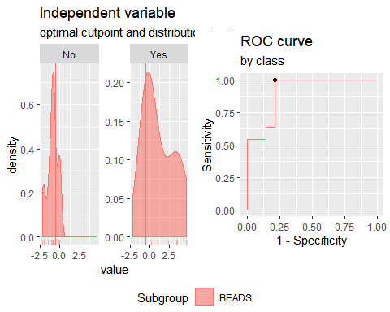

**"Combination IFNγ + IL2"**

Method: maximize_metric   
 Predictor: var   
 Outcome: GrupoNew   
 Direction: >=   
 Subgroups: BEADS   
   
 Subgroup: BEADS   
 ---------------------------------------------------------------------------   
 AUC n n_pos n_neg  
 0.9351 25 11 14  
   
 optimal_cutpoint youden acc sensitivity specificity tp fn fp tn  
 -0.4449 0.8571 0.92 1 0.8571 11 0 2 12  
   
 Predictor summary:   
 Min. 5% 1st Qu. Median Mean 3rd Qu. 95% Max. SD NAs  
 overall -1.696 -1.669 -1.243 -0.445 0.000 0.243 4.023 5.074 1.816 0  
 No -1.696 -1.681 -1.381 -1.193 -1.018 -0.881 0.211 0.851 0.681 0  
 Yes -0.445 -0.313 -0.141 0.243 1.296 2.566 4.616 5.074 2.003 0

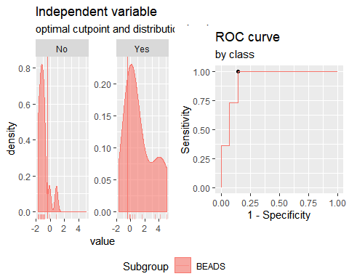

**"Combination IFNγ + CCL3"**

Method: maximize_metric   
 Predictor: var   
 Outcome: GrupoNew   
 Direction: >=   
 Subgroups: BEADS   
   
 Subgroup: BEADS   
 ---------------------------------------------------------------------------   
 AUC n n_pos n_neg  
 0.7597 25 11 14  
   
 optimal_cutpoint youden acc sensitivity specificity tp fn fp tn  
 -0.7404 0.4805 0.72 0.9091 0.5714 10 1 6 8  
   
 Predictor summary:   
 Min. 5% 1st Qu. Median Mean 3rd Qu. 95% Max. SD NAs  
 overall -1.738 -1.628 -0.941 -0.504 0.000 0.876 2.202 4.442 1.457 0  
 No -1.738 -1.647 -1.240 -0.870 -0.570 -0.325 1.130 1.603 0.988 0  
 Yes -1.635 -1.188 -0.498 0.663 0.725 1.213 3.397 4.442 1.671 0

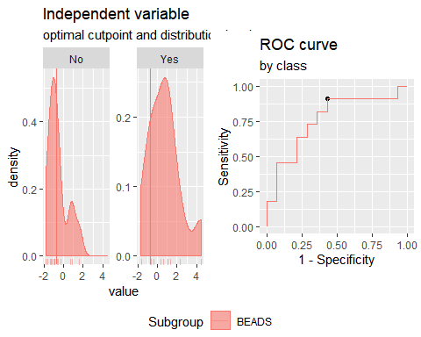

**"Combination IFNγ + CCL11"**

Method: maximize_metric   
 Predictor: var   
 Outcome: GrupoNew   
 Direction: >=   
 Subgroups: BEADS   
   
 Subgroup: BEADS   
 ---------------------------------------------------------------------------   
 AUC n n_pos n_neg  
 0.8442 25 11 14  
   
 optimal_cutpoint youden acc sensitivity specificity tp fn fp tn  
 -0.5955 0.6948 0.84 0.9091 0.7857 10 1 3 11  
   
 Predictor summary:   
 Min. 5% 1st Qu. Median Mean 3rd Qu. 95% Max. SD NAs  
 overall -2.020 -1.253 -1.013 -0.595 0.000 0.542 3.572 4.166 1.572 0  
 No -2.020 -1.540 -1.116 -0.929 -0.585 -0.732 1.445 4.166 1.437 0  
 Yes -1.022 -0.809 -0.305 0.542 0.744 1.384 3.180 3.833 1.467 0

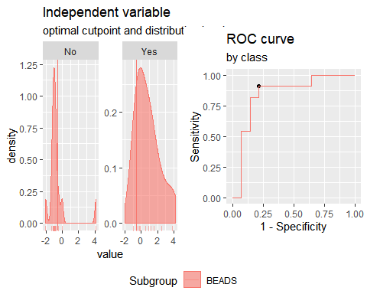

**"Combination IP10 + IL2"**

Method: maximize_metric   
 Predictor: var   
 Outcome: GrupoNew   
 Direction: >=   
 Subgroups: BEADS   
   
 Subgroup: BEADS   
 ---------------------------------------------------------------------------   
 AUC n n_pos n_neg  
 0.9416 25 11 14  
   
 optimal_cutpoint youden acc sensitivity specificity tp fn fp tn  
 0.2305 0.8377 0.92 0.9091 0.9286 10 1 1 13  
   
 Predictor summary:   
 Min. 5% 1st Qu. Median Mean 3rd Qu. 95% Max. SD NAs  
 overall -2.901 -2.124 -1.189 -0.151 0.000 0.588 3.052 4.491 1.706 0  
 No -2.901 -2.482 -1.423 -1.071 -1.055 -0.481 0.088 0.410 0.876 0  
 Yes -1.048 -0.409 0.426 0.933 1.342 2.194 3.813 4.491 1.566 0

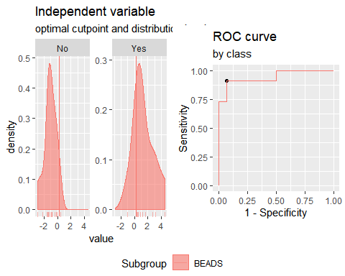

**"Combination IP10 + CCL3"**

Method: maximize_metric   
 Predictor: var   
 Outcome: GrupoNew   
 Direction: >=   
 Subgroups: BEADS   
   
 Subgroup: BEADS   
 ---------------------------------------------------------------------------   
 AUC n n_pos n_neg  
 0.7597 25 11 14  
   
 optimal_cutpoint youden acc sensitivity specificity tp fn fp tn  
 0.7384 0.5649 0.8 0.6364 0.9286 7 4 1 13  
   
 Predictor summary:   
 Min. 5% 1st Qu. Median Mean 3rd Qu. 95% Max. SD NAs  
 overall -3.410 -1.938 -0.921 -0.212 0.000 1.411 2.317 2.401 1.512 0  
 No -3.410 -2.333 -1.271 -0.603 -0.606 0.107 1.023 2.114 1.290 0  
 Yes -1.984 -1.664 -0.044 1.411 0.771 1.752 2.384 2.401 1.468 0

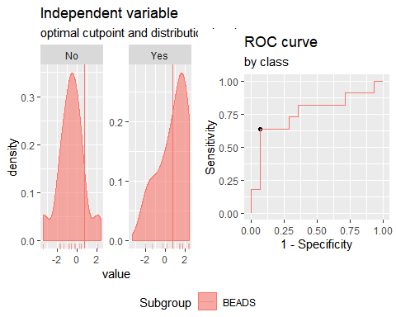

**"Combination IP10 + CCL11"**

Method: maximize_metric   
 Predictor: var   
 Outcome: GrupoNew   
 Direction: >=   
 Subgroups: BEADS   
   
 Subgroup: BEADS   
 ---------------------------------------------------------------------------   
 AUC n n_pos n_neg  
 0.8506 25 11 14  
   
 optimal_cutpoint youden acc sensitivity specificity tp fn fp tn  
 -0.0235 0.6753 0.84 0.8182 0.8571 9 2 2 12  
   
 Predictor summary:   
 Min. 5% 1st Qu. Median Mean 3rd Qu. 95% Max. SD NAs  
 overall -2.786 -1.776 -0.836 -0.276 0.000 0.869 2.247 3.725 1.465 0  
 No -2.786 -2.142 -1.117 -0.711 -0.621 -0.322 1.311 3.725 1.454 0  
 Yes -0.836 -0.651 0.009 0.869 0.791 1.595 2.247 2.247 1.082 0

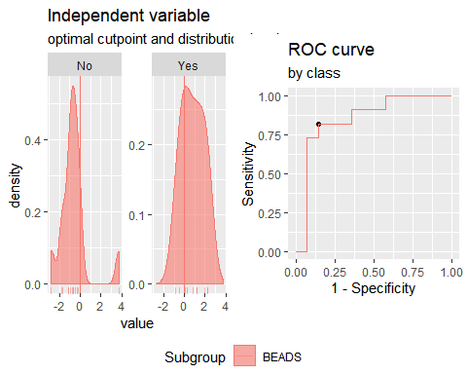

**"Combination IL2 + CCL3"**

Method: maximize_metric   
 Predictor: var   
 Outcome: GrupoNew   
 Direction: >=   
 Subgroups: BEADS   
   
 Subgroup: BEADS   
 ---------------------------------------------------------------------------   
 AUC n n_pos n_neg  
 0.8636 25 11 14  
   
 optimal_cutpoint youden acc sensitivity specificity tp fn fp tn  
 -0.0572 0.6948 0.84 0.9091 0.7857 10 1 3 11  
   
 Predictor summary:   
 Min. 5% 1st Qu. Median Mean 3rd Qu. 95% Max. SD NAs  
 overall -1.787 -1.675 -1.285 -0.057 0.000 1.148 2.208 2.222 1.364 0  
 No -1.787 -1.752 -1.441 -1.097 -0.699 -0.417 1.498 1.643 1.086 0  
 Yes -1.285 -0.671 0.114 0.559 0.890 2.135 2.216 2.222 1.175 0

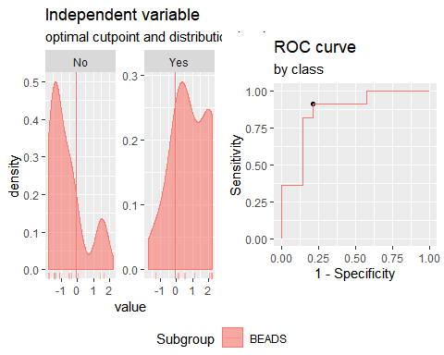

**"Combination IL2 + CCL11"**

Method: maximize_metric   
 Predictor: var   
 Outcome: GrupoNew   
 Direction: >=   
 Subgroups: BEADS   
   
 Subgroup: BEADS   
 ---------------------------------------------------------------------------   
 AUC n n_pos n_neg  
 0.9026 25 11 14  
   
 optimal_cutpoint youden acc sensitivity specificity tp fn fp tn  
 -0.5241 0.7662 0.88 0.9091 0.8571 10 1 2 12  
   
 Predictor summary:   
 Min. 5% 1st Qu. Median Mean 3rd Qu. 95% Max. SD NAs  
 overall -2.893 -1.374 -0.932 -0.752 0.000 0.406 3.455 4.710 1.718 0  
 No -2.893 -1.913 -1.278 -0.930 -0.714 -0.791 1.321 4.710 1.660 0  
 Yes -0.778 -0.651 0.087 0.406 0.909 1.794 3.058 3.719 1.369 0

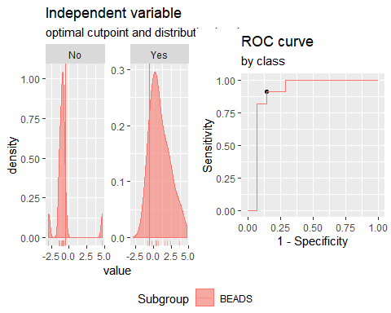

**"Combination CCL3 + CCL11"**

Method: maximize_metric   
 Predictor: var   
 Outcome: GrupoNew   
 Direction: >=   
 Subgroups: BEADS   
   
 Subgroup: BEADS   
 ---------------------------------------------------------------------------   
 AUC n n_pos n_neg  
 0.6948 25 11 14  
   
 optimal_cutpoint youden acc sensitivity specificity tp fn fp tn  
 -0.3248 0.4416 0.72 0.7273 0.7143 8 3 4 10  
   
 Predictor summary:   
 Min. 5% 1st Qu. Median Mean 3rd Qu. 95% Max. SD NAs  
 overall -2.080 -1.411 -1.102 -0.401 0.000 0.521 2.641 4.735 1.577 0  
 No -2.080 -1.646 -1.205 -0.941 -0.266 -0.332 2.937 4.735 1.761 0  
 Yes -1.401 -1.237 -0.516 0.087 0.338 1.080 2.348 2.810 1.308 0

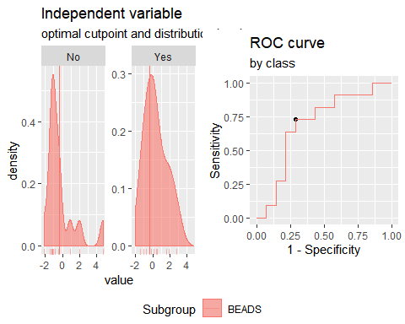

**"Combination IP10 + IL2+CCL3**"

Method: maximize_metric   
 Predictor: var   
 Outcome: GrupoNew   
 Direction: >=   
 Subgroups: BEADS   
   
 Subgroup: BEADS   
 ---------------------------------------------------------------------------   
 AUC n n_pos n_neg  
 0.8961 25 11 14  
   
 optimal_cutpoint youden acc sensitivity specificity tp fn fp tn  
 0.0229 0.7662 0.88 0.9091 0.8571 10 1 2 12  
   
 Predictor summary:   
 Min. 5% 1st Qu. Median Mean 3rd Qu. 95% Max. SD NAs  
 overall -3.844 -2.628 -1.599 -0.220 0.000 1.486 2.760 4.240 2.015 0  
 No -3.844 -3.115 -2.157 -1.235 -1.180 -0.573 1.256 1.486 1.436 0  
 Yes -1.838 -0.907 0.585 1.990 1.502 2.292 3.540 4.240 1.622 0

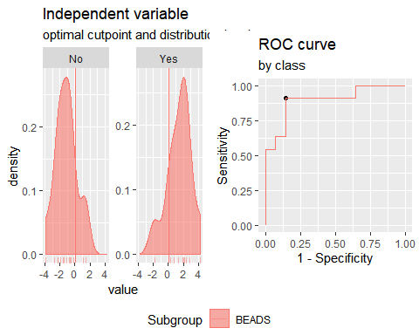

**"Combination IP10 + IL2+CCL11**"

Method: maximize_metric   
 Predictor: var   
 Outcome: GrupoNew   
 Direction: >=   
 Subgroups: BEADS   
   
 Subgroup: BEADS   
 ---------------------------------------------------------------------------   
 AUC n n_pos n_neg  
 0.8961 25 11 14  
   
 optimal_cutpoint youden acc sensitivity specificity tp fn fp tn  
 -0.3071 0.8377 0.92 0.9091 0.9286 10 1 1 13  
   
 Predictor summary:   
 Min. 5% 1st Qu. Median Mean 3rd Qu. 95% Max. SD NAs  
 overall -3.220 -2.989 -1.614 -0.582 0.000 1.832 4.343 4.423 2.238 0  
 No -3.220 -3.121 -1.771 -1.549 -1.195 -0.778 1.273 4.423 1.834 0  
 Yes -1.331 -0.819 0.363 1.832 1.521 2.286 4.233 4.416 1.762 0

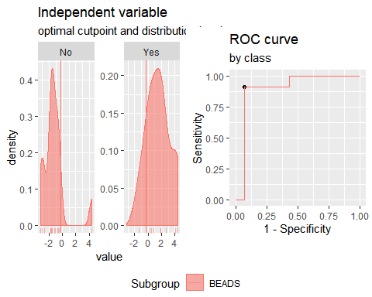

**"Combination IP10 + CCL3+CCL11"**

Method: maximize_metric   
 Predictor: var   
 Outcome: GrupoNew   
 Direction: >=   
 Subgroups: BEADS   
   
 Subgroup: BEADS   
 ---------------------------------------------------------------------------   
 AUC n n_pos n_neg  
 0.7727 25 11 14  
   
 optimal_cutpoint youden acc sensitivity specificity tp fn fp tn  
 0.7086 0.4935 0.76 0.6364 0.8571 7 4 2 12  
   
 Predictor summary:   
 Min. 5% 1st Qu. Median Mean 3rd Qu. 95% Max. SD NAs  
 overall -3.729 -2.238 -1.332 -0.479 0.000 1.708 2.681 4.448 1.979 0  
 No -3.729 -2.771 -1.980 -1.147 -0.747 -0.213 2.734 4.448 1.997 0  
 Yes -1.627 -1.348 -0.361 1.694 0.950 2.242 2.639 2.710 1.564 0

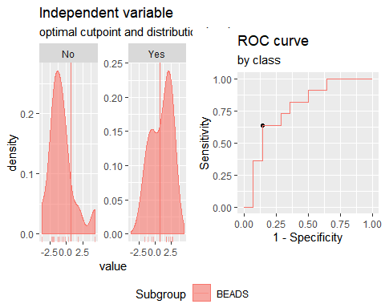

**"Combination IL2 + CCL3+CCL11"**

Method: maximize_metric   
 Predictor: var   
 Outcome: GrupoNew   
 Direction: >=   
 Subgroups: BEADS   
   
 Subgroup: BEADS   
 ---------------------------------------------------------------------------   
 AUC n n_pos n_neg  
 0.8506 25 11 14  
   
 optimal_cutpoint youden acc sensitivity specificity tp fn fp tn  
 -0.5493 0.6948 0.84 0.9091 0.7857 10 1 3 11  
   
 Predictor summary:   
 Min. 5% 1st Qu. Median Mean 3rd Qu. 95% Max. SD NAs  
 overall -3.353 -2.206 -1.619 -0.549 0.000 1.340 3.368 5.433 2.074 0  
 No -3.353 -2.646 -1.829 -1.548 -0.840 -0.733 2.772 5.433 2.110 0  
 Yes -1.569 -1.059 0.143 1.118 1.069 2.096 3.173 3.497 1.513 0

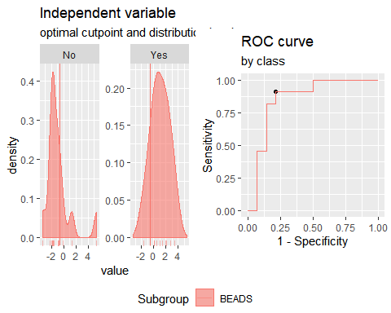

**"Combination IFNγ+IP10+IL2"**

Method: maximize_metric   
 Predictor: var   
 Outcome: GrupoNew   
 Direction: >=   
 Subgroups: BEADS   
   
 Subgroup: BEADS   
 ---------------------------------------------------------------------------   
 AUC n n_pos n_neg  
 0.9545 25 11 14  
   
 optimal_cutpoint youden acc sensitivity specificity tp fn fp tn  
 -0.1935 0.8377 0.92 0.9091 0.9286 10 1 1 13  
   
 Predictor summary:   
 Min. 5% 1st Qu. Median Mean 3rd Qu. 95% Max. SD NAs  
 overall -2.983 -2.503 -1.571 -0.513 0.000 0.564 4.296 7.092 2.481 0  
 No -2.983 -2.735 -2.009 -1.567 -1.499 -1.157 -0.099 0.564 0.915 0  
 Yes -0.998 -0.596 -0.028 0.853 1.908 3.871 5.740 7.092 2.556 0

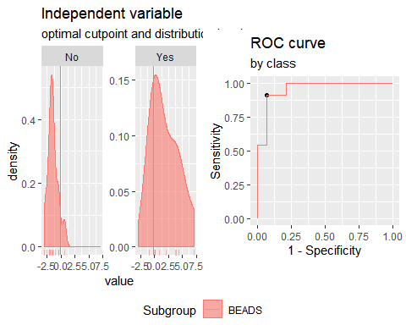

**"Combination IFNγ+CCL3+CCL11**"

Method: maximize_metric   
 Predictor: var   
 Outcome: GrupoNew   
 Direction: >=   
 Subgroups: BEADS   
   
 Subgroup: BEADS   
 ---------------------------------------------------------------------------   
 AUC n n_pos n_neg  
 0.8052 25 11 14  
   
 optimal_cutpoint youden acc sensitivity specificity tp fn fp tn  
 -1.0475 0.5714 0.76 1 0.5714 11 0 6 8  
   
 Predictor summary:   
 Min. 5% 1st Qu. Median Mean 3rd Qu. 95% Max. SD NAs  
 overall -2.480 -2.155 -1.465 -0.720 0.000 1.071 4.384 5.080 2.020 0  
 No -2.480 -2.308 -1.756 -1.272 -0.710 -0.728 2.556 4.889 1.913 0  
 Yes -1.048 -1.036 -0.652 0.863 0.904 1.785 3.722 5.080 1.852 0

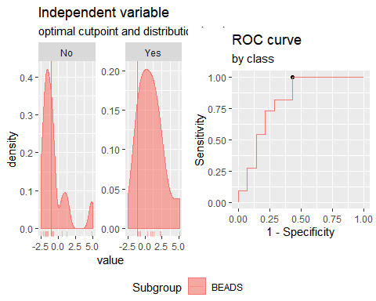

**"Combination IFNγ+CCL3+IP10"**

Method: maximize_metric   
 Predictor: var   
 Outcome: GrupoNew   
 Direction: >=   
 Subgroups: BEADS   
   
 Subgroup: BEADS   
 ---------------------------------------------------------------------------   
 AUC n n_pos n_neg  
 0.8247 25 11 14  
   
 optimal_cutpoint youden acc sensitivity specificity tp fn fp tn  
 0.6584 0.5649 0.8 0.6364 0.9286 7 4 1 13  
   
 Predictor summary:   
 Min. 5% 1st Qu. Median Mean 3rd Qu. 95% Max. SD NAs  
 overall -3.111 -2.463 -1.304 -0.575 0.000 0.966 4.218 4.672 2.087 0  
 No -3.111 -2.700 -2.040 -0.997 -1.050 -0.261 0.888 1.446 1.276 0  
 Yes -1.304 -1.299 -0.426 0.966 1.337 3.159 4.521 4.672 2.197 0

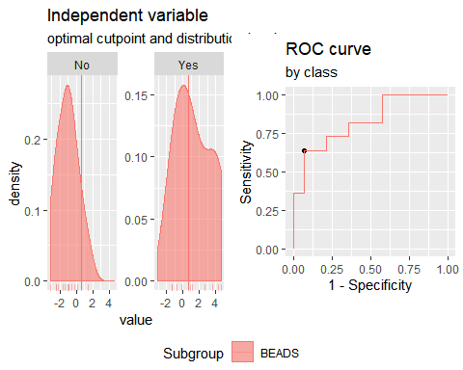

**"Combination IFNγ+CCL11+IP10"**

Method: maximize_metric   
 Predictor: var   
 Outcome: GrupoNew   
 Direction: >=   
 Subgroups: BEADS   
   
 Subgroup: BEADS   
 ---------------------------------------------------------------------------   
 AUC n n_pos n_neg  
 0.8961 25 11 14  
   
 optimal_cutpoint youden acc sensitivity specificity tp fn fp tn  
 -0.8053 0.7857 0.88 1 0.7857 11 0 3 11  
   
 Predictor summary:   
 Min. 5% 1st Qu. Median Mean 3rd Qu. 95% Max. SD NAs  
 overall -2.487 -2.380 -1.344 -0.786 0.000 0.754 4.026 4.546 2.136 0  
 No -2.487 -2.448 -1.795 -1.320 -1.066 -0.977 1.124 3.879 1.562 0  
 Yes -0.805 -0.796 -0.487 0.754 1.356 3.022 4.304 4.546 2.040 0

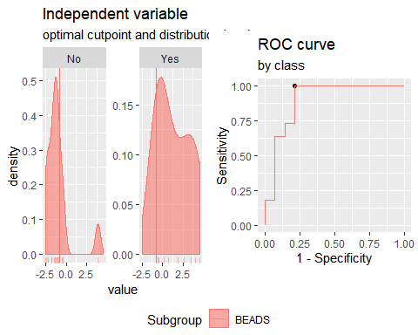

**"Combination IFNγ+CCL3+IL2"**

Method: maximize_metric   
 Predictor: var   
 Outcome: GrupoNew   
 Direction: >=   
 Subgroups: BEADS   
   
 Subgroup: BEADS   
 ---------------------------------------------------------------------------   
 AUC n n_pos n_neg  
 0.8896 25 11 14  
   
 optimal_cutpoint youden acc sensitivity specificity tp fn fp tn  
 -0.329 0.6948 0.84 0.9091 0.7857 10 1 3 11  
   
 Predictor summary:   
 Min. 5% 1st Qu. Median Mean 3rd Qu. 95% Max. SD NAs  
 overall -2.590 -2.159 -1.458 -0.329 0.000 1.169 4.212 5.405 2.069 0  
 No -2.590 -2.313 -2.112 -1.322 -1.143 -0.811 1.184 1.573 1.216 0  
 Yes -1.235 -0.782 0.040 1.169 1.455 1.760 5.114 5.405 2.047 0

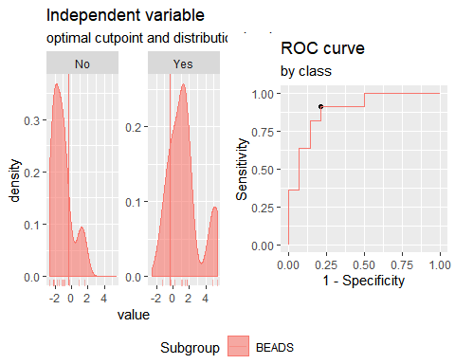

**"Combination IFNγ+CCL11+IL2"**

Method: maximize_metric   
 Predictor: var   
 Outcome: GrupoNew   
 Direction: >=   
 Subgroups: BEADS   
   
 Subgroup: BEADS   
 ---------------------------------------------------------------------------   
 AUC n n_pos n_neg  
 0.9221 25 11 14  
   
 optimal_cutpoint youden acc sensitivity specificity tp fn fp tn  
 -0.8636 0.8571 0.92 1 0.8571 11 0 2 12  
   
 Predictor summary:   
 Min. 5% 1st Qu. Median Mean 3rd Qu. 95% Max. SD NAs  
 overall -3.293 -2.129 -1.521 -0.864 0.000 0.561 4.850 4.999 2.391 0  
 No -3.293 -2.539 -1.852 -1.482 -1.159 -1.215 1.408 4.864 1.849 0  
 Yes -0.864 -0.796 -0.131 0.561 1.475 3.006 4.898 4.999 2.238 0

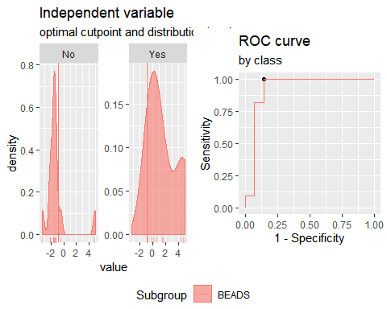

**Analysis PTB vs TSTn. Responses for all groups and cytokines corrected for background by division (ratio).**

**"Combination IFNγ +IP10"**

Method: maximize_metric   
 Predictor: var   
 Outcome: GrupoNew   
 Direction: >=   
 Subgroups: BEADS   
   
 Subgroup: BEADS   
 ---------------------------------------------------------------------------   
 AUC n n_pos n_neg  
 0.9286 25 11 14  
   
 optimal_cutpoint youden acc sensitivity specificity tp fn fp tn  
 -0.5878 0.7857 0.88 1 0.7857 11 0 3 11  
   
 Predictor summary:   
 Min. 5% 1st Qu. Median Mean 3rd Qu. 95% Max. SD NAs  
 overall -1.415 -1.255 -1.117 -0.587 0.000 0.180 2.133 7.659 1.887 0  
 No -1.415 -1.321 -1.167 -1.017 -0.897 -0.814 -0.146 0.041 0.418 0  
 Yes -0.588 -0.587 -0.496 0.237 1.142 1.777 4.937 7.659 2.400 0

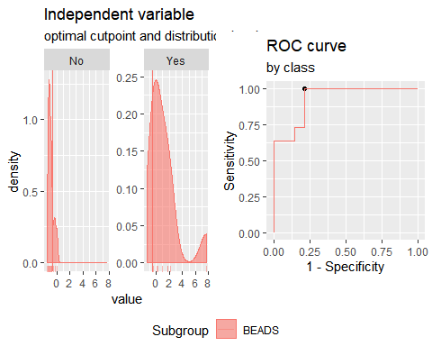

**"Combination IFNγ + IL2"**

Method: maximize_metric   
 Predictor: var   
 Outcome: GrupoNew   
 Direction: >=   
 Subgroups: BEADS   
   
 Subgroup: BEADS   
 ---------------------------------------------------------------------------   
 AUC n n_pos n_neg  
 0.961 25 11 14  
   
 optimal_cutpoint youden acc sensitivity specificity tp fn fp tn  
 -0.6242 0.9286 0.96 1 0.9286 11 0 1 13  
   
 Predictor summary:   
 Min. 5% 1st Qu. Median Mean 3rd Qu. 95% Max. SD NAs  
 overall -1.537 -1.454 -1.198 -0.743 0.000 0.300 4.331 5.899 1.901 0  
 No -1.537 -1.487 -1.313 -1.152 -1.033 -0.929 -0.303 0.514 0.510 0  
 Yes -0.624 -0.561 -0.153 0.300 1.315 2.077 5.266 5.899 2.223 0

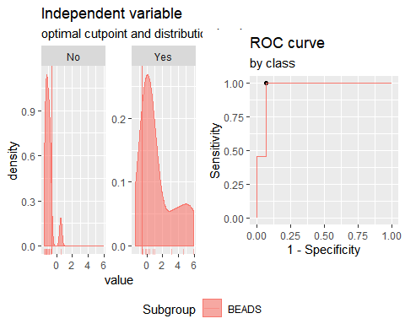

**"Combination IFNγ + CCL3"**

Method: maximize_metric   
 Predictor: var   
 Outcome: GrupoNew   
 Direction: >=   
 Subgroups: BEADS   
   
 Subgroup: BEADS   
 ---------------------------------------------------------------------------   
 AUC n n_pos n_neg  
 0.8377 25 11 14  
   
 optimal_cutpoint youden acc sensitivity specificity tp fn fp tn  
 -0.8174 0.6429 0.8 1 0.6429 11 0 5 9  
   
 Predictor summary:   
 Min. 5% 1st Qu. Median Mean 3rd Qu. 95% Max. SD NAs  
 overall -1.446 -1.327 -0.948 -0.472 0.000 0.429 2.951 3.504 1.345 0  
 No -1.446 -1.403 -1.093 -0.912 -0.566 -0.463 0.987 2.144 0.952 0  
 Yes -0.817 -0.740 -0.383 0.429 0.720 1.177 3.328 3.504 1.465 0

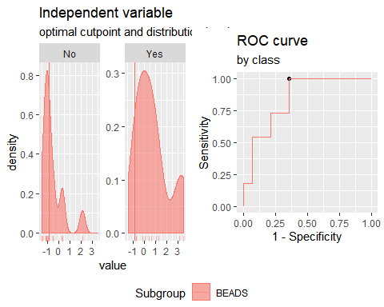

**"Combination IFNγ + CCL11"**

Method: maximize_metric   
 Predictor: var   
 Outcome: GrupoNew   
 Direction: >=   
 Subgroups: BEADS   
   
 Subgroup: BEADS   
 ---------------------------------------------------------------------------   
 AUC n n_pos n_neg  
 0.9351 25 11 14  
   
 optimal_cutpoint youden acc sensitivity specificity tp fn fp tn  
 -0.4576 0.8377 0.92 0.9091 0.9286 10 1 1 13  
   
 Predictor summary:   
 Min. 5% 1st Qu. Median Mean 3rd Qu. 95% Max. SD NAs  
 overall -2.249 -1.797 -1.089 -0.669 0.000 0.591 3.458 3.940 1.683 0  
 No -2.249 -2.013 -1.216 -1.050 -0.917 -0.802 0.454 2.266 1.024 0  
 Yes -0.755 -0.606 -0.048 0.591 1.167 2.361 3.741 3.940 1.661 0

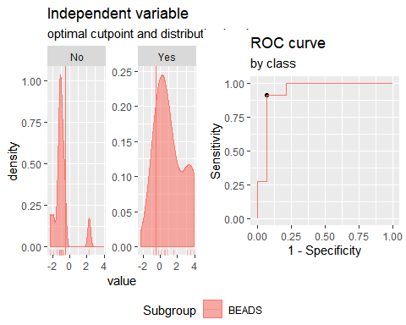

**"Combination IP10 + IL2"**

Method: maximize_metric   
 Predictor: var   
 Outcome: GrupoNew   
 Direction: >=   
 Subgroups: BEADS   
   
 Subgroup: BEADS   
 ---------------------------------------------------------------------------   
 AUC n n_pos n_neg  
 0.961 25 11 14  
   
 optimal_cutpoint youden acc sensitivity specificity tp fn fp tn  
 -0.1102 0.8377 0.92 0.9091 0.9286 10 1 1 13  
   
 Predictor summary:   
 Min. 5% 1st Qu. Median Mean 3rd Qu. 95% Max. SD NAs  
 overall -1.642 -1.416 -1.201 -0.351 0.000 0.338 2.862 6.668 1.806 0  
 No -1.642 -1.497 -1.258 -1.177 -0.989 -0.876 -0.038 0.171 0.523 0  
 Yes -0.866 -0.488 0.160 0.460 1.259 1.526 4.925 6.668 2.089 0

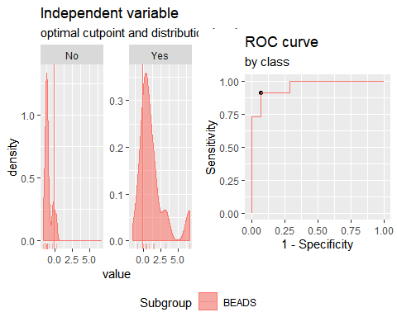

**"Combination IP10 + CCL3"**

Method: maximize_metric   
 Predictor: var   
 Outcome: GrupoNew   
 Direction: >=   
 Subgroups: BEADS   
   
 Subgroup: BEADS   
 ---------------------------------------------------------------------------   
 AUC n n_pos n_neg  
 0.7597 25 11 14  
   
 optimal_cutpoint youden acc sensitivity specificity tp fn fp tn  
 0.4851 0.5649 0.8 0.6364 0.9286 7 4 1 13  
   
 Predictor summary:   
 Min. 5% 1st Qu. Median Mean 3rd Qu. 95% Max. SD NAs  
 overall -2.114 -1.418 -1.059 -0.300 0.000 1.159 2.071 3.921 1.379 0  
 No -1.419 -1.417 -1.168 -0.803 -0.522 -0.058 0.955 2.168 0.961 0  
 Yes -2.114 -1.587 -0.180 1.159 0.664 1.204 2.801 3.921 1.581 0

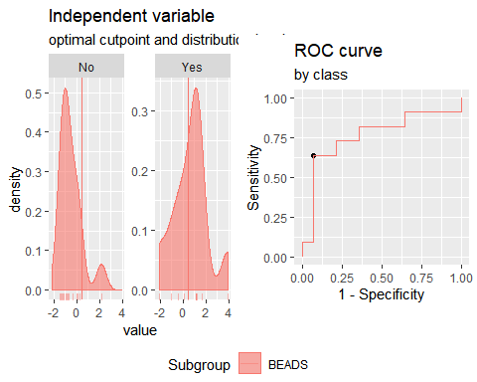

**"Combination IP10 + CCL11"**

Method: maximize_metric   
 Predictor: var   
 Outcome: GrupoNew   
 Direction: >=   
 Subgroups: BEADS   
   
 Subgroup: BEADS   
 ---------------------------------------------------------------------------   
 AUC n n_pos n_neg  
 0.8961 25 11 14  
   
 optimal_cutpoint youden acc sensitivity specificity tp fn fp tn  
 0.1726 0.7468 0.88 0.8182 0.9286 9 2 1 13  
   
 Predictor summary:   
 Min. 5% 1st Qu. Median Mean 3rd Qu. 95% Max. SD NAs  
 overall -2.242 -1.671 -1.179 -0.569 0.000 0.977 2.057 4.710 1.561 0  
 No -2.242 -1.924 -1.262 -1.122 -0.873 -0.590 0.623 1.924 0.966 0  
 Yes -0.699 -0.641 0.265 0.977 1.111 1.594 3.400 4.710 1.488 0

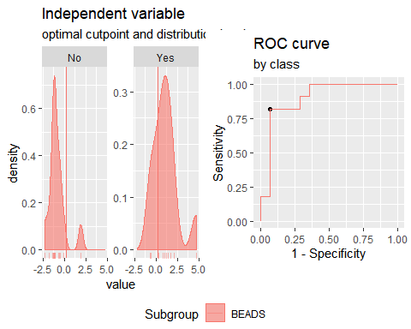

**"Combination IL2 + CCL3"**

Method: maximize_metric   
 Predictor: var   
 Outcome: GrupoNew   
 Direction: >=   
 Subgroups: BEADS   
   
 Subgroup: BEADS   
 ---------------------------------------------------------------------------   
 AUC n n_pos n_neg  
 0.8701 25 11 14  
   
 optimal_cutpoint youden acc sensitivity specificity tp fn fp tn  
 -0.2491 0.6948 0.84 0.9091 0.7857 10 1 3 11  
   
 Predictor summary:   
 Min. 5% 1st Qu. Median Mean 3rd Qu. 95% Max. SD NAs  
 overall -1.661 -1.439 -1.244 -0.249 0.000 0.986 2.138 2.161 1.319 0  
 No -1.661 -1.525 -1.324 -1.037 -0.657 -0.532 1.371 2.085 1.045 0  
 Yes -1.244 -0.747 -0.001 0.768 0.836 2.100 2.153 2.161 1.174 0

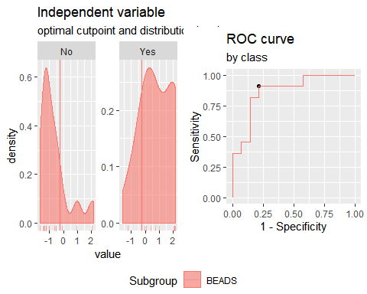

**"Combination IL2 + CCL11"**

Method: maximize_metric   
 Predictor: var   
 Outcome: GrupoNew   
 Direction: >=   
 Subgroups: BEADS   
   
 Subgroup: BEADS   
 ---------------------------------------------------------------------------   
 AUC n n_pos n_neg  
 0.9221 25 11 14  
   
 optimal_cutpoint youden acc sensitivity specificity tp fn fp tn  
 -0.8844 0.7857 0.88 1 0.7857 11 0 3 11  
   
 Predictor summary:   
 Min. 5% 1st Qu. Median Mean 3rd Qu. 95% Max. SD NAs  
 overall -2.861 -2.032 -1.125 -0.862 0.000 0.727 2.937 4.972 1.852 0  
 No -2.861 -2.367 -1.369 -1.113 -1.008 -0.935 0.745 2.888 1.272 0  
 Yes -0.884 -0.740 0.440 0.727 1.283 2.178 3.961 4.972 1.700 0

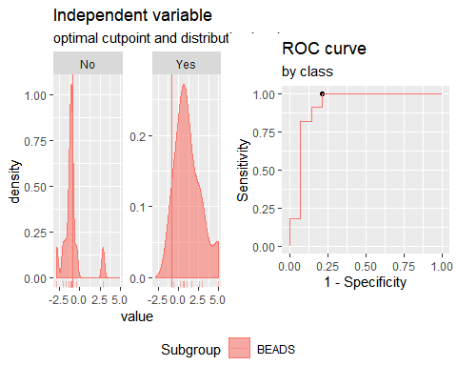

**"Combination CCL3 + CCL11"**

Method: maximize_metric   
 Predictor: var   
 Outcome: GrupoNew   
 Direction: >=   
 Subgroups: BEADS   
   
 Subgroup: BEADS   
 ---------------------------------------------------------------------------   
 AUC n n_pos n_neg  
 0.7857 25 11 14  
   
 optimal_cutpoint youden acc sensitivity specificity tp fn fp tn  
 -0.3235 0.6039 0.8 0.8182 0.7857 9 2 3 11  
   
 Predictor summary:   
 Min. 5% 1st Qu. Median Mean 3rd Qu. 95% Max. SD NAs  
 overall -2.275 -1.908 -1.129 -0.372 0.000 0.745 2.641 3.409 1.526 0  
 No -2.275 -2.103 -1.395 -1.036 -0.541 -0.410 2.420 2.739 1.475 0  
 Yes -1.078 -0.973 -0.060 0.282 0.688 1.428 2.751 3.409 1.353 0

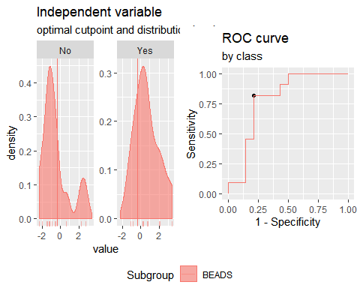

**"Combination IP10 + IL2+CCL3"**

Method: maximize_metric   
 Predictor: var   
 Outcome: GrupoNew   
 Direction: >=   
 Subgroups: BEADS   
   
 Subgroup: BEADS   
 ---------------------------------------------------------------------------   
 AUC n n_pos n_neg  
 0.9091 25 11 14  
   
 optimal_cutpoint youden acc sensitivity specificity tp fn fp tn  
 -0.2314 0.7662 0.88 0.9091 0.8571 10 1 2 12  
   
 Predictor summary:   
 Min. 5% 1st Qu. Median Mean 3rd Qu. 95% Max. SD NAs  
 overall -2.189 -2.033 -1.587 -0.349 0.000 1.512 2.058 6.375 1.976 0  
 No -2.189 -2.094 -1.877 -1.401 -1.084 -0.614 0.913 1.512 1.085 0  
 Yes -1.584 -0.908 0.146 1.591 1.379 1.968 4.219 6.375 2.025 0

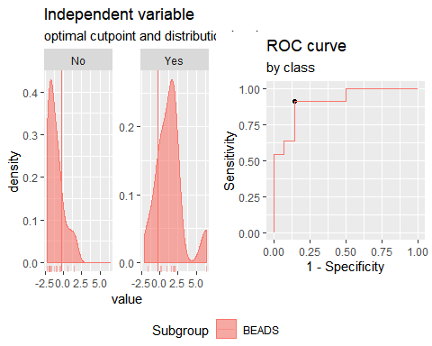

**"Combination IP10 + IL2+CCL11"**

Method: maximize_metric   
 Predictor: var   
 Outcome: GrupoNew   
 Direction: >=   
 Subgroups: BEADS   
   
 Subgroup: BEADS   
 ---------------------------------------------------------------------------   
 AUC n n_pos n_neg  
 0.9221 25 11 14  
   
 optimal_cutpoint youden acc sensitivity specificity tp fn fp tn  
 -0.4207 0.8377 0.92 0.9091 0.9286 10 1 1 13  
   
 Predictor summary:   
 Min. 5% 1st Qu. Median Mean 3rd Qu. 95% Max. SD NAs  
 overall -3.261 -2.540 -1.709 -0.936 0.000 1.658 4.596 7.164 2.476 0  
 No -3.261 -2.850 -1.995 -1.699 -1.435 -1.178 0.517 2.492 1.320 0  
 Yes -1.225 -0.823 0.553 1.658 1.826 2.145 6.143 7.164 2.428 0

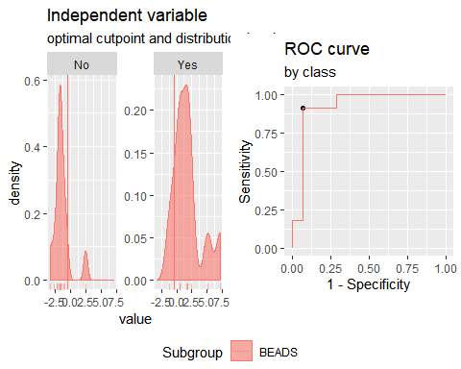

**"Combination IP10 + CCL3+CCL11"**

Method: maximize_metric   
 Predictor: var   
 Outcome: GrupoNew   
 Direction: >=   
 Subgroups: BEADS   
   
 Subgroup: BEADS   
 ---------------------------------------------------------------------------   
 AUC n n_pos n_neg  
 0.8377 25 11 14  
   
 optimal_cutpoint youden acc sensitivity specificity tp fn fp tn  
 -0.6929 0.6234 0.8 0.9091 0.7143 10 1 4 10  
   
 Predictor summary:   
 Min. 5% 1st Qu. Median Mean 3rd Qu. 95% Max. SD NAs  
 overall -2.675 -2.442 -1.693 -0.275 0.000 1.552 3.024 4.417 1.916 0  
 No -2.675 -2.586 -1.825 -1.443 -0.968 -0.432 1.909 2.342 1.494 0  
 Yes -1.418 -1.055 -0.034 1.432 1.231 1.988 3.806 4.417 1.711 0

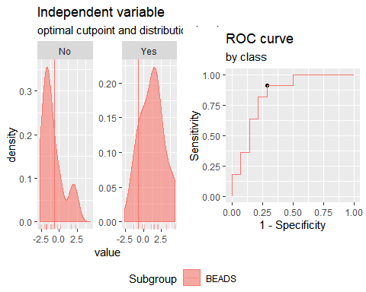

**"Combination IL2 + CCL3+CCL11"**

Method: maximize_metric   
 Predictor: var   
 Outcome: GrupoNew   
 Direction: >=   
 Subgroups: BEADS   
   
 Subgroup: BEADS   
 ---------------------------------------------------------------------------   
 AUC n n_pos n_neg  
 0.8571 25 11 14  
   
 optimal_cutpoint youden acc sensitivity specificity tp fn fp tn  
 0.4163 0.6753 0.84 0.8182 0.8571 9 2 2 12  
   
 Predictor summary:   
 Min. 5% 1st Qu. Median Mean 3rd Qu. 95% Max. SD NAs  
 overall -3.294 -2.773 -1.736 -0.654 0.000 1.593 3.234 4.083 2.121 0  
 No -3.294 -3.029 -1.882 -1.687 -1.103 -0.754 2.192 3.307 1.744 0  
 Yes -1.603 -1.154 0.446 1.402 1.404 2.682 3.514 4.083 1.723 0

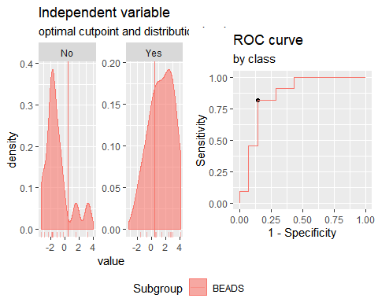

**"Combination IFNγ+IP10+IL2"**

Method: maximize_metric   
 Predictor: var   
 Outcome: GrupoNew   
 Direction: >=   
 Subgroups: BEADS   
   
 Subgroup: BEADS   
 ---------------------------------------------------------------------------   
 AUC n n_pos n_neg  
 0.9545 25 11 14  
   
 optimal_cutpoint youden acc sensitivity specificity tp fn fp tn  
 -0.3922 0.8377 0.92 0.9091 0.9286 10 1 1 13  
   
 Predictor summary:   
 Min. 5% 1st Qu. Median Mean 3rd Qu. 95% Max. SD  
 overall -2.258 -2.022 -1.670 -0.798 0.000 0.117 4.440 10.113 2.727  
 No -2.258 -2.133 -1.826 -1.664 -1.460 -1.398 -0.236 0.117 0.656  
 Yes -0.964 -0.678 -0.178 0.343 1.858 2.640 7.448 10.113 3.243  
 NAs  
 overall 0  
 No 0  
 Yes 0

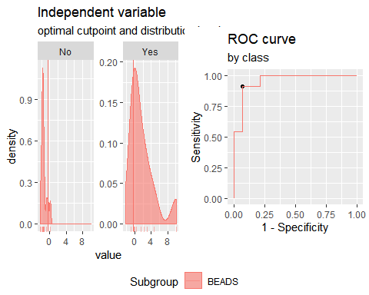

**"Combination IFNγ+CCL3+CCL11"**

Method: maximize_metric   
 Predictor: var   
 Outcome: GrupoNew   
 Direction: >=   
 Subgroups: BEADS   
   
 Subgroup: BEADS   
 ---------------------------------------------------------------------------   
 AUC n n_pos n_neg  
 0.8571 25 11 14  
   
 optimal_cutpoint youden acc sensitivity specificity tp fn fp tn  
 -0.8641 0.6948 0.84 0.9091 0.7857 10 1 3 11  
   
 Predictor summary:   
 Min. 5% 1st Qu. Median Mean 3rd Qu. 95% Max. SD NAs  
 overall -2.682 -2.538 -1.717 -0.864 0.000 1.278 3.525 4.360 1.992 0  
 No -2.682 -2.675 -1.764 -1.638 -1.012 -0.892 2.013 2.684 1.549 0  
 Yes -1.176 -1.020 0.317 0.879 1.287 2.290 4.004 4.360 1.775 0

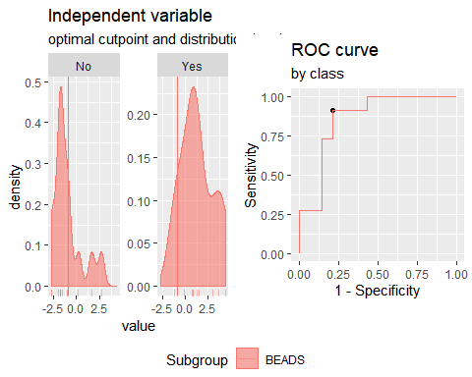

**"Combination IFNγ+CCL3+CCL10"**

Method: maximize_metric   
 Predictor: var   
 Outcome: GrupoNew   
 Direction: >=   
 Subgroups: BEADS   
   
 Subgroup: BEADS   
 ---------------------------------------------------------------------------   
 AUC n n_pos n_neg  
 0.8701 25 11 14  
   
 optimal_cutpoint youden acc sensitivity specificity tp fn fp tn  
 0.0705 0.6558 0.84 0.7273 0.9286 8 3 1 13  
   
 Predictor summary:   
 Min. 5% 1st Qu. Median Mean 3rd Qu. 95% Max. SD NAs  
 overall -2.034 -1.942 -1.401 -0.513 0.000 0.849 3.124 7.366 2.067 0  
 No -2.034 -1.995 -1.708 -1.321 -0.992 -0.304 0.529 1.572 1.005 0  
 Yes -1.157 -0.997 -0.221 0.849 1.263 1.521 5.410 7.366 2.410 0

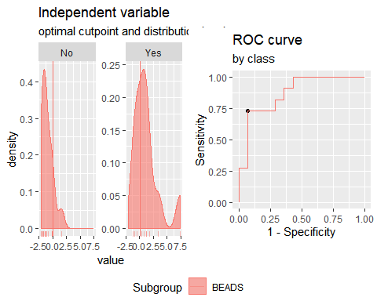

**"Combination IFNγ+CCL11+CCL10"**

Method: maximize_metric   
 Predictor: var   
 Outcome: GrupoNew   
 Direction: >=   
 Subgroups: BEADS   
   
 Subgroup: BEADS   
 ---------------------------------------------------------------------------   
 AUC n n_pos n_neg  
 0.9416 25 11 14  
   
 optimal_cutpoint youden acc sensitivity specificity tp fn fp tn  
 -0.7978 0.8571 0.92 1 0.8571 11 0 2 12  
   
 Predictor summary:   
 Min. 5% 1st Qu. Median Mean 3rd Qu. 95% Max. SD NAs  
 overall -2.649 -2.323 -1.662 -0.798 0.000 1.277 3.568 8.155 2.415 0  
 No -2.649 -2.496 -1.774 -1.644 -1.343 -1.084 0.425 1.870 1.092 0  
 Yes -0.798 -0.689 -0.177 1.277 1.710 2.563 5.923 8.155 2.590 0

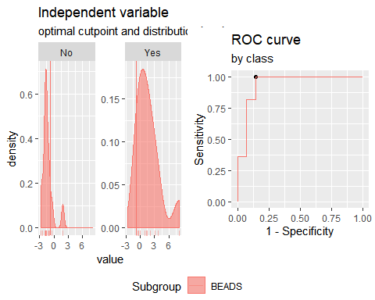

**"Combination IFNγ+CCL3+IL2"**

Method: maximize_metric   
 Predictor: var   
 Outcome: GrupoNew   
 Direction: >=   
 Subgroups: BEADS   
   
 Subgroup: BEADS   
 ---------------------------------------------------------------------------   
 AUC n n_pos n_neg  
 0.9091 25 11 14  
   
 optimal_cutpoint youden acc sensitivity specificity tp fn fp tn  
 -0.4671 0.7662 0.88 0.9091 0.8571 10 1 2 12  
   
 Predictor summary:   
 Min. 5% 1st Qu. Median Mean 3rd Qu. 95% Max. SD NAs  
 overall -2.322 -1.947 -1.567 -0.541 0.000 1.086 3.959 5.606 2.040 0  
 No -2.322 -2.087 -1.861 -1.533 -1.128 -0.952 1.127 1.488 1.104 0  
 Yes -1.343 -0.905 -0.133 1.086 1.435 2.053 4.981 5.606 2.087 0

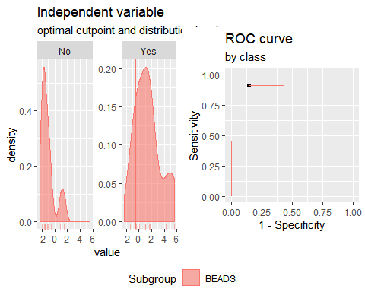

**"Combination IFNγ+CCL11+IL2"**

Method: maximize_metric   
 Predictor: var   
 Outcome: GrupoNew   
 Direction: >=   
 Subgroups: BEADS   
   
 Subgroup: BEADS   
 ---------------------------------------------------------------------------   
 AUC n n_pos n_neg  
 0.9481 25 11 14  
   
 optimal_cutpoint youden acc sensitivity specificity tp fn fp tn  
 -0.9831 0.9286 0.96 1 0.9286 11 0 1 13  
   
 Predictor summary:   
 Min. 5% 1st Qu. Median Mean 3rd Qu. 95% Max. SD NAs  
 overall -3.268 -2.662 -1.722 -1.039 0.000 1.127 5.910 6.574 2.622 0  
 No -3.268 -2.939 -1.944 -1.656 -1.479 -1.369 0.316 2.834 1.384 0  
 Yes -0.983 -0.788 0.167 1.127 1.882 3.124 6.484 6.574 2.655 0

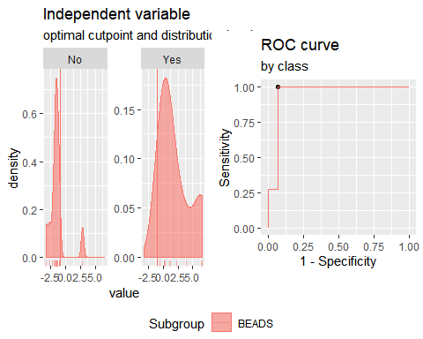

**Analysis PTB vs TSTp. Responses for all groups and cytokines corrected for background by subtraction.**

**"Combination IFNγ +IP10"**

Method: maximize_metric   
 Predictor: var   
 Outcome: GrupoNew   
 Direction: >=   
 Subgroups: BEADS   
   
 Subgroup: BEADS   
 ---------------------------------------------------------------------------   
 AUC n n_pos n_neg  
 0.8561 23 11 12  
   
 optimal_cutpoint youden acc sensitivity specificity tp fn fp tn  
 -0.8488 0.5833 0.7826 1 0.5833 11 0 5 7  
   
 Predictor summary:   
 Min. 5% 1st Qu. Median Mean 3rd Qu. 95% Max. SD NAs  
 overall -1.918 -1.506 -0.912 -0.683 0.000 0.216 3.489 4.501 1.708 0  
 No -1.918 -1.712 -1.151 -0.912 -0.913 -0.669 -0.147 0.433 0.575 0  
 Yes -0.849 -0.804 -0.687 -0.001 0.996 2.706 4.027 4.501 1.990 0

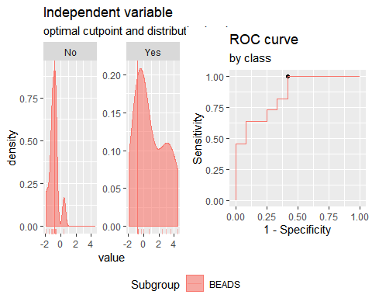

**"Combination IFNγ + IL2"**

Method: maximize_metric   
 Predictor: var   
 Outcome: GrupoNew   
 Direction: >=   
 Subgroups: BEADS   
   
 Subgroup: BEADS   
 ---------------------------------------------------------------------------   
 AUC n n_pos n_neg  
 0.9242 23 11 12  
   
 optimal_cutpoint youden acc sensitivity specificity tp fn fp tn  
 -0.3687 0.8258 0.913 0.9091 0.9167 10 1 1 11  
   
 Predictor summary:   
 Min. 5% 1st Qu. Median Mean 3rd Qu. 95% Max. SD NAs  
 overall -1.777 -1.672 -1.045 -0.387 0.000 0.258 3.652 4.763 1.749 0  
 No -1.777 -1.726 -1.526 -1.045 -0.972 -0.679 0.108 0.713 0.699 0  
 Yes -0.717 -0.543 -0.319 0.102 1.060 2.356 4.222 4.763 1.955 0

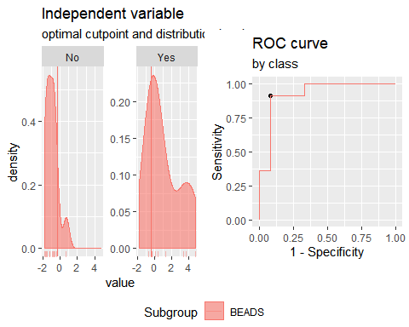

**"Combination IFNγ + CCL3"**

Method: maximize_metric   
 Predictor: var   
 Outcome: GrupoNew   
 Direction: >=   
 Subgroups: BEADS   
   
 Subgroup: BEADS   
 ---------------------------------------------------------------------------   
 AUC n n_pos n_neg  
 0.75 23 11 12  
   
 optimal_cutpoint youden acc sensitivity specificity tp fn fp tn  
 0.4094 0.4697 0.7391 0.6364 0.8333 7 4 2 10  
   
 Predictor summary:   
 Min. 5% 1st Qu. Median Mean 3rd Qu. 95% Max. SD NAs  
 overall -2.058 -1.770 -0.872 -0.392 0.000 0.720 1.938 4.234 1.409 0  
 No -1.807 -1.608 -1.128 -0.643 -0.580 -0.245 0.692 0.827 0.788 0  
 Yes -2.058 -1.481 -0.533 0.614 0.633 1.280 3.121 4.234 1.685 0

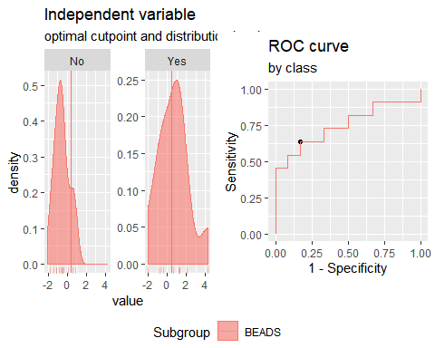

**"Combination IFNγ + CCL11"**

Method: maximize_metric   
 Predictor: var   
 Outcome: GrupoNew   
 Direction: >=   
 Subgroups: BEADS   
   
 Subgroup: BEADS   
 ---------------------------------------------------------------------------   
 AUC n n_pos n_neg  
 0.8788 23 11 12  
   
 optimal_cutpoint youden acc sensitivity specificity tp fn fp tn  
 -0.4136 0.7424 0.8696 0.9091 0.8333 10 1 2 10  
   
 Predictor summary:   
 Min. 5% 1st Qu. Median Mean 3rd Qu. 95% Max. SD NAs  
 overall -2.425 -1.597 -0.990 -0.414 0.000 0.610 2.558 4.301 1.600 0  
 No -2.425 -1.975 -1.092 -0.940 -0.934 -0.713 -0.028 0.361 0.676 0  
 Yes -1.505 -0.959 -0.248 0.860 1.019 2.340 3.441 4.301 1.715 0

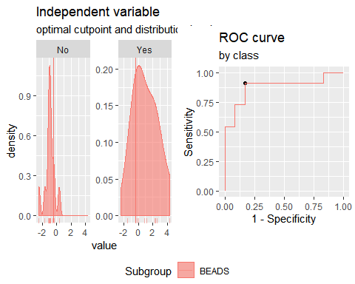

**"Combination IP10 + IL2"**

Method: maximize_metric   
 Predictor: var   
 Outcome: GrupoNew   
 Direction: >=   
 Subgroups: BEADS   
   
 Subgroup: BEADS   
 ---------------------------------------------------------------------------   
 AUC n n_pos n_neg  
 0.9242 23 11 12  
   
 optimal_cutpoint youden acc sensitivity specificity tp fn fp tn  
 -0.083 0.9091 0.9565 0.9091 1 10 1 0 12  
   
 Predictor summary:   
 Min. 5% 1st Qu. Median Mean 3rd Qu. 95% Max. SD  
 overall -2.043 -1.745 -1.189 -0.465 0.000 0.502 3.052 4.718 1.699  
 No -2.043 -1.894 -1.302 -1.068 -1.087 -0.808 -0.456 -0.446 0.499  
 Yes -1.507 -0.795 0.151 0.707 1.186 2.275 3.896 4.718 1.765  
 NAs  
 overall 0  
 No 0  
 Yes 0

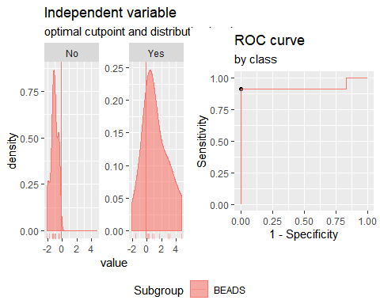

**"Combination IP10 + CCL3"**

Method: maximize_metric   
 Predictor: var   
 Outcome: GrupoNew   
 Direction: >=   
 Subgroups: BEADS   
   
 Subgroup: BEADS   
 ---------------------------------------------------------------------------   
 AUC n n_pos n_neg  
 0.7803 23 11 12  
   
 optimal_cutpoint youden acc sensitivity specificity tp fn fp tn  
 0.0825 0.6439 0.8261 0.7273 0.9167 8 3 1 11  
   
 Predictor summary:   
 Min. 5% 1st Qu. Median Mean 3rd Qu. 95% Max. SD NAs  
 overall -2.369 -1.916 -1.012 -0.317 0.000 1.136 2.574 2.692 1.467 0  
 No -1.929 -1.859 -1.088 -0.664 -0.696 -0.271 0.342 0.830 0.769 0  
 Yes -2.369 -2.031 -0.192 1.441 0.759 1.890 2.667 2.692 1.693 0

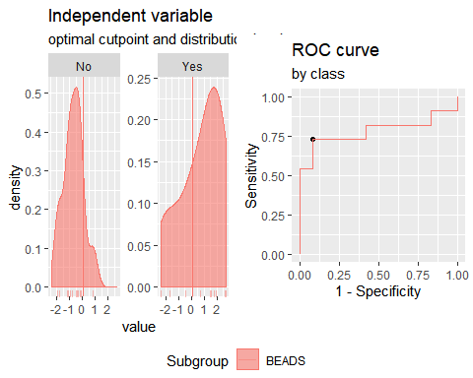

**"Combination IP10 + CCL11"**

Method: maximize_metric   
 Predictor: var   
 Outcome: GrupoNew   
 Direction: >=   
 Subgroups: BEADS   
   
 Subgroup: BEADS   
 ---------------------------------------------------------------------------   
 AUC n n_pos n_neg  
 0.8561 23 11 12  
   
 optimal_cutpoint youden acc sensitivity specificity tp fn fp tn  
 0.0757 0.8182 0.913 0.8182 1 9 2 0 12  
   
 Predictor summary:   
 Min. 5% 1st Qu. Median Mean 3rd Qu. 95% Max. SD  
 overall -2.419 -2.270 -0.997 -0.689 0.000 0.959 2.683 2.887 1.590  
 No -2.419 -2.406 -1.039 -0.811 -1.049 -0.706 -0.470 -0.360 0.667  
 Yes -1.152 -1.092 0.084 1.603 1.145 2.414 2.794 2.887 1.521  
 NAs  
 overall 0  
 No 0  
 Yes 0

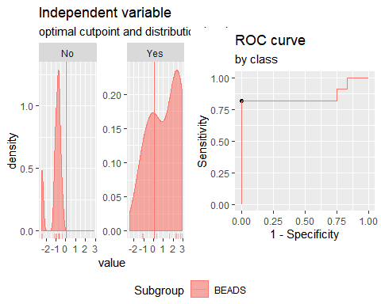

**"Combination IL2 + CCL3"**

Method: maximize_metric   
 Predictor: var   
 Outcome: GrupoNew   
 Direction: >=   
 Subgroups: BEADS   
   
 Subgroup: BEADS   
 ---------------------------------------------------------------------------   
 AUC n n_pos n_neg  
 0.8561 23 11 12  
   
 optimal_cutpoint youden acc sensitivity specificity tp fn fp tn  
 -0.1824 0.6591 0.8261 0.9091 0.75 10 1 3 9  
   
 Predictor summary:   
 Min. 5% 1st Qu. Median Mean 3rd Qu. 95% Max. SD NAs  
 overall -1.706 -1.688 -0.944 -0.151 0.000 0.756 2.293 2.303 1.345 0  
 No -1.706 -1.698 -1.652 -0.883 -0.754 -0.188 0.755 0.759 0.890 0  
 Yes -1.562 -0.872 -0.024 0.466 0.822 2.201 2.302 2.303 1.298 0

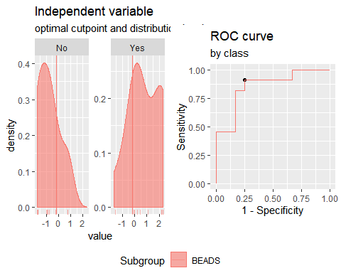

**"Combination IL2 + CCL11"**

Method: maximize_metric   
 Predictor: var   
 Outcome: GrupoNew   
 Direction: >=   
 Subgroups: BEADS   
   
 Subgroup: BEADS   
 ---------------------------------------------------------------------------   
 AUC n n_pos n_neg  
 0.8939 23 11 12  
   
 optimal_cutpoint youden acc sensitivity specificity tp fn fp tn  
 0.0632 0.7348 0.8696 0.8182 0.9167 9 2 1 11  
   
 Predictor summary:   
 Min. 5% 1st Qu. Median Mean 3rd Qu. 95% Max. SD NAs  
 overall -2.279 -2.090 -1.093 -0.503 0.000 0.483 3.300 4.888 1.807 0  
 No -2.279 -2.189 -1.681 -0.971 -1.107 -0.558 -0.167 0.147 0.746 0  
 Yes -1.112 -1.066 0.257 0.491 1.208 2.470 4.134 4.888 1.870 0

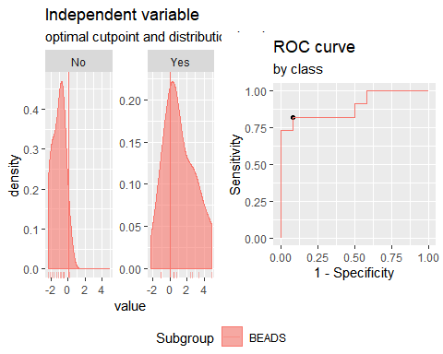

**"Combination CCL3 + CCL11"**

Method: maximize_metric   
 Predictor: var   
 Outcome: GrupoNew   
 Direction: >=   
 Subgroups: BEADS   
   
 Subgroup: BEADS   
 ---------------------------------------------------------------------------   
 AUC n n_pos n_neg  
 0.7803 23 11 12  
   
 optimal_cutpoint youden acc sensitivity specificity tp fn fp tn  
 -0.1837 0.4773 0.7391 0.7273 0.75 8 3 3 9  
   
 Predictor summary:   
 Min. 5% 1st Qu. Median Mean 3rd Qu. 95% Max. SD NAs  
 overall -2.308 -1.964 -1.171 -0.246 0.000 0.694 2.835 4.526 1.594 0  
 No -2.308 -2.139 -1.536 -0.500 -0.716 -0.213 0.820 1.013 1.032 0  
 Yes -1.208 -1.171 -0.370 0.316 0.781 1.539 3.723 4.526 1.770 0

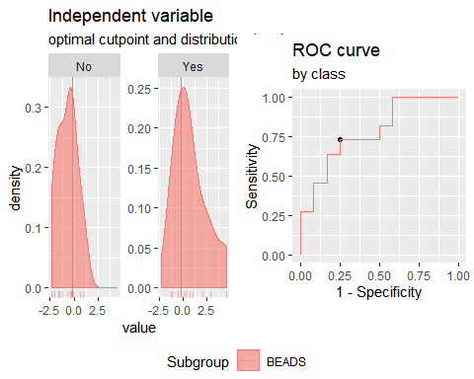

**"Combination IP10 + IL2+CCL3"**

Method: maximize_metric   
 Predictor: var   
 Outcome: GrupoNew   
 Direction: >=   
 Subgroups: BEADS   
   
 Subgroup: BEADS   
 ---------------------------------------------------------------------------   
 AUC n n_pos n_neg  
 0.9015 23 11 12  
   
 optimal_cutpoint youden acc sensitivity specificity tp fn fp tn  
 -0.2996 0.7424 0.8696 0.9091 0.8333 10 1 2 10  
   
 Predictor summary:   
 Min. 5% 1st Qu. Median Mean 3rd Qu. 95% Max. SD NAs  
 overall -2.811 -2.593 -1.438 -0.300 0.000 1.642 2.945 4.453 1.962 0  
 No -2.811 -2.704 -1.945 -1.266 -1.268 -0.369 -0.016 0.312 0.969 0  
 Yes -2.381 -1.340 0.286 2.020 1.383 2.252 3.729 4.453 1.844 0

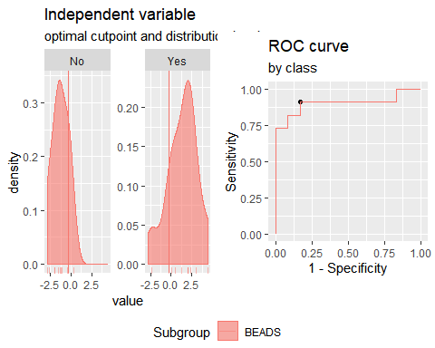

**"Combination IP10 + IL2+CCL11"**

Method: maximize_metric   
 Predictor: var   
 Outcome: GrupoNew   
 Direction: >=   
 Subgroups: BEADS   
   
 Subgroup: BEADS   
 ---------------------------------------------------------------------------   
 AUC n n_pos n_neg  
 0.9167 23 11 12  
   
 optimal_cutpoint youden acc sensitivity specificity tp fn fp tn  
 0.2421 0.8182 0.913 0.8182 1 9 2 0 12  
   
 Predictor summary:   
 Min. 5% 1st Qu. Median Mean 3rd Qu. 95% Max. SD  
 overall -3.276 -3.122 -1.662 -0.891 0.000 1.601 4.629 5.116 2.384  
 No -3.276 -3.254 -1.941 -1.401 -1.622 -0.992 -0.735 -0.655 0.887  
 Yes -1.840 -1.429 0.306 2.325 1.769 3.056 4.958 5.116 2.245  
 NAs  
 overall 0  
 No 0  
 Yes 0

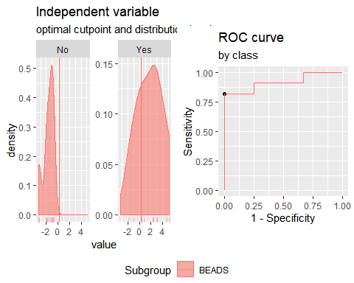

**"Combination IP10 + CCL3+CCL11"**

Method: maximize_metric   
 Predictor: var   
 Outcome: GrupoNew   
 Direction: >=   
 Subgroups: BEADS   
   
 Subgroup: BEADS   
 ---------------------------------------------------------------------------   
 AUC n n_pos n_neg  
 0.8561 23 11 12  
   
 optimal_cutpoint youden acc sensitivity specificity tp fn fp tn  
 -0.3268 0.6515 0.8261 0.8182 0.8333 9 2 2 10  
   
 Predictor summary:   
 Min. 5% 1st Qu. Median Mean 3rd Qu. 95% Max. SD NAs  
 overall -3.264 -3.049 -1.314 -0.375 0.000 1.432 3.243 4.244 2.055 0  
 No -3.264 -3.208 -1.795 -1.018 -1.230 -0.446 0.108 0.566 1.148 0  
 Yes -2.027 -1.534 -0.234 1.991 1.342 2.942 3.755 4.244 2.010 0

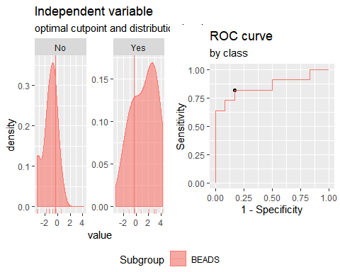

**"Combination IL2 + CCL3+CCL11"**

Method: maximize_metric   
 Predictor: var   
 Outcome: GrupoNew   
 Direction: >=   
 Subgroups: BEADS   
   
 Subgroup: BEADS   
 ---------------------------------------------------------------------------   
 AUC n n_pos n_neg  
 0.8561 23 11 12  
   
 optimal_cutpoint youden acc sensitivity specificity tp fn fp tn  
 0.2749 0.6515 0.8261 0.8182 0.8333 9 2 2 10  
   
 Predictor summary:   
 Min. 5% 1st Qu. Median Mean 3rd Qu. 95% Max. SD NAs  
 overall -3.124 -2.855 -1.370 -0.409 0.000 1.034 3.650 5.105 2.149 0  
 No -3.124 -2.991 -2.456 -1.154 -1.289 -0.467 0.624 0.781 1.277 0  
 Yes -1.895 -1.509 0.359 1.288 1.406 2.328 4.450 5.105 2.049 0

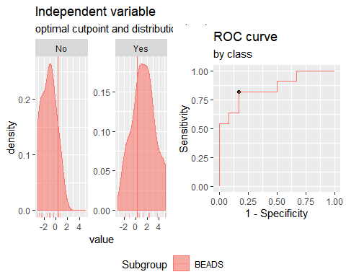

**"Combination IFNγ+IP10+IL2"**

Method: maximize_metric   
 Predictor: var   
 Outcome: GrupoNew   
 Direction: >=   
 Subgroups: BEADS   
   
 Subgroup: BEADS   
 ---------------------------------------------------------------------------   
 AUC n n_pos n_neg  
 0.9394 23 11 12  
   
 optimal_cutpoint youden acc sensitivity specificity tp fn fp tn  
 -0.5404 0.8258 0.913 0.9091 0.9167 10 1 1 11  
   
 Predictor summary:   
 Min. 5% 1st Qu. Median Mean 3rd Qu. 95% Max. SD  
 overall -2.733 -2.008 -1.531 -0.924 0.000 0.190 3.858 6.991 2.421  
 No -2.733 -2.336 -1.936 -1.475 -1.486 -1.006 -0.710 -0.449 0.624  
 Yes -1.536 -1.038 -0.333 0.560 1.621 3.702 5.428 6.991 2.633  
 NAs  
 overall 0  
 No 0  
 Yes 0

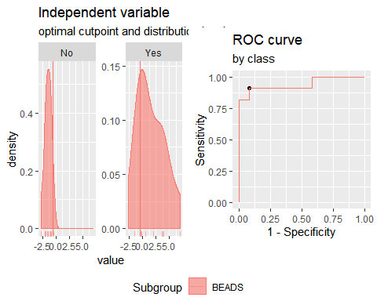

**"Combination IFNγ+CCL3+CCL11"**

Method: maximize_metric   
 Predictor: var   
 Outcome: GrupoNew   
 Direction: >=   
 Subgroups: BEADS   
   
 Subgroup: BEADS   
 ---------------------------------------------------------------------------   
 AUC n n_pos n_neg  
 0.8485 23 11 12  
   
 optimal_cutpoint youden acc sensitivity specificity tp fn fp tn  
 -0.3488 0.6515 0.8261 0.8182 0.8333 9 2 2 10  
   
 Predictor summary:   
 Min. 5% 1st Qu. Median Mean 3rd Qu. 95% Max. SD NAs  
 overall -3.270 -2.293 -1.144 -0.407 0.000 0.910 3.854 5.728 2.021 0  
 No -3.270 -2.759 -1.721 -0.927 -1.115 -0.624 0.229 0.318 1.027 0  
 Yes -1.516 -1.377 -0.182 1.240 1.217 1.787 4.889 5.728 2.170 0

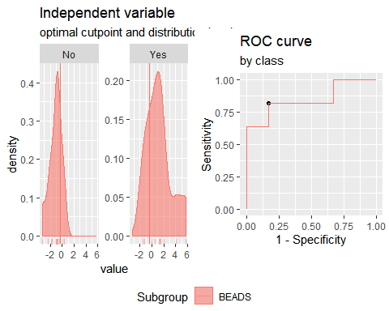

**"Combination IFNγ+CCL3+IP10"**

Method: maximize_metric   
 Predictor: var   
 Outcome: GrupoNew   
 Direction: >=   
 Subgroups: BEADS   
   
 Subgroup: BEADS   
 ---------------------------------------------------------------------------   
 AUC n n_pos n_neg  
 0.7879 23 11 12  
   
 optimal_cutpoint youden acc sensitivity specificity tp fn fp tn  
 -0.2986 0.6439 0.8261 0.7273 0.9167 8 3 1 11  
   
 Predictor summary:   
 Min. 5% 1st Qu. Median Mean 3rd Qu. 95% Max. SD NAs  
 overall -2.763 -1.819 -1.346 -0.639 0.000 0.760 4.183 4.343 2.013 0  
 No -2.763 -2.167 -1.421 -1.105 -1.095 -0.628 -0.124 0.135 0.737 0  
 Yes -1.829 -1.776 -0.611 0.965 1.194 3.291 4.289 4.343 2.305 0

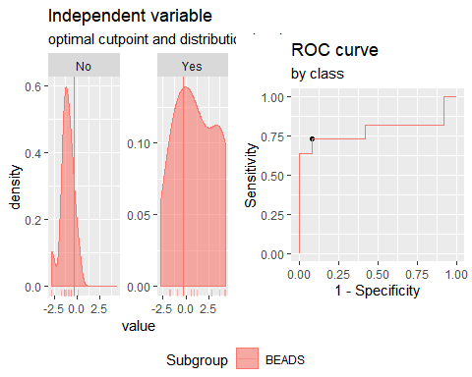

**"Combination IFNγ+CCL11+IP10"**

Method: maximize_metric   
 Predictor: var   
 Outcome: GrupoNew   
 Direction: >=   
 Subgroups: BEADS   
   
 Subgroup: BEADS   
 ---------------------------------------------------------------------------   
 AUC n n_pos n_neg  
 0.9091 23 11 12  
   
 optimal_cutpoint youden acc sensitivity specificity tp fn fp tn  
 -0.495 0.8182 0.913 0.8182 1 9 2 0 12  
   
 Predictor summary:   
 Min. 5% 1st Qu. Median Mean 3rd Qu. 95% Max. SD  
 overall -3.381 -1.816 -1.409 -0.958 0.000 1.106 4.341 4.582 2.237  
 No -3.381 -2.534 -1.532 -1.372 -1.448 -1.003 -0.878 -0.800 0.681  
 Yes -1.412 -1.297 -0.438 2.043 1.580 3.418 4.496 4.582 2.289  
 NAs  
 overall 0  
 No 0  
 Yes 0

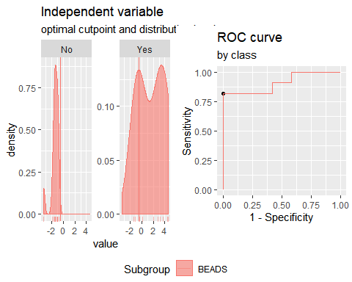

**"Combination IFNγ+CCL3+IL2"**

Method: maximize_metric   
 Predictor: var   
 Outcome: GrupoNew   
 Direction: >=   
 Subgroups: BEADS   
   
 Subgroup: BEADS   
 ---------------------------------------------------------------------------   
 AUC n n_pos n_neg  
 0.8712 23 11 12  
   
 optimal_cutpoint youden acc sensitivity specificity tp fn fp tn  
 -0.5076 0.6591 0.8261 0.9091 0.75 10 1 3 9  
   
 Predictor summary:   
 Min. 5% 1st Qu. Median Mean 3rd Qu. 95% Max. SD NAs  
 overall -2.622 -2.38 -1.449 -0.379 0.000 0.879 4.231 5.108 1.963 0  
 No -2.622 -2.51 -1.657 -1.312 -1.153 -0.472 0.146 0.247 0.951 0  
 Yes -1.592 -1.05 -0.164 0.971 1.258 1.708 4.803 5.108 2.037 0

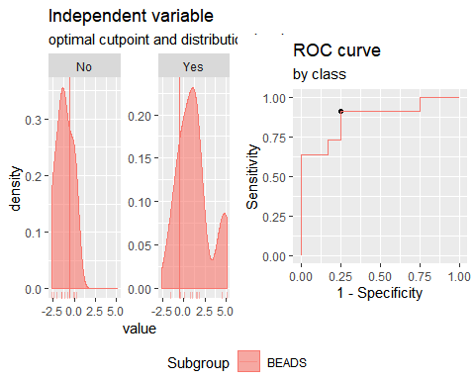

**"Combination IFNγ+CCL11+IL2**"

Method: maximize_metric   
 Predictor: var   
 Outcome: GrupoNew   
 Direction: >=   
 Subgroups: BEADS   
   
 Subgroup: BEADS   
 ---------------------------------------------------------------------------   
 AUC n n_pos n_neg  
 0.9167 23 11 12  
   
 optimal_cutpoint youden acc sensitivity specificity tp fn fp tn  
 -0.1361 0.8182 0.913 0.8182 1 9 2 0 12  
   
 Predictor summary:   
 Min. 5% 1st Qu. Median Mean 3rd Qu. 95% Max. SD  
 overall -3.240 -2.524 -1.485 -0.693 0.000 0.441 5.143 5.427 2.426  
 No -3.240 -2.877 -1.985 -1.406 -1.506 -0.950 -0.448 -0.359 0.857  
 Yes -1.493 -1.272 -0.051 0.584 1.643 3.874 5.301 5.427 2.538  
 NAs  
 overall 0  
 No 0  
 Yes 0

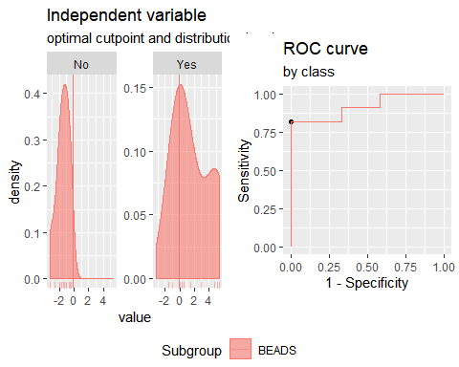

**Analysis PTB vs TSTp. Responses for all groups and cytokines corrected for background by division (ratio).**

**"Combination IFNγ +IP10"**

Method: maximize_metric   
 Predictor: var   
 Outcome: GrupoNew   
 Direction: >=   
 Subgroups: BEADS   
   
 Subgroup: BEADS   
 ---------------------------------------------------------------------------   
 AUC n n_pos n_neg  
 0.9015 23 11 12  
   
 optimal_cutpoint youden acc sensitivity specificity tp fn fp tn  
 -0.7118 0.75 0.8696 1 0.75 11 0 3 9  
   
 Predictor summary:   
 Min. 5% 1st Qu. Median Mean 3rd Qu. 95% Max. SD NAs  
 overall -1.411 -1.379 -1.007 -0.676 0.000 0.187 1.979 7.387 1.886 0  
 No -1.411 -1.399 -1.242 -1.007 -0.902 -0.710 -0.188 0.274 0.468 0  
 Yes -0.712 -0.711 -0.623 0.100 0.984 1.603 4.702 7.387 2.355 0

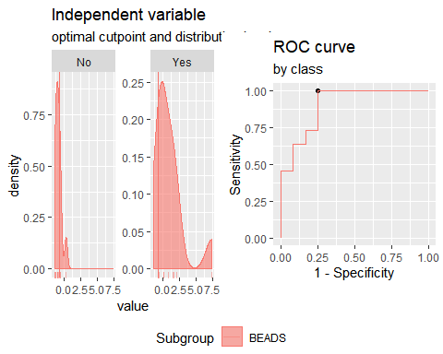

**"Combination IFNγ + IL2"**

Method: maximize_metric   
 Predictor: var   
 Outcome: GrupoNew   
 Direction: >=   
 Subgroups: BEADS   
   
 Subgroup: BEADS   
 ---------------------------------------------------------------------------   
 AUC n n_pos n_neg  
 0.9394 23 11 12  
   
 optimal_cutpoint youden acc sensitivity specificity tp fn fp tn  
 -0.6971 0.7424 0.8696 0.9091 0.8333 10 1 2 10  
   
 Predictor summary:   
 Min. 5% 1st Qu. Median Mean 3rd Qu. 95% Max. SD  
 overall -1.552 -1.508 -1.070 -0.697 0.000 0.069 4.356 5.710 1.893  
 No -1.552 -1.529 -1.479 -1.070 -1.044 -0.752 -0.446 -0.369 0.410  
 Yes -0.827 -0.762 -0.316 0.150 1.139 1.875 5.114 5.710 2.227  
 NAs  
 overall 0  
 No 0  
 Yes 0

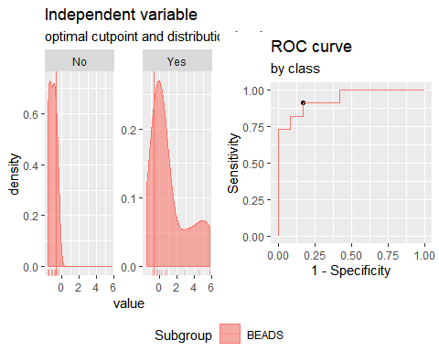

**"Combination IFNγ + CCL3"**

Method: maximize_metric   
 Predictor: var   
 Outcome: GrupoNew   
 Direction: >=   
 Subgroups: BEADS   
   
 Subgroup: BEADS   
 ---------------------------------------------------------------------------   
 AUC n n_pos n_neg  
 0.7879 23 11 12  
   
 optimal_cutpoint youden acc sensitivity specificity tp fn fp tn  
 -0.1111 0.6439 0.8261 0.7273 0.9167 8 3 1 11  
   
 Predictor summary:   
 Min. 5% 1st Qu. Median Mean 3rd Qu. 95% Max. SD NAs  
 overall -1.453 -1.347 -0.892 -0.497 0.000 0.414 2.880 3.700 1.330 0  
 No -1.453 -1.408 -0.903 -0.651 -0.681 -0.486 0.061 0.316 0.486 0  
 Yes -1.135 -1.037 -0.397 0.511 0.742 1.517 3.357 3.700 1.571 0

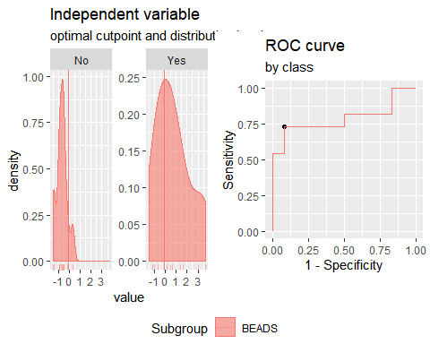

**"Combination IFNγ + CCL11"**

Method: maximize_metric   
 Predictor: var   
 Outcome: GrupoNew   
 Direction: >=   
 Subgroups: BEADS   
   
 Subgroup: BEADS   
 ---------------------------------------------------------------------------   
 AUC n n_pos n_neg  
 0.947 23 11 12  
   
 optimal_cutpoint youden acc sensitivity specificity tp fn fp tn  
 -0.2028 0.8182 0.913 0.8182 1 9 2 0 12  
   
 Predictor summary:   
 Min. 5% 1st Qu. Median Mean 3rd Qu. 95% Max. SD  
 overall -2.186 -1.855 -0.954 -0.555 0.000 0.577 3.718 3.887 1.698  
 No -2.186 -2.020 -1.298 -0.954 -1.103 -0.759 -0.481 -0.475 0.537  
 Yes -0.922 -0.739 -0.011 0.662 1.203 2.529 3.833 3.887 1.723  
 NAs  
 overall 0  
 No 0  
 Yes 0

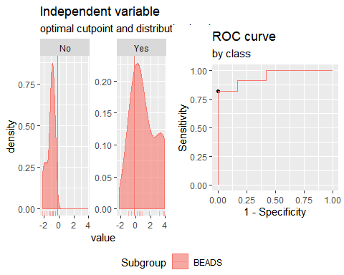

**"Combination IP10 + IL2"**

Method: maximize_metric   
 Predictor: var   
 Outcome: GrupoNew   
 Direction: >=   
 Subgroups: BEADS   
   
 Subgroup: BEADS   
 ---------------------------------------------------------------------------   
 AUC n n_pos n_neg  
 0.947 23 11 12  
   
 optimal_cutpoint youden acc sensitivity specificity tp fn fp tn  
 -0.3341 0.8258 0.913 0.9091 0.9167 10 1 1 11  
   
 Predictor summary:   
 Min. 5% 1st Qu. Median Mean 3rd Qu. 95% Max. SD  
 overall -1.589 -1.486 -1.147 -0.372 0.000 0.210 2.919 6.515 1.806  
 No -1.589 -1.534 -1.401 -1.147 -0.986 -0.504 -0.263 -0.129 0.498  
 Yes -1.087 -0.711 -0.033 0.282 1.076 1.332 4.802 6.515 2.113  
 NAs  
 overall 0  
 No 0  
 Yes 0

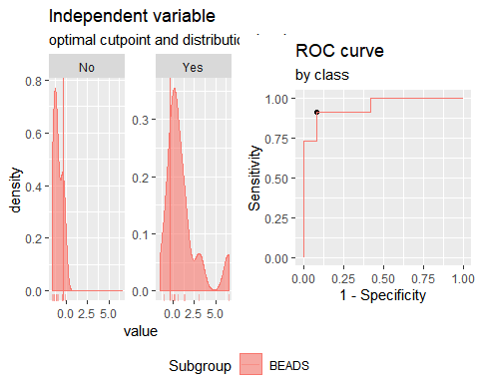

**"Combination IP10 + CCL3"**

Method: maximize_metric   
 Predictor: var   
 Outcome: GrupoNew   
 Direction: >=   
 Subgroups: BEADS   
   
 Subgroup: BEADS   
 ---------------------------------------------------------------------------   
 AUC n n_pos n_neg  
 0.7879 23 11 12  
   
 optimal_cutpoint youden acc sensitivity specificity tp fn fp tn  
 0.0397 0.6439 0.8261 0.7273 0.9167 8 3 1 11  
   
 Predictor summary:   
 Min. 5% 1st Qu. Median Mean 3rd Qu. 95% Max. SD NAs  
 overall -2.563 -1.338 -1.041 -0.223 0.000 0.840 1.971 3.820 1.389 0  
 No -1.350 -1.284 -1.112 -0.690 -0.622 -0.184 0.148 0.387 0.564 0  
 Yes -2.563 -1.881 -0.218 1.167 0.679 1.464 2.921 3.820 1.710 0

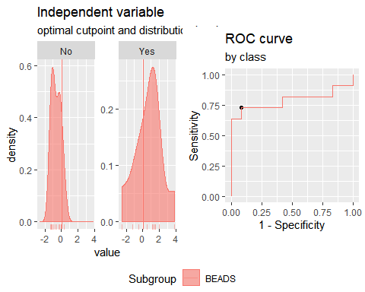

**"Combination IP10 + CCL11"**

Method: maximize_metric   
 Predictor: var   
 Outcome: GrupoNew   
 Direction: >=   
 Subgroups: BEADS   
   
 Subgroup: BEADS   
 ---------------------------------------------------------------------------   
 AUC n n_pos n_neg  
 0.9242 23 11 12  
   
 optimal_cutpoint youden acc sensitivity specificity tp fn fp tn  
 0.1559 0.8182 0.913 0.8182 1 9 2 0 12  
   
 Predictor summary:   
 Min. 5% 1st Qu. Median Mean 3rd Qu. 95% Max. SD  
 overall -1.945 -1.859 -0.975 -0.527 0.000 0.957 2.319 4.692 1.583  
 No -1.945 -1.900 -1.421 -0.975 -1.045 -0.593 -0.351 -0.287 0.581  
 Yes -0.815 -0.793 0.272 1.025 1.140 1.714 3.521 4.692 1.550  
 NAs  
 overall 0  
 No 0  
 Yes 0

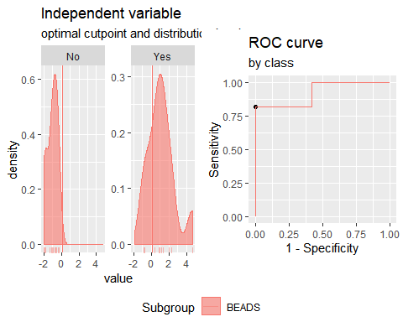

**"Combination IL2 + CCL3"**

Method: maximize_metric   
 Predictor: var   
 Outcome: GrupoNew   
 Direction: >=   
 Subgroups: BEADS   
   
 Subgroup: BEADS   
 ---------------------------------------------------------------------------   
 AUC n n_pos n_neg  
 0.8333 23 11 12  
   
 optimal_cutpoint youden acc sensitivity specificity tp fn fp tn  
 -0.1508 0.6515 0.8261 0.8182 0.8333 9 2 2 10  
   
 Predictor summary:   
 Min. 5% 1st Qu. Median Mean 3rd Qu. 95% Max. SD NAs  
 overall -1.667 -1.515 -0.926 -0.237 0.000 0.450 2.359 2.451 1.315 0  
 No -1.667 -1.587 -1.445 -0.872 -0.765 -0.261 0.449 0.460 0.729 0  
 Yes -1.458 -0.871 -0.083 0.386 0.834 2.228 2.408 2.451 1.323 0

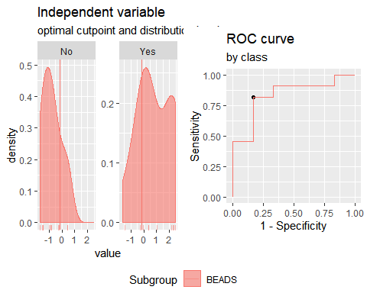

**"Combination IL2 + CCL11"**

Method: maximize_metric   
 Predictor: var   
 Outcome: GrupoNew   
 Direction: >=   
 Subgroups: BEADS   
   
 Subgroup: BEADS   
 ---------------------------------------------------------------------------   
 AUC n n_pos n_neg  
 0.9318 23 11 12  
   
 optimal_cutpoint youden acc sensitivity specificity tp fn fp tn  
 0.2283 0.8182 0.913 0.8182 1 9 2 0 12  
   
 Predictor summary:   
 Min. 5% 1st Qu. Median Mean 3rd Qu. 95% Max. SD NAs  
 overall -2.400 -2.138 -1.148 -0.508 0.000 0.662 3.002 5.299 1.863 0  
 No -2.400 -2.267 -1.855 -1.148 -1.187 -0.599 -0.171 0.122 0.777 0  
 Yes -1.073 -0.949 0.406 0.713 1.295 2.332 4.157 5.299 1.854 0

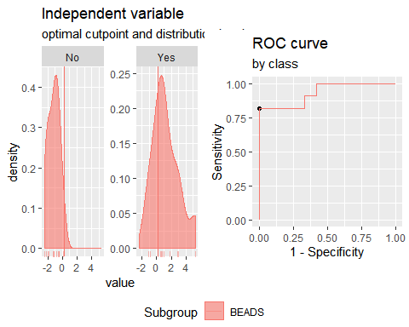

**"Combination CCL3 + CCL11"**

Method: maximize_metric   
 Predictor: var   
 Outcome: GrupoNew   
 Direction: >=   
 Subgroups: BEADS   
   
 Subgroup: BEADS   
 ---------------------------------------------------------------------------   
 AUC n n_pos n_neg  
 0.8106 23 11 12  
   
 optimal_cutpoint youden acc sensitivity specificity tp fn fp tn  
 0.3198 0.5606 0.7826 0.7273 0.8333 8 3 2 10  
   
 Predictor summary:   
 Min. 5% 1st Qu. Median Mean 3rd Qu. 95% Max. SD NAs  
 overall -2.301 -1.986 -1.055 -0.323 0.000 0.558 2.563 4.110 1.555 0  
 No -2.301 -2.138 -1.668 -0.524 -0.824 -0.288 0.551 0.634 0.973 0  
 Yes -1.186 -1.055 -0.017 0.414 0.898 1.786 3.340 4.110 1.605 0

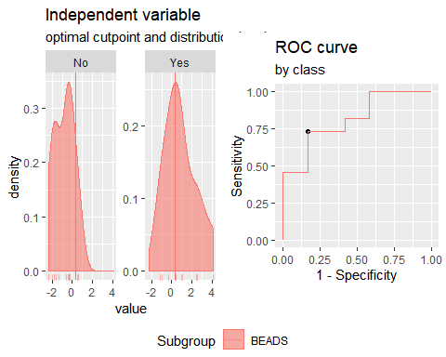

**"Combination IP10 + IL2+CCL3**"

Method: maximize_metric   
 Predictor: var   
 Outcome: GrupoNew   
 Direction: >=   
 Subgroups: BEADS   
   
 Subgroup: BEADS   
 ---------------------------------------------------------------------------   
 AUC n n_pos n_neg  
 0.9015 23 11 12  
   
 optimal_cutpoint youden acc sensitivity specificity tp fn fp tn  
 -0.0528 0.7348 0.8696 0.8182 0.9167 9 2 1 11  
   
 Predictor summary:   
 Min. 5% 1st Qu. Median Mean 3rd Qu. 95% Max. SD  
 overall -2.145 -2.023 -1.568 -0.344 0.000 0.961 2.282 6.239 1.980  
 No -2.145 -2.081 -1.881 -1.449 -1.186 -0.457 -0.084 -0.016 0.794  
 Yes -1.872 -1.137 0.014 1.465 1.294 2.129 4.266 6.239 2.098  
 NAs  
 overall 0  
 No 0  
 Yes 0

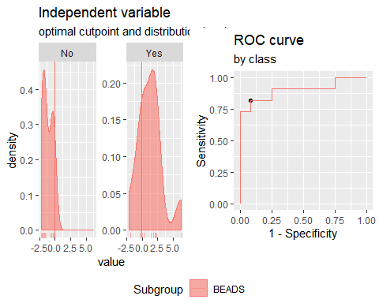

**"Combination IP10 + IL2+CCL11"**

Method: maximize_metric   
 Predictor: var   
 Outcome: GrupoNew   
 Direction: >=   
 Subgroups: BEADS   
   
 Subgroup: BEADS   
 ---------------------------------------------------------------------------   
 AUC n n_pos n_neg  
 0.9394 23 11 12  
   
 optimal_cutpoint youden acc sensitivity specificity tp fn fp tn  
 0.4257 0.8182 0.913 0.8182 1 9 2 0 12  
   
 Predictor summary:   
 Min. 5% 1st Qu. Median Mean 3rd Qu. 95% Max. SD  
 overall -2.743 -2.706 -1.681 -0.729 0.000 1.054 5.093 7.111 2.498  
 No -2.743 -2.726 -2.274 -1.657 -1.609 -0.907 -0.480 -0.354 0.855  
 Yes -1.488 -1.108 0.443 1.646 1.755 2.176 6.240 7.111 2.535  
 NAs  
 overall 0  
 No 0  
 Yes 0

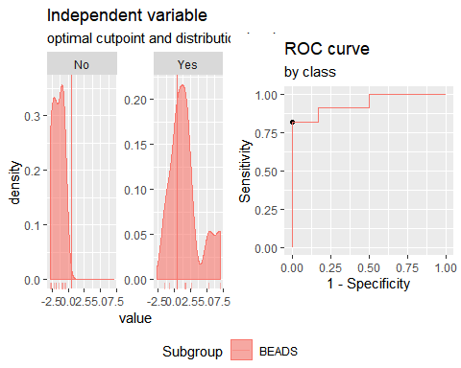

**"Combination IP10 + CCL3+CCL11"**

Method: maximize_metric   
 Predictor: var   
 Outcome: GrupoNew   
 Direction: >=   
 Subgroups: BEADS   
   
 Subgroup: BEADS   
 ---------------------------------------------------------------------------   
 AUC n n_pos n_neg  
 0.8864 23 11 12  
   
 optimal_cutpoint youden acc sensitivity specificity tp fn fp tn  
 0.1622 0.7273 0.8696 0.7273 1 8 3 0 12  
   
 Predictor summary:   
 Min. 5% 1st Qu. Median Mean 3rd Qu. 95% Max. SD NAs  
 overall -2.613 -2.582 -1.171 -0.282 0.000 1.392 3.682 4.416 1.963 0  
 No -2.613 -2.600 -2.087 -1.096 -1.245 -0.500 0.028 0.054 0.978 0  
 Yes -1.600 -1.214 -0.060 1.478 1.359 2.390 4.118 4.416 1.879 0

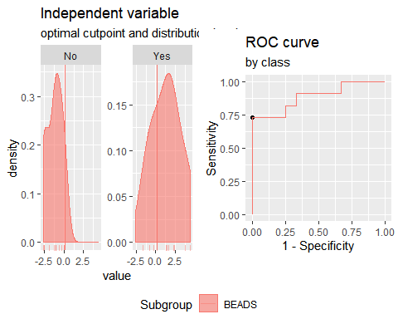

**"Combination IL2 + CCL3+CCL11"**

Method: maximize_metric   
 Predictor: var   
 Outcome: GrupoNew   
 Direction: >=   
 Subgroups: BEADS   
   
 Subgroup: BEADS   
 ---------------------------------------------------------------------------   
 AUC n n_pos n_neg  
 0.8939 23 11 12  
   
 optimal_cutpoint youden acc sensitivity specificity tp fn fp tn  
 0.4879 0.7348 0.8696 0.8182 0.9167 9 2 1 11  
   
 Predictor summary:   
 Min. 5% 1st Qu. Median Mean 3rd Qu. 95% Max. SD NAs  
 overall -3.184 -2.784 -1.511 -0.480 0.000 1.107 3.272 4.682 2.149 0  
 No -3.184 -2.974 -2.514 -1.228 -1.388 -0.566 0.299 0.532 1.194 0  
 Yes -1.859 -1.370 0.499 1.526 1.514 2.752 4.005 4.682 1.939 0

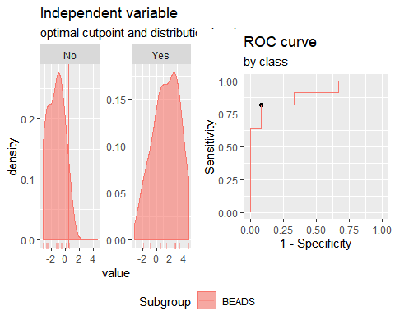

**"Combination IFNγ+IP10+IL2"**

Method: maximize_metric   
 Predictor: var   
 Outcome: GrupoNew   
 Direction: >=   
 Subgroups: BEADS   
   
 Subgroup: BEADS   
 ---------------------------------------------------------------------------   
 AUC n n_pos n_neg  
 0.9394 23 11 12  
   
 optimal_cutpoint youden acc sensitivity specificity tp fn fp tn  
 -0.6354 0.8258 0.913 0.9091 0.9167 10 1 1 11  
   
 Predictor summary:   
 Min. 5% 1st Qu. Median Mean 3rd Qu. 95% Max. SD  
 overall -2.228 -2.196 -1.527 -0.896 0.000 -0.014 4.407 9.806 2.721  
 No -2.228 -2.216 -1.924 -1.527 -1.466 -1.010 -0.543 -0.112 0.633  
 Yes -1.242 -0.939 -0.436 0.083 1.599 2.355 7.197 9.806 3.233  
 NAs  
 overall 0  
 No 0  
 Yes 0

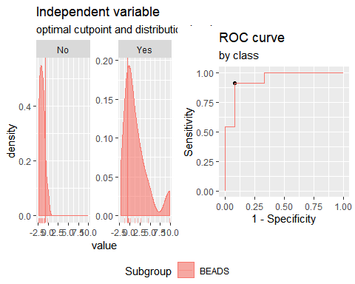

**"Combination IFNγ+CCL3+CCL11"**

Method: maximize_metric   
 Predictor: var   
 Outcome: GrupoNew   
 Direction: >=   
 Subgroups: BEADS   
   
 Subgroup: BEADS   
 ---------------------------------------------------------------------------   
 AUC n n_pos n_neg  
 0.9015 23 11 12  
   
 optimal_cutpoint youden acc sensitivity specificity tp fn fp tn  
 -0.045 0.7348 0.8696 0.8182 0.9167 9 2 1 11  
   
 Predictor summary:   
 Min. 5% 1st Qu. Median Mean 3rd Qu. 95% Max. SD  
 overall -2.970 -2.509 -1.222 -0.709 0.000 0.965 3.680 4.716 2.017  
 No -2.970 -2.733 -1.953 -1.050 -1.304 -0.786 -0.049 -0.017 0.929  
 Yes -1.341 -1.160 0.446 0.987 1.422 2.795 4.202 4.716 1.933  
 NAs  
 overall 0  
 No 0  
 Yes 0

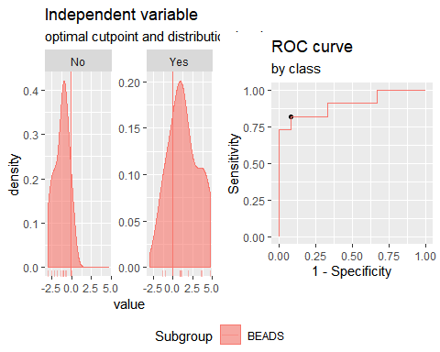

**"Combination IFNγ+CCL3+CCL10"**

Method: maximize_metric   
 Predictor: var   
 Outcome: GrupoNew   
 Direction: >=   
 Subgroups: BEADS   
   
 Subgroup: BEADS   
 ---------------------------------------------------------------------------   
 AUC n n_pos n_neg  
 0.8712 23 11 12  
   
 optimal_cutpoint youden acc sensitivity specificity tp fn fp tn  
 -0.0149 0.7273 0.8696 0.7273 1 8 3 0 12  
   
 Predictor summary:   
 Min. 5% 1st Qu. Median Mean 3rd Qu. 95% Max. SD  
 overall -2.066 -1.743 -1.293 -0.623 0.000 0.731 3.386 7.111 2.063  
 No -2.066 -1.900 -1.494 -1.228 -1.102 -0.611 -0.283 -0.263 0.593  
 Yes -1.354 -1.209 -0.475 1.080 1.203 1.610 5.341 7.111 2.435  
 NAs  
 overall 0  
 No 0  
 Yes 0

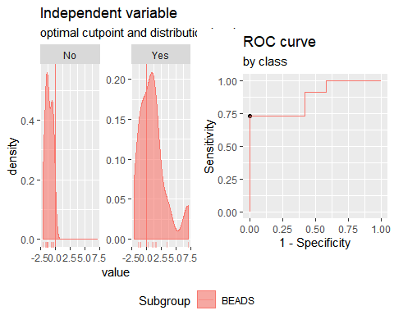

**"Combination IFNγ+CCL11+CCL10"**

Method: maximize_metric   
 Predictor: var   
 Outcome: GrupoNew   
 Direction: >=   
 Subgroups: BEADS   
   
 Subgroup: BEADS   
 ---------------------------------------------------------------------------   
 AUC n n_pos n_neg  
 0.9621 23 11 12  
   
 optimal_cutpoint youden acc sensitivity specificity tp fn fp tn  
 -0.3615 0.8182 0.913 0.8182 1 9 2 0 12  
   
 Predictor summary:   
 Min. 5% 1st Qu. Median Mean 3rd Qu. 95% Max. SD  
 overall -2.578 -2.467 -1.543 -0.826 0.000 1.054 3.768 7.982 2.439  
 No -2.578 -2.534 -1.876 -1.543 -1.525 -1.068 -0.676 -0.510 0.659  
 Yes -0.970 -0.898 -0.216 1.214 1.664 2.491 5.916 7.982 2.602  
 NAs  
 overall 0  
 No 0  
 Yes 0

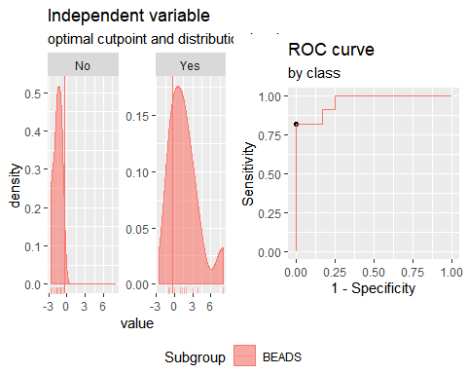

**"Combination IFNγ+CCL3+IL2**"

Method: maximize_metric   
 Predictor: var   
 Outcome: GrupoNew   
 Direction: >=   
 Subgroups: BEADS   
   
 Subgroup: BEADS   
 ---------------------------------------------------------------------------   
 AUC n n_pos n_neg  
 0.9091 23 11 12  
   
 optimal_cutpoint youden acc sensitivity specificity tp fn fp tn  
 -0.6094 0.7424 0.8696 0.9091 0.8333 10 1 2 10  
   
 Predictor summary:   
 Min. 5% 1st Qu. Median Mean 3rd Qu. 95% Max. SD  
 overall -2.336 -2.125 -1.485 -0.609 0.000 0.995 4.206 5.434 2.020  
 No -2.336 -2.242 -1.704 -1.344 -1.245 -0.777 -0.160 -0.098 0.711  
 Yes -1.613 -1.111 -0.243 1.066 1.358 1.938 4.946 5.434 2.129  
 NAs  
 overall 0  
 No 0  
 Yes 0

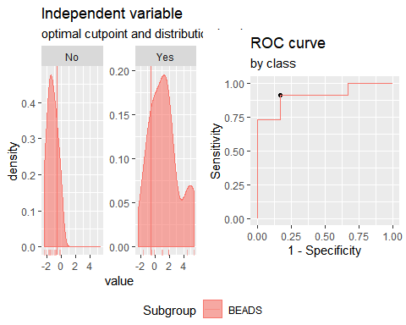

**"Combination IFNγ+CCL11+IL2"**

Method: maximize_metric   
 Predictor: var   
 Outcome: GrupoNew   
 Direction: >=   
 Subgroups: BEADS   
   
 Subgroup: BEADS   
 ---------------------------------------------------------------------------   
 AUC n n_pos n_neg  
 0.947 23 11 12  
   
 optimal_cutpoint youden acc sensitivity specificity tp fn fp tn  
 0.0669 0.8182 0.913 0.8182 1 9 2 0 12  
   
 Predictor summary:   
 Min. 5% 1st Qu. Median Mean 3rd Qu. 95% Max. SD  
 overall -3.069 -2.650 -1.636 -0.880 0.000 0.651 6.067 6.798 2.634  
 No -3.069 -2.854 -2.144 -1.636 -1.667 -1.097 -0.640 -0.436 0.800  
 Yes -1.228 -1.054 0.082 1.047 1.819 3.193 6.552 6.798 2.754  
 NAs  
 overall 0  
 No 0  
 Yes 0

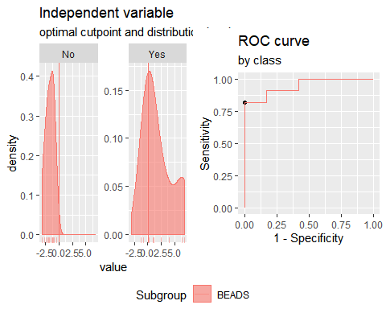

**Analysis TSTp vs TSTn. Responses for all groups and cytokinescorrected for background by subtraction.**

**"Diferencia entre B2 y B1**

**"Combination IFNγ +IP10"**

Method: maximize_metric   
 Predictor: var   
 Outcome: GrupoNew   
 Direction: >=   
 Subgroups: BEADS   
   
 Subgroup: BEADS   
 ---------------------------------------------------------------------------   
 AUC n n_pos n_neg  
 0.5952 26 12 14  
   
 optimal_cutpoint youden acc sensitivity specificity tp fn fp tn  
 -0.2887 0.2619 0.6154 0.8333 0.4286 10 2 8 6  
   
 Predictor summary:   
 Min. 5% 1st Qu. Median Mean 3rd Qu. 95% Max. SD NAs  
 overall -2.375 -2.025 -0.434 -0.014 0.000 0.538 1.422 3.396 1.184 0  
 No -2.375 -2.248 -0.749 -0.120 -0.225 0.315 1.403 1.433 1.177 0  
 Yes -1.558 -1.110 -0.258 0.213 0.262 0.595 1.927 3.396 1.187 0

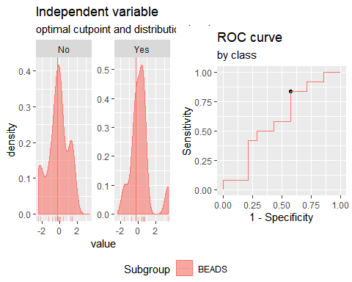

**"Combination IFNγ + IL2"**

Method: maximize_metric   
 Predictor: var   
 Outcome: GrupoNew   
 Direction: >=   
 Subgroups: BEADS   
   
 Subgroup: BEADS   
 ---------------------------------------------------------------------------   
 AUC n n_pos n_neg  
 0.631 26 12 14  
   
 optimal_cutpoint youden acc sensitivity specificity tp fn fp tn  
 0.5953 0.3571 0.6923 0.5 0.8571 6 6 2 12  
   
 Predictor summary:   
 Min. 5% 1st Qu. Median Mean 3rd Qu. 95% Max. SD NAs  
 overall -1.925 -1.749 -1.044 -0.244 0.000 0.737 3.220 3.959 1.502 0  
 No -1.925 -1.835 -1.124 -0.572 -0.285 0.006 2.323 3.959 1.521 0  
 Yes -1.386 -1.301 -0.874 0.221 0.332 1.009 2.613 3.725 1.472 0

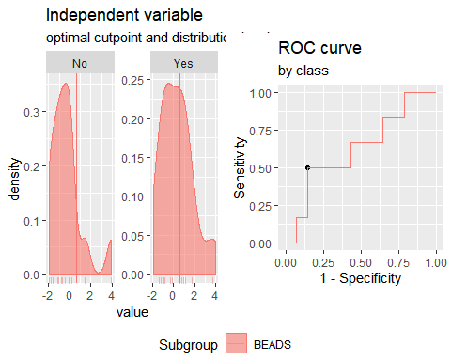

**"Combination IFNγ + CCL3"**

Method: maximize_metric   
 Predictor: var   
 Outcome: GrupoNew   
 Direction: >=   
 Subgroups: BEADS   
   
 Subgroup: BEADS   
 ---------------------------------------------------------------------------   
 AUC n n_pos n_neg  
 0.5357 26 12 14  
   
 optimal_cutpoint youden acc sensitivity specificity tp fn fp tn  
 -0.3335 0.2381 0.6154 0.6667 0.5714 8 4 6 8  
   
 Predictor summary:   
 Min. 5% 1st Qu. Median Mean 3rd Qu. 95% Max. SD NAs  
 overall -1.879 -1.708 -0.920 -0.285 0.000 0.360 2.555 3.473 1.336 0  
 No -1.769 -1.612 -1.027 -0.441 -0.042 0.360 2.354 2.680 1.376 0  
 Yes -1.879 -1.525 -0.582 -0.185 0.049 0.373 2.184 3.473 1.346 0

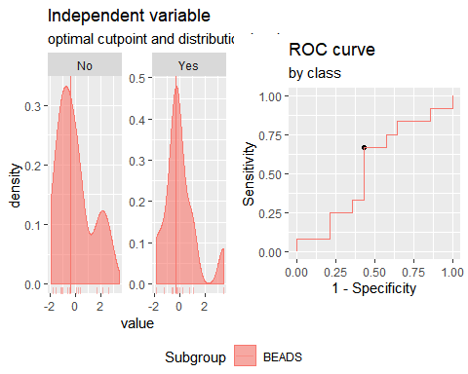

**"Combination IFNγ + CCL11"**

Method: maximize_metric   
 Predictor: var   
 Outcome: GrupoNew   
 Direction: >=   
 Subgroups: BEADS   
   
 Subgroup: BEADS   
 ---------------------------------------------------------------------------   
 AUC n n_pos n_neg  
 0.5536 26 12 14  
   
 optimal_cutpoint youden acc sensitivity specificity tp fn fp tn  
 -0.5201 0.25 0.6154 0.75 0.5 9 3 7 7  
   
 Predictor summary:   
 Min. 5% 1st Qu. Median Mean 3rd Qu. 95% Max. SD NAs  
 overall -1.725 -1.352 -0.633 -0.352 0.000 -0.035 3.057 5.673 1.520 0  
 No -1.475 -1.155 -0.666 -0.496 0.050 -0.055 2.790 5.673 1.739 0  
 Yes -1.725 -1.272 -0.549 -0.232 -0.058 -0.040 1.902 3.663 1.293 0

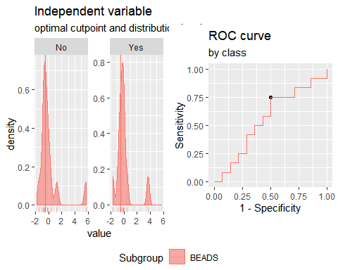

**"Combination IP10 + IL2"**

Method: maximize_metric   
 Predictor: var   
 Outcome: GrupoNew   
 Direction: >=   
 Subgroups: BEADS   
   
 Subgroup: BEADS   
 ---------------------------------------------------------------------------   
 AUC n n_pos n_neg  
 0.6667 26 12 14  
   
 optimal_cutpoint youden acc sensitivity specificity tp fn fp tn  
 -0.1522 0.4048 0.6923 0.8333 0.5714 10 2 6 8  
   
 Predictor summary:   
 Min. 5% 1st Qu. Median Mean 3rd Qu. 95% Max. SD NAs  
 overall -3.550 -2.484 -0.849 -0.020 0.000 1.176 1.620 3.113 1.476 0  
 No -3.550 -3.046 -1.408 -0.446 -0.364 0.811 2.035 3.113 1.757 0  
 Yes -1.258 -1.005 -0.127 0.342 0.425 1.310 1.616 1.623 0.968 0

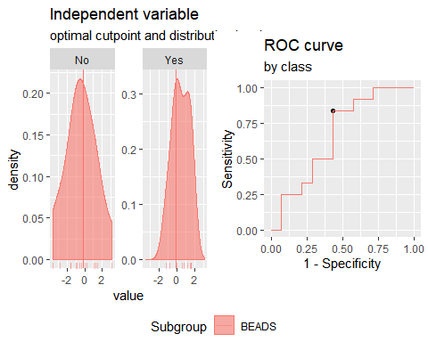

**"Combination IP10 + CCL3"**

Method: maximize_metric   
 Predictor: var   
 Outcome: GrupoNew   
 Direction: >=   
 Subgroups: BEADS   
   
 Subgroup: BEADS   
 ---------------------------------------------------------------------------   
 AUC n n_pos n_neg  
 0.5298 26 12 14  
   
 optimal_cutpoint youden acc sensitivity specificity tp fn fp tn  
 -1.51 0.2143 0.5769 1 0.2143 12 0 11 3  
   
 Predictor summary:   
 Min. 5% 1st Qu. Median Mean 3rd Qu. 95% Max. SD NAs  
 overall -4.724 -1.927 -0.454 0.055 0.000 0.866 1.785 3.593 1.548 0  
 No -4.724 -2.954 -0.961 -0.093 -0.121 1.082 2.128 3.593 1.948 0  
 Yes -1.510 -1.390 -0.260 0.214 0.141 0.681 1.423 1.934 0.959 0

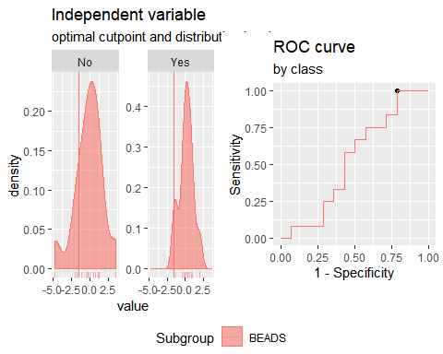

**"Combination IP10 + CCL11"**

Method: maximize_metric   
 Predictor: var   
 Outcome: GrupoNew   
 Direction: >=   
 Subgroups: BEADS   
   
 Subgroup: BEADS   
 ---------------------------------------------------------------------------   
 AUC n n_pos n_neg  
 0.5595 26 12 14  
   
 optimal_cutpoint youden acc sensitivity specificity tp fn fp tn  
 0.1394 0.3929 0.6923 0.75 0.6429 9 3 5 9  
   
 Predictor summary:   
 Min. 5% 1st Qu. Median Mean 3rd Qu. 95% Max. SD NAs  
 overall -3.755 -1.649 -0.638 0.175 0.000 0.511 1.188 4.827 1.428 0  
 No -3.755 -2.457 -0.770 -0.098 -0.029 0.561 2.489 4.827 1.884 0  
 Yes -1.320 -1.220 -0.006 0.238 0.034 0.368 0.659 0.757 0.660 0

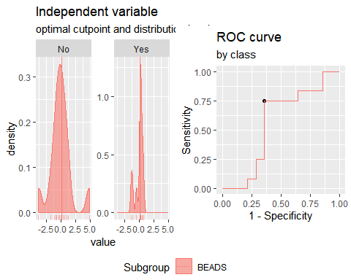

**"Combination IL2 + CCL3"**

Method: maximize_metric   
 Predictor: var   
 Outcome: GrupoNew   
 Direction: >=   
 Subgroups: BEADS   
   
 Subgroup: BEADS   
 ---------------------------------------------------------------------------   
 AUC n n_pos n_neg  
 0.5893 26 12 14  
   
 optimal_cutpoint youden acc sensitivity specificity tp fn fp tn  
 -1.3486 0.2857 0.6154 1 0.2857 12 0 10 4  
   
 Predictor summary:   
 Min. 5% 1st Qu. Median Mean 3rd Qu. 95% Max. SD NAs  
 overall -2.342 -1.848 -1.167 -0.164 0.000 0.361 2.804 4.062 1.579 0  
 No -2.342 -2.073 -1.340 -0.613 -0.181 0.303 3.257 4.062 1.775 0  
 Yes -1.349 -1.296 -1.134 0.061 0.212 1.200 2.351 2.747 1.361 0

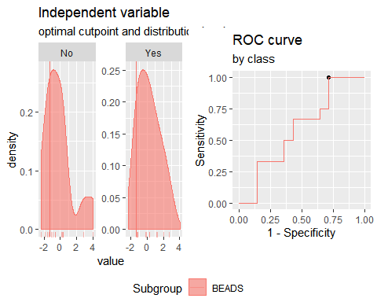

**"Combination IL2 + CCL11**"

Multiple optimal cutpoints found, applying break_ties.

Method: maximize_metric   
 Predictor: var   
 Outcome: GrupoNew   
 Direction: >=   
 Subgroups: BEADS   
   
 Subgroup: BEADS   
 ---------------------------------------------------------------------------   
 AUC n n_pos n_neg  
 0.6488 26 12 14  
   
 optimal_cutpoint youden acc sensitivity specificity tp fn fp tn  
 -0.3177 0 0.5 0.5 0.5 6 6 7 7  
   
 Predictor summary:   
 Min. 5% 1st Qu. Median Mean 3rd Qu. 95% Max. SD NAs  
 overall -3.420 -1.309 -0.984 -0.280 0.000 0.476 1.746 7.557 1.856 0  
 No -3.420 -2.084 -1.113 -0.295 -0.089 0.006 2.975 7.557 2.401 0  
 Yes -1.013 -1.001 -0.808 0.021 0.104 0.888 1.438 2.003 0.999 0

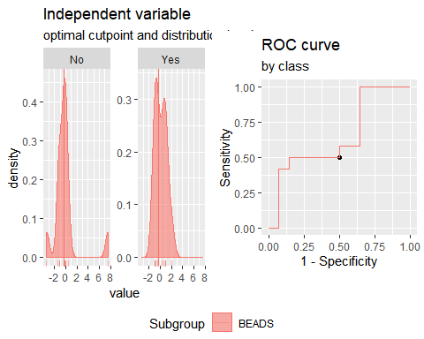

**"Combination CCL3 + CCL11"**

Method: maximize_metric   
 Predictor: var   
 Outcome: GrupoNew   
 Direction: >=   
 Subgroups: BEADS   
   
 Subgroup: BEADS   
 ---------------------------------------------------------------------------   
 AUC n n_pos n_neg  
 0.5536 26 12 14  
   
 optimal_cutpoint youden acc sensitivity specificity tp fn fp tn  
 0.1738 0.2857 0.6538 0.5 0.7857 6 6 3 11  
   
 Predictor summary:   
 Min. 5% 1st Qu. Median Mean 3rd Qu. 95% Max. SD NAs  
 overall -1.892 -1.412 -1.009 -0.486 0.000 0.233 2.752 5.776 1.630 0  
 No -1.892 -1.490 -1.026 -0.673 0.154 0.118 4.047 5.776 2.069 0  
 Yes -1.458 -1.339 -0.991 -0.104 -0.179 0.263 1.339 1.661 0.959 0

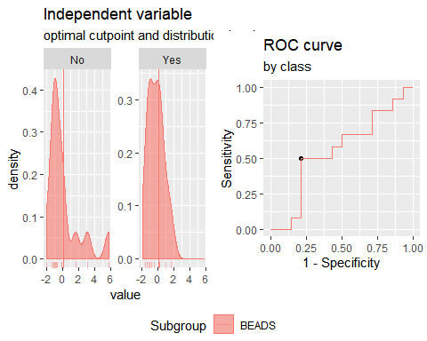

**"Combination IP10 + IL2+CCL3**"

Method: maximize_metric   
 Predictor: var   
 Outcome: GrupoNew   
 Direction: >=   
 Subgroups: BEADS   
   
 Subgroup: BEADS   
 ---------------------------------------------------------------------------   
 AUC n n_pos n_neg  
 0.631 26 12 14  
   
 optimal_cutpoint youden acc sensitivity specificity tp fn fp tn  
 0.004 0.3095 0.6538 0.6667 0.6429 8 4 5 9  
   
 Predictor summary:   
 Min. 5% 1st Qu. Median Mean 3rd Qu. 95% Max. SD NAs  
 overall -4.590 -2.900 -1.450 -0.036 0.000 1.346 3.011 4.254 2.017 0  
 No -4.590 -3.680 -1.925 -0.313 -0.333 0.887 3.599 4.254 2.393 0  
 Yes -1.974 -1.771 -0.718 0.247 0.389 1.895 2.214 2.306 1.473 0

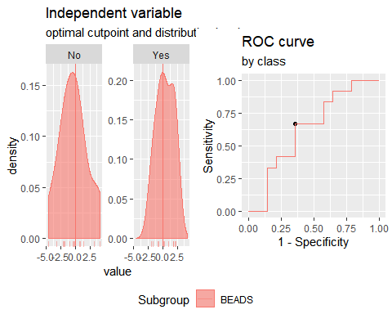

**"Combination IP10 + IL2+CCL11**"

Method: maximize_metric   
 Predictor: var   
 Outcome: GrupoNew   
 Direction: >=   
 Subgroups: BEADS   
   
 Subgroup: BEADS   
 ---------------------------------------------------------------------------   
 AUC n n_pos n_neg  
 0.6607 26 12 14  
   
 optimal_cutpoint youden acc sensitivity specificity tp fn fp tn  
 -0.4149 0.4048 0.6923 0.8333 0.5714 10 2 6 8  
   
 Predictor summary:   
 Min. 5% 1st Qu. Median Mean 3rd Qu. 95% Max. SD NAs  
 overall -3.621 -3.008 -1.167 -0.172 0.000 1.052 1.631 7.749 2.159 0  
 No -3.621 -3.236 -1.428 -0.689 -0.241 0.759 3.598 7.749 2.771 0  
 Yes -1.784 -1.601 -0.269 0.261 0.282 1.396 1.614 1.645 1.168 0

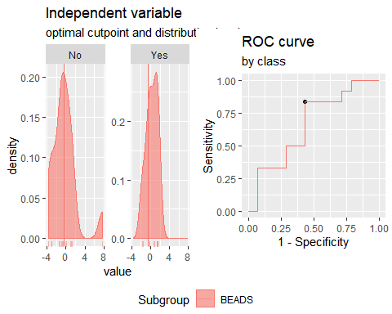

**"Combination IP10 + CCL3+CCL11"**

Method: maximize_metric   
 Predictor: var   
 Outcome: GrupoNew   
 Direction: >=   
 Subgroups: BEADS   
   
 Subgroup: BEADS   
 ---------------------------------------------------------------------------   
 AUC n n_pos n_neg  
 0.5417 26 12 14  
   
 optimal_cutpoint youden acc sensitivity specificity tp fn fp tn  
 -0.4365 0.3333 0.6538 0.8333 0.5 10 2 7 7  
   
 Predictor summary:   
 Min. 5% 1st Qu. Median Mean 3rd Qu. 95% Max. SD NAs  
 overall -4.795 -2.140 -1.177 -0.188 0.000 0.782 3.139 5.968 2.023 0  
 No -4.795 -3.092 -1.469 -0.442 0.002 1.075 4.389 5.968 2.597 0  
 Yes -2.036 -1.985 -0.424 0.174 -0.002 0.597 1.445 1.939 1.152 0

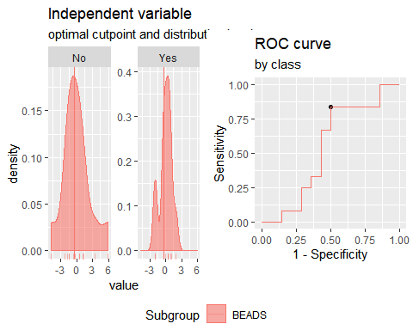

**"Combination IL2 + CCL3+CCL11"**

Method: maximize_metric   
 Predictor: var   
 Outcome: GrupoNew   
 Direction: >=   
 Subgroups: BEADS   
   
 Subgroup: BEADS   
 ---------------------------------------------------------------------------   
 AUC n n_pos n_neg  
 0.5893 26 12 14  
   
 optimal_cutpoint youden acc sensitivity specificity tp fn fp tn  
 -0.2319 0.2381 0.6154 0.6667 0.5714 8 4 6 8  
   
 Predictor summary:   
 Min. 5% 1st Qu. Median Mean 3rd Qu. 95% Max. SD NAs  
 overall -3.827 -2.075 -1.641 -0.206 0.000 0.430 2.877 8.698 2.366 0  
 No -3.827 -2.751 -1.581 -0.827 -0.059 0.335 4.844 8.698 2.947 0  
 Yes -1.771 -1.736 -1.544 -0.039 0.068 1.218 2.429 2.912 1.566 0

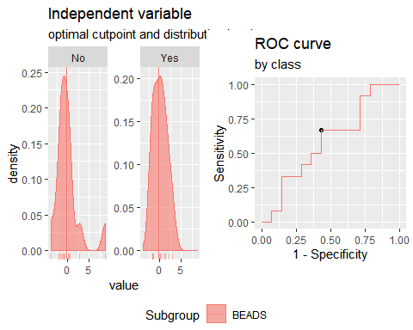

**"Combination IFNγ+IP10+IL2"**

Method: maximize_metric   
 Predictor: var   
 Outcome: GrupoNew   
 Direction: >=   
 Subgroups: BEADS   
   
 Subgroup: BEADS   
 ---------------------------------------------------------------------------   
 AUC n n_pos n_neg  
 0.6786 26 12 14  
   
 optimal_cutpoint youden acc sensitivity specificity tp fn fp tn  
 -0.6544 0.4167 0.6923 0.9167 0.5 11 1 7 7  
   
 Predictor summary:   
 Min. 5% 1st Qu. Median Mean 3rd Qu. 95% Max. SD NAs  
 overall -3.370 -2.149 -1.237 -0.350 0.000 1.277 2.595 4.151 1.684 0  
 No -3.370 -2.637 -1.507 -0.615 -0.437 0.308 2.441 4.151 1.877 0  
 Yes -1.871 -1.202 -0.635 0.654 0.510 1.362 2.191 2.932 1.325 0

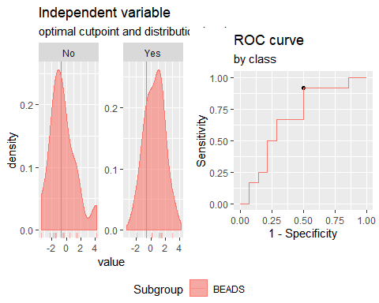

**"Combination IFNγ+CCL3+CCL11**"

Method: maximize_metric   
 Predictor: var   
 Outcome: GrupoNew   
 Direction: >=   
 Subgroups: BEADS   
   
 Subgroup: BEADS   
 ---------------------------------------------------------------------------   
 AUC n n_pos n_neg  
 0.5595 26 12 14  
   
 optimal_cutpoint youden acc sensitivity specificity tp fn fp tn  
 -0.8042 0.2619 0.6154 0.8333 0.4286 10 2 8 6  
   
 Predictor summary:   
 Min. 5% 1st Qu. Median Mean 3rd Qu. 95% Max. SD NAs  
 overall -2.531 -1.980 -1.231 -0.327 0.000 0.205 2.867 6.814 1.937 0  
 No -2.012 -1.928 -1.309 -0.648 0.081 0.203 4.092 6.814 2.361 0  
 Yes -2.531 -2.006 -0.797 -0.172 -0.094 0.389 1.951 2.947 1.388 0

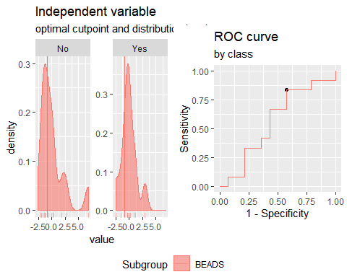

**"Combination IFNγ+CCL3+IP10"**

Method: maximize_metric   
 Predictor: var   
 Outcome: GrupoNew   
 Direction: >=   
 Subgroups: BEADS   
   
 Subgroup: BEADS   
 ---------------------------------------------------------------------------   
 AUC n n_pos n_neg  
 0.5774 26 12 14  
   
 optimal_cutpoint youden acc sensitivity specificity tp fn fp tn  
 -0.6377 0.2738 0.6154 0.9167 0.3571 11 1 9 5  
   
 Predictor summary:   
 Min. 5% 1st Qu. Median Mean 3rd Qu. 95% Max. SD NAs  
 overall -3.415 -2.538 -0.630 -0.010 0.000 0.866 2.602 3.103 1.607 0  
 No -3.415 -2.883 -1.637 -0.070 -0.194 1.240 2.627 3.103 1.913 0  
 Yes -2.364 -1.415 -0.110 0.073 0.226 0.748 1.980 2.680 1.200 0

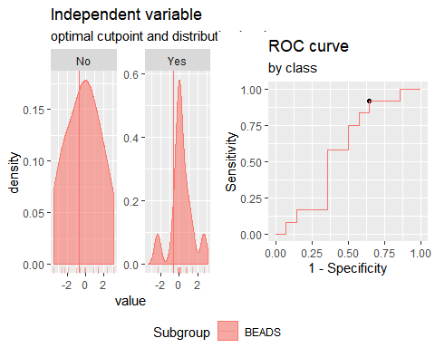

**"Combination IFNγ+CCL11+IP10"**

Method: maximize_metric   
 Predictor: var   
 Outcome: GrupoNew   
 Direction: >=   
 Subgroups: BEADS   
   
 Subgroup: BEADS   
 ---------------------------------------------------------------------------   
 AUC n n_pos n_neg  
 0.625 26 12 14  
   
 optimal_cutpoint youden acc sensitivity specificity tp fn fp tn  
 -0.5767 0.3452 0.6538 0.9167 0.4286 11 1 8 6  
   
 Predictor summary:   
 Min. 5% 1st Qu. Median Mean 3rd Qu. 95% Max. SD NAs  
 overall -2.446 -2.319 -0.639 -0.250 0.000 0.491 2.476 5.865 1.659 0  
 No -2.446 -2.387 -1.085 -0.354 -0.102 0.075 2.895 5.865 2.031 0  
 Yes -2.211 -1.312 -0.308 0.112 0.119 0.496 1.588 2.870 1.162 0

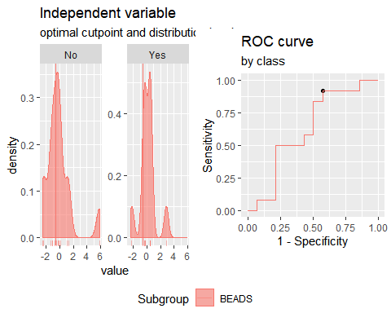

**"Combination IFNγ+CCL3+IL2"**

Method: maximize_metric   
 Predictor: var   
 Outcome: GrupoNew   
 Direction: >=   
 Subgroups: BEADS   
   
 Subgroup: BEADS   
 ---------------------------------------------------------------------------   
 AUC n n_pos n_neg  
 0.631 26 12 14  
   
 optimal_cutpoint youden acc sensitivity specificity tp fn fp tn  
 0.6345 0.3571 0.6923 0.5 0.8571 6 6 2 12  
   
 Predictor summary:   
 Min. 5% 1st Qu. Median Mean 3rd Qu. 95% Max. SD NAs  
 overall -2.668 -2.300 -1.522 0.034 0.000 0.818 2.910 5.100 1.880 0  
 No -2.668 -2.450 -1.761 -0.343 -0.254 0.390 3.301 5.100 2.075 0  
 Yes -2.192 -2.036 -0.784 0.416 0.296 1.313 2.791 3.009 1.662 0

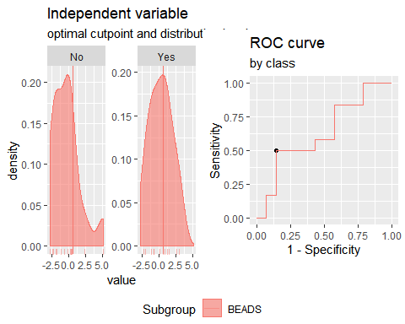

**"Combination IFNγ+CCL11+IL2"**

Method: maximize_metric   
 Predictor: var   
 Outcome: GrupoNew   
 Direction: >=   
 Subgroups: BEADS   
   
 Subgroup: BEADS   
 ---------------------------------------------------------------------------   
 AUC n n_pos n_neg  
 0.631 26 12 14  
   
 optimal_cutpoint youden acc sensitivity specificity tp fn fp tn  
 0.6307 0.3571 0.6923 0.5 0.8571 6 6 2 12  
   
 Predictor summary:   
 Min. 5% 1st Qu. Median Mean 3rd Qu. 95% Max. SD NAs  
 overall -3.410 -2.019 -1.037 -0.432 0.000 0.631 2.867 8.594 2.239 0  
 No -3.410 -2.468 -1.318 -0.673 -0.162 -0.045 3.899 8.594 2.762 0  
 Yes -2.038 -1.782 -0.886 0.241 0.189 1.011 2.467 3.199 1.516 0

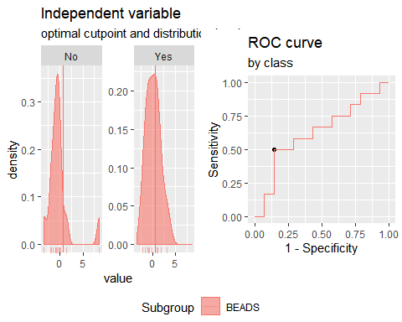

**Analysis TSTp vs TSTn. Responses for all groups and cytokines corrected for background by division (ratio).**

**"Combination IFNγ +IP10"**

Method: maximize_metric   
 Predictor: var   
 Outcome: GrupoNew   
 Direction: >=   
 Subgroups: BEADS   
   
 Subgroup: BEADS   
 ---------------------------------------------------------------------------   
 AUC n n_pos n_neg  
 0.5536 26 12 14  
   
 optimal_cutpoint youden acc sensitivity specificity tp fn fp tn  
 0.7418 0.2024 0.6154 0.4167 0.7857 5 7 3 11  
   
 Predictor summary:   
 Min. 5% 1st Qu. Median Mean 3rd Qu. 95% Max. SD NAs  
 overall -2.165 -1.841 -1.332 -0.204 0.000 0.887 2.915 5.078 1.741 0  
 No -2.165 -1.860 -1.344 -0.475 -0.207 0.159 2.425 3.222 1.606 0  
 Yes -1.889 -1.772 -1.208 -0.193 0.242 0.991 3.280 5.078 1.928 0

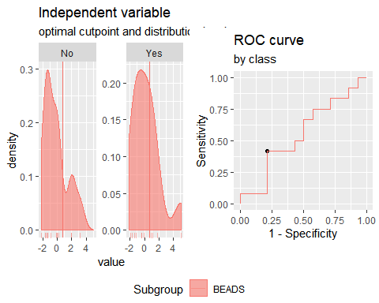

**"Combination IFNγ + IL2"**

Method: maximize_metric   
 Predictor: var   
 Outcome: GrupoNew   
 Direction: >=   
 Subgroups: BEADS   
   
 Subgroup: BEADS   
 ---------------------------------------------------------------------------   
 AUC n n_pos n_neg  
 0.6131 26 12 14  
   
 optimal_cutpoint youden acc sensitivity specificity tp fn fp tn  
 0.7489 0.369 0.6923 0.5833 0.7857 7 5 3 11  
   
 Predictor summary:   
 Min. 5% 1st Qu. Median Mean 3rd Qu. 95% Max. SD NAs  
 overall -2.136 -1.751 -1.245 -0.370 0.000 0.899 2.949 5.073 1.673 0  
 No -2.136 -1.931 -1.188 -0.821 -0.275 -0.074 2.415 5.073 1.782 0  
 Yes -1.543 -1.542 -1.279 0.789 0.321 1.163 2.415 3.395 1.550 0

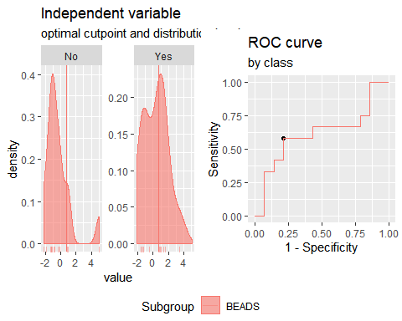

**"Combination IFNγ + CCL3"**

Method: maximize_metric   
 Predictor: var   
 Outcome: GrupoNew   
 Direction: >=   
 Subgroups: BEADS   
   
 Subgroup: BEADS   
 ---------------------------------------------------------------------------   
 AUC n n_pos n_neg  
 0.5595 26 12 14  
   
 optimal_cutpoint youden acc sensitivity specificity tp fn fp tn  
 0.0302 0.3095 0.6538 0.6667 0.6429 8 4 5 9  
   
 Predictor summary:   
 Min. 5% 1st Qu. Median Mean 3rd Qu. 95% Max. SD NAs  
 overall -1.901 -1.717 -0.967 -0.035 0.000 0.662 2.639 3.217 1.332 0  
 No -1.901 -1.741 -1.122 -0.289 -0.003 0.692 2.945 3.217 1.562 0  
 Yes -1.738 -1.685 -0.635 0.151 0.003 0.517 1.377 2.162 1.072 0

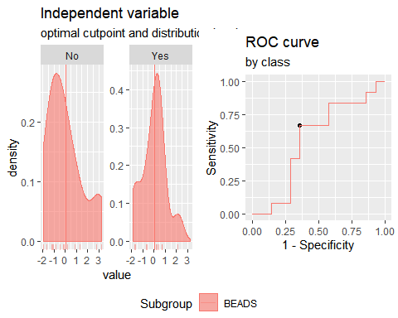

**"Combination IFNγ + CCL11"**

Method: maximize_metric   
 Predictor: var   
 Outcome: GrupoNew   
 Direction: >=   
 Subgroups: BEADS   
   
 Subgroup: BEADS   
 ---------------------------------------------------------------------------   
 AUC n n_pos n_neg  
 0.5893 26 12 14  
   
 optimal_cutpoint youden acc sensitivity specificity tp fn fp tn  
 0.2793 0.2976 0.6538 0.5833 0.7143 7 5 4 10  
   
 Predictor summary:   
 Min. 5% 1st Qu. Median Mean 3rd Qu. 95% Max. SD NAs  
 overall -2.056 -1.971 -0.834 -0.370 0.000 0.546 2.089 5.896 1.598 0  
 No -2.056 -1.776 -0.885 -0.541 -0.021 0.440 2.738 5.896 1.903 0  
 Yes -2.013 -1.920 -0.571 0.287 0.025 0.552 1.696 2.417 1.235 0

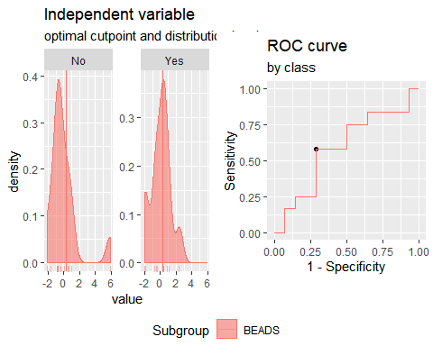

**"Combination IP10 + IL2**"

Method: maximize_metric   
 Predictor: var   
 Outcome: GrupoNew   
 Direction: >=   
 Subgroups: BEADS   
   
 Subgroup: BEADS   
 ---------------------------------------------------------------------------   
 AUC n n_pos n_neg  
 0.6488 26 12 14  
   
 optimal_cutpoint youden acc sensitivity specificity tp fn fp tn  
 -0.1569 0.381 0.6923 0.6667 0.7143 8 4 4 10  
   
 Predictor summary:   
 Min. 5% 1st Qu. Median Mean 3rd Qu. 95% Max. SD NAs  
 overall -2.335 -1.539 -1.092 -0.633 0.000 1.352 2.879 3.102 1.562 0  
 No -2.335 -1.819 -1.104 -0.877 -0.307 -0.029 2.627 3.037 1.593 0  
 Yes -1.490 -1.323 -0.885 -0.105 0.358 1.752 2.633 3.102 1.511 0

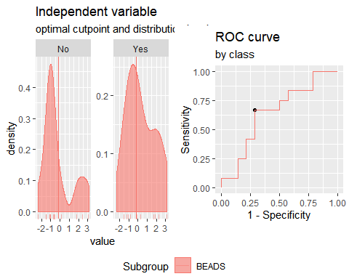

**"Combination IP10 + CCL3"**

Method: maximize_metric   
 Predictor: var   
 Outcome: GrupoNew   
 Direction: >=   
 Subgroups: BEADS   
   
 Subgroup: BEADS   
 ---------------------------------------------------------------------------   
 AUC n n_pos n_neg  
 0.5774 26 12 14  
   
 optimal_cutpoint youden acc sensitivity specificity tp fn fp tn  
 -0.3413 0.3095 0.6538 0.6667 0.6429 8 4 5 9  
   
 Predictor summary:   
 Min. 5% 1st Qu. Median Mean 3rd Qu. 95% Max. SD NAs  
 overall -1.688 -1.659 -1.038 -0.351 0.000 0.851 2.168 3.341 1.339 0  
 No -1.688 -1.677 -1.244 -0.490 -0.035 0.999 2.643 3.341 1.580 0  
 Yes -1.382 -1.198 -0.914 -0.211 0.041 0.847 1.639 1.870 1.059 0

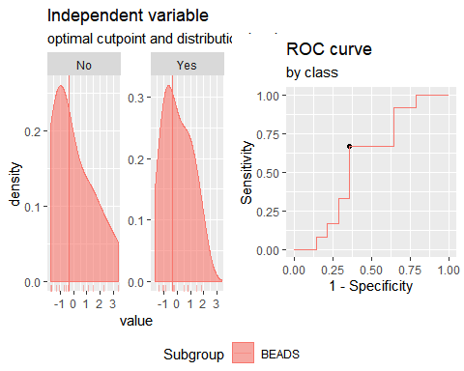

**"Combination IP10 + CCL11**"

Method: maximize_metric   
 Predictor: var   
 Outcome: GrupoNew   
 Direction: >=   
 Subgroups: BEADS   
   
 Subgroup: BEADS   
 ---------------------------------------------------------------------------   
 AUC n n_pos n_neg  
 0.5893 26 12 14  
   
 optimal_cutpoint youden acc sensitivity specificity tp fn fp tn  
 -0.6305 0.3333 0.6538 0.8333 0.5 10 2 7 7  
   
 Predictor summary:   
 Min. 5% 1st Qu. Median Mean 3rd Qu. 95% Max. SD NAs  
 overall -1.890 -1.481 -0.892 -0.431 0.000 0.638 2.375 3.860 1.392 0  
 No -1.890 -1.612 -0.944 -0.662 -0.054 0.338 2.949 3.860 1.631 0  
 Yes -1.487 -1.412 -0.629 -0.067 0.063 0.760 1.891 2.125 1.118 0

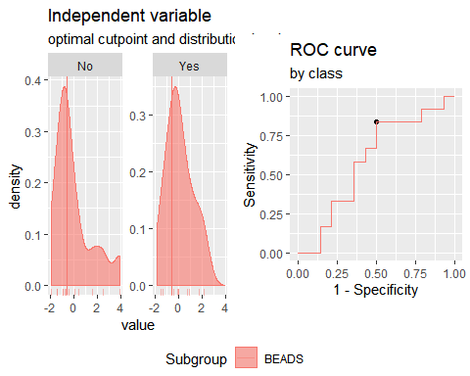

**"Combination IL2 + CCL3"**

Method: maximize_metric   
 Predictor: var   
 Outcome: GrupoNew   
 Direction: >=   
 Subgroups: BEADS   
   
 Subgroup: BEADS   
 ---------------------------------------------------------------------------   
 AUC n n_pos n_neg  
 0.6071 26 12 14  
   
 optimal_cutpoint youden acc sensitivity specificity tp fn fp tn  
 -0.4705 0.2381 0.6154 0.6667 0.5714 8 4 6 8  
   
 Predictor summary:   
 Min. 5% 1st Qu. Median Mean 3rd Qu. 95% Max. SD NAs  
 overall -1.942 -1.777 -1.056 -0.403 0.000 0.471 3.242 3.840 1.529 0  
 No -1.942 -1.898 -1.261 -0.571 -0.103 0.200 3.609 3.840 1.770 0  
 Yes -1.426 -1.316 -1.033 -0.074 0.120 1.139 1.984 2.512 1.259 0

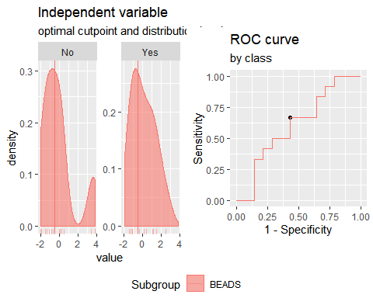

**"Combination IL2 + CCL11"**

Method: maximize_metric   
 Predictor: var   
 Outcome: GrupoNew   
 Direction: >=   
 Subgroups: BEADS   
   
 Subgroup: BEADS   
 ---------------------------------------------------------------------------   
 AUC n n_pos n_neg  
 0.5952 26 12 14  
   
 optimal_cutpoint youden acc sensitivity specificity tp fn fp tn  
 0.442 0.3571 0.6923 0.5 0.8571 6 6 2 12  
   
 Predictor summary:   
 Min. 5% 1st Qu. Median Mean 3rd Qu. 95% Max. SD NAs  
 overall -3.358 -2.022 -1.074 -0.210 0.000 0.553 2.353 6.937 1.901 0  
 No -3.358 -2.538 -0.930 -0.308 -0.121 -0.102 3.158 6.937 2.306 0  
 Yes -1.798 -1.566 -1.094 0.112 0.142 1.290 1.982 2.662 1.373 0

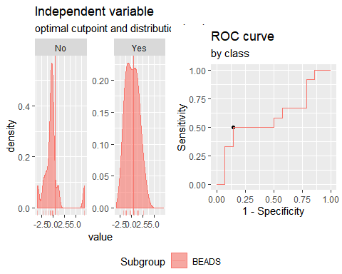

**"Combination CCL3 + CCL11"**

Method: maximize_metric   
 Predictor: var   
 Outcome: GrupoNew   
 Direction: >=   
 Subgroups: BEADS   
   
 Subgroup: BEADS   
 ---------------------------------------------------------------------------   
 AUC n n_pos n_neg  
 0.5179 26 12 14  
   
 optimal_cutpoint youden acc sensitivity specificity tp fn fp tn  
 0.102 0.2262 0.6154 0.5833 0.6429 7 5 5 9  
   
 Predictor summary:   
 Min. 5% 1st Qu. Median Mean 3rd Qu. 95% Max. SD NAs  
 overall -2.234 -1.888 -1.087 -0.158 0.000 0.401 3.400 4.663 1.645 0  
 No -2.234 -1.992 -1.015 -0.525 0.151 0.333 4.195 4.663 2.019 0  
 Yes -1.897 -1.707 -1.154 0.180 -0.176 0.447 1.410 1.494 1.128 0

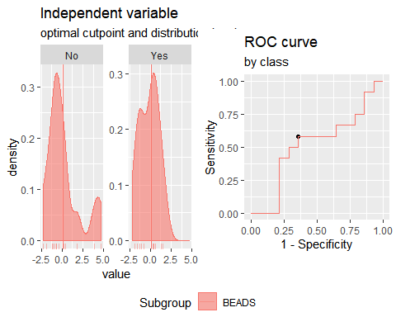

**"Combination IP10 + IL2+CCL3"**

Method: maximize_metric   
 Predictor: var   
 Outcome: GrupoNew   
 Direction: >=   
 Subgroups: BEADS   
   
 Subgroup: BEADS   
 ---------------------------------------------------------------------------   
 AUC n n_pos n_neg  
 0.6012 26 12 14  
   
 optimal_cutpoint youden acc sensitivity specificity tp fn fp tn  
 -1.8014 0.2857 0.6154 1 0.2857 12 0 10 4  
   
 Predictor summary:   
 Min. 5% 1st Qu. Median Mean 3rd Qu. 95% Max. SD NAs  
 overall -2.667 -2.278 -1.433 -0.797 0.000 1.739 2.808 3.819 1.890 0  
 No -2.667 -2.490 -1.813 -0.956 -0.223 1.015 3.212 3.819 2.068 0  
 Yes -1.801 -1.601 -1.045 -0.479 0.260 2.012 2.521 2.580 1.711 0

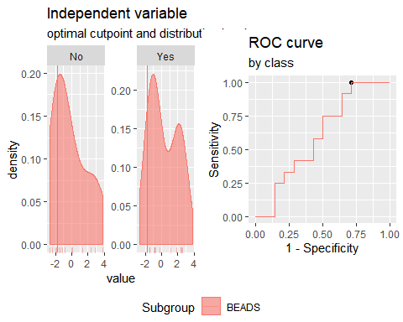

**"Combination IP10 + IL2+CCL11**"

Method: maximize_metric   
 Predictor: var   
 Outcome: GrupoNew   
 Direction: >=   
 Subgroups: BEADS   
   
 Subgroup: BEADS   
 ---------------------------------------------------------------------------   
 AUC n n_pos n_neg  
 0.6012 26 12 14  
   
 optimal_cutpoint youden acc sensitivity specificity tp fn fp tn  
 -0.6239 0.2262 0.6154 0.5833 0.6429 7 5 5 9  
   
 Predictor summary:   
 Min. 5% 1st Qu. Median Mean 3rd Qu. 95% Max. SD NAs  
 overall -3.389 -2.513 -1.261 -0.815 0.000 1.265 2.791 6.916 2.234 0  
 No -3.389 -2.844 -1.271 -0.910 -0.241 0.367 4.074 6.916 2.575 0  
 Yes -1.907 -1.837 -1.200 -0.208 0.281 2.116 2.738 2.835 1.828 0

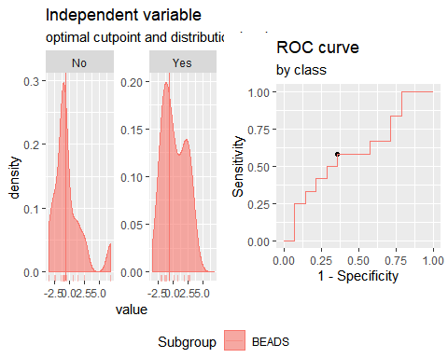

**"Combination IP10 + CCL3+CCL11"**

Method: maximize_metric   
 Predictor: var   
 Outcome: GrupoNew   
 Direction: >=   
 Subgroups: BEADS   
   
 Subgroup: BEADS   
 ---------------------------------------------------------------------------   
 AUC n n_pos n_neg  
 0.5417 26 12 14  
   
 optimal_cutpoint youden acc sensitivity specificity tp fn fp tn  
 -0.6386 0.3214 0.6538 0.75 0.5714 9 3 6 8  
   
 Predictor summary:   
 Min. 5% 1st Qu. Median Mean 3rd Qu. 95% Max. SD NAs  
 overall -2.316 -2.225 -1.509 -0.522 0.000 1.255 3.108 4.642 1.854 0  
 No -2.316 -2.283 -1.690 -0.858 0.031 1.504 3.798 4.642 2.229 0  
 Yes -2.103 -2.022 -0.826 -0.374 -0.036 1.160 1.718 1.860 1.393 0

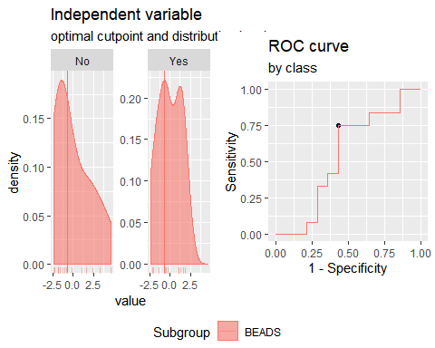

**"Combination IL2 + CCL3+CCL11"**

Method: maximize_metric   
 Predictor: var   
 Outcome: GrupoNew   
 Direction: >=   
 Subgroups: BEADS   
   
 Subgroup: BEADS   
 ---------------------------------------------------------------------------   
 AUC n n_pos n_neg  
 0.5595 26 12 14  
   
 optimal_cutpoint youden acc sensitivity specificity tp fn fp tn  
 -0.2599 0.2381 0.6154 0.6667 0.5714 8 4 6 8  
   
 Predictor summary:   
 Min. 5% 1st Qu. Median Mean 3rd Qu. 95% Max. SD NAs  
 overall -3.733 -2.853 -1.622 -0.205 0.000 0.993 3.429 7.720 2.379 0  
 No -3.733 -3.224 -1.295 -0.806 -0.037 0.638 4.968 7.720 2.851 0  
 Yes -2.560 -2.241 -1.713 -0.115 0.043 1.456 2.466 3.258 1.803 0

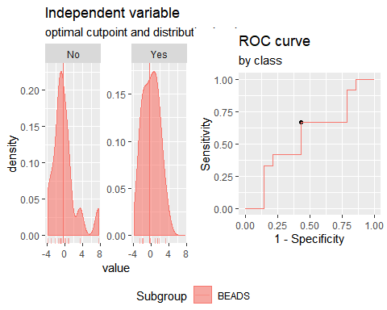

**"Combination IFNγ+IP10+IL2"**

Method: maximize_metric   
 Predictor: var   
 Outcome: GrupoNew   
 Direction: >=   
 Subgroups: BEADS   
   
 Subgroup: BEADS   
 ---------------------------------------------------------------------------   
 AUC n n_pos n_neg  
 0.6131 26 12 14  
   
 optimal_cutpoint youden acc sensitivity specificity tp fn fp tn  
 0.5066 0.369 0.6923 0.5833 0.7857 7 5 3 11  
   
 Predictor summary:   
 Min. 5% 1st Qu. Median Mean 3rd Qu. 95% Max. SD NAs  
 overall -3.160 -2.519 -1.668 -0.911 0.000 1.482 4.616 5.787 2.296 0  
 No -3.160 -2.789 -1.668 -1.004 -0.394 -0.096 3.917 5.052 2.290 0  
 Yes -2.309 -2.257 -1.240 0.662 0.460 1.623 3.770 5.787 2.313 0

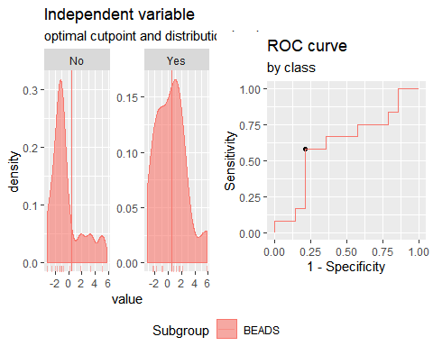

**"Combination IFNγ+CCL3+CCL11"**

Method: maximize_metric   
 Predictor: var   
 Outcome: GrupoNew   
 Direction: >=   
 Subgroups: BEADS   
   
 Subgroup: BEADS   
 ---------------------------------------------------------------------------   
 AUC n n_pos n_neg  
 0.5893 26 12 14  
   
 optimal_cutpoint youden acc sensitivity specificity tp fn fp tn  
 -0.5528 0.3333 0.6538 0.8333 0.5 10 2 7 7  
   
 Predictor summary:   
 Min. 5% 1st Qu. Median Mean 3rd Qu. 95% Max. SD NAs  
 overall -2.910 -2.696 -1.338 -0.254 0.000 0.694 2.888 6.678 2.009 0  
 No -2.910 -2.319 -1.411 -0.664 0.063 0.790 4.430 6.678 2.490 0  
 Yes -2.775 -2.601 -0.390 0.351 -0.074 0.660 1.424 1.895 1.355 0

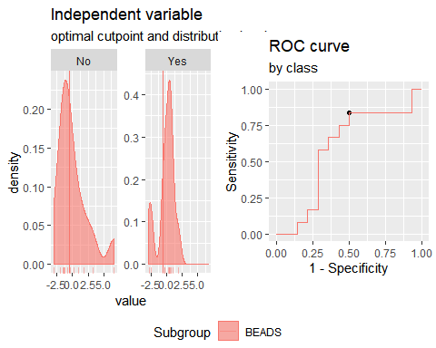

**"Combination IFNγ+CCL3+CCL10"**

Method: maximize_metric   
 Predictor: var   
 Outcome: GrupoNew   
 Direction: >=   
 Subgroups: BEADS   
   
 Subgroup: BEADS   
 ---------------------------------------------------------------------------   
 AUC n n_pos n_neg  
 0.5536 26 12 14  
   
 optimal_cutpoint youden acc sensitivity specificity tp fn fp tn  
 -0.5076 0.2381 0.6154 0.6667 0.5714 8 4 6 8  
   
 Predictor summary:   
 Min. 5% 1st Qu. Median Mean 3rd Qu. 95% Max. SD NAs  
 overall -2.519 -2.502 -1.391 -0.340 0.000 1.184 3.070 4.555 1.897 0  
 No -2.519 -2.504 -1.702 -0.656 -0.123 1.420 2.914 3.167 2.021 0  
 Yes -2.504 -2.011 -1.139 0.158 0.143 0.980 2.776 4.555 1.819 0

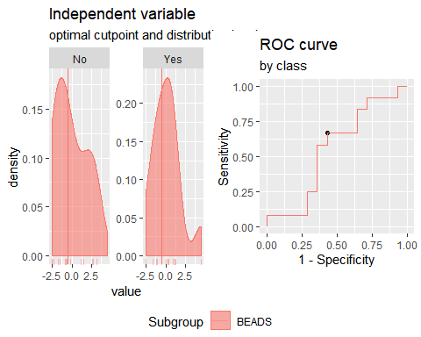

**"Combination IFNγ+CCL11+CCL10"**

Method: maximize_metric   
 Predictor: var   
 Outcome: GrupoNew   
 Direction: >=   
 Subgroups: BEADS   
   
 Subgroup: BEADS   
 ---------------------------------------------------------------------------   
 AUC n n_pos n_neg  
 0.5833 26 12 14  
   
 optimal_cutpoint youden acc sensitivity specificity tp fn fp tn  
 -0.0126 0.2976 0.6538 0.5833 0.7143 7 5 4 10  
   
 Predictor summary:   
 Min. 5% 1st Qu. Median Mean 3rd Qu. 95% Max. SD NAs  
 overall -2.61 -2.440 -1.436 -0.758 0.000 0.865 4.447 5.875 2.126 0  
 No -2.51 -2.328 -1.532 -0.875 -0.141 0.353 4.240 5.875 2.332 0  
 Yes -2.61 -2.003 -1.284 0.195 0.165 1.068 3.027 4.810 1.948 0

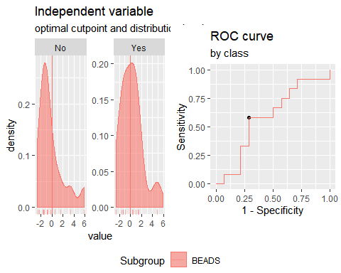

**"Combination IFNγ+CCL3+IL2**"

Method: maximize_metric   
 Predictor: var   
 Outcome: GrupoNew   
 Direction: >=   
 Subgroups: BEADS   
   
 Subgroup: BEADS   
 ---------------------------------------------------------------------------   
 AUC n n_pos n_neg  
 0.625 26 12 14  
   
 optimal_cutpoint youden acc sensitivity specificity tp fn fp tn  
 0.1286 0.3095 0.6538 0.6667 0.6429 8 4 5 9  
   
 Predictor summary:   
 Min. 5% 1st Qu. Median Mean 3rd Qu. 95% Max. SD NAs  
 overall -2.989 -2.268 -1.542 0.059 0.000 0.936 2.844 5.855 1.978 0  
 No -2.989 -2.445 -1.720 -0.497 -0.190 0.278 3.844 5.855 2.276 0  
 Yes -2.304 -2.224 -1.158 0.537 0.222 1.056 2.507 2.872 1.634 0

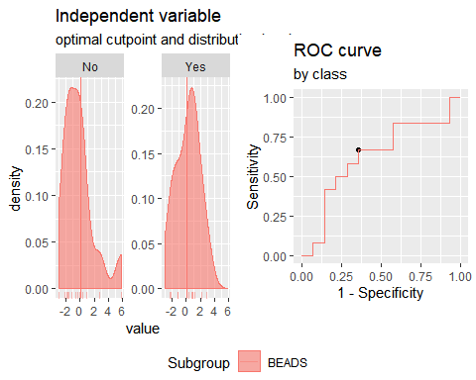

**"Combination IFNγ+CCL11+IL2"**

Method: maximize_metric   
 Predictor: var   
 Outcome: GrupoNew   
 Direction: >=   
 Subgroups: BEADS   
   
 Subgroup: BEADS   
 ---------------------------------------------------------------------------   
 AUC n n_pos n_neg  
 0.6429 26 12 14  
   
 optimal_cutpoint youden acc sensitivity specificity tp fn fp tn  
 1.239 0.3452 0.6923 0.4167 0.9286 5 7 1 13  
   
 Predictor summary:   
 Min. 5% 1st Qu. Median Mean 3rd Qu. 95% Max. SD NAs  
 overall -3.144 -3.012 -1.235 -0.257 0.000 1.009 2.935 8.953 2.443 0  
 No -3.144 -3.131 -1.643 -0.716 -0.209 0.151 3.863 8.953 2.925 0  
 Yes -2.677 -2.450 -1.020 0.120 0.244 1.482 2.704 3.127 1.825 0

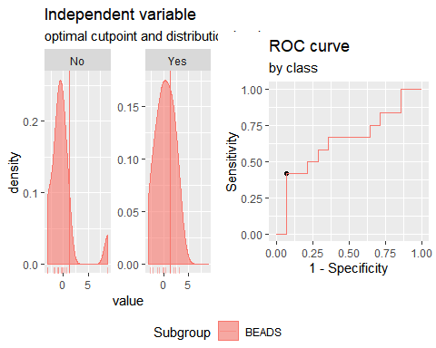

**Analysis PTB vs TSTp+TSTn. Responses for all groups and cytokines corrected for background by subtraction.**

**"Combination IFNγ +IP10**"

Method: maximize_metric   
 Predictor: var   
 Outcome: GrupoNew   
 Direction: >=   
 Subgroups: BEADS   
   
 Subgroup: BEADS   
 ---------------------------------------------------------------------------   
 AUC n n_pos n_neg  
 0.8811 37 11 26  
   
 optimal_cutpoint youden acc sensitivity specificity tp fn fp tn  
 -0.3609 0.6923 0.7838 1 0.6923 11 0 8 18  
   
 Predictor summary:   
 Min. 5% 1st Qu. Median Mean 3rd Qu. 95% Max. SD NAs  
 overall -2.357 -1.704 -0.798 -0.361 0.000 0.129 4.019 5.439 1.669 0  
 No -2.357 -1.954 -0.948 -0.638 -0.666 -0.299 0.274 1.242 0.742 0  
 Yes -0.361 -0.360 -0.297 0.462 1.575 3.498 4.841 5.439 2.185 0

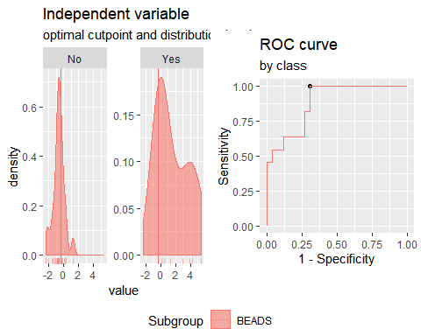

**"Combination IFNγ + IL2"**

Method: maximize_metric   
 Predictor: var   
 Outcome: GrupoNew   
 Direction: >=   
 Subgroups: BEADS   
   
 Subgroup: BEADS   
 ---------------------------------------------------------------------------   
 AUC n n_pos n_neg  
 0.9406 37 11 26  
   
 optimal_cutpoint youden acc sensitivity specificity tp fn fp tn  
 0.0912 0.8322 0.9189 0.9091 0.9231 10 1 2 24  
   
 Predictor summary:   
 Min. 5% 1st Qu. Median Mean 3rd Qu. 95% Max. SD NAs  
 overall -1.645 -1.601 -1.184 -0.484 0.000 0.168 4.396 5.970 1.773 0  
 No -1.645 -1.631 -1.243 -0.869 -0.735 -0.398 0.962 1.482 0.796 0  
 Yes -0.251 -0.080 0.151 0.595 1.736 3.186 5.409 5.970 2.239 0

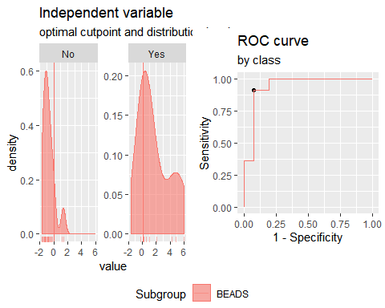

**"Combination IFNγ + CCL3"**

Method: maximize_metric   
 Predictor: var   
 Outcome: GrupoNew   
 Direction: >=   
 Subgroups: BEADS   
   
 Subgroup: BEADS   
 ---------------------------------------------------------------------------   
 AUC n n_pos n_neg  
 0.7587 37 11 26  
   
 optimal_cutpoint youden acc sensitivity specificity tp fn fp tn  
 0.6443 0.4441 0.7568 0.6364 0.8077 7 4 5 21  
   
 Predictor summary:   
 Min. 5% 1st Qu. Median Mean 3rd Qu. 95% Max. SD NAs  
 overall -1.736 -1.704 -0.952 -0.468 0.000 0.924 2.176 5.054 1.429 0  
 No -1.736 -1.697 -1.080 -0.599 -0.415 -0.117 1.345 2.040 0.988 0  
 Yes -1.696 -1.173 -0.353 0.924 0.982 1.547 3.886 5.054 1.844 0

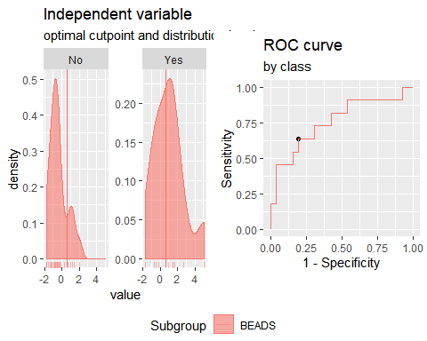

**"Combination IFNγ + CCL11"**

Method: maximize_metric   
 Predictor: var   
 Outcome: GrupoNew   
 Direction: >=   
 Subgroups: BEADS   
   
 Subgroup: BEADS   
 ---------------------------------------------------------------------------   
 AUC n n_pos n_neg  
 0.8497 37 11 26  
   
 optimal_cutpoint youden acc sensitivity specificity tp fn fp tn  
 -0.1271 0.7028 0.8649 0.8182 0.8846 9 2 3 23  
   
 Predictor summary:   
 Min. 5% 1st Qu. Median Mean 3rd Qu. 95% Max. SD NAs  
 overall -2.072 -1.287 -0.853 -0.595 0.000 0.152 3.293 5.179 1.562 0  
 No -2.072 -1.637 -0.892 -0.712 -0.464 -0.523 1.106 5.179 1.310 0  
 Yes -0.900 -0.636 -0.067 0.880 1.096 1.814 3.738 4.479 1.615 0

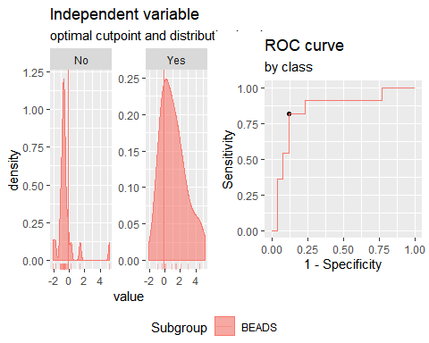

**"Combination IP10 + IL2"**

Method: maximize_metric   
 Predictor: var   
 Outcome: GrupoNew   
 Direction: >=   
 Subgroups: BEADS   
   
 Subgroup: BEADS   
 ---------------------------------------------------------------------------   
 AUC n n_pos n_neg  
 0.9336 37 11 26  
   
 optimal_cutpoint youden acc sensitivity specificity tp fn fp tn  
 0.5281 0.8706 0.9459 0.9091 0.9615 10 1 1 25  
   
 Predictor summary:   
 Min. 5% 1st Qu. Median Mean 3rd Qu. 95% Max. SD NAs  
 overall -3.166 -1.767 -0.972 -0.391 0.000 0.702 3.563 5.536 1.706 0  
 No -3.166 -2.199 -1.265 -0.679 -0.777 -0.219 0.155 0.734 0.851 0  
 Yes -0.972 -0.222 0.760 1.353 1.837 2.857 4.731 5.536 1.841 0

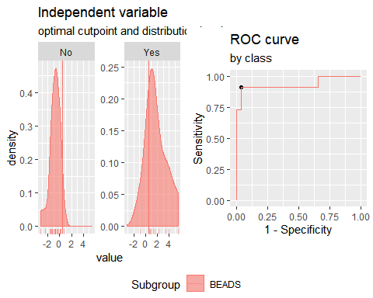

**"Combination IP10 + CCL3"**

Method: maximize_metric   
 Predictor: var   
 Outcome: GrupoNew   
 Direction: >=   
 Subgroups: BEADS   
   
 Subgroup: BEADS   
 ---------------------------------------------------------------------------   
 AUC n n_pos n_neg  
 0.7692 37 11 26  
   
 optimal_cutpoint youden acc sensitivity specificity tp fn fp tn  
 1.0276 0.5594 0.8378 0.6364 0.9231 7 4 2 24  
   
 Predictor summary:   
 Min. 5% 1st Qu. Median Mean 3rd Qu. 95% Max. SD NAs  
 overall -3.809 -1.908 -0.859 -0.142 0.000 0.656 2.644 3.013 1.514 0  
 No -3.809 -1.852 -0.875 -0.497 -0.458 0.145 1.033 2.564 1.191 0  
 Yes -2.051 -1.711 0.132 1.770 1.083 2.215 2.989 3.013 1.695 0

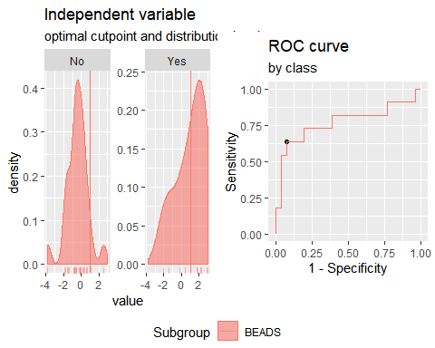

**"Combination IP10 + CCL11"**

Method: maximize_metric   
 Predictor: var   
 Outcome: GrupoNew   
 Direction: >=   
 Subgroups: BEADS   
   
 Subgroup: BEADS   
 ---------------------------------------------------------------------------   
 AUC n n_pos n_neg  
 0.8776 37 11 26  
   
 optimal_cutpoint youden acc sensitivity specificity tp fn fp tn  
 0.2332 0.7413 0.8919 0.8182 0.9231 9 2 2 24  
   
 Predictor summary:   
 Min. 5% 1st Qu. Median Mean 3rd Qu. 95% Max. SD NAs  
 overall -3.036 -1.772 -0.728 -0.315 0.000 0.274 2.920 4.661 1.492 0  
 No -3.036 -1.833 -1.000 -0.444 -0.506 -0.220 0.225 4.661 1.286 0  
 Yes -0.728 -0.508 0.272 1.288 1.197 2.148 2.920 2.921 1.280 0

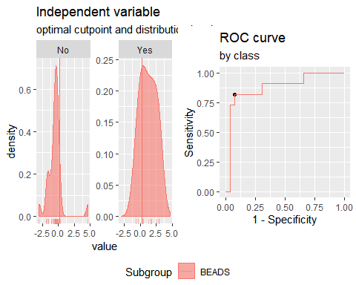

**"Combination IL2 + CCL3"**

Method: maximize_metric   
 Predictor: var   
 Outcome: GrupoNew   
 Direction: >=   
 Subgroups: BEADS   
   
 Subgroup: BEADS   
 ---------------------------------------------------------------------------   
 AUC n n_pos n_neg  
 0.8566 37 11 26  
   
 optimal_cutpoint youden acc sensitivity specificity tp fn fp tn  
 0.3296 0.6643 0.8378 0.8182 0.8462 9 2 4 22  
   
 Predictor summary:   
 Min. 5% 1st Qu. Median Mean 3rd Qu. 95% Max. SD NAs  
 overall -1.842 -1.519 -1.362 -0.375 0.000 0.864 2.730 2.815 1.412 0  
 No -1.842 -1.709 -1.400 -0.610 -0.527 0.043 1.665 2.050 1.084 0  
 Yes -1.261 -0.564 0.349 0.864 1.245 2.648 2.782 2.815 1.348 0

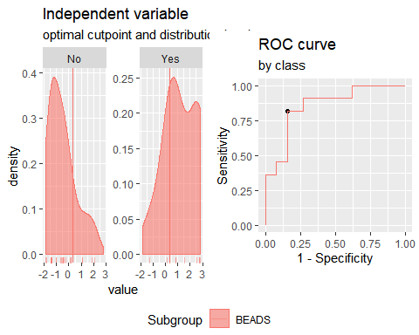

**"Combination IL2 + CCL11"**

Method: maximize_metric   
 Predictor: var   
 Outcome: GrupoNew   
 Direction: >=   
 Subgroups: BEADS   
   
 Subgroup: BEADS   
 ---------------------------------------------------------------------------   
 AUC n n_pos n_neg  
 0.9091 37 11 26  
   
 optimal_cutpoint youden acc sensitivity specificity tp fn fp tn  
 0.0894 0.7413 0.8919 0.8182 0.9231 9 2 2 24  
   
 Predictor summary:   
 Min. 5% 1st Qu. Median Mean 3rd Qu. 95% Max. SD NAs  
 overall -3.105 -1.380 -0.928 -0.588 0.000 0.476 3.404 5.849 1.735 0  
 No -3.105 -1.416 -1.216 -0.759 -0.575 -0.356 0.333 5.849 1.467 0  
 Yes -0.618 -0.473 0.397 0.767 1.358 2.402 3.871 4.649 1.605 0

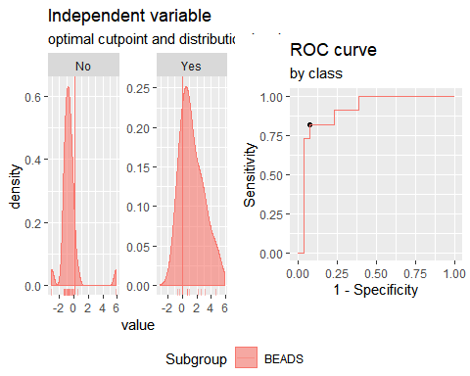

**"Combination CCL3 + CCL11"**

Method: maximize_metric   
 Predictor: var   
 Outcome: GrupoNew   
 Direction: >=   
 Subgroups: BEADS   
   
 Subgroup: BEADS   
 ---------------------------------------------------------------------------   
 AUC n n_pos n_neg  
 0.7063 37 11 26  
   
 optimal_cutpoint youden acc sensitivity specificity tp fn fp tn  
 0.0348 0.4441 0.7568 0.6364 0.8077 7 4 5 21  
   
 Predictor summary:   
 Min. 5% 1st Qu. Median Mean 3rd Qu. 95% Max. SD NAs  
 overall -2.222 -1.490 -1.143 -0.252 0.000 0.711 2.632 5.770 1.597 0  
 No -2.222 -1.608 -1.174 -0.684 -0.256 -0.064 2.122 5.770 1.596 0  
 Yes -1.329 -1.173 -0.391 0.309 0.604 1.439 2.918 3.457 1.495 0

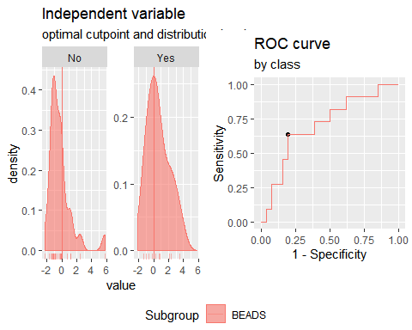

**"Combination IP10 + IL2+CCL3"**

Method: maximize_metric   
 Predictor: var   
 Outcome: GrupoNew   
 Direction: >=   
 Subgroups: BEADS   
   
 Subgroup: BEADS   
 ---------------------------------------------------------------------------   
 AUC n n_pos n_neg  
 0.8986 37 11 26  
   
 optimal_cutpoint youden acc sensitivity specificity tp fn fp tn  
 0.3579 0.7552 0.8649 0.9091 0.8462 10 1 4 22  
   
 Predictor summary:   
 Min. 5% 1st Qu. Median Mean 3rd Qu. 95% Max. SD NAs  
 overall -4.169 -2.396 -1.400 -0.385 0.000 1.370 3.243 5.317 2.049 0  
 No -4.169 -2.714 -1.797 -0.848 -0.881 -0.030 1.441 1.977 1.379 0  
 Yes -1.802 -0.722 1.054 2.669 2.082 2.952 4.495 5.317 1.890 0

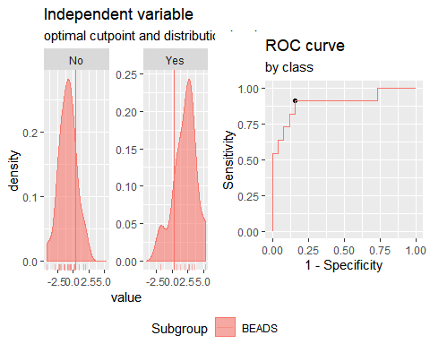

**"Combination IP10 + IL2+CCL11**"

Method: maximize_metric   
 Predictor: var   
 Outcome: GrupoNew   
 Direction: >=   
 Subgroups: BEADS   
   
 Subgroup: BEADS   
 ---------------------------------------------------------------------------   
 AUC n n_pos n_neg  
 0.9126 37 11 26  
   
 optimal_cutpoint youden acc sensitivity specificity tp fn fp tn  
 0.0434 0.8706 0.9459 0.9091 0.9615 10 1 1 25  
   
 Predictor summary:   
 Min. 5% 1st Qu. Median Mean 3rd Qu. 95% Max. SD NAs  
 overall -3.395 -2.829 -1.333 -0.427 0.000 0.733 5.243 5.622 2.269 0  
 No -3.395 -3.084 -1.609 -0.990 -0.929 -0.308 -0.012 5.622 1.637 0  
 Yes -1.159 -0.558 0.832 2.560 2.196 3.103 5.375 5.595 2.071 0

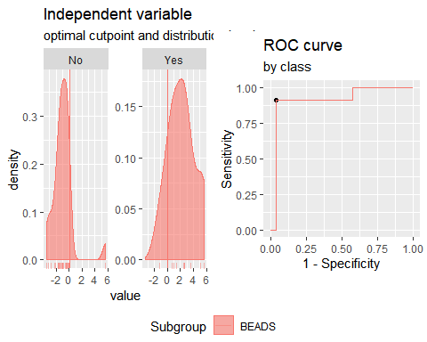

**"Combination IP10 + CCL3+CCL11**"

Method: maximize_metric   
 Predictor: var   
 Outcome: GrupoNew   
 Direction: >=   
 Subgroups: BEADS   
   
 Subgroup: BEADS   
 ---------------------------------------------------------------------------   
 AUC n n_pos n_neg  
 0.8007 37 11 26  
   
 optimal_cutpoint youden acc sensitivity specificity tp fn fp tn  
 1.1401 0.5594 0.8378 0.6364 0.9231 7 4 2 24  
   
 Predictor summary:   
 Min. 5% 1st Qu. Median Mean 3rd Qu. 95% Max. SD NAs  
 overall -4.038 -2.332 -1.178 -0.254 0.000 1.012 3.369 5.543 2.017 0  
 No -4.038 -2.337 -1.679 -0.833 -0.610 -0.011 2.018 5.543 1.802 0  
 Yes -1.558 -1.191 -0.095 2.261 1.442 2.943 3.400 3.452 1.809 0

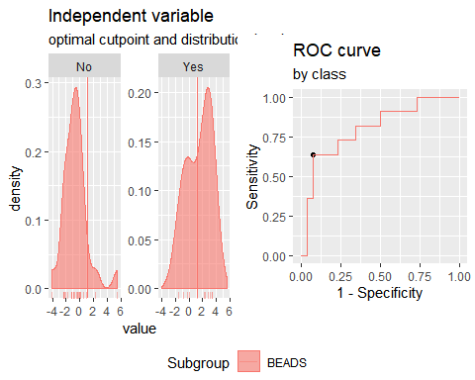

**"Combination IL2 + CCL3+CCL11"**

Method: maximize_metric   
 Predictor: var   
 Outcome: GrupoNew   
 Direction: >=   
 Subgroups: BEADS   
   
 Subgroup: BEADS   
 ---------------------------------------------------------------------------   
 AUC n n_pos n_neg  
 0.8601 37 11 26  
   
 optimal_cutpoint youden acc sensitivity specificity tp fn fp tn  
 0.5174 0.6643 0.8378 0.8182 0.8462 9 2 4 22  
   
 Predictor summary:   
 Min. 5% 1st Qu. Median Mean 3rd Qu. 95% Max. SD NAs  
 overall -3.561 -2.238 -1.591 -0.599 0.000 0.968 3.802 6.731 2.134 0  
 No -3.561 -2.253 -1.817 -0.843 -0.678 -0.113 1.669 6.731 1.929 0  
 Yes -1.449 -0.870 0.526 1.648 1.604 2.780 4.028 4.407 1.752 0

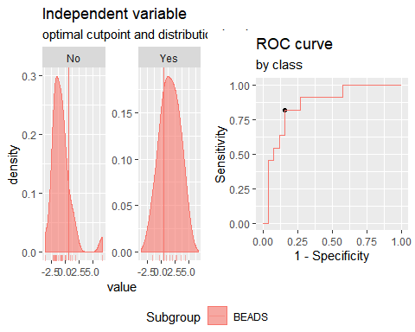

**"Combination IFNγ+IP10+IL2"**

Method: maximize_metric   
 Predictor: var   
 Outcome: GrupoNew   
 Direction: >=   
 Subgroups: BEADS   
   
 Subgroup: BEADS   
 ---------------------------------------------------------------------------   
 AUC n n_pos n_neg  
 0.9406 37 11 26  
   
 optimal_cutpoint youden acc sensitivity specificity tp fn fp tn  
 0.196 0.8322 0.9189 0.9091 0.9231 10 1 2 24  
   
 Predictor summary:   
 Min. 5% 1st Qu. Median Mean 3rd Qu. 95% Max. SD NAs  
 overall -3.054 -2.291 -1.397 -0.701 0.000 0.462 4.969 8.472 2.417 0  
 No -3.054 -2.584 -1.661 -1.250 -1.089 -0.393 0.422 1.026 0.949 0  
 Yes -0.792 -0.298 0.396 1.393 2.574 4.845 6.854 8.472 2.899 0

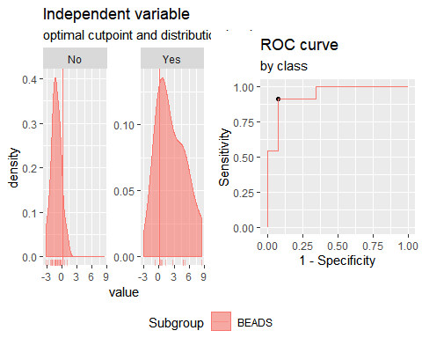

**"Combination IFNγ+CCL3+CCL11"**

Method: maximize_metric   
 Predictor: var   
 Outcome: GrupoNew   
 Direction: >=   
 Subgroups: BEADS   
   
 Subgroup: BEADS   
 ---------------------------------------------------------------------------   
 AUC n n_pos n_neg  
 0.8042 37 11 26  
   
 optimal_cutpoint youden acc sensitivity specificity tp fn fp tn  
 0.7567 0.521 0.8108 0.6364 0.8846 7 4 3 23  
   
 Predictor summary:   
 Min. 5% 1st Qu. Median Mean 3rd Qu. 95% Max. SD NAs  
 overall -2.597 -2.227 -1.327 -0.612 0.000 0.757 3.673 6.062 2.008 0  
 No -2.597 -2.434 -1.517 -0.756 -0.567 -0.401 1.623 6.062 1.725 0  
 Yes -0.864 -0.851 -0.382 1.308 1.341 2.258 4.529 5.956 2.063 0

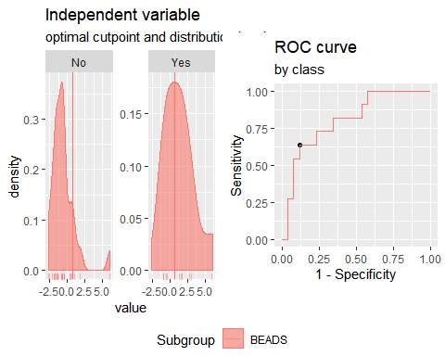

**"Combination IFNγ+CCL3+IP10"**

Method: maximize_metric   
 Predictor: var   
 Outcome: GrupoNew   
 Direction: >=   
 Subgroups: BEADS   
   
 Subgroup: BEADS   
 ---------------------------------------------------------------------------   
 AUC n n_pos n_neg  
 0.8112 37 11 26  
   
 optimal_cutpoint youden acc sensitivity specificity tp fn fp tn  
 1.0671 0.5979 0.8649 0.6364 0.9615 7 4 1 25  
   
 Predictor summary:   
 Min. 5% 1st Qu. Median Mean 3rd Qu. 95% Max. SD NAs  
 overall -3.360 -2.441 -1.190 -0.474 0.00 0.541 4.599 5.440 2.030 0  
 No -3.360 -2.503 -1.279 -0.787 -0.77 -0.162 0.846 1.968 1.190 0  
 Yes -1.191 -1.191 -0.154 1.415 1.82 3.951 5.331 5.440 2.472 0

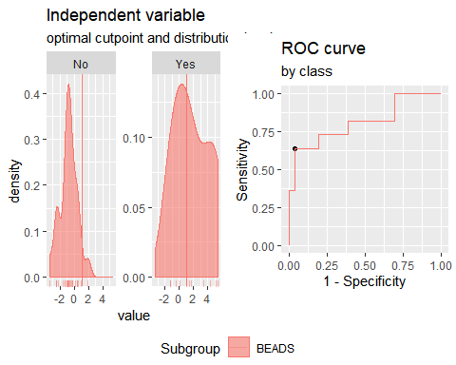

**"Combination IFNγ+CCL11+IP10"**

Method: maximize_metric   
 Predictor: var   
 Outcome: GrupoNew   
 Direction: >=   
 Subgroups: BEADS   
   
 Subgroup: BEADS   
 ---------------------------------------------------------------------------   
 AUC n n_pos n_neg  
 0.9056 37 11 26  
   
 optimal_cutpoint youden acc sensitivity specificity tp fn fp tn  
 -0.1766 0.7028 0.8649 0.8182 0.8846 9 2 3 23  
   
 Predictor summary:   
 Min. 5% 1st Qu. Median Mean 3rd Qu. 95% Max. SD NAs  
 overall -2.587 -2.422 -1.116 -0.548 0.000 0.001 4.883 5.499 2.110 0  
 No -2.587 -2.458 -1.288 -0.941 -0.818 -0.491 0.389 4.953 1.399 0  
 Yes -0.548 -0.539 -0.138 1.322 1.934 3.883 5.182 5.499 2.298 0

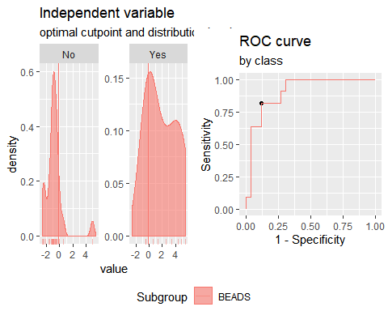

**"Combination IFNγ+CCL3+IL2"**

Method: maximize_metric   
 Predictor: var   
 Outcome: GrupoNew   
 Direction: >=   
 Subgroups: BEADS   
   
 Subgroup: BEADS   
 ---------------------------------------------------------------------------   
 AUC n n_pos n_neg  
 0.8881 37 11 26  
   
 optimal_cutpoint youden acc sensitivity specificity tp fn fp tn  
 -0.0025 0.6783 0.8108 0.9091 0.7692 10 1 6 20  
   
 Predictor summary:   
 Min. 5% 1st Qu. Median Mean 3rd Qu. 95% Max. SD NAs  
 overall -2.584 -2.148 -1.313 -0.531 0.000 0.759 3.046 6.326 2.044 0  
 No -2.584 -2.257 -1.898 -0.981 -0.838 -0.192 1.280 2.135 1.214 0  
 Yes -1.081 -0.542 0.378 1.725 1.981 2.330 6.039 6.326 2.284 0

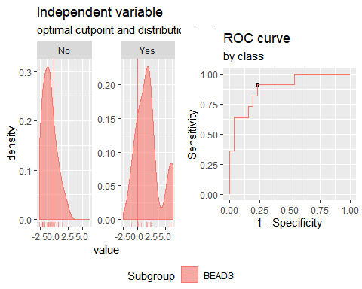

**"Combination IFNγ+CCL11+IL2"**

Method: maximize_metric   
 Predictor: var   
 Outcome: GrupoNew   
 Direction: >=   
 Subgroups: BEADS   
   
 Subgroup: BEADS   
 ---------------------------------------------------------------------------   
 AUC n n_pos n_neg  
 0.9196 37 11 26  
   
 optimal_cutpoint youden acc sensitivity specificity tp fn fp tn  
 -0.5677 0.7692 0.8378 1 0.7692 11 0 6 20  
   
 Predictor summary:   
 Min. 5% 1st Qu. Median Mean 3rd Qu. 95% Max. SD NAs  
 overall -3.411 -2.079 -1.319 -0.687 0.000 0.373 5.806 6.140 2.365 0  
 No -3.411 -2.278 -1.482 -1.217 -0.886 -0.620 0.590 6.140 1.660 0  
 Yes -0.568 -0.503 0.311 1.082 2.095 3.894 5.890 6.029 2.525 0

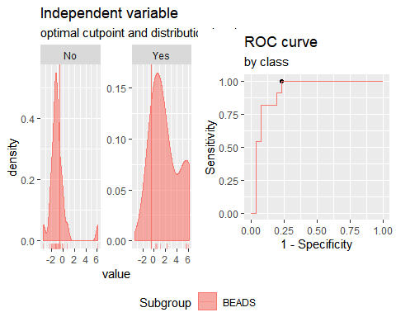

**Analysis PTB vs TSTp+TSTn. Responses for all groups and cytokines corrected for background by division (ratio).**

**"Combination IFNγ +IP10"**

Method: maximize_metric   
 Predictor: var   
 Outcome: GrupoNew   
 Direction: >=   
 Subgroups: BEADS   
   
 Subgroup: BEADS   
 ---------------------------------------------------------------------------   
 AUC n n_pos n_neg  
 0.9161 37 11 26  
   
 optimal_cutpoint youden acc sensitivity specificity tp fn fp tn  
 -0.3932 0.7692 0.8378 1 0.7692 11 0 6 20  
   
 Predictor summary:   
 Min. 5% 1st Qu. Median Mean 3rd Qu. 95% Max. SD NAs  
 overall -1.366 -1.209 -1.016 -0.528 0.000 0.008 2.514 9.306 1.889 0  
 No -1.366 -1.223 -1.070 -0.778 -0.694 -0.459 0.263 0.788 0.518 0  
 Yes -0.393 -0.392 -0.286 0.577 1.641 2.386 6.103 9.306 2.822 0

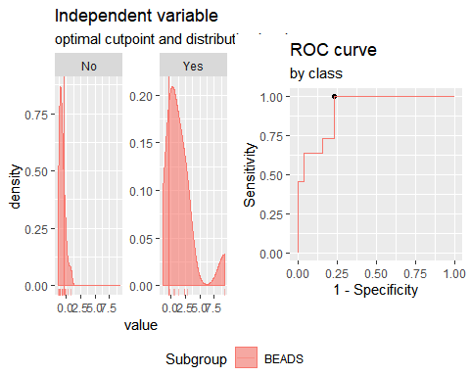

**"Combination IFNγ + IL2**"

Method: maximize_metric   
 Predictor: var   
 Outcome: GrupoNew   
 Direction: >=   
 Subgroups: BEADS   
   
 Subgroup: BEADS   
 ---------------------------------------------------------------------------   
 AUC n n_pos n_neg  
 0.9545 37 11 26  
   
 optimal_cutpoint youden acc sensitivity specificity tp fn fp tn  
 -0.405 0.8077 0.8649 1 0.8077 11 0 5 21  
   
 Predictor summary:   
 Min. 5% 1st Qu. Median Mean 3rd Qu. 95% Max. SD NAs  
 overall -1.474 -1.352 -1.142 -0.572 0.000 0.125 4.334 7.233 1.896 0  
 No -1.474 -1.374 -1.184 -0.841 -0.788 -0.551 0.074 0.923 0.543 0  
 Yes -0.405 -0.331 0.143 0.672 1.863 2.759 6.489 7.233 2.603 0

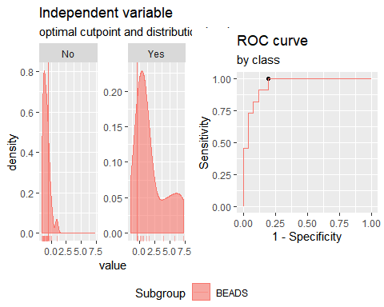

**"Combination IFNγ + CCL3**"

Method: maximize_metric   
 Predictor: var   
 Outcome: GrupoNew   
 Direction: >=   
 Subgroups: BEADS   
   
 Subgroup: BEADS   
 ---------------------------------------------------------------------------   
 AUC n n_pos n_neg  
 0.8322 37 11 26  
   
 optimal_cutpoint youden acc sensitivity specificity tp fn fp tn  
 0.1295 0.5734 0.8108 0.7273 0.8462 8 3 4 22  
   
 Predictor summary:   
 Min. 5% 1st Qu. Median Mean 3rd Qu. 95% Max. SD NAs  
 overall -1.437 -1.328 -0.776 -0.496 0.000 0.405 2.983 4.353 1.361 0  
 No -1.437 -1.351 -0.984 -0.674 -0.464 -0.291 0.654 2.739 0.861 0  
 Yes -0.700 -0.611 -0.186 0.751 1.096 1.615 4.155 4.353 1.713 0

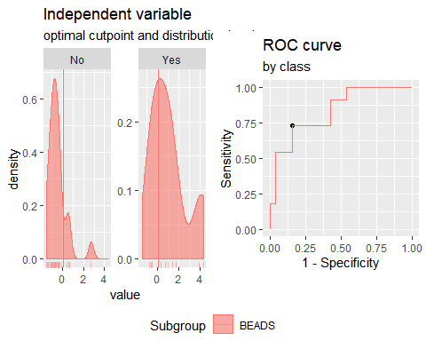

**"Combination IFNγ + CCL11**"

Method: maximize_metric   
 Predictor: var   
 Outcome: GrupoNew   
 Direction: >=   
 Subgroups: BEADS   
   
 Subgroup: BEADS   
 ---------------------------------------------------------------------------   
 AUC n n_pos n_neg  
 0.9476 37 11 26  
   
 optimal_cutpoint youden acc sensitivity specificity tp fn fp tn  
 -0.1534 0.8322 0.9189 0.9091 0.9231 10 1 2 24  
   
 Predictor summary:   
 Min. 5% 1st Qu. Median Mean 3rd Qu. 95% Max. SD NAs  
 overall -2.178 -1.797 -0.888 -0.515 0.000 0.096 4.073 4.965 1.691 0  
 No -2.178 -1.832 -1.025 -0.760 -0.721 -0.443 -0.148 2.901 0.905 0  
 Yes -0.481 -0.317 0.287 1.023 1.704 3.061 4.693 4.965 1.922 0

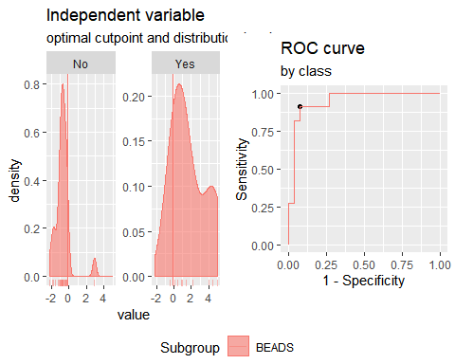

**"Combination IP10 + IL2"**

Method: maximize_metric   
 Predictor: var   
 Outcome: GrupoNew   
 Direction: >=   
 Subgroups: BEADS   
   
 Subgroup: BEADS   
 ---------------------------------------------------------------------------   
 AUC n n_pos n_neg  
 0.9545 37 11 26  
   
 optimal_cutpoint youden acc sensitivity specificity tp fn fp tn  
 0.1668 0.8322 0.9189 0.9091 0.9231 10 1 2 24  
   
 Predictor summary:   
 Min. 5% 1st Qu. Median Mean 3rd Qu. 95% Max. SD NAs  
 overall -1.632 -1.356 -1.116 -0.659 0.000 0.399 2.528 8.120 1.810 0  
 No -1.632 -1.364 -1.153 -0.973 -0.748 -0.238 0.329 0.488 0.598 0  
 Yes -0.722 -0.278 0.477 0.826 1.767 2.084 6.063 8.120 2.451 0

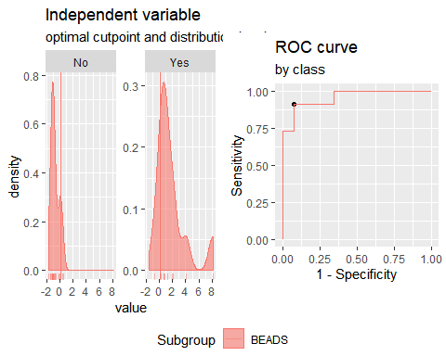

**"Combination IP10 + CCL3"**

Method: maximize_metric   
 Predictor: var   
 Outcome: GrupoNew   
 Direction: >=   
 Subgroups: BEADS   
   
 Subgroup: BEADS   
 ---------------------------------------------------------------------------   
 AUC n n_pos n_neg  
 0.7762 37 11 26  
   
 optimal_cutpoint youden acc sensitivity specificity tp fn fp tn  
 0.7883 0.5979 0.8649 0.6364 0.9615 7 4 1 25  
   
 Predictor summary:   
 Min. 5% 1st Qu. Median Mean 3rd Qu. 95% Max. SD NAs  
 overall -2.238 -1.438 -1.017 -0.278 0.000 0.490 2.285 4.842 1.393 0  
 No -1.440 -1.407 -1.039 -0.697 -0.423 0.052 0.545 2.733 0.893 0  
 Yes -2.238 -1.627 0.010 1.580 1.000 1.624 3.507 4.842 1.853 0

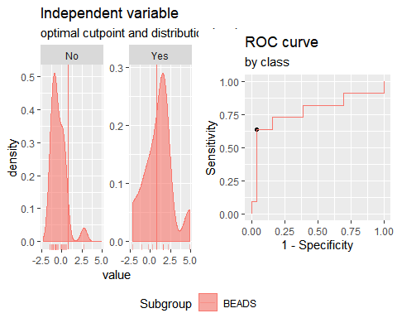

**"Combination IP10 + CCL11"**

Method: maximize_metric   
 Predictor: var   
 Outcome: GrupoNew   
 Direction: >=   
 Subgroups: BEADS   
   
 Subgroup: BEADS   
 ---------------------------------------------------------------------------   
 AUC n n_pos n_neg  
 0.9126 37 11 26  
   
 optimal_cutpoint youden acc sensitivity specificity tp fn fp tn  
 0.5213 0.7797 0.9189 0.8182 0.9615 9 2 1 25  
   
 Predictor summary:   
 Min. 5% 1st Qu. Median Mean 3rd Qu. 95% Max. SD NAs  
 overall -2.203 -1.609 -1.021 -0.430 0.000 0.521 2.509 5.851 1.578 0  
 No -2.203 -1.646 -1.107 -0.842 -0.680 -0.276 0.226 2.466 0.878 0  
 Yes -0.470 -0.391 0.622 1.446 1.608 2.146 4.267 5.851 1.730 0

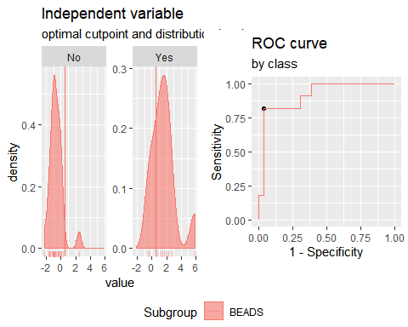

**"Combination IL2 + CCL3"**

Method: maximize_metric   
 Predictor: var   
 Outcome: GrupoNew   
 Direction: >=   
 Subgroups: BEADS   
   
 Subgroup: BEADS   
 ---------------------------------------------------------------------------   
 AUC n n_pos n_neg  
 0.8706 37 11 26  
   
 optimal_cutpoint youden acc sensitivity specificity tp fn fp tn  
 0.1816 0.6643 0.8378 0.8182 0.8462 9 2 4 22  
   
 Predictor summary:   
 Min. 5% 1st Qu. Median Mean 3rd Qu. 95% Max. SD NAs  
 overall -1.689 -1.440 -1.205 -0.388 0.000 0.729 2.711 2.770 1.369 0  
 No -1.689 -1.445 -1.226 -0.676 -0.517 -0.084 1.240 2.669 1.007 0  
 Yes -1.203 -0.624 0.245 1.151 1.222 2.692 2.756 2.770 1.368 0

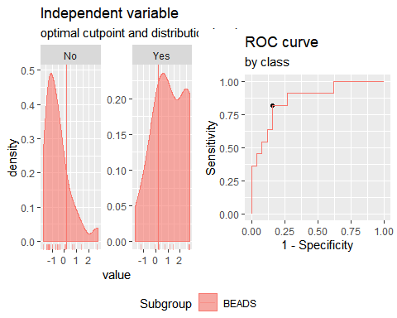

**"Combination IL2 + CCL11"**

Method: maximize_metric   
 Predictor: var   
 Outcome: GrupoNew   
 Direction: >=   
 Subgroups: BEADS   
   
 Subgroup: BEADS   
 ---------------------------------------------------------------------------   
 AUC n n_pos n_neg  
 0.9266 37 11 26  
   
 optimal_cutpoint youden acc sensitivity specificity tp fn fp tn  
 0.612 0.7797 0.9189 0.8182 0.9615 9 2 1 25  
   
 Predictor summary:   
 Min. 5% 1st Qu. Median Mean 3rd Qu. 95% Max. SD NAs  
 overall -2.895 -1.980 -0.959 -0.657 0.000 0.612 3.653 6.072 1.860 0  
 No -2.895 -2.019 -1.362 -0.863 -0.774 -0.477 0.467 3.622 1.166 0  
 Yes -0.657 -0.479 0.851 1.183 1.830 2.835 4.925 6.072 1.952 0

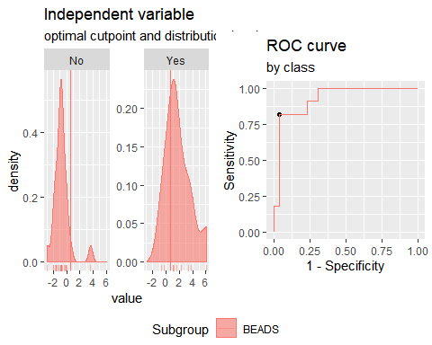

**"Combination CCL3 + CCL11"**

Method: maximize_metric   
 Predictor: var   
 Outcome: GrupoNew   
 Direction: >=   
 Subgroups: BEADS   
   
 Subgroup: BEADS   
 ---------------------------------------------------------------------------   
 AUC n n_pos n_neg  
 0.7937 37 11 26  
   
 optimal_cutpoint youden acc sensitivity specificity tp fn fp tn  
 0.5013 0.535 0.7838 0.7273 0.8077 8 3 5 21  
   
 Predictor summary:   
 Min. 5% 1st Qu. Median Mean 3rd Qu. 95% Max. SD NAs  
 overall -2.282 -2.004 -1.114 -0.232 0.000 0.666 3.013 4.168 1.572 0  
 No -2.282 -2.018 -1.363 -0.587 -0.450 -0.117 2.452 3.373 1.373 0  
 Yes -0.952 -0.822 0.165 0.592 1.063 1.927 3.426 4.168 1.555 0

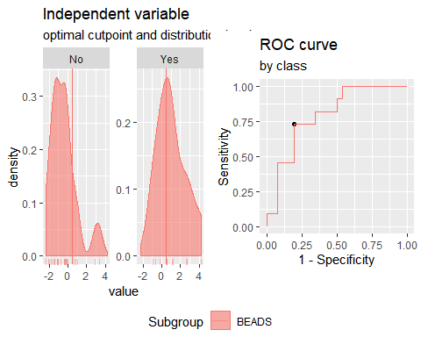

**"Combination IP10 + IL2+CCL3"**

Method: maximize_metric   
 Predictor: var   
 Outcome: GrupoNew   
 Direction: >=   
 Subgroups: BEADS   
   
 Subgroup: BEADS   
 ---------------------------------------------------------------------------   
 AUC n n_pos n_neg  
 0.9091 37 11 26  
   
 optimal_cutpoint youden acc sensitivity specificity tp fn fp tn  
 0.4548 0.7413 0.8919 0.8182 0.9231 9 2 2 24  
   
 Predictor summary:   
 Min. 5% 1st Qu. Median Mean 3rd Qu. 95% Max. SD NAs  
 overall -2.179 -1.967 -1.477 -0.254 0.000 0.648 2.758 7.866 2.022 0  
 No -2.179 -1.998 -1.666 -1.093 -0.844 -0.064 0.904 2.127 1.070 0  
 Yes -1.471 -0.682 0.552 2.248 1.994 2.668 5.322 7.866 2.374 0

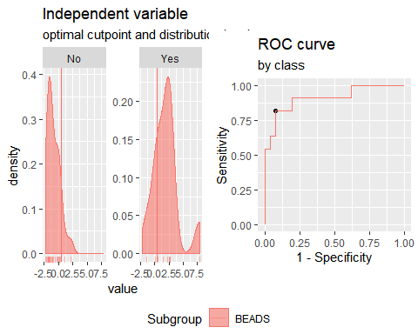

**"Combination IP10 + IL2+CCL11"**

Method: maximize_metric   
 Predictor: var   
 Outcome: GrupoNew   
 Direction: >=   
 Subgroups: BEADS   
   
 Subgroup: BEADS   
 ---------------------------------------------------------------------------   
 AUC n n_pos n_neg  
 0.9301 37 11 26  
   
 optimal_cutpoint youden acc sensitivity specificity tp fn fp tn  
 0.038 0.7937 0.8919 0.9091 0.8846 10 1 3 23  
   
 Predictor summary:   
 Min. 5% 1st Qu. Median Mean 3rd Qu. 95% Max. SD NAs  
 overall -3.233 -2.257 -1.492 -0.777 0.000 1.109 3.907 8.875 2.495 0  
 No -3.233 -2.442 -1.820 -1.419 -1.101 -0.526 0.223 3.288 1.238 0  
 Yes -0.924 -0.443 1.111 2.386 2.603 2.943 7.628 8.875 2.823 0

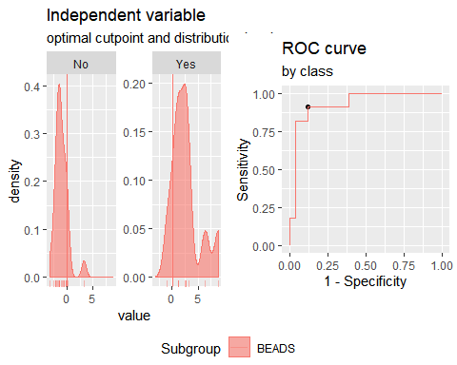

**"Combination IP10 + CCL3+CCL11"**

Method: maximize_metric   
 Predictor: var   
 Outcome: GrupoNew   
 Direction: >=   
 Subgroups: BEADS   
   
 Subgroup: BEADS   
 ---------------------------------------------------------------------------   
 AUC n n_pos n_neg  
 0.8601 37 11 26  
   
 optimal_cutpoint youden acc sensitivity specificity tp fn fp tn  
 0.5181 0.6119 0.8378 0.7273 0.8846 8 3 3 23  
   
 Predictor summary:   
 Min. 5% 1st Qu. Median Mean 3rd Qu. 95% Max. SD NAs  
 overall -2.62 -2.264 -1.532 -0.584 0.000 0.667 3.241 5.597 1.976 0  
 No -2.62 -2.419 -1.677 -0.861 -0.777 0.042 1.952 3.039 1.390 0  
 Yes -1.22 -0.786 0.327 2.092 1.835 2.708 4.823 5.597 1.988 0

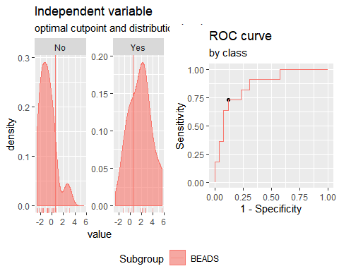

**"Combination IL2 + CCL3+CCL11"**

Method: maximize_metric   
 Predictor: var   
 Outcome: GrupoNew   
 Direction: >=   
 Subgroups: BEADS   
   
 Subgroup: BEADS   
 ---------------------------------------------------------------------------   
 AUC n n_pos n_neg  
 0.8741 37 11 26  
   
 optimal_cutpoint youden acc sensitivity specificity tp fn fp tn  
 0.9001 0.7028 0.8649 0.8182 0.8846 9 2 3 23  
   
 Predictor summary:   
 Min. 5% 1st Qu. Median Mean 3rd Qu. 95% Max. SD NAs  
 overall -3.312 -2.744 -1.613 -0.457 0.000 1.024 3.911 5.113 2.192 0  
 No -3.312 -2.826 -1.959 -1.055 -0.871 -0.165 1.993 4.196 1.643 0  
 Yes -1.406 -0.874 0.939 2.062 2.058 3.525 4.477 5.113 1.979 0

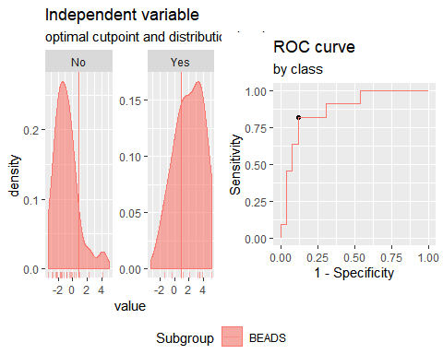

**"Combination IFNγ+IP10+IL2"**

Method: maximize_metric   
 Predictor: var   
 Outcome: GrupoNew   
 Direction: >=   
 Subgroups: BEADS   
   
 Subgroup: BEADS   
 ---------------------------------------------------------------------------   
 AUC n n_pos n_neg  
 0.9476 37 11 26  
   
 optimal_cutpoint youden acc sensitivity specificity tp fn fp tn  
 -0.0054 0.8322 0.9189 0.9091 0.9231 10 1 2 24  
   
 Predictor summary:   
 Min. 5% 1st Qu. Median Mean 3rd Qu. 95% Max. SD NAs  
 overall -2.192 -1.867 -1.502 -0.849 0.000 0.253 4.454 12.330 2.728 0  
 No -2.192 -1.933 -1.683 -1.355 -1.115 -0.569 0.432 0.656 0.757 0  
 Yes -0.673 -0.339 0.249 0.859 2.635 3.555 9.191 12.330 3.805 0

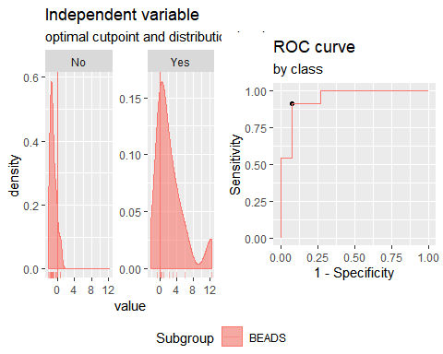

**"Combination IFNγ+CCL3+CCL11"**

Method: maximize_metric   
 Predictor: var   
 Outcome: GrupoNew   
 Direction: >=   
 Subgroups: BEADS   
   
 Subgroup: BEADS   
 ---------------------------------------------------------------------------   
 AUC n n_pos n_neg  
 0.8811 37 11 26  
   
 optimal_cutpoint youden acc sensitivity specificity tp fn fp tn  
 0.2742 0.7028 0.8649 0.8182 0.8846 9 2 3 23  
   
 Predictor summary:   
 Min. 5% 1st Qu. Median Mean 3rd Qu. 95% Max. SD NAs  
 overall -2.611 -2.595 -1.518 -0.628 0.000 1.311 4.057 5.512 2.045 0  
 No -2.611 -2.595 -1.587 -0.823 -0.817 -0.486 1.964 3.475 1.414 0  
 Yes -0.903 -0.712 0.792 1.470 1.931 3.063 5.112 5.512 2.054 0

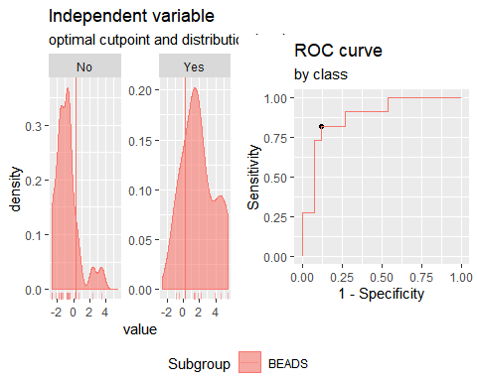

**"Combination IFNγ+CCL3+CCL10"**

Method: maximize_metric   
 Predictor: var   
 Outcome: GrupoNew   
 Direction: >=   
 Subgroups: BEADS   
   
 Subgroup: BEADS   
 ---------------------------------------------------------------------------   
 AUC n n_pos n_neg  
 0.8846 37 11 26  
   
 optimal_cutpoint youden acc sensitivity specificity tp fn fp tn  
 0.469 0.6888 0.8919 0.7273 0.9615 8 3 1 25  
   
 Predictor summary:   
 Min. 5% 1st Qu. Median Mean 3rd Qu. 95% Max. SD NAs  
 overall -1.998 -1.867 -1.256 -0.487 0.000 0.341 2.891 9.052 2.089 0  
 No -1.998 -1.908 -1.416 -1.039 -0.790 -0.257 0.317 2.197 0.944 0  
 Yes -0.968 -0.782 0.139 1.364 1.868 2.171 6.739 9.052 2.831 0

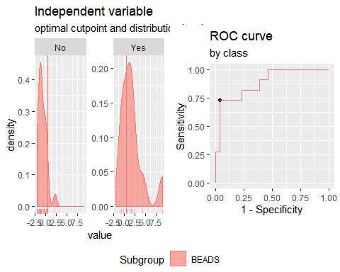

**"Combination IFNγ+CCL11+CCL10"**

Method: maximize_metric   
 Predictor: var   
 Outcome: GrupoNew   
 Direction: >=   
 Subgroups: BEADS   
   
 Subgroup: BEADS   
 ---------------------------------------------------------------------------   
 AUC n n_pos n_neg  
 0.9545 37 11 26  
   
 optimal_cutpoint youden acc sensitivity specificity tp fn fp tn  
 -0.4212 0.8462 0.8919 1 0.8462 11 0 4 22  
   
 Predictor summary:   
 Min. 5% 1st Qu. Median Mean 3rd Qu. 95% Max. SD NAs  
 overall -2.516 -2.190 -1.430 -0.654 0.000 0.216 4.193 10.061 2.433 0  
 No -2.516 -2.248 -1.551 -1.295 -1.048 -0.625 0.189 2.567 1.008 0  
 Yes -0.421 -0.281 0.269 1.979 2.477 3.479 7.395 10.061 3.028 0

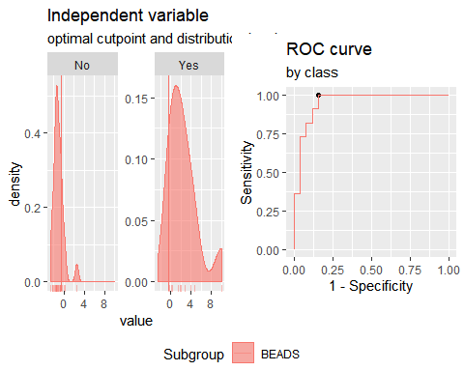

**"Combination IFNγ+CCL3+IL2"**

Method: maximize_metric   
 Predictor: var   
 Outcome: GrupoNew   
 Direction: >=   
 Subgroups: BEADS   
   
 Subgroup: BEADS   
 ---------------------------------------------------------------------------   
 AUC n n_pos n_neg  
 0.9126 37 11 26  
   
 optimal_cutpoint youden acc sensitivity specificity tp fn fp tn  
 -0.1361 0.7552 0.8649 0.9091 0.8462 10 1 4 22  
   
 Predictor summary:   
 Min. 5% 1st Qu. Median Mean 3rd Qu. 95% Max. SD NAs  
 overall -2.300 -1.906 -1.346 -0.688 0.000 0.479 3.659 6.980 2.079 0  
 No -2.300 -1.978 -1.691 -1.170 -0.884 -0.395 1.206 2.133 1.049 0  
 Yes -1.154 -0.645 0.255 1.678 2.090 2.813 6.244 6.980 2.443 0

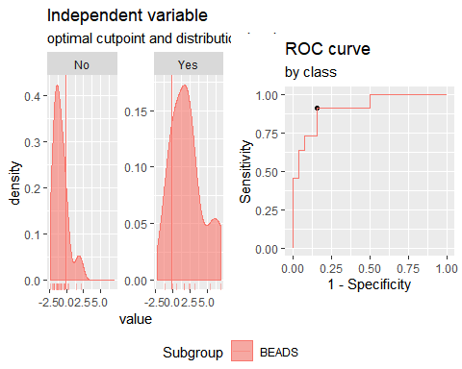

**"Combination IFNγ+CCL11+IL2"**

Method: maximize_metric   
 Predictor: var   
 Outcome: GrupoNew   
 Direction: >=   
 Subgroups: BEADS   
   
 Subgroup: BEADS   
 ---------------------------------------------------------------------------   
 AUC n n_pos n_neg  
 0.951 37 11 26  
   
 optimal_cutpoint youden acc sensitivity specificity tp fn fp tn  
 -0.1315 0.8322 0.9189 0.9091 0.9231 10 1 2 24  
   
 Predictor summary:   
 Min. 5% 1st Qu. Median Mean 3rd Qu. 95% Max. SD NAs  
 overall -3.208 -2.560 -1.480 -0.787 0.000 0.689 5.710 8.118 2.629 0  
 No -3.208 -2.620 -1.708 -1.294 -1.142 -0.712 0.078 3.723 1.262 0  
 Yes -0.607 -0.369 0.696 1.822 2.699 4.112 8.053 8.118 3.083 0

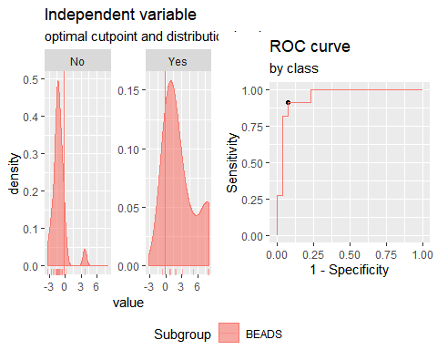**CCL11**  
 Method: maximize_metric   
 Predictor: var   
 Outcome: Grupo   
 Direction: >=   
 Subgroups: BEADS   
   
 Subgroup: BEADS   
 ---------------------------------------------------------------------------   
 AUC n n_pos n_neg  
 0.8571 25 11 14  
   
 optimal_cutpoint youden acc sensitivity specificity tp fn fp tn  
 1.051 0.7468 0.88 0.8182 0.9286 9 2 1 13  
   
 Predictor summary:   
 Min. 5% 1st Qu. Median Mean 3rd Qu. 95% Max. SD NAs  
 overall 0.829 0.901 0.959 0.986 1.024 1.077 1.233 1.270 0.106 0  
 No 0.829 0.872 0.946 0.969 0.977 0.983 1.104 1.270 0.097 0  
 Yes 0.944 0.965 1.051 1.077 1.084 1.105 1.232 1.233 0.087 0



**Analysis PTB+TSTp vs TSTn. Responses for all groups and cytokines corrected for background by subtraction.**

**"Combination IFNγ +IP10"**

Method: maximize_metric   
 Predictor: var   
 Outcome: GrupoNew   
 Direction: >=   
 Subgroups: BEADS   
   
 Subgroup: BEADS   
 ---------------------------------------------------------------------------   
 AUC n n_pos n_neg  
 0.7547 37 23 14  
   
 optimal_cutpoint youden acc sensitivity specificity tp fn fp tn  
 -0.3609 0.4814 0.7297 0.6957 0.7857 16 7 3 11  
   
 Predictor summary:   
 Min. 5% 1st Qu. Median Mean 3rd Qu. 95% Max. SD NAs  
 overall -2.357 -1.704 -0.798 -0.361 0.000 0.129 4.019 5.439 1.669 0  
 No -2.357 -2.169 -1.119 -0.733 -0.810 -0.446 0.262 0.281 0.781 0  
 Yes -1.613 -1.116 -0.516 -0.291 0.493 0.852 4.215 5.439 1.878 0

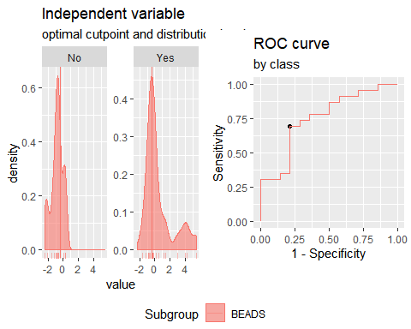 **"Combination IFNγ + IL2"**

Method: maximize_metric   
 Predictor: var   
 Outcome: GrupoNew   
 Direction: >=   
 Subgroups: BEADS   
   
 Subgroup: BEADS   
 ---------------------------------------------------------------------------   
 AUC n n_pos n_neg  
 0.7795 37 23 14  
   
 optimal_cutpoint youden acc sensitivity specificity tp fn fp tn  
 -0.484 0.5963 0.7838 0.7391 0.8571 17 6 2 12  
   
 Predictor summary:   
 Min. 5% 1st Qu. Median Mean 3rd Qu. 95% Max. SD NAs  
 overall -1.645 -1.601 -1.184 -0.484 0.000 0.168 4.396 5.970 1.773 0  
 No -1.645 -1.645 -1.293 -1.061 -0.877 -0.724 0.497 1.253 0.772 0  
 Yes -1.507 -1.365 -0.674 0.058 0.534 0.782 4.792 5.970 2.001 0

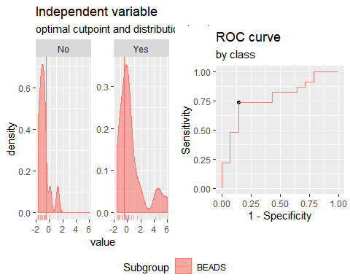

**"Combination IFNγ + CCL3"**

Method: maximize_metric   
 Predictor: var   
 Outcome: GrupoNew   
 Direction: >=   
 Subgroups: BEADS   
   
 Subgroup: BEADS   
 ---------------------------------------------------------------------------   
 AUC n n_pos n_neg  
 0.6491 37 23 14  
   
 optimal_cutpoint youden acc sensitivity specificity tp fn fp tn  
 -0.6502 0.354 0.7027 0.7826 0.5714 18 5 6 8  
   
 Predictor summary:   
 Min. 5% 1st Qu. Median Mean 3rd Qu. 95% Max. SD NAs  
 overall -1.736 -1.704 -0.952 -0.468 0.000 0.924 2.176 5.054 1.429 0  
 No -1.735 -1.636 -1.180 -0.767 -0.431 -0.158 1.477 2.040 1.112 0  
 Yes -1.736 -1.659 -0.641 -0.205 0.262 1.163 2.609 5.054 1.556 0

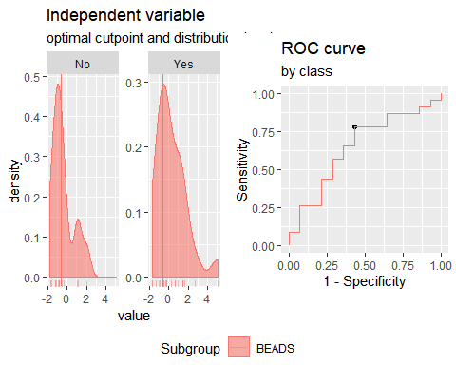 **"Combination IFNγ + CCL11"**

Method: maximize_metric   
 Predictor: var   
 Outcome: GrupoNew   
 Direction: >=   
 Subgroups: BEADS   
   
 Subgroup: BEADS   
 ---------------------------------------------------------------------------   
 AUC n n_pos n_neg  
 0.705 37 23 14  
   
 optimal_cutpoint youden acc sensitivity specificity tp fn fp tn  
 -0.6234 0.4099 0.7027 0.6957 0.7143 16 7 4 10  
   
 Predictor summary:   
 Min. 5% 1st Qu. Median Mean 3rd Qu. 95% Max. SD NAs  
 overall -2.072 -1.287 -0.853 -0.595 0.000 0.152 3.293 5.179 1.562 0  
 No -2.072 -1.478 -0.974 -0.772 -0.372 -0.554 1.956 5.179 1.676 0  
 Yes -1.797 -1.134 -0.696 -0.362 0.227 1.103 2.906 4.479 1.479 0

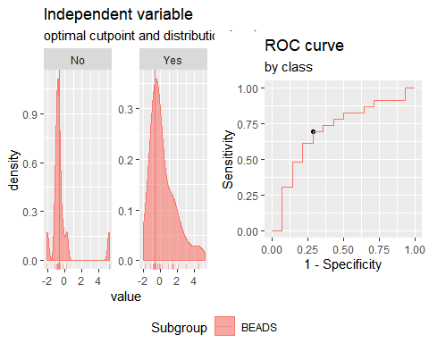**"Combination IP10 + IL2"**

Method: maximize_metric   
 Predictor: var   
 Outcome: GrupoNew   
 Direction: >=   
 Subgroups: BEADS   
   
 Subgroup: BEADS   
 ---------------------------------------------------------------------------   
 AUC n n_pos n_neg  
 0.7857 37 23 14  
   
 optimal_cutpoint youden acc sensitivity specificity tp fn fp tn  
 -0.8107 0.441 0.7568 0.8696 0.5714 20 3 6 8  
   
 Predictor summary:   
 Min. 5% 1st Qu. Median Mean 3rd Qu. 95% Max. SD NAs  
 overall -3.166 -1.767 -0.972 -0.391 0.000 0.702 3.563 5.536 1.706 0  
 No -3.166 -2.665 -1.407 -0.998 -0.979 -0.303 0.365 0.734 1.033 0  
 Yes -1.525 -1.221 -0.677 0.109 0.596 1.149 3.881 5.536 1.775 0

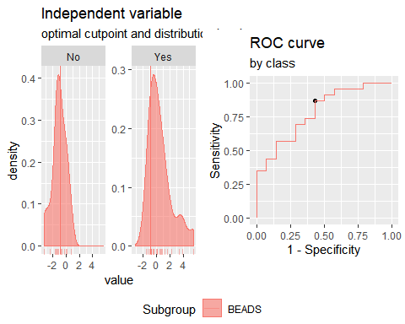**"Combination IP10 + CCL3"**

Method: maximize_metric   
 Predictor: var   
 Outcome: GrupoNew   
 Direction: >=   
 Subgroups: BEADS   
   
 Subgroup: BEADS   
 ---------------------------------------------------------------------------   
 AUC n n_pos n_neg  
 0.646 37 23 14  
   
 optimal_cutpoint youden acc sensitivity specificity tp fn fp tn  
 1.0276 0.2764 0.5676 0.3478 0.9286 8 15 1 13  
   
 Predictor summary:   
 Min. 5% 1st Qu. Median Mean 3rd Qu. 95% Max. SD NAs  
 overall -3.809 -1.908 -0.859 -0.142 0.000 0.656 2.644 3.013 1.514 0  
 No -3.809 -2.550 -1.282 -0.526 -0.533 0.317 1.324 2.564 1.487 0  
 Yes -2.051 -1.593 -0.690 0.008 0.324 1.464 2.896 3.013 1.468 0

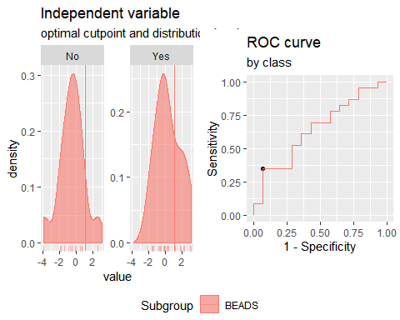**"Combination IP10 + CCL11"**

Method: maximize_metric   
 Predictor: var   
 Outcome: GrupoNew   
 Direction: >=   
 Subgroups: BEADS   
   
 Subgroup: BEADS   
 ---------------------------------------------------------------------------   
 AUC n n_pos n_neg  
 0.7081 37 23 14  
   
 optimal_cutpoint youden acc sensitivity specificity tp fn fp tn  
 -0.479 0.4689 0.7568 0.8261 0.6429 19 4 5 9  
   
 Predictor summary:   
 Min. 5% 1st Qu. Median Mean 3rd Qu. 95% Max. SD NAs  
 overall -3.036 -1.772 -0.728 -0.315 0.000 0.274 2.920 4.661 1.492 0  
 No -3.036 -2.271 -1.060 -0.580 -0.474 -0.120 1.810 4.661 1.718 0  
 Yes -1.607 -1.458 -0.408 -0.199 0.288 0.912 2.884 2.921 1.292 0

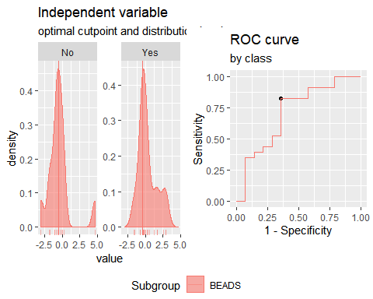**"Combination IL2 + CCL3"**

Method: maximize_metric   
 Predictor: var   
 Outcome: GrupoNew   
 Direction: >=   
 Subgroups: BEADS   
   
 Subgroup: BEADS   
 ---------------------------------------------------------------------------   
 AUC n n_pos n_neg  
 0.7174 37 23 14  
   
 optimal_cutpoint youden acc sensitivity specificity tp fn fp tn  
 0.1332 0.3944 0.6757 0.6087 0.7857 14 9 3 11  
   
 Predictor summary:   
 Min. 5% 1st Qu. Median Mean 3rd Qu. 95% Max. SD NAs  
 overall -1.842 -1.519 -1.362 -0.375 0.000 0.864 2.730 2.815 1.412 0  
 No -1.842 -1.812 -1.448 -1.048 -0.600 -0.277 1.916 2.050 1.239 0  
 Yes -1.430 -1.406 -0.610 0.193 0.365 1.106 2.746 2.815 1.409 0

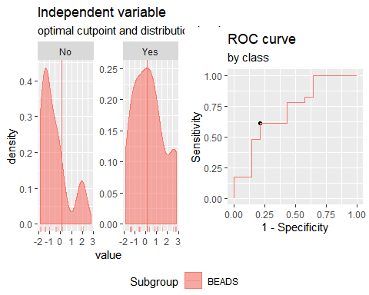

**"Combination IL2 + CCL11"**

Method: maximize_metric   
 Predictor: var   
 Outcome: GrupoNew   
 Direction: >=   
 Subgroups: BEADS   
   
 Subgroup: BEADS   
 ---------------------------------------------------------------------------   
 AUC n n_pos n_neg  
 0.7391 37 23 14  
   
 optimal_cutpoint youden acc sensitivity specificity tp fn fp tn  
 -0.3925 0.5528 0.7568 0.6957 0.8571 16 7 2 12  
   
 Predictor summary:   
 Min. 5% 1st Qu. Median Mean 3rd Qu. 95% Max. SD NAs  
 overall -3.105 -1.380 -0.928 -0.588 0.000 0.476 3.404 5.849 1.735 0  
 No -3.105 -1.950 -1.204 -0.796 -0.542 -0.634 1.854 5.849 1.956 0  
 Yes -1.432 -1.356 -0.671 -0.116 0.330 0.751 3.047 4.649 1.539 0

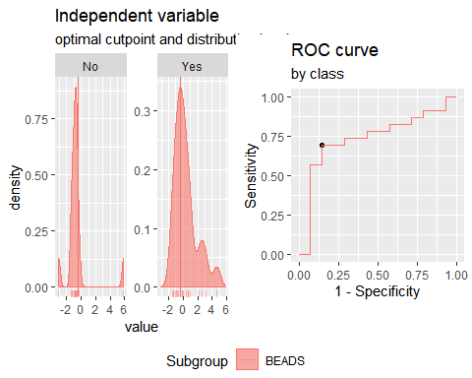

**"Combination CCL3 + CCL11"**

Method: maximize_metric   
 Predictor: var   
 Outcome: GrupoNew   
 Direction: >=   
 Subgroups: BEADS   
   
 Subgroup: BEADS   
 ---------------------------------------------------------------------------   
 AUC n n_pos n_neg  
 0.6118 37 23 14  
   
 optimal_cutpoint youden acc sensitivity specificity tp fn fp tn  
 -0.1067 0.3509 0.6486 0.5652 0.7857 13 10 3 11  
   
 Predictor summary:   
 Min. 5% 1st Qu. Median Mean 3rd Qu. 95% Max. SD NAs  
 overall -2.222 -1.490 -1.143 -0.252 0.000 0.711 2.632 5.770 1.597 0  
 No -2.222 -1.695 -1.170 -0.872 -0.095 -0.182 3.597 5.770 2.048 0  
 Yes -1.661 -1.435 -0.973 -0.101 0.058 0.714 2.347 3.457 1.298 0

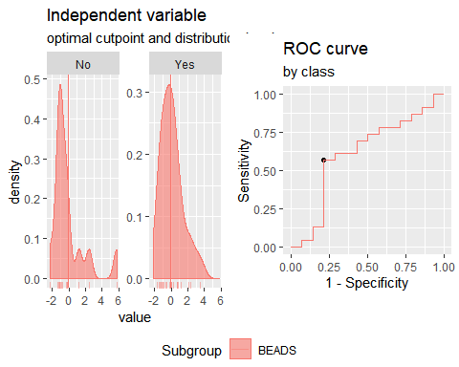

**"Combination IP10 + IL2+CCL3"**

Method: maximize_metric   
 Predictor: var   
 Outcome: GrupoNew   
 Direction: >=   
 Subgroups: BEADS   
   
 Subgroup: BEADS   
 ---------------------------------------------------------------------------   
 AUC n n_pos n_neg  
 0.7391 37 23 14  
   
 optimal_cutpoint youden acc sensitivity specificity tp fn fp tn  
 0.2461 0.4658 0.7027 0.6087 0.8571 14 9 2 12  
   
 Predictor summary:   
 Min. 5% 1st Qu. Median Mean 3rd Qu. 95% Max. SD NAs  
 overall -4.169 -2.396 -1.400 -0.385 0.000 1.370 3.243 5.317 2.049 0  
 No -4.169 -3.317 -2.171 -1.116 -1.056 -0.361 1.743 1.977 1.659 0  
 Yes -2.248 -2.024 -0.848 0.358 0.643 2.314 3.619 5.317 2.025 0

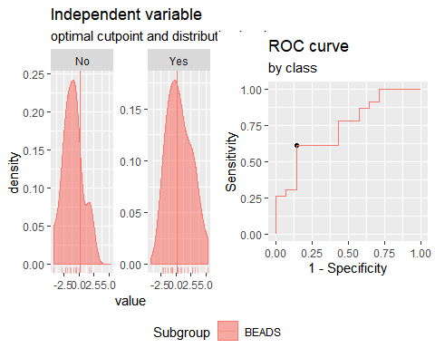

**"Combination IP10 + IL2+CCL11"**

Method: maximize_metric   
 Predictor: var   
 Outcome: GrupoNew   
 Direction: >=   
 Subgroups: BEADS   
   
 Subgroup: BEADS   
 ---------------------------------------------------------------------------   
 AUC n n_pos n_neg  
 0.764 37 23 14  
   
 optimal_cutpoint youden acc sensitivity specificity tp fn fp tn  
 -1.2201 0.4845 0.7838 0.913 0.5714 21 2 6 8  
   
 Predictor summary:   
 Min. 5% 1st Qu. Median Mean 3rd Qu. 95% Max. SD NAs  
 overall -3.395 -2.829 -1.333 -0.427 0.000 0.733 5.243 5.622 2.269 0  
 No -3.395 -3.268 -1.673 -1.413 -0.997 -0.503 1.912 5.622 2.161 0  
 Yes -2.249 -2.021 -0.989 -0.079 0.607 2.013 4.998 5.595 2.155 0

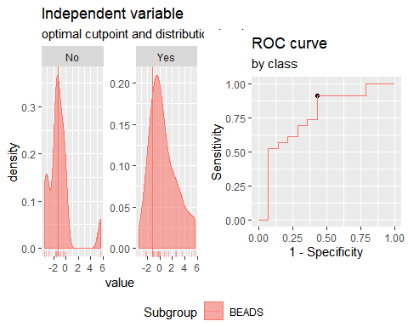

**"Combination IP10 + CCL3+CCL11"**

Method: maximize_metric   
 Predictor: var   
 Outcome: GrupoNew   
 Direction: >=   
 Subgroups: BEADS   
   
 Subgroup: BEADS   
 ---------------------------------------------------------------------------   
 AUC n n_pos n_neg  
 0.6553 37 23 14  
   
 optimal_cutpoint youden acc sensitivity specificity tp fn fp tn  
 -1.1677 0.3696 0.7297 0.8696 0.5 20 3 7 7  
   
 Predictor summary:   
 Min. 5% 1st Qu. Median Mean 3rd Qu. 95% Max. SD NAs  
 overall -4.038 -2.332 -1.178 -0.254 0.000 1.012 3.369 5.543 2.017 0  
 No -4.038 -2.919 -1.970 -1.018 -0.551 0.082 3.470 5.543 2.326 0  
 Yes -2.339 -2.253 -0.859 -0.048 0.335 1.701 3.325 3.452 1.774 0

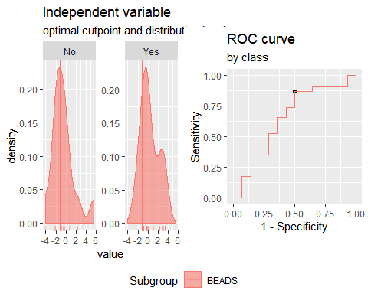

**"Combination IL2 + CCL3+CCL11"**

Method: maximize_metric   
 Predictor: var   
 Outcome: GrupoNew   
 Direction: >=   
 Subgroups: BEADS   
   
 Subgroup: BEADS   
 ---------------------------------------------------------------------------   
 AUC n n_pos n_neg  
 0.6832 37 23 14  
   
 optimal_cutpoint youden acc sensitivity specificity tp fn fp tn  
 -0.2906 0.3944 0.6757 0.6087 0.7857 14 9 3 11  
   
 Predictor summary:   
 Min. 5% 1st Qu. Median Mean 3rd Qu. 95% Max. SD NAs  
 overall -3.561 -2.238 -1.591 -0.599 0.000 0.968 3.802 6.731 2.134 0  
 No -3.561 -2.715 -1.761 -1.433 -0.619 -0.496 3.551 6.731 2.458 0  
 Yes -2.232 -2.076 -0.843 0.025 0.377 1.403 3.573 4.407 1.868 0

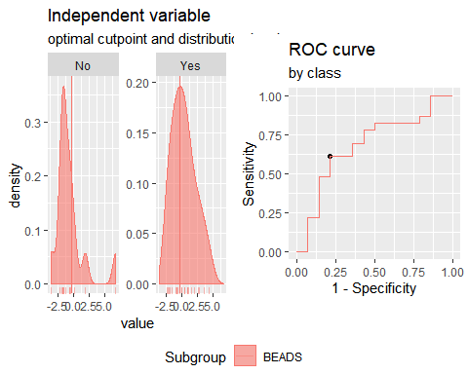

**"Combination IFNγ+IP10+IL2"**

Method: maximize_metric   
 Predictor: var   
 Outcome: GrupoNew   
 Direction: >=   
 Subgroups: BEADS   
   
 Subgroup: BEADS   
 ---------------------------------------------------------------------------   
 AUC n n_pos n_neg  
 0.8043 37 23 14  
   
 optimal_cutpoint youden acc sensitivity specificity tp fn fp tn  
 -1.033 0.5404 0.7838 0.8261 0.7143 19 4 4 10  
   
 Predictor summary:   
 Min. 5% 1st Qu. Median Mean 3rd Qu. 95% Max. SD NAs  
 overall -3.054 -2.291 -1.397 -0.701 0.000 0.462 4.969 8.472 2.417 0  
 No -3.054 -2.835 -1.919 -1.408 -1.333 -0.908 0.289 1.026 1.068 0  
 Yes -2.184 -1.406 -0.828 -0.225 0.811 0.996 5.202 8.472 2.658 0

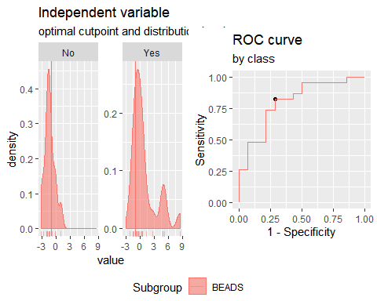

**"Combination IFNγ+CCL3+CCL11"**

Method: maximize_metric   
 Predictor: var   
 Outcome: GrupoNew   
 Direction: >=   
 Subgroups: BEADS   
   
 Subgroup: BEADS   
 ---------------------------------------------------------------------------   
 AUC n n_pos n_neg  
 0.677 37 23 14  
   
 optimal_cutpoint youden acc sensitivity specificity tp fn fp tn  
 -0.7299 0.382 0.7027 0.7391 0.6429 17 6 5 9  
   
 Predictor summary:   
 Min. 5% 1st Qu. Median Mean 3rd Qu. 95% Max. SD NAs  
 overall -2.597 -2.227 -1.327 -0.612 0.000 0.757 3.673 6.062 2.008 0  
 No -2.528 -2.284 -1.641 -1.093 -0.450 -0.487 3.311 6.062 2.211 0  
 Yes -2.597 -1.800 -0.784 -0.386 0.274 1.032 3.069 5.956 1.871 0

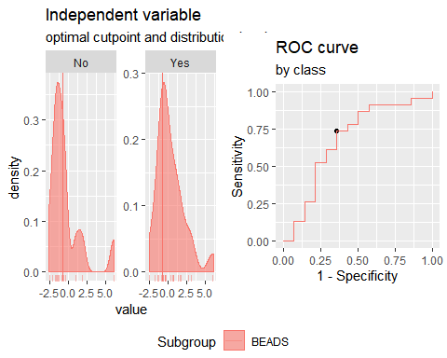

**"Combination IFNγ+CCL3+IP10"**

Method: maximize_metric   
 Predictor: var   
 Outcome: GrupoNew   
 Direction: >=   
 Subgroups: BEADS   
   
 Subgroup: BEADS   
 ---------------------------------------------------------------------------   
 AUC n n_pos n_neg  
 0.6957 37 23 14  
   
 optimal_cutpoint youden acc sensitivity specificity tp fn fp tn  
 -1.191 0.3416 0.7297 0.913 0.4286 21 2 8 6  
   
 Predictor summary:   
 Min. 5% 1st Qu. Median Mean 3rd Qu. 95% Max. SD NAs  
 overall -3.360 -2.441 -1.190 -0.474 0.000 0.541 4.599 5.440 2.030 0  
 No -3.360 -2.821 -1.987 -0.822 -0.887 0.046 1.305 1.968 1.467 0  
 Yes -2.414 -1.273 -0.889 -0.214 0.540 1.241 5.143 5.440 2.160 0

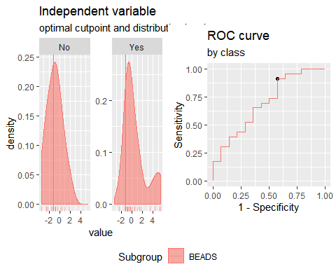

**"Combination IFNγ+CCL11+IP10"**

Method: maximize_metric   
 Predictor: var   
 Outcome: GrupoNew   
 Direction: >=   
 Subgroups: BEADS   
   
 Subgroup: BEADS   
 ---------------------------------------------------------------------------   
 AUC n n_pos n_neg  
 0.7609 37 23 14  
   
 optimal_cutpoint youden acc sensitivity specificity tp fn fp tn  
 -0.6141 0.5248 0.7568 0.7391 0.7857 17 6 3 11  
   
 Predictor summary:   
 Min. 5% 1st Qu. Median Mean 3rd Qu. 95% Max. SD NAs  
 overall -2.587 -2.422 -1.116 -0.548 0.000 0.001 4.883 5.499 2.110 0  
 No -2.587 -2.471 -1.662 -1.108 -0.828 -0.708 1.734 4.953 1.832 0  
 Yes -2.474 -1.120 -0.773 -0.469 0.504 0.948 4.814 5.499 2.144 0

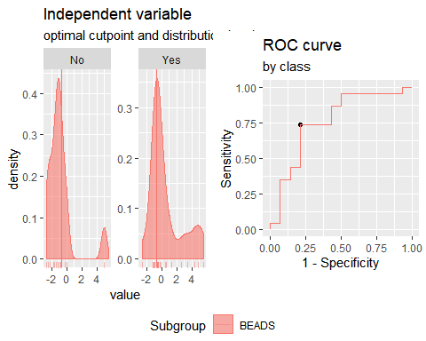

**"Combination IFNγ+CCL3+IL2"**

Method: maximize_metric   
 Predictor: var   
 Outcome: GrupoNew   
 Direction: >=   
 Subgroups: BEADS   
   
 Subgroup: BEADS   
 ---------------------------------------------------------------------------   
 AUC n n_pos n_neg  
 0.7391 37 23 14  
   
 optimal_cutpoint youden acc sensitivity specificity tp fn fp tn  
 -0.3428 0.4379 0.7027 0.6522 0.7857 15 8 3 11  
   
 Predictor summary:   
 Min. 5% 1st Qu. Median Mean 3rd Qu. 95% Max. SD NAs  
 overall -2.584 -2.148 -1.313 -0.531 0.000 0.759 3.046 6.326 2.044 0  
 No -2.584 -2.275 -2.049 -1.148 -0.954 -0.578 1.692 2.135 1.379 0  
 Yes -2.307 -2.022 -1.030 0.127 0.581 1.650 5.413 6.326 2.187 0

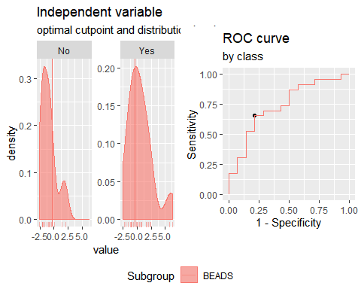

**"Combination IFNγ+CCL11+IL2"**

Method: maximize_metric   
 Predictor: var   
 Outcome: GrupoNew   
 Direction: >=   
 Subgroups: BEADS   
   
 Subgroup: BEADS   
 ---------------------------------------------------------------------------   
 AUC n n_pos n_neg  
 0.764 37 23 14  
   
 optimal_cutpoint youden acc sensitivity specificity tp fn fp tn  
 -0.6873 0.5963 0.7838 0.7391 0.8571 17 6 2 12  
   
 Predictor summary:   
 Min. 5% 1st Qu. Median Mean 3rd Qu. 95% Max. SD NAs  
 overall -3.411 -2.079 -1.319 -0.687 0.000 0.373 5.806 6.140 2.365 0  
 No -3.411 -2.499 -1.694 -1.271 -0.896 -0.949 2.059 6.140 2.157 0  
 Yes -2.368 -1.862 -0.849 -0.200 0.545 0.920 5.727 6.029 2.362 0

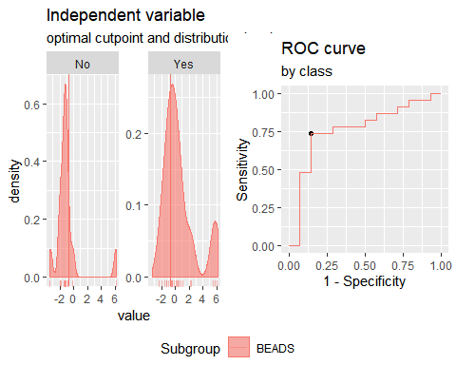

**Analysis PTB+TSTp vs TSTn. Responses for all groups and cytokinescorrected for background by division (ratio).**

**"Combination IFNγ +IP10"**

Method: maximize_metric   
 Predictor: var   
 Outcome: GrupoNew   
 Direction: >=   
 Subgroups: BEADS   
   
 Subgroup: BEADS   
 ---------------------------------------------------------------------------   
 AUC n n_pos n_neg  
 0.7453 37 23 14  
   
 optimal_cutpoint youden acc sensitivity specificity tp fn fp tn  
 -0.5276 0.4814 0.7297 0.6957 0.7857 16 7 3 11  
   
 Predictor summary:   
 Min. 5% 1st Qu. Median Mean 3rd Qu. 95% Max. SD NAs  
 overall -1.366 -1.209 -1.016 -0.528 0.000 0.008 2.514 9.306 1.889 0  
 No -1.366 -1.256 -1.075 -0.899 -0.757 -0.659 0.127 0.347 0.492 0  
 Yes -1.230 -1.190 -0.747 -0.352 0.461 0.683 2.851 9.306 2.261 0

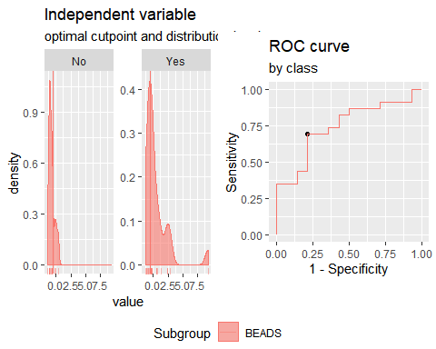

**"Combination IFNγ + IL2"**

Method: maximize_metric   
 Predictor: var   
 Outcome: GrupoNew   
 Direction: >=   
 Subgroups: BEADS   
   
 Subgroup: BEADS   
 ---------------------------------------------------------------------------   
 AUC n n_pos n_neg  
 0.8043 37 23 14  
   
 optimal_cutpoint youden acc sensitivity specificity tp fn fp tn  
 -0.4283 0.6242 0.7838 0.6957 0.9286 16 7 1 13  
   
 Predictor summary:   
 Min. 5% 1st Qu. Median Mean 3rd Qu. 95% Max. SD NAs  
 overall -1.474 -1.352 -1.142 -0.572 0.000 0.125 4.334 7.233 1.896 0  
 No -1.474 -1.416 -1.211 -1.025 -0.885 -0.764 -0.031 0.923 0.596 0  
 Yes -1.262 -1.217 -0.685 -0.256 0.539 0.596 5.568 7.233 2.207 0

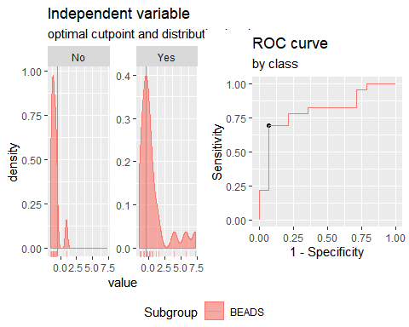**"Combination IFNγ + CCL3"**

Method: maximize_metric   
 Predictor: var   
 Outcome: GrupoNew   
 Direction: >=   
 Subgroups: BEADS   
   
 Subgroup: BEADS   
 ---------------------------------------------------------------------------   
 AUC n n_pos n_neg  
 0.7081 37 23 14  
   
 optimal_cutpoint youden acc sensitivity specificity tp fn fp tn  
 -0.7002 0.5124 0.7838 0.8696 0.6429 20 3 5 9  
   
 Predictor summary:   
 Min. 5% 1st Qu. Median Mean 3rd Qu. 95% Max. SD NAs  
 overall -1.437 -1.328 -0.776 -0.496 0.000 0.405 2.983 4.353 1.361 0  
 No -1.437 -1.388 -1.024 -0.816 -0.412 -0.291 1.397 2.739 1.107 0  
 Yes -1.320 -1.199 -0.621 -0.306 0.250 0.578 3.735 4.353 1.460 0

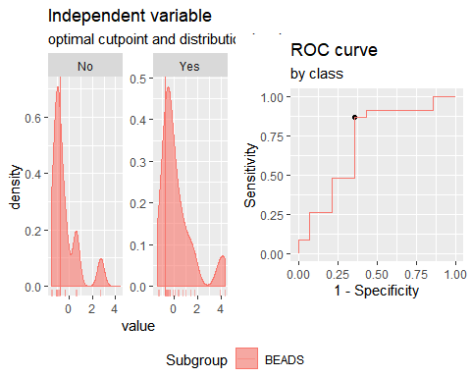**"Combination IFNγ + CCL11"**

Method: maximize_metric   
 Predictor: var   
 Outcome: GrupoNew   
 Direction: >=   
 Subgroups: BEADS   
   
 Subgroup: BEADS   
 ---------------------------------------------------------------------------   
 AUC n n_pos n_neg  
 0.7609 37 23 14  
   
 optimal_cutpoint youden acc sensitivity specificity tp fn fp tn  
 -0.6866 0.4969 0.7568 0.7826 0.7143 18 5 4 10  
   
 Predictor summary:   
 Min. 5% 1st Qu. Median Mean 3rd Qu. 95% Max. SD NAs  
 overall -2.178 -1.797 -0.888 -0.515 0.000 0.096 4.073 4.965 1.691 0  
 No -2.178 -1.922 -1.025 -0.844 -0.688 -0.563 0.858 2.901 1.154 0  
 Yes -1.848 -1.529 -0.658 -0.186 0.419 0.959 4.377 4.965 1.846 0

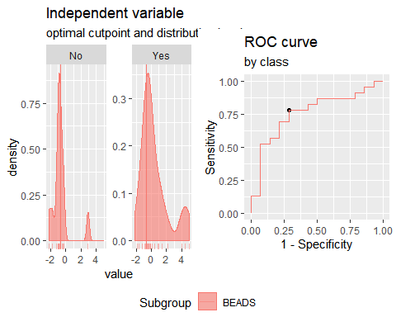**"Combination IP10 + IL2"**

Method: maximize_metric   
 Predictor: var   
 Outcome: GrupoNew   
 Direction: >=   
 Subgroups: BEADS   
   
 Subgroup: BEADS   
 ---------------------------------------------------------------------------   
 AUC n n_pos n_neg  
 0.7981 37 23 14  
   
 optimal_cutpoint youden acc sensitivity specificity tp fn fp tn  
 -0.8358 0.5404 0.7838 0.8261 0.7143 19 4 4 10  
   
 Predictor summary:   
 Min. 5% 1st Qu. Median Mean 3rd Qu. 95% Max. SD NAs  
 overall -1.632 -1.356 -1.116 -0.659 0.000 0.399 2.528 8.120 1.810 0  
 No -1.632 -1.461 -1.181 -1.086 -0.867 -0.736 0.248 0.488 0.612 0  
 Yes -1.308 -1.188 -0.792 0.105 0.528 0.758 3.822 8.120 2.090 0

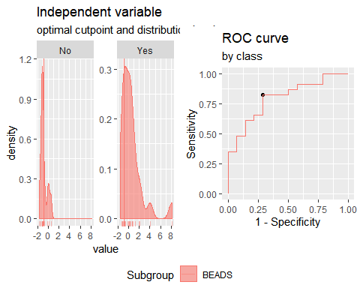**"Combination IP10 + CCL3"**

Method: maximize_metric   
 Predictor: var   
 Outcome: GrupoNew   
 Direction: >=   
 Subgroups: BEADS   
   
 Subgroup: BEADS   
 ---------------------------------------------------------------------------   
 AUC n n_pos n_neg  
 0.646 37 23 14  
   
 optimal_cutpoint youden acc sensitivity specificity tp fn fp tn  
 -0.4544 0.295 0.6486 0.6522 0.6429 15 8 5 9  
   
 Predictor summary:   
 Min. 5% 1st Qu. Median Mean 3rd Qu. 95% Max. SD NAs  
 overall -2.238 -1.438 -1.017 -0.278 0.000 0.490 2.285 4.842 1.393 0  
 No -1.440 -1.438 -1.150 -0.722 -0.393 0.148 1.323 2.733 1.118 0  
 Yes -2.238 -1.210 -0.842 -0.012 0.239 1.184 2.119 4.842 1.510 0

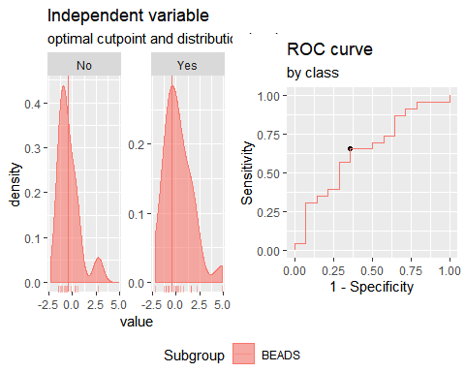**"Combination IP10 + CCL11"**

Method: maximize_metric   
 Predictor: var   
 Outcome: GrupoNew   
 Direction: >=   
 Subgroups: BEADS   
   
 Subgroup: BEADS   
 ---------------------------------------------------------------------------   
 AUC n n_pos n_neg  
 0.7329 37 23 14  
   
 optimal_cutpoint youden acc sensitivity specificity tp fn fp tn  
 -0.8072 0.4689 0.7568 0.8261 0.6429 19 4 5 9  
   
 Predictor summary:   
 Min. 5% 1st Qu. Median Mean 3rd Qu. 95% Max. SD NAs  
 overall -2.203 -1.609 -1.021 -0.430 0.000 0.521 2.509 5.851 1.578 0  
 No -2.203 -1.852 -1.107 -0.958 -0.670 -0.328 1.034 2.466 1.089 0  
 Yes -1.595 -1.529 -0.681 -0.088 0.408 1.339 2.644 5.851 1.708 0

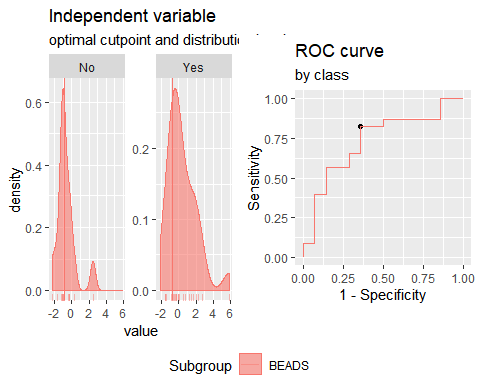**"Combination IL2 + CCL3"**

Method: maximize_metric   
 Predictor: var   
 Outcome: GrupoNew   
 Direction: >=   
 Subgroups: BEADS   
   
 Subgroup: BEADS   
 ---------------------------------------------------------------------------   
 AUC n n_pos n_neg  
 0.7081 37 23 14  
   
 optimal_cutpoint youden acc sensitivity specificity tp fn fp tn  
 -0.0455 0.3944 0.6757 0.6087 0.7857 14 9 3 11  
   
 Predictor summary:   
 Min. 5% 1st Qu. Median Mean 3rd Qu. 95% Max. SD NAs  
 overall -1.689 -1.440 -1.205 -0.388 0.000 0.729 2.711 2.770 1.369 0  
 No -1.689 -1.532 -1.297 -0.963 -0.521 -0.374 1.841 2.669 1.217 0  
 Yes -1.438 -1.286 -0.676 0.045 0.317 0.962 2.738 2.770 1.383 0

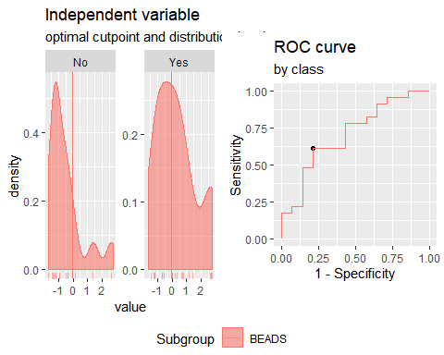**"Combination IL2 + CCL11"**

Method: maximize_metric   
 Predictor: var   
 Outcome: GrupoNew   
 Direction: >=   
 Subgroups: BEADS   
   
 Subgroup: BEADS   
 ---------------------------------------------------------------------------   
 AUC n n_pos n_neg  
 0.7547 37 23 14  
   
 optimal_cutpoint youden acc sensitivity specificity tp fn fp tn  
 -0.7035 0.5248 0.7568 0.7391 0.7857 17 6 3 11  
   
 Predictor summary:   
 Min. 5% 1st Qu. Median Mean 3rd Qu. 95% Max. SD NAs  
 overall -2.895 -1.980 -0.959 -0.657 0.000 0.612 3.653 6.072 1.860 0  
 No -2.895 -2.337 -1.211 -0.911 -0.797 -0.725 1.195 3.622 1.443 0  
 Yes -1.966 -1.700 -0.718 -0.051 0.485 1.152 3.736 6.072 1.944 0

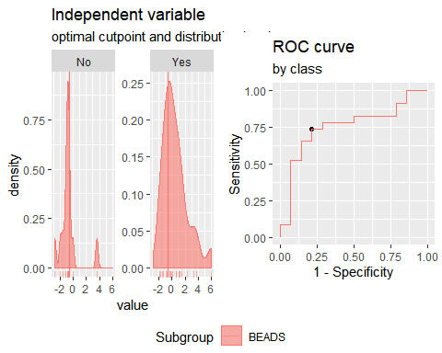**"Combination CCL3 + CCL11"**

Method: maximize_metric   
 Predictor: var   
 Outcome: GrupoNew   
 Direction: >=   
 Subgroups: BEADS   
   
 Subgroup: BEADS   
 ---------------------------------------------------------------------------   
 AUC n n_pos n_neg  
 0.6398 37 23 14  
   
 optimal_cutpoint youden acc sensitivity specificity tp fn fp tn  
 -0.2324 0.3665 0.6757 0.6522 0.7143 15 8 4 10  
   
 Predictor summary:   
 Min. 5% 1st Qu. Median Mean 3rd Qu. 95% Max. SD NAs  
 overall -2.282 -2.004 -1.114 -0.232 0.000 0.666 3.013 4.168 1.572 0  
 No -2.282 -2.098 -1.308 -0.894 -0.324 -0.181 3.080 3.373 1.685 0  
 Yes -2.024 -1.719 -0.822 -0.113 0.197 0.741 2.679 4.168 1.503 0

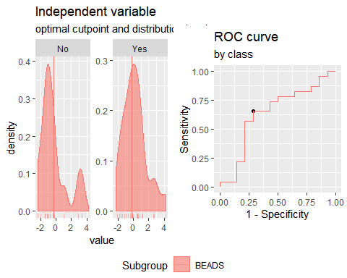**"Combination IP10 + IL2+CCL3"**

Method: maximize_metric   
 Predictor: var   
 Outcome: GrupoNew   
 Direction: >=   
 Subgroups: BEADS   
   
 Subgroup: BEADS   
 ---------------------------------------------------------------------------   
 AUC n n_pos n_neg  
 0.7484 37 23 14  
   
 optimal_cutpoint youden acc sensitivity specificity tp fn fp tn  
 -0.1446 0.4379 0.7027 0.6522 0.7857 15 8 3 11  
   
 Predictor summary:   
 Min. 5% 1st Qu. Median Mean 3rd Qu. 95% Max. SD NAs  
 overall -2.179 -1.967 -1.477 -0.254 0.000 0.648 2.758 7.866 2.022 0  
 No -2.179 -2.070 -1.815 -1.261 -0.890 -0.343 1.434 2.127 1.265 0  
 Yes -1.815 -1.670 -1.222 0.146 0.542 1.854 2.776 7.866 2.222 0

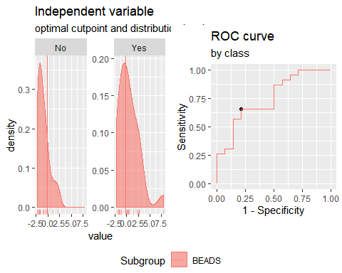**"Combination IP10 + IL2+CCL11"**

Method: maximize_metric   
 Predictor: var   
 Outcome: GrupoNew   
 Direction: >=   
 Subgroups: BEADS   
   
 Subgroup: BEADS   
 ---------------------------------------------------------------------------   
 AUC n n_pos n_neg  
 0.7453 37 23 14  
   
 optimal_cutpoint youden acc sensitivity specificity tp fn fp tn  
 -0.5008 0.5093 0.7297 0.6522 0.8571 15 8 2 12  
   
 Predictor summary:   
 Min. 5% 1st Qu. Median Mean 3rd Qu. 95% Max. SD NAs  
 overall -3.233 -2.257 -1.492 -0.777 0.000 1.109 3.907 8.875 2.495 0  
 No -3.233 -2.773 -1.803 -1.472 -1.167 -0.855 1.071 3.288 1.501 0  
 Yes -2.190 -2.130 -1.162 0.038 0.710 1.757 6.067 8.875 2.731 0

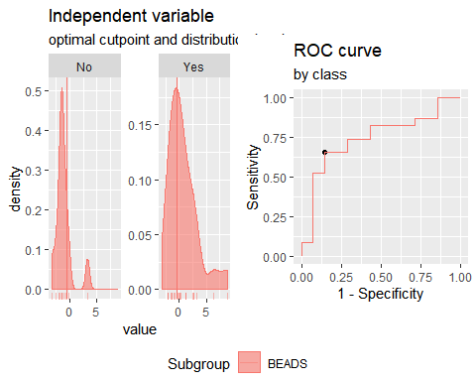**"Combination IP10 + CCL3+CCL11"**

Method: maximize_metric   
 Predictor: var   
 Outcome: GrupoNew   
 Direction: >=   
 Subgroups: BEADS   
   
 Subgroup: BEADS   
 ---------------------------------------------------------------------------   
 AUC n n_pos n_neg  
 0.6832 37 23 14  
   
 optimal_cutpoint youden acc sensitivity specificity tp fn fp tn  
 -1.5284 0.3696 0.7297 0.8696 0.5 20 3 7 7  
   
 Predictor summary:   
 Min. 5% 1st Qu. Median Mean 3rd Qu. 95% Max. SD NAs  
 overall -2.620 -2.264 -1.532 -0.584 0.000 0.667 3.241 5.597 1.976 0  
 No -2.620 -2.535 -1.677 -1.245 -0.693 -0.067 2.611 3.039 1.708 0  
 Yes -2.208 -2.168 -0.861 0.137 0.422 1.913 3.919 5.597 2.042 0

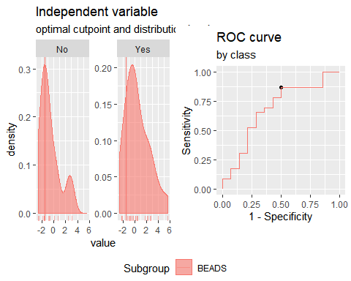**"Combination IL2 + CCL3+CCL11"**

Method: maximize_metric   
 Predictor: var   
 Outcome: GrupoNew   
 Direction: >=   
 Subgroups: BEADS   
   
 Subgroup: BEADS   
 ---------------------------------------------------------------------------   
 AUC n n_pos n_neg  
 0.6925 37 23 14  
   
 optimal_cutpoint youden acc sensitivity specificity tp fn fp tn  
 -1.4058 0.3975 0.7297 0.8261 0.5714 19 4 6 8  
   
 Predictor summary:   
 Min. 5% 1st Qu. Median Mean 3rd Qu. 95% Max. SD NAs  
 overall -3.312 -2.744 -1.613 -0.457 0.000 1.024 3.911 5.113 2.192 0  
 No -3.312 -3.020 -1.717 -1.497 -0.821 -0.423 2.974 4.196 1.995 0  
 Yes -2.714 -2.314 -1.055 -0.010 0.500 1.637 3.808 5.113 2.195 0

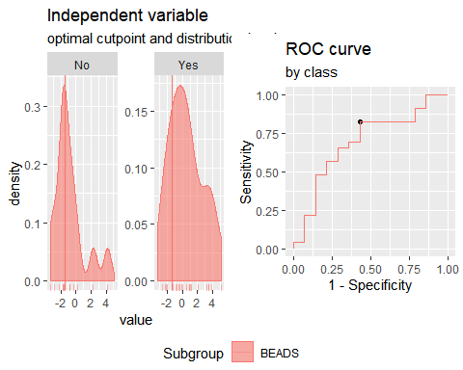**"Combination IFNγ+IP10+IL2"**

Method: maximize_metric   
 Predictor: var   
 Outcome: GrupoNew   
 Direction: >=   
 Subgroups: BEADS   
   
 Subgroup: BEADS   
 ---------------------------------------------------------------------------   
 AUC n n_pos n_neg  
 0.7919 37 23 14  
   
 optimal_cutpoint youden acc sensitivity specificity tp fn fp tn  
 -1.1225 0.5683 0.7838 0.7826 0.7857 18 5 3 11  
   
 Predictor summary:   
 Min. 5% 1st Qu. Median Mean 3rd Qu. 95% Max. SD NAs  
 overall -2.192 -1.867 -1.502 -0.849 0.000 0.253 4.454 12.330 2.728 0  
 No -2.192 -2.043 -1.683 -1.493 -1.254 -1.184 0.181 0.589 0.769 0  
 Yes -1.843 -1.809 -1.003 -0.293 0.764 0.757 5.853 12.330 3.196 0

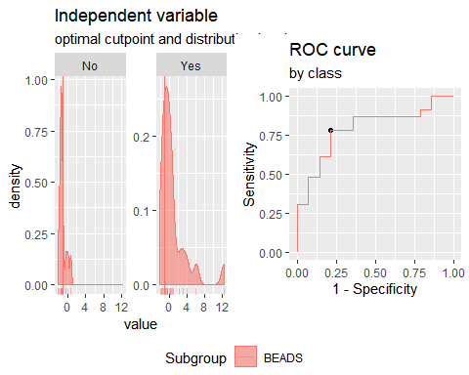**"Combination IFNγ+CCL3+CCL11"**

Method: maximize_metric   
 Predictor: var   
 Outcome: GrupoNew   
 Direction: >=   
 Subgroups: BEADS   
   
 Subgroup: BEADS   
 ---------------------------------------------------------------------------   
 AUC n n_pos n_neg  
 0.6957 37 23 14  
   
 optimal_cutpoint youden acc sensitivity specificity tp fn fp tn  
 -0.9027 0.3975 0.7297 0.8261 0.5714 19 4 6 8  
   
 Predictor summary:   
 Min. 5% 1st Qu. Median Mean 3rd Qu. 95% Max. SD NAs  
 overall -2.611 -2.595 -1.518 -0.628 0.000 1.311 4.057 5.512 2.045 0  
 No -2.611 -2.600 -1.587 -1.432 -0.712 -0.572 2.768 3.475 1.771 0  
 Yes -2.595 -2.151 -0.823 -0.377 0.433 1.431 4.630 5.512 2.114 0

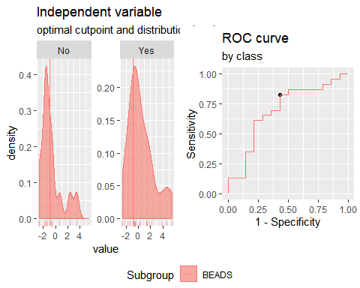**"Combination IFNγ+CCL3+CCL10"**

Method: maximize_metric   
 Predictor: var   
 Outcome: GrupoNew   
 Direction: >=   
 Subgroups: BEADS   
   
 Subgroup: BEADS   
 ---------------------------------------------------------------------------   
 AUC n n_pos n_neg  
 0.7112 37 23 14  
   
 optimal_cutpoint youden acc sensitivity specificity tp fn fp tn  
 -1.2414 0.3696 0.7297 0.8696 0.5 20 3 7 7  
   
 Predictor summary:   
 Min. 5% 1st Qu. Median Mean 3rd Qu. 95% Max. SD NAs  
 overall -1.998 -1.867 -1.256 -0.487 0.000 0.341 2.891 9.052 2.089 0  
 No -1.998 -1.951 -1.615 -1.162 -0.781 0.032 0.991 2.197 1.171 0  
 Yes -1.852 -1.445 -0.989 -0.221 0.475 1.115 4.234 9.052 2.388 0

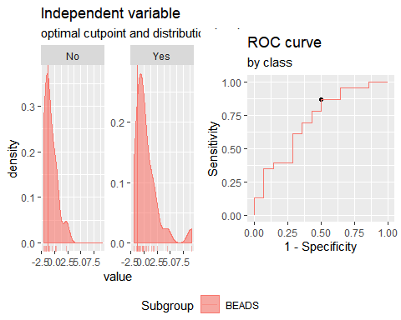**"Combination IFNγ+CCL11+CCL10"**

Method: maximize_metric   
 Predictor: var   
 Outcome: GrupoNew   
 Direction: >=   
 Subgroups: BEADS   
   
 Subgroup: BEADS   
 ---------------------------------------------------------------------------   
 AUC n n_pos n_neg  
 0.764 37 23 14  
   
 optimal_cutpoint youden acc sensitivity specificity tp fn fp tn  
 -0.5967 0.5093 0.7297 0.6522 0.8571 15 8 2 12  
   
 Predictor summary:   
 Min. 5% 1st Qu. Median Mean 3rd Qu. 95% Max. SD NAs  
 overall -2.516 -2.190 -1.430 -0.654 0.000 0.216 4.193 10.061 2.433 0  
 No -2.516 -2.358 -1.551 -1.408 -1.057 -0.742 0.967 2.567 1.237 0  
 Yes -2.170 -1.959 -1.052 -0.283 0.644 1.751 4.662 10.061 2.764 0

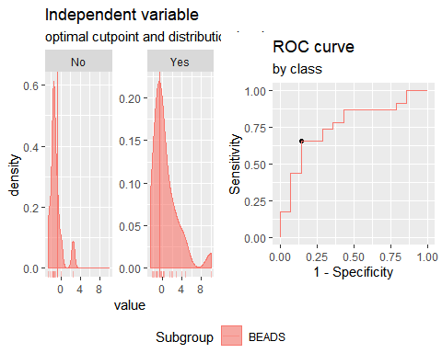**"Combination IFNγ+CCL3+IL2"**

Method: maximize_metric   
 Predictor: var   
 Outcome: GrupoNew   
 Direction: >=   
 Subgroups: BEADS   
   
 Subgroup: BEADS   
 ---------------------------------------------------------------------------   
 AUC n n_pos n_neg  
 0.7453 37 23 14  
   
 optimal_cutpoint youden acc sensitivity specificity tp fn fp tn  
 -1.2638 0.441 0.7568 0.8696 0.5714 20 3 6 8  
   
 Predictor summary:   
 Min. 5% 1st Qu. Median Mean 3rd Qu. 95% Max. SD NAs  
 overall -2.30 -1.906 -1.346 -0.688 0.000 0.479 3.659 6.980 2.079 0  
 No -2.30 -2.027 -1.763 -1.378 -0.908 -0.702 1.719 2.133 1.285 0  
 Yes -2.01 -1.793 -1.141 -0.136 0.553 1.652 5.276 6.980 2.291 0

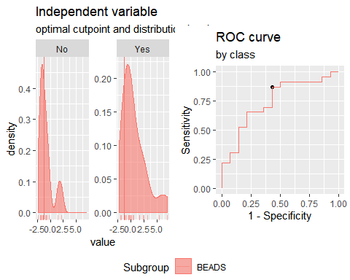**"Combination IFNγ+CCL11+IL2"**

Method: maximize_metric   
 Predictor: var   
 Outcome: GrupoNew   
 Direction: >=   
 Subgroups: BEADS   
   
 Subgroup: BEADS   
 ---------------------------------------------------------------------------   
 AUC n n_pos n_neg  
 0.7795 37 23 14  
   
 optimal_cutpoint youden acc sensitivity specificity tp fn fp tn  
 -0.6074 0.6242 0.7838 0.6957 0.9286 16 7 1 13  
   
 Predictor summary:   
 Min. 5% 1st Qu. Median Mean 3rd Qu. 95% Max. SD NAs  
 overall -3.208 -2.560 -1.480 -0.787 0.000 0.689 5.710 8.118 2.629 0  
 No -3.208 -2.844 -1.721 -1.390 -1.185 -1.066 0.856 3.723 1.574 0  
 Yes -2.538 -2.121 -1.122 -0.206 0.721 1.343 7.704 8.118 2.900 0

