Tech Overview — RAG Knowledgebase Chatbot
A high-level look at the system: the stack, the RAG pipeline, and how a question becomes a grounded answer.

What it is
A grounded chatbot for marketing landing pages. Anonymous visitors ask questions and the assistant answers only from a corpus an admin curates. Retrieval is hybrid (semantic + keyword) fused with Reciprocal Rank Fusion, and generation streams from Qwen over Server-Sent Events. If the answer isn’t in the corpus, the model is instructed to say so rather than fall back on its general training.

Stack
Layer | Technology
Frontend | React 19 + Vite + TypeScript, Tailwind v4, shadcn/ui, React Router v7, Zustand, React Hook Form + Zod, Axios
Backend | FastAPI + Uvicorn (Python 3.12), async SQLAlchemy + asyncpg, Pydantic v2, Alembic
Database | Postgres + pgvector + native Full-Text Search (Supabase)
Storage | Supabase Storage (original uploaded files)
Auth | Supabase Auth, ES256 JWT verified via JWKS (admin only; chat is anonymous)
AI models | qwen-plus-latest for chat, text-embedding-v3 (1024-dim) for embeddings, both via DashScope International
Deploy | Frontend on Vercel, backend on Railway, data layer on Supabase (ap-southeast-1)

Architecture
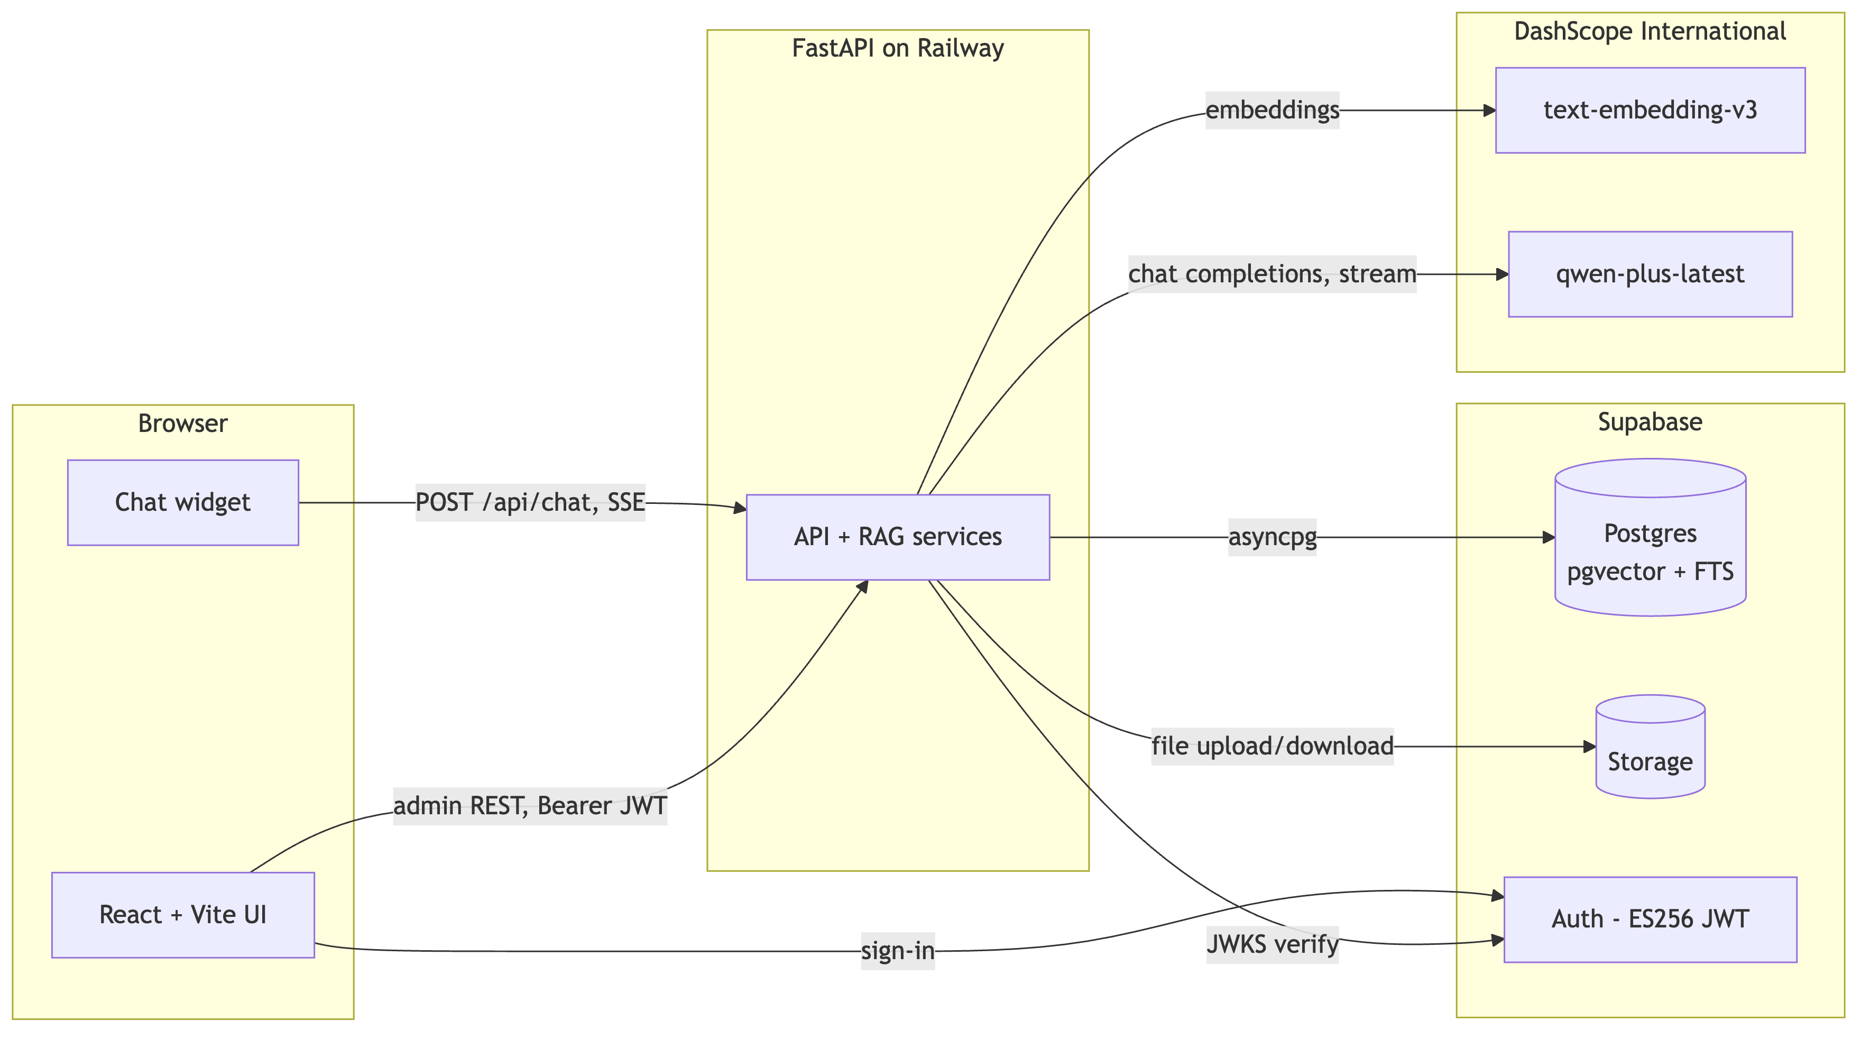

RAG pipeline
Two sides: a write side that builds the searchable index, and a read side that answers a question against it.
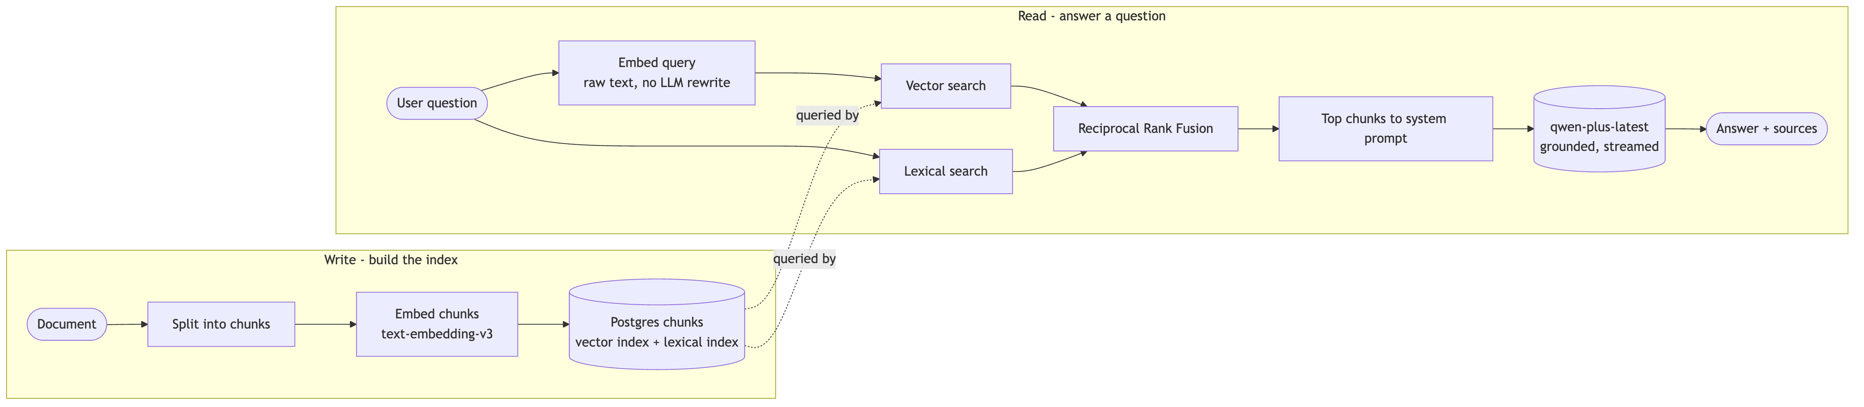

Ingestion (write side)
An admin uploads a file (PDF, DOCX, PPTX, XLSX, TXT, HTML). We store the original, parse it into chunks of roughly a few paragraphs each (small chunks keep retrieval sharp), embed every chunk with text-embedding-v3, and write the text plus its 1024-dim vector into Postgres. Each chunk also gets a lexical index entry for keyword search. Parsing is text-only; images in PDFs are dropped. The whole thing runs as a background job, and each file carries a status (uploaded, ingesting, ingested, failed) so the admin can retry anything that fails.

Chat (read side)
The visitor’s question is embedded as-is (no query rewriting), then run against both indexes. The top chunks go into the system prompt with a grounding instruction, and qwen-plus-latest streams the answer back token by token over SSE. The cited documents are surfaced alongside the answer as clickable sources.

Hybrid retrieval and RRF
Retrieval uses two arms, because each covers the other’s blind spot:
- Vector search (pgvector, cosine distance) finds semantically similar chunks even when no words match.
- Lexical search (Postgres Full-Text Search, ts_rank) matches exact terms like names, codes, and numbers. This is tf-idf-family ranking, not BM25.
Each arm returns its own top-ranked list. We merge them with Reciprocal Rank Fusion: every list a chunk appears in contributes 1 / (60 + its rank in that list), and we add those contributions up. Higher total wins. The constant 60 is the standard RRF default; it damps how much the very top ranks dominate.
A worked example makes it concrete. Say the two arms return these top chunks:
Chunk | Vector rank | Lexical rank | RRF score | Final
B | 2 | 1 | 1/62 + 1/61 = 0.0325 | 1st
A | 1 | 3 | 1/61 + 1/63 = 0.0323 | 2nd
D | – | 2 | 1/62 = 0.0161 | 3rd
C | 3 | – | 1/63 = 0.0159 | 4th

B wins because it ranks near the top of both arms. A is a close second despite topping the vector arm, since it’s weaker on keywords. C and D each show up in only one arm, so they land well below the chunks both arms agree on. That agreement-rewarding behavior is the whole point.
We fuse by rank instead of raw score on purpose. Vector cosine distance and ts_rank live on completely different scales, so adding the raw numbers would need per-corpus tuning to mean anything. Rank position sidesteps that and stays robust with zero tuning. After fusion we dedupe and keep the top handful (default 8, admin-configurable) for the prompt.

What we deliberately leave out
Technique | Why not, for now
Cross-encoder reranker | Marginal quality lift on a handful of chunks, adds latency
BM25 | Postgres ts_rank is good enough and built in
Query rewriting / HyDE / multi-query | Costs an extra LLM round-trip per turn
History-aware query rewriting | The most likely next addition; fixes context-losing follow-ups
Multimodal embeddings | All corpora are text-extractable today
These are easy to add later if usage or quality needs justify them. Building them now would mean paying for scale we don’t have yet.

