Artificial Intelligence – Assignment: Logical Reasoning, Semantic Networks and NLP
Student name | SYAHIRAH BINTI MOHD ZAKI
Student ID | 22010391
Submission date | 12 November 2026

Part A — Logical reasoning (3 marks)
Q1(a) Category of Tweet A and Tweet B
Tweet | Category | Rule used
A: “My flight has been cancelled and nobody has contacted me.” | Service complaint | Rule 1 – it reports a cancelled flight.
B: “What time does flight AB123 depart?” | Information request | Rule 3 – it only asks for general flight information (departure time).

Q1(b) Which tweet should be prioritised?
Tweet A should be prioritised. Step-by-step reasoning (forward chaining / modus ponens):
- Fact: Tweet A reports a cancelled flight.
- Rule 1: IF a tweet reports a cancelled or delayed flight THEN it is a service complaint. The condition is true, so: Tweet A is a service complaint.
- Rule 2: IF a tweet is a service complaint THEN it should be prioritised for support. The condition is now true, so: Tweet A should be prioritised for support.
- Tweet B does not mention a cancellation or delay, so Rule 1 does not fire and it is not a service complaint. Rule 2 therefore does not apply. Rule 3 fires instead: Tweet B is an information request, which is not prioritised.
Can we conclude Tweet B is positive or negative? No. None of the rules say anything about sentiment. They only define service complaint, priority and information request. Tweet B is a neutral factual question with no emotional words (no praise or complaint), so the rules give no basis to call it positive or negative. In logic we can only conclude what follows from the facts and rules we have. Labelling B positive or negative would be an unsupported assumption. At most, by its wording, it looks neutral.
Q1(c) Python implementation of the decision rules
Code (code/q1_classify_message.py):
# Q1(c) - Rule-based classification of airline messages
def classify_message(tweet):
tweet = tweet.lower()
if "cancelled" in tweet or "delayed" in tweet:
return "Service Complaint"
elif "what time" in tweet or "departure" in tweet:
return "Information Request"
else:
return "Other"
def should_prioritise(category):
# Rule 2: a service complaint should be prioritised for support
return category == "Service Complaint"
tweet_a = "My flight has been cancelled"
tweet_b = "What time does flight AB123 depart?"
print(classify_message(tweet_a))
print(classify_message(tweet_b))
# Extra: full tweets from part (a) and the priority rule
for name, tweet in [("A", "My flight has been cancelled and nobody has contacted me."),
("B", "What time does flight AB123 depart?")]:
category = classify_message(tweet)
print(f"Tweet {name}: {category} | prioritise for support: {should_prioritise(category)}")
Output:
Service Complaint
Information Request
Tweet A: Service Complaint | prioritise for support: True
Tweet B: Information Request | prioritise for support: False
Explanation of the output: the function first converts the tweet to lowercase so the keyword checks are not case-sensitive. For tweet_a, “cancelled” is in the text, so the first if condition is true and it returns “Service Complaint” (Rule 1). For tweet_b, neither “cancelled” nor “delayed” appears, so the code moves to the elif. “what time” is found in “what time does flight ab123 depart?”, so it returns “Information Request” (Rule 3). Note that the word “depart” would not match “departure”; the match comes from “what time”. The order of the checks matters: complaints are checked first, so a tweet such as “What time will my delayed flight leave?” is treated as a complaint, which is the safer choice. I also added should_prioritise() to implement Rule 2, which shows A is prioritised (True) and B is not (False).

Part B — Semantic network (3 marks)
Q2(a) Semantic network diagram
Nodes are concepts and labelled arrows are relationships. Solid arrows come from the given facts; dashed red arrows are relationships I added.
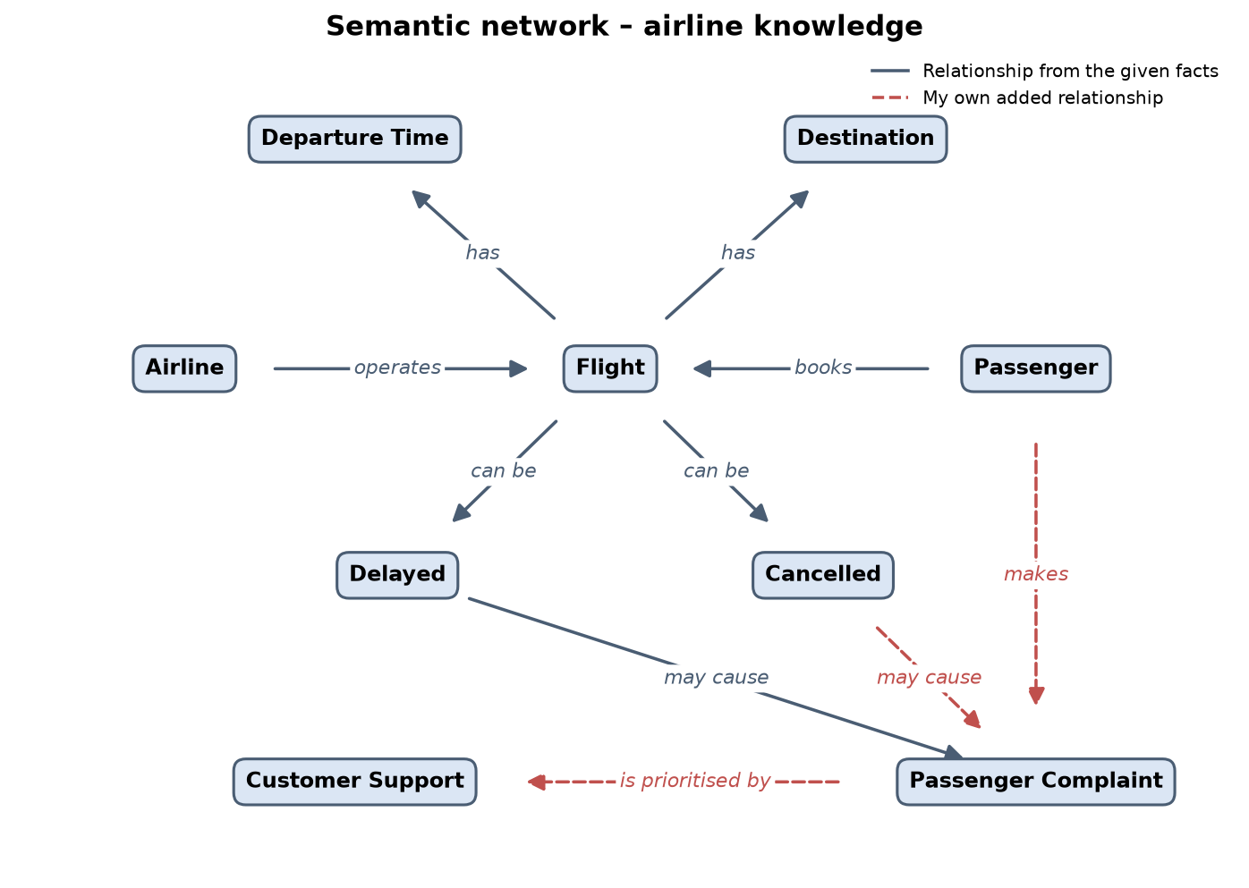
Figure 1 – Semantic network (semantic_network.png, drawn with code/draw_semantic_network.py).
Fact | Relationship(s) in the network
An Airline operates Flights. | Airline —operates→ Flight
A Flight has a Departure Time and a Destination. | Flight —has→ Departure Time; Flight —has→ Destination
A Passenger books a Flight. | Passenger —books→ Flight
A Flight can be Delayed or Cancelled. | Flight —can be→ Delayed; Flight —can be→ Cancelled
A Delay may cause a Passenger Complaint. | Delayed —may cause→ Passenger Complaint
My additions | Cancelled —may cause→ Passenger Complaint; Passenger —makes→ Passenger Complaint; Passenger Complaint —is prioritised by→ Customer Support

The network lets us follow links to infer new knowledge. For example, following Passenger → books → Flight → can be → Delayed → may cause → Passenger Complaint shows how a booked flight can lead to a complaint. This links to the rules in Part A, where complaints about cancelled or delayed flights are prioritised by customer support.
Q2(b) Relationships in Python
Code (code/q2_semantic_network.py):
# Q2(b) - Semantic network as (subject, relation, object) triples
semantic_network = [
("Airline", "operates", "Flight"),
("Passenger", "books", "Flight"),
("Flight", "has", "Destination"),
("Flight", "has", "Departure Time"),
("Flight", "can be", "Delayed"),
("Flight", "can be", "Cancelled"),
("Delayed", "may cause", "Passenger Complaint"),
# My own relationships
("Cancelled", "may cause", "Passenger Complaint"),
("Passenger", "makes", "Passenger Complaint"),
("Passenger Complaint", "is prioritised by", "Customer Support"),
]
for relationship in semantic_network:
print(relationship)
# Simple query: what can a Flight be?
print("\nA Flight can be:", [o for s, r, o in semantic_network if s == "Flight" and r == "can be"])
# Simple query: what may cause a Passenger Complaint?
print("Causes of Passenger Complaint:", [s for s, r, o in semantic_network if r == "may cause" and o == "Passenger Complaint"])
Output:
('Airline', 'operates', 'Flight')
('Passenger', 'books', 'Flight')
('Flight', 'has', 'Destination')
('Flight', 'has', 'Departure Time')
('Flight', 'can be', 'Delayed')
('Flight', 'can be', 'Cancelled')
('Delayed', 'may cause', 'Passenger Complaint')
('Cancelled', 'may cause', 'Passenger Complaint')
('Passenger', 'makes', 'Passenger Complaint')
('Passenger Complaint', 'is prioritised by', 'Customer Support')
A Flight can be: ['Delayed', 'Cancelled']
Causes of Passenger Complaint: ['Delayed', 'Cancelled']
Each relationship is stored as a (subject, relation, object) triple, which is one labelled arrow in the diagram. I included all of the given facts and added three of my own (Cancelled may cause Passenger Complaint, Passenger makes Passenger Complaint, Passenger Complaint is prioritised by Customer Support). The two extra queries at the end show that the network can be searched. For example, it can find everything a Flight “can be”, or everything that “may cause” a Passenger Complaint.

Part C — Natural Language Processing (4 marks)
Q3(a) Preprocessed text
Original: @SkyAir My flight is NOT good! It was delayed again. https://airline.example
Step | Result
1. Replace username with USER | USER My flight is NOT good! It was delayed again. https://airline.example
2. Replace URL with URL | USER My flight is NOT good! It was delayed again. URL
3. Convert to lowercase | user my flight is not good! it was delayed again. url
4. Remove extra whitespace | user my flight is not good! it was delayed again. url

Result: user my flight is not good! it was delayed again. url
Because lowercasing happens after the replacement, the placeholders also become lowercase (“user”, “url”). If they must stay in capitals, lowercase first and replace afterwards. The Lab 8 clean_text() function behaves the same way, so the placeholder words in the lab vocabulary are also lowercase.
Q3(b) Python preprocessing code
Code (code/q3_preprocess_text.py):
# Q3(b) - Basic tweet preprocessing
import re
def preprocess_text(text):
# Replace usernames with USER
text = re.sub(r"@\w+", "USER", text)
# Replace URLs with URL
text = re.sub(r"https?://\S+", "URL", text)
# Convert text to lowercase
text = text.lower()
# Remove extra whitespace
text = re.sub(r"\s+", " ", text).strip()
return text
tweet = "@SkyAir My flight is NOT good! It was delayed again. https://airline.example"
clean_tweet = preprocess_text(tweet)
print(clean_tweet)
# Why "not" must stay: the Lab 8 CountVectorizer uses stop_words="english",
# and that list contains "not", so two opposite tweets end up with the same features.
from sklearn.feature_extraction.text import CountVectorizer, ENGLISH_STOP_WORDS
print("\n'not' in scikit-learn's English stop words:", "not" in ENGLISH_STOP_WORDS)
v = CountVectorizer(stop_words="english")
X = v.fit_transform(["my flight is not good", "my flight is good"])
print("Vocabulary after stopword removal:", list(v.get_feature_names_out()))
print("Feature vector 'my flight is not good':", X.toarray()[0])
print("Feature vector 'my flight is good': ", X.toarray()[1])
Output:
user my flight is not good! it was delayed again. url
'not' in scikit-learn's English stop words: True
Vocabulary after stopword removal: ['flight', 'good']
Feature vector 'my flight is not good': [1 1]
Feature vector 'my flight is good': [1 1]
Why “not” should not be removed: “not” is a negation word. It flips the meaning of the words after it, so “not good” is negative while “good” is positive. If “not” is removed as a stopword, the tweet becomes “… flight … good … delayed …” and the strongest sentiment clue is reversed. The second half of my output proves this. scikit-learn’s English stopword list, which the Lab 8 CountVectorizer(stop_words="english") uses, contains “not”. After stopword removal, “my flight is not good” and “my flight is good” have exactly the same feature vector [1 1], so the classifier cannot tell them apart. This matches the Lab 8 error analysis, where several of the most confident mistakes were tagged “negation”. To keep it, I would remove negation words (not, no, never, n’t) from the stopword list, or join them to the next word (e.g. “not_good”), or use bigrams so that “not good” is kept as one feature.
Q4(a) Is 80% accuracy enough?
No. Accuracy only counts the total number of correct predictions, and with imbalanced classes it is dominated by the largest class. If most tweets are negative, a model can reach a high accuracy while almost never finding the neutral class. In the Lab 8 data, 63.5% of tweets are negative, so the majority baseline that always predicts “negative” already scores 0.635 accuracy without learning anything. Its macro F1 is only 0.259.
I demonstrated the scenario in the question with 100 tweets (60 negative, 20 neutral, 20 positive) where the model gets 80 right but finds only 2 of the 20 neutral tweets:
Code (code/q4_evaluate_classifier.py):
# Q4 - Why 80% accuracy is not enough: an example with 100 tweets
# 60 negative, 20 neutral, 20 positive. The model gets 80 right but misses most neutral tweets.
from sklearn.metrics import accuracy_score, classification_report, confusion_matrix, f1_score
LABELS = ["negative", "neutral", "positive"]
y_true = ["negative"] * 60 + ["neutral"] * 20 + ["positive"] * 20
y_pred = (["negative"] * 60
+ ["neutral"] * 2 + ["negative"] * 18 # only 2 of 20 neutral tweets found
+ ["positive"] * 18 + ["negative"] * 2)
print("Accuracy:", accuracy_score(y_true, y_pred))
print("Macro F1:", round(f1_score(y_true, y_pred, labels=LABELS, average="macro"), 3))
print("\nConfusion matrix (rows = true, columns = predicted):", LABELS)
print(confusion_matrix(y_true, y_pred, labels=LABELS))
print()
print(classification_report(y_true, y_pred, labels=LABELS, digits=3))
Output:
Accuracy: 0.8
Macro F1: 0.662
Confusion matrix (rows = true, columns = predicted): ['negative', 'neutral', 'positive']
[[60 0 0]
[18 2 0]
[ 2 0 18]]
precision recall f1-score support
negative 0.750 1.000 0.857 60
neutral 1.000 0.100 0.182 20
positive 1.000 0.900 0.947 20
accuracy 0.800 100
macro avg 0.917 0.667 0.662 100
weighted avg 0.850 0.800 0.740 100
Accuracy is 0.80, but neutral recall is only 0.10 (2 of 20) and neutral F1 is 0.182. 90% of neutral tweets are wrongly labelled, mostly as negative. So 80% accuracy hides a model that basically fails one of the three classes, and the airline would wrongly treat neutral questions as complaints.
Q4(b) A more balanced metric
Macro F1 (macro-averaged F1-score). F1 for each class is the harmonic mean of precision and recall: F1 = 2 × P × R / (P + R). Macro F1 calculates F1 separately for negative, neutral and positive, then takes the plain average. Each class counts equally, no matter how many tweets it has.
Why it is useful: a weak class pulls the score down. In my example: macro F1 = (0.857 + 0.182 + 0.947) / 3 = 0.662, much lower than the 0.80 accuracy, which exposes the neutral problem. It also cannot be inflated by always predicting the majority class. In Lab 8 the always-negative baseline scored accuracy 0.635 but macro F1 only 0.259, while Naive Bayes reached 0.698. This is why Lab 8 used validation macro F1 to choose the n-gram range and α. It should be read together with per-class recall and the confusion matrix.

Supporting evidence from Lab 8 (my run)
I ran lab07_airline_sentiment.py on lab07-Tweets.csv (14,640 tweets, 14,285 after removing duplicates; stratified 70/15/15 split, seed 42). Selected model: unigrams + bigrams, α = 0.3 (validation macro F1 0.697).
Model (test set) | Accuracy | Macro precision | Macro recall | Macro F1
Majority baseline | 0.635 | 0.212 | 0.333 | 0.259
Multinomial Naive Bayes | 0.770 | 0.704 | 0.693 | 0.698

Per-class F1: negative 0.86, positive 0.67, neutral 0.56. Neutral is the weakest class, the same issue as in Q4. Full outputs are in results/lab07/ in the repository.
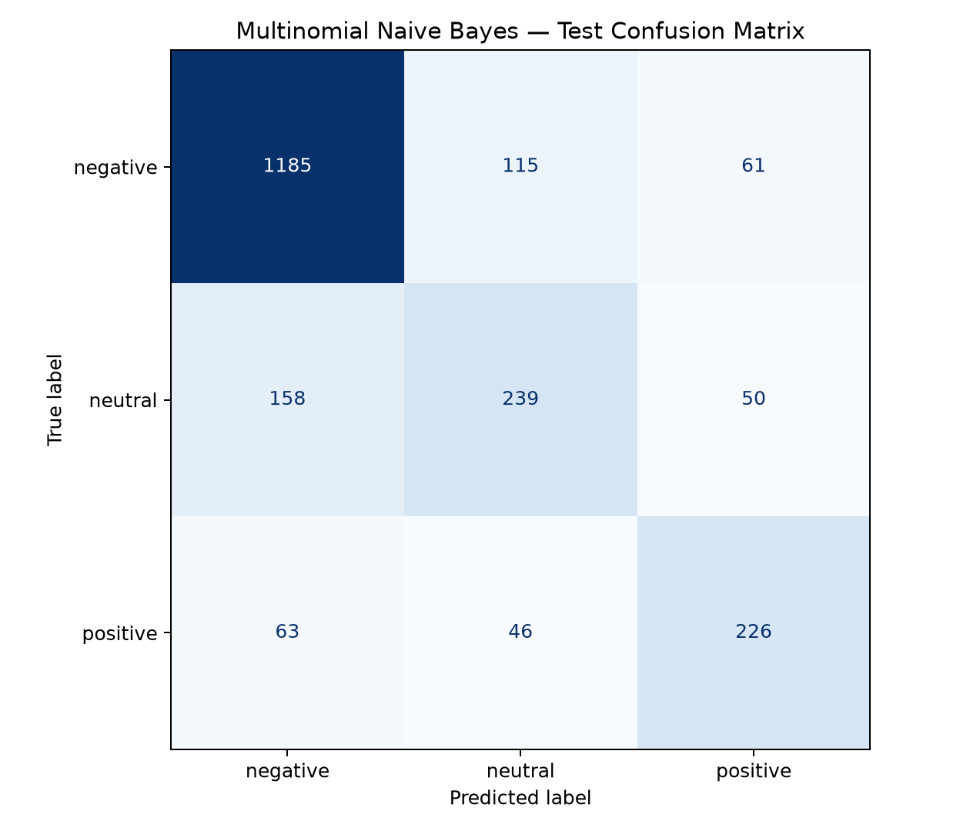
Figure 2 – Lab 8 test confusion matrix (results/lab07/confusion_matrix.png).

Files in this folder
- Lab08_AI_Assignment_SyahirahBintiMohdZaki.docx – this report
- semantic_network.png – semantic network diagram (Q2a)
- code/ – the Python code for Q1(c), Q2(b), Q3(b), Q4 and the diagram, each with its saved output (*.output.txt)

