Lab Assignment – NLP Foundations: Handwriting OCR Evaluation
Name: SYAHIRAH BINTI MOHD ZAKI
Student ID: 22010391
Course: Artificial Intelligence – Lab 6 of 8 (Handwriting OCR Evaluation)
Evidence source: I ran lab06_handwriting_ocr_worked.py live (OCR mode: live, Tesseract 5.4.0, --oem 1 --psm 7) on all 89 labelled images. My numbers are slightly different from the slide reference table (for example 42 blank baseline predictions instead of 39) because the exact output depends on the Tesseract version. The direction of every change is the same.

Part A – Understand the concepts
Q1. NLP pipeline
Stage | What it means | Example with a handwritten medicine-name image
Acquire | Get the raw language data into the computer. | The photo of the prescription is loaded and Tesseract (OCR) turns the pixels into a raw string, e.g. the image of “tab breaky” becomes “> Bveaky”.
Normalise | Put the text into one consistent format so unimportant differences disappear. | Both the OCR output and the label are lowercased and only a–z and 0–9 are kept: “> Bveaky” → “bveaky”, “tab breaky” → “tabbreaky”.
Represent | Turn the text into a form the computer can compute with. | The normalised string is treated as a sequence of characters, so it can be compared character by character (in other tasks it could become counts, n-grams or vectors).
Model | Apply a method to do the task. | Tesseract’s LSTM model recognises characters from the image. A later model could match the result to a list of known medicine names.
Evaluate | Compare the output with the correct reference. | Levenshtein distance between “bveaky” and “tabbreaky”, then exact match, normalised edit distance, CER and blank count over all 89 images.

An error in an early stage carries through to every later stage. If acquisition returns nothing, no later stage can recover the medicine name.
Q2. How OCR works
Segmentation finds where the text is: it locates the text region or line and separates it from the background. Character recognition then decides which letters and digits those shapes are.
- Segmentation failure: the engine does not find any text, so the output is empty. In my run, 42 raw images returned a blank string, e.g. “breeky” and “cefiget 40mg”.
- Recognition failure: the text is found but read wrongly, e.g. “nims” read as “nidu” or “dicloran” read as “divlerer”.
Knowing which stage caused the error tells me what to fix. Blank outputs point to image quality or layout (contrast, borders, size, page-segmentation mode), so preprocessing can help. Wrong characters point to the recognition model itself, which needs a handwriting-trained model or more data, not just a cleaner picture. Without this split I could waste time improving the wrong stage.
Q3. Text normalisation
Rule: convert to lowercase, then keep only letters and digits (re.sub(r"[^a-z0-9]", "", text.lower())).
 | Original | Lowercase | Keep only a–z, 0–9
Reference | Tab Azimax 40mg | tab azimax 40mg | tabazimax40mg
OCR output | tab azimax 40 mg | tab azimax 40 mg | tabazimax40mg

Both strings become “tabazimax40mg”, so this counts as an exact match with edit distance 0. The same rule must be applied to both sides, otherwise the comparison is unfair. If only the prediction were normalised, “tabazimax40mg” would be compared with “Tab Azimax 40mg”. Capital letters and spaces would then count as errors, and the metric would measure formatting differences instead of OCR quality.
Q4. Normalisation trade-off
Removing spaces can hide a difference in dosages. For example, the reference “tab 1 50mg” (one tablet of 50 mg) and the prediction “tab 150mg” (150 mg) both normalise to “tab150mg”. That would be scored as a perfect match even though the dose is three times higher. In the same way, “1 0mg” and “10mg” become identical.
For a situation like this I would collapse repeated spaces into a single space instead of deleting them, and keep characters that matter in dosages such as the decimal point (e.g. “0.5mg”). Example rule: re.sub(r"[^a-z0-9. ]", "", text.lower()) followed by re.sub(r"\s+", " ", ...).strip(). I could also score the medicine name and the dosage as separate fields, so a dose error can never be hidden by a correct name.

Part B – Work with OCR measurements
Q5. Levenshtein distance
Position | 1 | 2 | 3 | 4 | 5 | 6
Reference: breeky | b | r | e | e | k | y
Prediction: beeky | b | – | e | e | k | y
Operation | match | delete r | match | match | match | match

Only one edit is needed: delete “r” from “breeky” to get “beeky” (equivalently, the prediction is missing the “r”). There are no substitutions or insertions.
Levenshtein distance = 1
Lengths: “breeky” = 6, “beeky” = 5, so the longer string has 6 characters.
Normalised edit distance = 1 / 6 = 0.167
Q6. Character Error Rate (CER)
S = 4, D = 2, I = 1, N = 35
CER = (S + D + I) / N = (4 + 2 + 1) / 35 = 7 / 35 = 0.200
This means 20% of the reference characters needed a correction, about 1 edit for every 5 reference characters. Equivalently, about 80% of the text was right at character level. Lower is better.
Yes, CER can be greater than 1. The number of insertions is not limited by the reference length, so if the OCR outputs a lot of extra characters, the total edits can exceed N. Example: reference “nims” (N = 4) and prediction “nnimmsss123” needs 7 deletions, so CER = 7/4 = 1.75. This is why CER is not a percentage that stops at 100%.
Q7. Compare the metrics
Metric | What it measures | Better when
Exact-match accuracy | Fraction of images whose normalised prediction is exactly the normalised reference. | Higher
Mean normalised edit distance | Average of (edits ÷ length of longer string) per image; each image counts equally and the value is between 0 and 1. | Lower
Character error rate (CER) | Total edits over all images ÷ total reference characters; long names count more and it can exceed 1. | Lower
Blank predictions | Number of images where the normalised OCR output is empty (nothing detected). | Lower

Exact-match accuracy alone is not enough because it is all-or-nothing. “bveaky” for “tabbreaky” and an empty string both score 0, even though the first one is much closer. In my run the baseline and preprocessed pipelines have almost the same exact-match accuracy (0.000 vs 0.011). However, CER, edit distance and blank count show a clear improvement. Exact match also does not tell me why an image failed, whether text was not found or the characters were misread. The other metrics show partial progress and the type of error.

Part C – Interpret the Lab 6 experiment
My live results (Figure 1, evidence/results_table.png):
Metric | Raw images | Preprocessed | Change
Exact-match accuracy | 0.000 | 0.011 | +0.011
Mean normalised edit distance | 0.869 | 0.785 | −0.084
Character error rate | 0.883 | 0.807 | −0.077
Blank predictions | 42 | 15 | −27

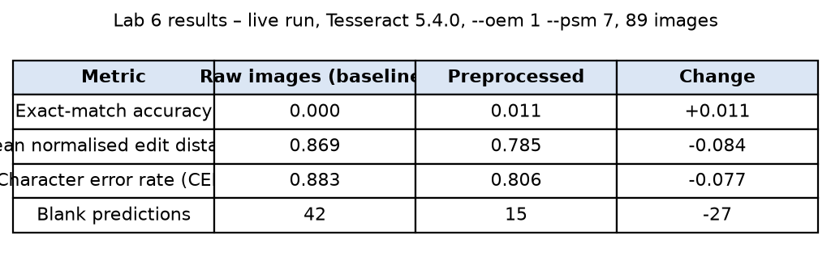
Figure 1 – Baseline vs preprocessed metrics from my live run.
Q8. Read the results
- Far fewer blank predictions: from 42 to 15 out of 89 images, so 27 more images now produce some text (non-blank outputs went from 47 to 74). This is the biggest improvement.
- Lower character error rate: from 0.883 to 0.807, a drop of 0.077. Fewer character edits are needed overall to fix the predictions.
- Lower mean normalised edit distance: from 0.869 to 0.785, a drop of 0.084. On average each prediction is closer to its reference.
- Exact-match accuracy rose from 0.000 to 0.011, i.e. 1 of 89 images. In my run this was “ostium”, read correctly only after preprocessing.
The slide reference table shows the same pattern (blanks 39 → 15, CER 0.875 → 0.788).
Q9. Explain the result pattern
Preprocessing mainly helps the segmentation stage, not the recognition stage. The grey-scale image, white border and enlargement make the handwriting easier for Tesseract to find. So many images that were blank before now return some text. Each recovered string shares some characters with the reference, which lowers the edit distance and CER. But the characters are still misread, so the full name is still not exactly right.
Example from my run (Figure 2): for “tab breaky” the raw image returned nothing (distance 1.0). The preprocessed image returned “> Bveaky” → “bveaky”, so the normalised edit distance fell to 0.444. The word was found, but “r” was read as “v” and the handwritten “Tab” was missed. This is a big partial improvement but still not an exact match. Similarly, “dicloran” improved from “divlerer” to “diclorew” (0.50 → 0.25) but is still wrong by one letter. Exact match needs every character correct, and Tesseract was trained mostly on printed text, so cursive letters like r/v, m/n and e/c are still confused.
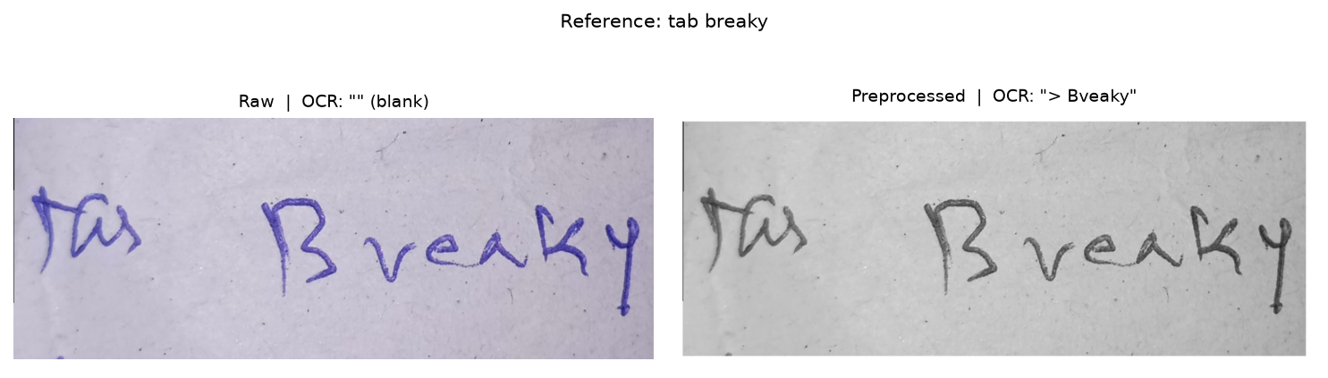
Figure 2 – The same image before and after preprocessing.
Note: preprocessing did not help every image. In my run 42 images got closer to the reference but 20 got further away, so the improvement is an average effect.
Q10. Controlled experiment
The lab changed only one thing, the image preprocessing, and kept everything else fixed. That makes it a controlled experiment, so any change in the metrics can be credited to the preprocessing.
- Same Tesseract settings (--oem 1 LSTM engine, --psm 7 single text line): changing the engine or segmentation mode can change results by itself.
- Same 89 images: if images were added or removed, especially hard ones that returned errors, the score could change just because the test set got easier.
- Same normalisation rule: a looser rule (e.g. ignoring more characters) would raise exact match without the OCR getting any better.
If several settings changed at once, for example a new psm, new preprocessing and a different normaliser, and CER dropped, I could not tell which change caused the improvement. One change might even be making things worse while another hides it. I also could not say whether the gain would survive if only one of those changes were kept.
Q11. Diagnose the failure
- (a) Tesseract raises an error while processing an image → engine error. This is a runtime or processing failure (e.g. a corrupt or unreadable file, or the engine crashing), not a reading mistake. The lab records it with ocr_status = "engine_error" and counts it as a failed recognition instead of deleting the image. My run had 0 engine errors.
- (b) OCR returns an empty string → no text detected. This is a segmentation failure: the engine could not find a text line, often because of faint or thin strokes, low contrast, lined paper or text touching the edge. Preprocessing targets this case, which is why blanks dropped from 42 to 15.
- (c) “nidu” for “nims” → character confusion. This is a recognition failure: the text was found (the first two letters “ni” are right) but the handwritten “m” was read as “d” and “s” as “u”. That is 2 substitutions, distance 2, normalised edit distance 2/4 = 0.50. Better image quality alone usually cannot fix this. It needs a model trained on handwriting.

Part D – Apply your understanding
Q12. Suggest improvements
Improvement 1 – A handwriting-specific recognition model, e.g. TrOCR (handwritten) or fine-tuning Tesseract/an LSTM on handwritten samples.
- Targets: character confusion. Most remaining errors are wrong letters, like nims → nidu and breaky → bveaky.
- How to test: keep the same 89 images, the same preprocessing and the same normalisation, and change only the recognition model. Compare exact match, CER, edit distance and blank count with my current results. If fine-tuning, train on separate images, never the 89 test images, otherwise the result is not trustworthy. I would only claim it helps if CER drops on the held-out test set.
Improvement 2 – Stronger image cleaning: contrast enhancement plus binarisation (e.g. Otsu or adaptive thresholding) and deskewing slanted text.
- Targets: the 15 images that are still blank (no text detected) and noise from lined or uneven paper.
- How to test: add one step at a time to the current pipeline and rerun with the same Tesseract settings and images. Record whether blank predictions and CER go down. Also count how many images get worse, because in my run 20 images got worse after preprocessing.
(Another option: a dictionary check against a list of known medicine names. This could correct “diclorew” to “dicloran”. It must be tested carefully because it can confidently pick the wrong but similar drug.)
Q13. Medical safety scenario
Risks of using OCR output without human checking:
- Wrong medicine: character confusion can turn one drug name into another real but different drug (sound-alike or look-alike names). The patient could get the wrong medicine. My run got only 1 of 89 names exactly right.
- Wrong dose: digits and units are easy to misread or merge, e.g. “1 50mg” vs “150mg”, “0.5mg” vs “5mg”, or “mg” vs “mcg”, and normalisation can hide this. A dosing error can cause overdose or underdose.
- Silent missing information: 15 of 89 images still returned nothing. A missing drug or instruction might not be noticed if the system does not flag blanks.
- Over-trust and bias: staff may assume the computer is correct (automation bias). Performance measured on 89 images from a few writers may also be worse for other doctors’ handwriting. There are also privacy risks with patient prescriptions.
Safer workflow:
- Use OCR only as a draft or suggestion, never as the final record.
- Match the result against an approved drug list and show a confidence score. Automatically flag blanks, low-confidence results and anything involving a dose.
- A pharmacist or nurse must check every medicine name and dose against the original image (shown side by side) and confirm or correct it before it is saved or dispensed.
- Log corrections and use them to monitor and re-evaluate the system on new, independent data. Where possible, move to e-prescribing so handwriting is not needed at all.
Q14. Reflection
The most important thing I learned is that one accuracy number can hide what is really happening. If I had looked only at exact-match accuracy, I would think preprocessing did almost nothing (0.000 → 0.011). Using CER, edit distance and blank counts together showed that preprocessing really helped the OCR find text (blanks 42 → 15), but the recognition of cursive letters is still the main problem. I also learned that an experiment has to change only one thing at a time to draw a fair conclusion.
A concept I initially found difficult was the difference between CER and mean normalised edit distance, because both use the Levenshtein distance. The example of “nims” vs “nidu” made it clear. The distance is 2 (m→d, s→u). The normalised edit distance divides by the longer string for that image only: 2/4 = 0.50, and every image counts equally in the average. CER adds up all edits across all images and divides by all reference characters, so long names like “cap caricef 40mg” count more. Also, the normalised distance can never go above 1, but CER can, if the OCR inserts lots of extra characters.

Evidence
The files are in the evidence folder:
- evidence/results_table.png – metrics table from my live run (Figure 1).
- evidence/example_1.png – 3×3 sample grid of the handwritten images.
- evidence/example_2_before_after.png – one image before and after preprocessing (Figure 2).
- evidence/ocr_failures.png – the six hardest images with reference and OCR output.
Full outputs (predictions.csv, metrics.csv, error_analysis.csv) are in results/lab06/ in the same repository.
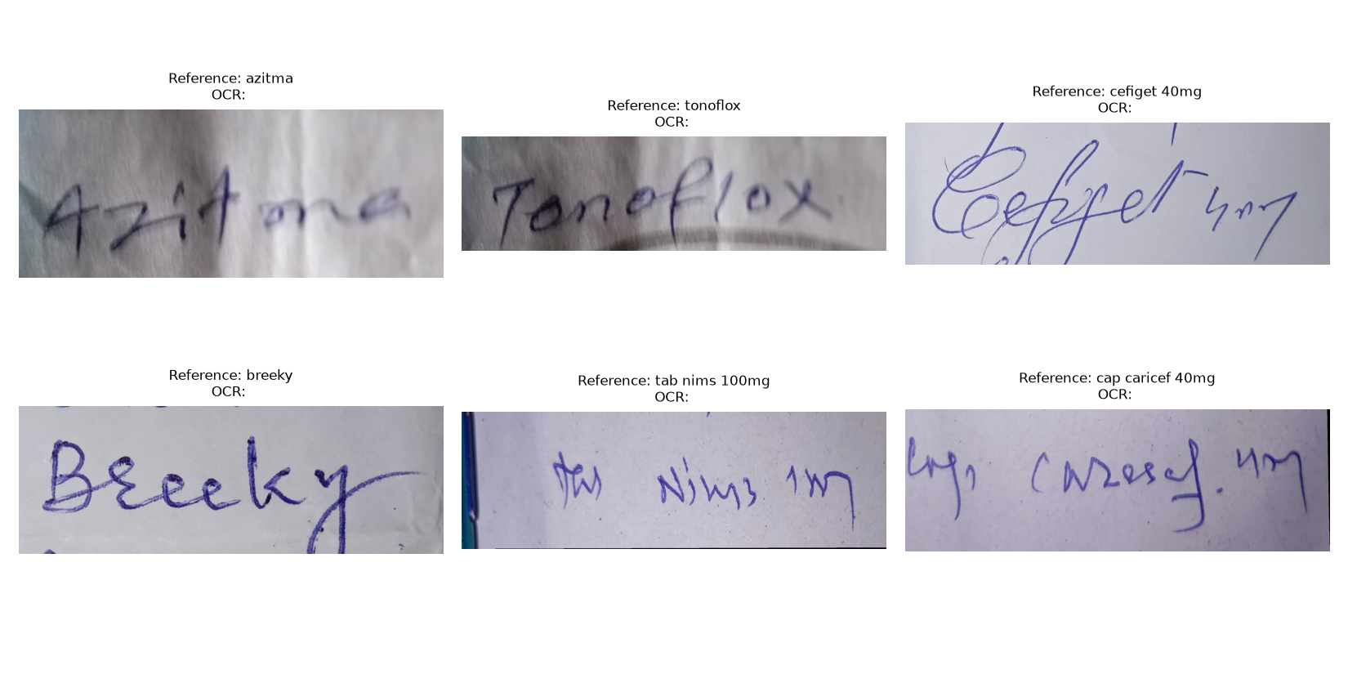
Figure 3 – The six hardest images after preprocessing.

