CSC 1103 Section 1 & 6 OOP

Lab Test 1

Name: Muhammad Syahmi Fathimi bin Ahmad Fauzi
Matric No.: 1715845

1. (Minutes and Second)
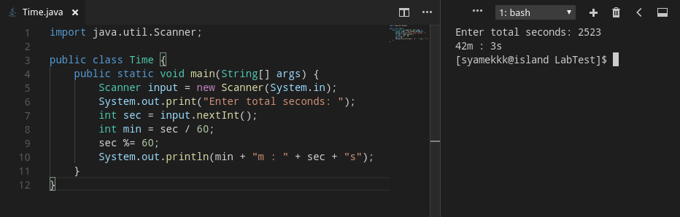

2. (Compare cost)
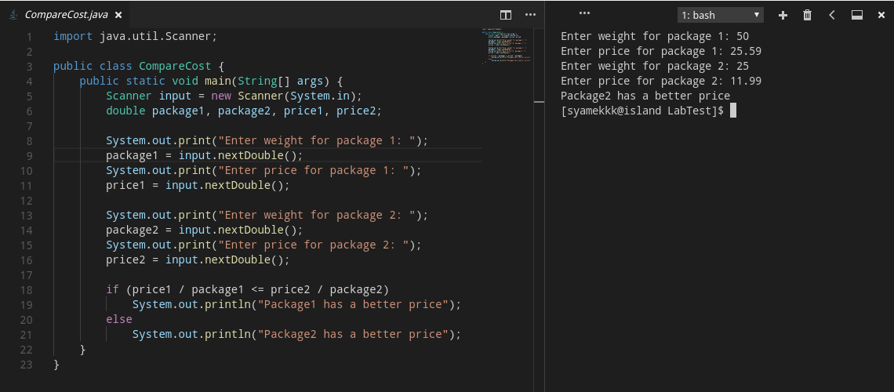

3. (Determine gender)
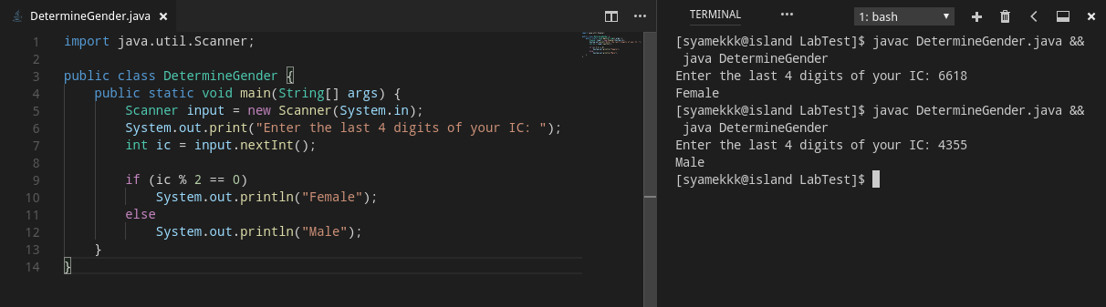

4. (Parking rate)
