CSC 1103 Section 1 & 6 OOP

Lab Test 2

Name: Muhammad Syahmi Fathimi bin Ahmad Fauzi
Matric No.: 1715845

1. (Menu and price)
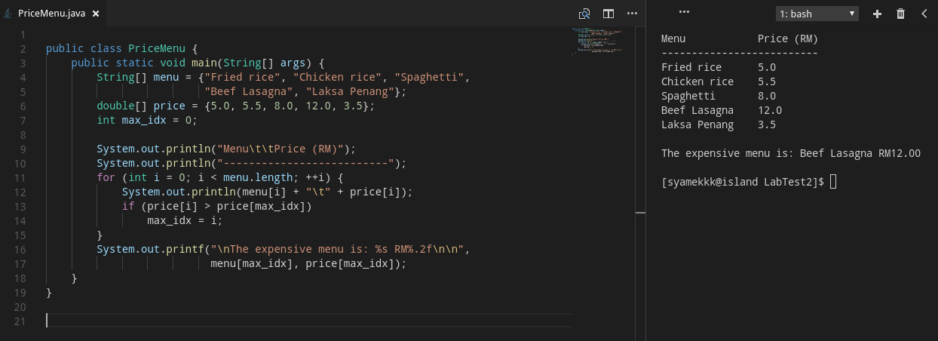

2. (Sorted)
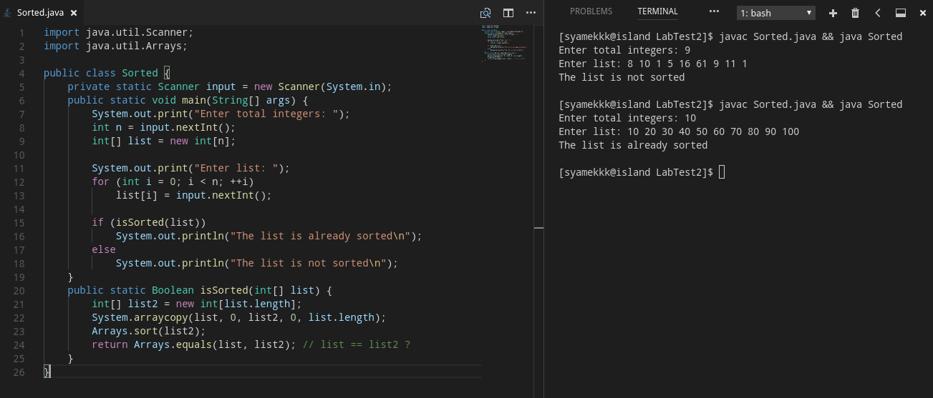

3. (Student’s score)
