Introduction
Every day, the healthcare sector produces a significant amount of patient-related data, such as treatment histories, appointments, doctor information, and patient records. To guarantee accurate record keeping, rapid information access, and efficient healthcare services, it is critical to manage this data effectively.
The goal of this project is to create a healthcare database management system utilizing MongoDB, a NoSQL database that offers flexibility in handling and storing massive amounts of structured and semi-structured data. The system is made to efficiently handle patient data, medical records, appointments, and treatment specifics.
This project's primary goal is to show how MongoDB database operations such as data insertion, retrieval, update, deletion, aggregation, and relationship handling through lookup operations are implemented. In order to guarantee effective and dependable data administration, the project also investigates database optimization and security principles.
This project creates and implements a healthcare database architecture that satisfies the needs of a contemporary healthcare information system while supporting data administration and analytical tasks.

Entity Relationship Diagram (ERD) for Healthcare Database System. (drawio)
- Patients stores patient information.
- Doctors stores doctor information.
- Appointments links patients and doctors.
- Treatments stores treatment history and costs.
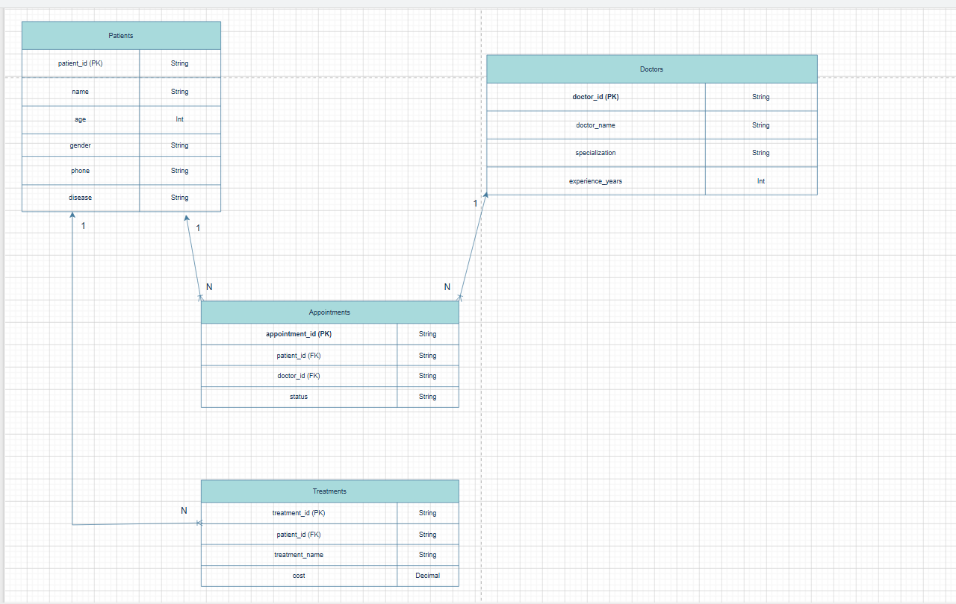
Index Strategy
Improve query performance and data retrieval efficiency, indexes were created on frequently searched fields. In this healthcare database, the disease field in the Patients collection was indexed because healthcare staff may frequently search patients based on their medical conditions.
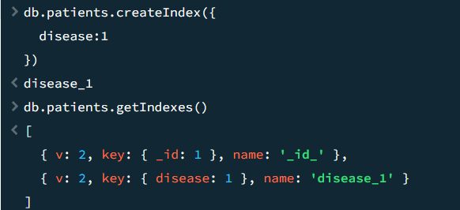
An index was created on the disease field to improve query performance when filtering patient records by disease type. Indexing reduces search time and improves database efficiency, particularly when managing large healthcare datasets containing thousands of records
Database
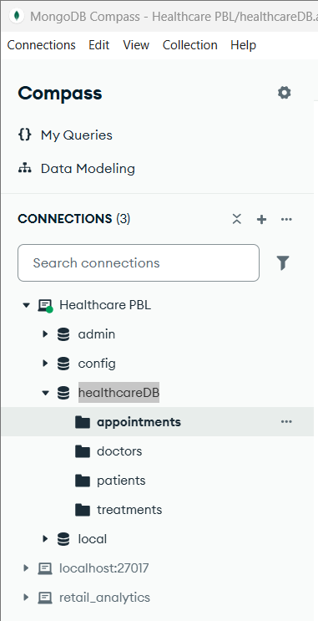
The Healthcare Database (healthcareDB) consists of four main collections: Patients, Doctors, Appointments, and Treatments. These collections are designed to store healthcare-related information and support data retrieval, management, and analysis. The database structure enables efficient organization of patient records, doctor information, appointment scheduling, and treatment history.

Sample Data Collection
Appointments
Stores appointment information between patients and doctors.
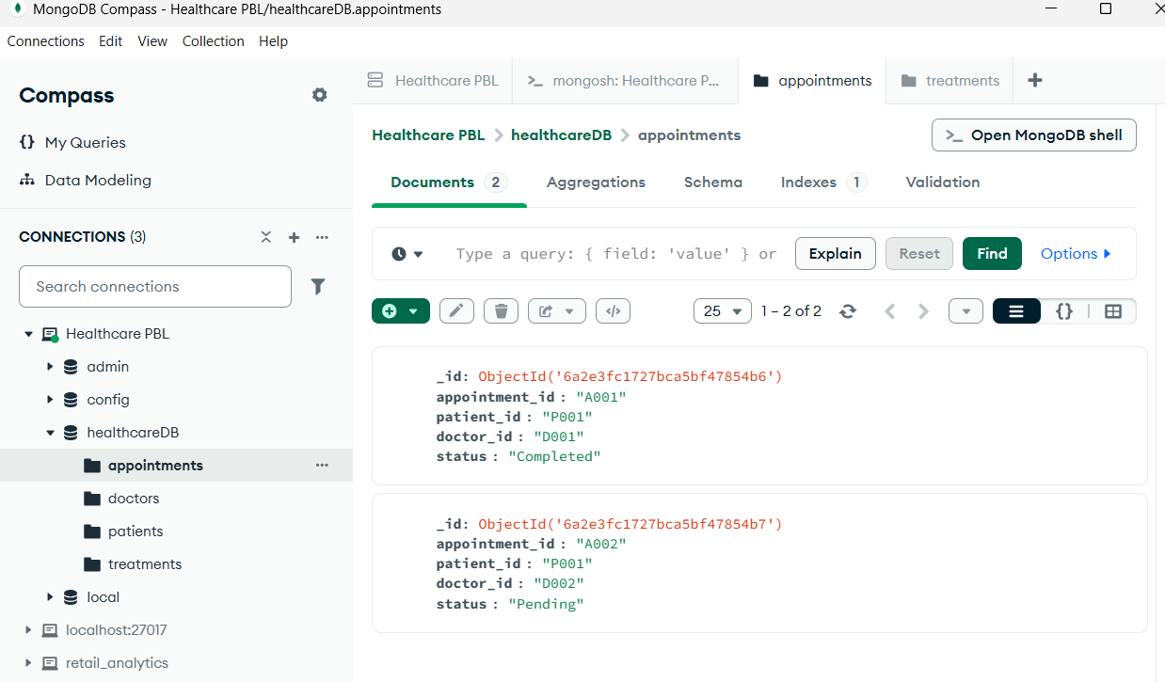

Doctors collection
Stores doctor information including doctor ID, doctor name, specialization, and years of experience.
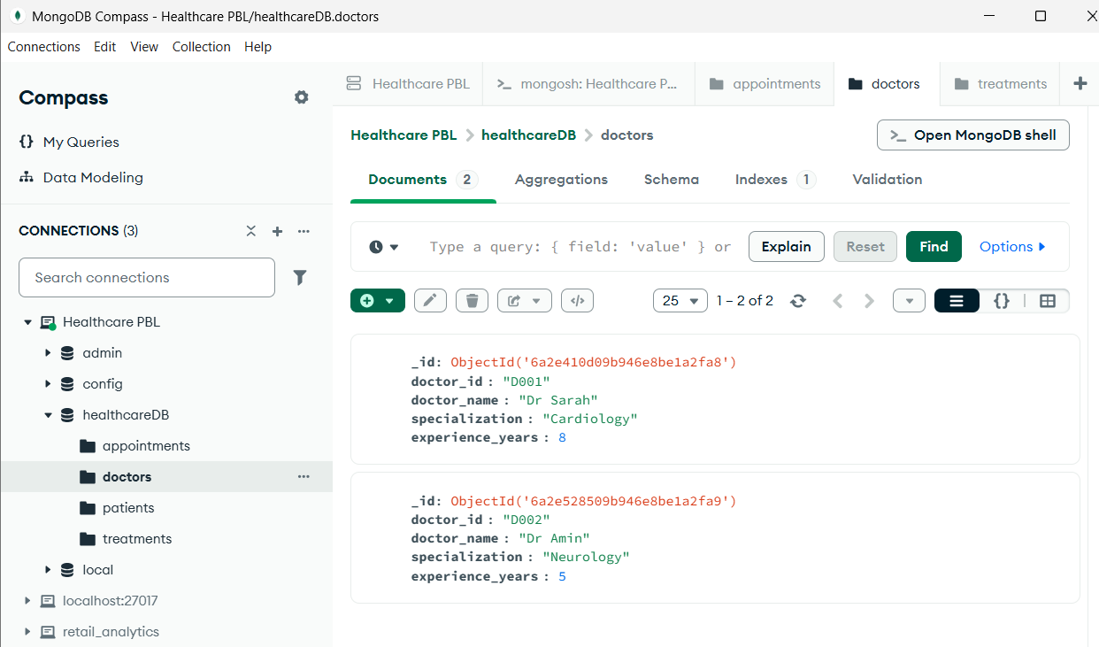

Patients Collection
Stores patient records including patient ID, personal information, and disease details.
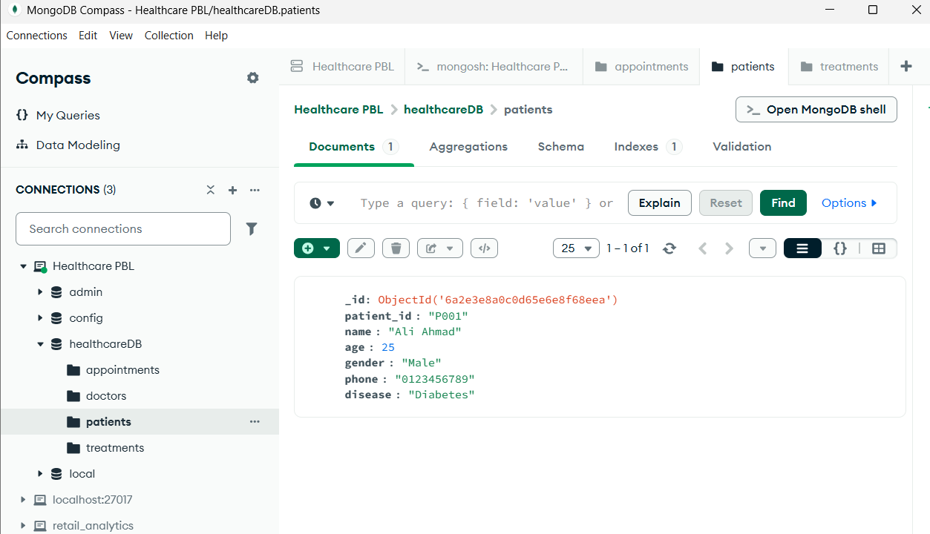

Treatments Collection
Stores treatment records and treatment costs for each patient.
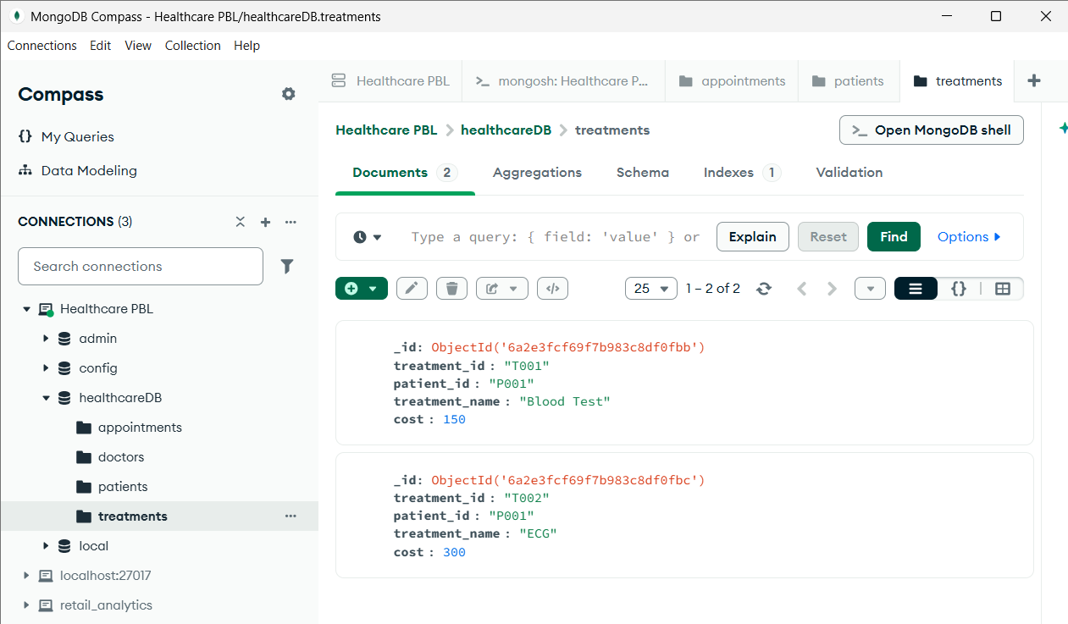

QUERY 1: Display All Patients
Purpose: Retrieve all patient records from the patients collection.
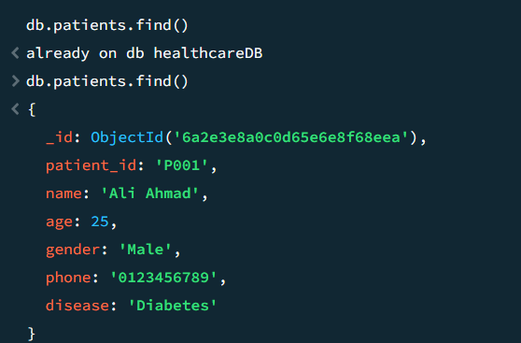

QUERY 2: Find Diabetes Patients
Purpose: Retrieve patient records diagnosed with Diabetes from the Patients collection.
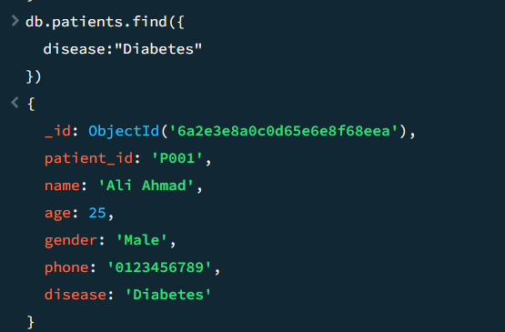

QUERY 3: Update Patient Age
Purpose: Modify and update a patient's information, specifically the age field, in the Patients collection.
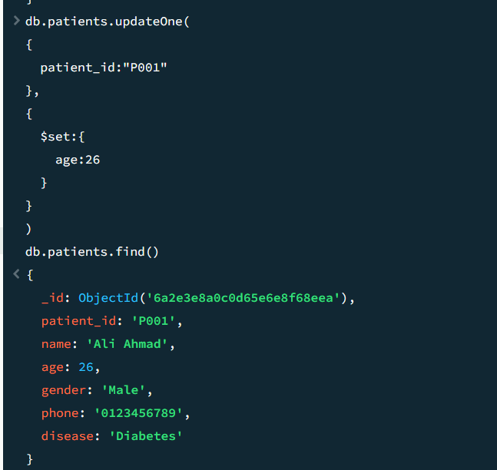

QUERY 4: Count Total Patients
Purpose: Calculate the total number of patient records stored in the Patients collection.
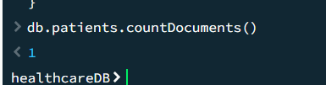

QUERY 5: Count Patients by Disease
Purpose: Analyze the number of patients grouped according to their disease type.
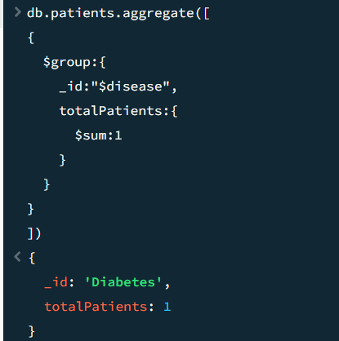
QUERY 6: Total Treatment Cost
Purpose: Calculate the total treatment cost incurred by each patient based on records in the Treatments collection.
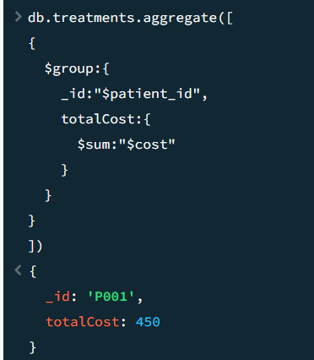

QUERY 7: Total Appointments per Patient
Purpose: Determine the total number of appointments made by each patient.
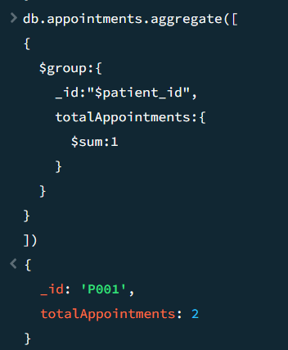

QUERY 8: Patient + Appointment ($lookup)
Purpose: Combine patient records with appointment records using the patient_id field and display patient information together with appointment details.
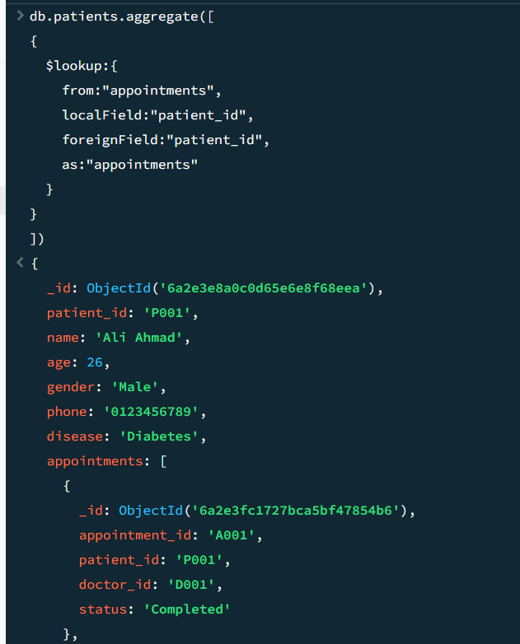
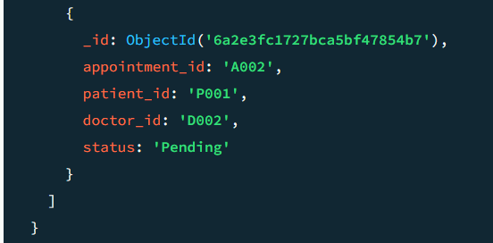

QUERY 9: Patient + Treatment ($lookup)
Purpose: Combine patient records with treatment records using the patient_id field and display patient information together with treatment history.
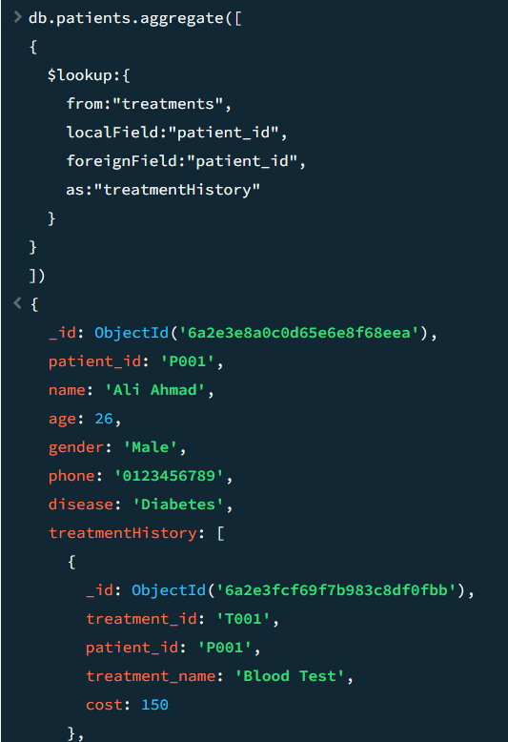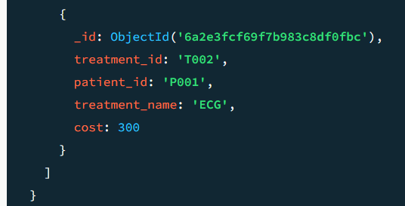

QUERY 10 : Doctor Appointment Ranking
Purpose: Identify and rank doctors based on the total number of appointments assigned to them.
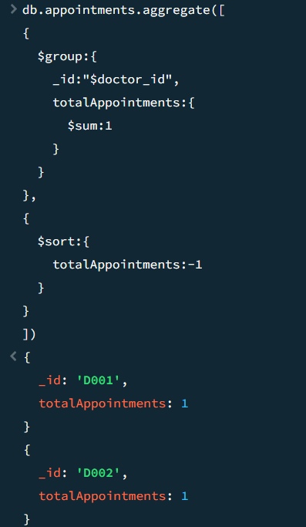
Sample data generation 1000 doc (Doctors)
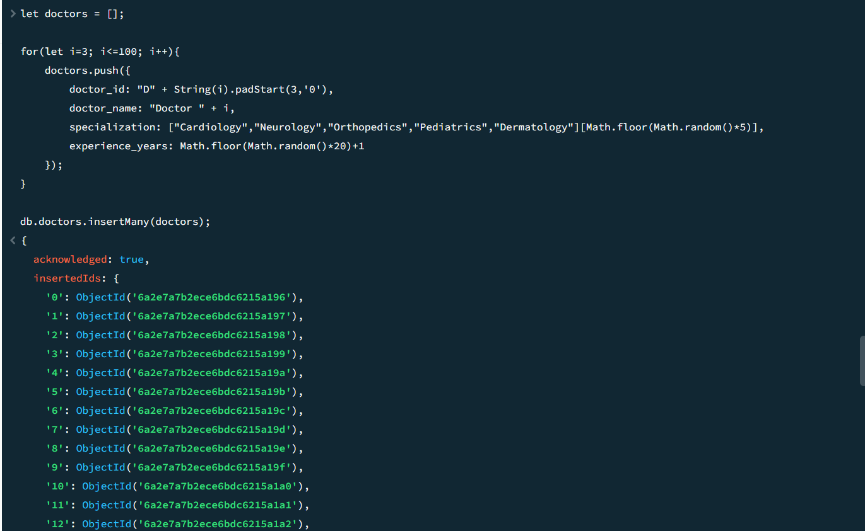

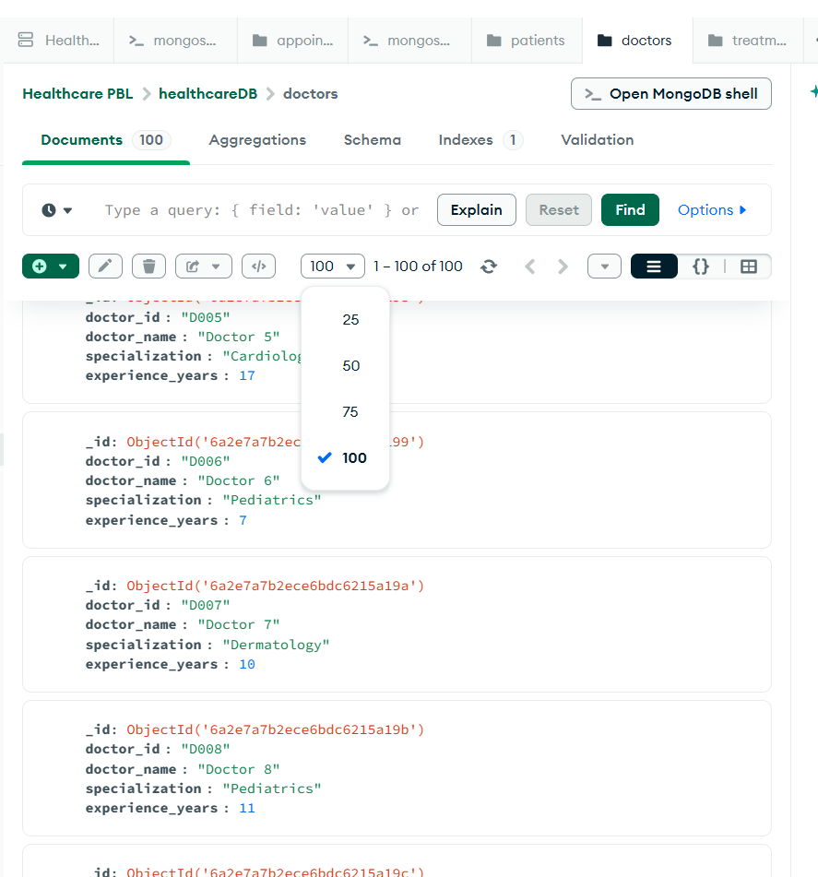

Sample data generation 1000 doc (Patients)
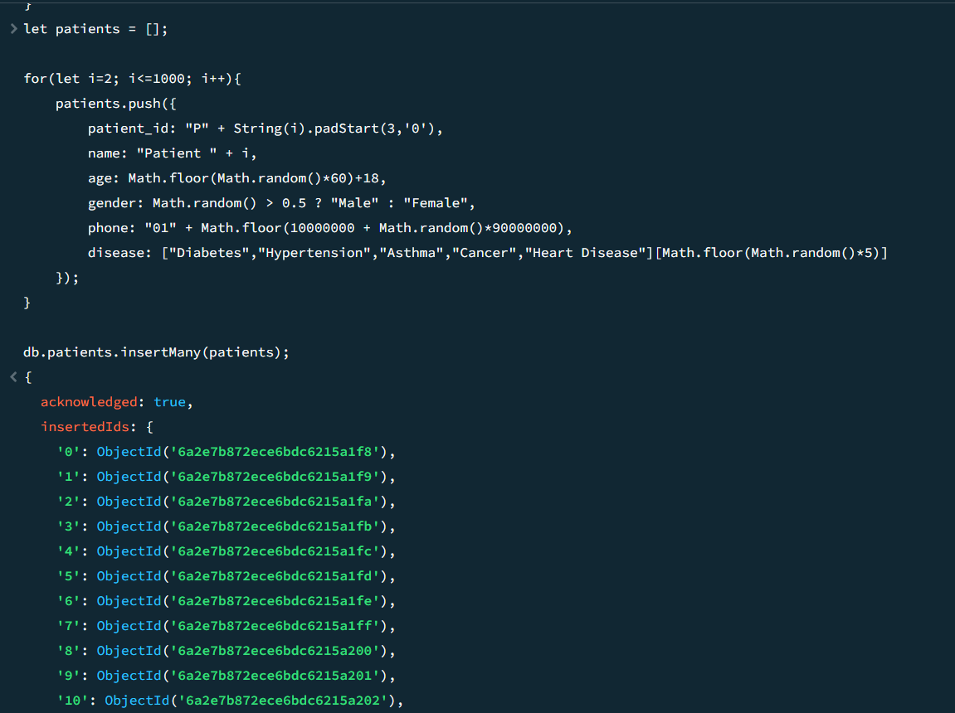

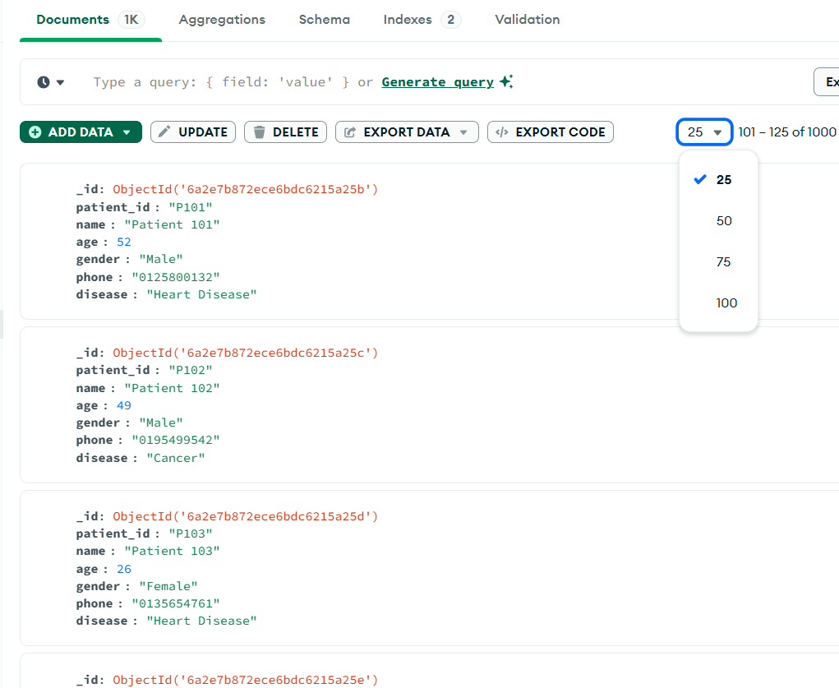

Sample data generation 1000 doc (Appointments)
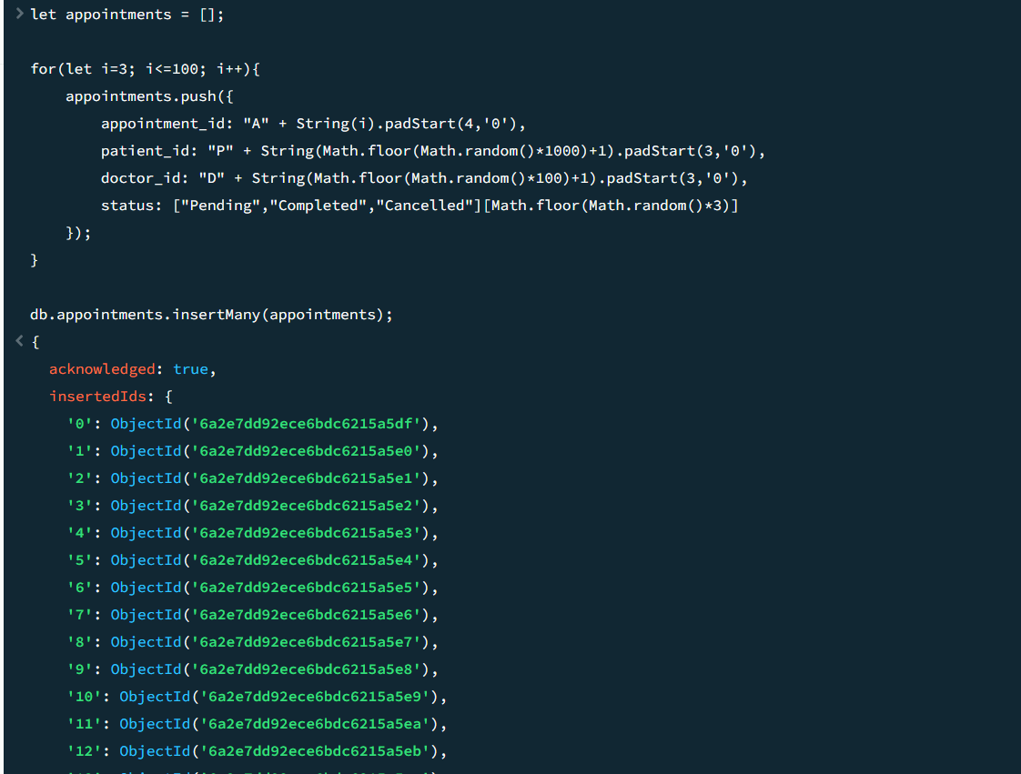

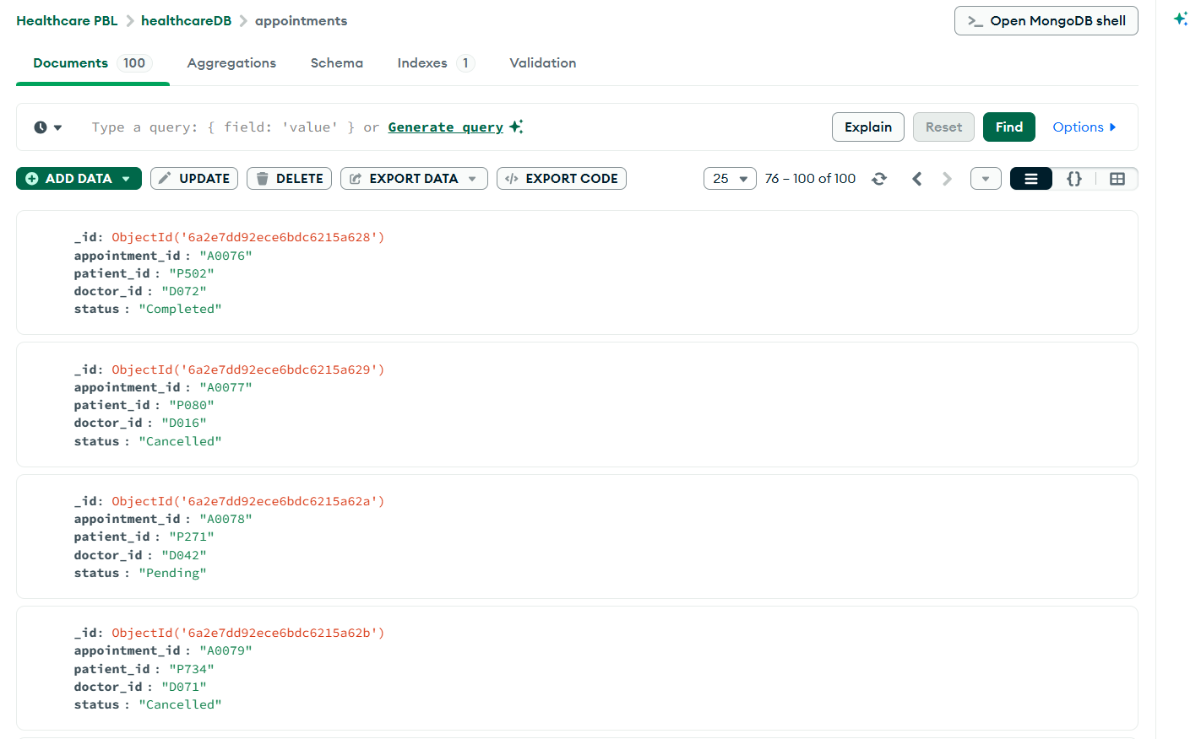

Sample data generation 1000 doc (Treatments)
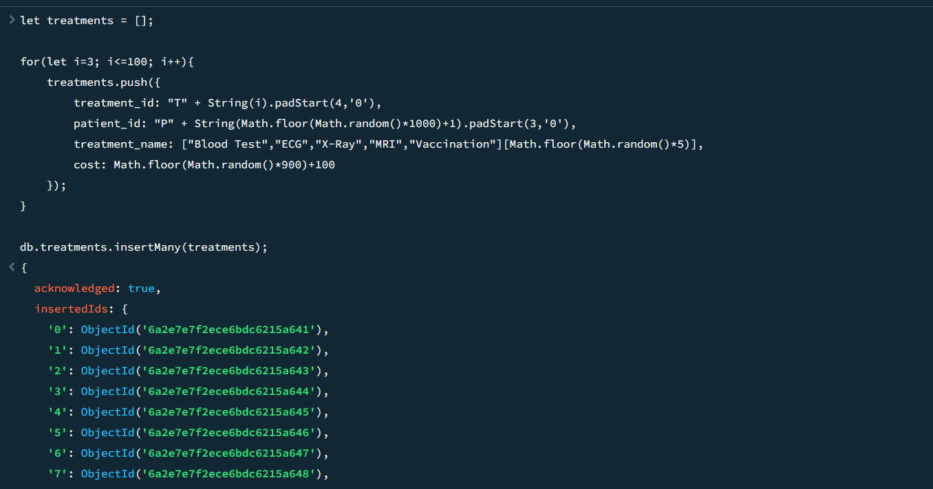
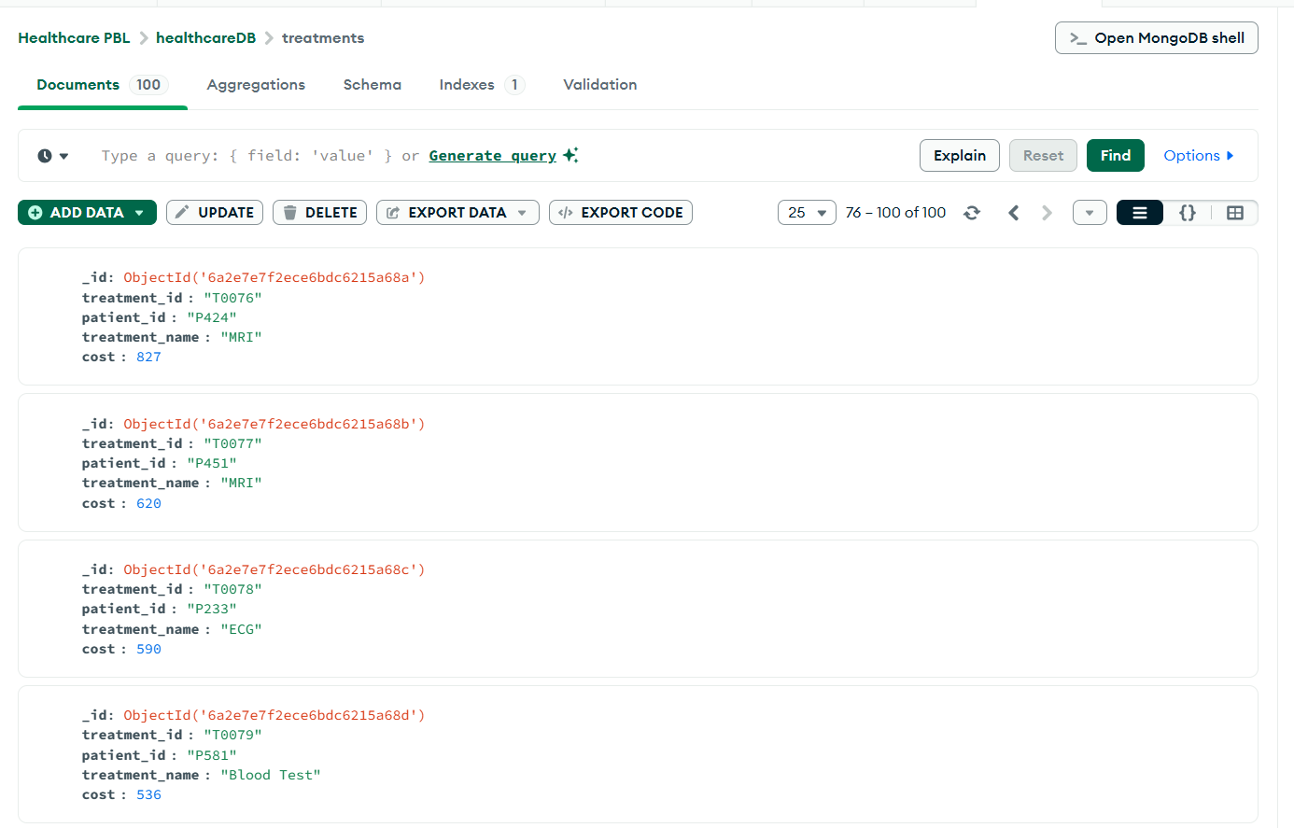
Coding nak check document semua
