1. The metrics from the VM Scale Set instance--this will show CPU %, Available Memory %, Information about the Disk, and information about the bytes sent and received. There will be 5 graphs which display this data

*Note: in project specification is mentioned There will be 7 graphs that display this data, so I add the graphs from aggregate charts*

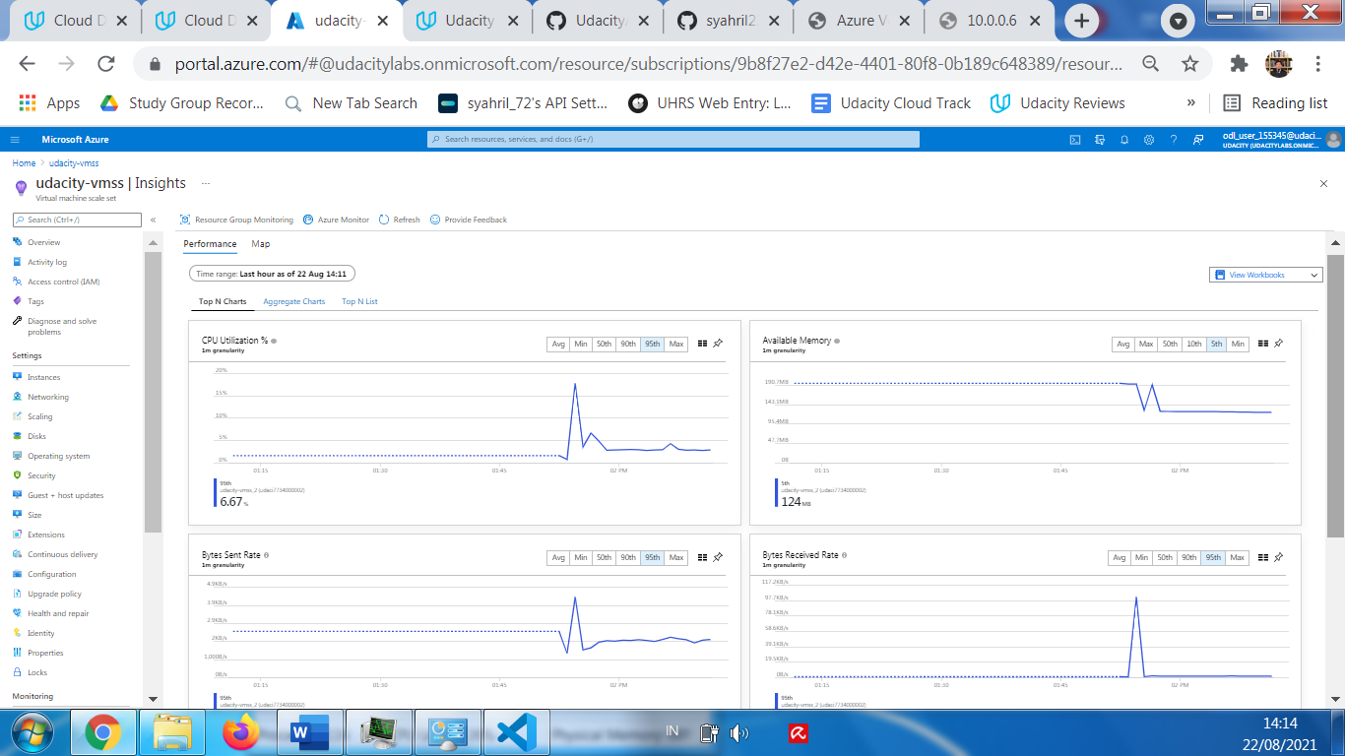

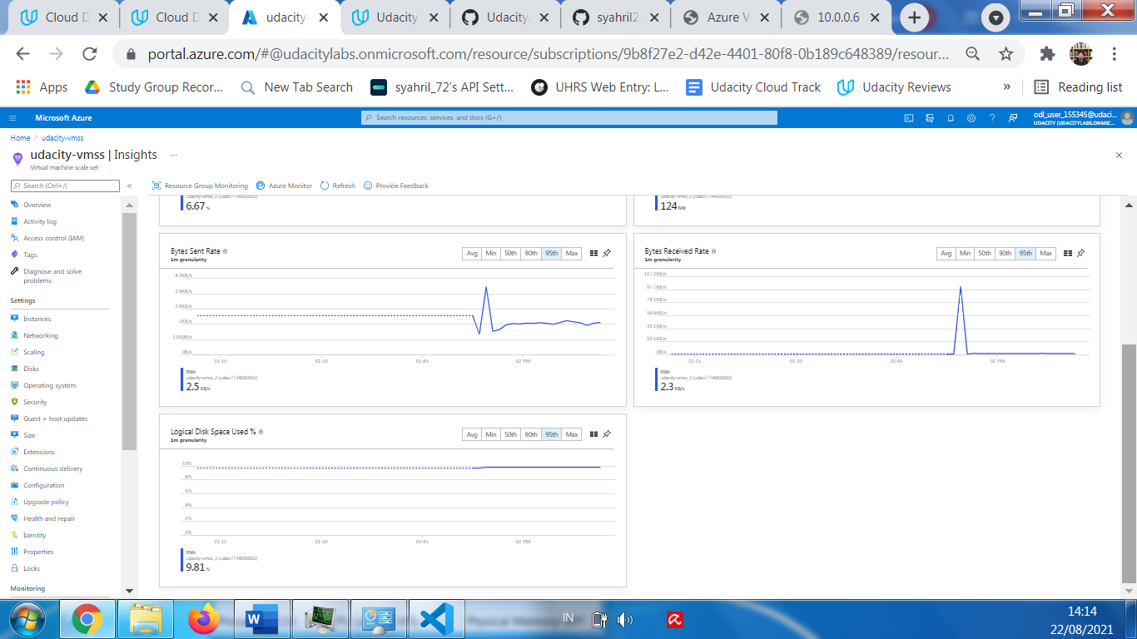

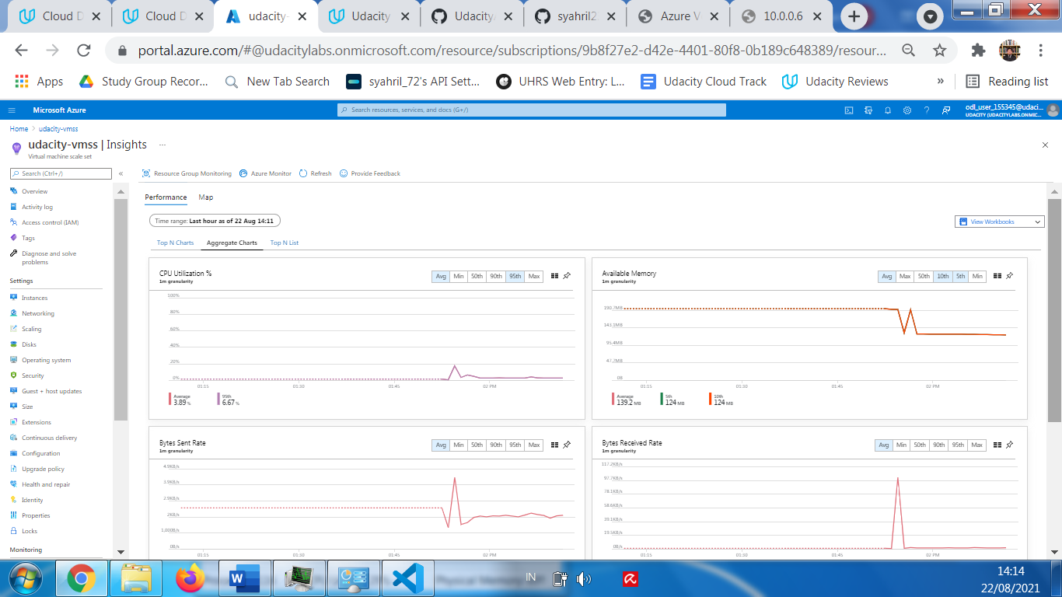

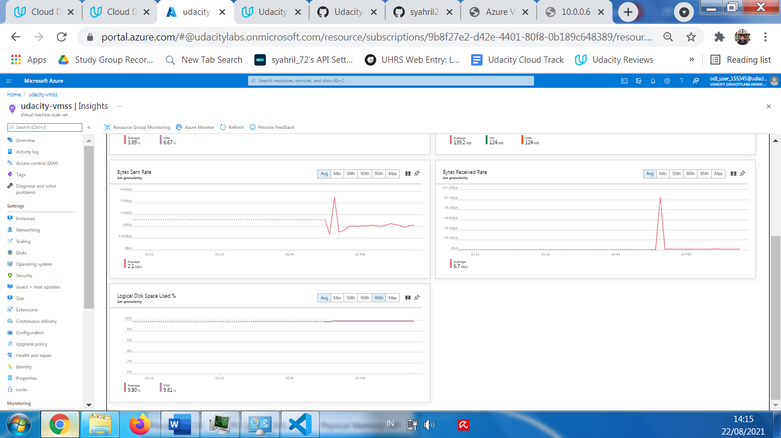

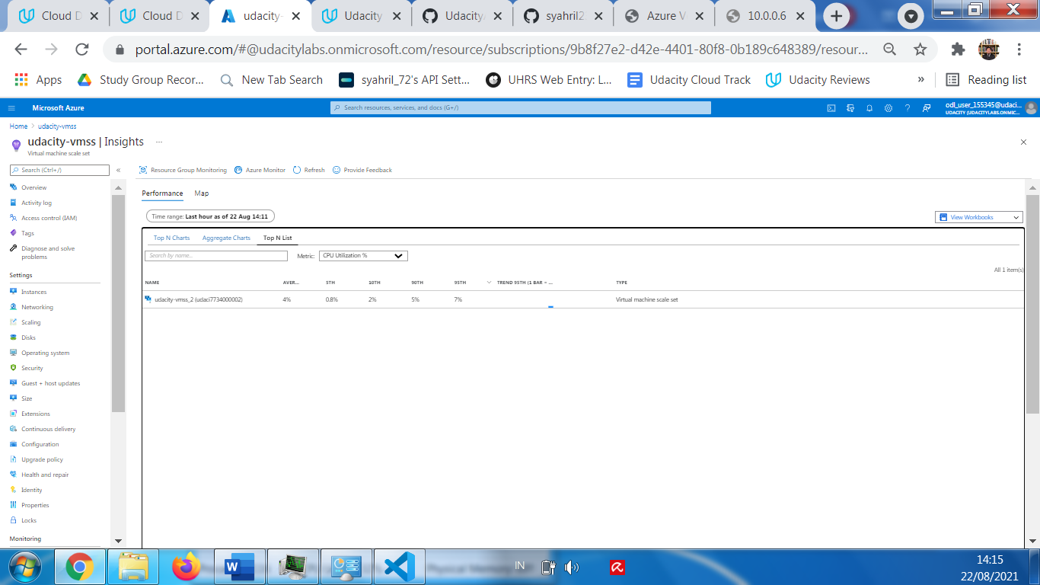

1. Application Insight Events which show the results of clicking 'vote' for each 'Dogs' & 'Cats'

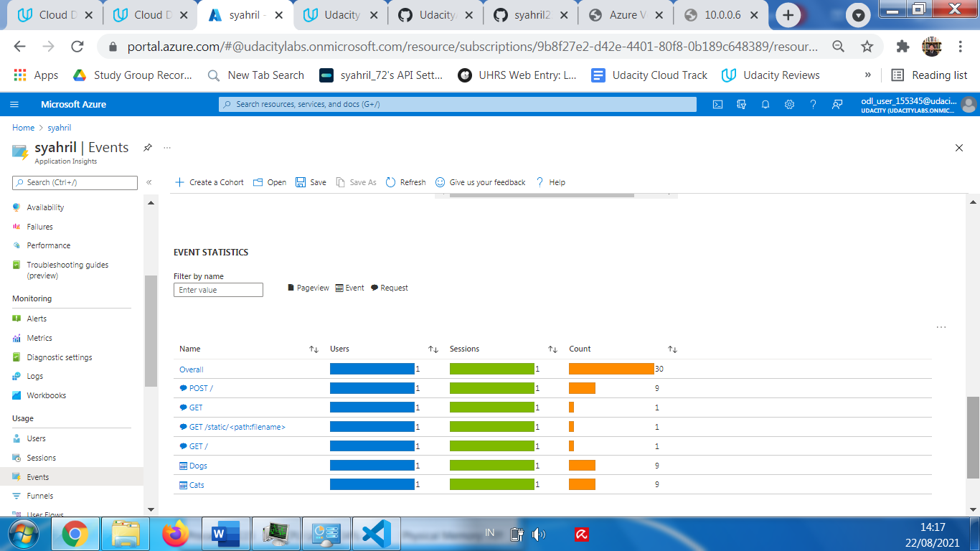

1. The output of the traces query in Azure Log Analytics

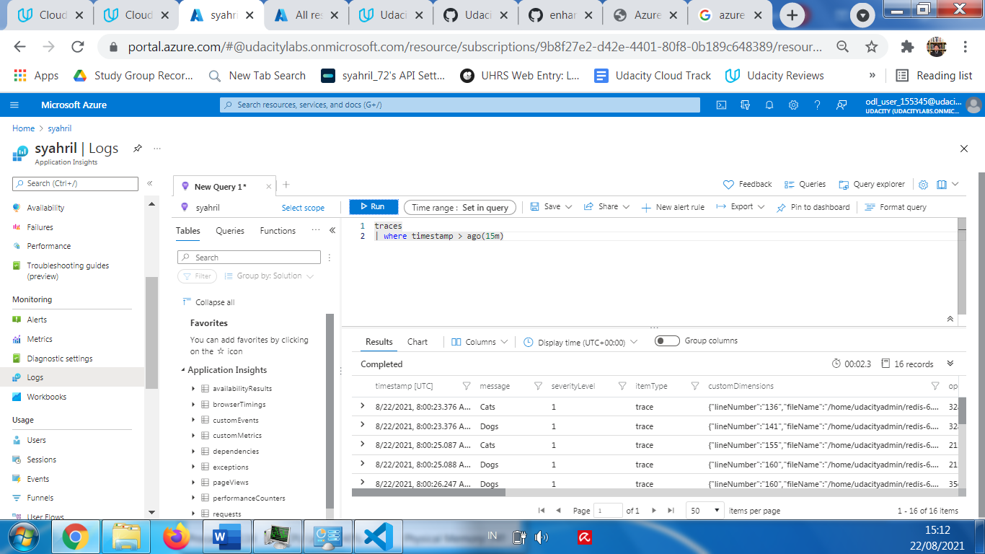

1. The chart created from the output of the traces query.

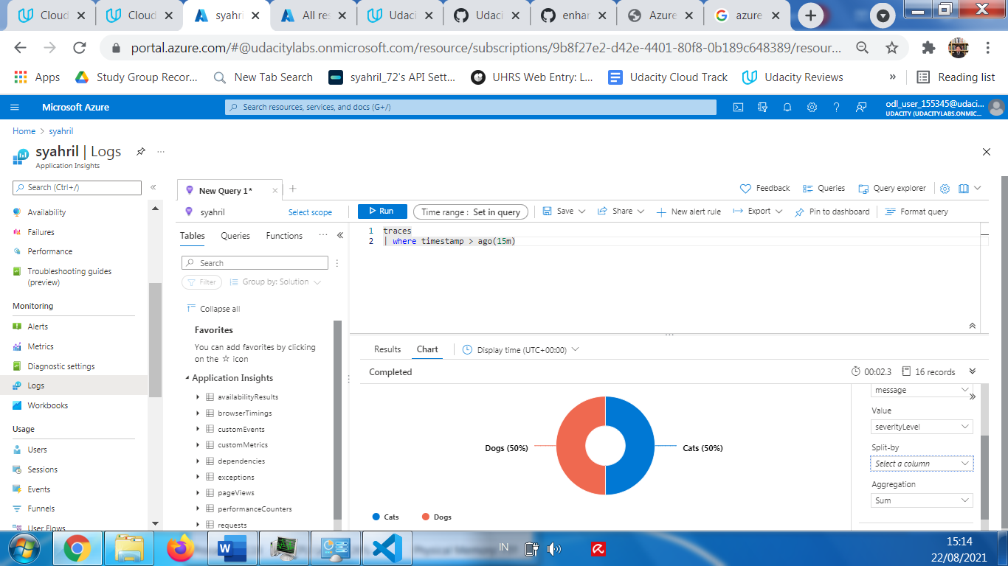

From Project Specification:

1. provide a screenshot of the resource group containing your running resources

