1. The conditions for which autoscaling will be triggered (found in the 'Scaling' item in the VM Scale Set)

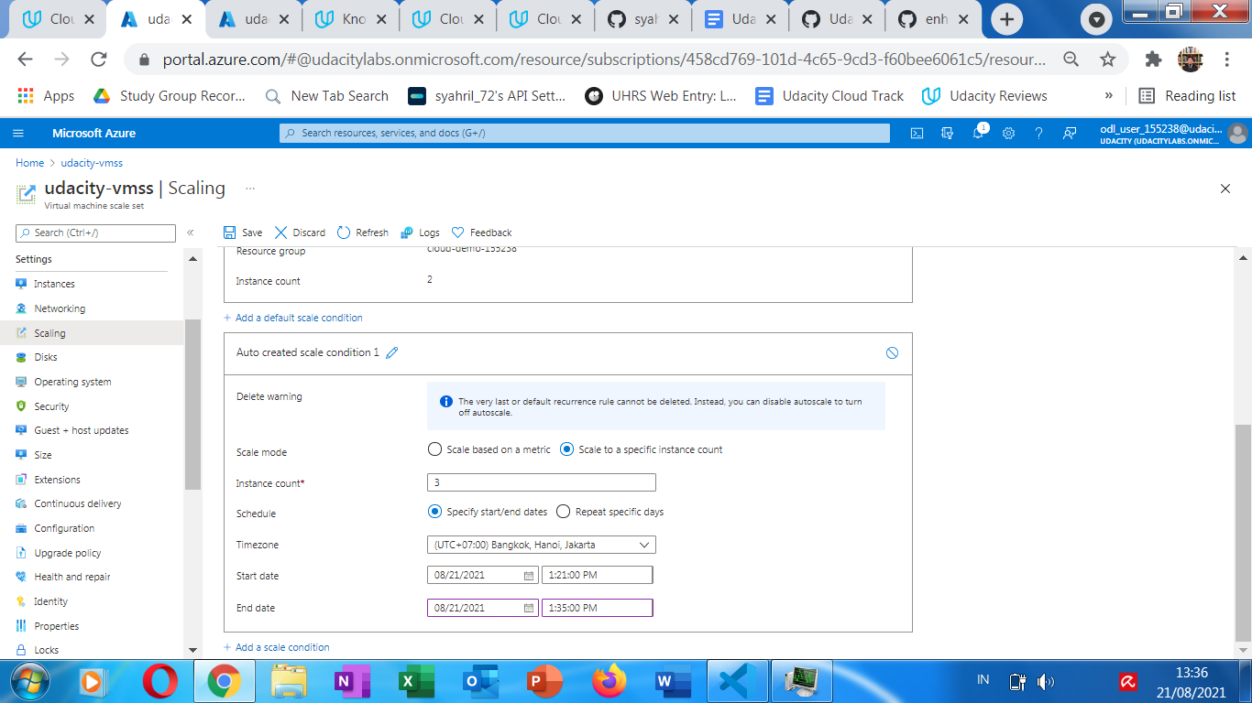

1. The Activity log of the VM scale set which shows that it scaled up with timestamp

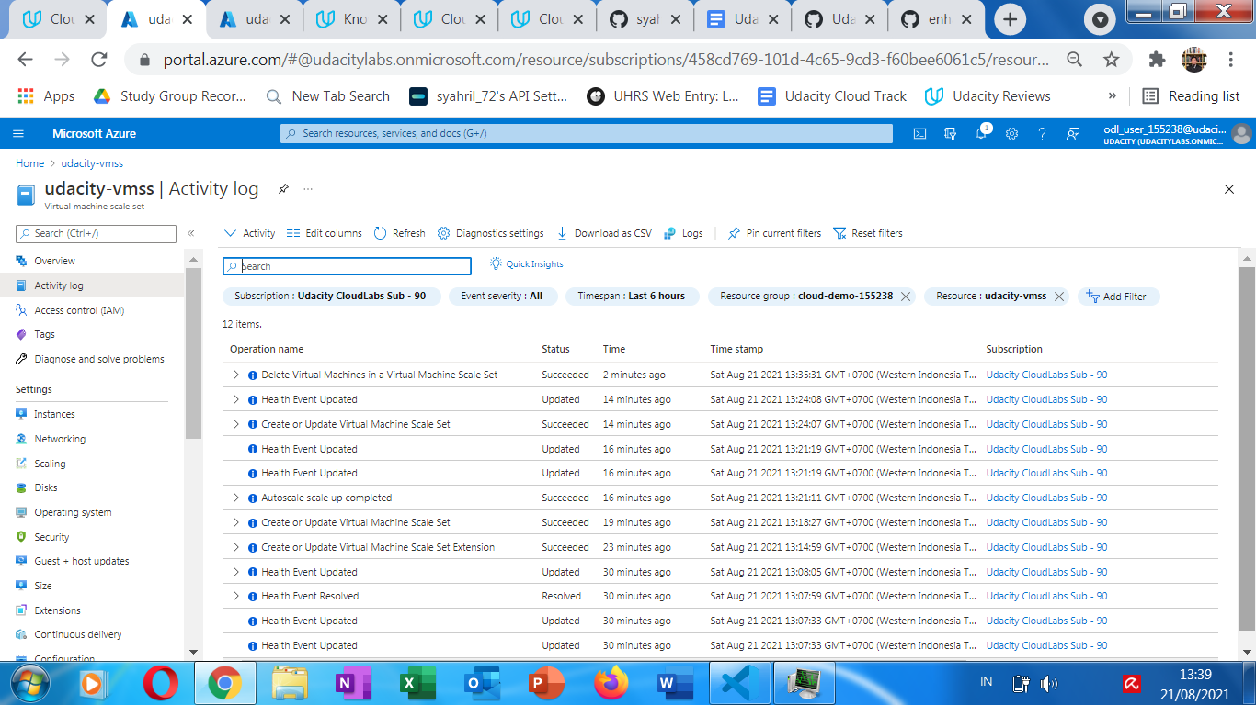

1. The new instances being created

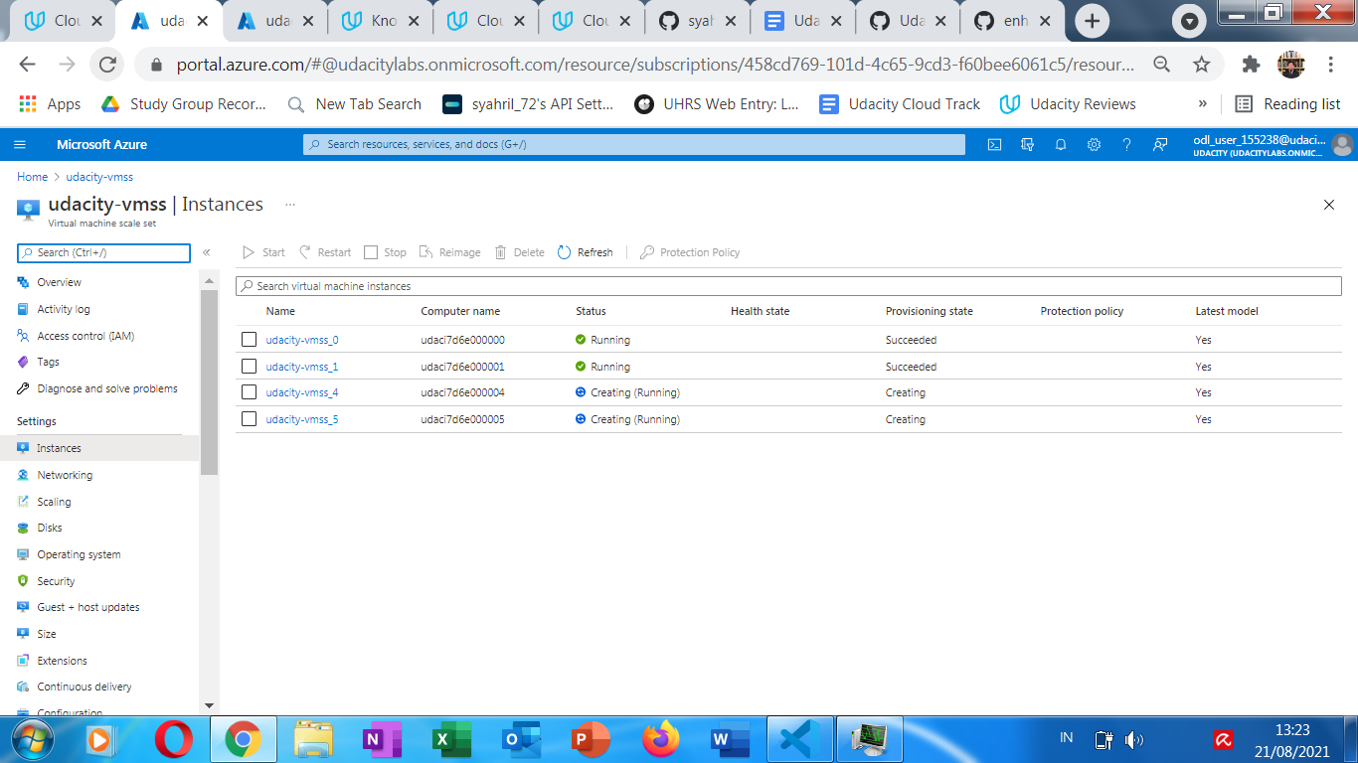

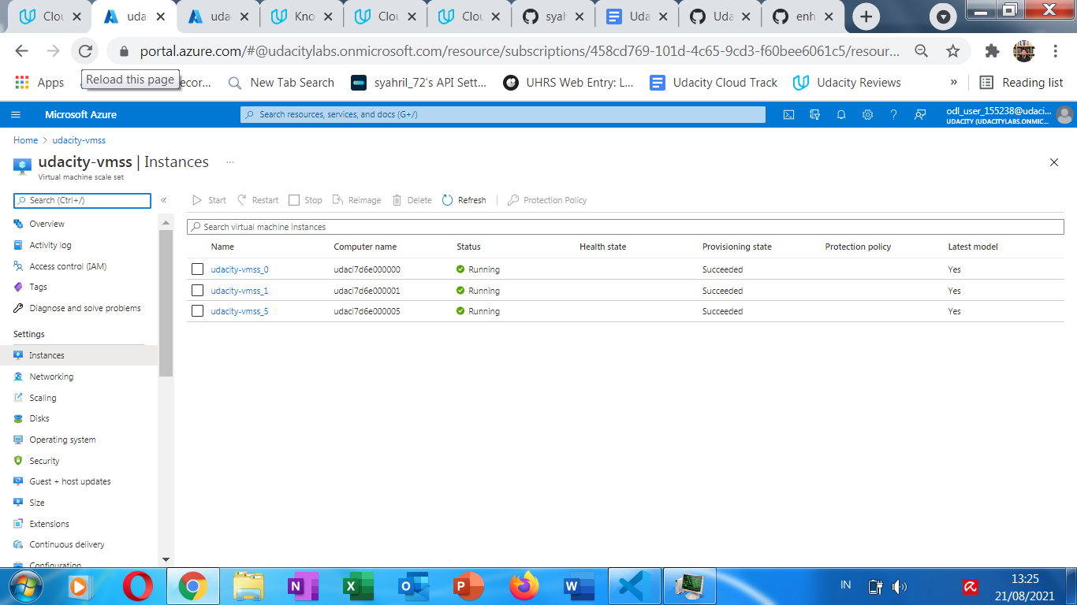

1. The metrics which show the load increasing, then decreasing once scaled up with timestamp

