1. The output of the Horizontal Pod Autoscaler, showing an increase in the number of pods

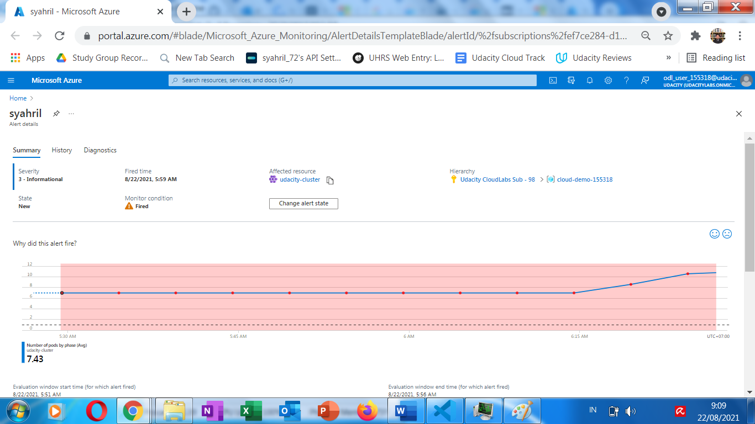

2. The Application Insights metrics which show the increase in the number of pods

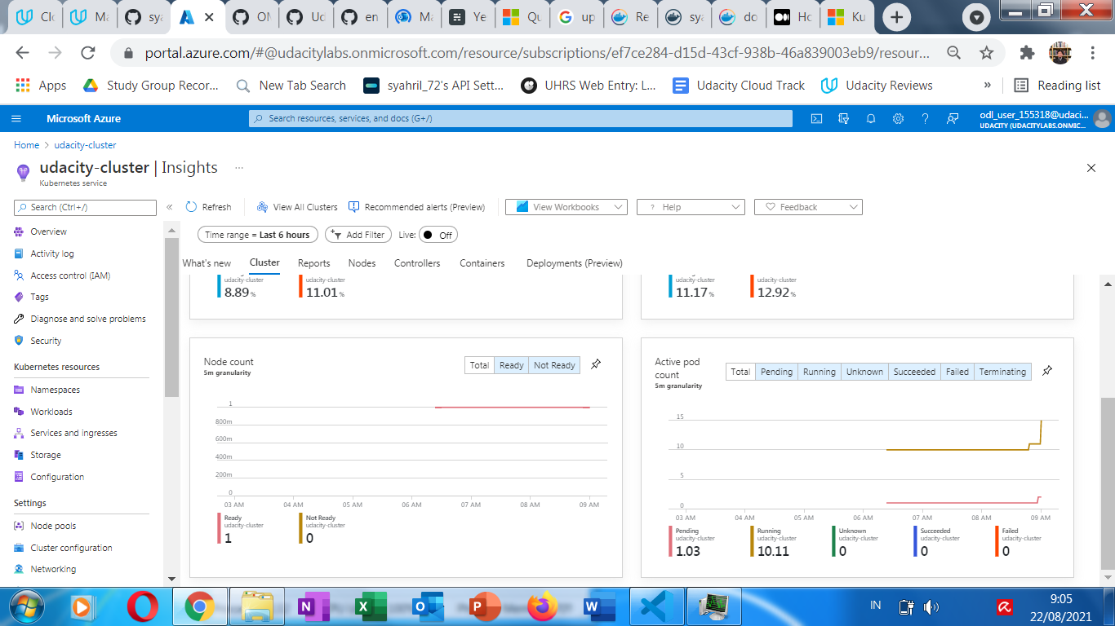

3. The email you received from the alert when the pod count increased

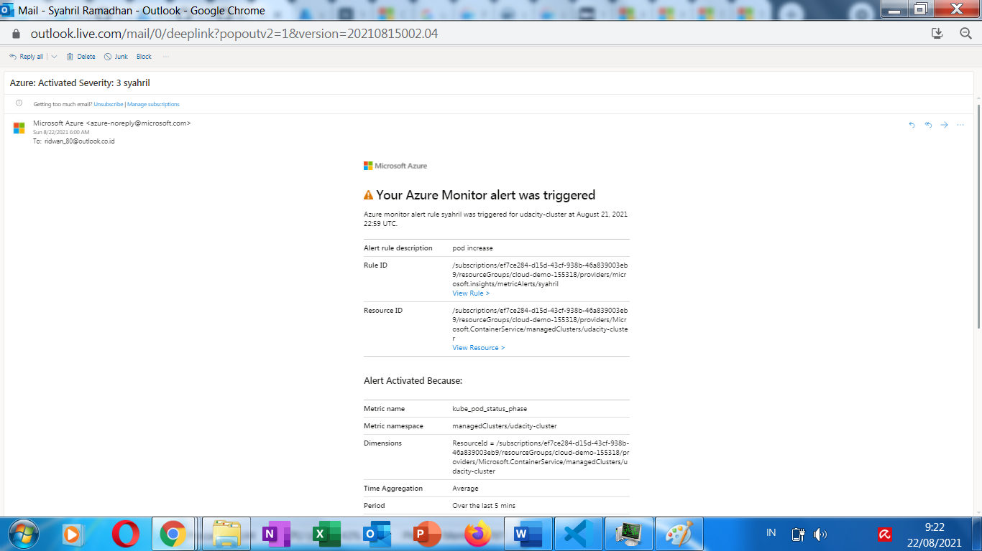

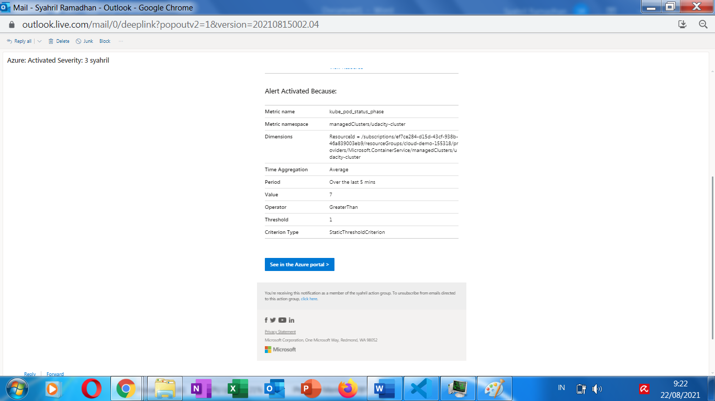

From Project Specification:

4. provide a screenshot of the resource group containing your running resources

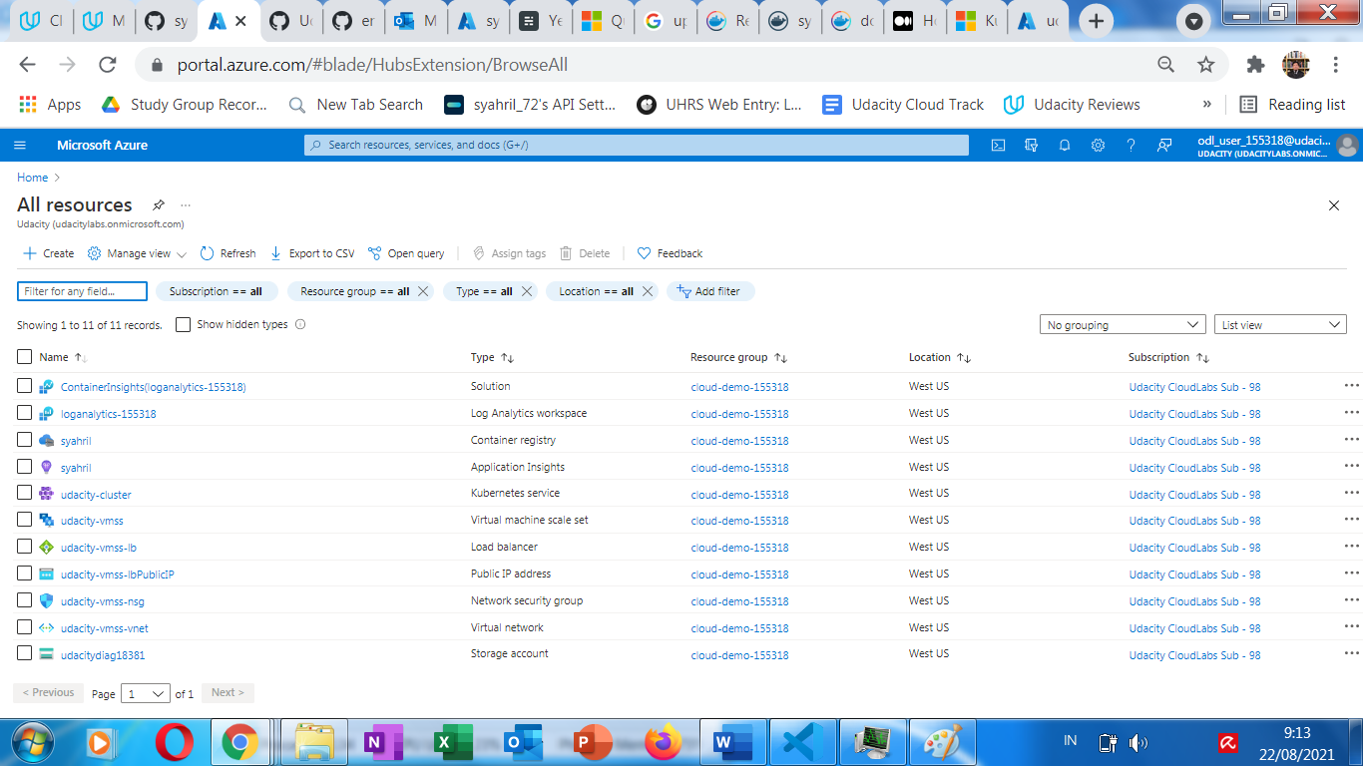

5. a screenshot of the Azure Alert

