1. The alert configuration in Azure Monitor which shows the resource, condition, action group (this should include a reference to your Runbook), and alert rule details (may need 2 screenshots)

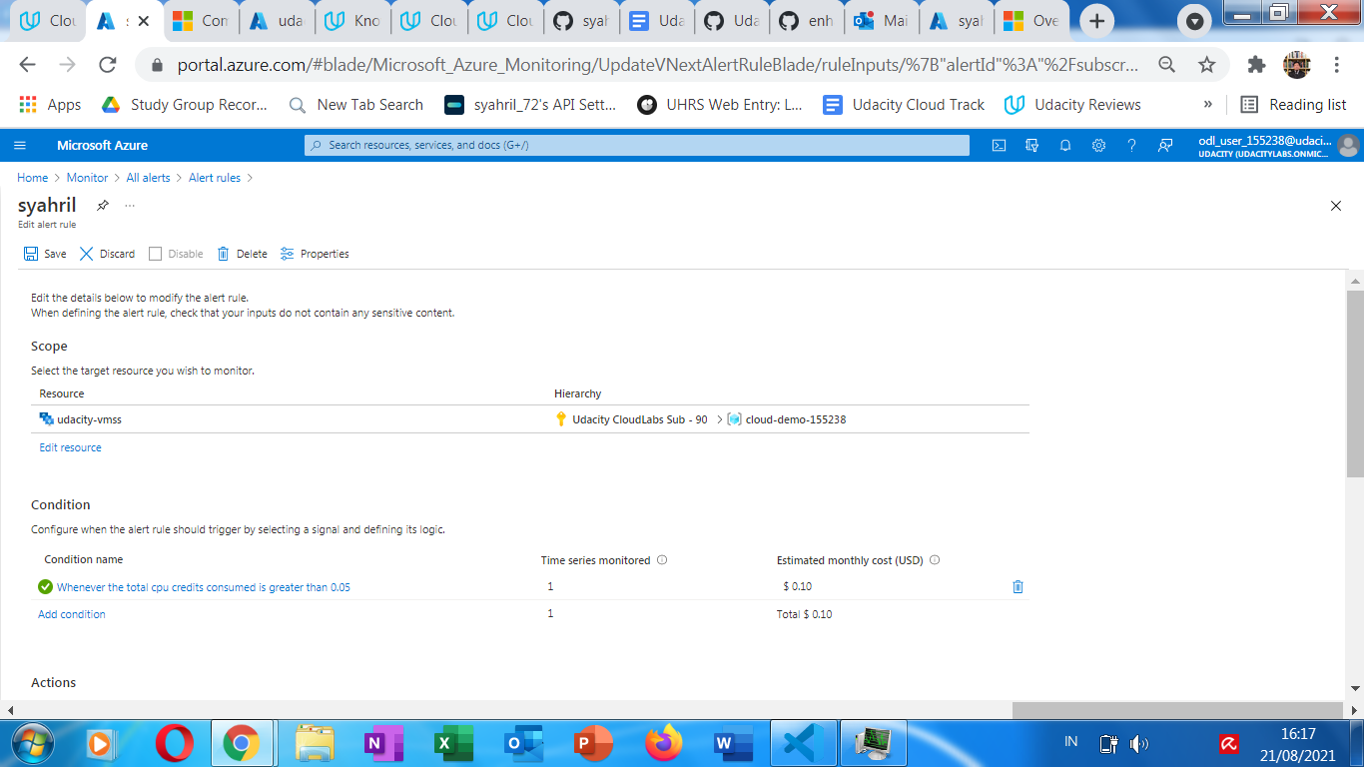

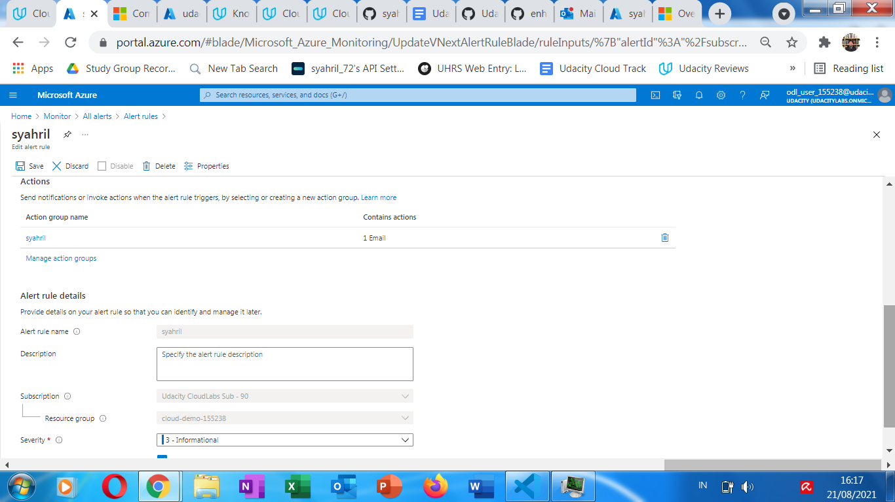

1. The email you received from the alert when the Runbook was executed

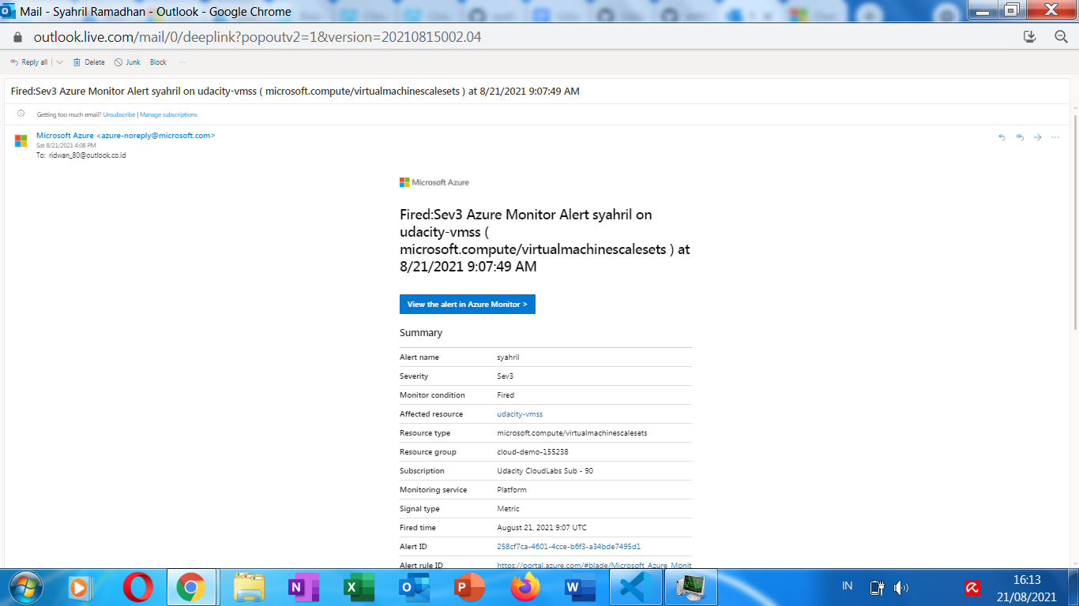

1. The summary of the alert which shows 'why did this alert fire?', timestamps, and the criterion in which it fired

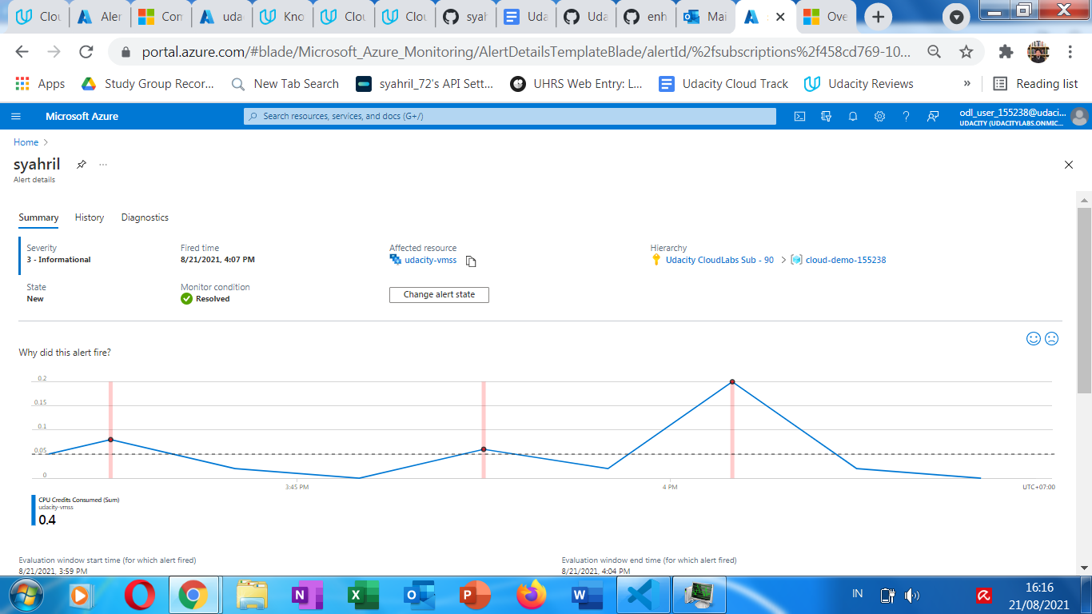

From project specification:

1. screenshot of your resource group containing your running resources

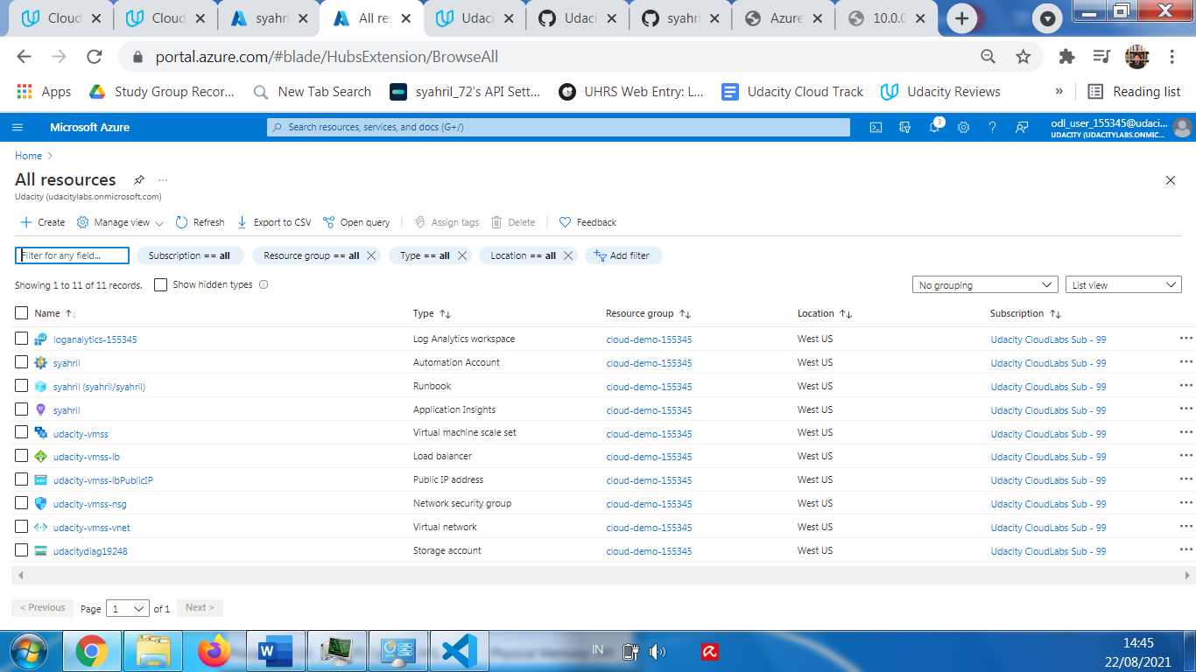

1. other evidence showing the RunBook executed and resolved the issue

