*COS30018*

*Intelligent Systems*

*Task B.7*

Saynab Ismail

103063323@student.swin.edu.au

**Table of Contents**

Introduction……………………………………………………………….. 3

Data Sources.………………………....……………………………....……3

Data Preprocessing…………………………………………………..……..4

Event Data Preprocessing………………………………………………….4

Multistep Prediction…...….….…………………..………………….……..5

Model Testing and Visualization…………………..………………………5

Results……………………………………………….…………………….6

Conclusion…………………………………..…………………………….6

References………………………………………………………………….7

Link to repository: https://github.com/syais/TaskB7

**Introduction**

This task aims to build a stock price prediction model by incorporating real-life events, such as earnings reports and regulatory changes that capture sudden market movements. Using stock price data together with event data that has sentiment scores will help increase the predictive accuracy and provide insight into how certain events drive stock prices.

### **Data Sources**

* **Stock Data:**

Stock prices were sourced from Yahoo Finance using the yfinance library for the period 2020-01-01 to 2024-07-02, focusing on the closing prices for CBA.AX.

* **Event Data:**

Event data includes significant occurrences such as earnings reports, economic indicators, and product launches. Each event entry has the following fields:

* **Date:**

The date of the event.

* **Event_Type:**

The type of event (e.g., Earnings Report, Economic Indicator).

* **Sentiment:**

A score representing the positive or negative sentiment associated with the event.

* **Intensity:**

The intensity of the event's impact on market sentiment.

The following CSV file shows the structure of our event data:

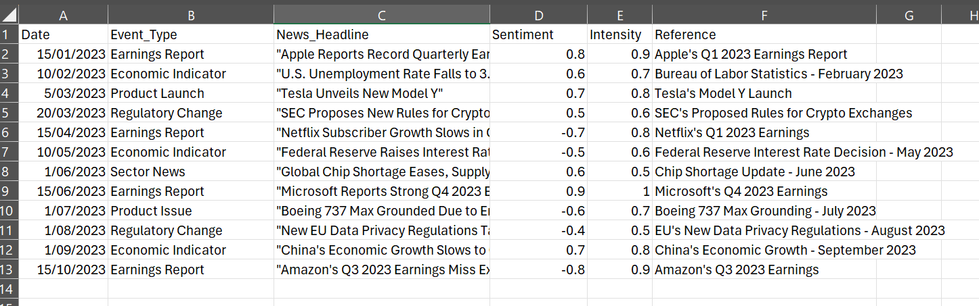

*Figure 1.CSV file*

**Data Preprocessing**

The stock data was loaded and scaled using a MinMaxScaler, which normalized the prices between 0 and 1. Scaling helps the model learn effectively by keeping the data within a similar range.

#### 

*Figure 2.Stock Data Loading and Scaling*

#### **Event Data Preprocessing**

Event data was preprocessed by converting dates to DateTime format and encoding event types with one-hot encoding. Sentiment and intensity scores were also used, which were combined with stock price data to provide additional features for the model.

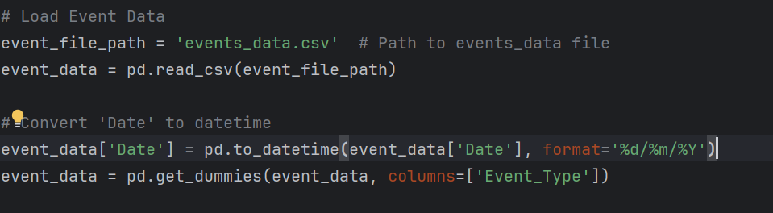

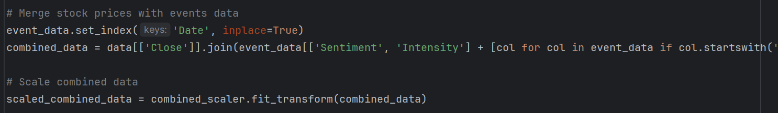

*Figure 3&4. Event Data Preprocessing*

### **Multistep Predictions**

To allow the model to predict stock prices over several days ahead, I reused the multistep prediction function to utilize the event-driven features in each prediction step.

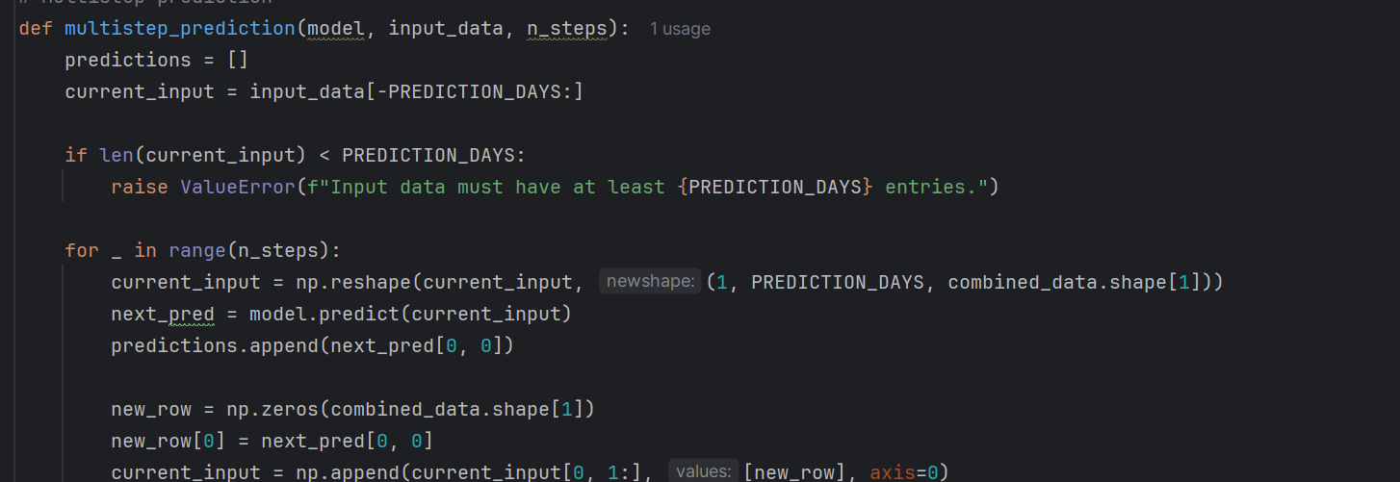

*Figure 5. Multistep Predictions*

**Model Testing and Visualization**

The trained model was tested on unseen data, and predictions were visualized. We incorporated event-driven data by plotting the predicted stock prices alongside actual prices and marking significant events on the timeline to illustrate their impact visually.

**Results**

The model predictions demonstrate that integrating event-driven data enables it to respond to price fluctuations tied to significant market events, such as earnings reports or regulatory changes. While the output shall focus on the predicted price versus the actual price, the effect of event-driven features is still reflected by showing how responsive the model would be to these events. Although the event data is not explicitly shown in the output, the alignment between predicted stock prices and actual price movements around key dates highlights the influence of event-driven features on stock price trends, showing the model's ability to adapt to shifts caused by real-world factors

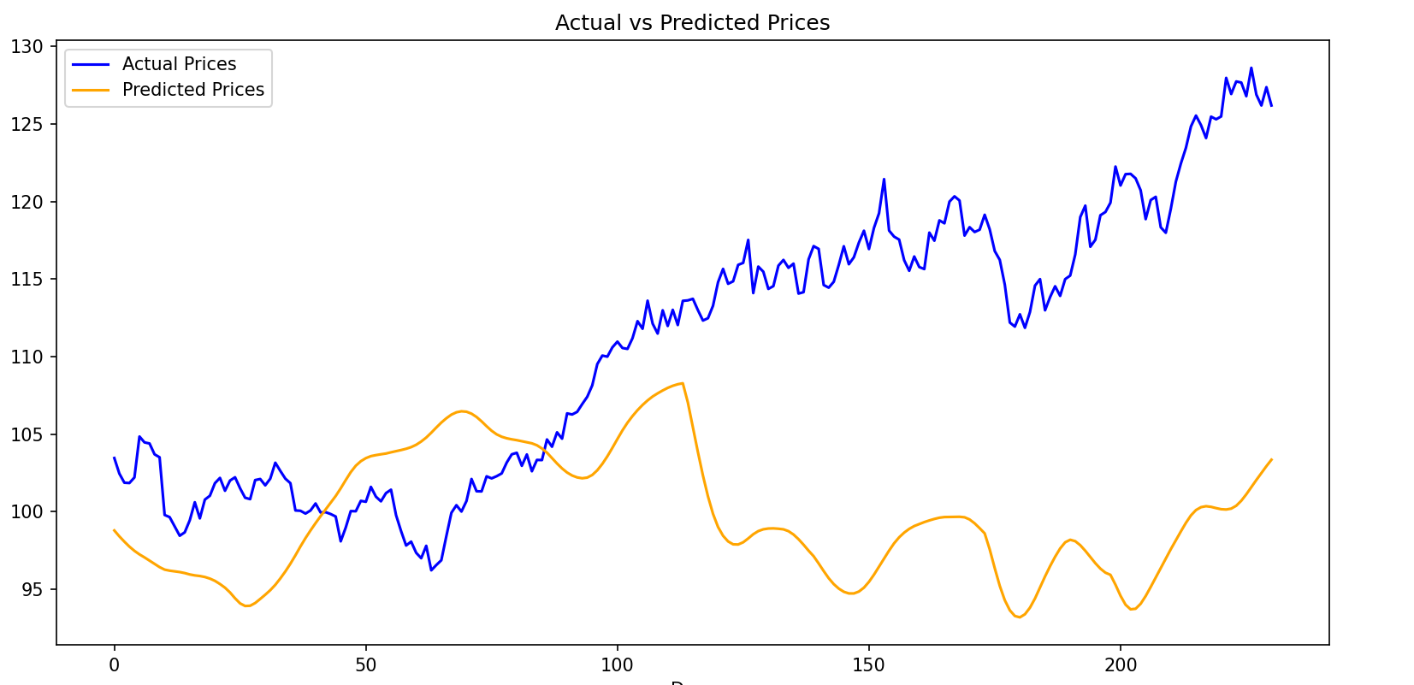

*Figure 6.Results*

**Conclusion**

Incorporating event-driven data into stock prediction models shows the potential to improve prediction accuracy by accounting for sudden market changes. Although real-world events introduce complexity, they provide valuable context for models that attempt to capture real-time market behaviour. This approach can be expanded with additional event types and more refined sentiment analysis to enhance predictive performance further.

**References:**

References are also included in CSV file (not with links)

Apple's Q1 2023 Earnings Report

<https://investor.apple.com/investor-relations/default.aspx>

Bureau of Labor Statistics - February 2023

<https://www.bls.gov/>

Tesla's Model Y Launch

<https://www.tesla.com/en_au/blog>

SEC's Proposed Rules for Crypto Exchanges

<https://www.sec.gov/>

Netflix's Q1 2023 Earnings

<https://ir.netflix.net/ir-overview/profile/default.aspx>

Federal Reserve Interest Rate Decision - May 2023

<https://www.federalreserve.gov/>

Chip Shortage Update - June 2023

<https://www.semiconductors.org/>

Microsoft's Q4 2023 Earnings

<https://www.microsoft.com/en-us/investor/default>

Boeing 737 Max Grounding - July 2023

<https://boeing.mediaroom.com/>

EU's New Data Privacy Regulations - August 2023

<https://commission.europa.eu/law/law-topic/data-protection_en>

China's Economic Growth - September 2023

<https://www.stats.gov.cn/english/>

Amazon's Q3 2023 Earnings

<https://ir.aboutamazon.com/overview/default.aspx>