Frontend Mentor - Order summary card solution
This is a solution to the [Order summary card challenge on Frontend Mentor]
(https://www.frontendmentor.io/challenges/order-summary-component-QlPmajDUj). Frontend Mentor challenges help you improve your coding skills by building realistic projects.

Table Of Contents
Overview
The challenge
Screenshot
Links
My process
Built with
What I learned
Useful resources
Author

Overview

The challenge
Your challenge is to build out this order summary card component and get it looking as close to the design as possible.
You can use any tools you like to help you complete the challenge. So if you've got something you'd like to practice, feel free to give it a go.
Your task is to build out the project to the designs inside the `/design` folder. You will find both a mobile and a desktop version of the design.
The designs are in JPG static format. Using JPGs will mean that you'll need to use your best judgment for styles such as `font-size`, `padding` and `margin`.
If you would like the design files (we provide Sketch & Figma versions) to inspect the design in more detail, you can [subscribe as a PRO member](https://www.frontendmentor.io/pro).
You will find all the required assets in the `/images` folder. The assets are already optimized.
There is also a `style-guide.md` file containing the information you'll need, such as color palette and fonts.
Screenshot
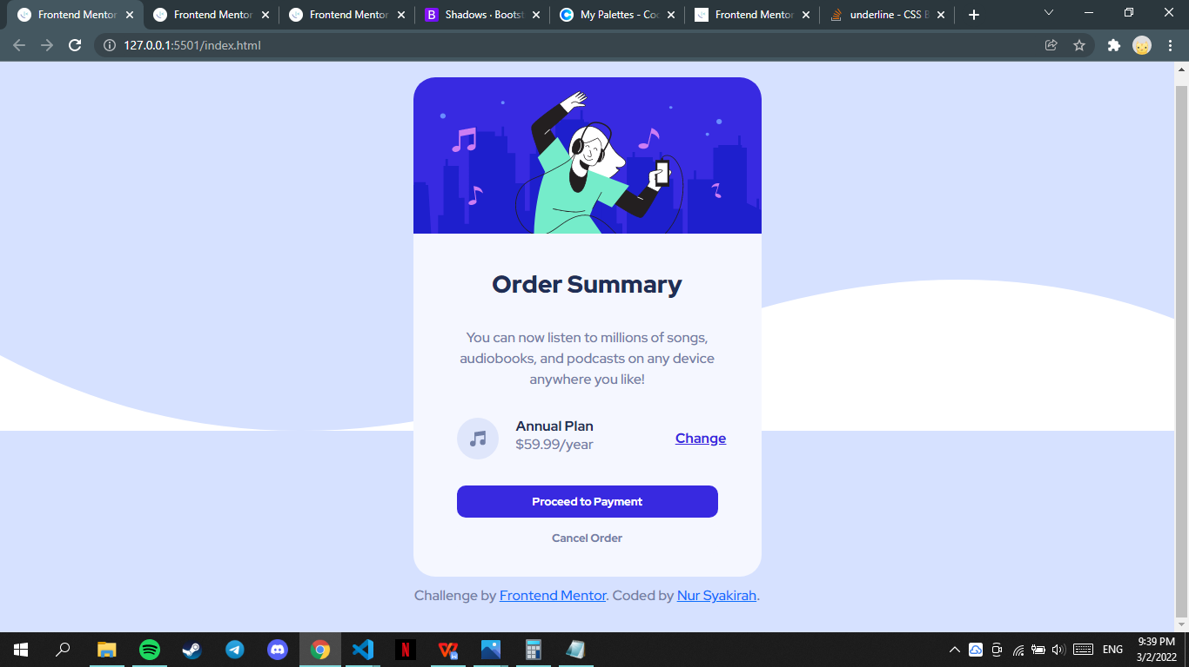

My process
Day 1
- Start designing
- Design for almost 4 hours\
- I’m using the template so it is more easier
- Create button
- Add shadow
- Add border radius
- Make it more responsive
- Add border radius to the corner of the div
- Add shadow to the corner of div
- Add shadow to the Proceed to Payment button
- Change the size of element to make every element the same size
Problem
- How to make the main-container div to center? [DONE]
SOLUTIONS:
display: flex;
justify-content: center;
align-items: center;

- How to make third-section div, music icon and Annual Plan space not too far but Annual
Plan with Change a little bit far
SOLUTIONS:
I add <div> with display flex and margin.
.sub-second-section {
display: flex;
flex-direction: column;
margin: 0 10px;
}

- issue with the main-container size, if too height it will display scroll bar. I don’t know if it only apply to my viewport only or it is responsive. **I don’t know how to solve this

Built with
- Semantic HTML5 markup
- CSS custom properties
- Flexbox
- Mobile-first workflow
- Bootstrap 5

What I learned
- Border radius property
Four values - border-radius: 15px 50px 30px 5px; (first value applies to top-left corner, second value applies to top-right corner, third value applies to bottom-right corner, and fourth value applies to bottom-left corner)

- Box shadow property
box-shadow: 5px 10px 8px 10px #888888; [to-right, bottom, blur effect, spread radius, colour]

Useful resources
- W3SCHOOLS (https://www.w3schools.com/) - TW3Schools is a freemium educational website for learning coding online.
- Bootstrap (https://getbootstrap.com/) - most popular HTML, CSS, and JavaScript framework for creating responsive, mobile-first websites. Bootstrap 5 is completely free to download and use!

Author
- Frontend Mentor - [@syakirahzalil](https://www.frontendmentor.io/profile/syakirahzalil)
- Github- [@syakirahzalil](https://github.com/syakirahzalil)

