4.0 API Testing
API testing was conducted using Postman to verify the functionality of the Venues API in the Event Ticketing and Venue Booking System. Testing covered creating, retrieving, updating and deleting venues, as well as checking venue availability. Both successful requests and error scenarios were tested to verify input validation, JWT authentication, role-based access control and protection of venues linked to existing events.

4.1 Testing Environment
Component | Configuration
API testing tool | Postman
Local Server | XAMPP with Apache
Backend | PHP
Database | MySQL/MariaDB
Database name | event_ticketing_db
API base URL | http://localhost/WebAPIFinalProject/api
Authentication | JWT Bearer Token

4.2 Test Cases and Results
No. | Test case | Method and endpoint | Expected result | Actual result
1 | Admin login | POST /auth/login | 200; JWT returned | Passed
2 | Retrieve all venues | GET /venues | 200; venue list returned | Passed
3 | Retrieve one venue | GET /venues/1 | 200; venue details returned | Passed
4 | Create venue | POST /venues | 201; venue created | Passed
5 | Update venue | PATCH /venues/{id} | 200; venue updated | Passed
6 | Delete test venue | DELETE /venues/{id} | 200; venue deleted | Passed
7 | Retrieve deleted venue | GET /venues/{id} | 404; venue not found | Passed
8 | Request without token | GET /venues | 401; authentication required | Passed
9 | Submit negative capacity | POST /venues | 422; validation error | Passed
10 | Delete venue linked to events | DELETE /venues/1 | 409; deletion blocked | Passed
11 | Check free time slot | GET /venues/2/availability | 200; available is true | Passed
12 | Check overlapping time slot | GET /venues/2/availability | 200; available is false; conflicting event returned | Passed
13 | Check maintenance venue | GET /venues/5/availability | 200; available is false | Passed
14 | Customer login | POST /auth/login | 200; customer JWT returned | Passed
15 | Customer attempts to create venue | POST /venues | 403; access denied | Passed
16 | Submit invalid venue ID | GET /venues/abc | 400; invalid ID message | Passed

For availability tests, the date was 14 November 2026. Venue 2 was available between 09:00 and 10:00, while 19:00 to 20:00 overlapped with Muar Music Fest 2026. Venue 5 was unavailable because its status was maintenance.
Error responses were expected outcomes in the negative tests. A test passed when the API returned the appropriate response.

4.3 Testing Evidence
The following Postman screenshots show successful requests and expected error responses. Each screenshot includes the HTTP method, request URL, response status and JSON response.
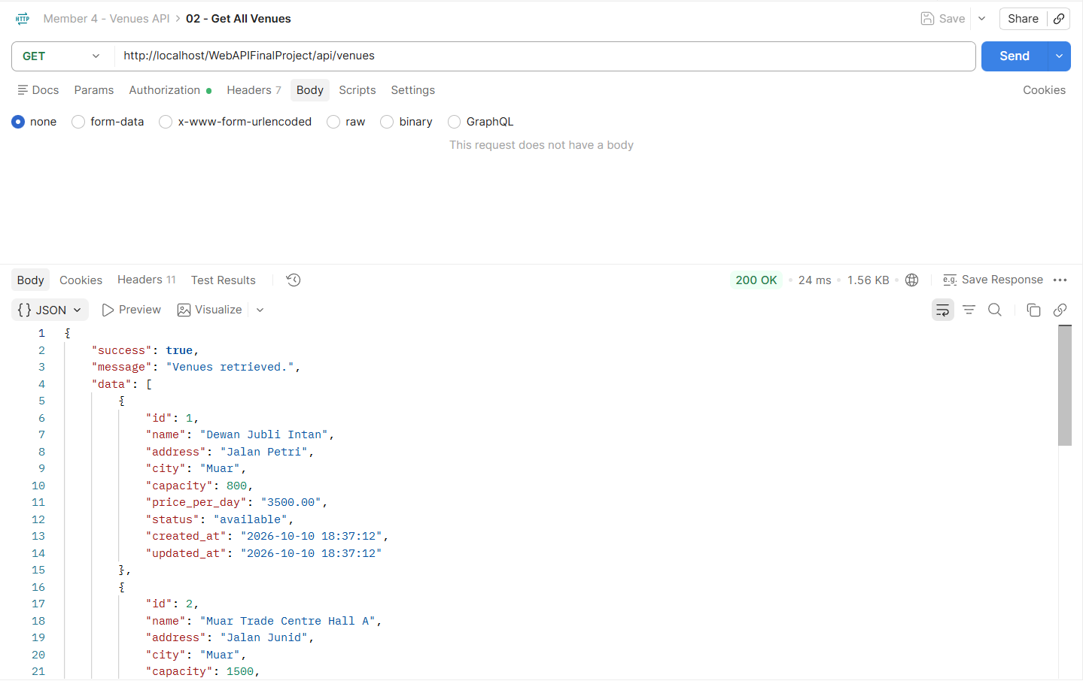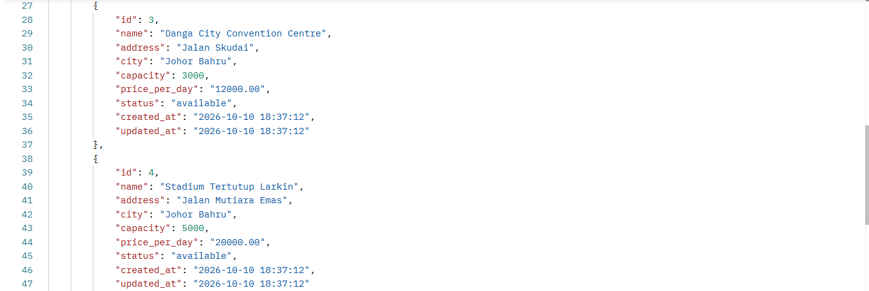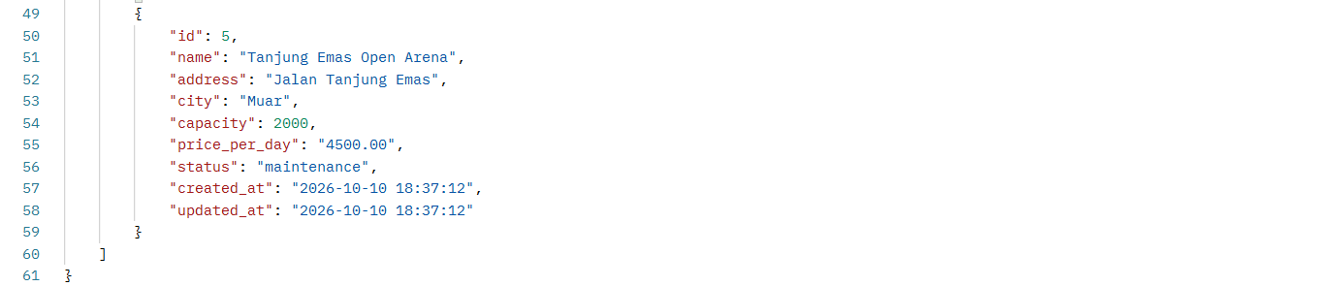
Figure 4.1: Successful retrieval of the venue list (200 OK).

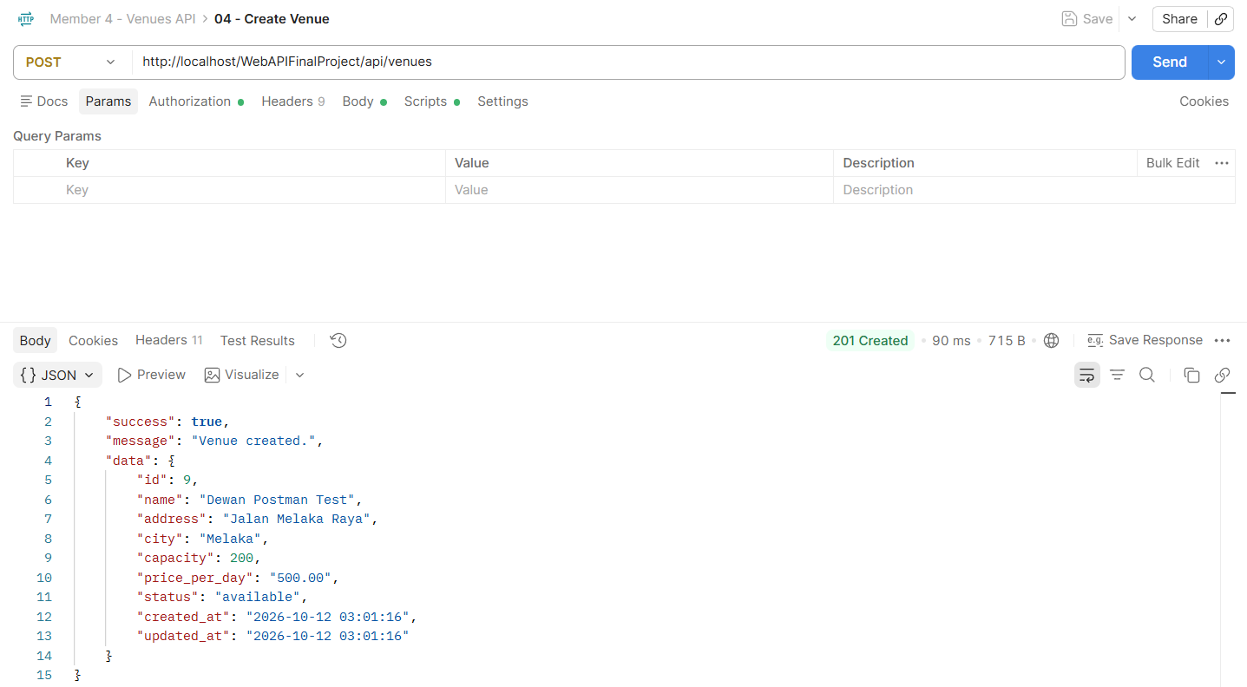
Figure 4.2: Successful creation of a venue (201 Created).
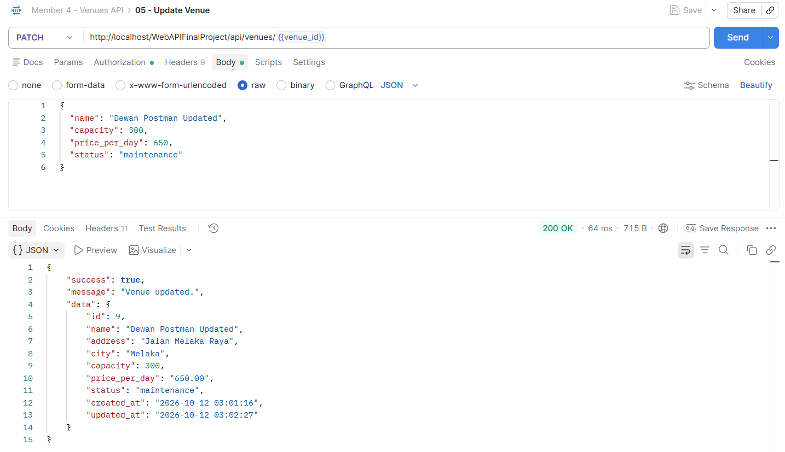
Figure 4.3: Successful update of venue details (200 OK).
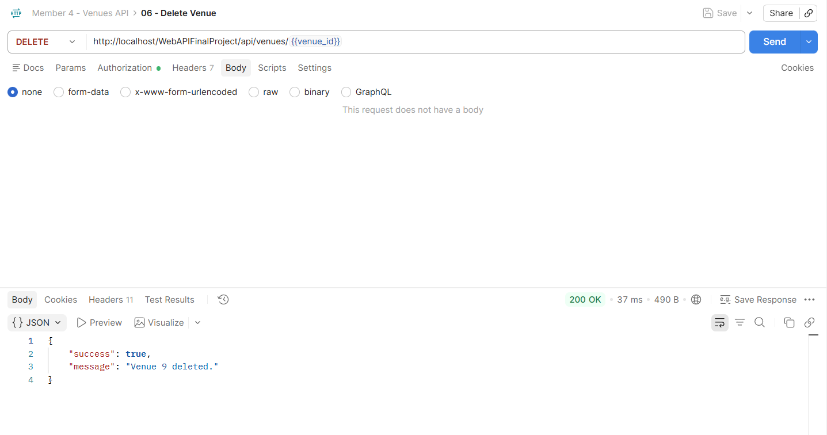
Figure 4.4: Successful deletion of the test venue (200 OK).
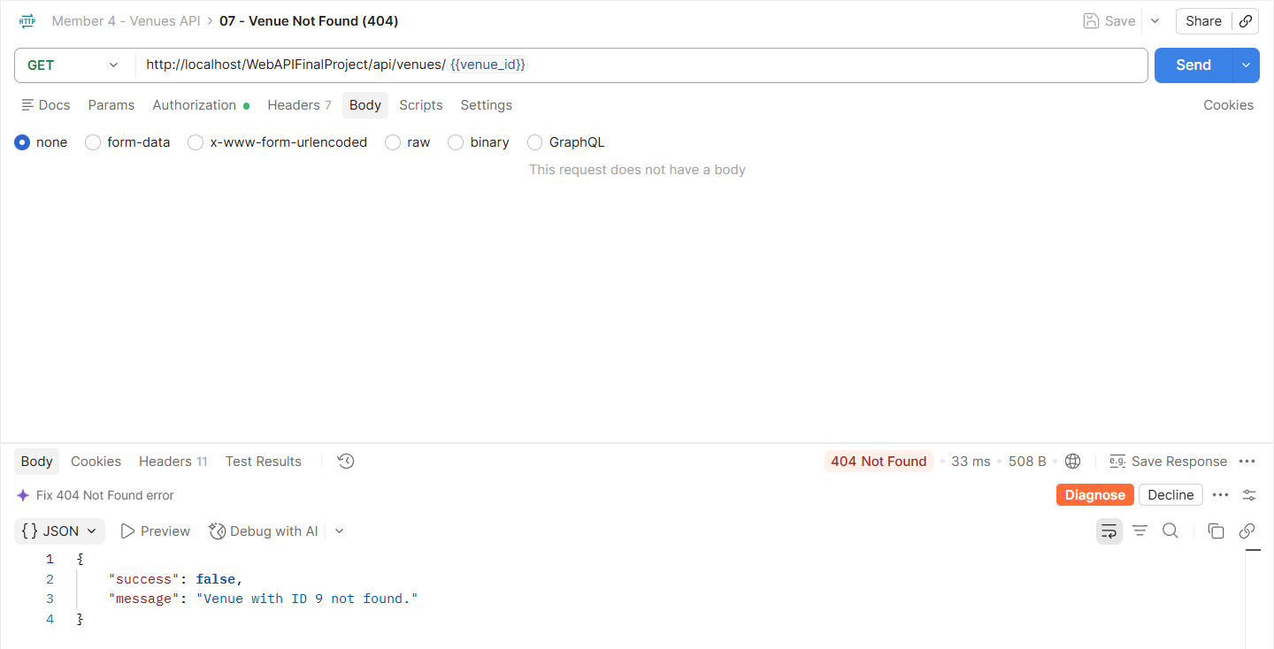
Figure 4.5: Request for a deleted venue returns 404 Not Found.
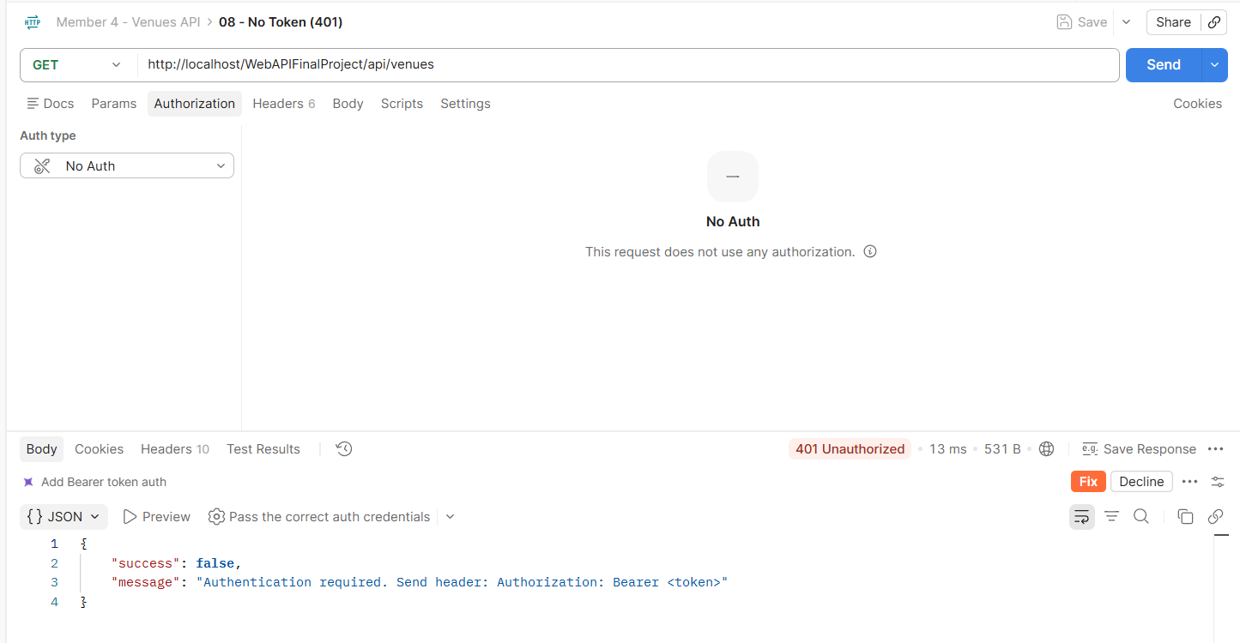
Figure 4.6: A request without a JWT token returns 401 Unauthorized.
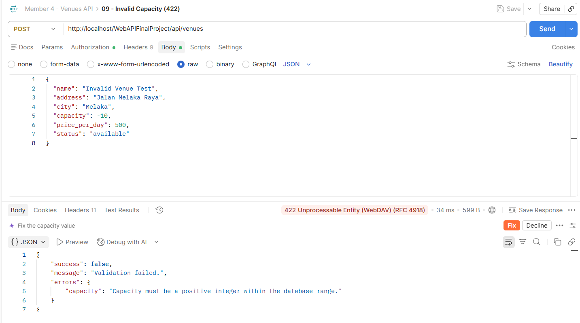
Figure 4.7: A negative venue capacity is rejected with a 422 validation response.
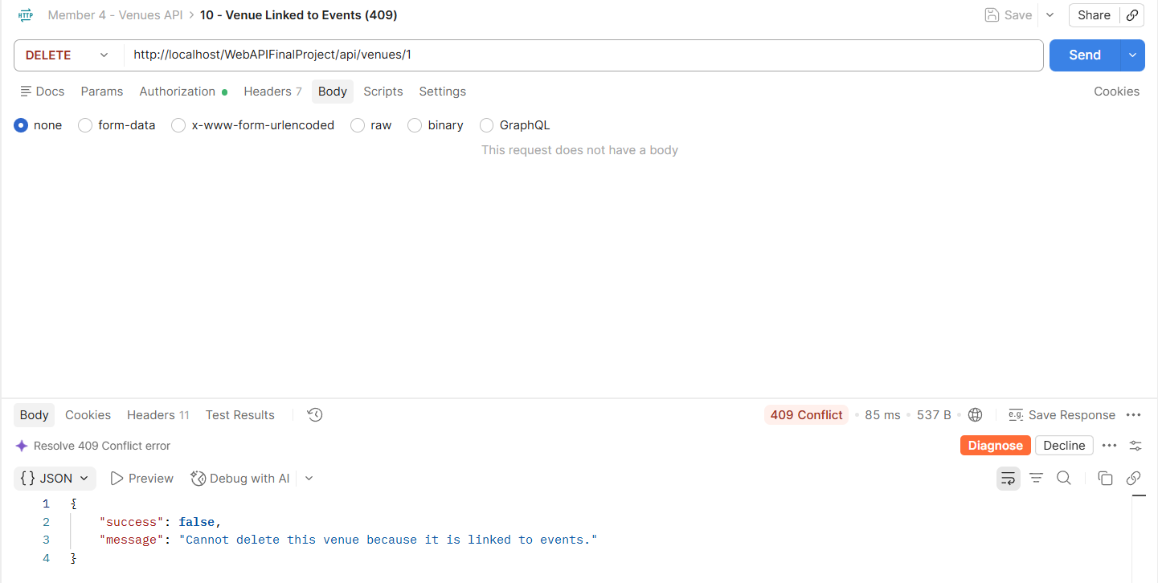
Figure 4.8: Deletion of a venue linked to existing events is blocked with 409 Conflict.
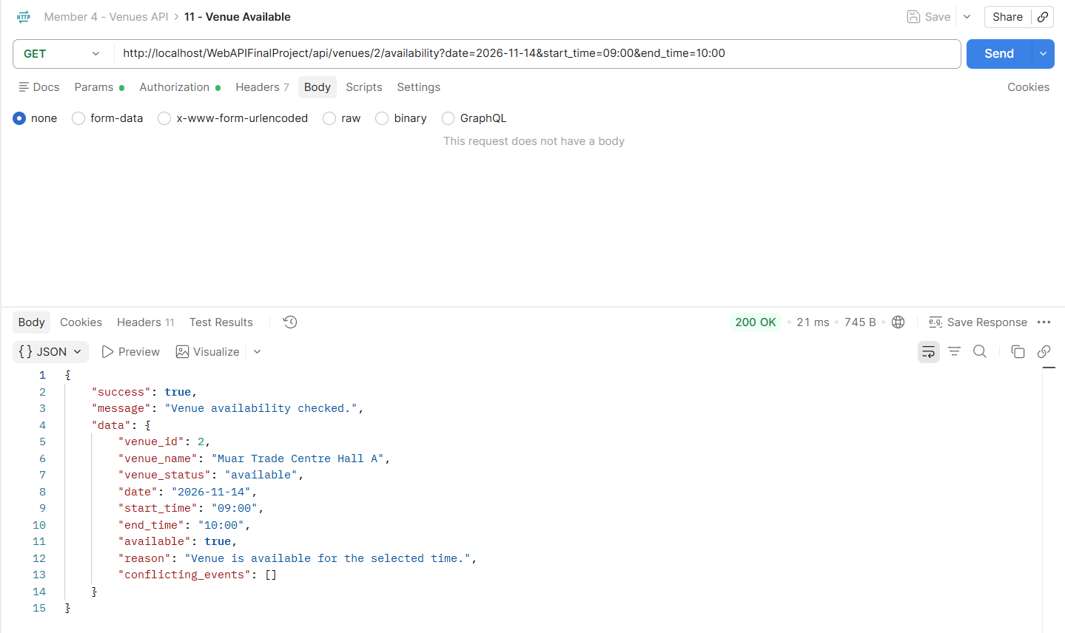
Figure 4.9: Venue 2 is available on 14 November 2026 from 09:00 to 10:00.
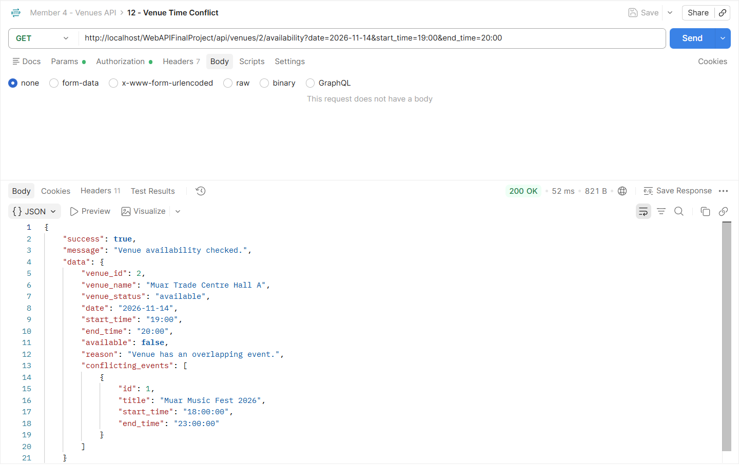
Figure 4.10: Venue 2 is unavailable from 19:00 to 20:00 on 14 November 2026 because the requested slot overlaps with an existing event.

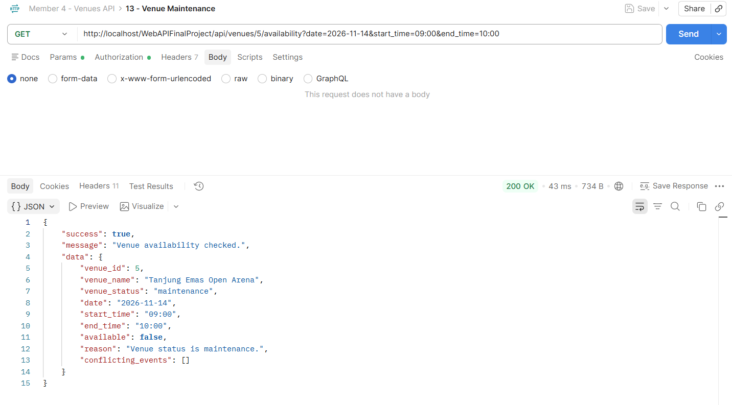
Figure 4.11: Venue 5 is unavailable because its status is maintenance.
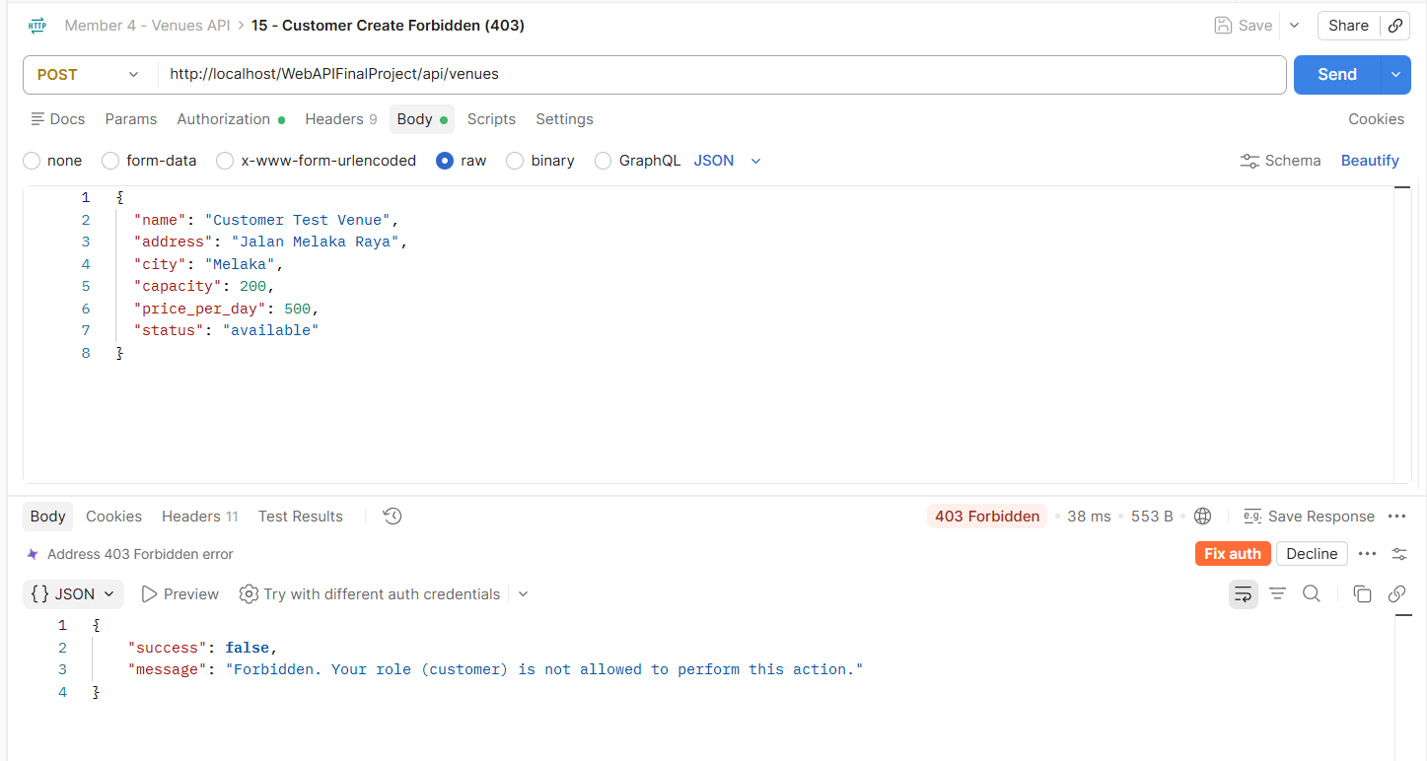
Figure 4.12: A customer is denied permission to create a venue with a 403 Forbidden response.
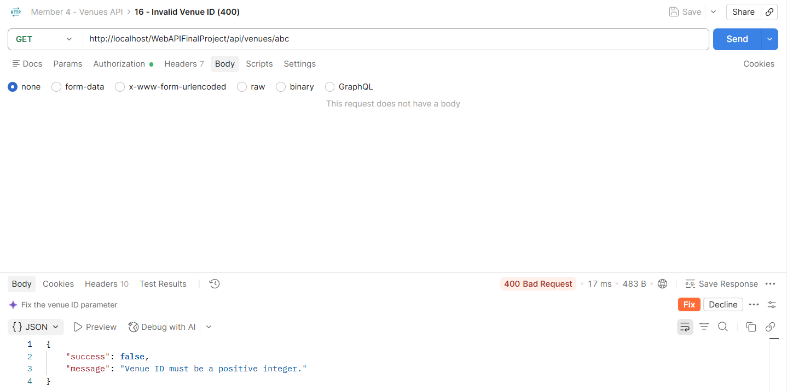
Figure 4.13: A non-numeric venue ID is rejected with 400 Bad Request.

4.4 Exported Postman Collection
The Venues API requests were saved in a Postman collection and exported as Member4_Venues_API.postman_collection.json, stored in the project’s docs folder. The collection contains CRUD requests, availability checks and negative test scenarios.
Login scripts automatically populate the admin_token and customer_token variables. The create-venue script stores the new venue ID in venue_id for subsequent update, delete and not-found requests. To repeat the tests, requests should be executed in numerical order. JWT values were cleared before export.

9.0 Debugging and Performance Optimisation
Debugging was carried out during API development and frontend integration. Postman responses were used to identify authentication, validation and database connection issues. The following table summarises the issues encountered and the solutions applied.
Issue | Cause | Solution
Database connection failed | MySQL used port 3307, but the PDO connection did not specify this port. | Added DB_PORT to the PDO connection string and matched the configuration to XAMPP.
API returned 401 when a token had expired | The JWT was no longer valid. | Logged in again to obtain a fresh token. Login scripts were added to Postman to populate token variables automatically.
Postman displayed “Secrets Detected” when saving requests | A JWT value was entered directly into the request. | Replaced literal tokens with {{admin_token}} and {{customer_token}}. Token values were cleared before exporting.
Update and delete requests depended on a fixed test ID | Newly created venues received different auto-increment IDs. | Added a post-response script to store the created ID in venue_id, then used {{venue_id}} in subsequent requests.

Responses such as 400, 403, 404, 409 and 422 were expected outcomes for invalid or restricted requests. These responses demonstrated correct error handling rather than unresolved system faults.

9.2 Performace Testing
The response time of GET /venues was measured using Postman on the local XAMPP server. After a warm-up request, five requests were sent sequentially, and the response time of each request was recorded.
Request | Response Time
1 | 44 ms
2 | 54 ms
3 | 38 ms
4 | 40 ms
5 | 49 ms
Average | 45 ms
Minimum | 38 ms
Maximum | 54 ms

The average response time was 45 ms, with readings ranging from 38 to 54 ms. These results describe a small local test using the sample database. They do not measure performance under concurrent users or demonstrate an improvement from a before-and-after optimisation comparison.
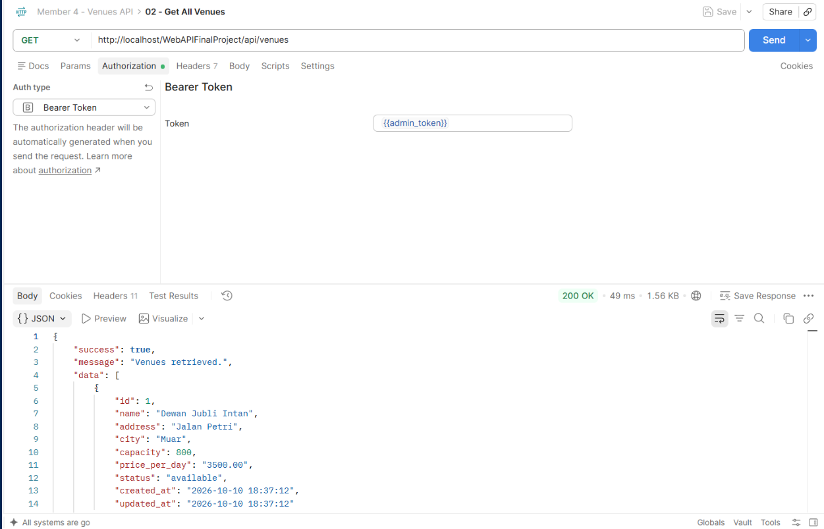
Figure 9.1: Postman response status and response time for GET /venues.
9.3 Implemented Improvements and Future Optimisation
The following improvements were implemented to support reliable API and frontend operation:
Improvement | Purpose
Server-side input validation | Rejects invalid venue details before database operations.
Prepared SQL statements | Keeps user-supplied values separate from SQL commands.
JWT authentication and role checks | Restricts venue management operations to authorised users.
Foreign-key error handling | Returns a clear 409 response when a venue is linked to events.
Availability conflict checking | Identifies overlapping draft or published events and checks venue status.
Disabled buttons during requests | Reduces repeated submissions while a request is processing.
Local frontend search | Filters the loaded venue list without sending an API request for each search input.
Postman token and venue ID variables | Makes the test sequence easier to repeat.

These changes improve validation, error handling and testing reliability. Their effect on response time was not measured through a before-and-after comparison.
For larger datasets, future optimisation could include server-side pagination and filtering. A composite index on event availability query fields could also be evaluated using EXPLAIN and repeatable performance tests. Concurrent-user testing would be required to assess performance under greater load.
Venue availability checking does not reserve a time slot. The Events API should enforce availability rules during event creation and updates to prevent conflicting schedules.

