Event Ticketing and Venue Booking System

2.0 Database Design

2.1 Overview
The system uses a MySQL database named event_ticketing_db (InnoDB engine, utf8mb4 character set) that runs on XAMPP. It contains four related tables: Users, Venues, Events and Bookings. Foreign keys enforce referential integrity. ON DELETE RESTRICT stops a user, venue or event from being deleted while other records still refer to it, so booking history is never lost by accident. In that situation the API returns a clear 409 Conflict message instead of a raw database error.
The design supports all three required roles. The Users table holds a role column (admin, organiser, customer) so that one login system can serve the Administrator, Organiser/Staff and Customer functions.

2.2 Entity Relationship Diagram (ERD)
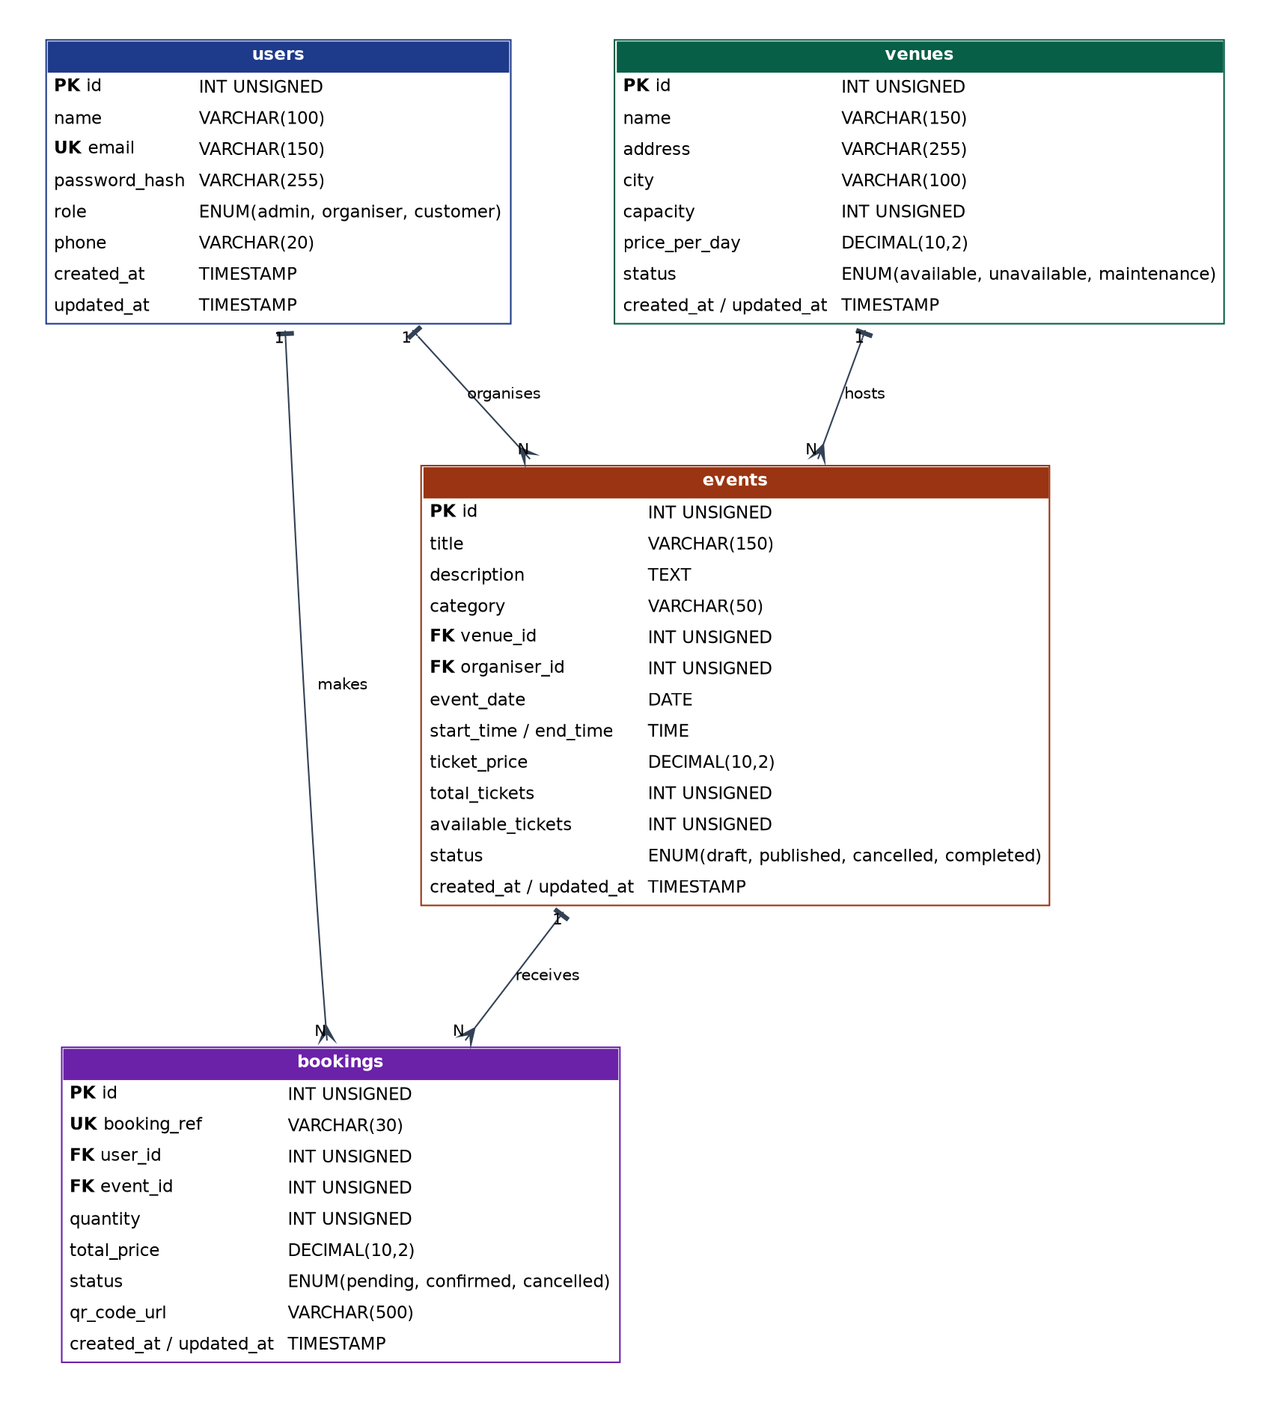
Figure 1: ERD of event_ticketing_db (PK = primary key, FK = foreign key, UK = unique key). A full-size copy is in docs/ERD.png.

Relationships
Relationship | Type | Foreign key
A venue hosts events | One-to-many | events.venue_id → venues.id
A user (organiser) organises events | One-to-many | events.organiser_id → users.id
A user (customer) makes bookings | One-to-many | bookings.user_id → users.id
An event receives bookings | One-to-many | bookings.event_id → events.id

Users and Events are therefore linked in a many-to-many way through the Bookings table, which acts as the junction table and also stores the quantity, total price and status of each booking.

2.3 Data Dictionary

users
Column | Type | Constraints / notes
id | INT UNSIGNED | Primary key, auto increment
name | VARCHAR(100) | Required
email | VARCHAR(150) | Required, UNIQUE (used to log in)
password_hash | VARCHAR(255) | Required. bcrypt hash, never plain text
role | ENUM | admin, organiser, customer. Default 'customer'
phone | VARCHAR(20) | Optional
created_at / updated_at | TIMESTAMP | Set automatically

venues
Column | Type | Constraints / notes
id | INT UNSIGNED | Primary key, auto increment
name | VARCHAR(150) | Required
address / city | VARCHAR(255) / VARCHAR(100) | Required
capacity | INT UNSIGNED | Required, CHECK capacity > 0
price_per_day | DECIMAL(10,2) | Default 0.00
status | ENUM | available, unavailable, maintenance. Default 'available'
created_at / updated_at | TIMESTAMP | Set automatically

events
Column | Type | Constraints / notes
id | INT UNSIGNED | Primary key, auto increment
title / description | VARCHAR(150) / TEXT | Title required, description optional
category | VARCHAR(50) | Required. Default 'Community' (for example Music, Technology, Sports)
venue_id | INT UNSIGNED | Foreign key → venues.id (RESTRICT)
organiser_id | INT UNSIGNED | Foreign key → users.id (RESTRICT)
event_date | DATE | Required, indexed
start_time / end_time | TIME | Required
ticket_price | DECIMAL(10,2) | Default 0.00
total_tickets / available_tickets | INT UNSIGNED | CHECK available_tickets <= total_tickets
status | ENUM | draft, published, cancelled, completed. Default 'draft', indexed
created_at / updated_at | TIMESTAMP | Set automatically

bookings
Column | Type | Constraints / notes
id | INT UNSIGNED | Primary key, auto increment
booking_ref | VARCHAR(30) | Required, UNIQUE (for example BK-20261001-0001)
user_id | INT UNSIGNED | Foreign key → users.id (RESTRICT), indexed
event_id | INT UNSIGNED | Foreign key → events.id (RESTRICT), indexed
quantity | INT UNSIGNED | CHECK quantity > 0
total_price | DECIMAL(10,2) | Required
status | ENUM | pending, confirmed, cancelled. Default 'pending'
qr_code_url | VARCHAR(500) | Link generated by the external QR Code API
created_at / updated_at | TIMESTAMP | Set automatically

2.4 SQL Scripts (DDL and DML)
- DDL – database/schema.sql: creates the database, drops old tables safely, then creates all four tables with primary keys, foreign keys, UNIQUE constraints, CHECK constraints and indexes.
- DML – database/seed.sql: inserts 6 users, 5 venues, 6 events and 8 bookings (the minimum required is 5 records per table). The available_tickets values in events already match the confirmed bookings.
- Import order: schema.sql first, then seed.sql. The complete scripts are listed in Appendix A and Appendix B.

2.5 Design Decisions
- One Users table with a role column keeps authentication simple and supports the three required roles.
- Passwords are hashed with bcrypt (PHP password_hash) so that no plain-text password is stored.
- ON DELETE RESTRICT protects booking history. The API converts the database error into a 409 Conflict response.
- A unique booking reference and a QR code URL give every booking a scannable ticket identity.
- Indexes on event_date, status, user_id and event_id speed up searching and filtering.
- CHECK constraints (capacity > 0, quantity > 0, available_tickets <= total_tickets) stop invalid data at database level, in addition to API validation.

Users API, Login and JWT Authentication (Member 2 coding)

Authentication flow
- The client sends POST /auth/login with email and password.
- The server finds the user and checks the password with password_verify(). The same 401 message is used for an unknown email and a wrong password, so it does not reveal which one failed.
- The server returns a signed JWT (HS256) containing sub (user id), role, name, email, iat and exp (valid for 2 hours).
- The client sends Authorization: Bearer <token> on every protected request.
- Middleware in core/auth.php verifies the signature and expiry (require_auth) and then checks the role (require_role).

Endpoints
Method | URL | Access | Description
POST | /auth/register | Public | Register a customer account
POST | /auth/login | Public | Log in and receive a JWT
GET | /auth/me | Logged-in user | View own profile
GET | /users | Admin | List users (page, limit, search, role)
GET | /users/{id} | Admin or self | View one user
POST | /users | Admin | Create a user with any role
PUT | /users/{id} | Admin or self | Update a user (only admin can change role)
DELETE | /users/{id} | Admin | Delete a user (not yourself)

Users API permissions
Action | Admin | Organiser | Customer
List users | Allowed | 403 Forbidden | 403 Forbidden
View user | Any user | Own profile only | Own profile only
Create user | Allowed | 403 Forbidden | 403 (use /auth/register)
Update user | Any user, including role | Own profile, no role change | Own profile, no role change
Delete user | Allowed (not self) | 403 Forbidden | 403 Forbidden

Validation and error handling
Name must be 2–100 characters, email must be valid, password must be at least 8 characters with letters and numbers, role must be admin, organiser or customer, and phone is optional but must match a phone format. Public registration can only create customers, which prevents privilege escalation. All errors use one JSON format:
{ "success": false, "message": "Validation failed.", "errors": { "email": "Email format is invalid." } }

Status | Meaning in this API
200 / 201 | Request succeeded / record created
400 | Bad request (invalid JSON, empty body, invalid ID, removing own admin role)
401 | Missing, invalid or expired token, or wrong login details
403 | Role not allowed to perform the action
404 | User or endpoint not found
409 | Duplicate email, or user still has events or bookings
422 | Validation failed (field-level errors returned)
500 | Unexpected server or database error

Extra features
- Pagination (page and limit, maximum 100 per page) with total and total_pages returned.
- Search by name or email, and filter by role.
- Consistent JSON response and error format shared with the other members.
- CORS headers so every member’s frontend can call the API.

Sample accounts
Role | Email | Password | User ID
Admin | admin@event.com | Admin@123 | 1
Organiser | hafiz@event.com | Organiser@123 | 2
Organiser | meiling@event.com | Organiser@123 | 3
Customer | daniel@mail.com | Customer@123 | 4
Customer | nurul@mail.com | Customer@123 | 5
Customer | arjun@mail.com | Customer@123 | 6

Test cases for Postman
# | Request | Expected result
1 | POST /auth/login with valid admin account | 200 and a token
2 | POST /auth/login with wrong password | 401
3 | POST /auth/login with empty fields | 422
4 | POST /auth/register with a new customer | 201
5 | POST /auth/register with a duplicate email | 409
6 | GET /users without a token | 401
7 | GET /users as customer | 403
8 | GET /users?page=1&limit=3&search=a as admin | 200 with pagination
9 | GET /users/999 as admin | 404
10 | PUT /users/4 as customer with {"role":"admin"} | 403
11 | PUT /users/4 as customer with {"phone":"011-1234567"} | 200
12 | DELETE /users/2 as admin (user has events) | 409
13 | DELETE /users/{newly created id} as admin | 200

7.0 Project Repository

7.1 Repository Information
- Platform: GitHub
- Repository name: event-ticketing
- Repository URL: https://github.com/<your-username>/event-ticketing (replace with the real link after you create the repository)
- Visibility: Private, with the lecturer or tutor added as a collaborator (or public if the course requires it).

7.2 Repository Structure
event-ticketing/
├── README.md setup + API guide
├── .gitignore
├── database/ schema.sql, seed.sql
├── api/ shared backend (PHP + MySQL)
│ ├── index.php router
│ ├── config/ config.php, database.php
│ ├── core/ jwt.php, auth.php, response.php, validator.php
│ └── routes/ auth.php, users.php (+ events, venues, bookings)
├── frontend/ each member's own frontend (member1 ... member5)
├── postman/ collection + screenshots
└── docs/ report, ERD.png, contribution evidence

Setup Instructions
- Install XAMPP and start Apache and MySQL in the XAMPP Control Panel.
- Clone or copy the event-ticketing folder into C:\xampp\htdocs\.
- Open http://localhost/phpmyadmin, choose Import, then import database/schema.sql followed by database/seed.sql.
- Check api/config/config.php. The XAMPP default is user root with an empty password. Every member must use the same JWT_SECRET.
- Open http://localhost/event-ticketing/api/ . The message "Event Ticketing & Venue Booking API is running." confirms that the backend works.
- Point your frontend to the API base URL: http://localhost/event-ticketing/api

Git Workflow
- The main branch must always work. After the first commit, nobody pushes directly to main.
- Each member works on a branch, for example member2-database-users.
- Changes are merged into main through a Pull Request reviewed by at least one other member.
- Commit messages follow a simple style: feat(users): add DELETE /users/{id}, fix(auth): return 401 for expired token, docs: add ERD.

Commands used to create the repository (Member 2)
cd C:\xampp\htdocs\event-ticketing
git init
git add .
git commit -m "chore: initial project structure, database scripts and users API"
git branch -M main
git remote add origin https://github.com/<your-username>/event-ticketing.git
git push -u origin main

After pushing, invite the other members and the lecturer under Settings → Collaborators.

7.5 Contribution Record
Member | Main contribution | Evidence
Member 1 | System overview, event browsing frontend | Commits and files in frontend/member1
Member 2 | Database design, ERD, SQL scripts, Users API, JWT login, repository setup | database/*.sql, api/routes/users.php, api/routes/auth.php, api/core/*, docs/ERD.png, GitHub commits
Member 3 | Events API, event management frontend, API documentation | Commits and files
Member 4 | Venues API, venue frontend, Postman testing | Commits and files
Member 5 | Bookings API, booking frontend, QR API, video | Commits and files

Appendix A – schema.sql (DDL)
-- =====================================================================
-- Event Ticketing and Venue Booking System | DDL (schema)
-- Database: event_ticketing_db | Engine: MySQL / MariaDB (XAMPP)
-- Import order: 1) schema.sql 2) seed.sql
-- =====================================================================
CREATE DATABASE IF NOT EXISTS event_ticketing_db
CHARACTER SET utf8mb4 COLLATE utf8mb4_unicode_ci;
USE event_ticketing_db;

SET FOREIGN_KEY_CHECKS = 0;
DROP TABLE IF EXISTS bookings;
DROP TABLE IF EXISTS events;
DROP TABLE IF EXISTS venues;
DROP TABLE IF EXISTS users;
SET FOREIGN_KEY_CHECKS = 1;

-- ---------------------------------------------------------------------
-- USERS (roles: admin | organiser | customer)
-- ---------------------------------------------------------------------
CREATE TABLE users (
id INT UNSIGNED AUTO_INCREMENT PRIMARY KEY,
name VARCHAR(100) NOT NULL,
email VARCHAR(150) NOT NULL,
password_hash VARCHAR(255) NOT NULL,
role ENUM('admin','organiser','customer') NOT NULL DEFAULT 'customer',
phone VARCHAR(20) NULL,
created_at TIMESTAMP NOT NULL DEFAULT CURRENT_TIMESTAMP,
updated_at TIMESTAMP NOT NULL DEFAULT CURRENT_TIMESTAMP ON UPDATE CURRENT_TIMESTAMP,
CONSTRAINT uq_users_email UNIQUE (email)
) ENGINE=InnoDB;

-- ---------------------------------------------------------------------
-- VENUES
-- ---------------------------------------------------------------------
CREATE TABLE venues (
id INT UNSIGNED AUTO_INCREMENT PRIMARY KEY,
name VARCHAR(150) NOT NULL,
address VARCHAR(255) NOT NULL,
city VARCHAR(100) NOT NULL,
capacity INT UNSIGNED NOT NULL,
price_per_day DECIMAL(10,2) NOT NULL DEFAULT 0.00,
status ENUM('available','unavailable','maintenance') NOT NULL DEFAULT 'available',
created_at TIMESTAMP NOT NULL DEFAULT CURRENT_TIMESTAMP,
updated_at TIMESTAMP NOT NULL DEFAULT CURRENT_TIMESTAMP ON UPDATE CURRENT_TIMESTAMP,
CONSTRAINT chk_venues_capacity CHECK (capacity > 0)
) ENGINE=InnoDB;

-- ---------------------------------------------------------------------
-- EVENTS (each event is held at one venue and owned by one organiser)
-- ---------------------------------------------------------------------
CREATE TABLE events (
id INT UNSIGNED AUTO_INCREMENT PRIMARY KEY,
title VARCHAR(150) NOT NULL,
description TEXT NULL,
category VARCHAR(50) NOT NULL DEFAULT 'Community',
venue_id INT UNSIGNED NOT NULL,
organiser_id INT UNSIGNED NOT NULL,
event_date DATE NOT NULL,
start_time TIME NOT NULL,
end_time TIME NOT NULL,
ticket_price DECIMAL(10,2) NOT NULL DEFAULT 0.00,
total_tickets INT UNSIGNED NOT NULL,
available_tickets INT UNSIGNED NOT NULL,
status ENUM('draft','published','cancelled','completed') NOT NULL DEFAULT 'draft',
created_at TIMESTAMP NOT NULL DEFAULT CURRENT_TIMESTAMP,
updated_at TIMESTAMP NOT NULL DEFAULT CURRENT_TIMESTAMP ON UPDATE CURRENT_TIMESTAMP,
CONSTRAINT fk_events_venue FOREIGN KEY (venue_id) REFERENCES venues(id) ON DELETE RESTRICT ON UPDATE CASCADE,
CONSTRAINT fk_events_organiser FOREIGN KEY (organiser_id) REFERENCES users(id) ON DELETE RESTRICT ON UPDATE CASCADE,
CONSTRAINT chk_events_tickets CHECK (available_tickets <= total_tickets),
INDEX idx_events_date (event_date),
INDEX idx_events_status (status)
) ENGINE=InnoDB;

-- ---------------------------------------------------------------------
-- BOOKINGS (a customer books tickets for one event)
-- ---------------------------------------------------------------------
CREATE TABLE bookings (
id INT UNSIGNED AUTO_INCREMENT PRIMARY KEY,
booking_ref VARCHAR(30) NOT NULL,
user_id INT UNSIGNED NOT NULL,
event_id INT UNSIGNED NOT NULL,
quantity INT UNSIGNED NOT NULL,
total_price DECIMAL(10,2) NOT NULL,
status ENUM('pending','confirmed','cancelled') NOT NULL DEFAULT 'pending',
qr_code_url VARCHAR(500) NULL, -- filled from the external QR Code API
created_at TIMESTAMP NOT NULL DEFAULT CURRENT_TIMESTAMP,
updated_at TIMESTAMP NOT NULL DEFAULT CURRENT_TIMESTAMP ON UPDATE CURRENT_TIMESTAMP,
CONSTRAINT uq_bookings_ref UNIQUE (booking_ref),
CONSTRAINT fk_bookings_user FOREIGN KEY (user_id) REFERENCES users(id) ON DELETE RESTRICT ON UPDATE CASCADE,
CONSTRAINT fk_bookings_event FOREIGN KEY (event_id) REFERENCES events(id) ON DELETE RESTRICT ON UPDATE CASCADE,
CONSTRAINT chk_bookings_qty CHECK (quantity > 0),
INDEX idx_bookings_user (user_id),
INDEX idx_bookings_event (event_id)
) ENGINE=InnoDB;

Appendix B – seed.sql (DML)
-- =====================================================================
-- Sample data (DML) | Run AFTER schema.sql
-- Login accounts (password in brackets):
-- admin@event.com (Admin@123) -> admin
-- hafiz@event.com (Organiser@123) -> organiser
-- meiling@event.com (Organiser@123) -> organiser
-- daniel@mail.com / nurul@mail.com / arjun@mail.com (Customer@123) -> customer
-- Passwords are stored as bcrypt hashes (never plain text).
-- =====================================================================
USE event_ticketing_db;

INSERT INTO users (id, name, email, password_hash, role, phone) VALUES
(1, 'Aisyah Rahman', 'admin@event.com', '$2b$10$5bSdp6a9JEKmgz9tbPLSaub5Y58PV8mnmYK.rn6Pi/.gOHH04nu7y', 'admin', '012-3456789'),
(2, 'Hafiz Ismail', 'hafiz@event.com', '$2b$10$ZztYr1.jw1FsgQCHpnA1eOWnuGU654IFoHnt.rWOG/IXiP33N33pe', 'organiser', '013-1112233'),
(3, 'Tan Mei Ling', 'meiling@event.com', '$2b$10$ZztYr1.jw1FsgQCHpnA1eOWnuGU654IFoHnt.rWOG/IXiP33N33pe', 'organiser', '014-5556677'),
(4, 'Daniel Lim', 'daniel@mail.com', '$2b$10$y33K3c8N1yN7j0uX6hQ1Ae0NV/vNdg6RiJdMzZHwm7gtzIGDkV17i', 'customer', '016-7778899'),
(5, 'Nurul Huda', 'nurul@mail.com', '$2b$10$y33K3c8N1yN7j0uX6hQ1Ae0NV/vNdg6RiJdMzZHwm7gtzIGDkV17i', 'customer', '017-2223344'),
(6, 'Arjun Kumar', 'arjun@mail.com', '$2b$10$y33K3c8N1yN7j0uX6hQ1Ae0NV/vNdg6RiJdMzZHwm7gtzIGDkV17i', 'customer', '019-8889900');

INSERT INTO venues (id, name, address, city, capacity, price_per_day, status) VALUES
(1, 'Dewan Jubli Intan', 'Jalan Petri', 'Muar', 800, 3500.00, 'available'),
(2, 'Muar Trade Centre Hall A', 'Jalan Junid', 'Muar', 1500, 6000.00, 'available'),
(3, 'Danga City Convention Centre', 'Jalan Skudai', 'Johor Bahru', 3000, 12000.00, 'available'),
(4, 'Stadium Tertutup Larkin', 'Jalan Mutiara Emas', 'Johor Bahru', 5000, 20000.00, 'available'),
(5, 'Tanjung Emas Open Arena', 'Jalan Tanjung Emas', 'Muar', 2000, 4500.00, 'maintenance');

INSERT INTO events (id, title, description, category, venue_id, organiser_id, event_date, start_time, end_time, ticket_price, total_tickets, available_tickets, status) VALUES
(1, 'Muar Music Fest 2026', 'A night of live local bands and food stalls.', 'Music', 2, 2, '2026-11-14', '18:00:00', '23:00:00', 60.00, 1000, 994, 'published'),
(2, 'Johor Tech Summit 2026', 'Talks and workshops on AI, cloud and startups.', 'Technology', 3, 3, '2026-12-05', '09:00:00', '17:00:00', 120.00, 300, 297, 'published'),
(3, 'Charity Gala Dinner', 'Fundraising dinner with live auction.', 'Charity', 1, 2, '2026-11-28', '19:00:00', '22:30:00', 45.00, 500, 500, 'published'),
(4, 'Stand-Up Comedy Night', 'Top comedians perform live.', 'Entertainment', 1, 3, '2026-12-12', '20:00:00', '22:00:00', 80.00, 200, 200, 'cancelled'),
(5, 'Startup Pitch Day', 'Student and early-stage startups pitch to investors.', 'Business', 2, 3, '2027-01-16', '10:00:00', '16:00:00', 35.00, 150, 148, 'published'),
(6, 'Futsal Charity Cup', 'Inter-school futsal tournament.', 'Sports', 4, 2, '2027-02-07', '08:00:00', '18:00:00', 25.00, 400, 395, 'published');

INSERT INTO bookings (id, booking_ref, user_id, event_id, quantity, total_price, status, qr_code_url) VALUES
(1, 'BK-20261001-0001', 4, 1, 2, 120.00, 'confirmed', 'https://api.qrserver.com/v1/create-qr-code/?size=200x200&data=BK-20261001-0001'),
(2, 'BK-20261001-0002', 5, 1, 4, 240.00, 'confirmed', 'https://api.qrserver.com/v1/create-qr-code/?size=200x200&data=BK-20261001-0002'),
(3, 'BK-20261002-0003', 6, 2, 1, 120.00, 'confirmed', 'https://api.qrserver.com/v1/create-qr-code/?size=200x200&data=BK-20261002-0003'),
(4, 'BK-20261003-0004', 4, 3, 3, 135.00, 'pending', NULL),
(5, 'BK-20261003-0005', 5, 4, 2, 160.00, 'cancelled', NULL),
(6, 'BK-20261004-0006', 6, 5, 2, 70.00, 'confirmed', 'https://api.qrserver.com/v1/create-qr-code/?size=200x200&data=BK-20261004-0006'),
(7, 'BK-20261005-0007', 4, 2, 2, 240.00, 'confirmed', 'https://api.qrserver.com/v1/create-qr-code/?size=200x200&data=BK-20261005-0007'),
(8, 'BK-20261006-0008', 5, 6, 5, 125.00, 'confirmed', 'https://api.qrserver.com/v1/create-qr-code/?size=200x200&data=BK-20261006-0008');

