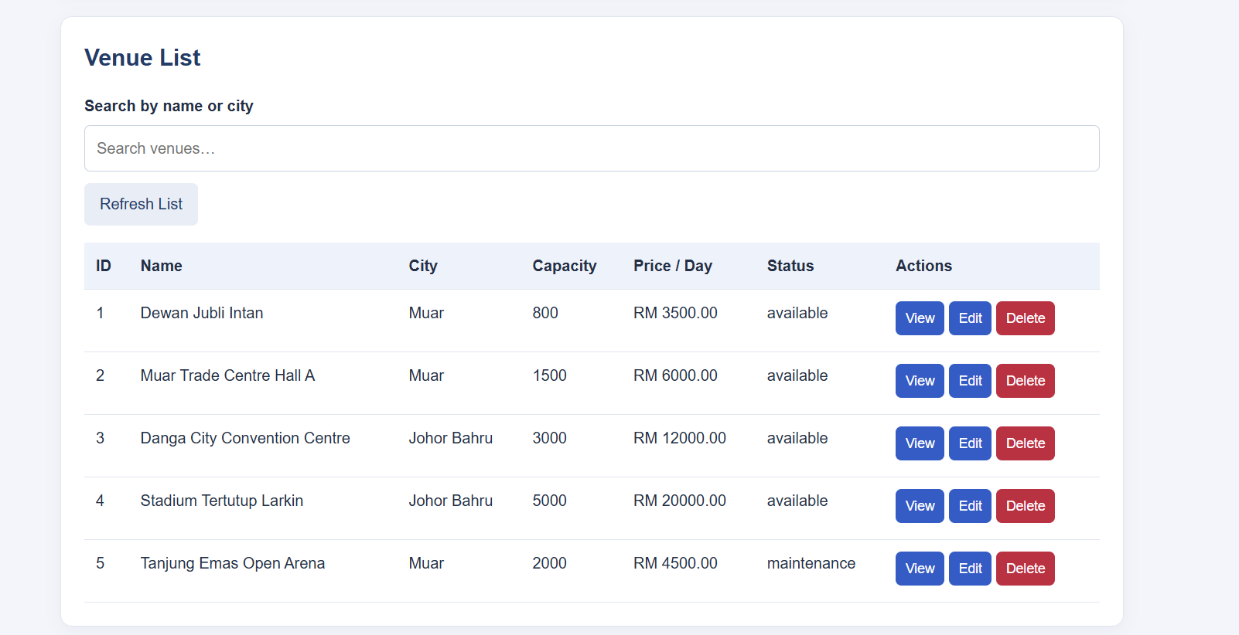
Figure 1: Admin Venue List

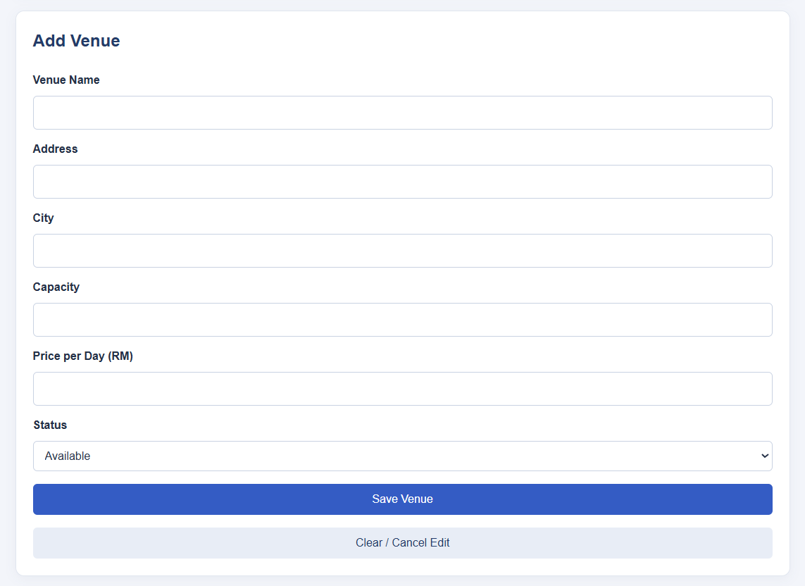
Figure 2: Admin Add Venue Form

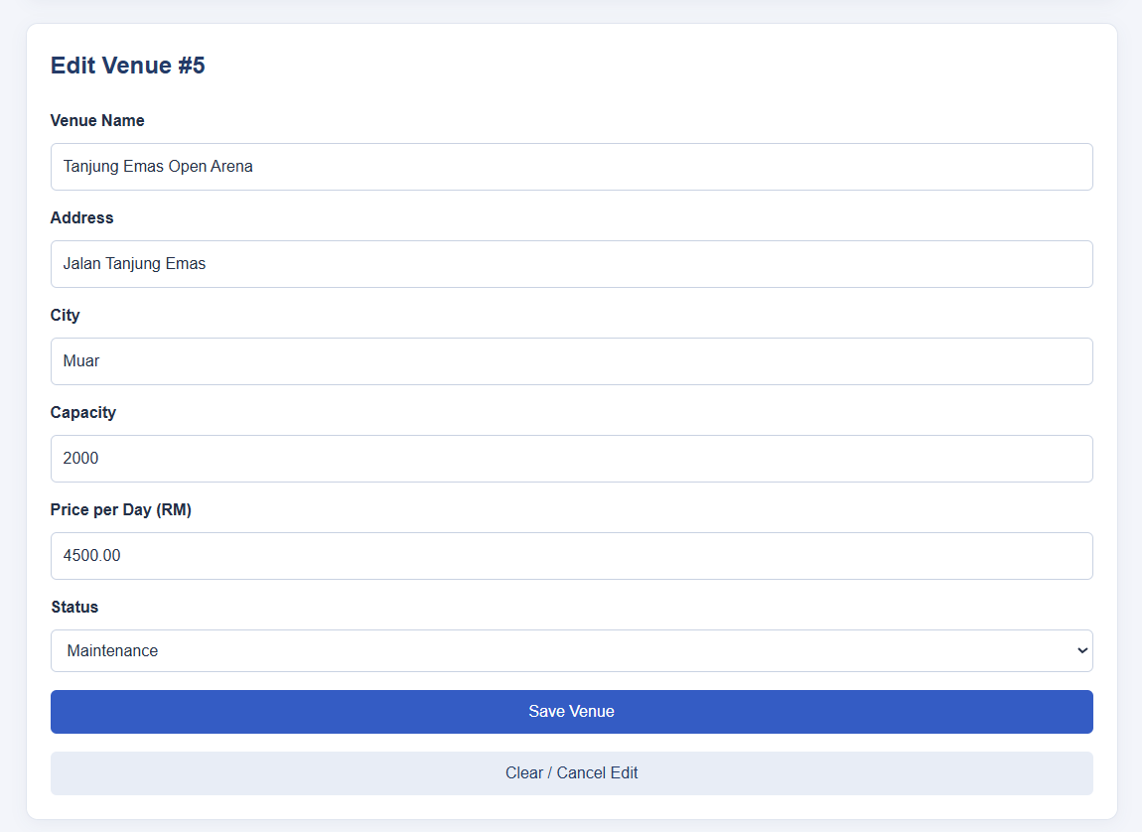
Figure 3: Admin Edit Venue Form

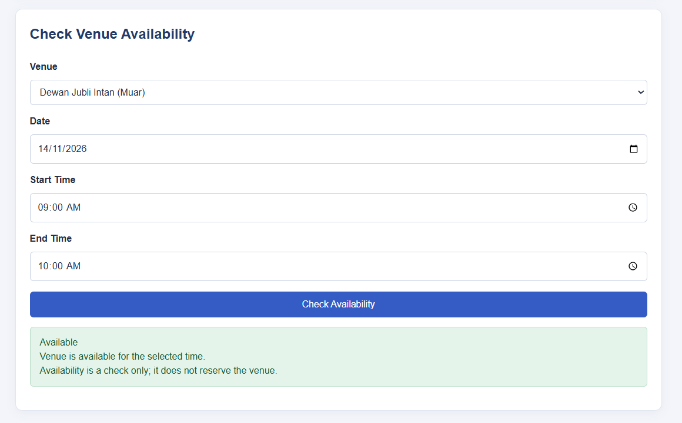Figure 4: Customer Venue Availability
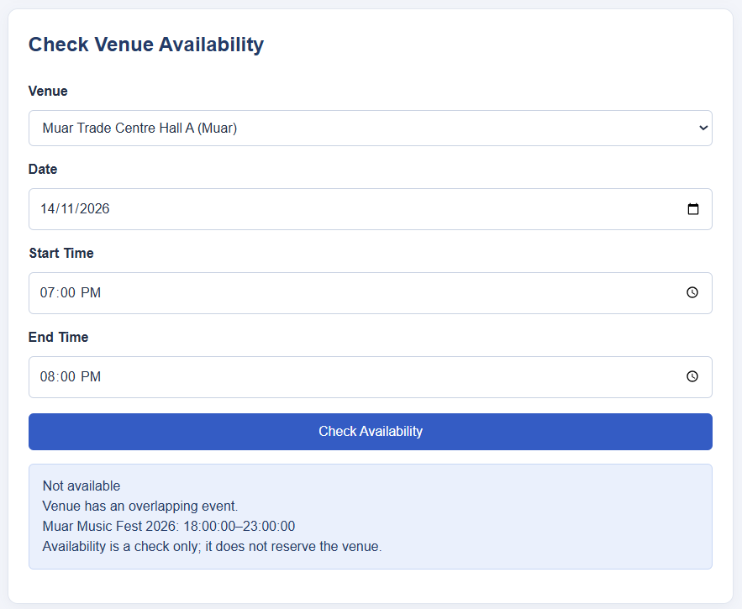
Figure 5: Venue Time Conflict

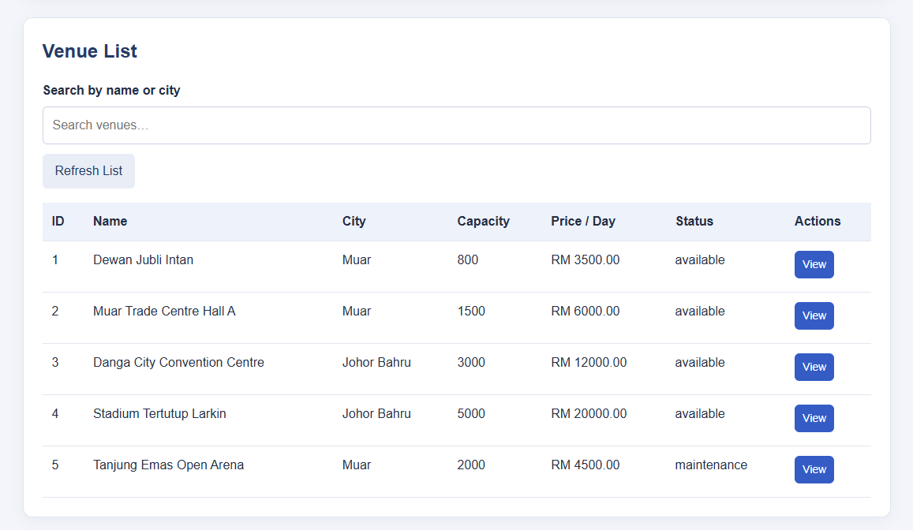Figure 6: Customer Venue List

