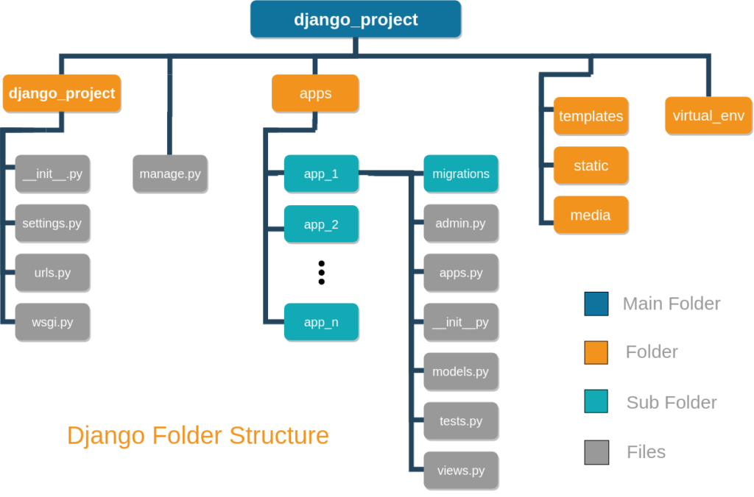

**Initial Setup for for an Django Project**

Step 1: Installing Virtual env

pip install virtualenvwrapper-win

Step 2: Create the virtual environment

mkvirtualenv test1

Step 2.1: Activate the virtual environment

mypthon\Scripts\activate

Step 2.2: Deactivate the virtual environment

Deactivate

Step 3: Install Django package

pip install Django

Step 3.1: Check Django package version

django-admin –version

Step 4 : Create Project

django-admin startproject example1

Step 4.1 : Get into the Project

cd example1

Step 5 : Command to run the Django project

python manage.py runserver

Step 6 : Url to start the Django project

<http://127.0.0.1:8000/>

Step 7 : Command to create new app

python manage.py startapp print_hello

**Hello World Program Using** **Django Framework**

Step 8 : Create urls.py in print_hello

from django.urls import path  
from . import views  
  
urlpatterns = [  
 path('',views.home, name = 'home')  
]

Step 9 : Modify views.py in print_hello

from django.shortcuts import render  
from django.http import HttpResponse  
  
*# Create your views here.*def home(request):  
 return HttpResponse("Hello World Example of PFSD Program")

Step 10 : Modify urls.py in Project – urls.py

path('',include('print_hello.urls'))

Step 11 : Add 1 line in Project – settings.py

INSTALLED_APPS = [  
 'print_hello'  
]

Step 12 : Run the code

Python manage.py runserver