🚦 Project Report – TrafficTelligence: Traffic Volume Prediction Using Machine Learning

1. INTRODUCTION

1.1 Project Overview
TrafficTelligence is a web-based AI solution that predicts traffic volume based on various input features like weather, holidays, and time. It leverages machine learning to provide real-time predictions, assisting city planners, commuters, and logistics companies in planning ahead.

1.2 Purpose
To build a predictive model that forecasts traffic volume using historical data and make it accessible via an easy-to-use web interface.

2. IDEATION PHASE

2.1 Problem Statement
Urban traffic congestion is a persistent problem affecting productivity, environment, and quality of life. Anticipating traffic volume can improve infrastructure planning and traffic management.

2.2 Empathy Map Canvas
Users: City commuters, municipal planners, logistics companies
Needs: Accurate predictions of traffic volume in various weather and time conditions
Pains: Delays, fuel costs, environmental impact
Gains: Smarter route planning, better scheduling, efficient traffic management

2.3 Brainstorming
- Use weather and time-based features for prediction
- Develop a machine learning model
- Deploy the solution via a simple web app
- Ensure it is user-friendly for non-technical users

3. REQUIREMENT ANALYSIS

3.1 Customer Journey Map
Stage | Action | Tool Used
--- | --- | ---
Input | User provides weather, time, etc. | HTML form
Processing | Flask app processes input | app.py, scaler, model
Output | Prediction is shown on screen | output.html

3.2 Solution Requirement
- Clean and preprocessed dataset
- Scikit-learn trained model
- Flask for web deployment
- HTML + Bootstrap for UI

3.3 Data Flow Diagram
[User Input Form] → [Flask app.py] → [Data Preprocessing] → [Scaler + ML Model] → [Prediction Output]

3.4 Technology Stack
- Frontend: HTML, CSS (Bootstrap)
- Backend: Flask (Python)
- ML Libraries: Scikit-learn, Pandas, NumPy
- Model: Trained regression model with scaling
- Tools: Jupyter Notebook, VS Code

4. PROJECT DESIGN

4.1 Problem-Solution Fit
By combining machine learning with weather and holiday-based data, we provide a solution that predicts traffic volume effectively.

4.2 Proposed Solution
A web-based tool where users input current conditions to receive a traffic volume estimate.

4.3 Solution Architecture
- UI collects inputs
- Flask backend transforms and scales data
- Pre-trained model predicts output
- Result rendered in output.html

5. PROJECT PLANNING & SCHEDULING

5.1 Project Planning
Phase | Timeline
--- | ---
Data Preprocessing | Week 1
Model Training | Week 2
Web App Integration | Week 3
Testing & Launch | Week 4

6. FUNCTIONAL AND PERFORMANCE TESTING

6.1 Performance Testing
- Model evaluated on MAE and RMSE
- Prediction latency tested on local server
- Input combinations tested for reliability

7. RESULTS

7.1 Output Screenshots
- index.html: Form to input weather, date, and time
- output.html: Displays predicted traffic volume{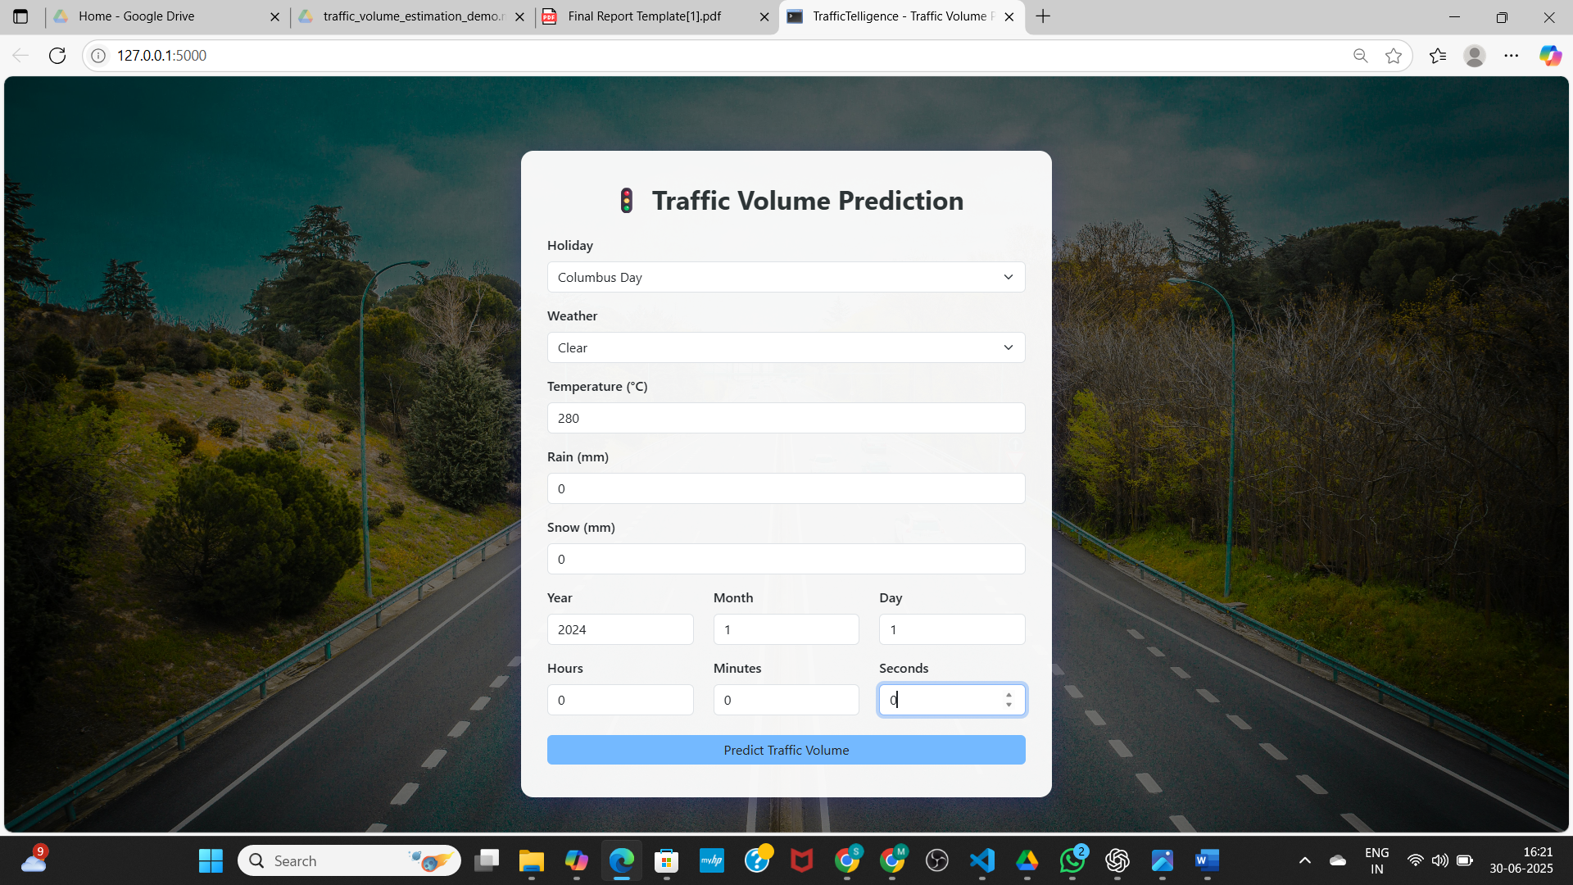}
{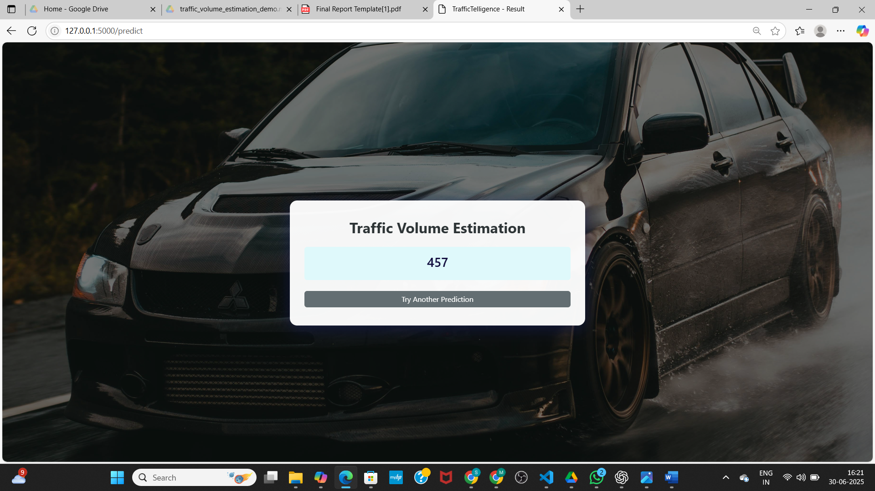)

8. ADVANTAGES & DISADVANTAGES

Advantages
- Real-time, user-friendly prediction system
- Scalable to other cities and more features
- Can aid in traffic and event planning

Disadvantages
- Trained on a fixed dataset; accuracy may drop for unusual conditions
- Model needs updates with newer data to stay accurate

9. CONCLUSION
TrafficTelligence demonstrates how machine learning can enhance urban mobility by predicting traffic volume using environmental and temporal data. The project bridges AI technology with practical city-life applications.

10. FUTURE SCOPE
- Integrate live traffic data APIs
- Add route-level prediction
- Implement mobile app version
- Support multiple cities with geo-tagged data

11. APPENDIX
- Source Code: Included in app.py, HTML templates, and notebook
- Dataset Link: traffic_volume.csv (https://drive.google.com/file/d/1iV5PfYAmI6YP0_0S4KYy1ZahHOqMgDbM/view)
- GitHub: https://github.com/syamalanakka07/TrafficIntelligence-Advanced-Traffic-Volume-Estimation-With-Machine-Learning.git
Demo Link: https://drive.google.com/file/d/1jtsDXGOVKjqRhjv7iOTYf5YwaDIsIiU_/view?usp=sharing

