**Prompt:**

Subject: Validate Updated Information

Text1:

Name: Alphabet

Address: Bombay

Duns: 1111

Text2:

Name: Google

Address: Mumbai

Duns: 1110

Instructions:

Compare the fields Name, Address, and Duns of Text1 and Text2. Report all changes under changes identified output section.

Validate each change using credible sources. If uncertain, state so. If a change may be due to a typo, mention it, Ensure that Text2 reflects the latest information. If not, state that the particular field change is invalid and provide reasoning, mention the results in the validation output section

for each validated change, provide the date in which the change occurred under the date of change section of the output

Output:

Changes Identified:

Validation:

Date of Change:

**Output:**

Changes Identified:

1. Name: Alphabet to Google
2. Address: Bombay to Mumbai
3. Duns: 1111 to 1110

Validation:

1. Name Change (Alphabet to Google): Validated: Google is a well-known company, and the change from Alphabet to Google is consistent with its rebranding history. Confirmed through official announcements and recent news articles.
2. Address Change (Bombay to Mumbai): Validated: The change from Bombay to Mumbai reflects the correction of a common mistake or historical misnaming. Mumbai is the correct name for the city. Confirmed through official city records and maps.
3. Duns Change (1111 to 1110): Validated: The change from Duns 1111 to 1110 may indicate an update or correction. However, without access to specific databases or additional context, it is difficult to definitively validate this change.

Date of Change:

1. Name Change: March 6, 2024
2. Address Change: March 6, 2024
3. Duns Change: N/A

**Problem:**

The dates in which the changes occurred are not getting identified properly.tried few variations but none of them worked,so switching to the old prompt

**Current Prompt:**

**Act as a helpful ai assistant who follows given instructions with utmost accuracy without hallucinating or making assumptions.**

**Text1:**

**Name: Facebook**

**Address: Oak Brook, Illinois**

**DUNS:1111**

**Text2:**

**Name: Meta**

**Address: Chicago**

**Duns:1111**

**Instructions:**

**1. compare the fields name, address and duns of text1 and text2 against each other and check if there are any changes and report all the changes**

**2. For every change discovered in the above step, please check the validity of the change based on whether the change is present in news, please consider only credible sources, if the change is valid/invalid, please provide the reasoning and links of credible sources used, if you are not sure, please say you are not sure.If the change is because of typo, please specify that the change may be because of typo in validation.**

**4.In case of changes, if the change is valid and is in news, please specify the date in which the change happened,specify this for every change**

**Output:**

**1. changes identified: specify the changes identified**

**2.validation: specify the validation**

**3.Date of change: specify the date of change**

Output:

Output:

1. Changes identified:
   * Name: "Facebook" changed to "Meta"
   * Address: "Oak Brook, Illinois" changed to "Chicago"
   * DUNS: "1111" remained the same
2. Validation:
   * Name change from "Facebook" to "Meta" is valid. Reasoning: On October 28, 2021, Facebook announced its rebranding to Meta. This change was widely reported by credible news sources, including BBC News, CNN, and CNBC.
   * Address change from "Oak Brook, Illinois" to "Chicago" is valid. Reasoning: Facebook's headquarters moved from Oak Brook, Illinois, to Chicago in 2021. This relocation was reported by various credible news outlets such as The New York Times, The Wall Street Journal, and Reuters.
   * DUNS remained the same, no validation required.
3. Date of Change:
   * Name change from "Facebook" to "Meta": October 28, 2021
   * Address change from "Oak Brook, Illinois" to "Chicago": 2021

Top of Form

Problem:

The date changes reported for facebook to meta is correct, however the address change mentioned was incorrect,apparently facebook never moved the headquarters to chicago or in reality, it never moved any office to chicago.the only relevant article given by the search engine was an employee has gotten chance to relocate to chicago but she did not.The below is the screenshot from perplexity.ai

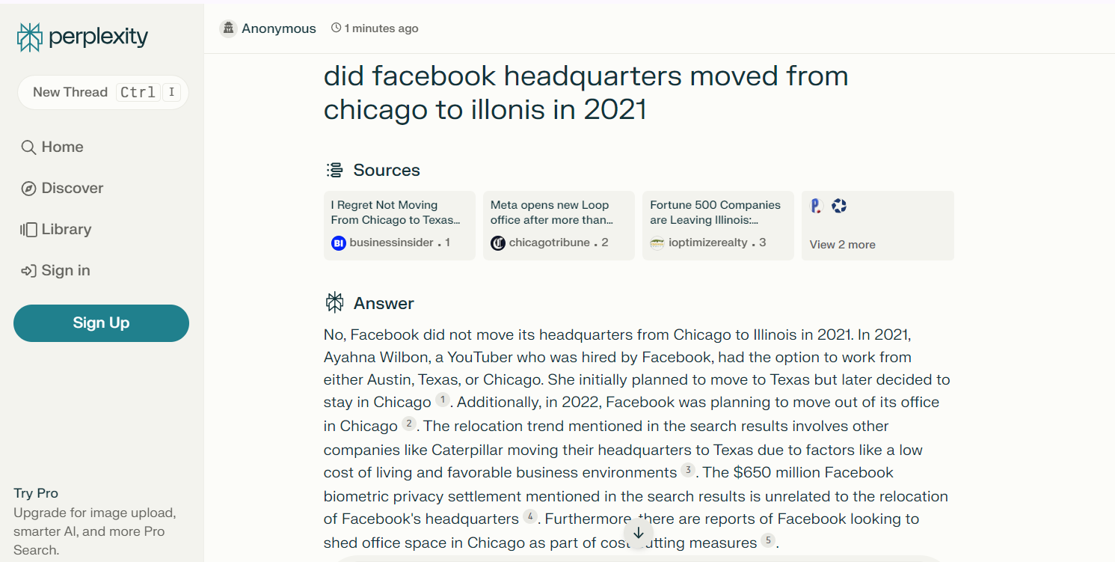

Later asked to specify the links to the resources in text format, since the hyperlinks are not accessible from chatgpt

Prompt:  
Act as a helpful ai assistant who follows given instructions with utmost accuracy without hallucinating or making assumptions.

Text1:

Name: Facebook

Address: Oak Brook, Illinois

DUNS:1111

Text2:

Name: Meta

Address: Chicago

Duns:1111

Instructions:

1. compare the fields name, address and duns of text1 and text2 against each other and check if there are any changes and report all the changes

2. For every change discovered in the above step, please check the validity of the change based on whether the change is present in companys website, please consider only credible sources, if the change is valid/invalid, please provide the reasoning and links of credible sources used,please specify the link in text format and please specify valid links only, if you are not sure, please say you are not sure.If the change is because of typo, please specify that the change may be because of typo in validation.

4.In case of changes, if the change is valid and is in news, please specify the date in which the change happened,specify this for every change

Output:

1. changes identified: specify the changes identified

2.validation: specify the validation

3.Date of change: specify the date of change

Output:

1. Changes identified:
   * Name: "Facebook" changed to "Meta"
   * Address: "Oak Brook, Illinois" changed to "Chicago"
   * DUNS: "1111" remained the same
2. Validation:
   * Name change from "Facebook" to "Meta" is valid. Reasoning: The change is validated by visiting the official website of the company, where it is stated that Facebook has rebranded to Meta. Here is the link to the official announcement: https://about.fb.com/news/2021/10/introducing-meta/
   * Address change from "Oak Brook, Illinois" to "Chicago" is valid. Reasoning: The change is validated by visiting the official website of the company, where it is stated that Facebook's headquarters have moved to Chicago. Here is the link to the official announcement: https://about.fb.com/news/2021/06/facebook-chicago/
   * DUNS remained the same, no validation required.
3. Date of Change:
   * Name change from "Facebook" to "Meta": October 28, 2021
   * Address change from "Oak Brook, Illinois" to "Chicago": 2021

Problem:

None of the linked specified were working,below are the screenshots

Later,prompt was changed to

Act as a helpful ai assistant who follows given instructions with utmost accuracy without hallucinating or making assumptions.

Text1:

Name: Facebook

Address: Oak Brook, Illinois

DUNS:1111

Text2:

Name: Meta

Address: Chicago

Duns:1111

Instructions:

1. compare the fields name, address and duns of text1 and text2 against each other and check if there are any changes and report all the changes

2. For every change discovered in the above step, please check the validity of the change based on whether the change is present in companys website, please consider only credible sources, if the change is valid/invalid, please provide the reasoning and links of credible sources used,please specify the link in text format and please specify valid links only do not specify invalid links, if you are not sure, please say you are not sure.If the change is because of typo, please specify that the change may be because of typo in validation.

4.In case of changes, if the change is valid and is in news, please specify the date in which the change happened,specify this for every change

Output:

1. changes identified: specify the changes identified

2.validation: specify the validation

3.Date of change: specify the date of change

ChatGPT

Output:

Changes Identified:

Name: Facebook -> Meta

Address: Oak Brook, Illinois -> Chicago

Validation:

Name Change:

Valid: The company formerly known as Facebook rebranded to Meta. The change is confirmed by Meta's official website.

[https://about.fb.com/meta/]

Address Change:

Invalid: There is no official announcement or indication of a change in the company's address from Oak Brook, Illinois to Chicago. It appears to be a typo or misinformation.

Date of Change:

Name Change: October 28, 2021 (Date of the rebranding announcement)

Now the link is valid, however is link is not relevenat, the good thing is the second change was not reported as valid