CS5590BD-Big data Analytics and Applications

Lab-04

By

Syamala Reddy Arimanda

16168332

Android App and Rest Web Services

Android call services:

A layout is designed in the android development kit.

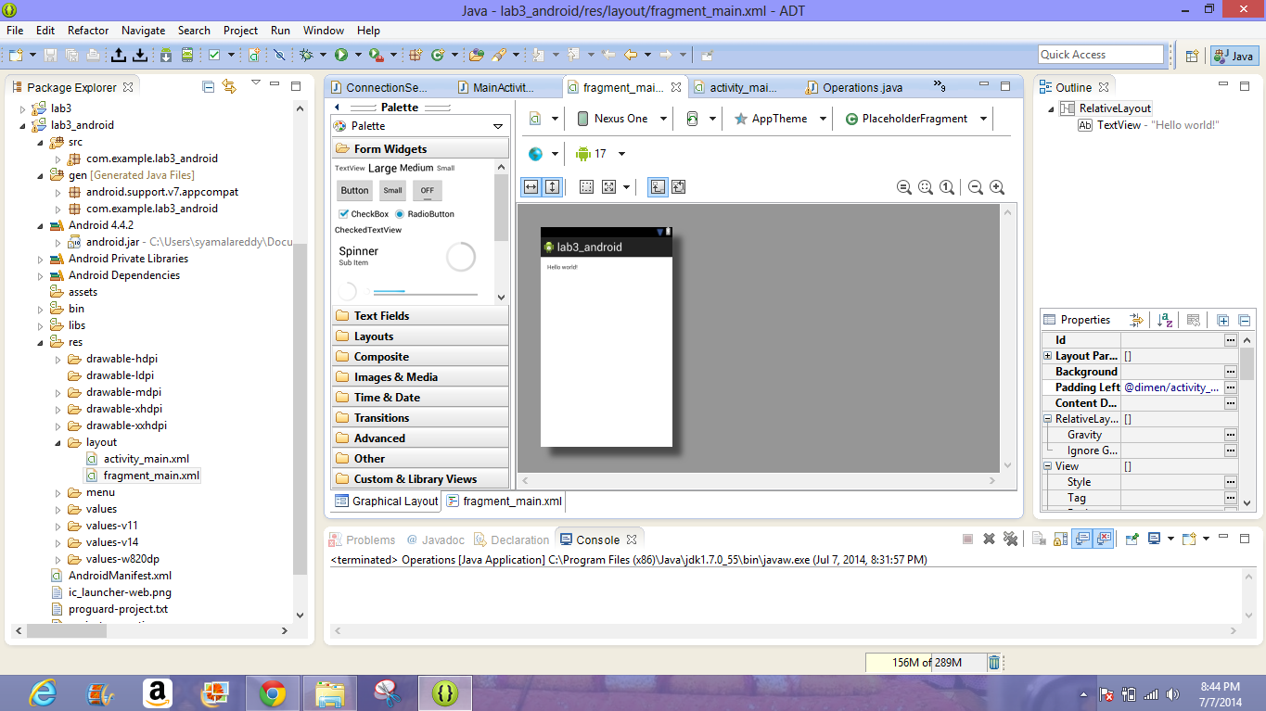

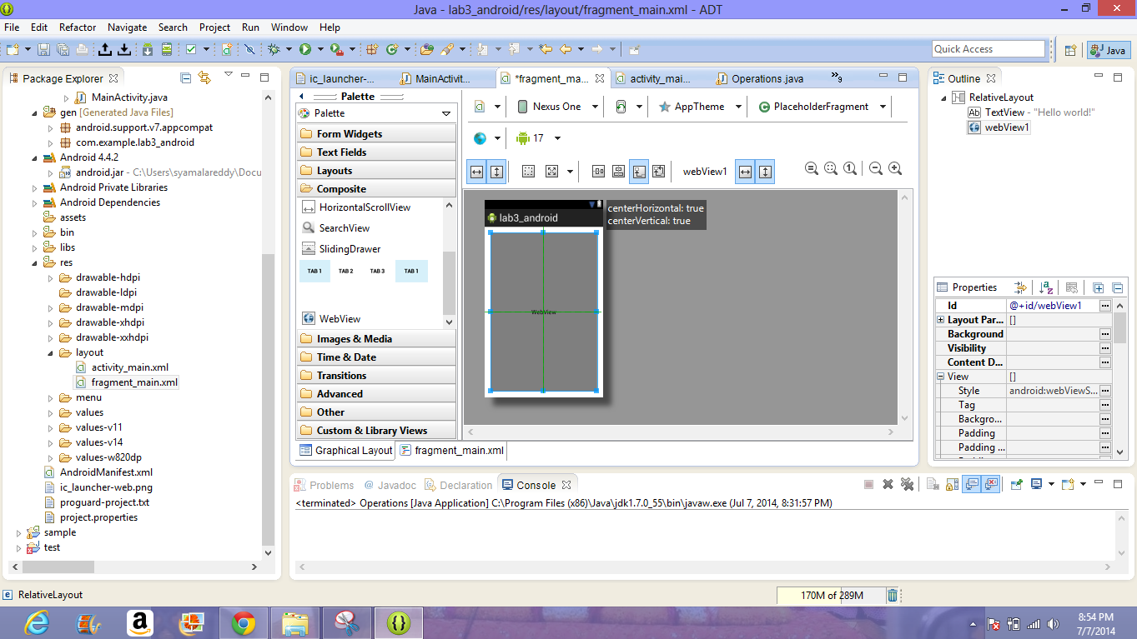

A source code is developed and then it is imported into the ADT platform.Then it is run as a android application.The result of the source code is shown in the following emulator as shown below

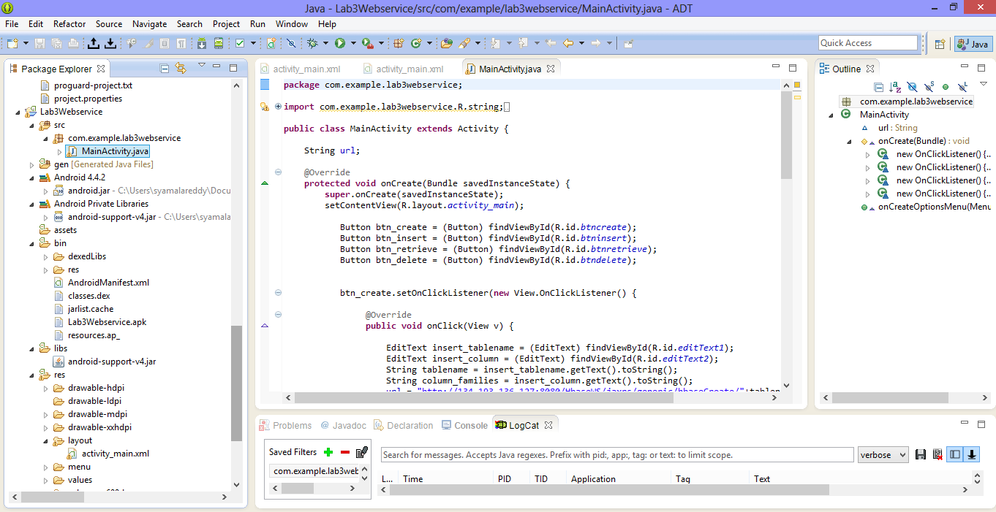

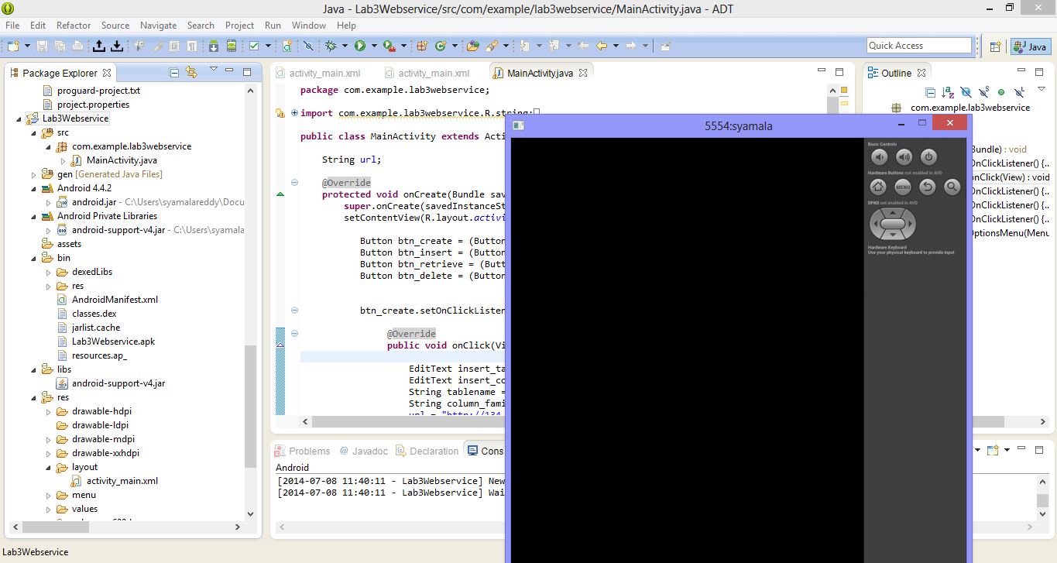

To perform the CRUD operation the table name and the columnfamilies are given as shown below.

