CS5590BD-Big data Analytics and Applications

Lab-04

By

Syamala Reddy Arimanda

16168332

**Motion recognition webservice Training and Testing:**

The data is being collected with the data in order to train and test the motion recognition.This data is collected from the android application by connecting a sensor tag and the android application is run.The below shown is the code.

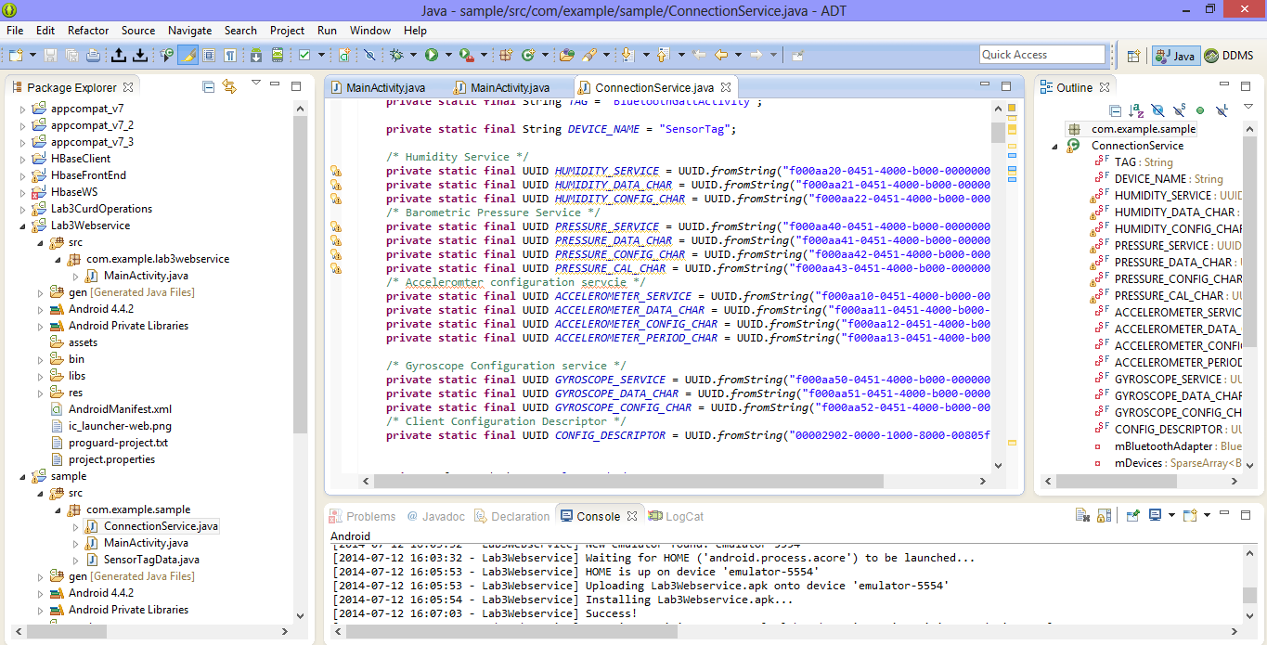

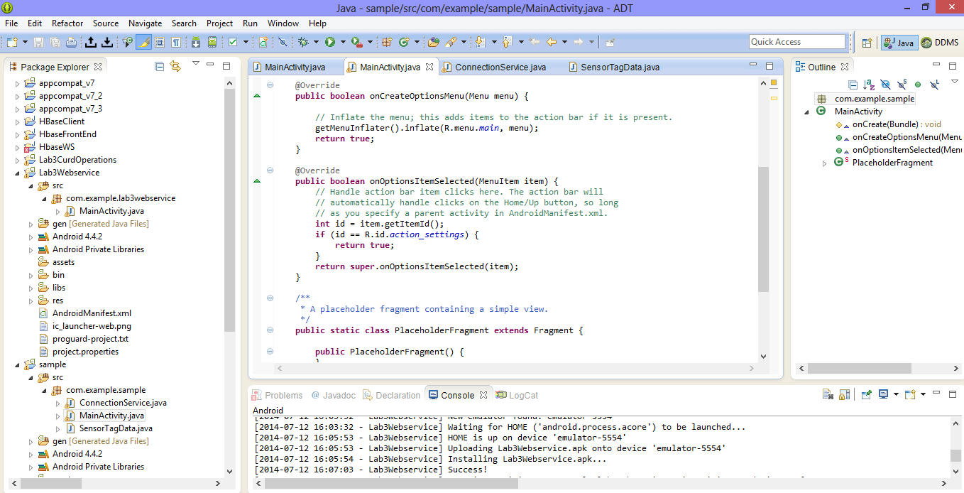

The data is collected from the sensors and the screenshots are shown below with tab spaces

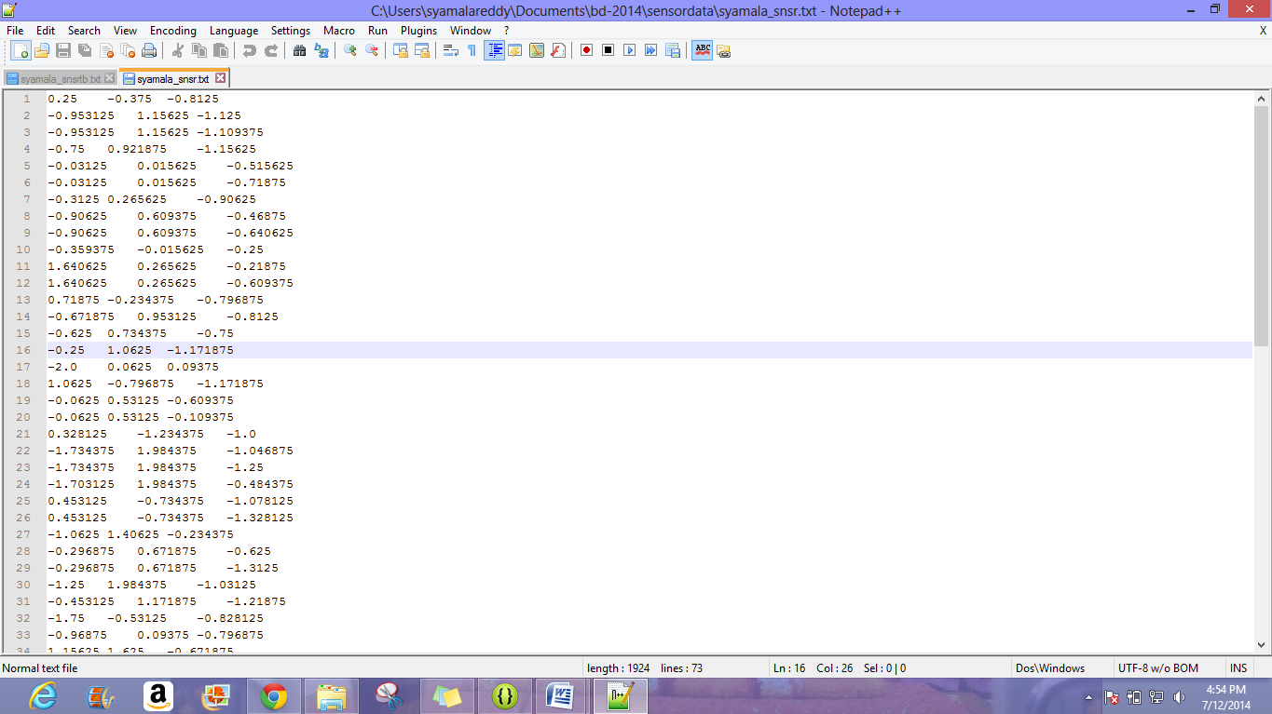

The data collected from sensor from top to bottom is shown below.

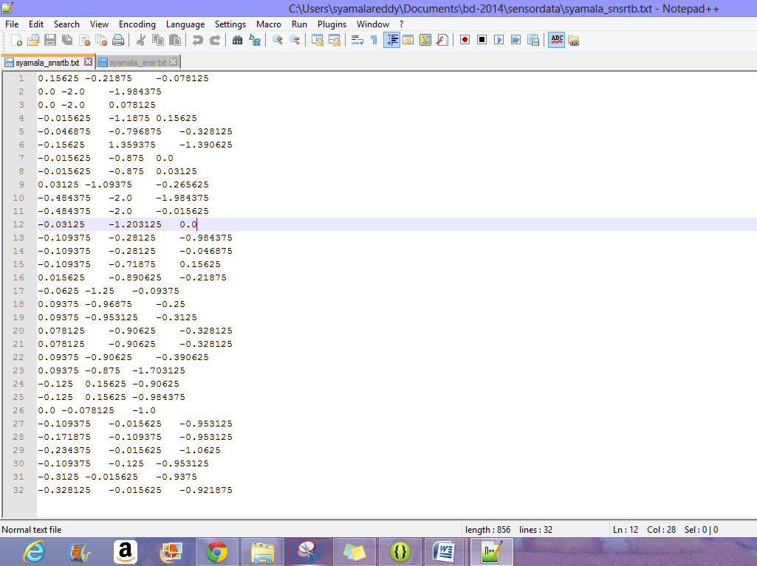

The data collected from the sensor from right to left is shown below.

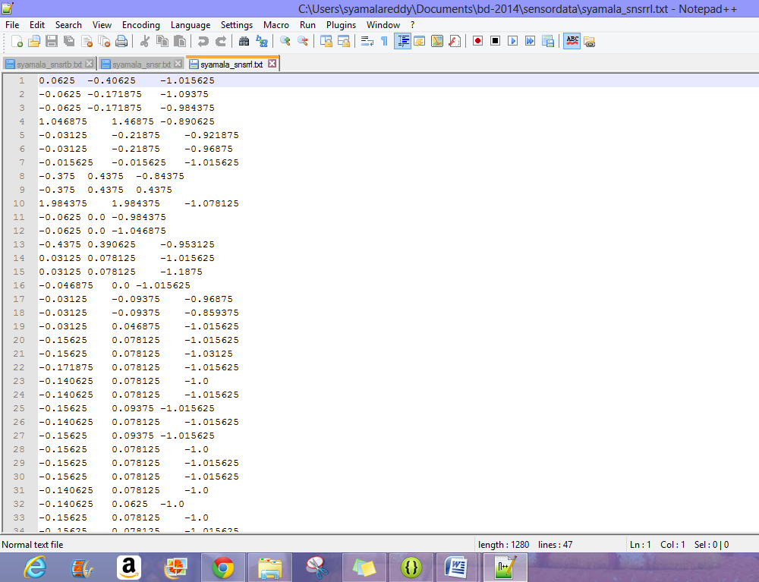

The data collected from the sensor from left to right is shown below

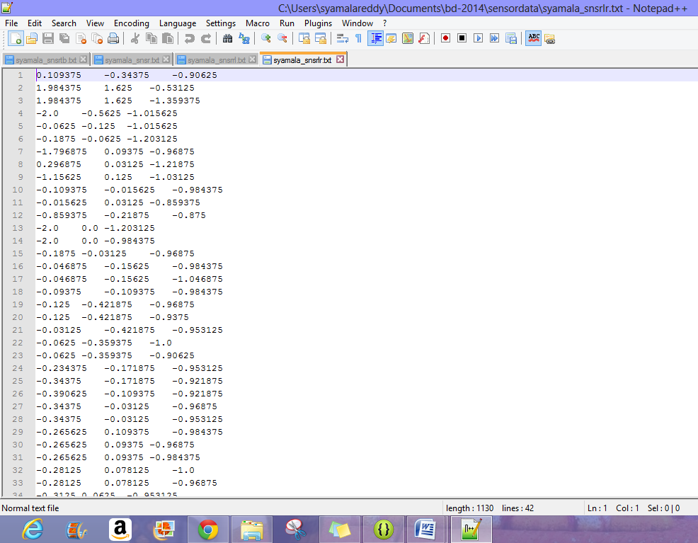

These text files which has the data and is used for the training generates a sequential file for all the particular patterns. For this we have to transfer the files to remote using the Secure Shell Transfer as shown below.

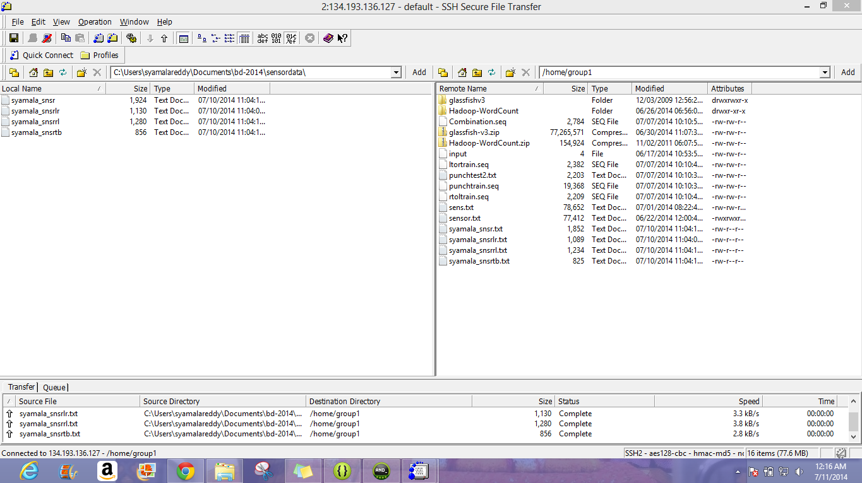

Sequence files are generated for the above text files with the following url shown below and the corresponding screenshots are provided.

<http://134.193.136.127:8080/HMMWS/jaxrs/generic/TrainFileOperation/-home-group1-syamala-snsrlr.txt/-home-group1-LefttoRightsyamala.seq>

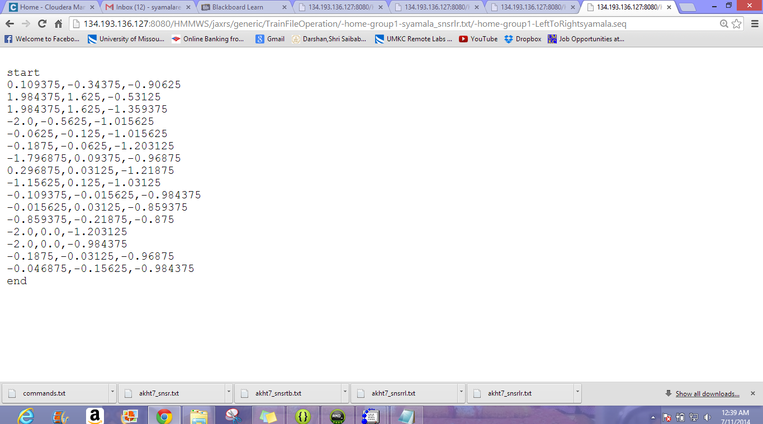

<http://134.193.136.127:8080/HMMWS/jaxrs/generic/TrainFileOperation/-home-group1-syamala-snsrrl.txt/-home-group1-RighttoLeftsyamala.seq>

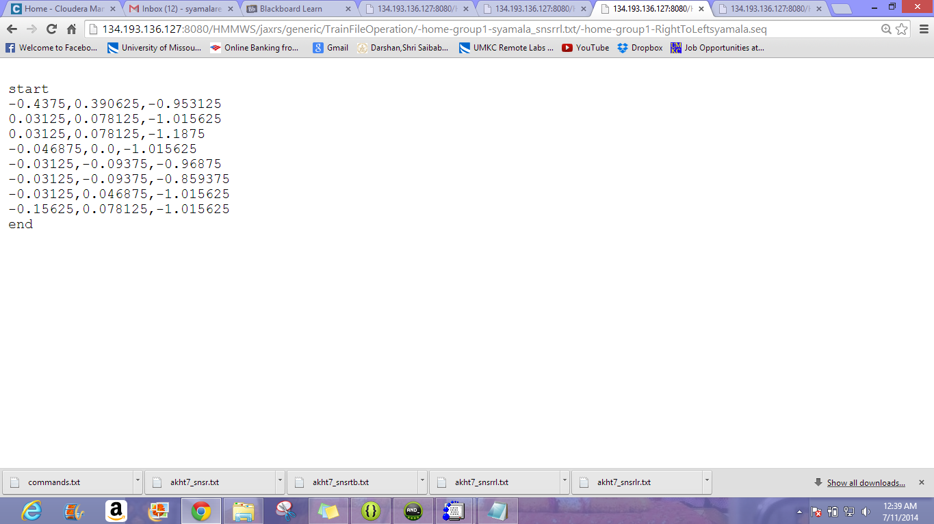

<http://134.193.136.127:8080/HMMWS/jaxrs/generic/TrainFileOperation/-home-group1-syamala-snsrtb.txt/-home-group1-bottomsyamala.seq>

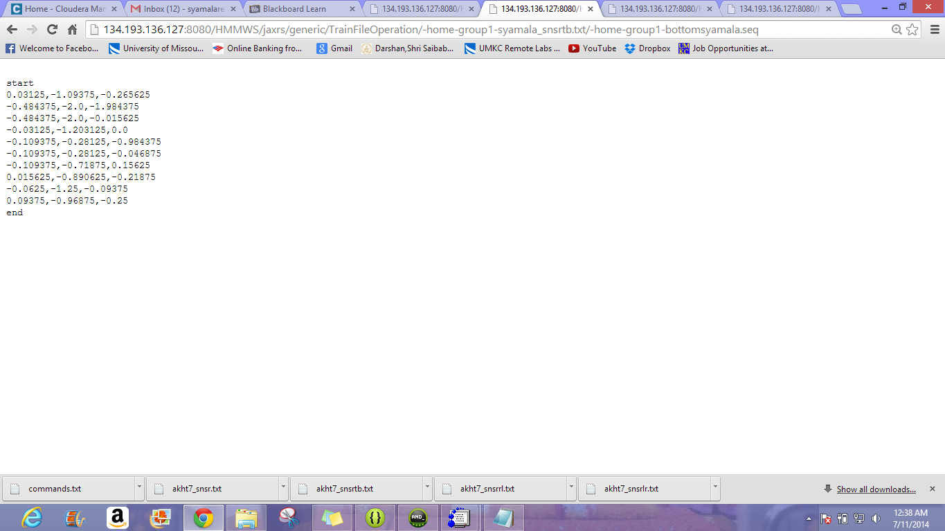

All these operations are performed and then these are all tested by the following url and the screenshot of the sequential file for the testing operation is shown below.

