**Task 2: Cloudera**

**Subtask 1: To access UMKC Cloudera Servers(Individual/Group Accounts)**

* To access UMKC cloudera services,I have downloaded UMKC vpn executable file from the university page.

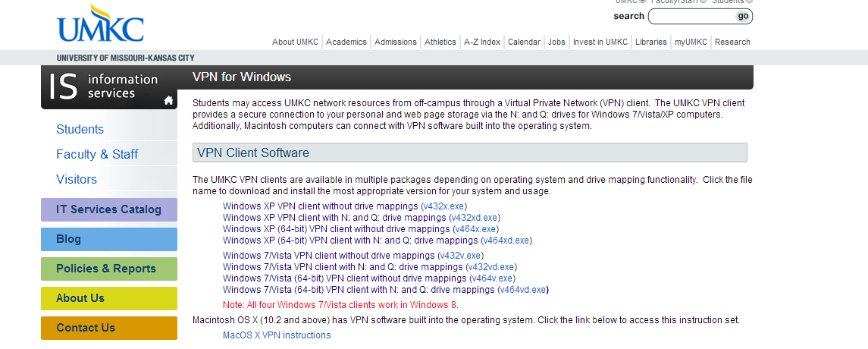

* Then,I entered my UMKC credentials and got connected to UMKC vpn.

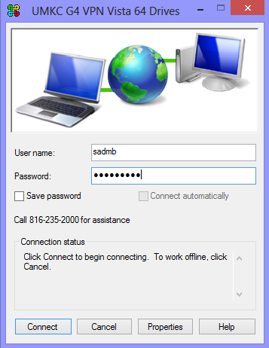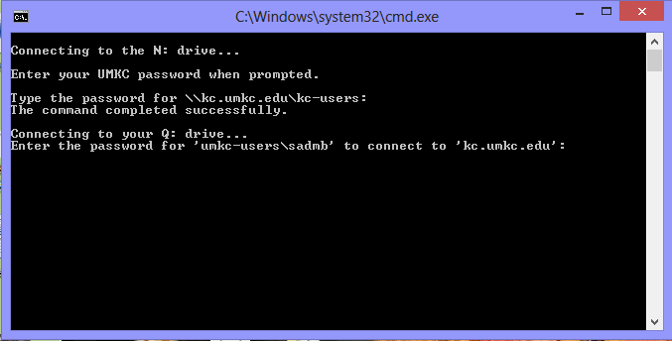

* Thus the command prompt enables us to get connected to the UMKC G4 vpn Vista 64 drives.
* I’ve gone to <http://134.193.136.127:7180> and reached Cloudera manager page.By giving my SSO id as username and password, I got logged into UMKC Cloudera manager.

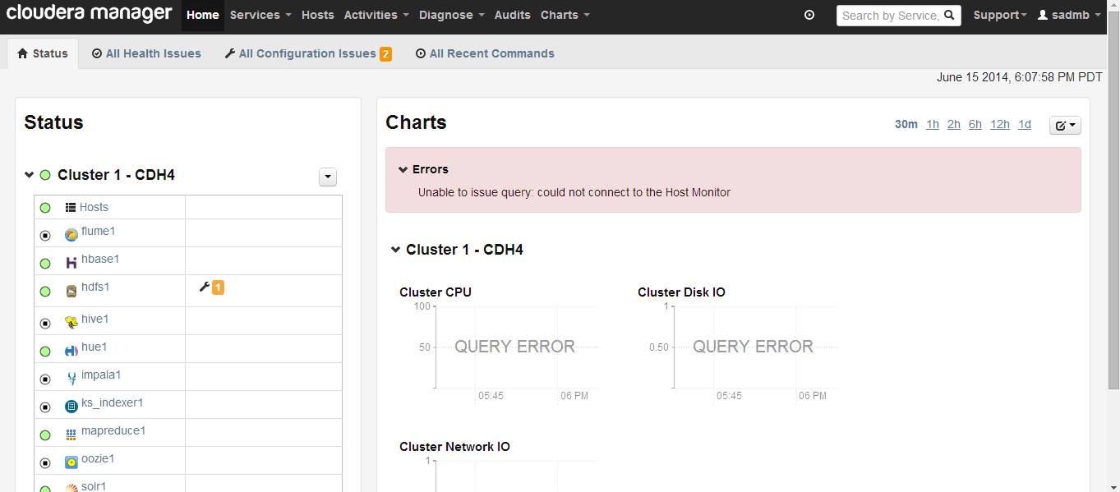

Thus,we can access UMKC Cloudera Servers.

**Subtask 2: To install my own Cloudera Server**

* I’ve downloaded Virtualbox one from the internet and installed it.
* Then opened Oracle VM Virtual box manager

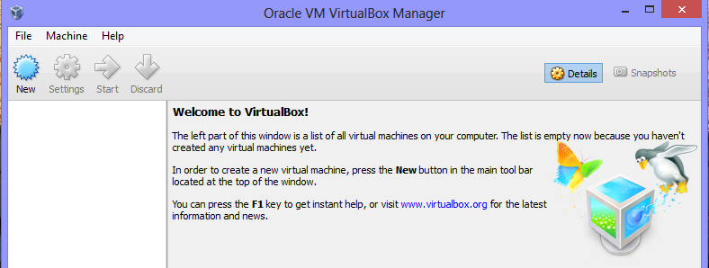

* Later on, from the import virtual appliance, imported virtual disk image

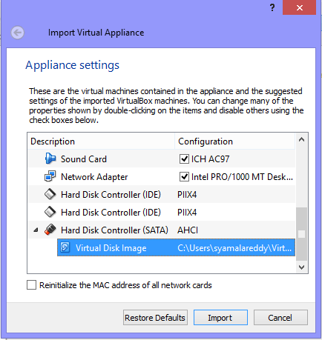

* After importing it,by giving the username and password as cloudera, the below shown Cloudera manager page is opened in the firefox..



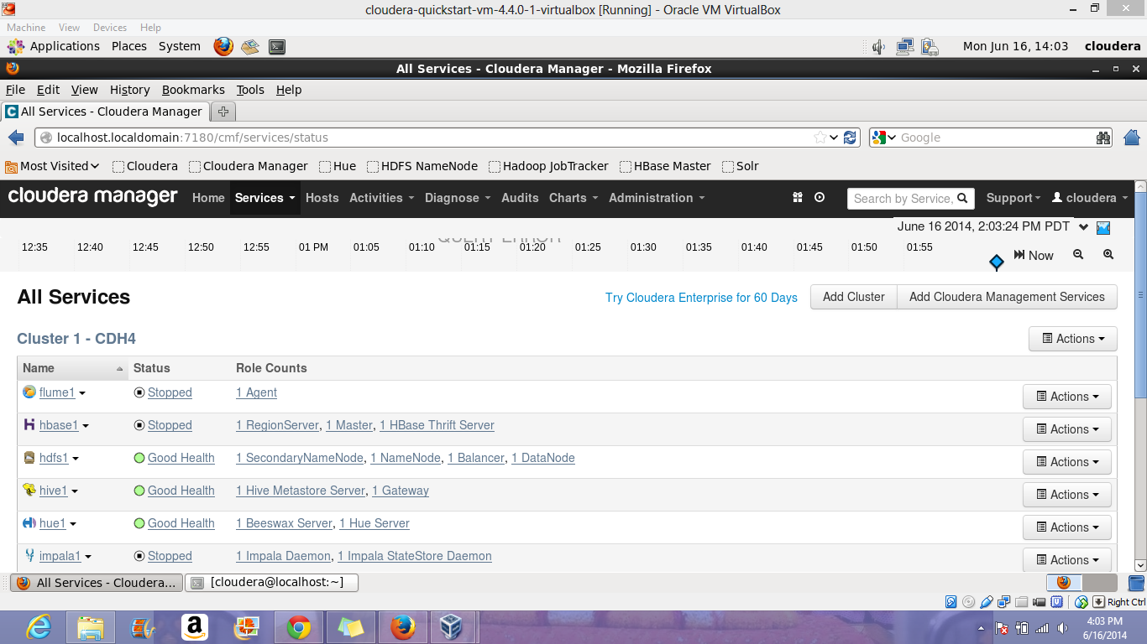

Thus,the above shown are the installation steps to install our own Cloudera.

**Subtask 3: To transfer files into Cloudera**

* In order to transfer the files from our system to linux, I installed WinSCP from the link given in the tutorial.

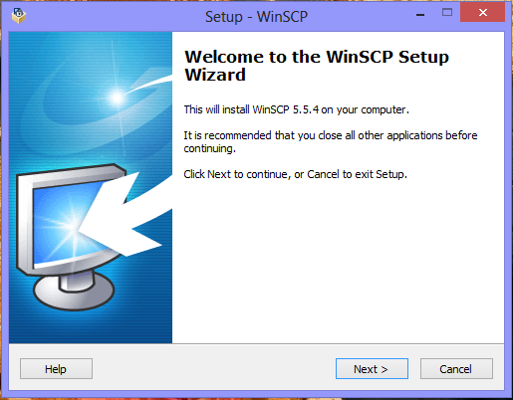

* In WinSCP login page, by giving the Host name as 134.193.136.127, Username as group1 and password, I got logged in.

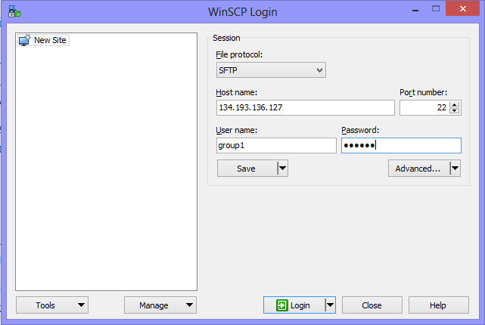

* Now, we can transfer the files directly by dragging a file and dropping it as shown below from our drive.

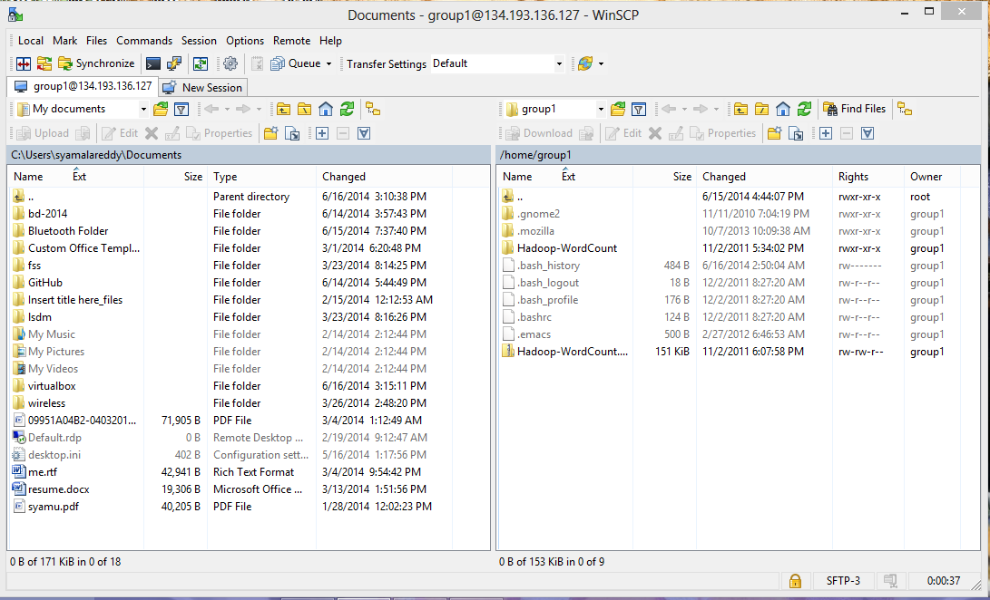

Thus, files can be transferred from our system to linux.

**Subtask 4: To run a program “Word Count” on Cloudera**

* In order to run the program on word count, an example of word count is downloaded from the given link.
* In order to run the program in Cloudera, I installed SSH Secure Shell
* I’ve used this SSH Secure File Transfer inorder to drag and transfer the files.

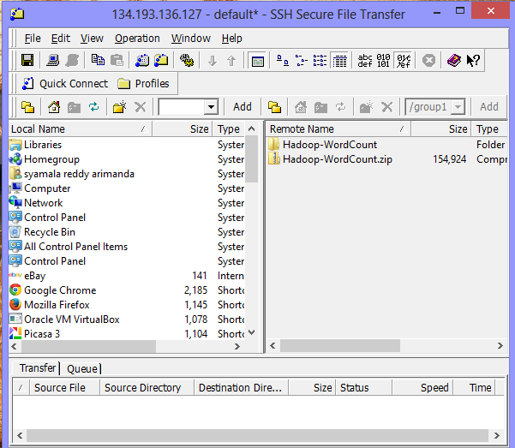

* After transferring the files, the word count file is unzipped using the command unzip Hadoop-Wordcount.zip. Local input file is put into the hadoop input directory using the command hadoop fs –put input input, run the hadoop and then view the result using the command hadoop fs –cat output67/*

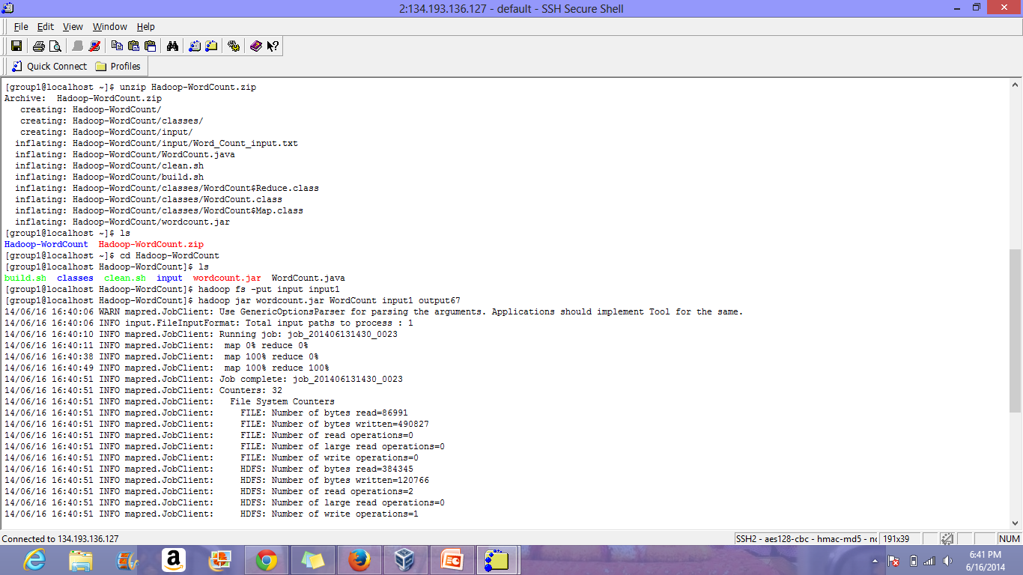

* The output for the word count program can be viewed as follows

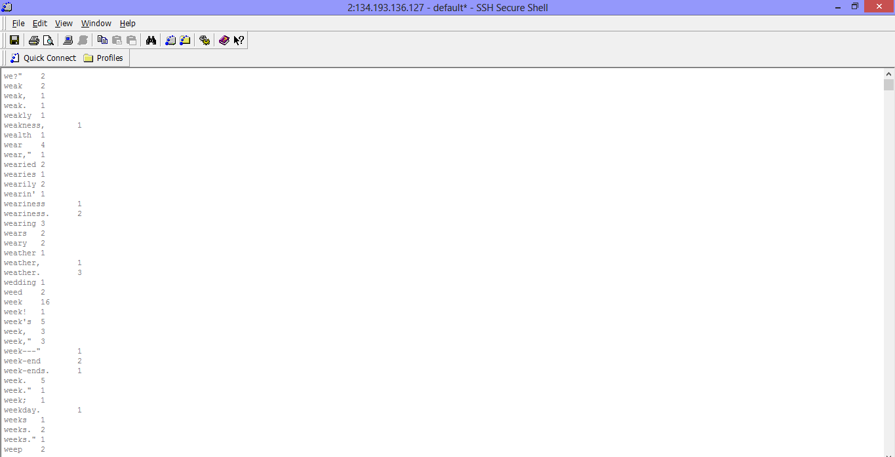

**Task 3: Github and Scrumdo**

**Subtask 1:To create an account and deploy files to Github**

* An account is created in the github by signing up from the link https://github.com.

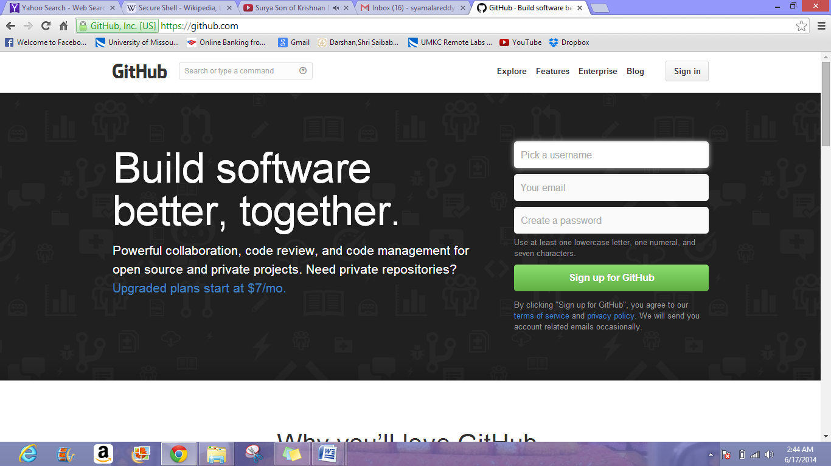

* A repository is created from the account by signing in.

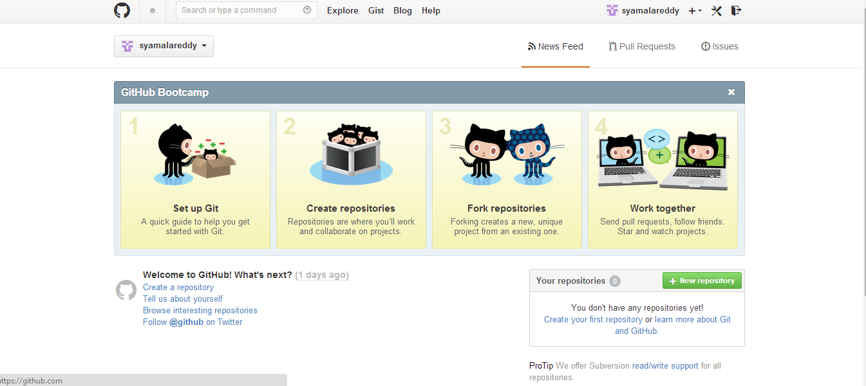

* In order to login Github for Windows I’ve downloaded Github for windows 2.0 from the site <https://windows.github.com>.

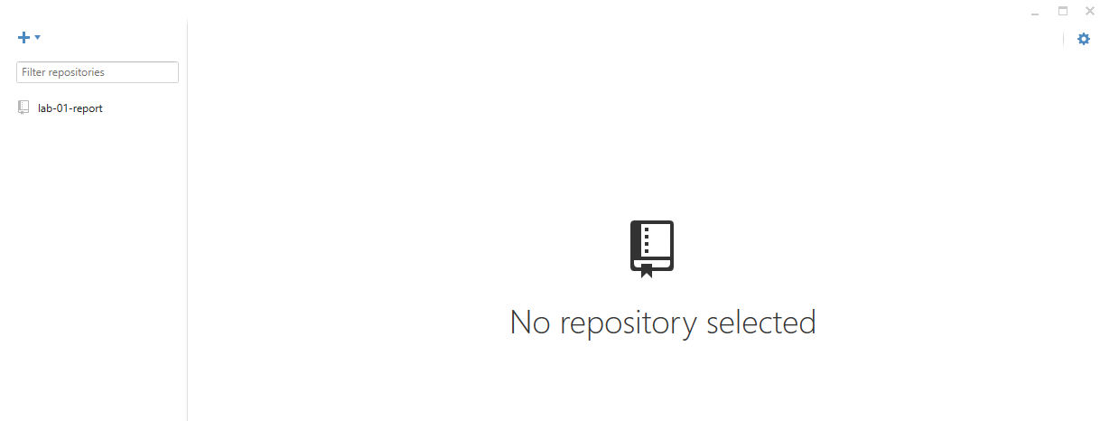

* A new repository is being created by filling all the necessary fields with the required data.

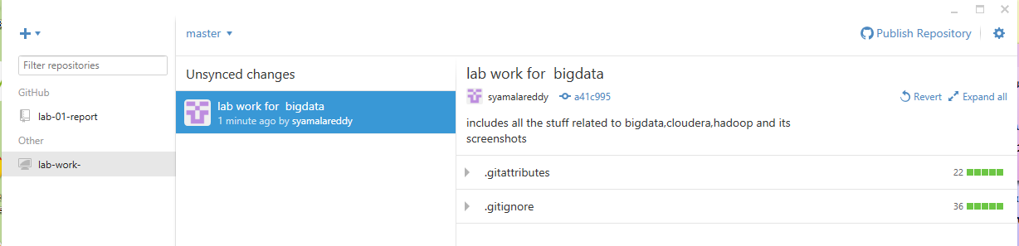

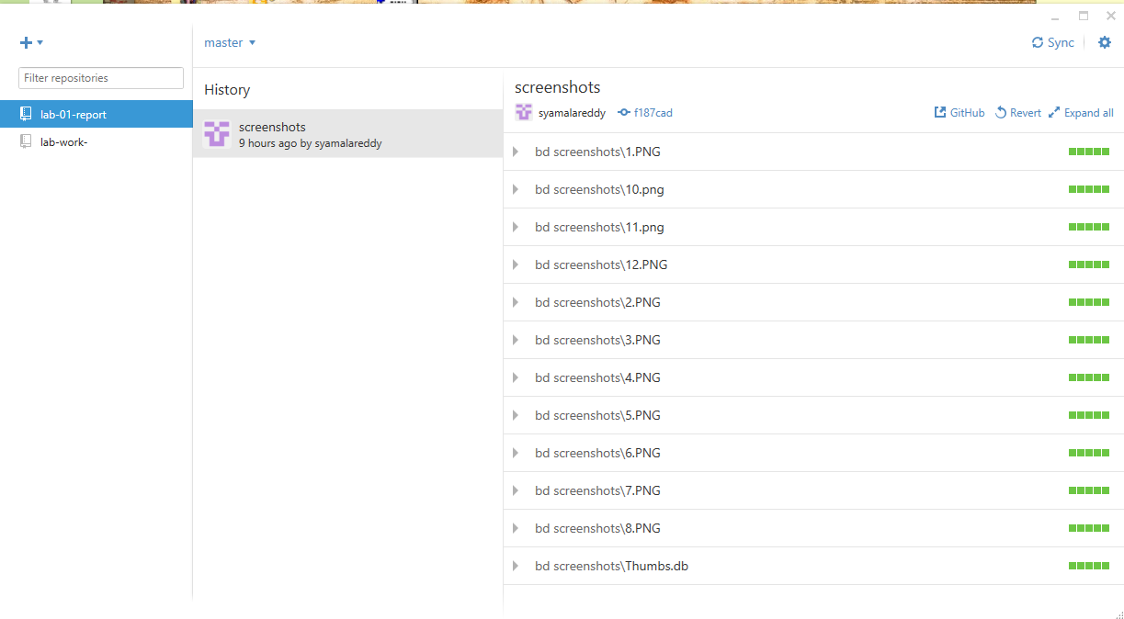

* I’ve created a repository and using this I can upload the files directly from my system drive to github.

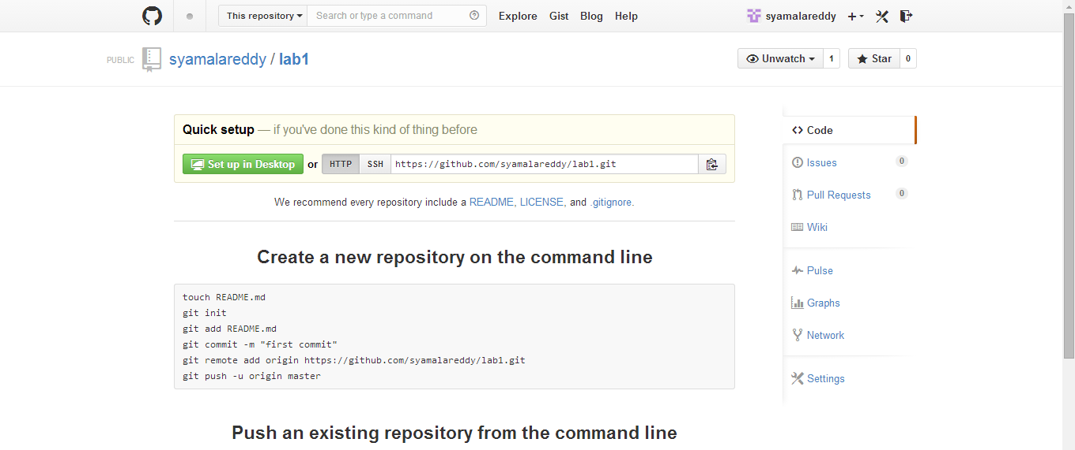

**Subtask2: To create an account and design projects with Srumdo:**

* I have created an account in scrumdo by giving all the necessary details in the signup sheet.Then I created a project as shown below

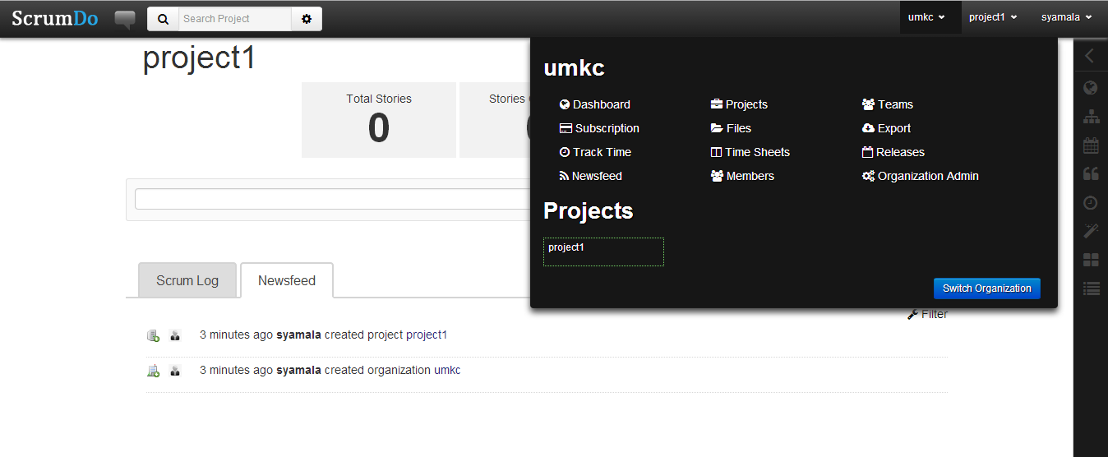

* 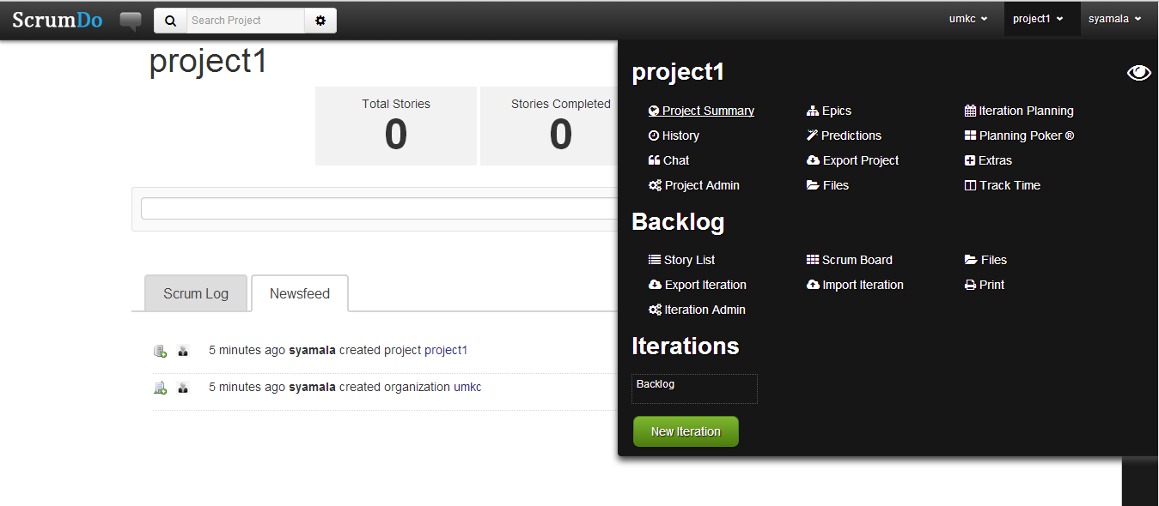Created a personal project

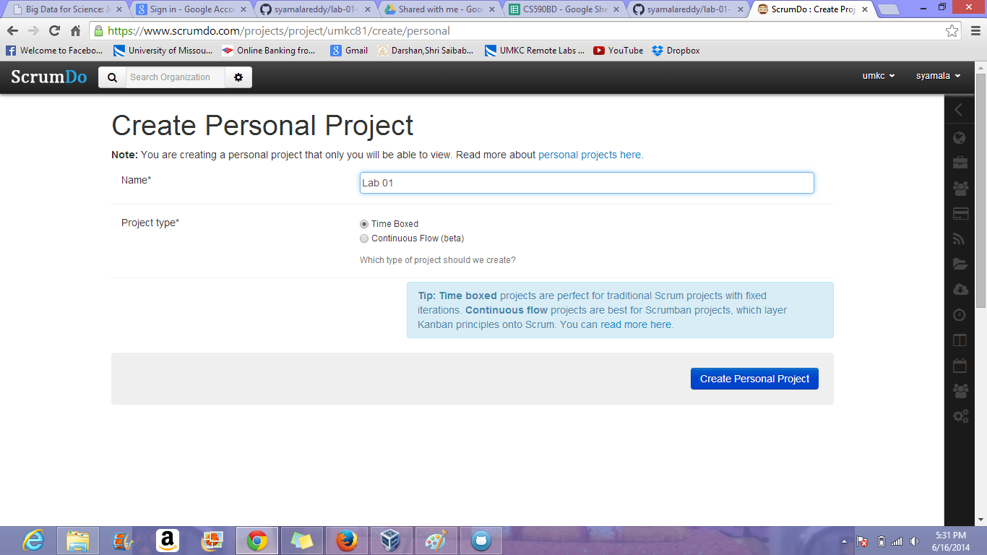

* I’ve created some tasks under my project.

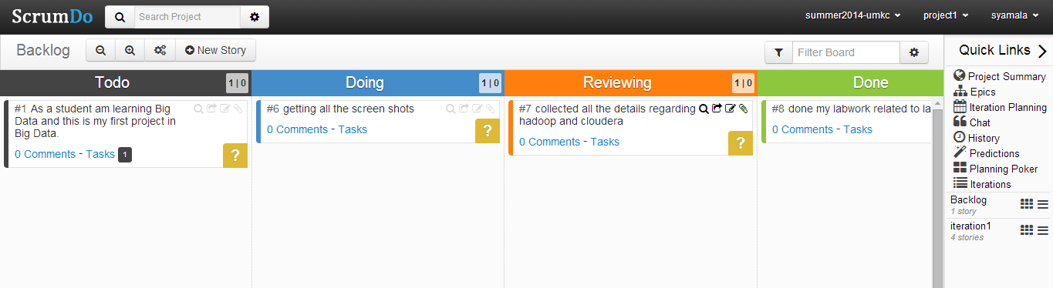

* I’ve added some members to the project which I’ve created.

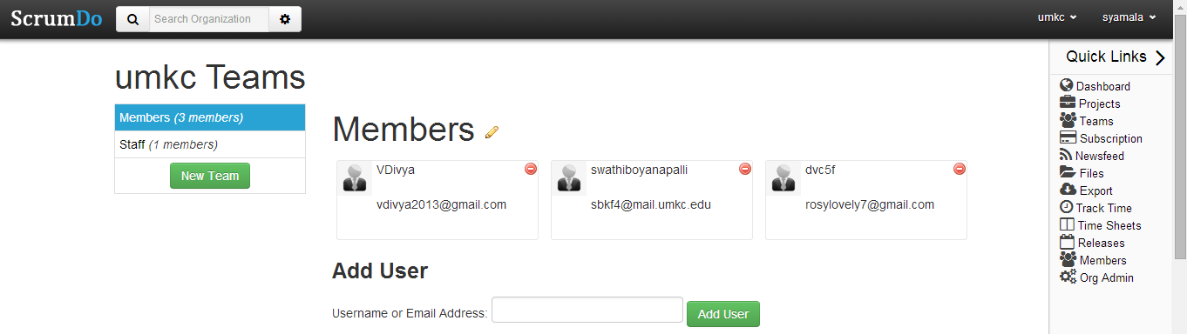

Thus,I created an account and designed the projects with scrumdo.