Project Plan

Submitted by

Arimanda,Syamala Reddy

Boyanapalli,Swathi

Vakalapudi,Vinod Kumar

Katib,Rayan Faruq

**Introduction:**

Planning for higher studies is a great step for having a bright future and is on high demand. To plan for higher studies, you need to go for required exams, for this a good preparation is necessary, this can be done by preparing a good book or having a good site in which one can find many different and difficult concepts that are required to the exam. Later they have to login for different websites and search for the required course material. Also, it will be difficult to search for different websites and patterns of questions as each website has their own in built course material. To avoid these problems, our project acts as a single stop where a student can find different materials in one place with a common user interface (UI). This project provides feasibility to prepare for the exams both through mobile and web applications. In this application, students can take advantage by getting good course material easily.

**System Architecture:**

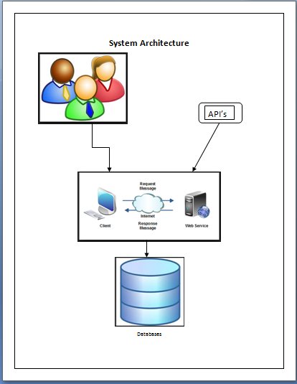

**Use Case Diagram:**

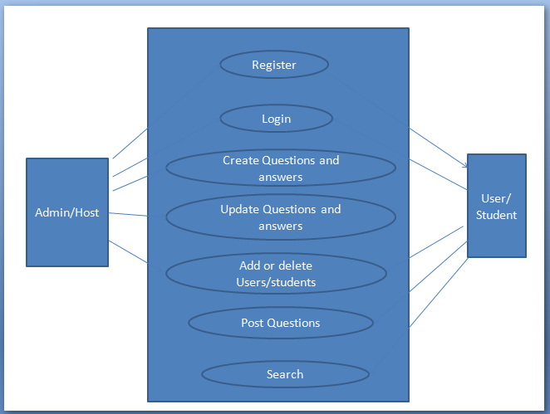

**Work Completed till 1st Increment:**

We have created both web pages for student and administrator registration, login authentication and profile updates. Same functionality pages were implemented even in android.

**Implementation Status Report:**

**Work Completed:**

Database plays a major role in our project. So, for the first increment we have created some tables in the database. The tables which we have created were:

· Student details

· Publisher details

**Student Details Table:**

In this table we have attributes like student name, password, email, contact number and zip code.

Queries used on these tables were:

1. Insert into table registration values (student name, password, email, contact number, zip code). These values are picked from the end student feed.
2. Select student name, email, contact number, zipcode from registration where student name=’studname’ and password=’pwd’
3. Update registration (student name=studname, email=email, zip code=zip, contact number=contactno)

**Publisher Details Table:**

In this table we have attributes like publisher name, password, email, contact number and zip code.

Queries used on these tables were:

1. Insert into table publisher values (publisher name, password, email, contact number, zip code). These values are picked from the end publisher feed.
2. Select name, email, contactno, zipcode from publisher where publisher name=‘pbname’ and password=’pwd’
3. Update vendor (publisher name=pbname, email=email, contact number=contactno, zip code=zip)

**ScreenShots:**

We have created the below web page with all the services enlisted in the right side of the web page.User when clicked on the start your preparation button which is redirected to the services page.

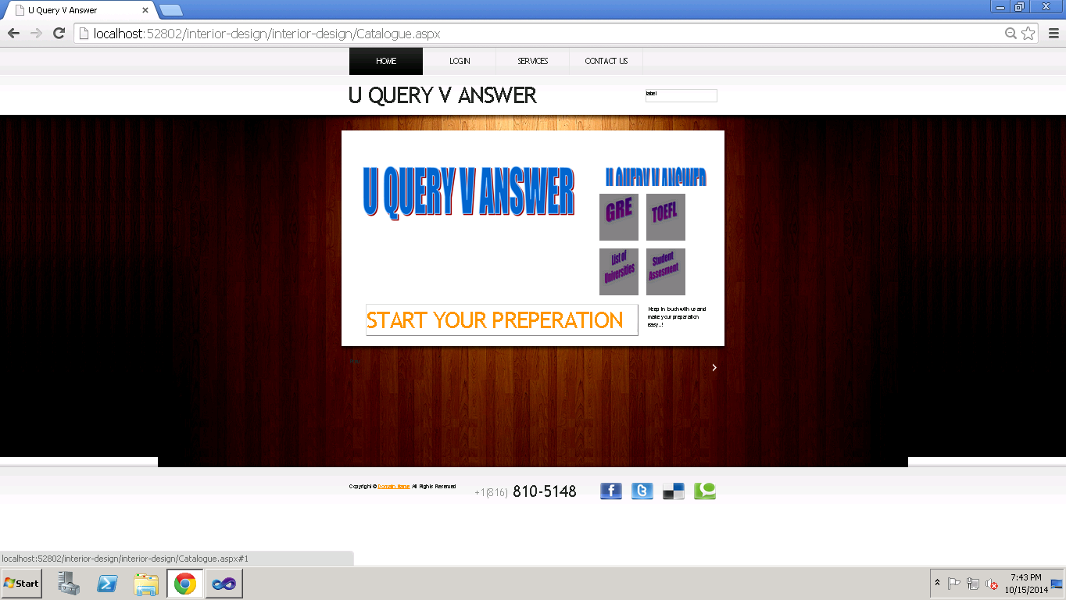

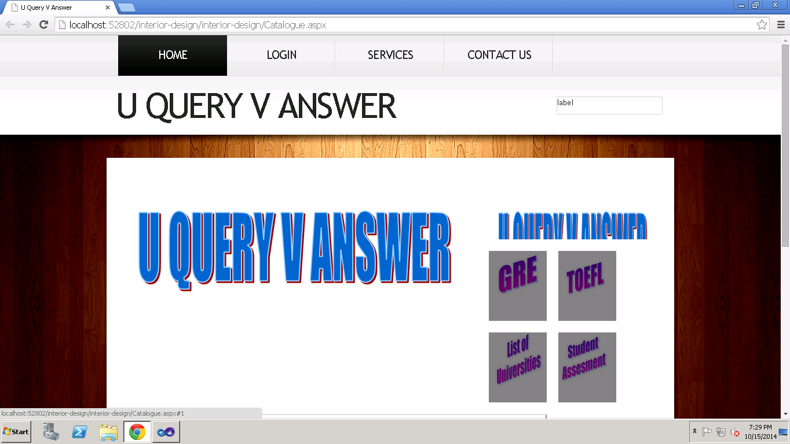

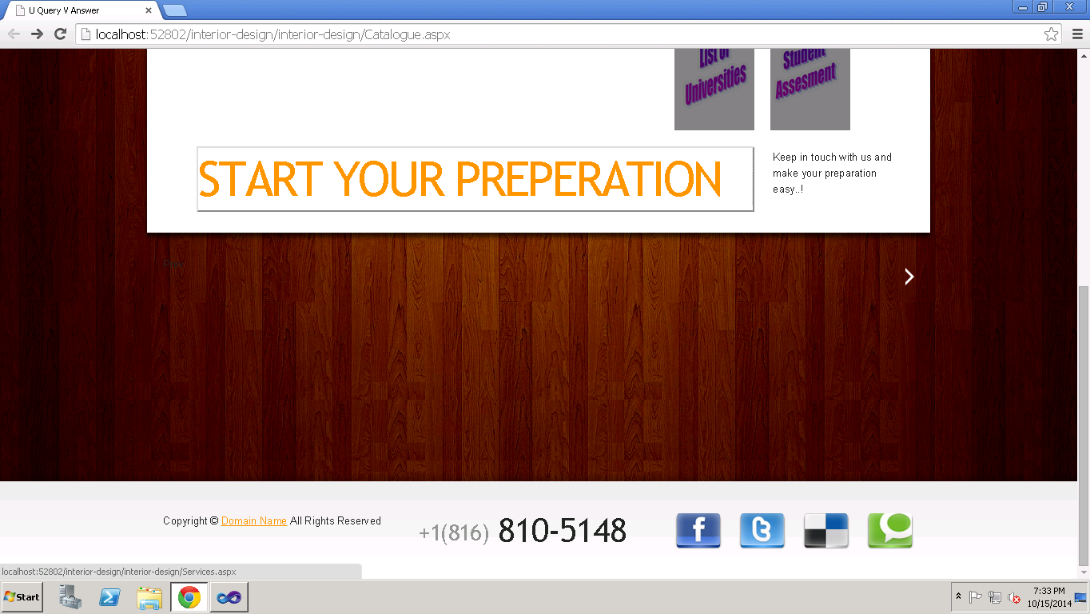

The below shown are the screenshots of the services page.We have the list of universities,gre,toefl mock tests and the assessments of the students are provided.

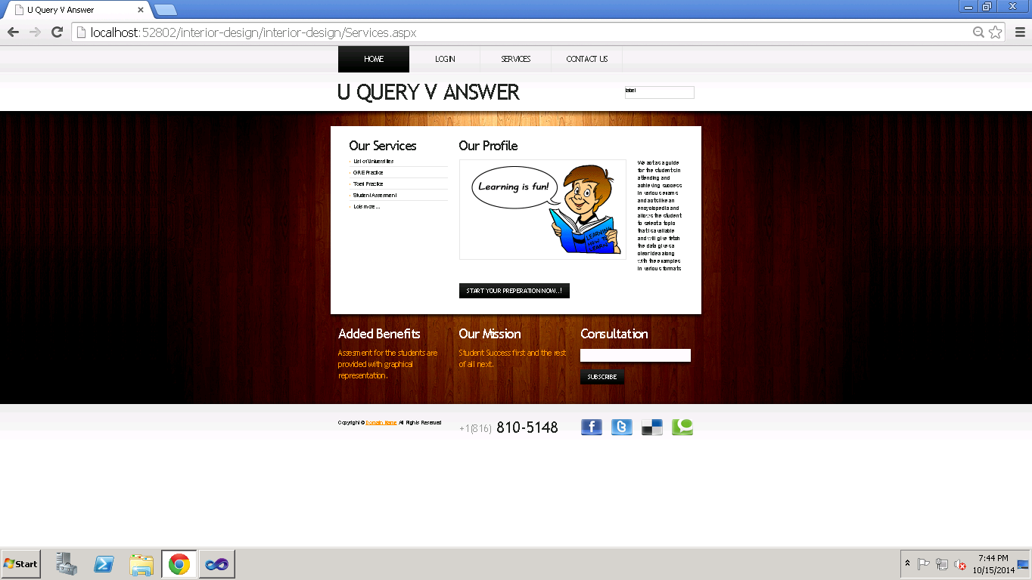

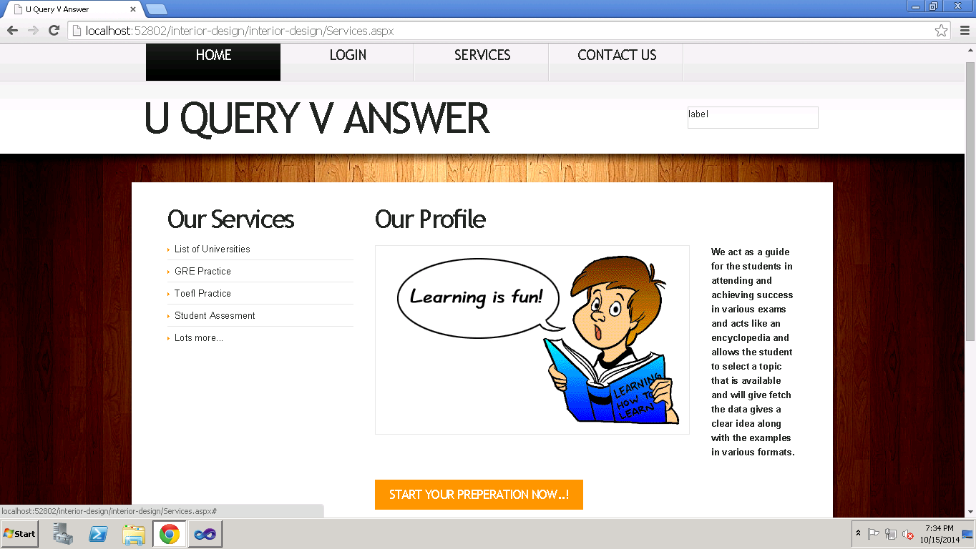

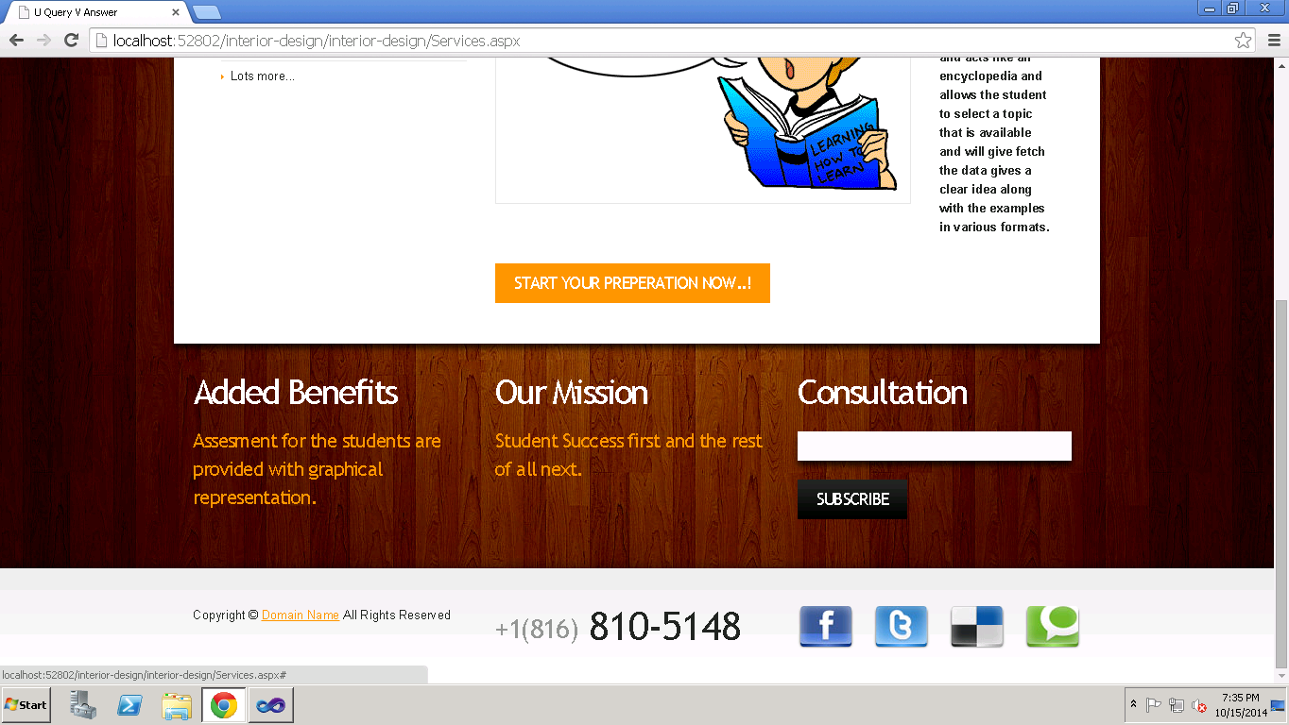

Student selects a particular service under the services provided and then he is directed to the login page where the student is registered.The credentials are given and then login,the screenshot is shown below.

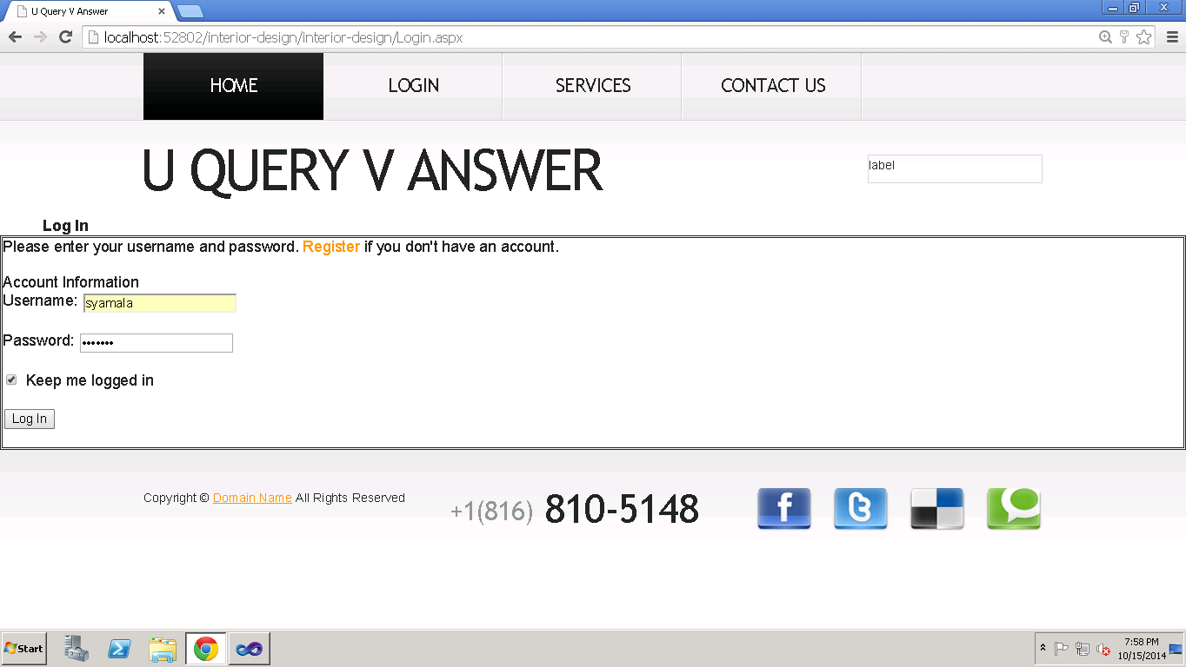

In the Contact form shown below,the users can submit their message and can send for the admin.

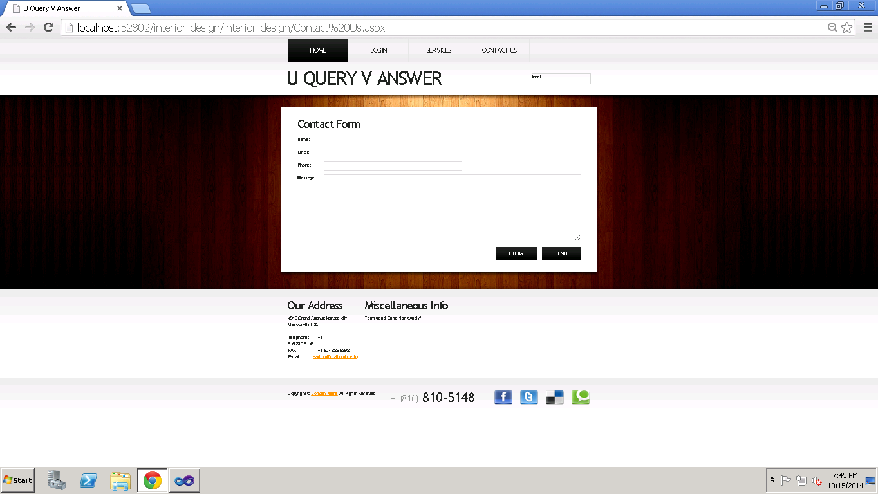

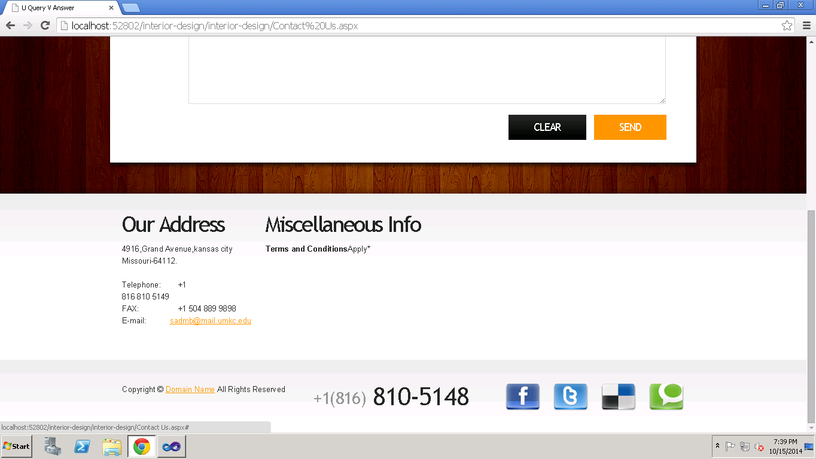

**Responsibilities:**

|  |  |  |  |
| --- | --- | --- | --- |
| **Sl.No** | **Task** | **Person involved** | **Estimated Time** |
| 1. | Designing of User Interface for both web and android application | Syamala  Swathi | 4 hr |
| 2. | Creating Database and connecting this using sql management studio to store student and publisher details | Swathi  Syamala  Vinod | 2 hr |
| 3. | Creating tables to store student details | Rayan | 2hr |
| 4. | Creating sessions to maintain the login details | Syamala  Swathi  Vinod | 2hr |
| 5. | Creating tables to store publisher details | Swathi | 2hr |
| 6. | Connecting API services | Syamala | 2 hr |
| 7. | Creating android login and home pages | Rayan | 2hr |
| 8. | Testing the project | Syamala  Swathi  Vinod | 2hr |

**Work To Be Completed As Part Of 2nd Increment:**

We will implement the web services in second increment and link those services to the database for the search engine and then create a webpage to display the search results.

**Responsibilities:**

|  |  |  |
| --- | --- | --- |
| **Sl.No** | **Task** | **Person involved** |
| 1. | Have to create web services for google and facebook | Syamala  Swathi  Vinod  Rayan |
| 2. | To create web services for searching the publisher | Swathi  Syamala  Rayan  Vinod |
| 3. | To implement web services on android. | Syamala  Swathi  Vinod  Rayan |
| 4. | To implement shopping cart page | Swathi  Syamala  Rayan  Vinod |
| 5. | To Test the web services by using Nunit testing | Syamala  Swathi  Vinod  Rayan |
| 6. | Documentation work | Swathi  Syamala  Rayan  Vinod |