**Robot Game**

By

Santosh Yamarthi

**Table of Contents**

1. Requirements 3

1.1. Description 3

1.2. Constraints 3

1.3. Example Input and Output 4

1.4. Deliverables 4

2 Solution Design 5

2.1 Design 5

2.2 Decisions 5

2.3 Deliverables 5

2.4 Build 6

2.5 How to Run 6

3 Test Coverage 7

3.1 Unit test cases 7

3.2 Test Summary Report 8

4 Known Issues 8

# Requirements

## Description

Toy Robot Simulator

===================

Description

-----------

- The application is a simulation of a toy robot moving on a square tabletop, of dimensions 5 units x 5 units.

- There are no other obstructions on the table surface.

- The robot is free to roam around the surface of the table, but must be prevented from falling to destruction. Any movement that would result in the robot falling from the table must be prevented, however further valid movement commands must still be allowed.

Create an application that can read in commands of the following form:

PLACE X,Y,F

MOVE

LEFT

RIGHT

REPORT

- PLACE will put the toy robot on the table in position X,Y and facing NORTH, SOUTH, EAST or WEST.

- The origin (0,0) can be considered to be the SOUTH WEST most corner.

- The first valid command to the robot is a PLACE command, after that, any sequence of commands may be issued, in any order, including another PLACE command. The application should discard all commands in the sequence until a valid PLACE command has been executed.

- MOVE will move the toy robot one unit forward in the direction it is currently facing.

- LEFT and RIGHT will rotate the robot 90 degrees in the specified direction without changing the position of the robot.

- REPORT will announce the X,Y and F of the robot. This can be in any form, but standard output is sufficient.

- A robot that is not on the table can choose the ignore the MOVE, LEFT, RIGHT and REPORT commands.

- Input can be from a file, or from standard input, as the developer chooses.

- Provide test data to exercise the application.

## Constraints

- The toy robot must not fall off the table during movement. This also includes the initial placement of the toy robot.

- Any move that would cause the robot to fall must be ignored.

## Example Input and Output

### Example a

PLACE 0,0,NORTH

MOVE

REPORT

Expected output:

0,1,NORTH

### Example b

PLACE 0,0,NORTH

LEFT

REPORT

Expected output:

0,0,WEST

### Example c

PLACE 1,2,EAST

MOVE

MOVE

LEFT

MOVE

REPORT

Expected output

3,3,NORTH

## Deliverables

The Ruby, JavaScript or Java source files, the test data and any test code.

It is not required to provide any graphical output showing the movement of

the toy robot.

# Solution Design

# Design

The Robot Board game solution has been kept to minimal implementation without any graphical representation and defined in a self-explanatory package and class structure.

The Application has been split into 5 different packages based on the functionality.

1. com.myarcade.robotgame.gamesetup - In this package, Board edges have been defined, robot is initiated and position set with location object (which contains x and y coordinates) and direction (north, east, west, south) object. Robot State is also set via IRobot and IOperation interfaces.
2. com.myarcade.robotgame.interfaces – All interfaces specific to robot and operations are defined in this package
3. com.myarcade.robotgame.instructions – The classes defined in this package reads input instructions either from flat files or stdin. Then it converts instructions into game specific operations implementing IRobot and IOperation interfaces and apply to RobotState
4. com.myarcade.robotgame.operations – The classes defined in this package perform various operations like right, move, left, place and report
5. com.myarcade.robotgame – Main class

# Decisions

* JUNIT version 4.12 has been used for unit testing instead of JUNIT Jupiter API (5.1) because of the known eclipse bug (below). This decision was due to time constraint in debugging the issue.

<https://bugs.eclipse.org/bugs/show_bug.cgi?id=538956>

* Interfaces have been combined into single package because, as an extension to future, new default methods can be easily incorporated inside interfaces without impacting any abstract classes that extend them or classes that implement them.
* Unit tests have been covered to test Robot initialisation, Read Instructions, Execute Instructions and Operations like right, left, move, report
* Unit tests also covers valid and invalid robot moves

# Deliverables

The application has been uploaded to GitHub and can be downloaded at below link

<https://github.com/syamarthi/robot-game>

I have also included zip version of the application and sent via email.

# Build

* Download application code from github or download zip file from email
* Unzip to a location
* Open command prompt
* Go to project root where pom.xml file exists.
* Use ‘***mvn clean install’***to build package (jar) in ***‘./target’*** folder

# How to Run

Command Line:

1. Java –jar robotgame-<version>.jar [instructions file]

Example

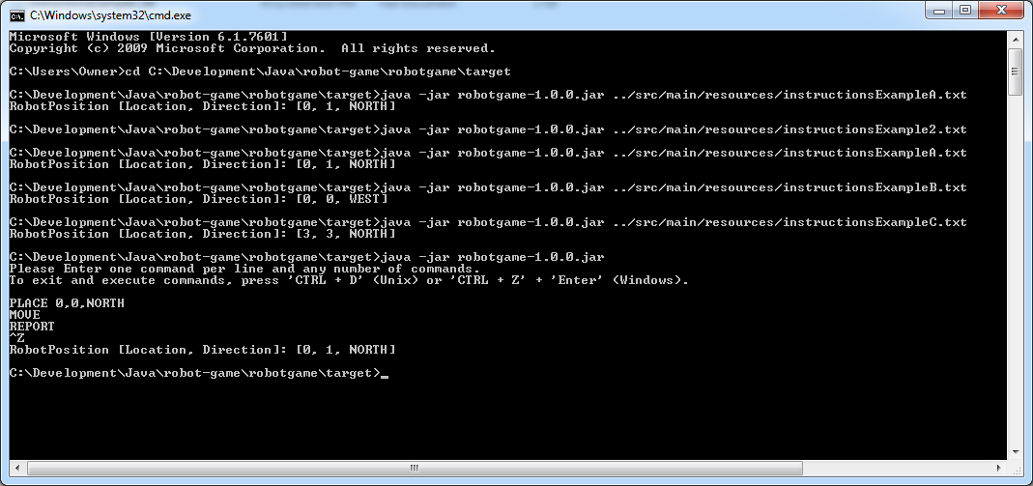

Note: The Robot game can be invoked by either instruction file as an input argument or empty arguments. When there are no arguments, application reads instructions from stdin.

# Test Coverage

# Unit test cases

|  |  |  |  |  |
| --- | --- | --- | --- | --- |
| **Package** | **Class** | **Testcases** | **Result** | **Description** |
| com.myarcade.robotgame.instructions | ExecuteInstructions | testInvalidInstruction1() | Pass | The test case tests invalid input with value "PLACE4,2,EAST" |
|  |  | testInvalidInstruction2() | Pass | The test case tests invalid input with value "PLACE 4, 2,EAST" |
|  |  | testInvalidInstruction3() | Pass | The test case tests invalid input with value "PLACE 4,2,LUNAR" |
|  |  | testOperationRight() | Pass | The test case tests RIGHT operation |
|  |  | testValidInstruction1() | Pass | The test case tests valid input "PLACE 0,0,NORTH" |
|  |  | testValidInstruction2() | Pass | The test case tests valid input PLACE 2,3,SOUTH |
|  |  | testValidInstruction3() | Pass | The test case tests valid input PLACE 2,3,SOUTH |
|  |  | testOperationLeft() | Pass | The test case tests LEFT operation |
|  |  | testOperationMove() | Pass | The test case tests MOVE operation |
|  |  | testOperationPlace() | Pass | The test case tests PLACE operation |
|  |  | testOperationReport() | Pass | The test case tests REPORT operation |
|  |  |  |  |  |
| com.myarcade.robotgame.gamesetup | PlaceRobot | testBoardEdges() | Pass | The test case tests board edges and robot placement |
|  |  | testMoveToInstruction() | Pass | The test case tests robot movements |
|  |  |  |  |  |
| com.myarcade.robotgame.operation | Operations (a generic test class to test operations) | testOperationLeft() | Pass | The test case tests LEFT operation |
|  |  | testOperationMove() | Pass | The test case tests MOVE operation |
|  |  | testOperationPlace() | Pass | The test case tests PLACE operation |
|  |  | testReportCommand() | Pass | The test case tests REPORT operation |
|  |  | testRightCommand() | Pass | The test case tests RIGHT operation |

# Unit Test Summary Report

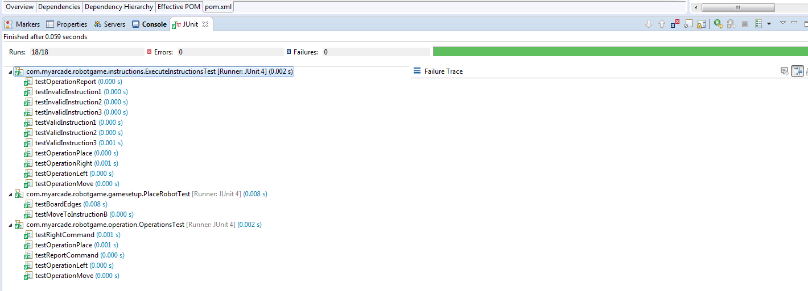

# Integration Test Cases

|  |  |  |  |  |
| --- | --- | --- | --- | --- |
| **Package** | **Class** | **Testcases** | **Result** | **Description** |
| com.myarcade.robotgame.integration | RobotGamePlay | testInstructionsExampleA() | Pass | The test case tests  ### Example a  PLACE 0,0,NORTH  MOVE  REPORT  Expected output:  0,1,NORTH |
|  |  | testInstructionsExampleB() | Pass | The test case tests  ### Example b  PLACE 0,0,NORTH  LEFT  REPORT  Expected output:  0,0,WEST |
|  |  | testInstructionsExampleC() | Pass | The test case tests  ### Example c  PLACE 1,2,EAST  MOVE  MOVE  LEFT  MOVE  REPORT  Expected output  3,3,NORTH |

# Integration Test Summary Report

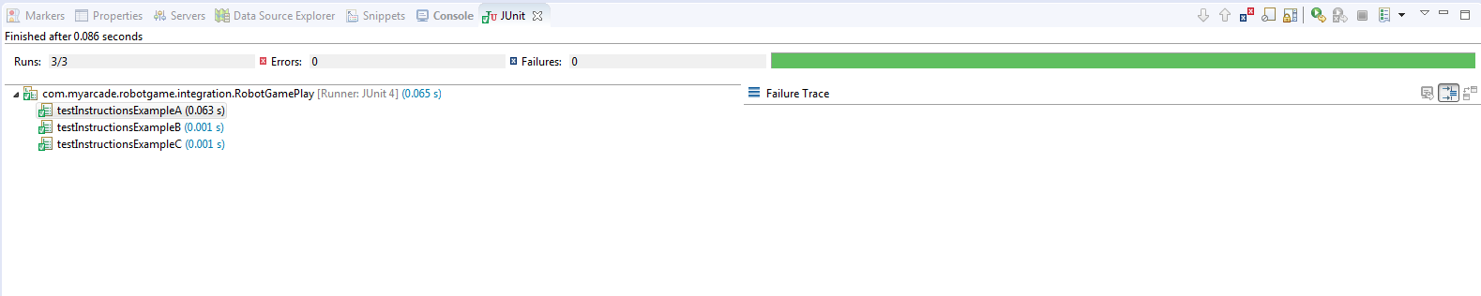

# Known Issues

In some of the older versions of java runtime, scanner methods that reads input from stdin can take longer time to exit. This causes program not to respond to ‘CNTR + z +enter’ on windows or ‘CNTR + D’ on unix.

**Solution**: As a future extension to the robot game application, a unique key like ‘##’ or ‘END’ can be given as an input to exit the stdin. This is not implemented in this solution.