Snaps for Questions(4-6)

4)

Checking the output with valid inputs:

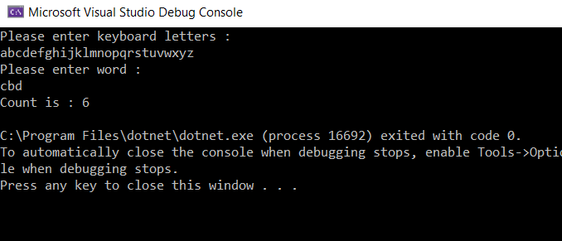

Now entering invalid inputs and checking for constraints:

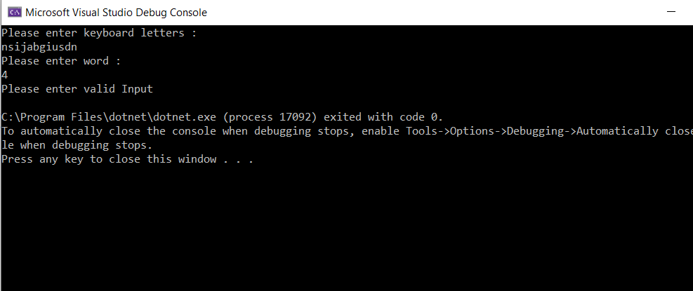

Another Invalid Input:

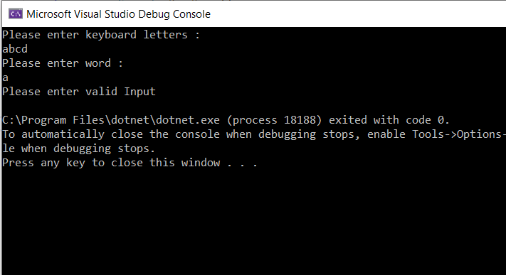

5)Output for flipped and Inverted Image (for 3x3 matrix): Input: [[1,1,0],[1,0,1],[0,0,0]]

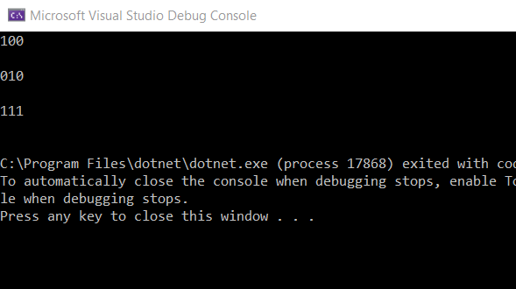

6)Checking for minimum no of rooms

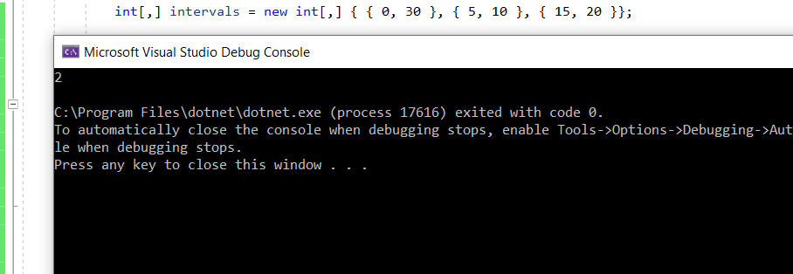

Checking with the constraint where start time is greater than end time

