AlarmMan.NET Setup Guide for PLC Alarms
(Revised 11/16/2007 for Robot Controllers with up to four arms)

PLC Alarm Data Table Layout
The alarm datatable for each device can be custom configured for that device, however in general the table should be organized as follows:

Data Words | Content
0 - n | Active Alarm Table
n+1 - n+n | Alarm Reference Table
n+n+1 - <end> | Associated Data Table (if applicable)

At a minimum, the PLC Alarm Data Table must consist of the Active Alarm Table and the Alarm Reference Table. The least significant bit in the start word of each of these tables corresponds to Alarm 000 for this device. Each data word is assumed to be 16 bits wide (i.e. any bits above 15 will be ignored) . The 16 bit value read from the PLC can be signed (-32768 to 32767) or unsigned (0 to 65535).

The Associated Data Table (if applicable) can be any practical length and comprises any or all of the following, for each of 4 equipments (arms):

Production ID - VIN Number or Carrier Number/ID
Job ID - Sequence Number
Style - Style Number or ID
Color - Color Number or ID

Each of these items can be either a number or an alpha-numeric string and can occupy one or more data words. The items can exist in any order in the Associated Data table.

In the (unlikely) case where a number value occupies more than one data word, the (string) values read from the PLC will be concatinated with the first data word in the sequence having the most significant value and the last word in the sequence having the least significant value.

Example: Data word n has a value of 33 and data word n+1 has a value of 17. The resulting value would be 3317.

In the case where an Associated Data item is an alpha-numeric string, the data will be organized as follows:

Bits 8-15 | Bits 0 -7
ASCII Most Significant Character | ASCII Least Significant Character

In the case where the character sting occupies more than one data word, , the values will be concatinated with the first data word in the sequence having the most significant value and the last word in the sequence having the least significant value.

Example: Data word n holds the characters AB, data word n+1 holds the characters CD, and data word n+2 holds the characters EF. The resulting value would be ABCDEF.

PLC Alarm Logic

For each PLC Alarm Zone, AlarmMan.NET will poll a unique Status Word in the PLC data table. Each PLC Alarm Device in the PLC Alarm Zone will have a corresponding bit in this Status Word that is TRUE / ON when a change has been found in the Active Alarm Table for that device.

While the Status Word has a value of zero (0), PLC logic for each PLC Alarm Device will compare the value of data words in it's Active Alarm Table to the value of the corresponding data words in it's Alarm Reference Table. If a mismatch is located, the PLC logic will copy the values in the Active Alarm Table to the Alarm Reference Table and set a flag (not located in the Status Word) to indicate a mismatch has been found. This flag only needs to be TRUE / ON for one scan only.

PLC logic located at the beginning (or end) of the program scan will map the mismatch flags to their assigned bits in the Status Word. Bits in the status word will be latched ON. If the value of the Status Word is non-zero, this PLC logic block will start an AlarmMan Response Timer, set the value of the Acknowledge Word (unique to the PLC Alarm Zone) to zero (0) and monitor the value of that word.

At this time, AlarmMan will read the Alarm Reference Table and Associated Data Table (if applicable) for each PLC Alarm Device that has reported a change.

When the value of the Acknowledge word is non-zero (indicating that AlarmMan is finished with processing), the PLC will set the value of the Status word to zero(0). When AlarmMan detects that the value of the Status word is zero(0), it sets the value of the Acknowledge word to zero(0). This, in turn, re-enables the comparison of Active and Reference Alarm Tables for each PLC Alarm Device in this zone.

If the Response Timer times out (indicating that AlarmMan is not running or has not responded within a reasonable time period), the PLC logic will set the Status and Acknowledge words to a value of zero(0). This, in turn, re-enables the comparison of Active and Reference Alarm Tables for each PLC Alarm Device in this zone.
.

Config.mdb PLC Alarm Zones Datatable Configuration

A new table named PLC Alarm Zones has been added to Config.mdb to hold PLC Alarm Zone configuration data. The table is organized as shown in the diagram below.

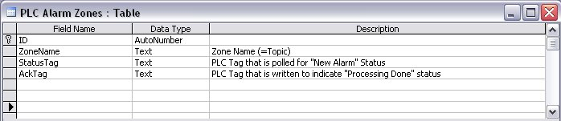

Enter unique values for the [ZoneName], [StatusTag], and [AckTag] fields for each zone. The [ZoneName] field is linked to the [Zone Name] field in the Config.mdb Zones table so it can be chosen from a list..

Config.mdb PLC Alarm Devices Datatable Configuration

A new table named PLC Alarm Devices has been added to Config.mdb to hold configuration data for each PLC Alarm Device in all zones. The table is organized as shown in the diagram below.

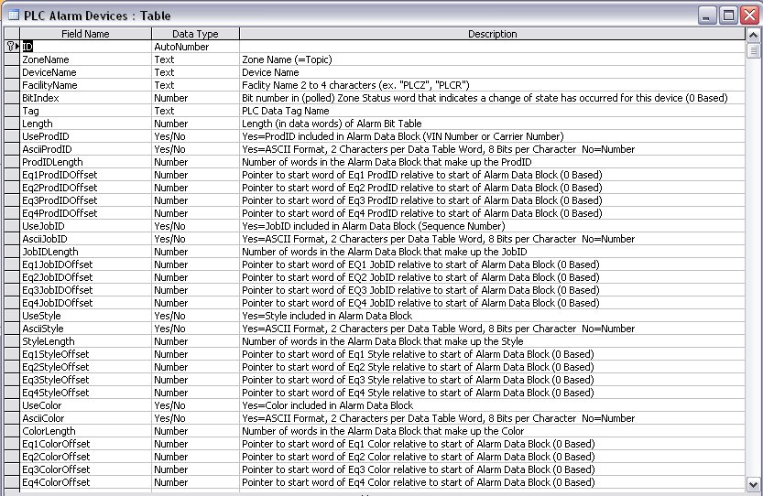

The Description in the table above explains the function of each field. The [ZoneName] field is linked to the [Zone Name] field in the Config.mdb Zones table so it can be chosen from a list.. Likewise, The [DeviceName] field is linked to the [Robots] field in the Config.mdb Robots table so the controller name can be chosen from a list.. Vaules in this field can also be entered manually for non-robot devices (ex. Booth).

Note: In regard to Associated Data Offset field values, it is assumed that the offset for the start word of the Alarm Reference Table is 0. So, for example, if the PLC Alarm Data table for a given device is organized as shown in Table A below, the Associated Data Offset and Length fields would have the values shown in Table B.

Table A
Data Word | Description
0 | Active Alarm Table word 0 (alarms 000 - 015)
1 | Active Alarm Table word 1 (alarms 016 - 031)
2 | Active Alarm Table word 2 (alarms 032 - 047)
3 | Alarm Reference Table word 0 (alarms 000 - 015)
4 | Alarm Reference Table word 1 (alarms 016 - 031)
5 | Alarm Reference Table word 2 (alarms 032 - 047)
6 | Eq1 Production ID word 0
7 | Eq1 Production ID word 1
8 | Eq2 Production ID word 0
9 | Eq2 Production ID word 1
10 | Eq1 Job ID word 0
11 | Eq2 Job ID word 0
12 | Eq1 Style word 0
13 | Eq2 Style Word 0
14 | Eq1 Color word 0
15 | Eq2 Color word 0

Table B
Field | Description | Value
Length | Length (in data words) of Alarm Bit Table | 3
ProdIDLength | Number of words in the Alarm Data Block that make up the ProdID | 2
Eq1ProdIDOffset | Pointer to start word of Eq 1 ProdID relative to start of Alarm Data Block (0 Based) | 3
Eq2ProdIDOffset | Pointer to start word of Eq 2 ProdID relative to start of Alarm Data Block (0 Based) | 5
JobIDLength | Number of words in the Alarm Data Block that make up the JobID | 1
Eq1JobIDOffset | Pointer to start word of Eq1 JobID relative to start of Alarm Data Block (0 Based) | 7
Eq2JobIDOffset | Pointer to start word of Eq2 JobID relative to start of Alarm Data Block (0 Based) | 8
StyleLength | Number of words in the Alarm Data Block that make up the Style | 1
Eq1StyleOffset | Pointer to start word of Eq1 Style relative to start of Alarm Data Block (0 Based) | 9
Eq2StyleOffset | Pointer to start word of Eq2 Style relative to start of Alarm Data Block (0 Based) | 10
ColorLength | Number of words in the Alarm Data Block that make up the Color | 1
Eq1ColorOffset | Pointer to start word of Eq1 Color relative to start of Alarm Data Block (0 Based) | 11
Eq2ColorOffset | Pointer to start word of Eq2 Color relative to start of Alarm Data Block (0 Based) | 12

Note: Values in this table will be ignored if the enable field for a particlar type of data (ex. UseProdID) is set to "No".

AlarmManConfig.XML Configuration

An XML data file associated with AlarmMan.NET named AlarmManConfig.xml holds configuration data that, among other things, will enable or disable the monitoring and logging of PLC Alarms. This datafile contains a table named Configuration that is organized as shown below. The contents of this table must be edited manually using a text editor like Notepad. Change the EnablePLCAlarms value from false to true to enable the monitoring and logging of PLC Alarms.

<Configuration>
<MaxAlarms>200</MaxAlarms>
<EnableRobotAlarms>false</EnableRobotAlarms>
<EnablePLCAlarms>false</EnablePLCAlarms>
</Configuration>

PLC Alarm Message Text, Severity, and Cause Mnemonic

PLC Alarm text is stored in Resource files to allow for multiple language support. By default, this data is stored in a file named PLCAlarmStrings.resx and contains English text. If multiple languages must be supported, additional resource files must be created theat include the culture string in the name (ex. PLCAlarmStrings.es-MX.resx would contain Mexican-Spanish strings). String data in the resource files is organized as shown below.

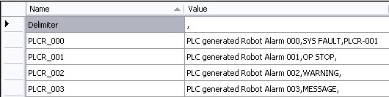

The Delimiter item stores the character that is used to separate the fields in the text value for each alarm. In the example case it is a comma ",". Note: Choose a character for this function that won't be used in Alarm Message, Severity, or Cause Mnemonic fields.

For each PLC Alarm, the [Name] field stores the value that will be used by AlarmMan to select the text associated with an Alarm. It consists of the FacilityName associated with this Device (see section 4) and the alarm bit number separated by an underbar "_" character as shown below.

<FacilityName>_<Alarm table bit number (padded with 0s to 3 places>

For each PLC Alarm, the [Value] field stores 3 text strings that are separated by the Delimiter character.

- Message text - The Alarm message to be displayed
- Severity - For PLC Alarms, this can be 1 of 4 levels
SYS FAULT - System fault that causes a line stop
OP STOP - Operator Stop
WARNING - Abnormal condition that does not cause a line stop
MESSAGE - Status message
- Cause Mnemonic - If another alarm causes this alarm to occur, this field contains the Mnemonic for that alarm which is formatted as shown below. Leave this field blank if it doesn't apply.
<FacilityName>-<Alarm number (padded with 0s to 3 places>

